Microservices Aggregator Pattern in Java: Building Efficient Composite Services in Java | Java Design Patterns

On This Page
- Also known as
- Intent of Microservices Aggregator Design Pattern
- Detailed Explanation of Microservices Aggregator Pattern with Real-World Examples
- Programmatic Example of Microservices Aggregator Pattern in Java
- When to Use the Microservices Aggregator Pattern in Java
- Benefits and Trade-offs of Microservices Aggregator Pattern
- Related Java Design Patterns
- References and Credits
Also known as
- API Composition
Intent of Microservices Aggregator Design Pattern
The Microservices Aggregator pattern helps aggregate responses from multiple microservices into a single unified response, optimizing client-server interactions in scalable systems.
Detailed Explanation of Microservices Aggregator Pattern with Real-World Examples
Real-world example
In a travel booking platform, an Aggregator Microservice consolidates data from flights, hotels, and car rentals microservices, providing a seamless user experience and enhancing scalability. Instead of the user making separate requests to each service, the platform employs an Aggregator Microservice. This microservice calls each of these services, collects their responses, and then consolidates the information into a single, unified response that is sent back to the user. This simplifies the user experience by providing all necessary travel details in one place and reduces the number of direct interactions the user needs to have with the underlying services.
In plain words
Microservices Aggregator collects pieces of data from various microservices and returns an aggregate for processing.
Stack Overflow says
Microservices Aggregator invokes multiple services to achieve the functionality required by the application.
Architecture diagram
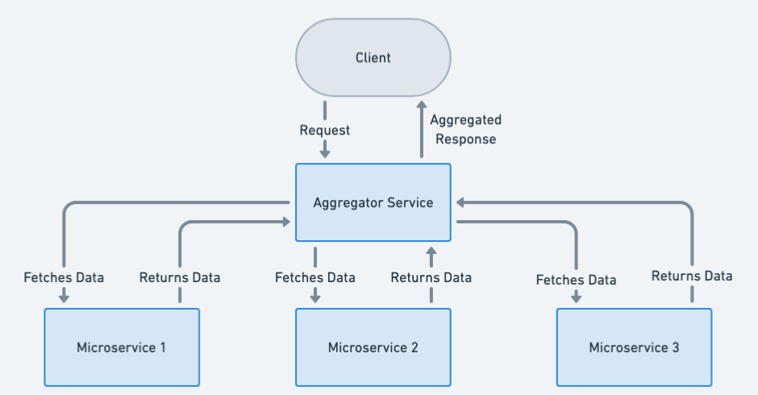
Programmatic Example of Microservices Aggregator Pattern in Java
Our web marketplace utilizes an Aggregator microservice to fetch combined product and inventory information from separate microservices, ensuring efficient data processing and improved system performance.
Let's start from the data model. Here's our Product.
public class Product {
private String title;
private int productInventories;
// Other properties and methods...
}
Next we can introduce our Aggregator microservice. It contains clients ProductInformationClient and ProductInventoryClient for calling respective microservices.

@RestController
public class Aggregator {

@Resource
private ProductInformationClient informationClient;

@Resource
private ProductInventoryClient inventoryClient;

@RequestMapping(path = "/product", method = RequestMethod.GET)
public Product getProduct() {

var product = new Product();
var productTitle = informationClient.getProductTitle();
var productInventory = inventoryClient.getProductInventories();

//Fallback to error message
product.setTitle(requireNonNullElse(productTitle, "Error: Fetching Product Title Failed"));

//Fallback to default error inventory
product.setProductInventories(requireNonNullElse(productInventory, -1));

return product;
}
}
Here's the essence of information microservice implementation. Inventory microservice is similar, it just returns inventory counts.

@RestController
public class InformationController {
@RequestMapping(value = "/information", method = RequestMethod.GET)
public String getProductTitle() {
return "The Product Title.";
}
}
Now calling our Aggregator REST API returns the product information.
# Example bash call
curl http://localhost:50004/product

# Example output
{"title":"The Product Title.","productInventories":5}
When to Use the Microservices Aggregator Pattern in Java
The Microservices Aggregator pattern is ideal for scenarios requiring composite responses from multiple microservices, such as in e-commerce and dashboard applications where aggregated data enhances user experience and system efficiency.
Benefits and Trade-offs of Microservices Aggregator Pattern
Benefits:
- Simplified Client: Clients interact with just one service rather than managing calls to multiple microservices, which simplifies client-side logic.
- Reduced Latency: By aggregating responses, the number of network calls is reduced, which can improve the application's overall latency.
- Decoupling: Clients are decoupled from the individual microservices, allowing for more flexibility in changing the microservices landscape without impacting clients.
- Centralized Logic: Aggregation allows for centralized transformation and logic application on the data collected from various services, which can be more efficient than handling it in the client or spreading it across multiple services.
Trade-offs:
- Single Point of Failure: The aggregator service can become a bottleneck or a single point of failure if not designed with high availability and scalability in mind.
- Complexity: Implementing an aggregator can introduce complexity, especially in terms of data aggregation logic and error handling when dealing with multiple services.
Related Java Design Patterns
- API Gateway: The Microservices Aggregator pattern is often used in conjunction with an API Gateway, which provides a single entry point for clients to access multiple microservices.
- Composite: The Microservices Aggregator pattern can be seen as a form of the Composite pattern, where the composite is the aggregated response from multiple microservices.
- Facade: The Microservices Aggregator pattern can be seen as a form of the Facade pattern, where the facade is the aggregator service that provides a simplified interface to the client.
References and Credits

Service Aggregator Pattern. In this article, we are going to talk… | by Mehmet Ozkaya | Design Microservices Architecture with Patterns & Principles | Medium
Design Microservices Architecture with Patterns & Principles
Guided Exercise - Microservices - Design Patterns - Aggregator Pattern · akash-coded/spring-framework · Discussion #156
Aggregator Pattern in Spring Microservices
The Aggregator is a Microservices pattern where one service (the Aggregator) calls multiple services to perform some task. The Aggregator will then compile the results and send a unified response back to the consumer. This pattern simplifies the consumer code, centralizes some request-handling aspects, and makes it possible to optimize calls for better performance.
Prerequisites
- Java Development Kit (JDK 8 or above)
- Maven
- IDE like IntelliJ IDEA or Eclipse
- Docker (for running services)
Architecture Overview
We will create 3 services:
- OrderService - Manages orders
- PaymentService - Manages payments
- AggregatorService - Aggregates data from the Order and Payment services and provides a unified API to the client
Step 1: Create Microservices
Create three separate Spring Boot projects (either via Spring Initializr or your preferred method).
Step 2: Add Dependencies
For all three projects, you will need the following dependencies:
<!-- Web -->
<dependency>
<groupId>org.springframework.boot</groupId>
<artifactId>spring-boot-starter-web</artifactId>
</dependency>
<!-- Actuator for monitoring -->
<dependency>
<groupId>org.springframework.boot</groupId>
<artifactId>spring-boot-starter-actuator</artifactId>
</dependency>
For the AggregatorService, add Spring Cloud OpenFeign for declarative REST calls:
<!-- Feign -->
<dependency>
<groupId>org.springframework.cloud</groupId>
<artifactId>spring-cloud-starter-openfeign</artifactId>
</dependency>
Step 3: Business Logic
- OrderService: Create a REST API to get an order by ID.
- PaymentService: Create a REST API to get payment details by order ID.
- AggregatorService: Use Feign clients to call the above services and aggregate the data.
Here's a simple Feign client in AggregatorService:
@FeignClient("order-service")
public interface OrderClient {
@GetMapping("/order/{id}")
Order getOrderById(@PathVariable("id") String id);
}

@FeignClient("payment-service")
public interface PaymentClient {
@GetMapping("/payment/{orderId}")
Payment getPaymentByOrderId(@PathVariable("orderId") String orderId);
}
Step 4: Aggregation Logic
In the AggregatorService, use the Feign clients to aggregate data.
@RestController
public class AggregatorController {
@Autowired
private OrderClient orderClient;
@Autowired
private PaymentClient paymentClient;

@GetMapping("/aggregate/{id}")
public AggregateData aggregate(@PathVariable String id) {
Order order = orderClient.getOrderById(id);
Payment payment = paymentClient.getPaymentByOrderId(id);
return new AggregateData(order, payment);
}
}
Step 5: Run Services
- Run the OrderService and PaymentService locally or package them and run as Docker containers.
- Run the AggregatorService.
Step 6: Test Aggregator
Test by calling http://localhost:8080/aggregate/1.
Internal Details
The Aggregator pattern can add an extra layer for request/response management, enabling optimizations like response caching, parallel calls, and more. It also decouples consumers from the details of internal microservices, making the architecture more flexible.
Best Practices, Dos and Don'ts, Optimization Strategies
- Caching: Cache common queries in the aggregator.
- Asynchronous Calls: Use async mechanisms for calling services to reduce the overall time.
- Bulk API: Where possible, use bulk APIs to retrieve data.
- Error Handling: Handle errors gracefully; a failure in one service should not lead to a complete failure in the aggregator.
- Monitoring: Monitor aggregators carefully as they are a common point of failure.
- Rate Limiting: Implement rate limiting to prevent misuse.
- Decoupling: Keep the aggregator decoupled from business logic; it should only be responsible for data gathering.
Code Repository Structure
Your code structure might look something like this for the three services:
- OrderService
  - src
    - main
      - java
        - com
          - example
            - OrderServiceApplication.java
            - controller
              - OrderController.java
            - model
              - Order.java
      - resources
        - application.properties
- PaymentService
  - src
    - main
      - java
        - com
          - example
            - PaymentServiceApplication.java
            - controller
              - PaymentController.java
            - model
              - Payment.java
      - resources
        - application.properties
- AggregatorService
  - src
    - main
      - java
        - com
          - example
            - AggregatorServiceApplication.java
            - controller
              - AggregatorController.java
            - feignclient
              - OrderClient.java
              - PaymentClient.java
            - model
              - AggregateData.java
      - resources
        - application.properties
Sample Code for Controllers and Models
OrderService
@RestController
public class OrderController {
@GetMapping("/order/{id}")
public Order getOrderById(@PathVariable String id) {
return new Order(id, "Product_" + id, 10);
}
}

public class Order {
private String id;
private String name;
private double price;
// Getters and Setters
}
PaymentService
@RestController
public class PaymentController {
@GetMapping("/payment/{orderId}")
public Payment getPaymentByOrderId(@PathVariable String orderId) {
return new Payment(orderId, "PAID");
}
}

public class Payment {
private String orderId;
private String status;
// Getters and Setters
}
AggregatorService
@RestController
public class AggregatorController {
@Autowired
private OrderClient orderClient;
@Autowired
private PaymentClient paymentClient;

@GetMapping("/aggregate/{id}")
public AggregateData aggregate(@PathVariable String id) {
Order order = orderClient.getOrderById(id);
Payment payment = paymentClient.getPaymentByOrderId(id);
return new AggregateData(order, payment);
}
}

public class AggregateData {
private Order order;
private Payment payment;
// Getters and Setters
}
Further Considerations
Performance
- Aggregator services can be prone to performance bottlenecks and can add latency if not properly designed.
Fault Tolerance
- Use patterns like Circuit Breaker to make the aggregator service more resilient.
Authentication & Authorization
- The aggregator may need to handle security aspects, both for incoming requests and for the service-to-service calls it makes. Spring Security can be used here.
Monitoring & Logging
- Aggregator services can be crucial in terms of observability. Integrate them with centralized logging and monitoring solutions.
Versioning
- Be cautious with versioning. When one of the internal services changes its API, the aggregator must be updated accordingly.
API Documentation
- Use tools like Swagger to document the aggregator API to make it easier for clients to understand what is being offered.
Testing
- Include unit tests for the individual services and integration tests that include the aggregator.

