https://www.youtube.com/watch?v=SvjdJoNPcHs&list=PLJq-63ZRPdBsPWE24vdpmgeRFMRQyjvvj&index=13&pp=iAQB

(3377) What is CQRS Pattern | CQRS Pattern in Microservices - YouTube

CQRS - Command Query Responsibility Segregation Design Pattern - GeeksforGeeks
CQRS - Command Query Responsibility Segregation Design Pattern
Last Updated : 14 Feb, 2026

Command Query Responsibility Segregation (CQRS) is an architectural pattern that improves scalability and performance by separating read and write operations into distinct models. Instead of using a single model to both retrieve and modify data, CQRS divides responsibilities into two parts:
- Commands, which handle state-changing operations such as insert, update, and delete.
- Queries, which retrieve data without modifying the system state.
This separation allows the write side to focus on enforcing business rules and maintaining consistency, while the read side can be optimized for fast data access. As applications grow in complexity and scale, this division helps improve flexibility and system performance.

- Write operations update the write database, which acts as the source of truth.
- Changes are propagated—often through events—to update the read database.
- Queries retrieve data exclusively from the read database, ensuring clear separation between data modification and data retrieval.
Detailed Architecture of CQRS
To understand how CQRS is implemented in real-world systems, the following diagram illustrates a structured service-level architecture.

In a structured implementation, CQRS is realized using separate services and storage layers:
- UI (User Interface): Sends commands for write operations and queries for read operations.
- Command Service (Command Model): Processes commands, applies business logic, and updates the write storage.
- Write Storage: Acts as the source of truth and stores authoritative data.
- Synchronization Mechanism: Propagates changes from write storage to read storage, often using events.
- Read Storage: Maintains a read-optimized view of the data for fast retrieval.
- Query Service (Query Model): Handles read-only requests and fetches data from read storage.
This architecture enables independent scaling of read and write components, improving system flexibility and supporting high-load applications.
Limitations of Traditional Architectures and Solution by CQRS
Traditional architectures often face challenges in handling high loads and managing complex data requirements. In these systems, the same model is used for both reading (fetching data) and writing (updating data), which can lead to performance issues. As the application grows, handling large read and write requests together becomes harder, creating bottlenecks and slowing down responses.
CQRS addresses this by allowing read and write workloads to scale and evolve independently.
- As a result, CQRS allows systems to handle higher traffic efficiently, improves performance, and simplifies scaling by allowing independent optimization of read and write parts.
Relationship between CQS and CQRS
Command Query Separation (CQS) and CQRS are related in that CQRS extends upon the fundamental concept of CQS. To put it simply, this is how they are related:
- CQS: It is a programming principle that says you should separate operations that change data (commands) from those that read data (queries). If you have a method, for instance, it should either return something or update something, but not both.
- CQRS: By dividing the design of the entire system into two sections—one for managing commands (writing or modifying data) and another for managing queries (reading data), CQRS expands on this idea. Each side can have its own database or model to optimize how they work.
So, CQS is the basic rule, and CQRS is like an advanced version of it used for bigger systems where you want to handle reading and writing differently.
Uses
You should use the CQRS design pattern when your application has different types of operations—like when reading data is very frequent and writing data is complex or infrequent. Here are some common scenarios where CQRS is helpful:
- Handling complex queries: If your application needs to perform complicated read operations (queries), separating the read and write sides can optimize performance.
- Scalability: When you need to scale reading and writing operations independently, CQRS allows you to optimize each side separately for better scalability.
- Event-driven systems: In systems where changes trigger events, CQRS works well with event sourcing to handle complex workflows.
- When data models differ: If the way you store data for writing is different from how it should be optimized for reading, CQRS helps by keeping separate models.
CQRS is most suitable for systems with high read/write imbalance, complex business logic, or strong scalability requirements.
Database Synchronization in CQRS
Synchronizing databases in a system that follows the CQRS pattern can be challenging due to the separation of the write and read sides of the application.

- Step 1: Write to the Command Database: When you make changes (create, update, delete), they are first saved in the command database. This database is optimized for handling write operations.
- Step 2: Generate Events: After the write operation is successful, the system generates events that describe what changed (like "Order Created" or "User Updated"). These events serve as notifications about the updates.
- Step 3: Update the Query Database: The read database, optimized for fast queries, listens for these events and applies the changes to its own copy of the data. This way, the query database gets updated with the latest information.
- Step 4: Eventual Consistency: The key idea is that the query database doesn’t have to update immediately. There can be a slight delay, but eventually, both databases will sync, ensuring consistency over time.
This approach ensures that the systems are synchronized, with the command side focusing on data integrity and the query side on performance.
Example
In our E-commerce microservices architecture, we're introducing a new approach to database design using the CQRS pattern. We've decided to split our databases into two separate parts to better manage our data and improve performance.

- Firstly, we'll have a write database that focuses on handling all write operations, such as creating and updating orders.
- This database will be optimized for transactional consistency and relational data modeling, making it suitable for managing the core data changes.
- Secondly, we'll introduce a read database dedicated to handling read operations, such as querying for order details and order history.
- This database will be designed for high performance and scalability, using a NoSQL database like MongoDB or Cassandra.
Event Sourcing and CQRS
Event Sourcing and CQRS are often used together in systems that require high scalability, traceability, and complex business logic.
- Event Sourcing stores every state change as an immutable event instead of persisting only the latest state. For example, rather than updating a user’s balance directly, each transaction (such as “Deposit 100” or “Withdraw 50”) is recorded as a separate event. The current state is reconstructed by replaying these events. This approach provides a complete audit trail and makes it easier to track history or recover past states.
- When combined with CQRS, the command side records events as the source of truth, while the query side builds optimized read models based on those events. This separation enables high performance on reads while maintaining strong consistency and traceability on writes.
Together, Event Sourcing and CQRS provide traceability on the write side and optimized read models for performance-critical queries.
Challenges
Below are the challenges of using CQRS Design Pattern:
- Complexity: Your system may become more complex if you use CQRS, particularly if you are unfamiliar with the pattern. It can be difficult to coordinate data synchronization, manage distinct read and write models, and guarantee consistency between the two.
- Consistency: Maintaining consistency between the read and write models can be challenging, especially in distributed systems where data updates may not propagate immediately. Careful planning and execution are necessary to guarantee stability over time without compromising scalability or performance.
- Data Synchronization: It might be difficult to keep the read and write models in sync, particularly when handling complicated data transformations or big data sets. Message queues or event streams are commonly used to handle synchronization.
- Performance Overhead: Implementing CQRS can introduce performance overhead, especially if not done carefully. For example, using event sourcing for the write model can impact write performance, while keeping the read model updated in real-time can impact read performance.
- Operational Complexity: Operational complexity may rise while managing two databases or data storage (one for read and one for write). This covers duties including monitoring, backup and restoration, and guaranteeing data durability and high availability.
Best Practices for implementing CQRS pattern
Below are some of the best practices for implementing CQRS pattern:
- Separate Read and Write Models Carefully: Clearly divide the system into models for reading data (queries) and writing data (commands). This separation helps keep each model simple and optimized for its specific task.
- Use Asynchronous Communication When Needed: Since commands and queries are separated, consider using asynchronous messaging for commands. This helps the system stay responsive and handle high traffic efficiently, even if some operations take longer.
- Keep Commands and Queries as Simple as Possible: Design commands to focus only on changing data (like “CreateOrder” or “UpdateUser”) and queries only on retrieving data (like “GetOrderDetails”). Avoid mixing read and write logic in either part to keep things clean and maintainable.
- Embrace Event Sourcing for Data Consistency: Event sourcing can be paired with CQRS to keep a record of all changes. Each change is saved as an event, and the current state is rebuilt from these events. This can make it easier to track history, recover data, or audit changes.
- Consider the Complexity of Your System: CQRS adds some complexity, so it’s best suited for systems with high read and write demands or complex business rules. For simpler systems, CQRS might be overkill and add unnecessary development overhead.

CQRS: A Deep Dive into Command Query Responsibility Segregation | by Rahul Krishnan | Medium
CQRS: A Deep Dive into Command Query Responsibility Segregation



Rahul Krishnan
Follow
10 min read
·
Nov 8, 2024
27

What is CQRS?
Command Query Responsibility Segregation (CQRS) is a design pattern that separates the responsibilities of reading (queries) and writing (commands) data within an application. This separation can lead to improved performance, scalability, and maintainability, especially in complex systems.
Important Considerations for CQRS
- Consistency: Ensuring data consistency across the command and query models is crucial. Techniques like eventual consistency or two-phase commit can be used to manage this.
- Complexity: Implementing CQRS can introduce additional complexity to your application. Carefully evaluate whether the benefits outweigh the costs.
- Performance: While CQRS can improve performance in certain scenarios, it might introduce additional overhead. Benchmarking is essential to assess performance implications.
- Testability: Designing CQRS systems with testability in mind is important. Consider using dependency injection and mocking techniques to isolate components.
When to Use CQRS
CQRS is well-suited for:
- Complex systems: Applications with intricate data models or frequent updates can benefit from CQRS.
- High-performance requirements: If your application needs to handle a large number of reads or writes, CQRS can help optimize performance.
- Scalability: CQRS can improve scalability by allowing you to scale the command and query models independently.
- Security: CQRS can help enforce security policies by separating read and write operations.
When Not to Use CQRS
- Simple systems: If your application is relatively simple and doesn’t have significant performance or scalability requirements, CQRS might be overkill.
- Tightly coupled systems: If your read and write operations are tightly coupled, the benefits of CQRS might be limited.
- Limited resources: Implementing CQRS can require additional resources, so consider your team’s expertise and available technology.
CQRS vs Event Sourcing vs Read Replicas
- CQRS: Focuses on separating read and write responsibilities, often using different models for each.
- Event Sourcing: Stores a sequence of events as the primary source of truth, allowing for reconstructing the state of the system at any point in time.
- Read Replicas: Create copies of data for read-only access, improving performance and reducing load on the primary database.
While CQRS and Event Sourcing can be used together, they are not mutually exclusive. Read replicas can be used in conjunction with both CQRS and Event Sourcing to further optimize read performance.
Alternatives to CQRS
- Traditional CRUD: In simpler applications, traditional Create, Read, Update, and Delete (CRUD) operations might suffice.
- Layered architecture: A layered architecture can help separate concerns within an application, but it might not provide the same level of optimization as CQRS.
- Microservices: Microservices architecture can also be used to distribute read and write responsibilities, but it introduces additional complexity.
To determine whether CQRS is suitable for your application, consider factors such as system complexity, performance requirements, scalability needs, and team expertise.
Typical Tools and Technology Stack
- Message brokers: Apache Kafka, RabbitMQ, or AWS SQS can be used to communicate between the command and query models.
- Databases: Different databases can be used for commands and queries, such as relational databases (e.g., PostgreSQL) for commands and NoSQL databases (e.g., MongoDB) for queries.
- Frameworks: Frameworks like Axon Framework or CQRS.NET can simplify CQRS implementation.
- Programming languages: CQRS can be implemented in various programming languages, including Java, C#, Python, and JavaScript.
Sample Implementation
Domain Models (Write Model)
// Domain/Order.cs
public class Order : AggregateRoot
{
public Guid Id { get; private set; }
public DateTime Date { get; private set; }
public string CustomerName { get; private set; }
public OrderStatus Status { get; private set; }
public Order(Guid id, DateTime date, string customerName)
{
Id = id;
Date = date;
CustomerName = customerName;
Status = OrderStatus.New;
}
public void ShipOrder()
{
Status = OrderStatus.Shipped;
AddEvent(new OrderShippedEvent(Id));
}
}
// Domain/OrderStatus.cs
public enum OrderStatus
{
New,
Shipped,
Delivered
}
// Domain/OrderShippedEvent.cs
public class OrderShippedEvent : DomainEvent
{
public Guid OrderId { get; }
public OrderShippedEvent(Guid orderId)
{
OrderId = orderId;
}
}
The Domain Model code defines an Order class, representing a business entity, which inherits from AggregateRoot. The Order class has properties: Id (unique identifier), Date, CustomerName, and Status (enum: New, Shipped, Delivered). The constructor initializes an order with Id, Date, and CustomerName. The ShipOrder method updates the Status to Shipped and adds an OrderShippedEvent to the domain events. This implementation encapsulates the business logic and rules for managing orders, ensuring consistency and validity of the domain state.
Key Aspects:
- Order class represents the business entity.
- AggregateRoot inheritance defines the aggregate boundary.
- Properties (Id, Date, CustomerName, Status) define the domain data.
- ShipOrder method updates the status and raises a domain event (OrderShippedEvent).
- OrderStatus enum defines the possible order statuses.
Command Handlers (Write Side)
// CommandHandlers/ShipOrderCommandHandler.cs
public class ShipOrderCommandHandler : ICommandHandler<ShipOrderCommand>
{
private readonly IRepository<Order> _repository;
public ShipOrderCommandHandler(IRepository<Order> repository)
{
_repository = repository;
}
public async Task Handle(ShipOrderCommand command)
{
var order = await _repository.GetAsync(command.OrderId);
order.ShipOrder();
await _repository.SaveAsync(order);
}
}
// Commands/ShipOrderCommand.cs
public class ShipOrderCommand : ICommand
{
public Guid OrderId { get; }
public ShipOrderCommand(Guid orderId)
{
OrderId = orderId;
}
}
The Command Handlers code defines a ShipOrderCommandHandler class that handles the ShipOrderCommand. When the command is received, the handler retrieves the corresponding Order aggregate from the repository, invokes the ShipOrder method on the aggregate, and saves the updated aggregate back to the repository. This process ensures that the business logic and rules defined in the Order aggregate are executed consistently, maintaining the integrity of the domain state. The command handler acts as an intermediary between the application's command interface and the domain model, encapsulating the logic for processing commands.
Key Aspects:
- ShipOrderCommandHandler class handles ShipOrderCommand.
- Retrieves Order aggregate from repository.
- Invokes ShipOrder method on aggregate.
- Saves updated aggregate to repository.
- Encapsulates command processing logic.
Event Handlers (Read Side)
// EventHandlers/OrderShippedEventHandler.cs
public class OrderShippedEventHandler : IEventHandler<OrderShippedEvent>
{
private readonly IOrderSummaryRepository _repository;
public OrderShippedEventHandler(IOrderSummaryRepository repository)
{
_repository = repository;
}
public async Task Handle(OrderShippedEvent @event)
{
var orderSummary = await _repository.GetAsync(@event.OrderId);
orderSummary.Status = "Shipped";
await _repository.SaveAsync(orderSummary);
}
}
The Event Handlers code defines an OrderShippedEventHandler class that handles the OrderShippedEvent. When the event is received, the handler updates the corresponding OrderSummary in the read-model repository, setting its status to "Shipped". This ensures that the read-model reflects the latest state of the order, allowing for efficient and up-to-date querying. The event handler acts as a bridge between the domain model (write-side) and the read-model (query-side), maintaining data consistency and integrity by reacting to significant domain events.

Key Aspects:
- OrderShippedEventHandler class handles OrderShippedEvent.
- Updates OrderSummary status to "Shipped" in read-model repository.
- Ensures read-model consistency with domain model state.
- Reacts to significant domain events.
Query Handlers (Read Side)
// QueryHandlers/GetOrderSummaryQueryHandler.cs
public class GetOrderSummaryQueryHandler : IQueryHandler<GetOrderSummaryQuery, OrderSummary>
{
private readonly IOrderSummaryRepository _repository;
public GetOrderSummaryQueryHandler(IOrderSummaryRepository repository)
{
_repository = repository;
}
public async Task<OrderSummary> Handle(GetOrderSummaryQuery query)
{
return await _repository.GetAsync(query.OrderId);
}
}
// Queries/GetOrderSummaryQuery.cs
public class GetOrderSummaryQuery : IQuery<OrderSummary>
{
public Guid OrderId { get; }
public GetOrderSummaryQuery(Guid orderId)
{
OrderId = orderId;
}
}
The Query Handlers code defines a GetOrderSummaryQueryHandler class that handles the GetOrderSummaryQuery. When the query is received, the handler retrieves the corresponding OrderSummary from the read-model repository, using the provided OrderId. The retrieved OrderSummary contains the order's status, date, customer name, and other relevant details. The handler then returns the OrderSummary as the query result. This implementation follows the Command-Query Separation (CQS) pattern, separating read operations from write operations, and utilizing a optimized read-model for efficient querying.
Key Aspects:
- GetOrderSummaryQueryHandler class handles GetOrderSummaryQuery.
- Retrieves OrderSummary from read-model repository.
- Returns OrderSummary as query result.
- Follows Command-Query Separation (CQS) pattern.
Infrastructure
// Infrastructure/Repository.cs
public interface IRepository<T>
{
Task<T> GetAsync(Guid id);
Task SaveAsync(T aggregate);
}
// Infrastructure/EventStore.cs
public interface IEventStore
{
Task SaveAsync(DomainEvent @event);
}
// Infrastructure/OrderSummaryRepository.cs
public class OrderSummaryRepository : IOrderSummaryRepository
{
private readonly DbContext _context;
public OrderSummaryRepository(DbContext context)
{
_context = context;
}
public async Task<OrderSummary> GetAsync(Guid id)
{
return await _context.OrderSummaries.FindAsync(id);
}
public async Task SaveAsync(OrderSummary summary)
{
_context.OrderSummaries.Update(summary);
await _context.SaveChangesAsync();
}
}
The Infrastructure code provides the foundation for the application’s architecture, defining interfaces and implementations for data access, event storage, and repository patterns. Specifically, it includes the IRepository interface, which outlines methods for retrieving and saving aggregates, and the OrderSummaryRepository class, which implements this interface using a DbContext to interact with the database. Additionally, the IEventStore interface defines methods for saving events, enabling event sourcing and CQRS patterns. This infrastructure layer decouples the domain model from the data storage and event handling mechanisms, promoting flexibility, testability, and maintainability.
Key Components:
- IRepository interface: Defines data access methods.
- OrderSummaryRepository class: Implements IRepository using DbContext.
- IEventStore interface: Defines event storage methods.
CQRS Pattern Advanced Topics
Command Model vs. Query Model
Press enter or click to view image in full size
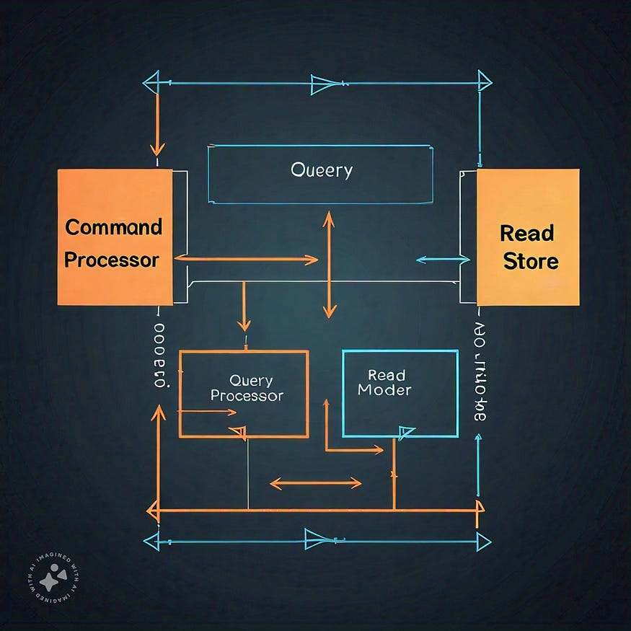
Ensuring consistency between the command and query models in a CQRS architecture is crucial to maintain data integrity. This is achieved through event sourcing, where commands generate events that update the command model, and these events are then handled by event handlers that update the query model. The command model, also known as the write model, is responsible for handling business logic and validating data, while the query model, or read model, provides a optimized view of the data for querying purposes. By using events to update both models, consistency is maintained, albeit eventually.
The trade-offs between eventual consistency and strong consistency in CQRS lie in the balance between availability, performance, and data accuracy. Eventual consistency offers higher availability and performance, as updates are asynchronous, but may result in temporary data inconsistencies. Strong consistency, on the other hand, ensures data accuracy but may compromise availability and performance, as updates are synchronous. In CQRS, eventual consistency is often preferred, as it allows for scalability and flexibility, while strong consistency is typically reserved for critical systems requiring real-time data accuracy. By understanding these trade-offs, developers can choose the appropriate consistency model based on business requirements, ensuring a well-designed and efficient CQRS architecture.
CQRS and Domain Driven Design
Press enter or click to view image in full size

Photo by hannah joshua on Unsplash
CQRS complements Domain-Driven Design’s (DDD) concepts of bounded contexts and aggregate roots by providing a technical architecture that aligns with DDD’s strategic and tactical design principles. Bounded contexts define the boundaries of a specific business capability, while aggregate roots define the consistency boundaries within those contexts. CQRS’s separation of command and query models allows for a natural alignment with these boundaries, enabling developers to define commands that operate within specific aggregate roots and bounded contexts. This alignment ensures that business logic and consistency rules are enforced within the command model, while the query model provides a optimized view of the data for querying purposes.
Applying DDD principles to model commands and queries in a CQRS system involves several key considerations. Commands should be designed to reflect the intentions of the business, using the ubiquitous language defined in the domain. Aggregate roots should be identified and used to define the consistency boundaries for commands. Queries, on the other hand, should be designed to meet the needs of the business, using read models that reflect the required data. Value objects and domain events can also be used to enrich the command and query models. By applying DDD principles, developers can create a CQRS system that accurately reflects the business domain, ensuring that the system is maintainable, scalable, and meets the business requirements.
CQRS and Legacy Systems
Press enter or click to view image in full size
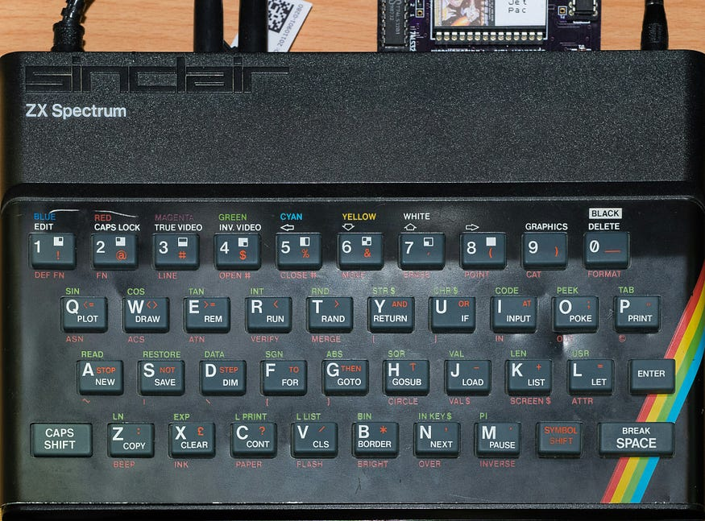
Photo by William Warby on Unsplash
Introducing CQRS into an existing legacy system requires a strategic and incremental approach. Start by identifying a specific business capability or domain area that would benefit from CQRS. Then, create a new command and query model alongside the existing system, gradually replacing legacy components with CQRS-based ones. This can be achieved through various techniques, such as wrapping legacy data access with a repository pattern, introducing event sourcing, or using a facade to decouple the command and query models. Additionally, consider implementing anti-corruption layers to translate between legacy and CQRS models, ensuring seamless integration.
Migrating a legacy system to a CQRS architecture presents several challenges and considerations. Technical debt, tightly coupled code, and outdated infrastructure can hinder the transition. Key considerations include:
(1) understanding the existing domain logic and identifying bounded contexts;
(2) managing data consistency and integrity;
(3) handling legacy data migration;
(4) integrating with existing infrastructure; and
(5) addressing scalability and performance concerns.
Challenges also arise from organizational and cultural changes, such as adopting new design principles, training teams, and shifting to an event-driven mindset. To overcome these challenges, prioritize incremental refactoring, continuous testing, and monitoring, and consider seeking expertise from experienced CQRS practitioners.
CQRS Debugging
Press enter or click to view image in full size

Photo by Nubelson Fernandes on Unsplash
Testing a CQRS system presents unique challenges due to its event-driven and asynchronous nature. Key challenges include:
(1) verifying event handling and processing;
(2) ensuring data consistency across command and query models;
(3) testing asynchronous and decoupled components; and
(4) simulating real-world scenarios and edge cases.
To address these challenges, developers can employ various strategies, such as:
(1) unit testing individual components;
(2) integrating tests to verify event flows;
(3) using mock event stores and repositories;
(4) implementing test-specific event handlers; and
(5) leveraging behavioral-driven development (BDD) frameworks.
Debugging issues related to data consistency or performance bottlenecks in a CQRS architecture requires a systematic approach. To identify data consistency issues, developers can:
(1) monitor event logs and audit trails;
(2) use event store visualization tools;
(3) implement data validation and reconciliation processes; and
(4) analyze event handling and processing timelines.
For performance bottlenecks, developers can:
(1) profile command and query execution;
(2) monitor system metrics and latency;
(3) optimize event handling and processing;
(4) implement caching and read-model optimization; and
(5) conduct load testing and stress testing.
Additionally, leveraging logging, tracing, and monitoring tools, such as OpenTelemetry or AppMetrics, can provide valuable insights into system behavior and performance.

CQRS Design Pattern
CQRS Design Pattern
November 28, 2025 by Vojtěch Juránek
cqrs design-patterns postgres mysql questdb replication
Command Query Responsibility Segregation (CQRS) is a design pattern that separates read and write operations to and from the database. It can also be used to aggregate data from multiple sources into a single, centralized data store. Although this pattern is commonly used in microservice architectures, it is not limited to them. In this blog post, we will explore how to implement the pattern in different setups and how Debezium can simplify its implementation.
Understanding the CQRS Design Pattern
In a traditional architecture, both reads and writes are handled by the same application and use the same database for all operations. This means they share the same data model and are subject to the same performance constraints. As the application grows, this unified approach can become a bottleneck. Read and write operations often have different performance characteristics, and operating on the same data can lead to lock contention. Using a single data model can also increase database load, since reads and writes may need different sets of fields. A shared database also requires elevated permissions, which can introduce security risks.
In a microservice architecture, it’s common to use the Database per Service pattern, where each microservice has its own database. However, workflows and user interfaces often require combining data from multiple microservices. This can be challenging and may result in delayed responses, as one slow service can block the entire query. It’s often more efficient to have an aggregating database that continuously collects data from all microservice databases and serves as a read-only database for complex queries.
All these challenges can be addressed with the CQRS design pattern. The pattern separates reads and writes into distinct data models stored in separate databases, handled by different parts of the application—or even by entirely separate microservices. The following diagram illustrates this concept:
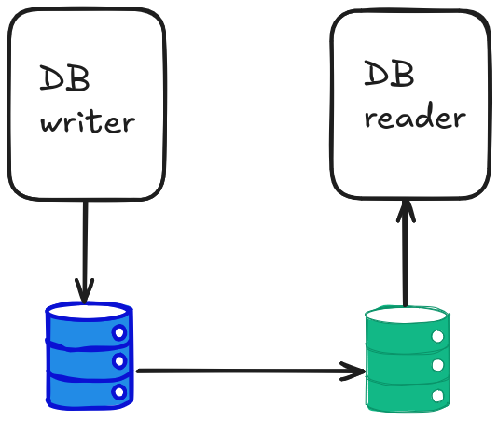
Benefits and challenges
The database that serves read operations is typically configured as read-only for the application. This reduces the attack surface and improves the overall security of the system. The read database can be a replica of the write database, but it can also be a completely different type of database—one that is better optimized for read queries (for example, a time-series database) or one that aggregates data from multiple data sources. In principle, both read and write data models can reside within the same database instance, but in practice, it is much more common to use separate databases. This approach allows each database to be tuned and scaled independently according to its workload.
In the microservice world, different microservices are often developed by different teams and deployed on independent schedules. Synchronizing data schemas and managing changes in data formats can therefore become challenging. The CQRS pattern helps mitigate this issue by decoupling data models between services, allowing each service to evolve its schema independently without tight coordination with other teams.
Of course, adopting the CQRS pattern also introduces some challenges. The most obvious one is the increased complexity of deployment and data management. Replicating data between databases can lead to an eventual consistency model, where newly written data might not be immediately available on the read side. However, in most microservice architectures, this short delay is acceptable and rarely causes real issues.
Possible Deployment Architectures
The main challenge in implementing the CQRS pattern is how to replicate data from the write database to the read database. There are three typical deployment scenarios.
The first scenario is when both data models exist in the same database. In such a case, there is no need to replicate data to another database instance, which makes this setup very simple to implement. However, this approach forfeits most of the benefits of the CQRS pattern and is therefore rarely used in production.
A more common setup is to use the same database type for both instances and leverage the database’s built-in replication capabilities. This, of course, assumes that the database you are using supports replication. Databases with replication features are usually mature enough to provide several options how to configure replication. In some cases, you can even configure the primary database to commit transactions only after the data has been replicated to the replica. This ensures strong consistency between the two instances if your use case requires it.
The third scenario arises when the database does not natively support replication, or when you want to use different database types, or even aggregate data from multiple databases into one central read database. In such cases, you need to set up replication using a third-party tool. A convenient and reliable approach is to use Change Data Capture (CDC) with Debezium. Debezium can capture database changes in real time and propagate them to one or more target databases.
In this blog post, we will focus on the latter two approaches—replication via database-native mechanisms and replication using Debezium.
The Demo Application
Use Case
Since our main objective is to demonstrate how to implement data replication within the CQRS pattern, we will use a very simple use case. We will build a basic voting application, without any user management or security checks. A user will be able to create a poll with several options through a REST API, and other users will be able to cast their votes for any of these options. Naturally, we will also want to view the results of the polls. Results will be available again over a REST API, and to make the application a bit more engaging, we will add a simple web UI that displays the current voting results.
The application will be split into two microservices, each with its own database. The first microservice will expose a REST API for creating new polls and casting votes. New polls and votes will be written into its database. Poll and voting data will then be replicated into another database instance, which will serve the second microservice responsible for displaying poll results.
Application Source Code
You can find the application source code in the Debezium example repository. The application uses the Quarkus framework and its REST module for implementing REST APIs, along with Panache and Hibernate ORM for persistence. In the first microservice, there is a one-to-one mapping between entities and database tables, and Panache handles most of the persistence logic automatically. In the second microservice, which executes custom SQL queries to read poll results, it is probably more straightforward to use Hibernate directly.
Integrating the UI is also simple with Quarkus. The application leverages Quarkus Quinoa to integrate a lightweight Node.js web application using ReactJS. The frontend periodically polls the REST API to fetch the latest results and updates the displayed chart. Thanks to Quarkus, the entire application codebase remains compact, and a notable highlight is how effectively Quarkus reduces boilerplate.
The source code can be found in Debezium examples repository.
CQRS with Database Built-in Replication
As mentioned earlier, the simplest implementation of the CQRS pattern is when your database provides built-in replication capabilities. In our example, we use the PostgreSQL database, which supports streaming replication. Schematically, our demo application looks like this:
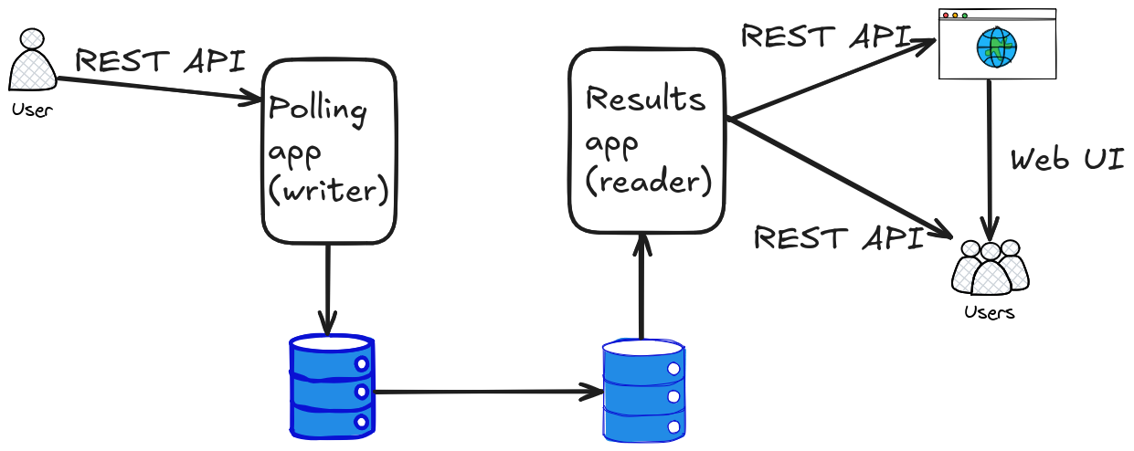
To enable streaming replication between two PostgreSQL instances, we first need to create a publication on the primary instance and a replication role with SELECT rights on the required tables:
CREATE PUBLICATION poll_pub FOR ALL TABLES;
CREATE ROLE replicator WITH REPLICATION LOGIN PASSWORD 'replicator';
GRANT SELECT ON ALL TABLES IN SCHEMA public TO replicator;
For simplicity, we granted SELECT rights on all tables. In a production setup, you should limit these privileges to only the tables that actually need to be replicated.
Because Hibernate may drop rows during update operation, we also need to replicate DELETE operations. To do this, we configure full table replication for the tables that need to be synchronized:
ALTER TABLE OptionEntity REPLICA IDENTITY FULL;
ALTER TABLE PollEntity REPLICA IDENTITY FULL;
...
Since Hibernate can dynamically create tables, you may also want to grant SELECT permissions to the replication role for any tables that might be created in the future:
ALTER DEFAULT PRIVILEGES IN SCHEMA public GRANT SELECT ON TABLES TO replicator;
However, this is not required in our demo application, as all tables are created in advance.
On the replica database, you simply need to subscribe to the publication created on the primary database using the appropriate credentials:
CREATE SUBSCRIPTION poll_sub
CONNECTION 'dbname=postgres host=postgres_primary user=replicator password=replicator'
PUBLICATION poll_pub;
After setting this up, all changes will automatically be replicated from the primary database, which serves the writer microservice, to the replica database used by the reader microservice. This is a straightforward and reliable solution that does not require any third-party tools. It can serve well until you need to integrate multiple data sources or use a different database type for the reader microservice.
CQRS in Heterogeneous Environments
In more heterogeneous environments, where different database technologies are used for the write and read sides, built-in replication mechanisms are usually not sufficient. You may want to replicate data between different types of databases or aggregate data from several systems into a single read-optimized store. In such cases, a Change Data Capture (CDC) solution like Debezium becomes extremely useful.
Debezium continuously monitors changes in a source database by reading its transaction log and publishes these changes to the destination configured by the user. In our demo, we will publish the events to Apache Kafka. From there, the data can be written into another database or system using a suitable Kafka Connect sink connector. For database which support inserting data over JDBC, we can use JDBC sink connector, eventually for MongoDB we can use MongoDB sink connector. For databases which don’t support inserts over JDBC, other than MongoDB, we have to rely on the custom sink connector provided by the database vendor.
However, Debezium usage is not limited to Kafka Connect runtime. Besides using standalone Debezium server, Debezium can be embedded into a custom microservice using Debezium embedded engine. Another option is to consume CDC events leveraging Debezium extension for Quarkus. This is probably the most easy way how to consume CDC events in your microservice, as it’s just a matter of simple configuration and annotating appropriate consumer methods with the right annotations. None the less, in all these cases we still have to implement sink part (part which writes the captured data into target database) ourselves.
The following diagram illustrates this setup:
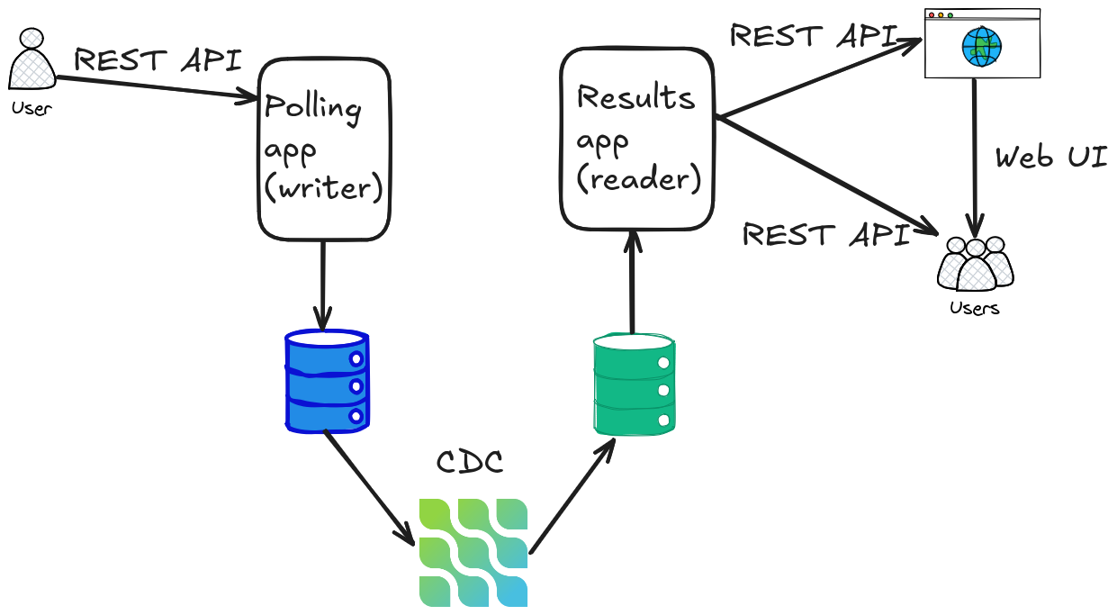
For simplicity, in out demo application we will also include Kafka Connect as the Debezium runtime. We will show two examples of using Debezium for data replication:
- Replicating data from PostgreSQL to MySQL using the Debezium JDBC Sink Connector.
- Replicating data from PostgreSQL to QuestDB using the QuestDB Kafka Sink Connector.
Replicating from PostgreSQL to MySQL
This setup demonstrates how to use Debezium with Kafka Connect to replicate data between two relational databases and the target database supports JDBC API.
The source side uses the Debezium PostgreSQL connector with a minimal configuration that specifies connection details and the tables to monitor:
{
"name": "postgres-source",
"config": {
"connector.class": "io.debezium.connector.postgresql.PostgresConnector",
"tasks.max": "1",
"database.hostname": "postgres",
"database.port": "5432",
"database.user": "postgres",
"database.password": "postgres",
"database.dbname": "postgres",
"topic.prefix": "polls",
"table.include.list": "public.optionentity, public.pollentity, public.pollentity_optionentity, public.pollentity_voteentity, public.voteentity"
}
}
This configuration captures all changes in the specified tables and publishes them to Kafka topics under the prefix polls.
On the sink side, we use the Debezium JDBC Sink Connector to insert these records into a MySQL database. Since the JDBC sink understands Debezium’s event format, no single message transformation (SMT) is required.
{
"name": "mysql-sink",
"config": {
"connector.class": "io.debezium.connector.jdbc.JdbcSinkConnector",
"tasks.max": "1",
"connection.url": "jdbc:mysql://mysql:3306/polls",
"connection.username": "mysqluser",
"connection.password": "mysqlpw",
"insert.mode": "upsert",
"delete.enabled": "true",
"primary.key.mode": "record_key",
"schema.evolution": "basic",
"collection.name.format": "${source.table}",
"topics": "polls.public.voteentity, polls.public.optionentity, polls.public.pollentity, polls.public.pollentity_optionentity"
}
}
In this configuration, the insert.mode is set to upsert, which ensures that both new inserts are properly reflected in the target database. Deletes are enabled as well, since Hibernate does deletes during updating the collection of votes. The ${source.table} placeholder ensures that each target table in MySQL matches the corresponding table name in PostgreSQL.
With just two simple configurations, Debezium ensures continuous data replication between two different database vendors.
Replicating from PostgreSQL to QuestDB
One of the advantages of using CQRS design pattern is that for aggregating and reading data we may use some special-purpose database which is able to optimize our query much better than general-purpose database. However, such database may not work with Debezium JDBC sink connector and if our database of choice is not MongoDB, it may look like we are out of luck. Fortunately not. We can take advantage of popularity of Kafka Connect platform. Due to Kafka popularity many database vendors provides their own sink connectors for Kafka Connect.
In the second example, we are going to replicate data from PostgreSQL into QuestDB, a high-performance time-series database optimized for analytical queries. To keep out demo application simple and unified across all the examples, we don’t use any QuestDB features or don’t so provide any time-related charts, e.g. how the number of votes evolved during the time, but you can easily image that it would just a simple modification of the reader microservice to provide such plots. We cannot use JDBC sink connector for QuestDB as for ingesting the data it supports InfluxDB Line Protocol. However, QuestDB provides their own sink connector for Kafka Connect. Moreover it works well with Debezium format.
The configuration of the PostgreSQL source connector can remain the same:
{
"name": "postgres-source",
"config": {
"connector.class": "io.debezium.connector.postgresql.PostgresConnector",
"tasks.max": "1",
"database.hostname": "postgres",
"database.port": "5432",
"database.user": "postgres",
"database.password": "postgres",
"database.dbname": "postgres",
"topic.prefix": "polls",
"table.include.list": "public.optionentity, public.pollentity, public.pollentity_optionentity, public.pollentity_voteentity, public.voteentity"
}
}
QuestDB sink connector behaves little bit differently to Debezium sink connectors. It coverts into table columns all fields in the records. Thus, as the first step, we will flatten Debezium records to contain only new record state. Conveniently Debezium provides New record state SMT, which does exactly this - extracts only new state from the Debezium record.
The configuration for the QuestDB poll sink would look like this:
{
"name": "questdb-sink",
"config": {
"connector.class": "io.questdb.kafka.QuestDBSinkConnector",
"tasks.max": "5",
"topics": "optionentity, pollentity, pollentity_optionentity, voteentity",
"table": "${topic}",
"client.conf.string": "http::addr=questdb:9000;",
"timestamp.field.name": "ts",
"include.key": false,
"value.converter": "org.apache.kafka.connect.json.JsonConverter",
"value.converter.schemas.enable": true,
"key.converter": "org.apache.kafka.connect.storage.StringConverter",
"transforms": "unwrap",
"transforms.unwrap.type": "io.debezium.transforms.ExtractNewRecordState"
}
}
The setup is quite similar to JDBC sink connector setup and additional SMT configuration is just for the convenience and simplicity.
Application point of view
We have shown several ways how to replicate data from one database instance to the other as a main building block for implementing CQRS pattern. No matter which setup you choose, the end result from the user perspective should be always the same and you should see something like this when looking on the poll results:
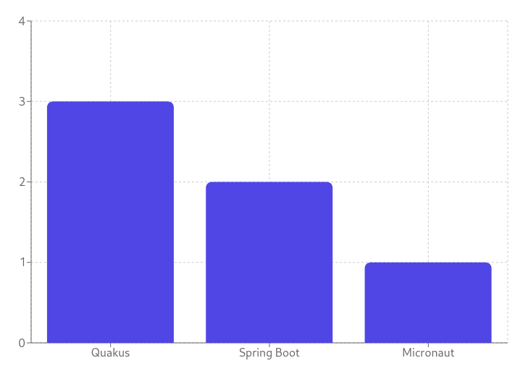
The results plot should be automatically updated as the votes are casted by the voters. The writer microservice which accepts the votes doesn’t need to be changed as you change the backend databases. The reader microservice which shows the results needs to be changed and re-deployed as we change the replica database. But the only change which needs to be done is change in database URL and connection credentials. In the case of QuestDB we also have to slightly modify SQL query as we simplified the deployment and merged several tables together. However, all these things can be parametrized and be solved by using Quarkus profiles. As a result we don’t have to do any changes in the application source code, we just need to recompile the reader application with appropriate Quarkus profile and redeploy the microservice. This nicely demonstrates another advantage of CQRS pattern - decoupling of the reader and writer parts into separate applications/microservices allows to change the backend, but it also shows the microservices can also change their data model without letting the other microservice know. Thus each microservice can be developed and updated completely independently and using CQRS pattern gives developer teams much more freedom and flexibility.
Summary
CQRS design pattern is a powerful pattern which suggests to split the application into part responsible for manipulating with the database data and part responsible for reading this data. This separation allows us to use different databases for each microservice. Independent databases allows independent scaling and tuning adjusted exactly to their needs and workload of given microservice. This segregation also allows different data models for each microservice allowing fine tuning of the models, but also independent evolution of each microservice. Other benefits of implementing this pattern involves increased security as only microservice which push data into database needs to have write access, better clarity and simplicity of the code and more.
In this blog post, besides introducing the pattern itself, we concentrate on the main obstacle in implementation of this pattern - how to replicate the data between the databases. We discussed several possible architectures and described ways how to ensure data replication in each setup. We started with the simple case when the replication is ensured by database itself, continued with replication between two different relational databases and concluded with setup where the relational database is replicated into special-purpose database.
We have shown how Debezium can tackle this problem, while the setup and configuration remains simple and declarative. It allows you to replicate data between heterogeneous databases in real time, regardless of vendor differences. This flexibility makes Debezium a perfect fit for implementing CQRS in complex, polyglot environments.

