https://www.youtube.com/watch?v=hrvx8Nv9eQA&list=PLJq-63ZRPdBsPWE24vdpmgeRFMRQyjvvj&index=1&pp=iAQB

Event Sourcing Pattern - GeeksforGeeks
Event Sourcing Pattern
Last Updated : 28 Feb, 2026

The Event Sourcing Pattern is like keeping a detailed diary for your software. Instead of just updating the current state of your data, you record every change as a separate event. These events form a complete history of what happened to your data over time. Therefore, you may rebuild your data by replaying these events to find out how it got to where it is now.
- These events are stored sequentially, forming a log or journal of actions that have occurred.
- The status of the program can be restored at any moment by replaying these events.
- It is frequently utilized in fields like finance and e-commerce where precise historical data are essential.
Event Sourcing
Core Concepts and Components
Event Sourcing in system design revolves around several core concepts and components:
- Events: These are permanent records of system state changes. In addition to representing a particular action or occurrence, each event includes all the relevant information required to rebuild the system's state at the moment of the event.
- Event Store: The event store is a durable storage system that maintains the complete stream of events in the exact order they were generated. Since events act as the source of truth in Event Sourcing, they must be stored permanently in a database or specialized event store. Messaging systems like Apache Kafka or RabbitMQ can be used to publish and distribute events to other services. However, they are not always used as the primary long-term storage for events.
- Aggregate: For the purposes of processing commands and producing events, an aggregate is a logical collection of linked domain objects that are handled as a single unit. The system's state changes and business logic are contained in aggregates. In the event store, each aggregate is linked to a distinct stream of events.
- Command: Clients or other system components can issue commands, which are requests or instructions to carry out particular tasks. Aggregates process commands by validating them, applying business logic, and, if the command is approved, generating the appropriate events.
- Projection: Projections are read models created from the stream of events kept in the event store that shows the system's current state. Projections are used to give effective access to data for reporting and querying.
- Event Bus: An event bus is a messaging infrastructure that makes it easier for various system components to communicate about events. It enables components to respond asynchronously to particular event types and subscribe to them.
Working
Below are the steps to understand how event sourcing pattern works:
- Capture Events Instead of State: Every system modification is documented as an event (e.g., "order created," "item added," "order completed") rather than just preserving the final state (e.g., "order is completed"). Every event denotes a distinct action or modification.
- Store Events in Sequence: All events are stored in a sequence (often in a database or event store) in the exact order they occurred. This sequence of events acts as the "source of truth" for the system.
- Reconstruct State by Replaying Events: When you need to know the current state, the system “replays” or processes all past events to build up the state from scratch.
- Handle New Events: As new changes happen, new events are created and added to the sequence. For instance, if an order is updated, a new event (e.g., "order updated") is added to the sequence without changing or removing past events.
- Replay Events for Debugging: If you need to see the history or investigate an issue, you can replay events to see how the state evolved over time. This replay ability makes it easy to understand the sequence of actions taken and trace any errors or issues.
Example
Lets understand event sourcing pattern with the help of an example of registration system:
1. Registration System Before Event Sourcing
In a traditional event registration system, user registrations and cancellations are handled using a direct approach where the state is updated immediately in the database. This can lead to challenges such as difficulty in tracking changes, loss of historical data, and issues in notifying users when their registration status changes.
traditional registration class in which there are several issues:
- When users register or cancel their registrations, the system updates the database immediately without maintaining a history of actions.
- The system does not record the reasons for registration changes, making it hard to audit past actions.
- Notifications to users must be handled separately, leading to potential delays and errors in communication.
#include <string>
#include <vector>

enum class RegistrationState {
REGISTERED,
CANCELLED
};

class Database {
public:
static void update(Registration* registration) {
// Update the database directly
}
};

class Registration {
private:
RegistrationState state;
std::string userId;
std::string eventId;

public:
void registerUser(const std::string& userId, const std::string& eventId) {
this->state = RegistrationState::REGISTERED;
this->userId = userId;
this->eventId = eventId;
// Update the database directly
Database::update(this);
}

void cancel() {
this->state = RegistrationState::CANCELLED;
// Update the database directly
Database::update(this);
}
};
- Direct database updates during registration or cancellation can lead to data inconsistencies if failures occur.
- Notifications are not integrated with the registration process, which may cause missed or delayed user alerts.
2. Registration System Using Event Sourcing
With the move to an event-sourced architecture, the system now records each significant change as an event, allowing better tracking and historical analysis.
- Instead of directly updating the database, the system processes commands to create and cancel registrations and generates events for each action.
- Each state change is represented by an event, providing a clear audit trail of user actions.
- Notifications are handled through event subscribers, ensuring users are promptly informed about their registration status changes.
event sourced registration class:
#include <vector>
#include <string>

class Event {};
class EventRegisteredEvent : public Event { public: std::string userId; std::string eventId; EventRegisteredEvent(std::string userId, std::string eventId) : userId(userId), eventId(eventId) {} };
class RegistrationCancelledEvent : public Event {};

enum class RegistrationState { REGISTERED, CANCELLED };

class RegisterForEventCommand { public: std::string getUserId() { return userId; } std::string getEventId() { return eventId; } private: std::string userId; std::string eventId; };
class CancelRegistrationCommand {};

class Registration {
private:
RegistrationState state;
std::string userId;
std::string eventId;

public:
RegistrationState getState() { return state; }

std::vector<Event> process(RegisterForEventCommand cmd) {
return { EventRegisteredEvent(cmd.getUserId(), cmd.getEventId()) };
}

std::vector<Event> process(CancelRegistrationCommand cmd) {
return { RegistrationCancelledEvent() };
}

void apply(EventRegisteredEvent event) {
this->state = RegistrationState::REGISTERED;
this->userId = event.userId;
this->eventId = event.eventId;
}

void apply(RegistrationCancelledEvent event) {
this->state = RegistrationState::CANCELLED;
}
};
By transitioning to an event-sourced architecture, the event registration system gains a clear advantage in tracking registration states, maintaining a complete history of actions, and ensuring timely notifications to users.
Challenges
While Event Sourcing offers various benefits, it also presents several challenges:
- Events may take on a different structure as the system develops. It becomes essential to manage event versioning and backward compatibility to guarantee seamless migrations and upgrades without erasing previous data.
- It can be difficult to properly store and retrieve huge amounts of events, particularly in situations with high throughput or lengthy event histories. It becomes crucial to put in place efficient querying and event storing systems.
- Various components of the system may see state changes at various times due to eventual consistency, which is usually the outcome of event sourcing. Handling stale data, resolving conflicts, and data synchronization all need careful thought when dealing with eventual consistency.
Use Cases and Applications
Event Sourcing finds applications in diverse domains and use cases where tracking and analyzing historical data is crucial. Below are some notable examples:
- Financial Systems: To keep an unchangeable record of transactions, account activity, and compliance events, banking and financial institutions use event sourcing.
- Healthcare Records: Electronic health record (EHR) systems use event sourcing to document patient contacts, treatment histories, and medical procedures.
- Supply Chain Management: Event sourcing is used in supply chain and logistics management to track inventory movements, shipping updates, and supply chain interruptions.
- E-commerce Platforms: Event sourcing is a useful tool for e-commerce applications to record customer interactions, order fulfillment processes, and inventory changes. This makes it feasible to track orders, offer customized recommendations, and examine customer behavior in order to boost sales and customer satisfaction.
- Gaming and Virtual Environments: Event Sourcing is used in virtual worlds and multiplayer online games to record player movements, game state changes, and in-game purchases.
Real-World Example
A real-world example of Event Sourcing can be seen in a modern banking system.
Consider a scenario where a bank wants to implement Event Sourcing for its account management system.
- Account Operations: The system creates related events whenever a consumer does an action that impacts their account, like making a deposit, taking money out of their account, moving money to another account, or changing personal data.
- Event Logging: Relevant details including the kind of operation, the amount involved, timestamps, and any additional metadata required to recreate the account's status are contained in each event.
- Event Processing: These events are consumed by event handlers or processors, who then alter the status of the impacted accounts appropriately. For instance, the account balance is increased if a "Deposit" event is noted. The balance is reduced if a "Withdrawal" event is recorded.
- Scalability and Resilience: Event Sourcing distributes event processing over several nodes, enabling the bank's system to scale horizontally. The system can recover by replaying events from the event storage to restore the status of accounts in the event of malfunctions or outages.
When to Use Event Sourcing Pattern
Use Event Sourcing Pattern when:
- It's good for apps with complicated rules that need to keep track of how things change over time.
- It helps when you need a complete history of changes for legal reasons or audits.
- Useful for systems that need to save old data, like financial information.
- Helps your app bounce back quickly from problems by rep
- laying past events.
- Works well in systems with separate parts (like microservices) that need to communicate without being tightly linked.
When Not to Use Event Sourcing Pattern
Event Sourcing may not be the best choice in these situations:
- If the system only needs to maintain the latest state and does not require a full history or audit trail, Event Sourcing adds unnecessary complexity.
- Since every change is stored as a separate event, frequent updates can significantly increase storage requirements over time.
- Ensuring consistency across multiple events—especially in distributed systems—can be difficult and requires careful coordination.
- Rebuilding state by replaying events can impact performance in applications where fast data retrieval and low latency are essential.

When to Use Event Driven Architecture In System Design Interviews
When to Use Event Driven Architecture In System Design Interviews
And when not to!
Hello Interview
Jul 10, 2025
When using microservices (typically the go-to choice in system design interviews), it's common for one action in one service to trigger multiple other services to take action.
Subscribe for free, bi-weekly updates on all things SWE interviewing

Subscribe

Consider an e-commerce website where we have separate services for orders, payments, inventory, email, and analytics. When someone clicks "buy", the order service processes the order but then the payment service needs to charge the card, the inventory service needs to reserve items, the email service needs to send confirmation, and analytics needs to record the purchase.
The most direct approach is having the order service make RPC or API calls to each service directly.

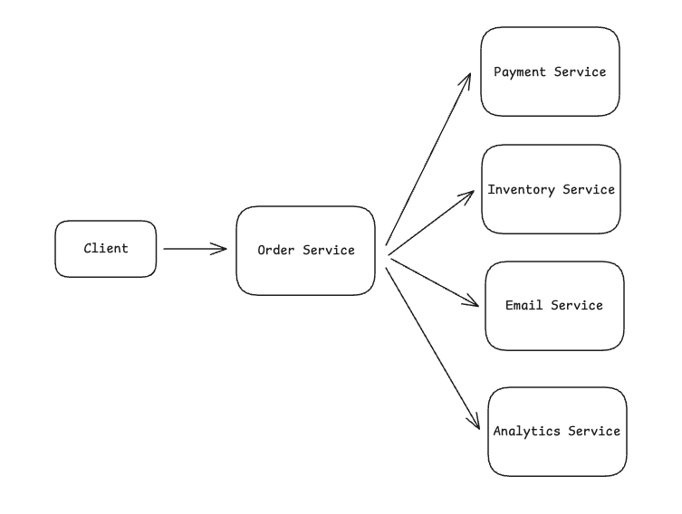

But, when the email service is down, the entire order fails even though email isn't critical. Worse, payment succeeds but then inventory fails, leaving you with a charged customer but no reserved items.
So, with this durability issue in mind, we can add message queues to decouple things. Now the order service sends messages to different queues, and each service processes them independently.

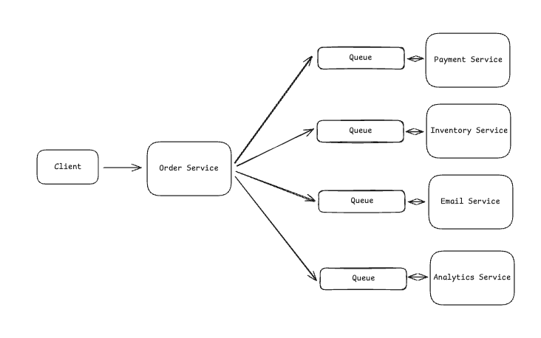

This helped with resilience. If email is down, messages just sit in its queue until the service comes back online. But you still have a problem, the order service needs to know about every system that cares about orders.
Several months later the team decides to add a new fraud detection service. The order service now needs to be modified to send messages to the fraud queue. Then, the marketing team wants to trigger campaigns on large orders. Another code change to the order service. Each new requirement forces you to modify and redeploy the order service since it is acting as a central orchestrator.
Lastly, coordination is a headache. Messages in different queues process at different speeds. A user might get their confirmation email before the payment actually processes. Or they check their order history and see conflicting information because the inventory service updated but analytics hasn't caught up yet.
The fundamental issue is coupling through knowledge. Whether using direct API calls or message queues, the order service must know about every downstream system and what they need. This creates a bottleneck where one team (orders) becomes responsible for integrating everyone else's requirements.
To solve each of these problems, we can use what is called an event-driven architecture.
The Solution: Event Driven Architecture (EDA)
Instead of the order service sending commands to other services, it announces what happened. That's the core shift with event-driven architecture. Services publish events - facts about things that occurred - and other services listen for the events they care about.
The key difference is that a message says "charge this card for $50" while an event says "order #123 was placed for $50". The first is a command that expects action. The second is just a fact. The order service doesn't care what happens next.

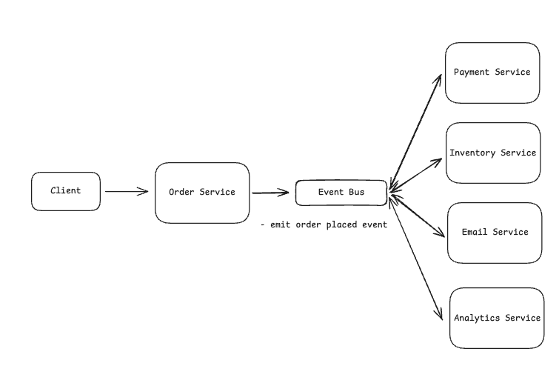

Now the payment service subscribes to `OrderPlaced` events and charges cards when it sees them. The inventory service also subscribes and reserves items. Same for the email service and so on. The order service has no idea these other services even exist. And it doesn't need to.
When to Use in Interviews
In reality I see more candidates introduce event driven architecture incorrectly than I see candidates miss it when it's actually needed.
My advice is to solve your problem as simply as possible. Most requests should be handled entirely within one service. When the client calls the order service to place an order, that service can handle everything internally. No need to coordinate with other services at all. Keep your services truly independent where you can.
That said, event-driven architecture does solve real problems. Here are a few places where it may make sense in an interview.
1. When you're dealing with financial data or audit requirements
Financial systems and anything touching money need immutable audit trails. Every transaction, refund, and dispute must be recorded forever - not just for good practice but for legal compliance. This is why Stripe publishes an event for every payment action. When a charge fails, when it's refunded, when it's disputed - each becomes an immutable event that forms their audit log.
The same applies to healthcare systems tracking patient records, trading platforms recording every order, or any system where "show me exactly what happened" is a regulatory requirement. If you can't delete or modify history, you need events.

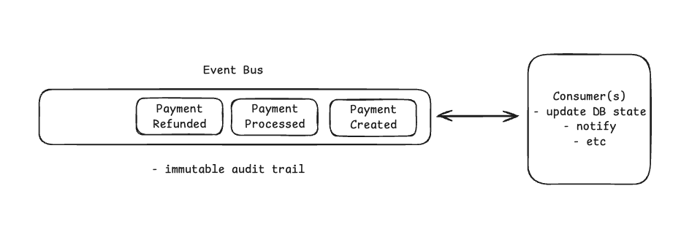

2. When building platforms with external integrations
If you're designing a platform where third-party developers or unknown consumers need your data, events become important. Shopify is a good example, they publish events to webhooks because they can't possibly know what each merchant wants to do. One merchant sends orders to their accounting system, another updates inventory, a third triggers dropshipping, and a fourth runs custom analytics.
Shopify publishes the event once, and thousands of apps consume it in their own way. The alternative - having Shopify directly integrate with every possible merchant system - would be impossible to maintain. This pattern shows up whenever you have an ecosystem of integrations rather than a fixed set of internal services.

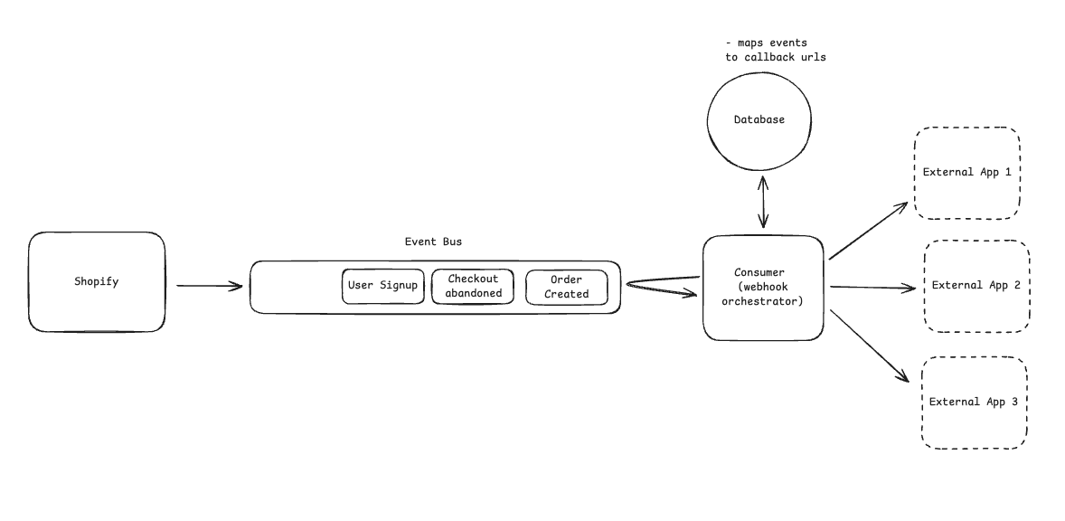

3. When you need real-time data pipelines
Real-time analytics and streaming data require events, but be careful with the word "real-time." If hourly or even 15-minute batches work, stick with them. True real-time means sub-second latency where the business genuinely can't wait.
Uber processes millions of ride events through Kafka specifically for dynamic pricing. They need to detect demand spikes instantly to trigger surge pricing as waiting even 5 minutes would mean lost revenue and poor driver distribution. Netflix uses event streaming for their content finance systems, but not because it's "cool" but because they need to track viewing instantly for content licensing costs that accrue per view.
This is where event-driven architecture meets stream processing. EDA is the architectural pattern where services communicate through discrete events rather than direct calls. Stream processing is the computational technique, continuously analyzing sequences of events as they arrive. Uber's pricing system uses both: event-driven communication between services (driver location updates, ride requests) and stream processing to aggregate those events into demand patterns. You can have stream processing without EDA (batch jobs that process event logs) and EDA without stream processing (simple event handlers that update databases), but they work well together for real-time systems.

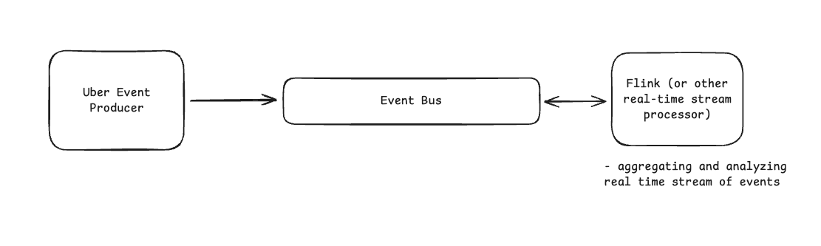

4. When you need to replay or reprocess historical data
Traditional CRUD operations are destructive. Meaning, once you update a record, the old state is gone. Event sourcing keeps everything, letting you replay history with new logic. This becomes critical when you need to fix past mistakes or apply new rules retroactively.
Consider fraud detection at a payment processor. You develop new fraud rules that would have caught attacks from last month. With events, you replay last month's transactions through the new rules to identify previously missed fraud. With traditional architecture, that historical data is gone or transformed beyond use. Investment banks use this same pattern to recalculate risk when models change, replaying months of trades through updated algorithms.
What doesn't need EDA
Most system requirements that seem complex actually don't need events:
Service-to-service communication - If the order service needs to tell the payment service to charge a card and wait for the result, that's a synchronous API call. Don't complicate it with events unless you truly need fire-and-forget semantics.
Known integrations between fixed services - If three specific services need order data, just call their APIs. Events are for unbounded, unknown consumers, not a fixed set of internal services.
Scaling challenges - Regular horizontal scaling with load balancers works fine for most systems. Events don't magically make things scale better - they just move the complexity to managing event brokers and consumer lag.
Microservices architectures - Simply having microservices doesn't mean you need events. Most microservice communication should be synchronous API calls. Only add events when you need true decoupling or one of the specific patterns above.
Making the decision
In your interview, listen for these specific requirements:
- Compliance and audit trails that must be immutable
- Open platforms where external developers integrate
- Real-time processing with sub-second latency requirements
- Need to replay historical data with new logic
If you don't hear these specific needs, stick with simpler architectures. You can always add events later if requirements change, but you can't easily remove the complexity once it's there.
The best system designers know when not to use a pattern. For event-driven architecture, that's most of the time. Save it for the specific scenarios where its benefits outweigh the significant complexity it adds.
Conclusion
Event-driven architecture is a powerful pattern that solves some of the hardest problems in distributed systems. When you need immutable audit trails, external integrations, real-time streaming, or historical replay, events are often the only viable solution. But this power comes with significant complexity - eventual consistency, debugging challenges, schema evolution, and operational overhead that can overwhelm teams who adopt it too eagerly.
In interviews, demonstrate maturity by exploring simpler solutions first. When they describe microservices, start with synchronous APIs. When they mention scale, consider whether horizontal scaling solves the problem. Only reach for events when you hear those specific triggers: compliance requirements, unknown external consumers, sub-second latency needs, or replay requirements. Show that you understand what you're signing up for.
The best system designers know that great systems aren't built by applying every available pattern, but are built by choosing the right pattern for each problem. Event-driven architecture is a sharp tool in your toolbox. The ability to recognize when not to use it is just as important as knowing how to implement it. Master that restraint, and you'll design better systems than candidates who throw trendy patterns at every problem.
Changelog
People are constantly asking us what’s new with Hello Interview, so we’re going to keep a changelog here to keep you up-to-date. Since our last update:
New Features:
- Run code in multiple languages - you can now try each of the problems in our DSA course in any of the major common languages
- Fullscreen code editor - you can also expand the inline code editor to full screen
- Global search - a new search bar in the top right makes it easy for you to find the content and features you’re looking for
New Content:
- Bot Detection ML System Design Breakdown
We’ve got more coming down the pipe that we’re excited to share in our next update!
You can vote for what content you want to see next here.

when to use API Calls and when to use event driven architecture for placing requests?
Great question — this is a very important system design decision in microservices architecture.
I'll explain it in simple terms with a banking example, since you were learning microservices patterns.

1️⃣ API Calls (Synchronous Communication)
An API call means one service directly calls another service and waits for the response.
Example technologies:
- REST API
- gRPC
- GraphQL
Flow
Client → Order Service → Payment Service → Response
The caller blocks and waits until the other service responds.

Example: Banking Fund Transfer
User transfers money.
Steps:
- User calls Transfer API
- Transfer service calls Account Service
- Account Service checks balance
- Response returned immediately
User
|
v
Transfer Service
|
v
Account Service
|
v
Response (Success/Failure)
Why API Call?
Because the user needs immediate confirmation.
Example response:
Transfer Successful
Transaction ID: 789123

When to Use API Calls
Use API calls when:
1️⃣ Immediate Response Required
User must get result instantly.
Examples:
- Login
- Check account balance
- Payment authorization
- Fetch order details

2️⃣ Strong Consistency Needed
If the operation must complete fully or fail immediately.
Example:
Debit account
Credit account

3️⃣ Simple Request–Response
Example:
GetCustomerDetails(customerId)

Pros
✔ Immediate response
✔ Simple to implement
✔ Easy debugging

Cons
❌ Tight coupling
❌ Service dependency
❌ Cascading failures
Example failure chain:
Order Service → Payment Service → Notification Service
If Payment Service is down → Order Service fails.

2️⃣ Event Driven Architecture (Asynchronous)
In event-driven architecture, services do not call each other directly.
Instead they publish events to a message broker.
Common tools:
- Apache Kafka
- RabbitMQ
- Amazon SQS

Flow
Order Service → Event Bus → Payment Service
→ Notification Service
→ Analytics Service
The sender does NOT wait for response.

Example: Banking Transaction
User transfers money.
After transaction success:
Transaction Service publishes event
Event:
TransactionCompletedEvent
Multiple services consume it:
TransactionCompletedEvent
|
|------ Notification Service (Send SMS)
|
|------ Audit Service (Store logs)
|
|------ Analytics Service

Event Flow Diagram
+----------------+
| TransactionSvc |
+--------+-------+
|
| Publish Event
v
Message Broker
(Kafka/RabbitMQ)
/ | \
v v v
Notification Audit Analytics
Service Service Service

When to Use Event Driven Architecture
1️⃣ Loose Coupling Required
Services should not depend on each other.
Example:
Order Service should not know about
- Email Service
- Analytics Service
- Fraud Detection

2️⃣ Multiple Consumers
One event triggers many services.
Example:
OrderPlaced Event
Triggers:
- Payment Service
- Inventory Service
- Email Service
- Shipping Service

3️⃣ High Scalability
Event systems scale easily.
Example:
10 million transactions/day
Message brokers like Apache Kafka can handle huge throughput.

4️⃣ Background Processing
Example tasks:
- Email sending
- SMS sending
- Data analytics
- Fraud detection
These don't require immediate response.

Pros
✔ Loose coupling
✔ Highly scalable
✔ Failure tolerant
✔ Async processing

Cons
❌ Complex debugging
❌ Eventual consistency
❌ Harder to trace flows

3️⃣ Real Banking System Example
Scenario: Money Transfer
Step 1 — API Call
POST /transfer
Used for:
User → Transfer Service
Why?
User must know success/failure immediately.

Step 2 — Event Driven
After success:
TransferCompletedEvent
Published to broker.
Consumers:
Notification Service
Fraud Detection
Audit Logging
Analytics

Combined Architecture
User
|
v
Transfer API
|
v
Transaction Service
|
| Publish Event
v
Event Bus (Kafka)
|
+---- Notification Service
|
+---- Fraud Detection
|
+---- Audit Service
|
+---- Analytics

4️⃣ Simple Rule (Interview Answer)
Use API Calls When
✔ Immediate response needed
✔ Strong consistency required
✔ Simple request-response
Examples:
- Login
- Payment authorization
- Balance check

Use Event Driven When
✔ Async processing
✔ Multiple services react to event
✔ Loose coupling required
Examples:
- Order placed
- Transaction completed
- User registered

5️⃣ Real Production Architecture
Most large systems use BOTH.
Example companies using this approach:
- Netflix
- Amazon
- Uber
Pattern:
API calls for core workflow
Event driven for side effects

6️⃣ One Interview Golden Line ⭐
You can say:
"Synchronous API calls are used for core business workflows requiring immediate response, while event-driven architecture is used for asynchronous processing and decoupled communication between services."

✅ If you want, I can also explain:
- API vs Event Driven in Microservices (real architecture diagram)
- How 10 million users hitting API is handled using Kafka
- Event Driven + SAGA pattern together (very common interview question for senior engineers).
Yes Please
Great 👍
Let’s go one level deeper into real microservices architecture that companies like Netflix, Amazon, and Uber use.
I’ll explain 3 important things:
1️⃣ API + Event Driven combined architecture
2️⃣ How 10 Million users hitting API is handled
3️⃣ Event Driven + Saga Pattern (very common in senior engineer interviews)

1️⃣ Real Microservices Architecture (API + Events Together)
Most systems do NOT choose only one.
They combine API calls + Event driven architecture.
Core Rule
Communication | Used For
API (Sync) | Core business workflow
Events (Async) | Side effects / background tasks

Example: E-Commerce Order Placement
Step 1 — API Request
User places order.
POST /orders
Flow:
User
|
v
API Gateway
|
v
Order Service
The Order Service calls other services synchronously.
Order Service → Payment Service
Order Service → Inventory Service
Why?
Because we must confirm immediately:
Order placed successfully

Step 2 — Event Published
After order success:
OrderPlacedEvent
Published to event broker like:
- Apache Kafka
- RabbitMQ

Step 3 — Multiple Services React
OrderPlacedEvent
|
v
Event Broker
/ | \
v v v
Email Shipping Analytics
Service Service Service
These services do not affect the user response.
Example tasks:
- Send confirmation email
- Start shipping
- Update analytics
- Fraud detection

2️⃣ Handling 10 Million API Requests
Imagine 10 million users hitting the API.
A typical architecture looks like this:
Users
|
v
CDN
|
v
Load Balancer
|
v
API Gateway
|
v
Microservices

Step-by-Step Flow
1️⃣ CDN Layer
Static content handled by CDN.
Example:
- Cloudflare
- Akamai
This reduces traffic to backend.

2️⃣ Load Balancer
Distributes requests.
Example tools:
- NGINX
- HAProxy
Request → Load Balancer
|
-------------------
| | |
Server1 Server2 Server3

3️⃣ API Gateway
Manages:
- Authentication
- Rate limiting
- Routing
- Logging
Example:
- Kong API Gateway
- Amazon API Gateway

4️⃣ Autoscaling Containers
Services run in containers managed by:
- Kubernetes
- Red Hat OpenShift
If traffic increases:
Order Service
|
v
Pods auto scale
3 pods → 20 pods

5️⃣ Queue / Event Buffer
Heavy processing goes to event queue.
Example:
OrderPlacedEvent → Kafka
Queue absorbs traffic spikes.
Tools:
- Apache Kafka
- Amazon SQS

Architecture Diagram
Users (10M)
|
v
CDN
|
v
Load Balancer
|
v
API Gateway
|
v
Microservices
|
v
Kafka Event Bus
|
Multiple Consumers
This architecture can handle millions of requests.

3️⃣ Saga Pattern with Event Driven Architecture
In microservices, a single transaction may involve multiple services.
Example:
Order Placement:
Order Service
Payment Service
Inventory Service
Shipping Service
Traditional database transaction won't work.
Solution:
Saga Pattern
Saga = Series of local transactions + compensation

Example: Order Saga
Step 1
Order created
Order Service → OrderCreatedEvent

Step 2
Payment processed
Payment Service
If success:
PaymentSuccessEvent
If failure:
PaymentFailedEvent

Step 3
Inventory reserved
Inventory Service

Successful Flow
OrderCreated
|
v
PaymentSuccess
|
v
InventoryReserved
|
v
OrderConfirmed

Failure Scenario
Payment fails.
OrderCreated
|
v
PaymentFailed
|
v
Cancel Order
This is called compensation transaction.

4️⃣ Two Types of Saga
1️⃣ Choreography Saga
Services communicate using events only.
OrderCreated → Payment Service
PaymentSuccess → Inventory Service
InventoryReserved → Shipping Service
No central controller.

2️⃣ Orchestration Saga
A central Saga Orchestrator controls the flow.
Saga Orchestrator
|
v
Order Service
Payment Service
Inventory Service

5️⃣ Simple Interview Answer
If interviewer asks:
When to use API vs Event Driven?
Answer:
"Synchronous API calls are used for core business workflows requiring immediate response and strong consistency. Event-driven architecture is used for asynchronous processing, loose coupling, and triggering multiple downstream services without blocking the user request."

6️⃣ Senior Engineer Insight ⭐
Modern architectures follow this pattern:
API → Core workflow
Events → Side effects
Saga → Distributed transactions

✅ If you'd like, I can also explain one extremely common senior-level system design question:
“Design an Order Processing System handling 50 million users using Kafka, Microservices, and Kubernetes.”
That explanation will teach you real production architecture used in companies like Amazon and Netflix, and it's very useful for senior software engineer interviews.

Event-Driven Microservice Architecture | by Bahadir Tasdemir | Trendyol Tech | Medium
Event-Driven Microservice Architecture



Bahadir Tasdemir
Follow
7 min read
·
Nov 20, 2019
697
7

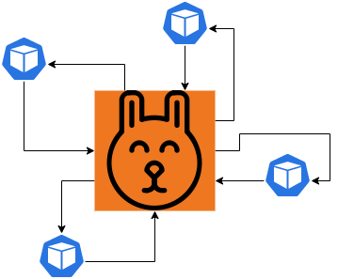
Event-Driven Microservice Architecture
To begin with, in an event-driven microservice architecture, services communicate each-other via event messages. When business events occur, producers publish them with messages. At the same time, other services consume them through event listeners.
Thus, the main benefits of event-driven systems are asynchronous behavior and loosely coupled structures. For example, instead of requesting data when needed, apps consume them via events before the need. Therefore overall app performance increases. On the other hand, keeping coupling loose is one of the main key points of a microservice environment.
Event-Driven Architecture as a Solution
As well as you can build your systems with event-driven structures, you can also use it as a solution to your already built highly coupled environments. Let’s discuss how we can apply the event-driven approach as a solution.
A Basic REST Driven Approach
Press enter or click to view image in full size
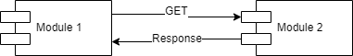
REST (synchronous) API Call
Even though your application may work properly, these are the downsides:
- Module 1 waits for the response
- Module 2 can be down
- Network delays decrease performance
- If data is huge, it will paginate. This means more REST calls
- Module 2 can be under heavy load and can respond very late
When your system becomes less efficient because of synchronized connections, you can apply the event-driven solution.
Real-World Scenario: How Our Team Applied It
In Trendyol/Marketplace team, we have a reporting application (GIB API). It transmits all sale reports to the government. So, this app has to fetch all the sale data from another API. In the beginning, the transaction volume was very low. Thus, we have quickly built the API with the REST approach.
Press enter or click to view image in full size
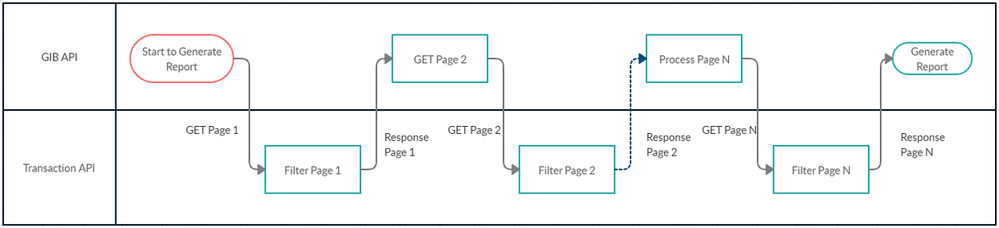
Report Generation Timing Diagram
In spite of the low amount of data at the beginning, it increased up suddenly. Because Trendyol is a fast-growing company, we often face this problem. On the other hand, the solution is simple: converting to event messaging.
Solution 1: Converting to Event Messaging
As soon as we realized that the reports are not being generated efficiently, we applied the event-driven solution.
Above all, our plan was simple:
- Publish an event when a transaction item created
- Fetch the related data when event received
- Convert to a piece of report string
- Persist in the RDBMS (PostgreSQL)
- Query data when generating the report
- Concat the string data and persist as a file to disk
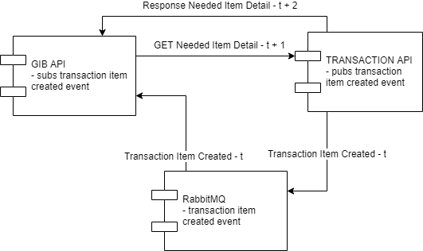
Gathering DATA via Async Event Messaging
As a result of this, the needed transaction items are persisted in the Reporting API. As soon as report creation starts, it queries and concatenates the report data from the RDBMS.
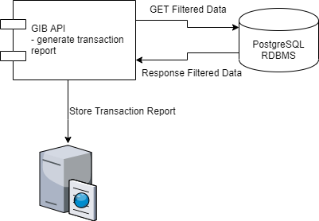
Generate Transaction Report
Success doesn’t Come Easy
While we converted the sync process into an async architecture, the transaction API faced another performance issue. Because the reporting (GIB) API requested the detail every time a transaction item created, the transaction API went under a heavy load. The reason is, the transaction records are created for every item sold in Trendyol. So, the huge number of transaction item detail requests choked the API.
Solution 2: Fat Event
To explain, a fat event means that the message contains the detail with the entity identifier.
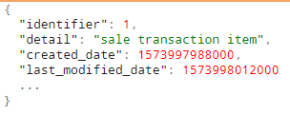
Fat Event Message Sample
After converting the message into a fat event, we didn’t need any additional REST calls. As a result of this, our architecture became a complete async event-driven system.
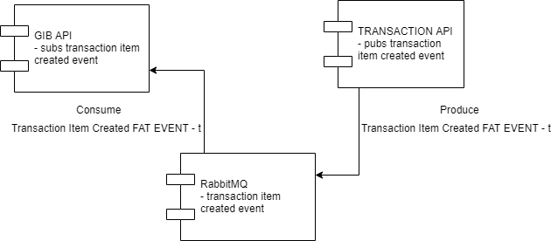
Complete Even-Driven Architecture
Solution 3: Outbox Pattern
While we are talking about the sale transactions, it is already clear how important these data. Because they are about financial business. Thus, the calculations must be correct 100%.
To be able to access this accuracy, we must be sure that our system is not losing any event messages. As a result of this, we applied the outbox pattern.

What is the outbox pattern? Simply, when your API publishes event messages, it doesn’t directly send them. Instead, the messages are persisted in a DB table. A job sends cumulative messages in predefined time intervals.
Press enter or click to view image in full size
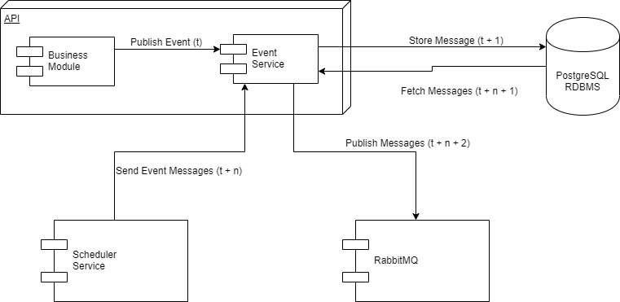
Outbox Pattern
To explain the figure:
- Business module publishes an event
- Event service persists the message in RDBMS
- Scheduler service triggers the job “Send Event Messages”
- Event service queries the cumulative event messages
- Event service publishes the messages via RabbitMQ
Let’s list down the pros and cons of the outbox pattern.
Pros:
- Event messages first persisted in RDBMS. ACID properties of transactions guarantee the persistence.
- When an event is lost, the message can be checked from the DB.
- A lost event can be recovered from the RDBMS efficiently.
Cons:
- Increase in complexity.
- Delay in publishing events.
- To publish a basic event, at least two technologies are needed: Storage System and Message Queueing Protocol.
Benefits of the Event-Driven Microservice Architecture
- Loosely coupled structure
- Complete isolation of the microservices
- No synchronous REST calls
- Asynchronous event-driven functionality
- Performance gain
Among all of them, the most important benefit is the first one. Because we want to separate the components by microservice architecture, all of the units must be separated enough (loosely-coupled). Otherwise, microservice architecture won’t work and your system will turn into a distributed-monolith.
Downsides
Single point of failure: If your RabbitMQ faces any issues during the production processes, your whole system will also fail.
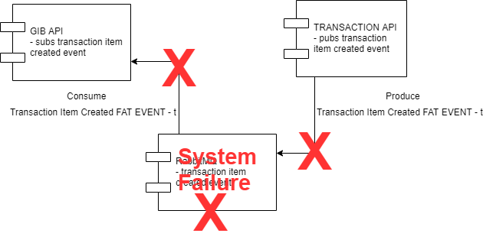
To overcome failures:
- Construct your RabbitMQ as a cluster
- Create your queues durable
- Publish your messages persisted
As a result of this, you can quickly recover any failures. In the time any error happens, your other instances in the cluster will take the work over and recreate the durable queues. Also, your persisted messages will be recovered from the disk.
Duplicated event messages: An event publisher API can face trouble and resend the same messages. To resolve any duplication in the system, any consumer endpoint has to be idempotent: always consider to check first if your API acquired the event before.
TL;DR
In microservice architecture environments, we have to keep coupling low. To be able to keep the coupling low, we have to focus on the connections between modules. One way to do this is to use event-driven approaches.
In the meanwhile, direct REST calls are expensive. The destination API can be out of service. Additionally, the source API has to wait until the response is received.
To create an event-driven microservice structure, we can simply create a RabbitMQ cluster with persisted messages. All needed events can be published via the service-in-responsibility. Also, all the other services can bind their consumers and process their works when event messages are sent.
While building event-driven systems, we can consider fat events. Fat events provide all the needed data when the event occurs. As a result of this, the APIs don’t need any additional external calls.
On the other hand, there can be lost events because of a system failure or a network brake-down. To be sure that all events are published and consumed successfully, the outbox-pattern can be applied. Simply, the events are stored in a storage system instead of publishing them directly. After that, a configured job sends the events at definite time intervals. The lost messages can be recovered easily via the storage system.
Conclusion
To sum up, the microservice architecture is quite new and we, all the developers are learning it better every day. Whenever we are not careful, our system can turn into a distributed monolith and this is the worst case. Because you can’t gain any benefits as well as you have to deal with the complexity. Above all, keeping coupling loose with event-driven architecture is one of the most important things.
If you want to learn more about the RabbitMQ please follow this link.
Finally, if you like the post, please like it and share it. Also, please don’t forget to read my other post about the Trendyol Scheduler Service.

When to Use An Event-Driven Architecture (EDA) - 3Pillar
When to Use An Event-Driven Architecture (EDA)
September 20, 2021
Ask experts what is needed for the success of the Internet of Things (IoT)—now and in the future—and one of the responses you will often hear is “interoperability.” This makes sense. IoT devices never know what devices they will be asked to interoperate with, who the manufacturer is, and what the protocols are. Like the introduction of printer drivers in the distant past, something is needed to enable any device to connect to any other device.
The past few years have seen rapid changes in many aspects of how we use technologies. Classic monolithic applications have given way to orchestrated microservices in containers that are readily transported throughout the “cloud.”
In addition to interoperability, we need greater interactivity. The traditional method of a user issuing a request or command has been replaced by the more interactive concept of identifying an event—a change in state sufficient to warrant a response or responses from other parts of the system or other systems.
EDA In Action
A common example of EDA begins when a motorist runs a red light. A camera mounted near the traffic light is triggered by an event—the movement of the automobile beyond the stop line. It then records the event. That recording, along with the time and location data, triggers the registering of a violation and the creation of a summons.
Automated mailing systems send out the summons, and the motorist receives it a few days later. The violation is eventually resolved when payment is issued (another event). But the record of the violation remains for consolidation with previous and future violations to drive the decision to suspend that driver’s license temporarily.
Note that the payment began with the violator writing and mailing a check or using an online credit card service that is received by the system that issued the summons. This example integrates interactions between different systems as well as human involvement.
As to when you should use an Event-Driven Architecture? EDA is ideal when you want to capture behaviors in the real world as well as the digital, along with pertinent facts that can be used for decision-making. A record of the event is stored for future analysis. This reflects how humans react to events happening around them.
Evolving from Requests to Events
According to Cisco Systems, the number of devices connected to the global Internet exceeded the number of people using it in 2008 and has continued to increase at an accelerating pace ever since. Where the original interactions conducted across the Internet were from people to machines and then back to the people, the presence of tens of thousands more devices produced interactions among machines.
The change from Request-Driven Architecture to the event-driven approach parallels this increase in machine-to-machine (M2M) activity as opposed to the decreased percentage of Internet transactions that are person-to-machine. When machines talk to machines, their interactions trigger events, advertising something has happened.
Some events communicate a result or trigger further events. Because of that, there is a need for speedier responses. To compare the request-driven and event-driven approaches, let us examine two interactions:
- A pedestrian comes to a corner where the light is red, forbidding them to cross. They press a button on a nearby lamppost that says, “Press Here to Cross.” That pedestrian will wait for a considerable time for that light to change. This request-driven event anticipates some latency.
- An autonomous vehicle approaches the same corner intending to turn left. As it gets close, the light turns red, and cars coming the opposite way begin to proceed. If that event—the light turning red—experiences any latency whatsoever, it may become a matter of life-and-death for several people. This requires an event-driven response that is consistently high-speed with no latency.
Characteristics of EDA Applications
EDA facilitates high data volumes and high velocity such as traffic between things on the Internet. More complex events may require identification of multiple events in diverse locations at different points in time, perhaps even on different systems or multiple subsystems. These systems may need to process responses to the same event.
EDA serves these scenarios by bringing true real-time data processing with minimum or no latency whatsoever. The completely decentralized platform can even include systems from different organizations, which is critical in an interoperable IoT.
Deciding When to Use an Event-Driven Architecture
The decision to use EDA should consider the presence or absence of several characteristics:
Asynchronous and Loosely-Coupled
Each component of an EDA application operates independently, which allows them to move on to their next task—even while downstream components perform further processing. In fact, each service in the EDA has no knowledge or awareness of other components, including protocols and other details.
This also allows an event router to queue received events where they can wait for processing until their intended event consumer becomes available. They can also be tested, validated, updated, and deployed independently. Since the event queue in the event router stores every event, events may be “replayed” later for purposes of analysis and recovery of lost data.
Scaling
Absent any awareness of each other, the loose coupling of the various components of a service makes scaling simple. Each service may be scaled independently without dependencies on any other components.
EDA significantly increases process velocity and agility, making it ideal for modern applications that use microservices, or any application featuring decoupled components. This requires shifting your paradigm to align more closely with EDA.
Things to consider when aligning with EDA:
- The resilience of event sources—Especially if the expectation is that you will service every event. If so, your event source must guarantee delivery.
- Anomaly troubleshooting—Since there is no designed workflow in an EDA system, it is not possible to trace errors through the code. You will want to create a strategy that monitors and evaluates each segment independently.
- Data management—Where earlier systems collected data and then processed and analyzed it before producing an outcome, with EDA the event itself is the data. If you ever need to rebuild the current state during any past event transaction, you will need to provide indexing and deduplication.
When decision time is measured in milliseconds instead of minutes, such as determining whether a financial exchange is fraudulent while the transaction is in mid-flight, your best choice is EDA. Other examples include payment processing, web product monitoring, online customer experiences, and other real-time marketing activities.
Improving AI Experiences Requires Event-Driven Architecture
As the use of natural-language AI-driven human interfaces increases, EDA will be critical to the natural cadence of the required conversation. If a user asks a question, and the AI is delayed in replying, the illusion of true interactivity may be shattered. Latency is once again the enemy.
An Event-Driven Architecture will also be pivotal in enabling AI to consume events that may be relevant to human users. An early example is the traffic function of some GPS devices. When heavy traffic or an accident is detected, AI is cued to advise the user and provide alternate routes.
EDA puts the digital side of the human/digital interface on more of an even footing—a level playing field with digital intelligence. When both can detect an event and decide to take specific actions in response to the event, the concept of a truly symbiotic relationship between people and processors comes much closer to a reality.

Event-Driven Architecture is just one of the methods our product development teams use to drive your success. Contact 3Pillar Global today to learn how we can do it for you.
[adinserter name=”EDA Guide”]

