The Sidecar Pattern Explained: Decoupling Operational Features
The Sidecar Pattern Explained: Decoupling Operational Features
ByteByteGo
Dec 19, 2024
Design patterns are reusable solutions to common problems in software design. They provide a structured approach to solving architectural challenges without reinventing the wheel each time.
The sidecar pattern is one such design pattern that has gained prominence in modern software engineering.
At its core, the sidecar pattern pairs a secondary process or service (the "sidecar") with a primary application to handle complementary tasks. These tasks include logging, monitoring, proxying, security, or configuration management. The sidecar runs alongside the main application, sharing the same host or container, but remains logically and operationally independent.
The sidecar pattern can be compared to a motorcycle with a sidecar. The motorcycle (the primary service) is the main driver, responsible for the core functionality, like transporting a person. The sidecar (the auxiliary service) carries additional tools or passengers, assisting the main vehicle without interfering with its operation.
Similarly, in software systems, the sidecar extends the capabilities of the primary application without being tightly coupled to it.
In this article, we’ll learn about the sidecar pattern in detail and understand how it works. In the end, we will also look at its benefits and challenges that can help us make better decisions when using the pattern.

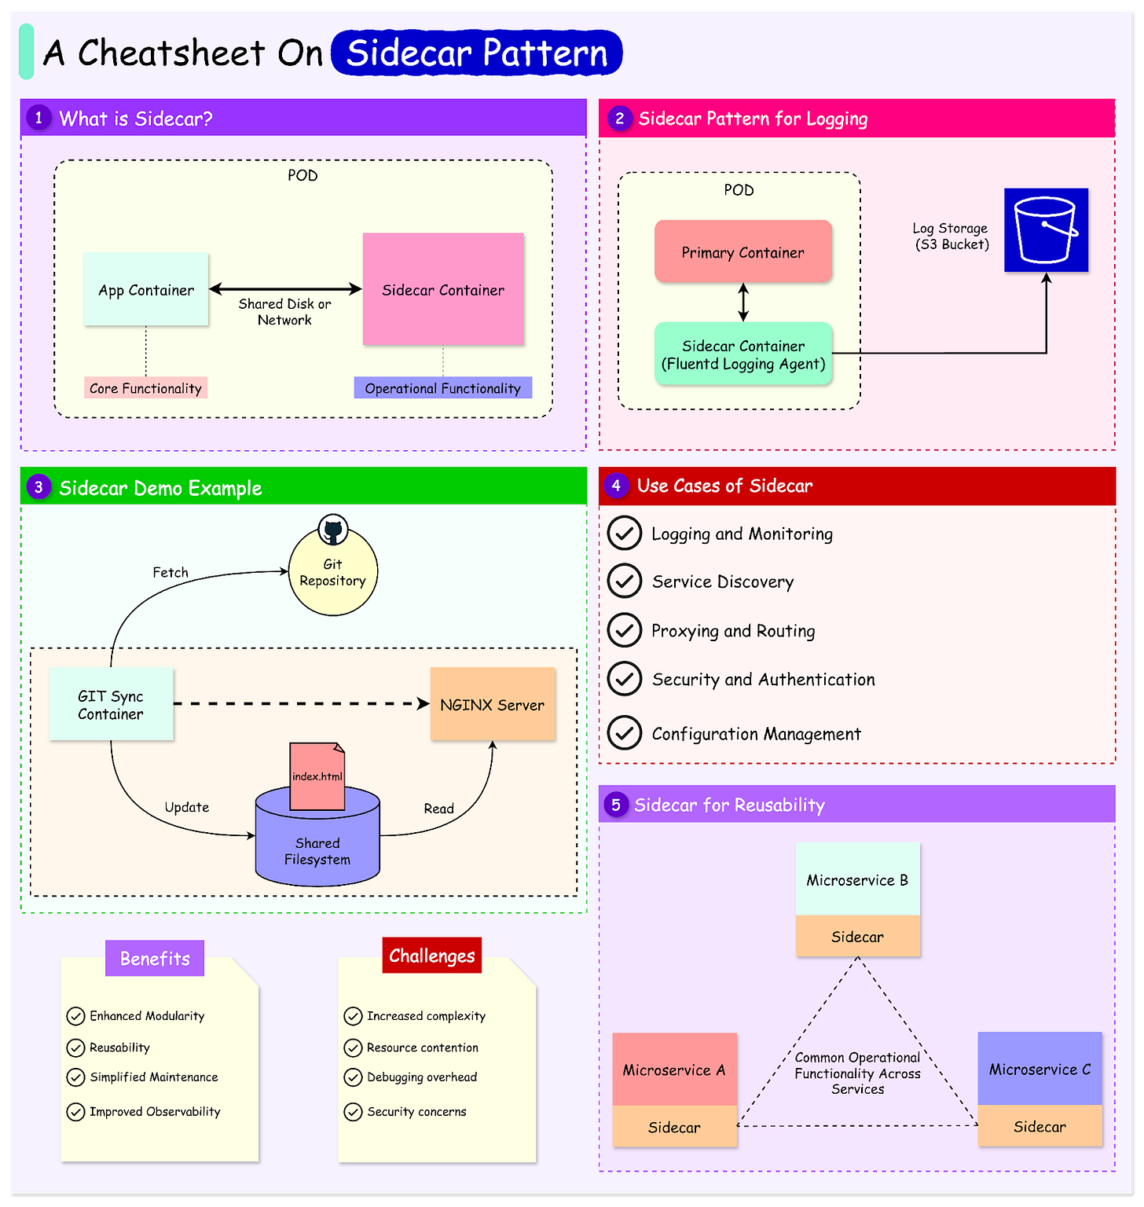

Core Concept of the Sidecar Pattern
The sidecar pattern is a structural design pattern used in distributed systems architecture.
It involves pairing a primary application or service with a secondary, co-located process known as the sidecar.
See the diagram below that shows the concept of a bare-minimum sidecar implementation using a Kubernetes Pod.

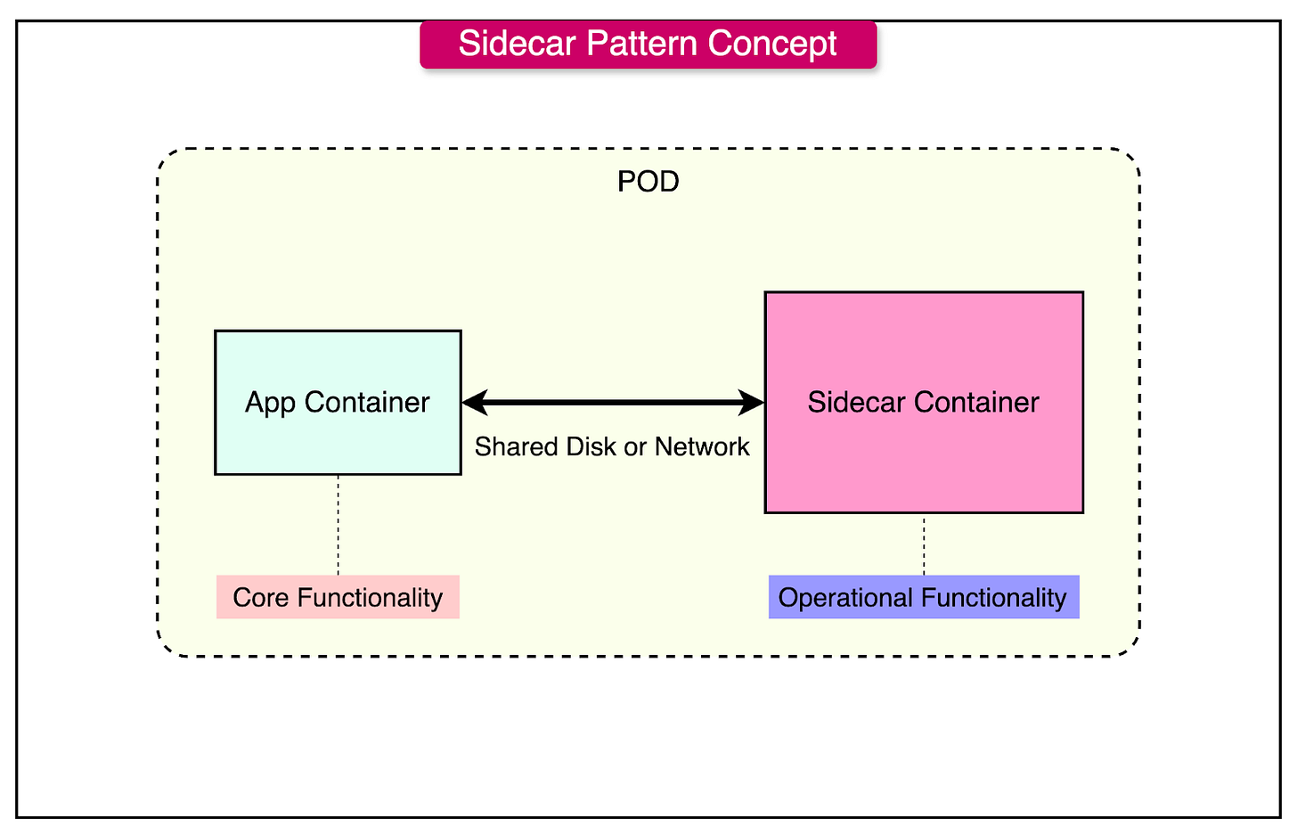

There are two containers in this setup:
- The application container has the core logic that serves the business requirement.
- The sidecar container augments the application container.
There are some key characteristics associated with the pattern:
- Co-location: The sidecar is deployed alongside the primary service, often in the same pod in Kubernetes. This ensures low-latency communication and shared resource access.
- Independence: The sidecar is loosely coupled to the main application, allowing for independent updates and debugging.
- Resource Sharing: Both services share resources such as CPU, memory, and network interfaces.
- Communication: Communication between the primary service and the sidecar is typically facilitated via local network interfaces or shared volumes.
Common Use Cases of Sidecar
The sidecar pattern is well-suited for distributed systems and containerized environments. Below are some of the common use cases:
- Logging and Monitoring: Sidecars like Fluentd or Logstash can aggregate logs from the main application and forward them to a centralized logging system. This approach decouples log processing from application logic.
- Service Discovery: Sidecars act as service discovery agents, dynamically registering the primary service with a service registry (for example, Consul, etcd). This ensures that the service can locate and communicate with other services in the system without embedding discovery logic in the application.
- Proxying and Routing: Proxies like Envoy or HAProxy are used as sidecars to handle incoming and outgoing network traffic. They provide features like load balancing, circuit breaking, and request/response transformation, which can be managed independently of the main application.
- Security and Authentication: Sidecars can handle security concerns, such as injecting TLS certificates (for example, using HashiCorp Vault) or managing API tokens. This centralizes security practices and reduces the burden on application developers.
- Configuration Management: Sidecars can periodically fetch or reload configuration settings from a central repository, ensuring that the primary service operates with the latest configurations without requiring restarts.
See the diagram below that shows the use of a sidecar container in the context of logging:

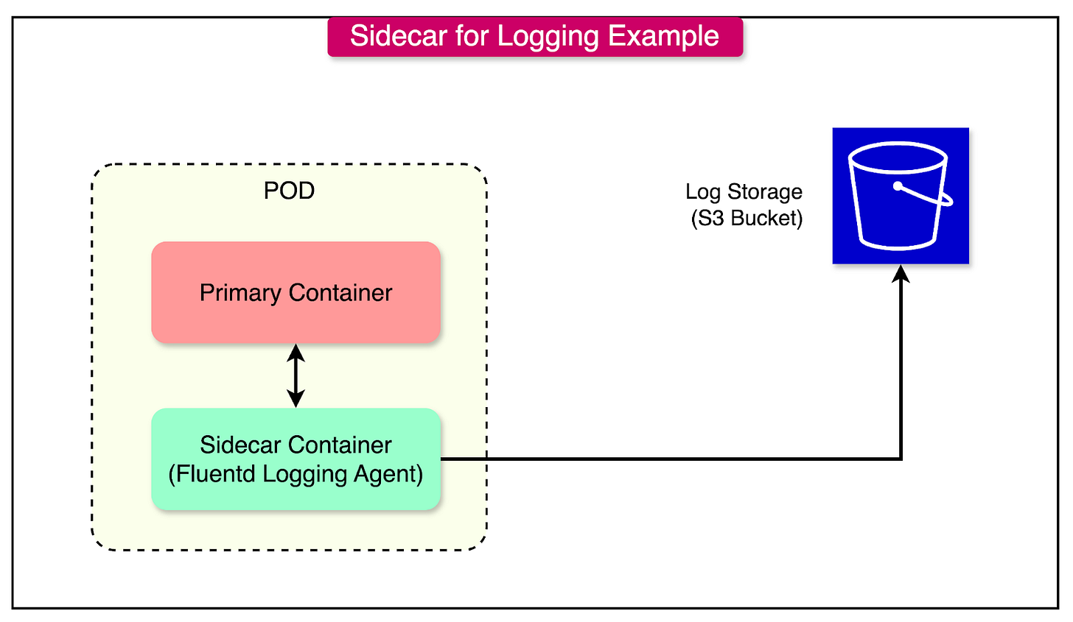

Architectural Components of the Sidecar Pattern
From an architectural point of view, the sidecar pattern consists of two primary components and a mechanism for their communication:
- Primary Service: The main application or service for core business logic and functionalities. It is designed to operate independently of the auxiliary tasks managed by the sidecar. For example, a web application, an API service, or a database.
- Sidecar Service: A lightweight, co-located service that handles auxiliary tasks such as logging, monitoring, service discovery, or security. The sidecar focuses on non-core functionalities to support the primary service. For example, Fluentd for logging, Envoy Proxy for traffic routing, or Vault Agent for managing secrets.
- Communication Mechanisms: These define how the primary service and sidecar interact and share data. Communication is typically designed to be efficient and localized within the same environment.
Sidecar Deployment in Containerized Environments
In containerized environments, the sidecar pattern is implemented as part of a pod.
A pod is the smallest deployable unit in Kubernetes and can contain multiple containers. The primary and sidecar containers are deployed within the same pod, which means they share resources and a network namespace.
- Shared Network: Both containers use the same IP address and communicate via localhost or specific ports.
- Shared Volumes: Kubernetes supports shared volumes within a pod, allowing both containers to access the same filesystem for data exchange.
Here’s an example of a Kubernetes YAML file for a Pod that demonstrates the sidecar pattern:
apiVersion: v1
kind: Pod
metadata:
name: sidecar-example
spec:
containers:
- name: primary-service
image: my-primary-service:latest
ports:
- containerPort: 8080
volumeMounts:
- name: shared-volume
mountPath: /shared
- name: sidecar-service
image: my-sidecar-service:latest
volumeMounts:
- name: shared-volume
mountPath: /shared
volumes:
- name: shared-volume
emptyDir: {}
The containers section in the YAML lists two containers that will run within the Pod.
- First, we have the primary service that runs an image named my-primary-service using the latest version. It exposes port 8080 for communication with this container and mounts a shared volume at the directory /shared inside the container.
- The second container is the sidecar service. The container runs an image named my-sidecar-service using its latest version. It mounts the same shared volume at /shared directory, enabling data sharing between the sidecar and primary service.
The volume is defined later using emptyDir. It creates a temporary empty directory that exists only while the Pod is running. This allows the two containers to share files.
Sidecar Pattern Example Demo
Now that we've covered the basics of the sidecar pattern and its applications, let's dive into a practical demonstration of the pattern using Kubernetes.
In this example, we'll use the sidecar pattern to implement a basic Git-based workflow for deploying new code to a running service.
The Kubernetes pod will include two containers:
- Nginx container: Serves the index.html file stored in a shared filesystem.
- Sidecar container: Continuously polls a Git repository for the latest version of index.html and updates it in the shared filesystem.
The workflow will be as follows:
- When changes are pushed to the Git repository, the sidecar container retrieves the updated index.html file and writes it to the shared filesystem.
- The Nginx container automatically serves the updated file, ensuring the latest changes are reflected without requiring a pod restart.
The diagram below shows the various parts of this demo. Note that this is just an example and the code is just to demonstrate the concept of sidecar pattern in action.

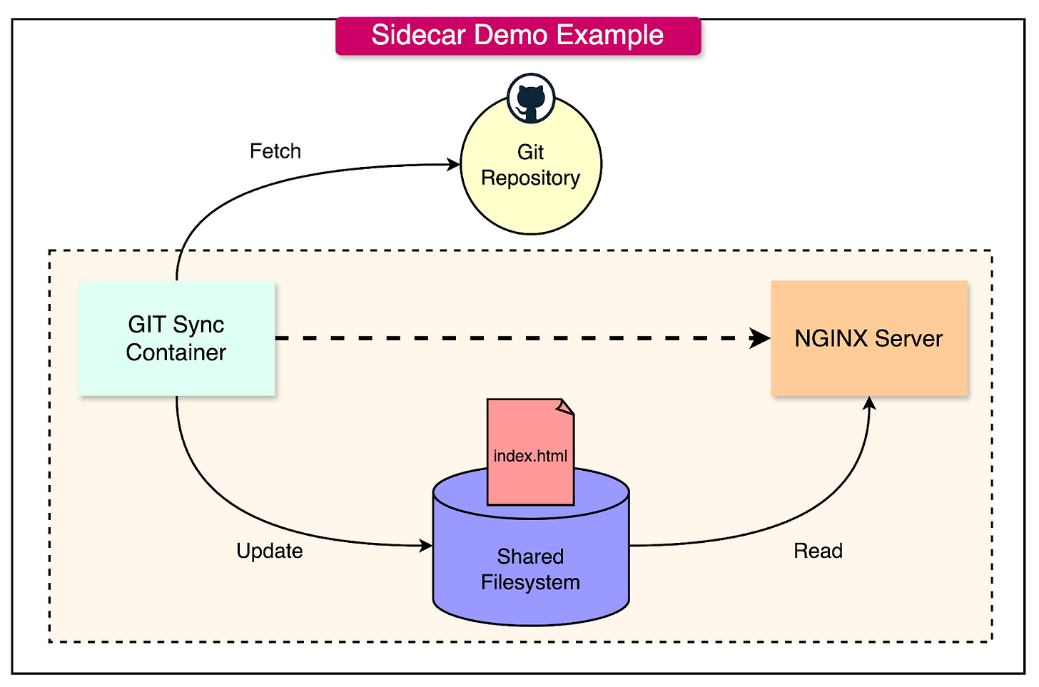

Step 1: Deploying the Nginx Container
We begin by creating a simple HTML file to be served by the Nginx server.
<html>
<body bgcolor="#FFFFFF">
<h1><strong>This is demo for the Sidecar Pattern</strong></h1>
</body>
</html>
Next, we build a Docker image to deploy this file using Nginx. Below is a basic Dockerfile for this purpose.
FROM nginx

ADD index.html /usr/share/nginx/html/index.html
Finally, we create a Kubernetes deployment for Nginx:
apiVersion: apps/v1
kind: Deployment
metadata:
labels:
app: nginx
name: nginx
spec:
replicas: 1
selector:
matchLabels:
app: nginx
template:
metadata:
labels:
app: nginx
spec:
containers:
- image: demo-example/nginx
name: nginx
ports:
- containerPort: 80
Step 2: Implement the Sidecar Container
Next, we build a Docker image for the sidecar container that runs a synchronization script named “page-refresher.sh”. This script polls a Git repository every few seconds for updates to the HTML file.
FROM alpine

WORKDIR /usr/share/nginx

ADD page-refresher.sh page-refresher.sh

ENTRYPOINT sh page-refresher.sh
We build the image and update the Kubernetes deployment to use it as a sidecar container.
apiVersion: apps/v1
kind: Deployment
metadata:
labels:
app: nginx
name: nginx
spec:
replicas: 1
selector:
matchLabels:
app: nginx
template:
metadata:
labels:
app: nginx
spec:
containers:
- image: demo-example/sidecar
name: sidecar
env:
- name: STATIC_SOURCE
value: https://raw.githubusercontent.com/your-repo/sidecar-demo/main/index.html
volumeMounts:
- name: shared-data
mountPath: /usr/share/nginx/html
- image: demo-example/nginx
name: nginx
ports:
- containerPort: 80
volumeMounts:
- name: shared-data
mountPath: /usr/share/nginx/html/
volumes:
- name: shared-data
emptyDir: {}
The key points to note here are as follows:
- Sidecar Container: The demo-example/sidecar image runs the synchronization script.
- Shared Volume: Both containers share the emptyDir volume, ensuring that updates from the sidecar are visible to the Nginx container.
- Environment Variable: The STATIC_SOURCE variable specifies the Git repository URL where index.html is stored.
Step 3: Testing the Workflow
The workflow can be tested as follows:
- Modify the index.html file in the Git repository and push the changes.
- The sidecar container polls the repository, retrieves the updated file, and writes it to the shared volume.
- The Nginx server automatically serves the updated file from the shared filesystem.
- Export a NodePort Kubernetes service to access the application and view the contents of the HTML file in the browser.
Advantages of Using the Sidecar Pattern
The sidecar pattern offers several advantages making it a useful choice in modern distributed systems.
Here’s a detailed look at these benefits with practical examples:
1 - Modularity
By isolating non-core functionalities into a separate sidecar service, the sidecar pattern promotes modularity. The primary service focuses solely on its business logic, while the sidecar handles auxiliary tasks like logging, monitoring, or routing.
For example, a web application can delegate traffic routing and load balancing to a sidecar proxy like Envoy. This separation ensures that any updates to routing rules or traffic policies do not require changes to the web application’s codebase. If an issue arises in the routing logic, it can be fixed in the sidecar without affecting the primary application’s functionality.
2 - Simplified Maintenance
Sidecars can be updated, restarted, or replaced independently of the primary application.
This simplifies the maintenance process and reduces downtime, as auxiliary tasks can evolve without disrupting the core service.
For example, a sidecar handling TLS certificate renewal (e.g., using Certbot) can be updated to support new cryptographic standards without requiring changes to the primary web server.
3 - Improved Observability
Sidecars play a crucial role in improving observability by centralizing logging, metrics collection, and tracing.
For example, a metrics collection sidecar runs alongside the main application, collecting data such as CPU usage, memory consumption, and request rates. This data is forwarded to a monitoring dashboard (such as Grafana) for visualization.
4 - Reusability
A single sidecar implementation can be reused across multiple services, standardizing certain functionalities across a distributed system. This reduces development effort and promotes consistency.
For example, a sidecar for service discovery can be deployed alongside all microservices in a system, ensuring that each service can dynamically locate and communicate with others.
See the diagram below that shows multiple microservices sharing a single sidecar:

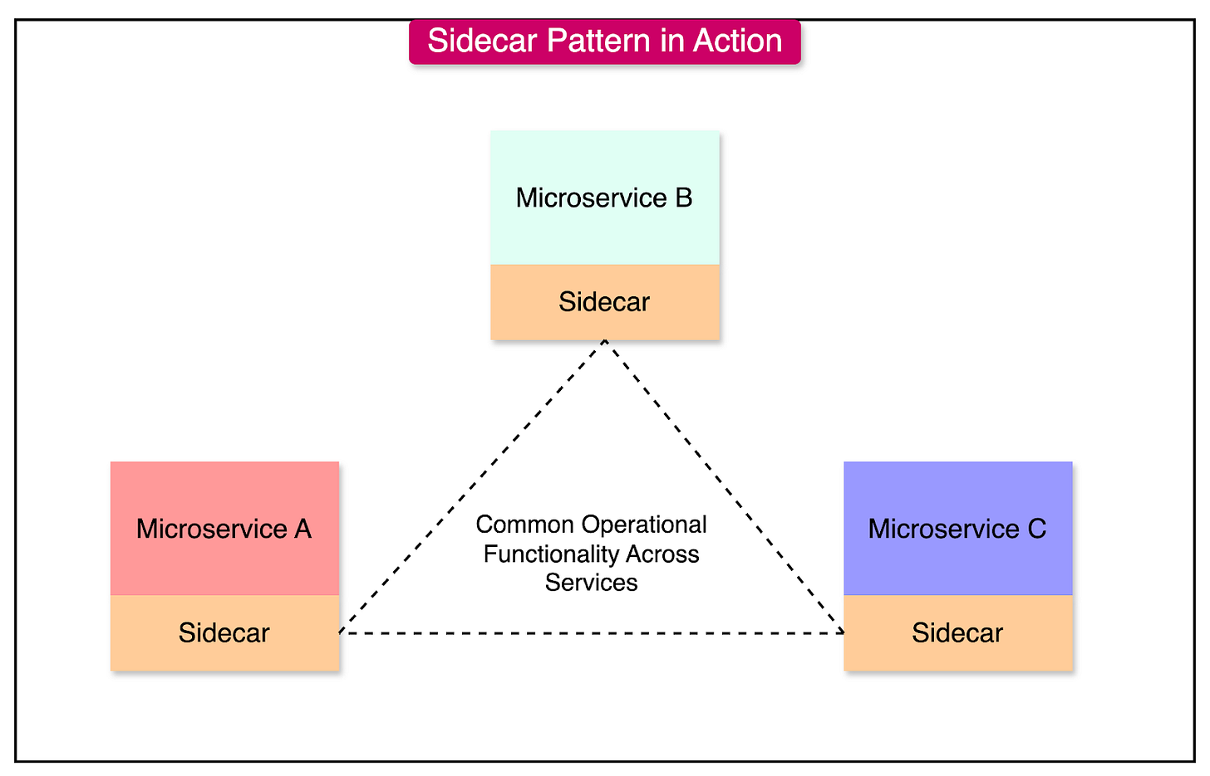

Challenges and Trade-offs with the Sidecar Pattern
While the sidecar pattern offers some great advantages in modularity, scalability, and maintainability, it is not without challenges.
Below are the key challenges and strategies to mitigate them:
1 - Increased Complexity
The sidecar pattern adds a new layer of architectural complexity by introducing additional components and interactions.
Managing the lifecycle, deployment, and communication between the primary service and sidecar can become challenging, particularly in large-scale distributed systems. As the number of services grows, debugging and troubleshooting inter-container dependencies becomes increasingly difficult.
To mitigate this, we can use tools like Helm to simplify the configuration and management of sidecars in Kubernetes. Also, it helps when there is a clear separation of responsibilities between the primary service and the sidecar.
2 - Resource Contention
Since the primary service and sidecar share the same environment, they compete for resources such as CPU, memory, and disk I/O. Poorly optimized sidecars can negatively impact the performance of the main application.
For example, a logging sidecar like Fluentd performing high-volume log aggregation may consume excessive CPU or memory, leading to degraded application performance.
To mitigate this, we can set resource limits and requests in Kubernetes pod configurations to ensure fair resource allocation. We can also optimize sidecar configurations to reduce their resource footprint.
resources:
requests:
memory: "256Mi"
cpu: "500m"
limits:
memory: "512Mi"
cpu: "1"
3 - Debugging Overhead
Sidecar-based architectures increase the number of components involved in a system, making debugging more complex. When an issue arises, it can be challenging to determine whether the problem originates in the primary service, the sidecar, or their interaction.
For example, a failure in a sidecar service can disrupt communication for the entire application, leading to cascading failures.
To mitigate this, it’s important to implement logging and monitoring for both primary service and sidecar to get clear visibility. Also, it can be a good idea to adopt a circuit breaker pattern for sidecar dependencies to minimize the impact of sidecar failures.
4 - Security Concerns
Sidecars can become a security vulnerability if not properly secured.
A misconfigured sidecar might expose sensitive data, such as logs containing personal information to unauthorized users. Also, vulnerabilities in sidecar dependencies can be exploited to compromise the system.
As a mitigation approach, it’s important to follow best practices for securing containerized applications and using appropriate network policies. Also, regularly audit sidecar configurations and perform security scans.
Summary
In this article, we’ve taken a detailed look at the sidecar pattern along with a basic implementation example.
Let’s summarize our learnings in brief:
- The sidecar pattern is a design pattern commonly used in distributed systems to decouple auxiliary tasks from the main application. It is used to enhance modularity and reusability.
- The pattern involves deploying a sidecar service along with the primary application in the same environment so it can share resources.
- The primary and sidecar services communicate via shared volumes or network interfaces.
- The sidecar pattern can be implemented using Kubernetes pod. This was demonstrated through an example of a Git-based workflow where a sidecar synchronizes content from a Git repository to a shared filesystem.
- The benefits of sidecars include enhanced modularity, maintenance, observability, and reusability.
- The challenges of a sidecar are increased complexity, resource contention, debugging overhead, and possible security concerns.
- Sidecars are used in scenarios like service discovery, logging, monitoring, and dynamic configuration management.

Sidecar Design Pattern for Microservices - GeeksforGeeks
Sidecar Design Pattern for Microservices
Last Updated : 21 Jan, 2026

The Sidecar Pattern is a design pattern used in software architecture, particularly in microservices environments. In this pattern, a "sidecar" container or process is deployed alongside a primary application container to extend or enhance its functionality.

- The sidecar container runs within the same execution environment as the primary application and typically provides supporting services such as logging, monitoring, security, or communication with other services.
- This pattern enables the primary application container to focus on its core functionality while offloading secondary tasks(logging, monitoring, security, service discovery, or communication proxies) to the sidecar, promoting modularity, scalability, and maintainability in distributed systems.
Benefits of Using the Sidecar Pattern
The Sidecar Pattern offers several benefits in microservices architectures:
- Modularity and Encapsulation: By separating secondary functionality into sidecar containers, each microservice can focus solely on its core business logic. This promotes modularity, encapsulation, and cleaner code organization, making it easier to develop, test, and maintain individual microservices.
- Scalability: Sidecar containers can be scaled independently of the primary application containers, allowing fine-grained control over resource allocation. This enables better resource utilization and scalability, as additional instances of sidecars can be deployed to handle increased loads or specific tasks without affecting the primary microservices.
- Flexibility and Extensibility: The Sidecar Pattern allows for flexible and extensible architectures by enabling the addition of new functionalities or services without modifying the primary microservices. New features can be implemented as separate sidecar containers, providing agility and adaptability to changing requirements or technology stacks.
- Isolation of Concerns: By isolating secondary functionalities such as logging, monitoring, or security into separate sidecar containers, the Sidecar Pattern helps maintain clear boundaries between concerns. This improves system maintainability, troubleshooting, and fault isolation, as changes or updates to one aspect of the system do not impact others.
- Dynamic Configuration and Orchestration: Sidecar containers can dynamically configure themselves or be orchestrated alongside primary microservices by container orchestration platforms such as Kubernetes or Docker Swarm. This enables seamless deployment, scaling, and management of microservices-based applications in dynamic and distributed environments.
Overall, the Sidecar Pattern enhances the flexibility, scalability, maintainability, and observability of microservices architectures by separating secondary functionalities into modular, independently deployable components.
Components of Sidecar Design Pattern for Microservices
The Sidecar Pattern for microservices typically consists of the following key components:
- Primary Application Container: This is the main container hosting the microservice's core business logic or application code. It runs within its own execution environment and is responsible for handling incoming requests and performing the primary functionality of the microservice.
- Sidecar Container: The sidecar container is deployed alongside the primary application container and provides additional functionalities or services that support the operation of the microservice. These functionalities can include logging, monitoring, security, service discovery, communication proxies, or other cross-cutting concerns.
- Inter-Container Communication: To facilitate communication between the primary application container and the sidecar container, inter-container communication mechanisms are employed. This can include local networking, shared volumes, IPC (Inter-Process Communication), or other communication channels provided by the container runtime or orchestration platform.
- Configuration and Coordination: Configuration management and coordination mechanisms are used to ensure that the primary application container and the sidecar container are properly configured and synchronized. This may involve dynamic configuration updates, service registration and discovery, or coordination through APIs provided by the container platform.
- Observability and Monitoring: The sidecar container often includes components for monitoring and observability, such as log collectors, metrics collectors, or distributed tracing agents. These components gather data about the microservice's behavior, performance, and health, providing insights into its operation and facilitating troubleshooting and optimization.
- Lifecycle Management: Lifecycle management mechanisms ensure that both the primary application container and the sidecar container are properly started, stopped, and managed throughout their lifecycle. This may involve container orchestration tools, lifecycle hooks, or custom scripts to coordinate their operation.
By incorporating these key components, the Sidecar Pattern enhances the modularity, scalability, maintainability, and observability of microservices architectures by separating secondary functionalities into independent, reusable components deployed alongside primary microservices.
Challenges of Sidecar Design Pattern
Below are the challenges of Sidecar Design Pattern:
- Increased Resource Consumption: Deploying additional sidecar containers alongside each microservice increases resource consumption, including memory, CPU, and network bandwidth.
- Complexity in Orchestration: Orchestrating multiple containers per microservice can introduce complexity in deployment, configuration management, and lifecycle management, requiring advanced orchestration tools and practices.
- Synchronization and Coordination: Ensuring synchronization and coordination between the primary application container and the sidecar container may introduce challenges, particularly in dynamic environments with frequent updates or scaling events.
- Overhead in Inter-container Communication: Inter-container communication between the primary application container and the sidecar container may introduce overhead, impacting performance and latency, especially in high-throughput or latency-sensitive applications.
- Debugging and Troubleshooting: Debugging and troubleshooting issues across multiple containers in a sidecar architecture can be more challenging compared to monolithic or traditional architectures, requiring specialized tools and practices.
Overall, while the Sidecar Design Pattern offers benefits in terms of modularity, scalability, and flexibility, it also presents challenges related to resource consumption, orchestration complexity, synchronization, and debugging. Organizations should carefully consider these factors when adopting the Sidecar Pattern in their microservices architectures.
Useful Scenarios of Sidecar Design Pattern
The Sidecar pattern is most effective when common cross-cutting concerns need to be handled consistently alongside microservices.
- Cross-cutting Concerns: When multiple microservices require common functionalities such as logging, monitoring, or security enforcement, the Sidecar Pattern can centralize these concerns into reusable sidecar containers, promoting code reuse and simplifying maintenance.
- Dynamic Configuration: For microservices that require dynamic configuration updates or feature toggles, the Sidecar Pattern can provide an isolated environment for managing configuration changes without disrupting the primary application containers.
- Service Mesh Integration: In service mesh architectures, the Sidecar Pattern is commonly used to deploy service proxies (such as Envoy or Linkerd) alongside microservices to handle communication, routing, and traffic management, enhancing observability and resilience.
- Feature Expansion: When introducing new features or functionalities to existing microservices, the Sidecar Pattern enables seamless integration by deploying feature-specific sidecar containers alongside the primary application containers, without requiring modifications to the core services.
Less Ideal Scenarios of Sidecar Design Pattern
The Sidecar pattern is less suitable when added complexity and resource overhead outweigh the benefits for the service.
- Performance-sensitive Applications: In applications where low latency and high throughput are critical, the overhead introduced by inter-container communication and resource sharing in the Sidecar Pattern may impact performance, making it less suitable for such scenarios.
- Resource-constrained Environments: Deploying additional sidecar containers alongside each microservice increases resource consumption, making the Sidecar Pattern less suitable for resource-constrained environments where optimal resource utilization is essential.
- Simple or Monolithic Applications: For simple or monolithic applications that do not require extensive cross-cutting concerns or dynamic configuration management, the additional complexity introduced by the Sidecar Pattern may outweigh its benefits, making it unnecessary.
- Lack of Container Orchestration: Without proper container orchestration tools or platforms, managing and coordinating multiple containers per microservice in production environments can be challenging, making the Sidecar Pattern less suitable for such scenarios.
Implementation of Sidecar Design Pattern
Implementing the Sidecar Design Pattern involves several steps:
The Sidecar Design Pattern is implemented by deploying supporting services alongside the main application to handle cross-cutting concerns.
Step 1: Identify Secondary Functionalities
Identify functionalities that support the application but are not part of core business logic.
- Includes logging, monitoring, security, service discovery, and communication proxies.
- Helps keep the main application focused and lightweight.
Step 2: Design Sidecar Containers
Design sidecar containers to encapsulate the identified secondary responsibilities.
- Each sidecar is self-contained and handles a single concern.
- Can be reused across multiple services.
Step 3: Define Inter-container Communication
Define how the main application and sidecar containers will communicate.
- Use local networking, shared volumes, or IPC mechanisms.
- Ensure low-latency and reliable communication.
Step 4: Implement Sidecar Containers
Develop and package sidecar logic as independent container images.
- Sidecars are deployed alongside the primary application container.
- Run within the same execution environment for close interaction.
Step 5: Configure and Coordinate Sidecar Containers
Configure sidecars so they work in coordination with the main application.
- Manage configuration updates and service discovery.
- Use container platform APIs or configuration tools.
Step 6: Handle Lifecycle Management
Ensure both the application and sidecar containers share a synchronized lifecycle.
- Start, stop, and restart together.
- Use orchestration tools or lifecycle hooks.
Step 7: Integrate Observability and Monitoring
Integrate monitoring and observability tools within sidecar containers.
- Collect logs, metrics, and traces.
- Improve visibility into application health and performance.
Communication Mechanisms between Microservices and Sidecar Instances
Communication between microservices and Sidecar instances typically occurs through inter-container communication mechanisms provided by the container runtime or orchestration platform. Some common communication mechanisms include:
- Local Networking: Microservices and Sidecar instances deployed within the same container network can communicate with each other using local networking. They can exchange messages over TCP/IP or UDP protocols using localhost or container-local IP addresses.
- Shared Volumes: Microservices and Sidecar instances can share data or files through shared volumes mounted into their respective containers. This allows them to read from and write to common directories or files, enabling data exchange or synchronization.
- Inter-Process Communication (IPC): Microservices and Sidecar instances running within the same container environment can communicate through inter-process communication mechanisms provided by the operating system, such as Unix sockets or named pipes. This allows for efficient and low-latency communication between processes.
- Message Brokers: In some cases, microservices and Sidecar instances may communicate indirectly through a message broker or event bus. Microservices can publish messages or events to a broker, and Sidecar instances can subscribe to these messages for processing or forwarding to other services.
- Service Mesh: In service mesh architectures, communication between microservices and Sidecar instances is often facilitated by a service mesh infrastructure. Sidecar proxies intercept and route traffic between microservices, providing features such as load balancing, circuit breaking, and observability.
The choice of communication mechanism depends on factors such as the nature of the communication, performance requirements, deployment environment, and architectural preferences. Organizations may leverage multiple communication mechanisms concurrently to meet different communication needs within their microservices architectures.
Different Deployment Strategies for Sidecar Instances
There are several deployment strategies for Sidecar instances in microservices architectures, each offering different trade-offs in terms of scalability, reliability, resource utilization, and operational complexity. Some common deployment strategies include:
1. Collocated Deployment
In this strategy, the Sidecar runs within the same container as the primary microservice.
- Shares the same resources and lifecycle as the application.
- Simplifies deployment but limits flexibility and independent scaling.
2. Separate Container Deployment
The Sidecar is deployed as a separate container alongside the microservice within the same pod or host.
- Allows independent scaling, management, and resource isolation.
- Provides greater flexibility but increases orchestration complexity.
3. DaemonSet Deployment
In Kubernetes, Sidecars are deployed on every node using a DaemonSet.
- Ensures consistent services like logging or monitoring across all nodes.
- May cause resource overhead on nodes running many microservices.
4. Proxy-based Deployment
Sidecars act as network proxies, commonly used in service mesh architectures.
- Handles traffic routing, load balancing, security, and observability.
- Enables advanced traffic management but adds configuration complexity.
Choosing the Right Deployment Strategy
The deployment strategy should align with architectural and operational requirements.
- Depends on scalability goals, resource usage, and platform capabilities.
- Organizations may combine strategies based on service needs.
Use Cases of Sidecar Design Pattern for Microservices
The Sidecar Design Pattern for microservices finds application in various use cases across different industries. Some common use cases include:
- Logging and Monitoring: Sidecar containers can be used to collect logs and metrics from microservices, standardize log formats, and forward them to centralized logging and monitoring systems. This enhances observability, troubleshooting, and performance analysis of microservices architectures.
- Security and Authentication: Sidecar containers can enforce security policies, handle authentication and authorization, and provide encryption and decryption services for microservices communication. This improves security posture and compliance with security standards in distributed systems.
- Service Discovery and Registration: Sidecar instances can assist with service discovery and registration by dynamically registering microservices with service registries and providing service discovery endpoints. This facilitates dynamic service discovery and load balancing in distributed environments.
- Traffic Splitting and Canary Deployment: Sidecar proxies can be used to implement traffic splitting and canary deployment strategies by intercepting and routing traffic based on predefined rules or weights. This enables controlled rollout of new features or versions, minimizing risk and ensuring smooth transitions.
These use cases demonstrate the versatility and utility of the Sidecar Design Pattern in addressing various cross-cutting concerns, enhancing functionality, and improving operational efficiency in microservices architectures.
Impact of the Sidecar Pattern on Scalability and Performance
The Sidecar Design Pattern can have both positive and negative effects on scalability and performance in microservices architectures, depending on how it's implemented and configured. Here's how it can impact scalability and performance:
Positive Effects of Sidecar Pattern
The Sidecar pattern improves scalability and performance by offloading cross-cutting concerns from the main application and enabling more efficient resource management.
- Modular Scalability: By decoupling secondary functionalities into separate Sidecar containers, the Sidecar Pattern enables modular scalability. Each microservice can scale independently of its associated Sidecar instances, allowing for fine-grained resource allocation and efficient utilization of resources.
- Efficient Resource Utilization: Sidecar containers can offload non-core functionalities from primary microservices, allowing them to focus solely on their core business logic. This separation of concerns can improve resource utilization and performance by reducing the computational overhead of individual microservices.
- Enhanced Observability: Sidecar containers often include monitoring and observability components that collect metrics, logs, and traces from microservices. This enhanced observability enables better insight into the performance and behavior of microservices, facilitating optimization and scalability efforts.
- Isolation of Concerns: The Sidecar Pattern promotes isolation of concerns by separating cross-cutting functionalities into independent containers. This isolation improves fault tolerance, scalability, and performance by containing failures and limiting the impact of changes or updates to secondary functionalities.
Negative Effects of Sidecar Pattern
The Sidecar pattern can introduce additional resource overhead and operational complexity, which may impact scalability and performance if not managed carefully.
- Increased Resource Overhead: Deploying additional Sidecar containers alongside microservices can increase resource overhead, including memory, CPU, and network bandwidth. This additional overhead may impact scalability and performance, particularly in resource-constrained environments or during peak loads.
- Inter-container Communication: Communication between microservices and Sidecar instances introduces overhead, latency, and potential bottlenecks. Depending on the communication mechanisms used, inter-container communication may degrade performance and scalability, especially in high-throughput or latency-sensitive applications.
- Complexity in Orchestration: Managing multiple containers per microservice introduces complexity in orchestration, configuration management, and deployment pipelines. Orchestrating Sidecar instances alongside microservices requires advanced container orchestration tools and practices, adding overhead and complexity to the operational workflow.
- Synchronization and Coordination: Ensuring synchronization and coordination between microservices and their associated Sidecar instances may introduce performance overhead and scalability challenges. Dynamic configuration updates, service discovery, and load balancing mechanisms can impact scalability and performance if not properly managed.

