(11) Post | LinkedIn
🔹 Angular Frontend
1. Angular Basics
What is Angular and how is it different from AngularJS?
Explain components, modules, services, and directives.
What is the use of ngOnInit()?
How does data binding work in Angular?
Difference between @Input() and @Output()?
2. Routing and Forms
How do you implement routing in Angular?
What is the difference between template-driven and reactive forms?
How do you handle form validation?
What are route guards?
3. HTTP and Services
How do you make HTTP requests in Angular?
How do you handle error responses?
How does Angular's HttpClient work?
What is an interceptor and how is it used?
4. State Management & Performance
How do you manage state in Angular (RxJS, BehaviorSubject, NgRx)?
What are Observables and how are they different from Promises?
How do you optimize Angular performance?
What are lifecycle hooks in Angular?

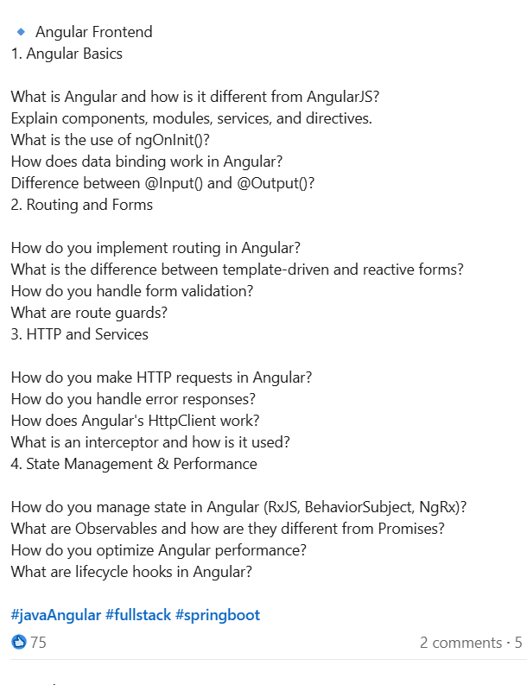

Angular Advanced Questions)
🔍 Angular Interview Questions (6+ Years Experience) – Real Interview Insights L2 Round.
One of my LinkedIn connections recently attended an interview for a Senior Angular Developer role (6+ years experience) and shared the actual questions He faced.
Posting this here so it can help others preparing for similar roles. 👇
📌 Experience with Angular 17 and features used
📌 Which forms were used (Reactive / Template-driven)
📌 Experience in migrating Angular projects
📌 How lazy loading was implemented
📌 Authentication mechanism used in Current project, Access & Refresh tokens , How to handle Token expiry, refresh Token
📌 Any state management experience (NgRx / Nx)
📌 Usage of Observables vs Promises
📌 ES6 features commonly used in Angular apps, Some Scenarios on Destructuring and spread Operator
📌 How data sharing between components was handled
📌 Real use cases for forkJoin
📌 CI/CD pipeline , Build Deployment , How you managed different Env Build Like Dev , QA and prod
📌 Usage of shared modules / Core Module in Lazzy Loaded Structure
📌 Module Federation / Micro-Frontend experience
📌 Angular Universal vs SSR
📌 Subject vs BehaviorSubject (asked to provide scenario when to use which)
📌 Internationalization (i18n), do you have any working experience
📌 Dependency Injection – internal working concept
📌 HTTP Interceptors
📌 In standalone architecture, is zone.js still required?
📌 Are you familiar working with Agile, working Environment in your current project, Sprint Duration, Sprint planning.
📌 Have you worked on any feature / task where you needed guidance from Senior or it was challenging for you.
📌 will you be open to work on Other js Framework like react or next

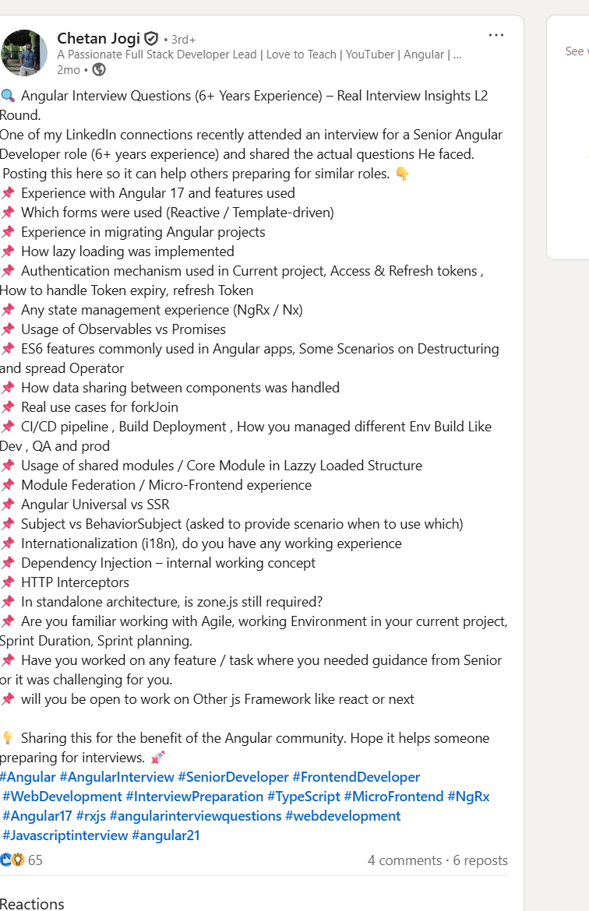

- Post | LinkedIn
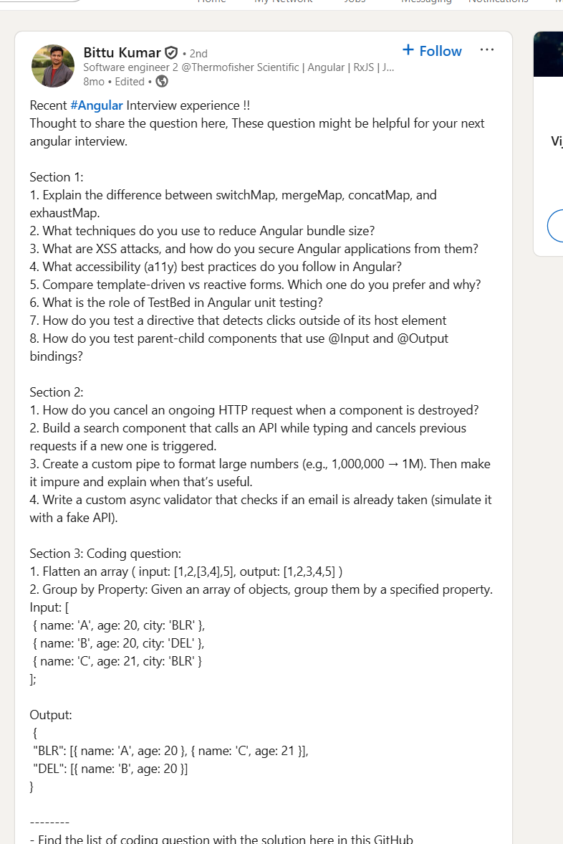

Recent hashtag#Angular Interview experience !!
Thought to share the question here, These question might be helpful for your next angular interview.
Section 1:
1. Explain the difference between switchMap, mergeMap, concatMap, and exhaustMap.
2. What techniques do you use to reduce Angular bundle size?
3. What are XSS attacks, and how do you secure Angular applications from them?
4. What accessibility (a11y) best practices do you follow in Angular?
5. Compare template-driven vs reactive forms. Which one do you prefer and why?
6. What is the role of TestBed in Angular unit testing?
7. How do you test a directive that detects clicks outside of its host element
8. How do you test parent-child components that use @Input and @Output bindings?
Section 2:
1. How do you cancel an ongoing HTTP request when a component is destroyed?
2. Build a search component that calls an API while typing and cancels previous requests if a new one is triggered.
3. Create a custom pipe to format large numbers (e.g., 1,000,000 → 1M). Then make it impure and explain when that’s useful.
4. Write a custom async validator that checks if an email is already taken (simulate it with a fake API).
Section 3: Coding question:
1. Flatten an array ( input: [1,2,[3,4],5], output: [1,2,3,4,5] )
2. Group by Property: Given an array of objects, group them by a specified property.
Input: [
{ name: 'A', age: 20, city: 'BLR' },
{ name: 'B', age: 20, city: 'DEL' },
{ name: 'C', age: 21, city: 'BLR' }
];
Output:
{
"BLR": [{ name: 'A', age: 20 }, { name: 'C', age: 21 }],
"DEL": [{ name: 'B', age: 20 }]
}

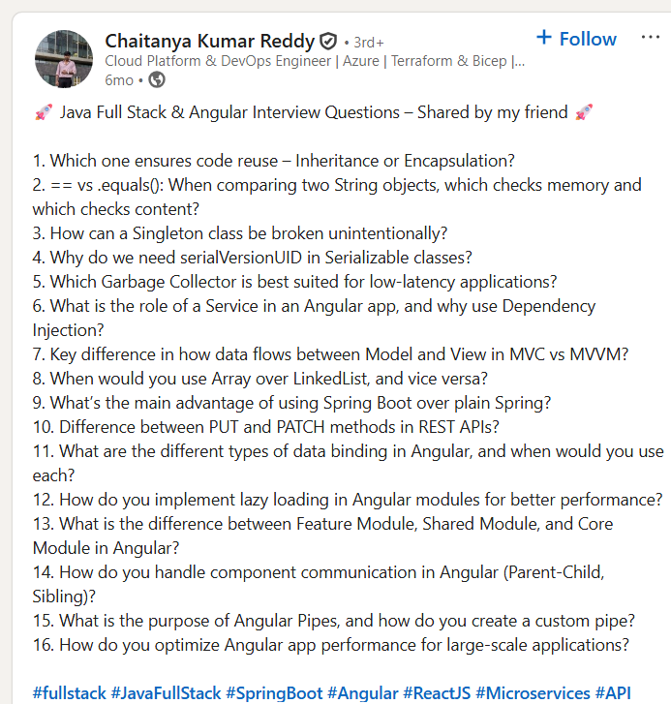

🚀 Java Full Stack & Angular Interview Questions – Shared by my friend 🚀
1. Which one ensures code reuse – Inheritance or Encapsulation?
2. == vs .equals(): When comparing two String objects, which checks memory and which checks content?
3. How can a Singleton class be broken unintentionally?
4. Why do we need serialVersionUID in Serializable classes?
5. Which Garbage Collector is best suited for low-latency applications?
6. What is the role of a Service in an Angular app, and why use Dependency Injection?
7. Key difference in how data flows between Model and View in MVC vs MVVM?
8. When would you use Array over LinkedList, and vice versa?
9. What’s the main advantage of using Spring Boot over plain Spring?
10. Difference between PUT and PATCH methods in REST APIs?
11. What are the different types of data binding in Angular, and when would you use each?
12. How do you implement lazy loading in Angular modules for better performance?
13. What is the difference between Feature Module, Shared Module, and Core Module in Angular?
14. How do you handle component communication in Angular (Parent-Child, Sibling)?
15. What is the purpose of Angular Pipes, and how do you create a custom pipe?
16. How do you optimize Angular app performance for large-scale applications?
hashtag#fullstack hashtag#JavaFullStack hashtag#SpringBoot hashtag#Angular hashtag#ReactJS hashtag#Microservices hashtag#API hashtag#CloudComputing hashtag#AWS hashtag#AzureDevOps hashtag#Terraform hashtag#CI_CD hashtag#InfrastructureAsCode hashtag#CloudNative hashtag#IaC hashtag#Kubernetes hashtag#GitOps hashtag#DevOps hashtag#SecretsManagement hashtag#Automation hashtag#InterviewExperience hashtag#CrackTheInterview hashtag#JavaDeveloper hashtag#CloudEngineering hashtag#MultiCloud

