https://www.javainuse.com/java/permgen

Java - PermGen space vs Heap space

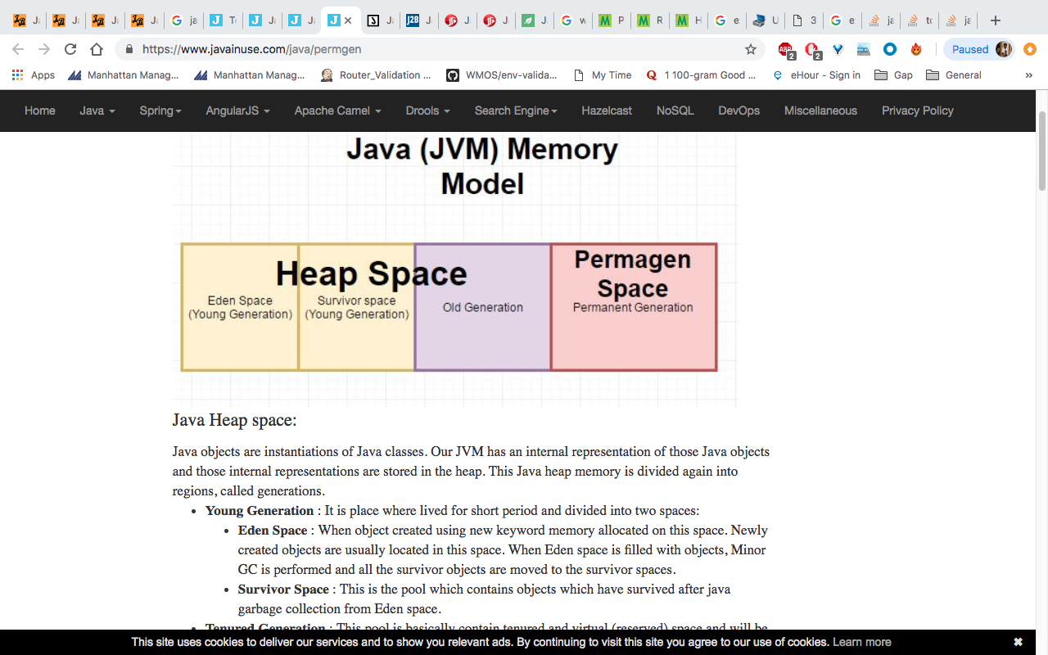

JVM memory is divided into separate parts as follows-
Java Heap space:
Java objects are instantiations of Java classes. Our JVM has an internal representation of those Java objects and those internal representations are stored in the heap. This Java heap memory is divided again into regions, called generations.
- Young Generation : It is place where lived for short period and divided into two spaces:
  - Eden Space : When object created using new keyword memory allocated on this space. Newly created objects are usually located in this space. When Eden space is filled with objects, Minor GC is performed and all the survivor objects are moved to the survivor spaces.
  - Survivor Space : This is the pool which contains objects which have survived after java garbage collection from Eden space.
- Tenured Generation : This pool is basically contain tenured and virtual (reserved) space and will be holding those objects which survived after garbage collection from Young Generation. This memory pool contains objects which survived after multiple garbage collection means object which survived after garbage collection from Survivor space.
Java PermGen space:
JVM also has an internal representation of the Java classes and those are stored in the permanent generation. Class definitions are stored here, as are static instances. The PermGen is garbage collected like the other parts of the heap.
PermGen contains meta-data of the classes and the objects i.e. pointers into the rest of the heap where the objects are allocated. The PermGen also contains Class-loaders which have to be manually destroyed at the end of their use else they stay in memory and also keep holding references to their objects on the heap. PermGen always has a fixed maximum size.PerGen space cannot be made to auto increase so it is difficult to tune it. The GC here is not that efficient so we get Out of Memory : Permgen space error quite a few times.
Next we will create a simple java project to generate a PermGen space error.
Lets Begin
Lets create a java project to generate the Permgen space error and analyze it-
Create the class TestMemory as follows-
package com.javainuse;

public class TestMemory {

static int i = 0;

public static void main(String[] args) {

if (i < 25) {
i++;
System.out.println(i);
main(new String[] { (args[0] + args[0]).intern() });
}

}

}
Click on run as configuration and to the arguments add the following.
-verbose:gc -XX:+PrintGCDetails -XX:+PrintGCTimeStamps -Xloggc:C:/log/gc.log
This will redirect verbose garbage collection output to a file gc.log.

On running the application we get the following-
Go to C:/log/gc.log we see the following

See Also

https://www.javainuse.com/java/metaspace

Java - Metaspace vs PermGen space
In previous chapter we saw JVM memory model till java 7 and before. In this chapter we look at JVM memory model for Java 8. It is as follows-

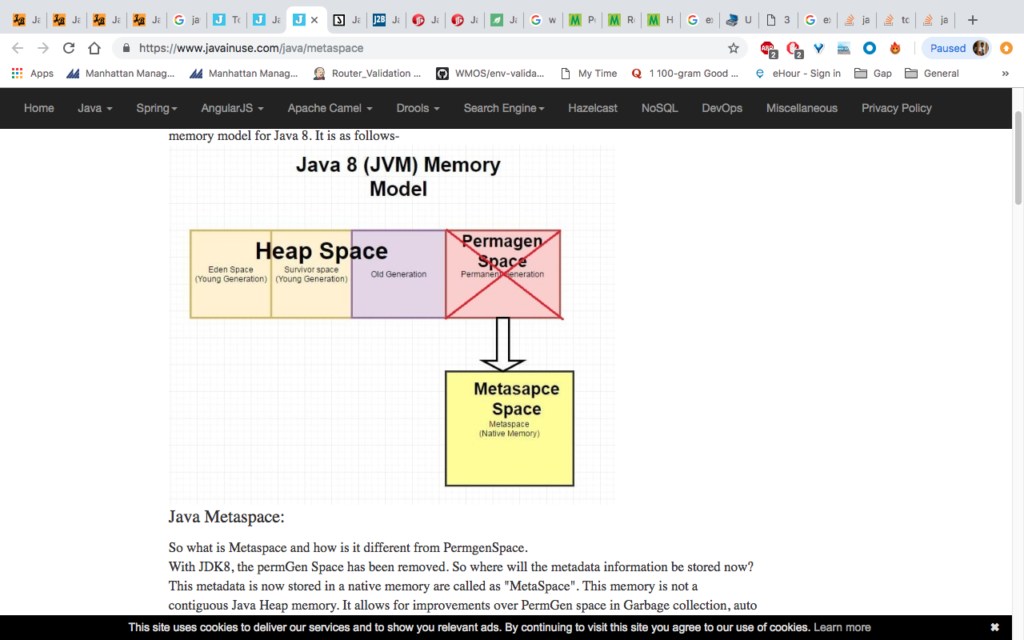

Java Metaspace:
So what is Metaspace and how is it different from PermgenSpace.
With JDK8, the permGen Space has been removed. So where will the metadata information be stored now? This metadata is now stored in a native memory are called as "MetaSpace". This memory is not a contiguous Java Heap memory. It allows for improvements over PermGen space in Garbage collection, auto tuning, concurrent de-allocation of metadata.
Difference between PermGen space and MetaSpace.
PermGen Space | MetaSpace
PermGen always has a fixed maximum size. | Metaspace by default auto increases its size depending on the underlying OS.
Contiguous Java Heap Memory | Native Memory(provided by underlying OS)
Max size can be set using XX:MaxPermSize | Max size can be set using XX:MetaspaceSize
Comparatively ineffiecient Garbage collection. Frequent GC pauses and no concurrent deallocation. | Comparatively effiecient Garbage collection. Deallocate class data concurrently and not during GC pause.
In previous chapter we saw how we got a permgen space error on running the following program. We analyzed the gc verbose logs. please follow the steps mentioned in that chapter.
package com.javainuse;

public class TestMemory {

static int i = 0;

public static void main(String[] args) {

if (i < 25) {
i++;
System.out.println(i);
main(new String[] { (args[0] + args[0]).intern() });
}

}

}

The gc verbose logs are as below-
See Also

https://www.baeldung.com/java-permgen-metaspace

Permgen vs Metaspace in Java
Last modified: September 9, 2018
by baeldung
- Java+

I just announced the new Learn Spring course, focused on the fundamentals of Spring 5 and Spring Boot 2:
>> CHECK OUT THE COURSE

1. Introduction
In this quick tutorial, we’re going to examine the differences between the PermGen and Metaspace memory regions in the Java environment.
It’s important to keep in mind that, starting with Java 8, the Metaspace replaces the PermGen – bringing some substantial changes.

2. PermGen
PermGen (Permanent Generation) is a special heap space separated from the main memory heap.
The JVM keeps track of loaded class metadata in the PermGen. Additionally, the JVM stores all the static content in this memory section. This includes all the static methods, primitive variables, and references to the static objects.
Furthermore, it contains data about bytecode, names and JIT information. Before Java 7, the String Pool was also part of this memory. The disadvantages of the fixed pool size are listed in our write-up.
The default maximum memory size for 32-bit JVM is 64 MB and 82 MB for the 64-bit version.
However, we can change the default size with the JVM options:
- -XX:PermSize=[size] is the initial or minimum size of the PermGen space
- -XX:MaxPermSize=[size] is the maximum size
Most importantly, Oracle completely removed this memory space in JDK 8 release.
With its limited memory size, PermGen is involved in generating the famous OutOfMemoryError. Simply put, the class loaders aren’t garbage collected properly and, as a result, generated a memory leak.
Therefore, we receive a memory space error; this happens mostly on development environment while creating new class loaders.

3. Metaspace
Simply put, Metaspace is a new memory space – starting from the Java 8 version; it has replaced the older PermGen memory space. The most significant difference is how it handles the memory allocation.
As a result, this native memory region grows automatically by default. Here we also have new flags to tune-up the memory:
- MetaspaceSize and MaxMetaspaceSize – we can set the Metaspace upper bounds.
- MinMetaspaceFreeRatio – is the minimum percentage of class metadata capacity free after garbage collection
- MaxMetaspaceFreeRatio – is the maximum percentage of class metadata capacity free after a garbage collection to avoid a reduction in the amount of space
Additionally, the garbage collection process also gains some benefits from this change. The garbage collector now automatically triggers cleaning of the dead classes once the class metadata usage reaches its maximum metaspace size.
Therefore, with this improvement, JVM reduces the chance to get the OutOfMemory error.
Despite all of this improvements, we still need to monitor and tune up the metaspace to avoid memory leaks.

4. Summary
This quick write-up presents a brief description of PermGen and Metaspace memory regions. Additionally, we explained the key differences between each of them.
PermGen is still around with JDK 7 and older versions, but Metaspace offers more flexible and reliable memory usage for our applications

