https://www.javabrahman.com/java-8/default-methods-in-java-8-with-examples/

Default Methods in Java 8 with examples
November 1, 2015
This tutorial explains what are default methods in Java 8 with examples, why they are useful and how they can be used to enhance the design of your code.
A little background: Prior to Java 8 interfaces could not have any implemented code. Methods defined in an interface for a type were considered to be the API methods for that type and any classes implementing that API had to implement all the methods. Well, the API part is still true in Java 8 i.e. interfaces will act as APIs for your design. However, interfaces can have implemented code in Java 8. These can be written in 2 ways – static methods & default methods. I have dealt with static methods in a separate article. This article will focus on default methods.
What are Default Methods
Default methods are methods implemented in an interface, are non-abstract, and marked by the modifier default. These methods are available to all classes which implement this interface.
Format of default methods
Inside an interface we need to mark a default method with the modifier default as shown in example below –
Interface with a default method
//MyInterface.java
public interface MyInterface{
default void printHello(){
System.out.println("Hello Default");
}
}
//MyInterfaceImpl.java
public class MyInterfaceImpl implements MyInterface{
public static void main(String args[]){
new MyInterfaceImpl().printHello();
}
}
OUTPUT obtained by running MyInterfaceImpl
Hello Default
Few points to note about the above program
- MyInterface implements a default method printHello().
- Method printHello() is implemented to simply print "Hello Default".
- MyInterfaceImpl class implements MyInterface
- In the main method of MyInterfaceImpl when printHello() method is invoked on an instance of MyInterfaceImpl then it calls the default implementation of printHello() and prints "Hello Default"
How are default methods Useful
Default methods are useful in a big way for API designers and indirectly for API implementors. Lets see how. Lets say we define an interface for a group of handheld devices called DeviceAPI. It has methods like getOS(), getMaxResolution() and getBrand() – all abstract. Our interface DeviceAPI would then look like this –
DeviceAPI.java
public interface DeviceAPI{
public String getOS();
public String getMaxResolution();
public String getBrand();
}
Now, over a period of time many devices are rolled out and for each new device we implement the DeviceAPIinterface and hence, we also implement all the abstract methods. Its all going fine when we come to know that a wearable device has come out which needs to have a check for whether bluetooth is enabled on the device.
We promptly write a method isBlueToothEnabled() in the interface DeviceAPI. But then we notice that DeviceAPI has had more than a few, infact 20-30 implementations, many of these implementations were done by device vendors using this API and we have no access to their source code. If we go ahead and add this new method isBlueToothEnabled() to DeviceAPI, everything will be fine for the vendors till they do not recompile their implementation class along with the new DeviceAPI. Then their code will start failing as compiler will not find the new method in their implementation. Secondly, we will have to change all of the 20-30 implementations. Even though that device maybe a wearable type of device or not.
How to overcome the issue of adding a new functionality to the API without breaking the code
Till Java 7 this kind of new functionality was very difficult to introduce due to the problems we noted above. But in Java 8 we have a solution for this. We can implement this isBlueToothEnabled() method as a default method in DeviceAPI. This implementation will then automatically be available to all the classes which implement DeviceAPI.
The code for DeviceAPI with the default method would look like this –
DeviceAPI.java with default method
public interface DeviceAPI{
default boolean isBlueToothEnabled(){
//default method implementation goes here
}
public String getOS();
public String getMaxResolution();
public String getBrand();
}
Default methods as optional
To continue with the previous example, our design was good and default methods solved the problem. However, many device vendors complained that their classes were unnecessarily getting this new method isBlueToothEnabled(). Vendors complain to us that their maintenance engineers may end up using this method as they might miss reading the documentation around this method. Basically, vendors want this method to be available if they need it, else they do not want to support this method for their devices.
As owners of DeviceAPI we then tweak the default implementation of isBlueToothEnabled() method to the one shown below –
DeviceAPI.java with default method made optional to inherit
public interface DeviceAPI{
default boolean isBlueToothEnabled(){
throw new UnsupportedOperationException();
}
public String getOS();
public String getMaxResolution();
public String getBrand();
}
Lets understand how the above code solves our problem
- isBlueToothEnabled() is the default method. However, it does not contain any implementation.
- isBlueToothEnabled() by default throws UnsupportedOperationException.
- Any class which implements DeviceAPI will not be forced with a default implementation if they do not need it. By default, this new operation isBlueToothEnabled() will be unsupported.
- Only when an implementation class really needs the isBlueToothEnabled() method they will override this method and write their own version
- A default method written in the above way thus becomes optional.
Default Methods and multiple inheritance
A class can implement multiple interfaces and each of these interfaces can have default methods. Then this becomes an instance of multiple inheritance which was till Java 7 not possible in Java while it was possible in languages such as C++. Multiple inheritance in Java 8 using default methods is a topic on its own and I have written a separate tutorial on it here – multiple inheritance tutorial.
Summary
This concludes the tutorial on default methods where we understood what are default methods, how we implement default methods in Java 8 interfaces, what kind of a basic design extensibility default methods solve,had a look at making default methods optional and lastly saw that default methods enable multiple inheritance in Java.

https://www.javabrahman.com/java-8/java-8-multiple-inheritance-of-behavior-from-interfaces-using-default-methods/

Java 8 Multiple Inheritance of Behavior from Interfaces using Default Methods
November 7, 2015
This article explains how default methods enable multiple inheritance of behavior in Java 8 using the new default methods feature in Interfaces.
Multiple Inheritance of Behavior with Default Methods
Until Java 7 multiple interface inheritance was possible but interfaces were not allowed to have concrete methods. Thus, behavior inheritance was not possible. With Java 8, where interfaces can now have default methods
implemented in them, it is now possible to have a derived class inherit methods from multiple parent interfaces. So, multiple inheritance of behavior is now possible.
Example to understand multiple inheritance using default methods
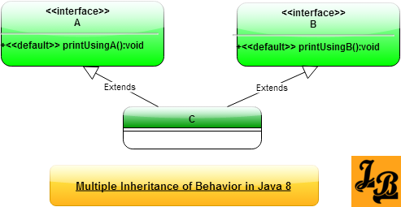
In the above class diagram –
- A is an interface with a default implemented method printUsingA().
- B is an interface with a default implemented method printUsingB().
- C is a concrete class implementing both A and B interfaces.
Now, since C implements both A & B interfaces, it inherits the default methods of both the interfaces. An instance of C can thus be used to invoke default methods of A and B. Lets see code of such an invocation on class C below, starting off with code defining interfaces A & B –
Java 8 code showing multiple inheritance for interfaces A,B & class C
//A.java
public interface A{
public default void printUsingA(){
System.out.println("Print from A");
}
}
//B.java
public interface B{
public default void printUsingB(){
System.out.println("Print from B");
}
}
//C.java
public class C implements A,B{
public static void main(String args[]){
C cObj=new C();
cObj.printUsingA();
cObj.printUsingB();
}
}
OUTPUT of the above code
Print from A
Print from B
Explanation of the code
- In the main() method of C an instance of C called cObj is created.
- Methods printUsingA() & printUsingB() are invoked on cObj.
- Multiple inheritance of behavior is thus achieved as C inherits 2 implemented methods(or behaviors from A & B).
Conflict Resolution in case of inheriting methods with same signature
We just saw above how C inherits implemented default methods from interfaces A & B. The two inherited methods had different names so there was no confusion. But what if the default methods being inherited had the same signatures – same name and same return types. Java 8 provides resolution rules for this.
I have covered conflict resolution rules for such scenarios and the classic diamond problem resolution in my

https://www.javabrahman.com/java-8/java-8-multiple-inheritance-conflict-resolution-rules-and-diamond-problem/

Java 8 Multiple Inheritance Conflict Resolution Rules and Diamond Problem
November 8, 2015
This article explains how to resolve conflicts when inheriting default methods with same signatures from multiple interfaces using java 8’s conflict resolution rules. It then looks in to the classic Diamond Problem and its resolution in Java 8.
What is default method resolution conflict
In my previous article I explained how Java 8 supports multiple inheritance
of behavior using default methods. However, what-if the multiple default interfaces implemented have default methods with the same signatures. Then which of the default implementations from the many parent interfaces will be invoked in the implementing class.
Java 8 designers have thought of this conflict and have defined resolution rules for such scenarios. Let us now take a look at the possible conflict scenarios and the resolution rules in-built in Java 8 for avoiding them.
Conflict resolution rules for inherited default methods
Conflict Resolution Rules for inherited default methods in order of precedence are –
- Rule 1 – Classes take higher precedence than interfaces – Any method inherited from a class or a superclass is invoked over any default method inherited from an interface.
Example to explain Rule 1
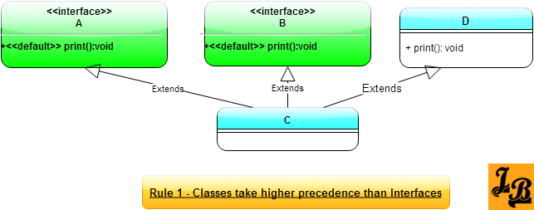
In the above class diagram, Class C inherits default method print() from interface A, interface B and super class C. If print() method is invoked in Class C then the implementation in super class C is executed.
- Rule 2 – Derived interfaces or sub-interfaces take higher precedence than the interfaces higher-up in the inheritance hierarchy – If default methods with the same method signature exist in an interface and its child interfaces, then the default method from the child interface is invoked.
Example to explain Rule 2
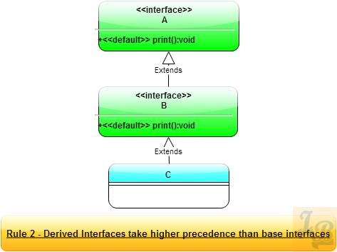
In the above class diagram, interface B inherits from interface A. Both have a default method print() with the same signature. Class C implements both interfaces A & B. When print() method is invoked on an instance of class C then the implementation in interface B is invoked as it is the lowest child/most derived interface in the inheritance hierarchy.
- Rule 3 – In case Rule 1 and Rule 2 are not able to resolve the conflict then the implementing class has to specifically override and provide a method with the same method definition – The implementing class can, of course, invoke the specific default method from the specific parent interface to get desired behavior. But still the class needs to override and invoke the default method to resolve the conflict.
Example to explain Rule 3
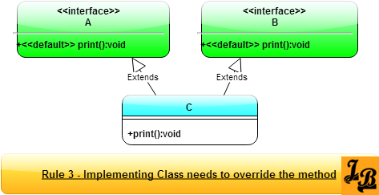
In the above class diagram, class C inherits from interfaces A & B, both of which have the default implementations of print(). Since, both interfaces A & B are parents of C, they are at the same hierarchy level, and hence, C has to provide its own implementation of method print().
Important Note – Inside Class C’s implementation of print() method it should invoke the specific implementation of interface A or B. For this Java 8 has a special syntax –
<super-interface-name>.super<method-name>
In this case print() method in class C will invoke print() method of B,its parent, like this – B.super.print()
Diamond Problem Revisited with Java 8’s Default Methods in Interfaces
Diamond Problem, wherein the grand-child class has both of its parents inheriting from a single grand-parent class, is a common problem faced in languages with multiple inheritance. Java 8 is affected by the diamond problem in 2 ways/2 scenarios which I will cover below –
- Scenario 1 of diamond problem in Java 8 –
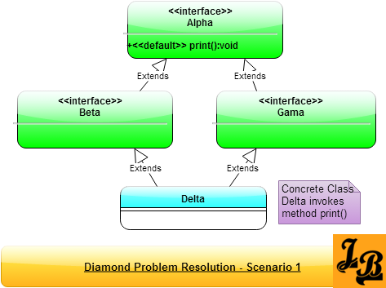
In the above class diagram, interfaces Beta & Gama implement interface Alpha. Class Delta is a concrete class and it implements both the interfaces Beta & Gama. The question in this scenario is that if Delta invokes the print() method, then which one will be invoked – the one inherited from Beta or that which was inherited from Gama?
(On a side note – If one sees the 4 inheritance arrows marked “extends” then they form a diamond shape and hence the name Diamond Problem).
Resolution for Scenario 1 of Diamond Problem –
Java 8 resolves this situation by considering that there is only one implementation of print() method, which is in class Alpha. Hence, when Delta invokes print() then the implementation of print() in Alpha is executed.
- Scenario 2 of diamond problem in Java 8 –
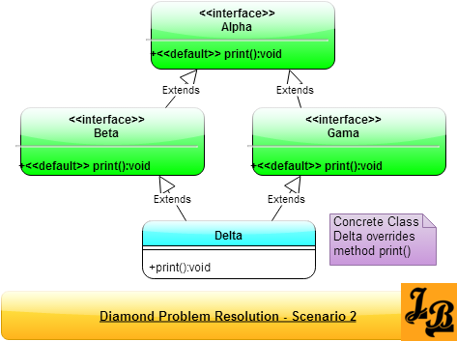
In the above class diagram, interfaces Beta & Gama implement interface Alpha like in scenario 1 above. However, here both of them override the print() method of Alpha. Now, when Delta wants to invoke print() which instance of print() will be invoked, the one inherited from Beta or the one inherited from Gama?
Resolution for Scenario 2 of Diamond Problem –
The answer lies in Rule 3 of the conflict resolution scenarios described earlier in this tutorial. Delta will have to override print() method and explicitly invoke the print() method on one of its parents – Beta or Gama. This will resolve the issue.
Summary
In this tutorial we looked at what do we mean by conflict resolution when inheriting behavior from multiple interfaces using default methods and rules defined in Java 8 for resolving these conflicts. We then looked at couple of scenarios how Diamond Problem can occur in Java 8 along with how to resolve them in Java 8.

https://www.javabrahman.com/java-8/java-8-static-methods-vs-default-methods-in-interfaces/

Java 8 Static Methods vs Default Methods in Interfaces
November 3, 2015
This article explains Java 8 Static Methods and Default Methods in Interfaces w.r.t to their various aspects with examples. An important point to understand before we start looking at static and default methods in interfaces is that they are not an either/or options. Its not like you have to choose one of them to implement. On the contrary, static and default methods work together to deliver the full functionality of an interface.
Quick Introductions to Static & Default Methods
What are Static Methods: These are methods written in Interfaces which are static. Till Java 7, static methods were only allowed on Classes. Beginning Java 8 static methods are now allowed in Interfaces as well.
Static methods in interfaces are accessible through the interface name like this –
<Interface-Name>.<Static-Method-Name>.
For example:java.util.Predicate Interface has a static method isEqual() which can be accessed like this Predicate.isEqual().
Note – This is same as the way static methods are accessed on a Class.
What are Default Methods: These are methods written in Interfaces, indicated by the modifier default. As their name suggests these methods are available by default to all the classes which implement this interface. In case you are not familar with default methods, please refer the detailed article I have written on them here – default methods tutorial.
Java 8 Static Methods vs Default Methods in Interfaces
Listed below are the main diftferences in the way static and default methods are used in interfaces –
Difference 1 – Definition in code\usage
Lets see how static and default methods are defined in code with an example –
Java 8 code showing static and default methods' definition
//InterfaceWithDefaultStatic.java
public interface InterfaceWithDefaultStatic {
public static void staticMethod() {
System.out.println("Static Method's print");
}
public default void defaultMethod() {
System.out.println("Static Method's print");
}
}
A static method is defined similar to the way a static variable or method is defined in classes –
<access modifier> static <return-parameter> method-name([<method-params>])[throws <Exceptions>]
Example: public static void staticMethod()
A default method is defined in a very similar way except that instead of static keyword, the default keyword is used –
<access modifier> default <return-parameter> method-name([<method-params>])[throws <Exceptions>]
Example: public default void defaultMethod()
Difference 2 – Scope for method invocation
A static method is visible/usable in Interface Scope. Once the interface has been compiled, then the static method can be invoked as –
<Interface-Name>.<static-method-name>([params])
For Example: For the code shown in difference-1 above, staticMethod() would be invoked as – InterfaceWithDefaultStatic.staticMethod()
A default method is visible\usable in the object instance scope. A Class needs to implement the interface containing the default method, then the default method can be invoked on the instance of the implementing class. The format of invocation of a default method is –
<ObjectInstance-name>.<default-method-name>([params])
For Example: Lets say there is a class named DefaultImpl as shown below –
DefaultImpl.java
public class DefaultImpl implements InterfaceWithDefaultStatic{
//class contents
}
For the above class DefaultImpl, to invoke the default method we will have to create an instance of the class, and then invoke it like this –
Invocation of default method of DefaultImpl.java
DefaultImpl defaultImplInstance=new DefaultImpl();
defaultImplInstance.defaultMethod();
Difference 3 – Purpose served in the overall design
When to design\use Static Methods: Static Methods are the utility(util) methods which are associated to an Interface. So, in case you need any util methods which can operate on an Interface’s implementing class’s instances, then add that as a static method to the Interface itself.
Until Java 7, the general practice was to have such util methods in a separate utility class which contains all the static methods which can be invoked on an interface’s implementation’s instance.
For example: Collections class has a sort method –
static <T> void sort(List<T> list, Comparator<? super T> c).
This is how any list was sorted till Java 7. The sorting util methods is present in the Collections Class as a static method.
From Java 8 onwards, since Interfaces can have static methods, it makes the design more cohesive by keeping these static util methods inside List itself. The Java designers also thought of the same and added a static method sort() to List –
default void sort(Comparator<? super E> c)
To summarize, whenever you need a static utility method for interface’s implementors, add that static utility method in Interface itself as a static method.
When to design\use Default Methods: Default methods are used when a feature is added to an existing hierarchy of classes which is not needed for the whole hierarchy.In that case, making that method an abstract method makes it mandatory for all the classes in the hierarchy to implement. This is an unnecessary overhead and a maintenance nightmare.
In this scenario, it is much simpler to add that method as a default method so that any Interface implementation which wants to use it can do so and the rest of the implementations can just ignore it. In effect making the functionality implemented through default methods an optional feature rather than a mandatory one.
Summary
In the above article we looked at the basics of the new static and default methods in interfaces. Then we looked at the key differences in their usage from syntax, scope and design angles.

