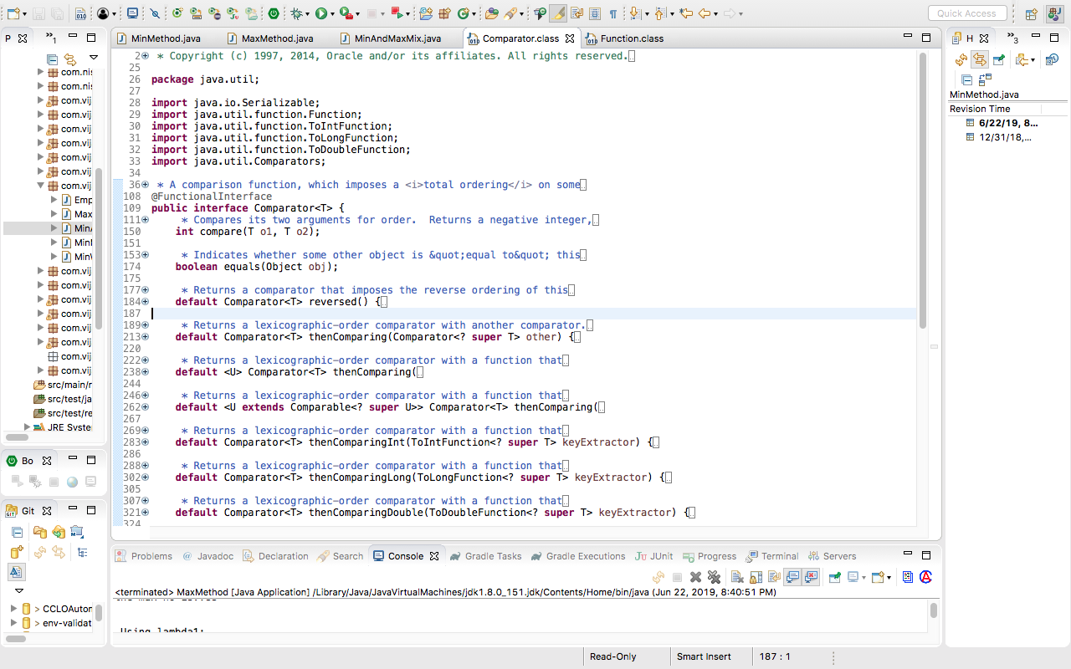

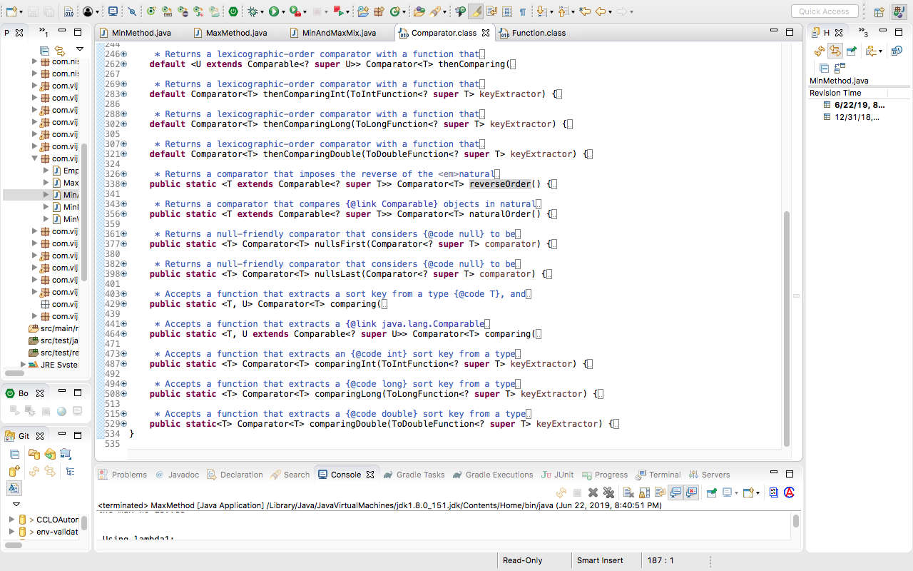

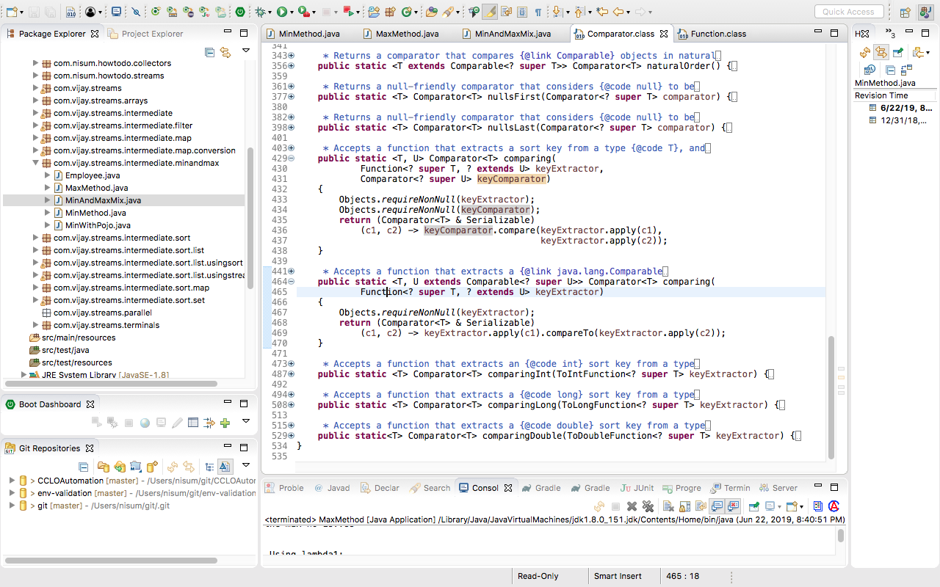

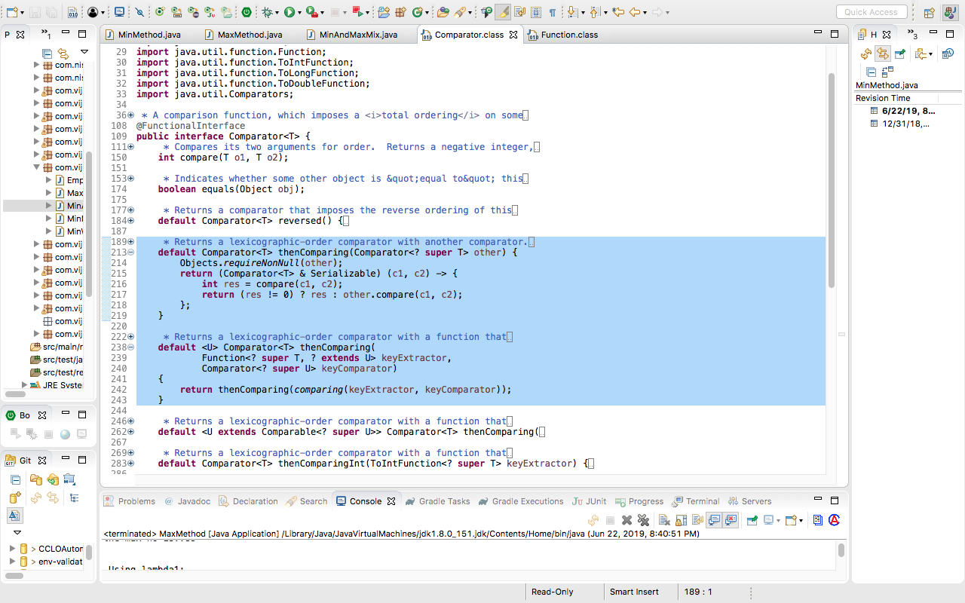

https://www.javabrahman.com/java-8/the-complete-java-8-comparator-tutorial-with-examples/

JAVA 8

The Complete Java 8 Comparator Tutorial with examples
September 2, 2016
Do You Know – Comparator in Java 7 had just 2 methods – compare() and equals(). The enhanced Comparator in Java 8 now boasts of 19 methods. Yes, 17 more methods! What’s more Comparator now is an official Functional Interface as well!
Comparator has undergone a major overhaul in Java 8 while still retaining its essence which is to compare and sort objects in Collections. Comparator now supports declarations via lambda expressions as it is a Functional Interface. Comparator has a new method comparing() which uses an instance ofjava.util.function.Function functional interface, specified using lambda expression or its equivalent method reference, for Comparator instance creation. In addition, multiple sort criteria can now be clubbed using comparing() with a thenComparing() method. The range of new capabilities is rounded off with methods for using natural comparison order, in-built Null handling and sort order reversal.
In this tutorial, we will first take a quick look at how Comparators were used before Java 8. We will then take an in-depth look at the new Comparator aspects mentioned above to see how java.util.Comparator has evolved into an enhanced comparison and ordering utility in Java 8.
How Comparator was used prior to Java 8
Until Java 7, Comparator interface could only be used in one single way. Given a collection of objects of type <T> to sort, one would create an implementation of Comparator<T> interface, override the compare()method of the interface with the desired comparison logic and use Collections.sort() or similar such methods in Collections API to sort the collection of objects.
Let us now see an example of how Comparators were used prior to Java 8. Let us first create a Class Employeewhich will be the type of object we will be sorting across all our examples for Java 7 and Java 8 Comparators-
Employee.java
//Employee.java
package com.javabrahman.java8;
public class Employee{
private String name;
private Integer age;
public Employee(String name, Integer age){
this.name=name;
this.age=age;
}
//--getters/setters for name and age go here
public String toString(){
return "Employee Name:"+this.name
+" Age:"+this.age;
}
@Override
public boolean equals(Object obj) {
if (obj == this) {
return true;
}
if (!(obj instanceof Employee)) {
return false;
}
Employee empObj = (Employee) obj;
return this.age==empObj.age
&& this.name.equalsIgnoreCase(empObj.name);
}
@Override
public int hashCode() {
int hash = 1;
hash = hash * 17 + this.name.hashCode();
hash = hash * 31 + this.age;
return hash;
}
}
Next we will see how Comparator was used to sort collections prior to Java 8 –
How Comparator was used prior to Java 8
package com.javabrahman.java8.comparator;
import java.util.Comparator;
import com.javabrahman.java8.Employee;
public class EmployeeComparator implements Comparator<Employee> {
@Override
public int compare(Employee emp1, Employee emp2) {
return (emp1.getName().compareTo(emp2.getName()));
}
}
//ComparatorOldWay.java
package com.javabrahman.java8.comparator;
import java.util.Arrays;
import java.util.Collections;
import java.util.List;
import com.javabrahman.java8.Employee;
public class ComparatorOldWay {
static List<Employee> employeeList =
Arrays.asList(new Employee("Tom Jones", 45),
new Employee("Harry Major", 35),
new Employee("Harry Major", 25),
new Employee("Ethan Hardy", 65),
new Employee("Nancy Smith", 15),
new Employee("Deborah Sprightly", 29));

public static void main(String args[]) {
Collections.sort(employeeList, new EmployeeComparator());
employeeList.forEach(System.out::println);
}
}
OUTPUT of the above code
Employee Name:Deborah Sprightly Age:29
Employee Name:Ethan Hardy Age:65
Employee Name:Harry Major Age:35
Employee Name:Harry Major Age:25
Employee Name:Nancy Smith Age:15
Employee Name:Tom Jones Age:45
Quick Explanation of the above code-
- EmployeeComparator class implements Comparator inteface and overrides the compare() method to compare Employee objects passed to it based on the natural ordering of their names of String type.
- ComparatorOldWay class sorts a static list of Employee objects using an instance of EmployeeComparator and the Collections.sort() method.
- Output shows that the employeeList gets sorted alphabetically based on the names of the employees.
Java 8’s Comparator is a Functional Interface
Owing to the fact that the Comparator interface has just one abstract method, compare(), it automatically qualifies to be a Functional Interface
in Java 8. Nevertheless, Java 8 designers have gone ahead and annotated the Comparator class interface @FunctionalInterface to enforce its role as a Functional Interface. Being a functional interface, Comparator can now be used as an assignment target for a lambda expression or a method reference.
Java 8’s Comparator as an assignment target for LambdaExpressions
Given the fact that its a functional interface, an instance of a Comparator can now be created in Java 8 with a lambda expression specifying its comparison logic. Take a look at the code snippet below –
Defining a Comparator using lambda expression
package com.javabrahman.java8.comparator;
import java.util.Arrays;
import java.util.Collections;
import java.util.Comparator;
import java.util.List;
import com.javabrahman.java8.Employee;
public class ComparatorsInJava8 {
static List<Employee> employeeList =
Arrays.asList(new Employee("Tom Jones", 45),
new Employee("Harry Major", 35),
new Employee("Harry Major", 25),
new Employee("Ethan Hardy", 65),
new Employee("Nancy Smith", 15),
new Employee("Deborah Sprightly", 29));
public static void main(String[] args) {
Comparator<Employee> empNameComparator = (Employee emp1, Employee emp2) -> {
return (emp1.getName().compareTo(emp2.getName()));
};
Collections.sort(employeeList, empNameComparator);
employeeList.forEach(System.out::println);
}
}
OUTPUT of the above code
Employee Name:Deborah Sprightly Age:29
Employee Name:Ethan Hardy Age:65
Employee Name:Harry Major Age:35
Employee Name:Harry Major Age:25
Employee Name:Nancy Smith Age:15
Employee Name:Tom Jones Age:45
Quick Explanation of the above code-
- ComparatorsInJava8 class uses the same list of Employee objects as that used for the previous example for Java 7 style of Comparator.
- An instance of the Comparator, empNameComparator, is created using a lambda expression.
- The lambda expression takes 2 Employee instances,emp1 and emp2, as input and outputs the comparison of their names using the natural comparison order of Strings.
- Using empNameComparator for sorting results in a correctly sorted Employee list by name.
Java 8 Comparator’s comparing() method’s working
The comparing() method is a new static method introduced in Comparators in Java 8. It has the signature –
static <T,U extends Comparable<? super U>> Comparator<T> comparing(Function<? super T,? extends U> keyExtractor)
comparing() method works by taking a Function<T,R> functional interface instance as an input, where Tis the type of input object and R is the sort key which is returned (or extracted) from the input object when Function<T,R> processes it.
Let’s see a code snippet to understand the use of comparing() method. I have removed the code which was same as previous example below for brevity –
Comparator creation using static method comparing()
public static void main(String[] args) {
Comparator<Employee> comparatorObj=Comparator.comparing(Employee emp -> emp.getName());
Collections.sort(employeeList, comparatorObj);
employeeList.forEach(System.out::println);
}
OUTPUT of the above code
Employee Name:Deborah Sprightly Age:29
Employee Name:Ethan Hardy Age:65
Employee Name:Harry Major Age:35
Employee Name:Harry Major Age:25
Employee Name:Nancy Smith Age:15
Employee Name:Tom Jones Age:45
Quick Explanation of the above code-
- An instance of the Comparator, comparatorObj, is created using the static method Comparator.comparing().
- The comparing() is passed a lambda expression, which corresponds to a Function<T,R> instance accepting an Employee object as input and returns an employee name – the sort key.
- Using comparatorObj for sorting results in a correctly sorted Employee list by name.
- NOTE – Instead of the lambda expression, you can also use an equivalent method reference as well. The comparing() method with a method reference will then be written like this –
Comparator empNameComparator = Comparator.comparing(Employee::getName);
Java 8 Comparator’s thenComparing() method for multiple sort criteria
Many-a-times we need to sort with multiple sort orders. I.e. on more than one attributes of an object. The second level sort order gets used if the first level sort criteria is indecisive. In the list of Employees we are using as an example, there are two employees with the name Harry Major. Let us take a second sort order of age and say that in such cases we will put the employee with the younger age first.
For exactly these kinds of multiple sort ordering, Java 8 Comparator provides a default method thenComparing() which has the signature –
default Comparator<T> thenComparing(Comparator<? super T> other)
The thenComparing() method then does the second level sort, if the first level sort is indecisive. Let us extend the above code example to add a second-level sort criteria by age.
Comparator's thenComparing() method for multiple sort criteria
public static void main(String[] args) {
Comparator<Employee> empNameComparator = Comparator.comparing(Employee::getName).thenComparing(Employee::getAge);
Collections.sort(employeeList, empNameComparator);
employeeList.forEach(System.out::println);
}
OUTPUT of the above code
Employee Name:Deborah Sprightly Age:29
Employee Name:Ethan Hardy Age:65
Employee Name:Harry Major Age:25
Employee Name:Harry Major Age:35
Employee Name:Nancy Smith Age:15
Employee Name:Tom Jones Age:45
Quick Explanation of the above code-
- First comparing() method is invoked with method reference for Employee's getName() method. This returns a Comparator instance with the first level sort based on Employee name as we saw in previous section.
- We append .thenComparing(Employee::getAge) to the Comparator instance returned using comparing() method, which adds a second level sort based on Employee's getAge() method.
- The output is as expected with the employee named ‘Harry Major’ with the lesser age placed earlier in the sorted employeeList than his elder namesake employee.
Java 8 Comparator’s natural order comparison methods
Java 8 Comparator supports natural order comparison of elements in a Collection. I.e. instead of defining our own comparison logic, we can instead use the inherent natural order defined for that type of element via its implementation of Comparable interface. Comparator provides two static methods naturalOrder() and reverseOrder() to allow natural order comparison and reverse natural order comparison respectively. These have the syntax –
static <T extends Comparable<? super T>> Comparator<T> naturalOrder()
AND
static <T extends Comparable<? super T>> Comparator<T> reverseOrder()
Let us take the case of String type which has natural comparison order defined as alphabetical. To use our existing example for sorting using Employee objects, we will extract out all the names of Employees by utilizing the stream() method to convert the Employee list into a Stream of Employee objects. We will then map these Employee objects using a Function into their names and collect these names into a list of Strings holding these names.
(In case you are not aware of mapping of elements in a Stream using map() method you can read the tutorial on Stream.map() method
, and tutorial on Function interface
.)
Java 8 Comparator natural order sorting
public static void main(String[] args) {
List<String> empNames = employeeList.stream().map(Employee::getName).collect(Collectors.toList());
empNames.sort(Comparator.naturalOrder());
empNames.forEach(System.out::println);
OUTPUT of the above code
Deborah Sprightly
Ethan Hardy
Harry Major
Harry Major
Nancy Smith
Tom Jones
Quick Explanation of the above code-
- Employee names are extracted into an empNames List as explained before the code snippet.
- empNames List is then sorted using the Comparator.naturalOrder() method which returns a Comparator instance of String’s natural comparison order based on the empName’s generic type of String.
- Employee names are sorted in natural comparison order, i.e. alphabetical order, and printed.
- Instead of invoking the Comparator.naturalOrder() method to the empNames.sort() method, you can invoke the Comparator.reverseOrder() method in order to sort the empNames List in reverse of natural comparison order or reverse alphabetical order.
Java 8 Comparator’s null handling using nullsFirst()and nullsLast() methods
There are instances where the sort key value is nullable. We have to then decide whether we want to place objects with sort key as null earlier in the ordering than the objects with non-null sort key or at the end of the list after the objects with non-null sort key. Java 8 Comparators provide nullsFirst() and nullsLast() static methods for exactly such sort order handling of null valued sort keys. These methods have the signature –
static <T> Comparator<T> nullsFirst(Comparator<? super T> comparator)
AND
static <T> Comparator<T> nullsLast(Comparator<? super T> comparator)
To understand the functioning of these methods, let us make the two of the employee names as null. The below two sections of code and respective output shows how the use of nullsFirst() and nullsLast() handles sorting when some objects have sort-key as null.
Java 8 Comparator with sort key null and using nullsFirst()
public class ComparatorsInJava8 {
static List<Employee> employeeList = Arrays.asList(
new Employee(null, 45),
new Employee("Harry Major", 35),
new Employee("Harry Major", 25),
new Employee(null, 65),
new Employee("Nancy Smith", 15),
new Employee("Deborah Sprightly", 29));
public static void main(String[] args) {
Comparator<Employee> empNameComparator = Comparator.comparing(Employee::getName, Comparator.nullsFirst(String::compareTo));
Collections.sort(employeeList, empNameComparator);
employeeList.forEach(System.out::println);
}
}
OUTPUT of the above code
Employee Name:null Age:45
Employee Name:null Age:65
Employee Name:Deborah Sprightly Age:29
Employee Name:Harry Major Age:35
Employee Name:Harry Major Age:25
Employee Name:Nancy Smith Age:15
Keeping the employee list same and invoking the Comparator using nullLast() –
Java 8 Comparator with sort key null and using nullsLast()
public static void main(String[] args) {
Comparator<Employee> empNameComparator = Comparator.comparing(Employee::getName, Comparator.nullsLast(String::compareTo));
Collections.sort(employeeList, empNameComparator);
employeeList.forEach(System.out::println);
}
}
OUTPUT of the above code
Employee Name:Deborah Sprightly Age:29
Employee Name:Harry Major Age:35
Employee Name:Harry Major Age:25
Employee Name:Nancy Smith Age:15
Employee Name:null Age:45
Employee Name:null Age:65
Quick Explanation of the above code-
- Using nullsFirst(), the comparator places the two Employee objects with the sort key null (employee name null) before the other Employee objects in the list.
- Likewise, nullsLast(), the comparator places these two Employee objects after the other Employee objects in the list.
Java 8 Comparator’s sort order reversal method – reversed()
In case you simply want to sort in the order opposite to a defined comparator’s sorting order then you need not write the reverse comparison logic again. Instead simply use the Comparator.reversed() default method.
The reversed() method has the signature –
default Comparator<T> reversed()
Java 8 Comparator order reversal using reversed() method
public static void main(String[] args) {
Comparator<Employee> empNameComparator = Comparator.comparing(Employee::getName).reversed();
Collections.sort(employeeList, empNameComparator);
employeeList.forEach(System.out::println);
}
OUTPUT of the above code
Employee Name:Tom Jones Age:45
Employee Name:Nancy Smith Age:15
Employee Name:Harry Major Age:35
Employee Name:Harry Major Age:25
Employee Name:Ethan Hardy Age:65
Employee Name:Deborah Sprightly Age:29
Quick Explanation of the above code-
- Comparator’s default method reversed() is applied to the empNameComparator which has been initially defined to sort in alphabetical order of Employee names.
- Due to reversed() being applied to it, the Employee objects are printed in reverse alphabetical order of their names.
Summary– In this tutorial on Java 8 Comparators we first had a look at how Comparators were used till Java 7. Next we learnt that Comparator is now a functional interface and how it can be defined using a lambda expression. We then had a look at the comparing() method which allows us to define a Comparator using a Function instance which returns the sort key. Next we looked at thenComparing() method which allows us to sort using multiple sort orders. This was followed by understanding the natural order comparison related methods of Comparator – naturalOrder() and reverseOrder(). Next we looked at the null-valued sort key handling methods – nullsFirst() and nullsLast(). Lastly, we understood the reversed() method which allows us to sort in the reverse order of a defined Comparator.

https://www.baeldung.com/java-8-comparator-comparing
Guide to Java 8 Comparator.comparing()
Last modified: April 4, 2018
by baeldung
- Java+
- Java 8

I just announced the new Spring Boot 2 material, coming in REST With Spring:
>> CHECK OUT THE COURSE

1. Overview
Java 8 introduced several enhancements to the Comparator interface, including a handful of static functions that are of great utility when coming up with a sort order for collections.
Java 8 lambdas can be leveraged effectively with the Comparator interface as well. A detailed explanation of lambdas and Comparator can be found here, and a chronicle on sorting and applications of Comparator can be found here.
In this tutorial, we will explore several functions introduced for the Comparator interface in Java 8.

2. Getting Started

2.1. Sample Bean Class
For the examples in this article, let’s create an Employee bean and use its fields for comparing and sorting purposes:
1  2  3  4  5  6  7  8 | public class Employee {  String name;  int age;  double salary;  long mobile;  // constructors, getters & setters  }

2.2. Our Testing Data
Let’s also create an array of employees that will be used to store the results of our type in various test cases throughout the article:
1 | employees = new Employee[] { ... };
The initial ordering of elements of employees will be:
1  2  3 | [Employee(name=John, age=25, salary=3000.0, mobile=9922001),  Employee(name=Ace, age=22, salary=2000.0, mobile=5924001),  Employee(name=Keith, age=35, salary=4000.0, mobile=3924401)]
Throughout the article, we’ll be sorting above Employee array using different functions.
For test assertions, we’ll use a set of pre-sorted arrays that we will compare to our sort results (i.e., the employees array) for different scenarios.
Let’s declare a few of these arrays:
1  2  3  4  5  6  7  8 | @Before  public void initData() {  sortedEmployeesByName = new Employee[] {...};  sortedEmployeesByNameDesc = new Employee[] {...};  sortedEmployeesByAge = new Employee[] {...};  // ...  }
Like always, feel free to refer our GitHub link for the complete code.

3. Using Comparator.comparing
This section covers variants of the Comparator.comparing static function.

3.1. Key Selector Variant
The Comparator.comparing static function accepts a sort key Function and returns a Comparator for the type which contains the sort key:
1  2 | static <T,U extends Comparable<? super U>> Comparator<T> comparing(  Function<? super T,? extends U> keyExtractor)
To see this in action, let’s use the name field in Employee as the sort key and pass its method reference as an argument of type Function. The Comparator returned from the same is used for sorting:
1  2  3  4  5  6  7  8  9 | @Test  public void whenComparing_thenSortedByName() {  Comparator<Employee> employeeNameComparator  = Comparator.comparing(Employee::getName);  Arrays.sort(employees, employeeNameComparator);  assertTrue(Arrays.equals(employees, sortedEmployeesByName));  }
As you can see, the employees array values are sorted by name as a result of the sort:
1  2  3 | [Employee(name=Ace, age=22, salary=2000.0, mobile=5924001),  Employee(name=John, age=25, salary=3000.0, mobile=9922001),  Employee(name=Keith, age=35, salary=4000.0, mobile=3924401)]

3.2. Key Selector and Comparator Variant
There is another option that facilitates overriding the natural ordering of the sort key by providing the Comparator that creates a custom ordering for the sort key:
1  2  3 | static <T,U> Comparator<T> comparing(  Function<? super T,? extends U> keyExtractor,  Comparator<? super U> keyComparator)
Let’s modify the test above, overriding the natural order of sorting by the name field by providing a Comparator for sorting the names in descending order as the second argument to Comparator.comparing:
1  2  3  4  5  6  7  8  9  10  11  12 | @Test  public void whenComparingWithComparator_thenSortedByNameDesc() {  Comparator<Employee> employeeNameComparator  = Comparator.comparing(  Employee::getName, (s1, s2) -> {  return s2.compareTo(s1);  });  Arrays.sort(employees, employeeNameComparator);  assertTrue(Arrays.equals(employees, sortedEmployeesByNameDesc));  }
As you can see, the results are sorted in descending order by name:
1  2  3 | [Employee(name=Keith, age=35, salary=4000.0, mobile=3924401),  Employee(name=John, age=25, salary=3000.0, mobile=9922001),  Employee(name=Ace, age=22, salary=2000.0, mobile=5924001)]

3.3. Using Comparator.reversed
When invoked on an existing Comparator, the instance method Comparator.reversed returns a new Comparator that reverses the sort order of the original.
Let’s use the Comparator that sorts the employees by name and reverse it so that employees are sorted in descending order of the name:
1  2  3  4  5  6  7  8  9 | @Test  public void whenReversed_thenSortedByNameDesc() {  Comparator<Employee> employeeNameComparator  = Comparator.comparing(Employee::getName);  Comparator<Employee> employeeNameComparatorReversed  = employeeNameComparator.reversed();  Arrays.sort(employees, employeeNameComparatorReversed);  assertTrue(Arrays.equals(employees, sortedEmployeesByNameDesc));  }
The results are sorted in descending order by name:
1  2  3 | [Employee(name=Keith, age=35, salary=4000.0, mobile=3924401),  Employee(name=John, age=25, salary=3000.0, mobile=9922001),  Employee(name=Ace, age=22, salary=2000.0, mobile=5924001)]

3.4. Using Comparator.comparingInt
There is also a function Comparator.comparingInt which does the same thing as Comparator.comparing, but it takes only int selectors. Let’s try this with an example where we order employees by age:
1  2  3  4  5  6  7  8  9 | @Test  public void whenComparingInt_thenSortedByAge() {  Comparator<Employee> employeeAgeComparator  = Comparator.comparingInt(Employee::getAge);  Arrays.sort(employees, employeeAgeComparator);  assertTrue(Arrays.equals(employees, sortedEmployeesByAge));  }
Let’s see how the employees array values are ordered after the sort:
1  2  3 | [Employee(name=Ace, age=22, salary=2000.0, mobile=5924001),  Employee(name=John, age=25, salary=3000.0, mobile=9922001),  Employee(name=Keith, age=35, salary=4000.0, mobile=3924401)]

3.5. Using Comparator.comparingLong
Similar to what we did for int keys, let’s see an example using Comparator.comparingLong to consider a sort key of type long by ordering the employees array by the mobile field:
1  2  3  4  5  6  7  8  9 | @Test  public void whenComparingLong_thenSortedByMobile() {  Comparator<Employee> employeeMobileComparator  = Comparator.comparingLong(Employee::getMobile);  Arrays.sort(employees, employeeMobileComparator);  assertTrue(Arrays.equals(employees, sortedEmployeesByMobile));  }
Let’s see how the employees array values are ordered after the sort with mobile as the key:
1  2  3 | [Employee(name=Keith, age=35, salary=4000.0, mobile=3924401),  Employee(name=Ace, age=22, salary=2000.0, mobile=5924001),  Employee(name=John, age=25, salary=3000.0, mobile=9922001)]

3.6. Using Comparator.comparingDouble
Again, similar to what we did for int and long keys, let’s see an example using Comparator.comparingDouble to consider a sort key of type double by ordering the employees array by the salary field:
1  2  3  4  5  6  7  8  9 | @Test  public void whenComparingDouble_thenSortedBySalary() {  Comparator<Employee> employeeSalaryComparator  = Comparator.comparingDouble(Employee::getSalary);  Arrays.sort(employees, employeeSalaryComparator);  assertTrue(Arrays.equals(employees, sortedEmployeesBySalary));  }
Let’s see how the employees array values are ordered after the sort with salary as the sort key:
1  2  3 | [Employee(name=Ace, age=22, salary=2000.0, mobile=5924001),  Employee(name=John, age=25, salary=3000.0, mobile=9922001),  Employee(name=Keith, age=35, salary=4000.0, mobile=3924401)]

4. Considering Natural Order in Comparator
The natural order is defined by the behavior of the Comparable interface implementation. More information about the difference between Comparator and uses of the Comparableinterface can be found in this article.
Let’s implement Comparable in our Employee class so that we can try the natrualOrder and reverseOrder functions of the Comparator interface:
1  2  3  4  5  6  7  8 | public class Employee implements Comparable<Employee>{  // ...  @Override  public int compareTo(Employee argEmployee) {  return name.compareTo(argEmployee.getName());  }  }

4.1. Using Natural Order
The naturalOrder function returns the Comparator for the return type mentioned in the signature:
1 | static <T extends Comparable<? super T>> Comparator<T> naturalOrder()
Given the above logic to compare employees based on name field, let’s use this function to obtain to a Comparator which sorts the employees array in natural order:
1  2  3  4  5  6  7  8  9 | @Test  public void whenNaturalOrder_thenSortedByName() {  Comparator<Employee> employeeNameComparator  = Comparator.<Employee> naturalOrder();  Arrays.sort(employees, employeeNameComparator);  assertTrue(Arrays.equals(employees, sortedEmployeesByName));  }
Let’s see how the employees array values are ordered after the sort:
1  2  3 | [Employee(name=Ace, age=22, salary=2000.0, mobile=5924001),  Employee(name=John, age=25, salary=3000.0, mobile=9922001),  Employee(name=Keith, age=35, salary=4000.0, mobile=3924401)]

4.2. Using Reverse Natural Order
Similar to naturalOrder, let’s use the reverseOrder method to generate a Comparator which will produce a reverse ordering of employees to the one in the naturalOrder example:
1  2  3  4  5  6  7  8  9 | @Test  public void whenReverseOrder_thenSortedByNameDesc() {  Comparator<Employee> employeeNameComparator  = Comparator.<Employee> reverseOrder();  Arrays.sort(employees, employeeNameComparator);  assertTrue(Arrays.equals(employees, sortedEmployeesByNameDesc));  }
Let’s see how the employees array values are ordered after the sort:
1  2  3 | [Employee(name=Keith, age=35, salary=4000.0, mobile=3924401),  Employee(name=John, age=25, salary=3000.0, mobile=9922001),  Employee(name=Ace, age=22, salary=2000.0, mobile=5924001)]

5. Considering Null Values in Comparator
This section covers functions nullsFirst and nullsLast, which consider null values in ordering and keep the null values at the beginning or end of the ordering sequence.

5.1. Considering Null First
Let’s randomly insert null values in employees array:
1  2  3  4  5 | [Employee(name=John, age=25, salary=3000.0, mobile=9922001),  null,  Employee(name=Ace, age=22, salary=2000.0, mobile=5924001),  null,  Employee(name=Keith, age=35, salary=4000.0, mobile=3924401)]
The nullsFirst function will return a Comparator that keeps all nulls at the beginning of the ordering sequence:
1  2  3  4  5  6  7  8  9  10  11  12  13  14 | @Test  public void whenNullsFirst_thenSortedByNameWithNullsFirst() {  Comparator<Employee> employeeNameComparator  = Comparator.comparing(Employee::getName);  Comparator<Employee> employeeNameComparator_nullFirst  = Comparator.nullsFirst(employeeNameComparator);  Arrays.sort(employeesArrayWithNulls,  employeeNameComparator_nullFirst);  assertTrue(Arrays.equals(  employeesArrayWithNulls,  sortedEmployeesArray_WithNullsFirst));  }
Let’s see how the employees array values are ordered after the sort:
1  2  3  4  5 | [null,  null,  Employee(name=Ace, age=22, salary=2000.0, mobile=5924001),  Employee(name=John, age=25, salary=3000.0, mobile=9922001),  Employee(name=Keith, age=35, salary=4000.0, mobile=3924401)]

5.2. Considering Null Last
The nullsLast function will return a Comparator that keeps all nulls at the end of the ordering sequence:
1  2  3  4  5  6  7  8  9  10  11  12 | @Test  public void whenNullsLast_thenSortedByNameWithNullsLast() {  Comparator<Employee> employeeNameComparator  = Comparator.comparing(Employee::getName);  Comparator<Employee> employeeNameComparator_nullLast  = Comparator.nullsLast(employeeNameComparator);  Arrays.sort(employeesArrayWithNulls, employeeNameComparator_nullLast);  assertTrue(Arrays.equals(  employeesArrayWithNulls, sortedEmployeesArray_WithNullsLast));  }
Let’s see how the employees array values are ordered after the sort:
1  2  3  4  5 | [Employee(name=Ace, age=22, salary=2000.0, mobile=5924001),  Employee(name=John, age=25, salary=3000.0, mobile=9922001),  Employee(name=Keith, age=35, salary=4000.0, mobile=3924401),  null,  null]

6. Using Comparator.thenComparing
The thenComparing function lets you set up lexicographical ordering of values by provisioning multiple sort keys in a particular sequence.
Let’s consider another array of Employee class:
1 | someMoreEmployees = new Employee[] { ... };
Consider the following sequence of elements in the above array:
1  2  3  4 | [Employee(name=Jake, age=25, salary=3000.0, mobile=9922001),  Employee(name=Jake, age=22, salary=2000.0, mobile=5924001),  Employee(name=Ace, age=22, salary=3000.0, mobile=6423001),  Employee(name=Keith, age=35, salary=4000.0, mobile=3924401)]
Let’s write a sequence of comparisons as age followed by the name and see the ordering of this array:
1  2  3  4  5  6  7  8  9  10 | @Test  public void whenThenComparing_thenSortedByAgeName(){  Comparator<Employee> employee_Age_Name_Comparator  = Comparator.comparing(Employee::getAge)  .thenComparing(Employee::getName);  Arrays.sort(someMoreEmployees, employee_Age_Name_Comparator);  assertTrue(Arrays.equals(someMoreEmployees, sortedEmployeesByAgeName));  }
Here the ordering will be done by age, and for the values with the same age, ordering will be done by name. Let’s observe this in the sequence we receive after sorting:
1  2  3  4 | [Employee(name=Ace, age=22, salary=3000.0, mobile=6423001),  Employee(name=Jake, age=22, salary=2000.0, mobile=5924001),  Employee(name=Jake, age=25, salary=3000.0, mobile=9922001),  Employee(name=Keith, age=35, salary=4000.0, mobile=3924401)]
Let’s use the other version of thenComparing that is thenComparingInt, by changing the lexicographical sequence to name followed by age:
1  2  3  4  5  6  7  8  9  10  11 | @Test  public void whenThenComparing_thenSortedByNameAge() {  Comparator<Employee> employee_Name_Age_Comparator  = Comparator.comparing(Employee::getName)  .thenComparingInt(Employee::getAge);  Arrays.sort(someMoreEmployees, employee_Name_Age_Comparator);  assertTrue(Arrays.equals(someMoreEmployees,  sortedEmployeesByNameAge));  }
Let’s see how the employees array values are ordered after the sort:T
1  2  3  4 | [Employee(name=Ace, age=22, salary=3000.0, mobile=6423001),  Employee(name=Jake, age=22, salary=2000.0, mobile=5924001),  Employee(name=Jake, age=25, salary=3000.0, mobile=9922001),  Employee(name=Keith, age=35, salary=4000.0, mobile=3924401)]
Similarly, there are functions thenComparingLong and thenComparingDouble for using longand double sorting keys.

7. Conclusion
This article is a guide to several features introduced in Java 8 for the Comparator interface.
As usual, the source code can be found over on Github.

https://www.webucator.com/how-to/how-use-the-comparatorcomparing-method-java-8.cfm

How to Use the Comparator.comparing Method in Java 8
The Comparator.comparing method, introduced in Java 8, returns a Comparator object that will use the specified field as the sort key. The Comparator interface is a functional interface in Java 8, and the method implemented is the compare method. Therefore, the compare method is implemented by the comparingmethod using the specified key. To learn how to use the Comparator.comparing method, follow these seven steps.
- Open your text editor and create a new file that will contain the musical instrument class that ultimately will be sorted. Type in the following Java statements:
- public class MusicalInstrument {
- private String name;
- private String type;
- public MusicalInstrument(String name, String type) {
- setName(name);
- setType(type);
- }
- public String getName() {
- return name;
- }
- public void setName (String name) {
- this.name=name;
- }
- public String getType() {
- return type;
- }
- public void setType (String type) {
- this.type=type;
- }
- public String toString() {
- return name + " is a " + type + " instrument";
- }
}
This is a straightforward Java bean that contains two properties: musical instrument name (e.g., trumpet) and type of musical instrument (e.g., brass). I have highlighted the two properties in the image below:
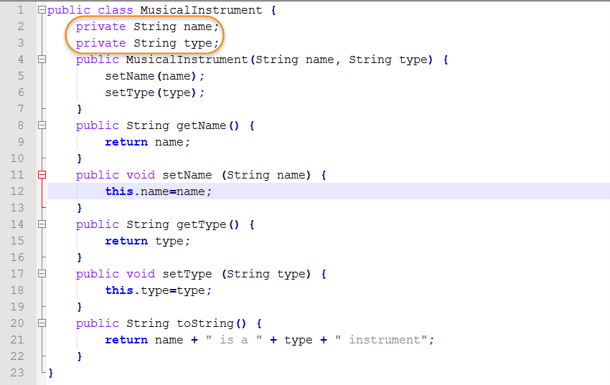
- Save your file as MusicalInstrument.java.
- Open a command prompt and navigate to the directory containing your new Java program. Then type in the command to compile the source and hit Enter.
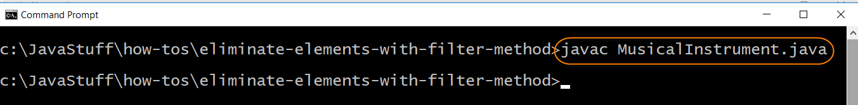
- Open your text editor and create the Java program that will demonstrate the use of the Comparator.comparing method. Type in the following Java statements:

- import java.util.stream.*;
- import java.util.*;
- public class UseComparatorcomparingMethod {
- private static List musicalInstruments=new ArrayList<>();
- static {
- musicalInstruments.add(new MusicalInstrument("Trumpet","brass"));
- musicalInstruments.add(new MusicalInstrument("Tuba","brass"));
- musicalInstruments.add(new MusicalInstrument("Timpani","percussion"));
- musicalInstruments.add(new MusicalInstrument("Piano","keyboard"));
- }
- public static void main (String args[]) {
- System.out.println("Musical instruments in the collection sorted by name:");
- Collections.sort(musicalInstruments, Comparator.comparing((MusicalInstrument instrument) -> instrument.getName()));
- musicalInstruments.stream().forEach(System.out::println);

- System.out.println("Musical instruments in the collection sorted by type:");
- Collections.sort(musicalInstruments, Comparator.comparing((MusicalInstrument instrument) -> instrument.getType()));
- musicalInstruments.stream().forEach(instrument->System.out.println(instrument));
- }
}
The stream will be created from the ArrayList that is defined on line 4. Note that a static block is used to add elements to the ArrayList. A static block is executed one time when the program is loaded into memory. The ArrayList will be sorted by Collections.sort. This static method accepts an ArrayList and a Comparator object. Note that the Comparator object will be returned by the comparing method. The parameter passed to the comparing method is a lambda expression that determines the sort field. The musical instrument name is passed to the first comparing method and the musical instrument type is passed to the second comparing method. I have highlighted the comparing method calls below:
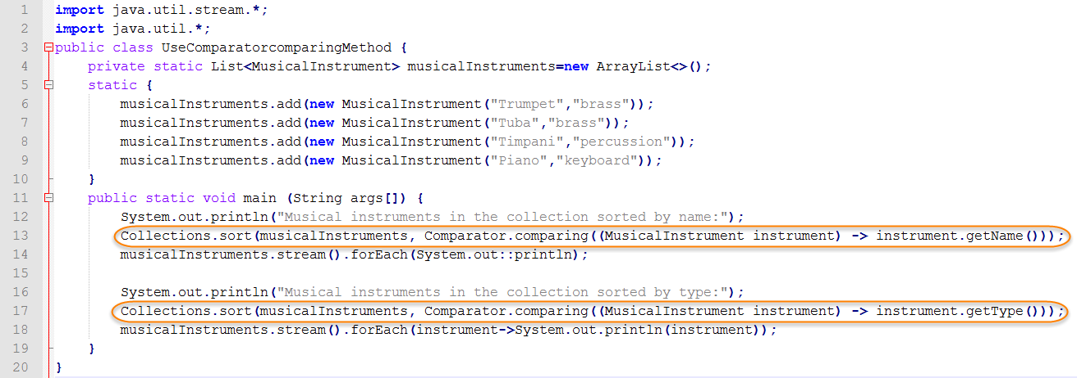
- Save your file as UseComparatorcomparingMethod.java.
- Open a command prompt and navigate to the directory containing your new Java program. Then type in the command to compile the source and hit Enter.
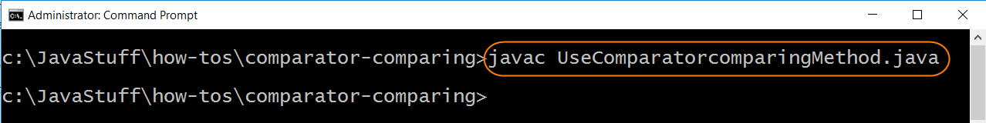
- You are ready to test your Java program. Type in the command to run the Java runtime launcher and hit Enter. The output displays the musical instruments sorted first by name and then by type.
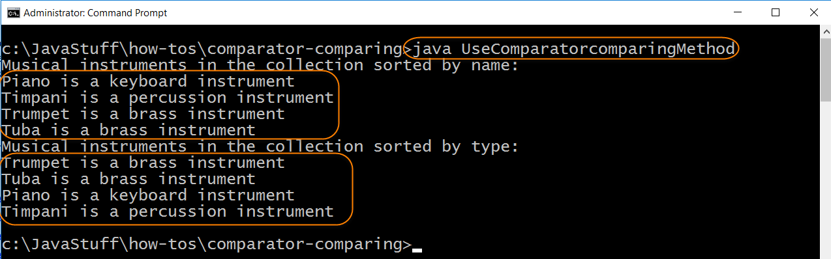

https://www.javadevjournal.com/java/java-sorting-example-comparable-comparator/

Java Sorting Example(Comparable and Comparator)
- Last updated:January 30, 2018
- / Java
- / By Umesh

Java Sorting Example(Comparable and Comparator)
In this article, we will cover Java Sorting Example(Comparable and Comparator). Java Collection API provides a way to sort Array and Lists but it expects input from the developer.This articles will try to give some example to use both java.lang.Comparable and java.util.Comparator to sort objects.

1. Sort an ArrayList
Collections API’s utility class Collections provide a handy way to sort an ArrayList in natural ordering provided all elements in the list must implement the Comparable interface.
public class SimpleSorting {

public static void main(String[] args) {

List<String> locationList = new ArrayList<String>();
locationList.add("California");
locationList.add("Texas");
locationList.add("Seattle");
locationList.add("New Delhi");

Collections.sort(locationList);

for (String location : locationList) {
System.out.println("Location is: " + location);
}
}
}
Output
Location is: California
Location is: New Delhi
Location is: Seattle
Location is: Texas
Above example worked perfectly with Collections.Sort() as List defined in example was Lits<String> and java.lang.String implements the Comparable interface.
In the case of List contains custom objects, Collections.sort() will fail if the custom object does not implement the Comparable interface.

2. Sort Object using Comparable
public class Person implements Comparable<Person> {

private String name;
private int age;

public Person(String name, int age) {
super();
this.name = name;
this.age = age;
}

public String getName() {
return name;
}

public void setName(String name) {
this.name = name;
}

public int getAge() {
return age;
}

public void setAge(int age) {
this.age = age;
}

public int compareTo(Person person) {
return this.age > person.age ? 1 : this.age < person.age ? -1 : 0;
}
}
To sort it, we will use Collections.sort() method
public class ComparableDemo {

public static void main(String[] args) {

List<Person> persons = new ArrayList<Person>();

persons.add(new Person("Umesh Awasthi", 35));
persons.add(new Person("Robert Hickle", 55));
persons.add(new Person("John Smith", 40));
persons.add(new Person("David", 23));

Collections.sort(persons);

for (Person person : persons) {
System.out.println("Person is: " + person.getName());
}

}
}
Output is
Person is: David
Person is: Umesh Awasthi
Person is: John Smith
Person is: Robert Hickle
Pay close attention to Person class declaration public class Person implements Comparable<Person> which indicates that Person class is a comparable if you remove Comparable<Person> from your Person class and try Collection.sort(persons) , compile will give the following error
Error:(21, 20) java: no suitable method found for sort(java.util.List<com.umeshawasthi.tutorials.corejava.sorting.Person>)
method java.util.Collections.<T>sort(java.util.List<T>) is not applicable
(inferred type does not conform to upper bound(s)
inferred: com.umeshawasthi.tutorials.corejava.sorting.Person
upper bound(s): java.lang.Comparable<? super com.umeshawasthi.tutorials.corejava.sorting.Person>)
method java.util.Collections.<T>sort(java.util.List<T>,java.util.Comparator<? super T>) is not applicable
(cannot infer type-variable(s) T
(actual and formal argument lists differ in length))
As a developer, it’s out responsibility to pass the comparable object to Collections.sort() method.
It’s up to you how you want to use the compareTo method and what will be your comparison logic, I have used a simple logic to compare the age of the person but you can use any custom logic to in compareTo() method.

3. Sort Object using Comparator
java.lang.Comparable interface provides only one way to compare this object with another one, what are the options in case we need to compare 2 objects to sort them correctly.How about sorting Person with name or age? What if we want to override the natural ordering. We need to create a Comparator for these requirements.
First and super short template is to provide a custom comparator while calling Collections.sort() method
public class ComparatorDemo {

public static void main(String[] args) {
List<Person> persons = new ArrayList<Person>();

persons.add(new Person("Umesh Awasthi", 35));
persons.add(new Person("Robert Hickle", 55));
persons.add(new Person("John Smith", 40));
persons.add(new Person("David", 23));
persons.add(new Person("David", 63));

Collections.sort(persons, new Comparator<Person>() {
public int compare(Person person, Person person1) {
int name = person.getName().compareTo(person1.getName());
if(name == 0){
return name;
}
return person.getAge() > person1.getAge() ? 1 : person.getAge() < person1.getAge() ? -1 : 0;
}
});

for (Person person : persons) {
System.out.println("Person is: " + person.getName());
}
}
}
Output
Person is: David
Person is: Umesh Awasthi
Person is: John Smith
Person is: Robert Hickle
Person is: David
Check the output, the interesting part is David, which is first and last result of the output.
Another efficient way is to define the Comparators in the Contact itself to reuse them instead of recreating every time
public class ComparatorPerson {

private String name;
private int age;

public ComparatorPerson(String name, int age) {
super();
this.name = name;
this.age = age;
}

public String getName() {
return name;
}

public void setName(String name) {
this.name = name;
}

public int getAge() {
return age;
}

public void setAge(int age) {
this.age = age;
}

public static Comparator<ComparatorPerson> COMPARE_BY_NAME = new Comparator<ComparatorPerson>() {
public int compare(ComparatorPerson one, ComparatorPerson other) {
return one.name.compareTo(other.name);
}
};

public static Comparator<ComparatorPerson> COMPARE_BY_AGE = new Comparator<ComparatorPerson>() {
public int compare(ComparatorPerson one, ComparatorPerson other) {
return one.age > other.age ? 1 : one.age < other.age ? -1 : 0;
}
};
}
Comparator with multi options
public class MultiComparatorDemo {
public static void main(String[] args) {
List<ComparatorPerson> persons = new ArrayList<ComparatorPerson>();

persons.add(new ComparatorPerson("Umesh Awasthi", 35));
persons.add(new ComparatorPerson("Robert Hickle", 55));
persons.add(new ComparatorPerson("John Smith", 40));
persons.add(new ComparatorPerson("David", 23));
persons.add(new ComparatorPerson("David", 63));

Collections.sort(persons,ComparatorPerson.COMPARE_BY_AGE );

for (ComparatorPerson person : persons) {
System.out.println("Person Name Sorted by Age is: " + person.getName());
}

System.out.println("######################################################");
Collections.sort(persons,ComparatorPerson.COMPARE_BY_NAME );

for (ComparatorPerson person : persons) {
System.out.println("Person Name Sorted by Name is: " + person.getName());
}
}
}
Output
Person Name Sorted by Age is: David
Person Name Sorted by Age is: Umesh Awasthi
Person Name Sorted by Age is: John Smith
Person Name Sorted by Age is: Robert Hickle
Person Name Sorted by Age is: David
######################################################
Person Name Sorted by Name is: David
Person Name Sorted by Name is: David
Person Name Sorted by Name is: John Smith
Person Name Sorted by Name is: Robert Hickle
Person Name Sorted by Name is: Umesh Awasthi

4. Sort Object using Java8
Java 8 added a new way of making Comparators that reduces the amount of code you have to write Comparator.comparing. Java 8 streaming API provides neater approach. It’s always good to understand how compareTo() and compare() method work under the hood
public class Java8CompareExample {

public static void main(String[] args) {

List<Person> persons = new ArrayList<Person>();

persons.add(new Person("Umesh Awasthi", 35));
persons.add(new Person("Robert Hickle", 55));
persons.add(new Person("John Smith", 40));
persons.add(new Person("David", 23));
persons.add(new Person("David", 63));

persons.sort(Comparator.comparing(Person::getName).thenComparingInt(Person::getAge));

for (Person person : persons) {
System.out.println("Person Name is: " + person.getName());
}

persons.sort(Comparator.comparingInt(Person::getAge).thenComparing(Person::getName));

for (Person person : persons) {
System.out.println("Person Name is: " + person.getName());
}
}
}
In this article, we cover Java Sorting Example(Comparable and Comparator) provided by JDK, we will cover some other API which provides the same functionalities with additional features.
All the code of this article is available Over on Github. This is a Maven-based project.
As a bonus, have a look at Apache Common ComparatorUtils which provide some of the ready to use a feature for you.

Reference
- Comparator
- Comparable
- Comparator.comparing

Umesh
Hello!! I am Umesh- an engineer by profession and a photographer by passion.I like to build stuff on the web using OSS and love to capture the world through my lens.

https://www.geeksforgeeks.org/comparator-interface-java/

Comparator Interface in Java with Examples
Comparator interface is used to order the objects of user-defined classes. A comparator object is capable of comparing two objects of two different classes. Following function compare obj1 with obj2
Syntax:
public int compare(Object obj1, Object obj2):
Suppose we have an array/arraylist of our own class type, containing fields like rollno, name, address, DOB etc and we need to sort the array based on Roll no or name?

Method 1: One obvious approach is to write our own sort() function using one of the standard algorithms. This solution requires rewriting the whole sorting code for different criterion like Roll No. and Name.
Method 2: Using comparator interface- Comparator interface is used to order the objects of user-defined class. This interface is present in java.util package and contains 2 methods compare(Object obj1, Object obj2) and equals(Object element). Using comparator, we can sort the elements based on data members. For instance it may be on rollno, name, age or anything else.
Method of Collections class for sorting List elements is used to sort the elements of List by the given comparator.
// To sort a given list. ComparatorClass must implement
// Comparator interface.
public void sort(List list, ComparatorClass c)
How does Collections.Sort() work?
Internally the Sort method does call Compare method of the classes it is sorting. To compare two elements, it asks “Which is greater?” Compare method returns -1, 0 or 1 to say if it is less than, equal, or greater to the other. It uses this result to then determine if they should be swapped for its sort.
Working Program:
filter_none
edit
play_arrow
brightness_4
// Java program to demonstrate working of Comparator
// interface
import java.util.*;
import java.lang.*;
import java.io.*;

// A class to represent a student.
class Student
{
int rollno;
String name, address;

// Constructor
public Student(int rollno, String name,
String address)
{
this.rollno = rollno;
this.name = name;
this.address = address;
}

// Used to print student details in main()
public String toString()
{
return this.rollno + " " + this.name +
" " + this.address;
}
}

class Sortbyroll implements Comparator<Student>
{
// Used for sorting in ascending order of
// roll number
public int compare(Student a, Student b)
{
return a.rollno - b.rollno;
}
}

class Sortbyname implements Comparator<Student>
{
// Used for sorting in ascending order of
// roll name
public int compare(Student a, Student b)
{
return a.name.compareTo(b.name);
}
}

// Driver class
class Main
{
public static void main (String[] args)
{
ArrayList<Student> ar = new ArrayList<Student>();
ar.add(new Student(111, "bbbb", "london"));
ar.add(new Student(131, "aaaa", "nyc"));
ar.add(new Student(121, "cccc", "jaipur"));

System.out.println("Unsorted");
for (int i=0; i<ar.size(); i++)
System.out.println(ar.get(i));

Collections.sort(ar, new Sortbyroll());

System.out.println("\nSorted by rollno");
for (int i=0; i<ar.size(); i++)
System.out.println(ar.get(i));

Collections.sort(ar, new Sortbyname());

System.out.println("\nSorted by name");
for (int i=0; i<ar.size(); i++)
System.out.println(ar.get(i));
}
}
Output:
Unsorted
111 bbbb london
131 aaaa nyc
121 cccc jaipur

Sorted by rollno
111 bbbb london
121 cccc jaipur
131 aaaa nyc

Sorted by name
131 aaaa nyc
111 bbbb london
121 cccc jaipu
By changing the return value in inside compare method you can sort in any order you want. eg.for descending order just change the positions of a and b in above compare method.

Sort collection by more than one field:
In previous articles, we have discussed how to sort list of objects on the basis of single field using Comparable and Comparator interface But, what if we have a requirement to sort ArrayList objects in accordance with more than one fields like firstly sort, according to student name and secondly sort according to student age.
Below is the implementation of above approach:
filter_none
edit
play_arrow
brightness_4
// Java program to demonstrate working of Comparator
// interface more than one field

import java.util.ArrayList;
import java.util.Collections;
import java.util.Iterator;
import java.util.List;
import java.util.Comparator;

class Student {

// instance member variables
String Name;
int Age;

// parameterized constructor
public Student(String Name, Integer Age) {
this.Name = Name;
this.Age = Age;
}

public String getName() {
return Name;
}

public void setName(String Name) {
this.Name = Name;
}

public Integer getAge() {
return Age;
}

public void setAge(Integer Age) {
this.Age = Age;
}

// overriding toString() method
@Override
public String toString() {
return "Customer{" + "Name=" + Name + ", Age=" + Age + '}';
}

static class CustomerSortingComparator implements Comparator<Student> {

@Override
public int compare(Student customer1, Student customer2) {

// for comparison
int NameCompare = customer1.getName().compareTo(customer2.getName());
int AgeCompare = customer1.getAge().compareTo(customer2.getAge());

// 2-level comparison using if-else block
if (NameCompare == 0) {
return ((AgeCompare == 0) ? NameCompare : AgeCompare);
} else {
return NameCompare;
}
}
}

public static void main(String[] args) {

// create ArrayList to store Student
List<Student> al = new ArrayList<>();

// create customer objects using constructor initialization
Student obj1 = new Student("Ajay", 27);
Student obj2 = new Student("Sneha", 23);
Student obj3 = new Student("Simran", 37);
Student obj4 = new Student("Ajay", 22);
Student obj5 = new Student("Ajay", 29);
Student obj6 = new Student("Sneha", 22);

// add customer objects to ArrayList
al.add(obj1);
al.add(obj2);
al.add(obj3);
al.add(obj4);
al.add(obj5);
al.add(obj6);

// before Sorting arraylist: iterate using Iterator
Iterator<Student> custIterator = al.iterator();

System.out.println("Before Sorting:\n");
while (custIterator.hasNext()) {
System.out.println(custIterator.next());
}

// sorting using Collections.sort(al, comparator);
Collections.sort(al, new CustomerSortingComparator());

// after Sorting arraylist: iterate using enhanced for-loop
System.out.println("\n\nAfter Sorting:\n");
for (Student customer : al) {
System.out.println(customer);
}
}
}
Output:
Before Sorting:

Customer{Name=Ajay, Age=27}
Customer{Name=Sneha, Age=23}
Customer{Name=Simran, Age=37}
Customer{Name=Ajay, Age=22}
Customer{Name=Ajay, Age=29}
Customer{Name=Sneha, Age=22}

After Sorting:

Customer{Name=Ajay, Age=22}
Customer{Name=Ajay, Age=27}
Customer{Name=Ajay, Age=29}
Customer{Name=Simran, Age=37}
Customer{Name=Sneha, Age=22}
Customer{Name=Sneha, Age=23}
References:
http://www.dreamincode.net/forums/topic/169079-how-collectionssort-is-doing-its-stuff-here/
http://www.javatpoint.com/Comparator-interface-in-collection-framework
This article is contributed by Rishabh Mahrsee. If you like GeeksforGeeks and would like to contribute, you can also write an article and mail your article to contribute@geeksforgeeks.org. See your article appearing on the GeeksforGeeks main page and help other Geeks.Please write comments if you find anything incorrect, or you want to share more information about the topic discussed above.

