https://www.geeksforgeeks.org/java-and-multiple-inheritance/

Java and Multiple Inheritance
Multiple Inheritance is a feature of object oriented concept, where a class can inherit properties of more than one parent class. The problem occurs when there exist methods with same signature in both the super classes and subclass. On calling the method, the compiler cannot determine which class method to be called and even on calling which class method gets the priority.
Why Java doesn’t support Multiple Inheritance?
Consider the below Java code. It shows error.
filter_none
edit
play_arrow
brightness_4
// First Parent class
class Parent1
{
void fun()
{
System.out.println("Parent1");
}
}

// Second Parent Class
class Parent2
{
void fun()
{
System.out.println("Parent2");
}
}

// Error : Test is inheriting from multiple
// classes
class Test extends Parent1, Parent2
{
public static void main(String args[])
{
Test t = new Test();
t.fun();
}
}
Output :

Compiler Error
From the code, we see that, on calling the method fun() using Test object will cause complications such as whether to call Parent1’s fun() or Parent2’s fun() method.
1. The Diamond Problem:
GrandParent
/ \
/ \
Parent1 Parent2
\ /
\ /
Test
filter_none
edit
play_arrow
brightness_4
// A Grand parent class in diamond
class GrandParent
{
void fun()
{
System.out.println("Grandparent");
}
}

// First Parent class
class Parent1 extends GrandParent
{
void fun()
{
System.out.println("Parent1");
}
}

// Second Parent Class
class Parent2 extends GrandParent
{
void fun()
{
System.out.println("Parent2");
}
}

// Error : Test is inheriting from multiple
// classes
class Test extends Parent1, Parent2
{
public static void main(String args[])
{
Test t = new Test();
t.fun();
}
}
From the code, we see that: On calling the method fun() using Test object will cause complications such as whether to call Parent1’s fun() or Child’s fun() method.
Therefore, in order to avoid such complications Java does not support multiple inheritance of classes.

2. Simplicity – Multiple inheritance is not supported by Java using classes , handling the complexity that causes due to multiple inheritance is very complex. It creates problem during various operations like casting, constructor chaining etc and the above all reason is that there are very few scenarios on which we actually need multiple inheritance, so better to omit it for keeping the things simple and straightforward.

How are above problems handled for Default Methods and Interfaces ?
Java 8 supports default methods where interfaces can provide default implementation of methods. And a class can implement two or more interfaces. In case both the implemented interfaces contain default methods with same method signature, the implementing class should explicitly specify which default method is to be used or it should override the default method.
filter_none
edit
play_arrow
brightness_4
// A simple Java program to demonstrate multiple
// inheritance through default methods.
interface PI1
{
// default method
default void show()
{
System.out.println("Default PI1");
}
}

interface PI2
{
// Default method
default void show()
{
System.out.println("Default PI2");
}
}

// Implementation class code
class TestClass implements PI1, PI2
{
// Overriding default show method
public void show()
{
// use super keyword to call the show
// method of PI1 interface
PI1.super.show();

// use super keyword to call the show
// method of PI2 interface
PI2.super.show();
}

public static void main(String args[])
{
TestClass d = new TestClass();
d.show();
}
}
Output:
Default PI1
Default PI2
If we remove implementation of default method from “TestClass”, we get compiler error. See this for a sample run.
If there is a diamond through interfaces, then there is no issue if none of the middle interfaces provide implementation of root interface. If they provide implementation, then implementation can be accessed as above using super keyword.
filter_none
edit
play_arrow
brightness_4
// A simple Java program to demonstrate how diamond
// problem is handled in case of default methods

interface GPI
{
// default method
default void show()
{
System.out.println("Default GPI");
}
}

interface PI1 extends GPI { }

interface PI2 extends GPI { }

// Implementation class code
class TestClass implements PI1, PI2
{
public static void main(String args[])
{
TestClass d = new TestClass();
d.show();
}
}
Output:
Default GPI
This article is contributed by Vishal S. If you like GeeksforGeeks and would like to contribute, you can also write an article using contribute.geeksforgeeks.org or mail your article to contribute@geeksforgeeks.org. See your article appearing on the GeeksforGeeks main page and help other Geeks.
Please write comments if you find anything incorrect, or you want to share more information about the topic discussed above.

Recommended Posts:
- Multiple Inheritance in C++

https://www.javainterviewpoint.com/multiple-inheritance-diamond-problem/

Why Java does not supports Multiple Inheritance – Diamond Problem?
August 22, 2016 by javainterviewpoint Leave a Comment
Multiple Inheritance is nothing but one class extending more than one class. In JavaMultiple Inheritance is not supported due to the reason it will be quiet complex to manage the dependencies. Lets look into the most famous problem called “Diamond Problem“ which occurs if Java supported Multiple Inheritance.

Multiple Inheritance in Java – Diamond Problem
In Multiple inheritance there is a lot of chances of having a multiple properties or multiple methods with the same name available in different sub classes which may lead to ambiguity. Lets take the below Java Multiple Inheritance Example
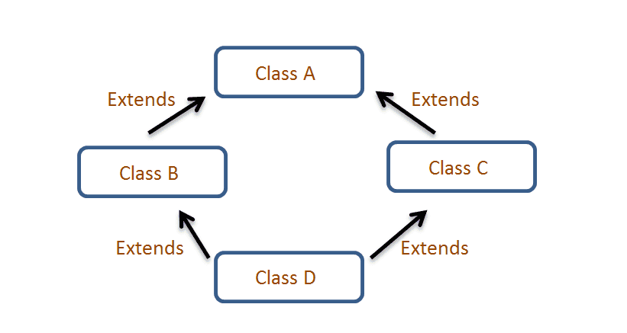
class A
{
public void disp()
{
System.out.println("A disp() called");
}
}
class B extends A
{
@Override
public void disp()
{
System.out.println("B disp() called");
}
}
class C extends A
{
@Override
public void disp()
{
System.out.println("C disp() called");
}
}
public class D extends B,C //Not Supported by Java
{
public static void main(String args[])
{
D d = new D();
d.disp(); // Ambiguity which disp() to call
}
}
- Class B and Class C inherits Class A and the disp() method of Class A is overridden by both B and C
- Class D inherits both Class B and C (Not Supported by Java), If suppose we need to call the disp() method through the instance of Class D, then the Java compiler will not know which method to call whether disp() method of Class Bor Class C. It results in ambiguity
- In order to overcome the above
As in Java we can implement more than one java interface we achieve the same effect using interfaces.

Flow Diagram
Conceptually Multiple Inheritance has to be like the below diagram, ClassA andClassB both inherited by ClassC. Since it is not supported we will changing the ClassA to InterfaceA and ClassB to InterfaceB.
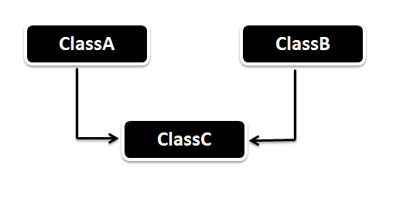

Example of Multiple Inheritance
Here we have two interfaces Car and Bus.
- Car interface has a attribute speed and a method defined distanceTravelled()
- Bus interface has a attribute distance and method speed()
The Vehicle class implements both interface Car and Bus and provides implementation.
package com.javainterviewpoint.inheritance;

interface Car
{
int speed=60;
public void distanceTravelled();
}
interface Bus
{
int distance=100;
public void speed();
}
public class Vehicle implements Car,Bus
{
int distanceTravelled;
int averageSpeed;
public void distanceTravelled()
{
distanceTravelled=speed*distance;
System.out.println("Total Distance Travelled is : "+distanceTravelled);
}
public void speed()
{
int averageSpeed=distanceTravelled/speed;
System.out.println("Average Speed maintained is : "+averageSpeed);
}
public static void main(String args[])
{
Vehicle v1=new Vehicle();
v1.distanceTravelled();
v1.speed();
}
}
Output :
Total Distance Travelled is : 6000
Average Speed maintained is : 100
In the above code we doesn’t have ambiguity even when we use classes instead of interfaces, then there comes the question why Java is not supporting ?. The problem arises when both the classes has the same method in it ? and the compiler will not know which method to call whereas the methods of the interfaces are by default abstract and implementations are not provided by the interface and hence we can avoid the ambiguity.
package com.javainterviewpoint.inheritance;

interface InterfaceA
{
public void disp();
}
interface InterfaceB
{
public void disp();
}
public class Client implements InterfaceA,InterfaceB
{
@Override
public void disp()
{
System.out.println("disp() method implementation");
}
public static void main(String args[])
{
Client c = new Client();
c.disp();
}
}
Output :
disp() method implementation
As we can see in the above code the Client class has implemented both the interfaces InterfaceA and InterfaceB. In this case we didn’t have ambiguity even though both the interfaces are having same method.

https://beginnersbook.com/2013/05/java-multiple-inheritance/

Does Java support Multiple inheritance?
BY CHAITANYA SINGH | FILED UNDER: OOPS CONCEPT
When one class extends more than one classes then this is called multiple inheritance. For example: Class C extends class A and B then this type of inheritance is known as multiple inheritance. Java doesn’t allow multiple inheritance. In this article, we will discuss why java doesn’t allow multiple inheritance and how we can use interfaces instead of classes to achieve the same purpose.
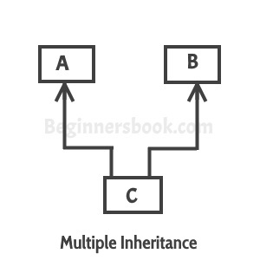

Why Java doesn’t support multiple inheritance?
C++ , Common lisp and few other languages supports multiple inheritance while java doesn’t support it. Java doesn’t allow multiple inheritance to avoid the ambiguity caused by it. One of the example of such problem is the diamond problem that occurs in multiple inheritance.
To understand the basics of inheritance, refer this main guide: Inheritance in Java
What is diamond problem?
We will discuss this problem with the help of the diagram below: which shows multiple inheritance as Class D extends both classes B & C. Now lets assume we have a method in class A and class B & C overrides that method in their own way. Wait!! here the problem comes – Because D is extending both B & C so if D wants to use the same method which method would be called (the overridden method of B or the overridden method of C). Ambiguity. That’s the main reason why Java doesn’t support multiple inheritance.
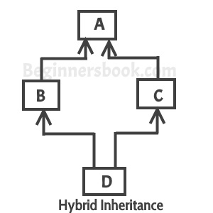

Can we implement more than one interfaces in a class
Yes, we can implement more than one interfaces in our program because that doesn’t cause any ambiguity(see the explanation below).
interface X
{
public void myMethod();
}
interface Y
{
public void myMethod();
}
class JavaExample implements X, Y
{
public void myMethod()
{
System.out.println("Implementing more than one interfaces");
}
public static void main(String args[]){
JavaExample obj = new JavaExample();
obj.myMethod();
}
}
Output:
Implementing more than one interfaces
As you can see that the class implemented two interfaces. A class can implement any number of interfaces. In this case there is no ambiguity even though both the interfaces are having same method. Why? Because methods in an interface are always abstract by default, which doesn’t let them give their implementation (or method definition ) in interface itself.
❮ PreviousNext ❯

https://www.journaldev.com/1775/multiple-inheritance-in-java

Multiple Inheritance in Java
PANKAJ 20 COMMENTS
Today we will look into Multiple Inheritance in Java. Sometime back I wrote few posts about inheritance, interface and composition in java. In this post, we will look into java multiple inheritance and then compare composition and inheritance.
Table of Contents [hide]
- 1 Multiple Inheritance in Java
  - 1.1 Diamond Problem in Java
- 2 Multiple Inheritance in Java Interfaces
  - 2.1 Composition for the rescue
  - 2.2 Composition vs Inheritance

Multiple Inheritance in Java

Multiple inheritance in java is the capability of creating a single class with multiple superclasses. Unlike some other popular object oriented programming languages like C++, java doesn’t provide support for multiple inheritance in classes.
Java doesn’t support multiple inheritance in classes because it can lead to diamond problem and rather than providing some complex way to solve it, there are better ways through which we can achieve the same result as multiple inheritance.

Diamond Problem in Java
To understand diamond problem easily, let’s assume that multiple inheritance was supported in java. In that case, we could have a class hierarchy like below image.
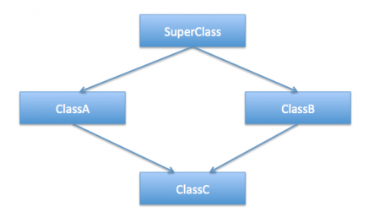
Let’s say SuperClass is an abstract class declaring some method and ClassA, ClassB are concrete classes.
SuperClass.java

package com.journaldev.inheritance;

public abstract class SuperClass {

public abstract void doSomething();
}
ClassA.java

package com.journaldev.inheritance;

public class ClassA extends SuperClass{

@Override
public void doSomething(){
System.out.println("doSomething implementation of A");
}

//ClassA own method
public void methodA(){

}
}
ClassB.java

package com.journaldev.inheritance;

public class ClassB extends SuperClass{

@Override
public void doSomething(){
System.out.println("doSomething implementation of B");
}

//ClassB specific method
public void methodB(){

}
}
Now let’s say ClassC implementation is something like below and it’s extending both ClassA and ClassB.
ClassC.java

package com.journaldev.inheritance;

public class ClassC extends ClassA, ClassB{

public void test(){
//calling super class method
doSomething();
}

}
Notice that test() method is making a call to superclass doSomething() method. This leads to the ambiguity as compiler doesn’t know which superclass method to execute. Because of the diamond shaped class diagram, it’s referred as Diamond Problem in java. Diamond problem in java is the main reason java doesn’t support multiple inheritance in classes.
Notice that the above problem with multiple class inheritance can also come with only three classes where all of them has at least one common method.

Multiple Inheritance in Java Interfaces
You might have noticed that I am always saying that multiple inheritance is not supported in classes but it’s supported in interfaces. A single interface can extend multiple interfaces, below is a simple example.
InterfaceA.java

package com.journaldev.inheritance;

public interface InterfaceA {

public void doSomething();
}
InterfaceB.java

package com.journaldev.inheritance;

public interface InterfaceB {

public void doSomething();
}
Notice that both the interfaces are declaring same method, now we can have an interface extending both these interfaces like below.
InterfaceC.java

package com.journaldev.inheritance;

public interface InterfaceC extends InterfaceA, InterfaceB {

//same method is declared in InterfaceA and InterfaceB both
public void doSomething();

}
This is perfectly fine because the interfaces are only declaring the methods and the actual implementation will be done by concrete classes implementing the interfaces. So there is no possibility of any kind of ambiguity in multiple inheritance in java interfaces.
Thats why a java class can implement multiple inheritance, something like below example.
InterfacesImpl.java

package com.journaldev.inheritance;

public class InterfacesImpl implements InterfaceA, InterfaceB, InterfaceC {

@Override
public void doSomething() {
System.out.println("doSomething implementation of concrete class");
}

public static void main(String[] args) {
InterfaceA objA = new InterfacesImpl();
InterfaceB objB = new InterfacesImpl();
InterfaceC objC = new InterfacesImpl();

//all the method calls below are going to same concrete implementation
objA.doSomething();
objB.doSomething();
objC.doSomething();
}

}
Did you noticed that every time I am overriding any superclass method or implementing any interface method, I am using @Override annotation. Override annotation is one of the three built-in java annotationsand we should always use override annotation when overriding any method.

Composition for the rescue
So what to do if we want to utilize ClassA function methodA() and ClassB function methodB() in ClassC. The solution lies in using composition. Here is a refactored version of ClassC that is using composition to utilize both classes methods and also using doSomething() method from one of the objects.
ClassC.java

package com.journaldev.inheritance;

public class ClassC{

ClassA objA = new ClassA();
ClassB objB = new ClassB();

public void test(){
objA.doSomething();
}

public void methodA(){
objA.methodA();
}

public void methodB(){
objB.methodB();
}
}

Composition vs Inheritance
One of the best practices of java programming is to “favor composition over inheritance”. We will look into some of the aspects favoring this approach.
- Suppose we have a superclass and subclass as follows:
ClassC.java

package com.journaldev.inheritance;

public class ClassC{

public void methodC(){
}
}
ClassD.java

package com.journaldev.inheritance;

public class ClassD extends ClassC{

public int test(){
return 0;
}
}
The above code compiles and works fine but what if ClassC implementation is changed like below:
ClassC.java

package com.journaldev.inheritance;

public class ClassC{

public void methodC(){
}

public void test(){
}
}
Notice that test() method already exists in the subclass but the return type is different. Now the ClassD won’t compile and if you are using any IDE, it will suggest you to change the return type in either superclass or subclass.
Now imagine the situation where we have multiple level of class inheritance and superclass is not controlled by us. We will have no choice but to change our subclass method signature or it’s name to remove the compilation error. Also we will have to make change in all the places where our subclass method was getting invoked, so inheritance makes our code fragile.
The above problem will never occur with composition and that makes it more favorable over inheritance.
- Another problem with inheritance is that we are exposing all the superclass methods to the client and if our superclass is not properly designed and there are security holes, then even though we take complete care in implementing our class, we get affected by the poor implementation of superclass.
Composition helps us in providing controlled access to the superclass methods whereas inheritance doesn’t provide any control of the superclass methods, this is also one of the major advantage of composition over inheritance.
- Another benefit with composition is that it provides flexibility in invocation of methods. Our above implementation of ClassC is not optimal and provides compile time binding with the method that will be invoked, with minimal change we can make the method invocation flexible and make it dynamic.
ClassC.java

package com.journaldev.inheritance;

public class ClassC{

SuperClass obj = null;

public ClassC(SuperClass o){
this.obj = o;
}
public void test(){
obj.doSomething();
}

public static void main(String args[]){
ClassC obj1 = new ClassC(new ClassA());
ClassC obj2 = new ClassC(new ClassB());

obj1.test();
obj2.test();
}
}
Output of above program is:

doSomething implementation of A
doSomething implementation of B
This flexibility in method invocation is not available in inheritance and boosts the best practice to favor composition over inheritance.
- Unit testing is easy in composition because we know what all methods we are using from superclass and we can mock it up for testing whereas in inheritance we depend heavily on superclass and don’t know what all methods of superclass will be used, so we need to test all the methods of superclass, that is an extra work and we need to do it unnecessarily because of inheritance.
That’s all for multiple inheritance in java and a brief look on composition.
TWITTERFACEBOOKLINKEDINEMAIL

PREVIOUS
Exception Handling in Java

NEXT
Java Reflection Example Tutorial



About Pankaj
If you have come this far, it means that you liked what you are reading. Why not reach little more and connect with me directly on Google Plus, Facebook or Twitter. I would love to hear your thoughts and opinions on my articles directly.
Recently I started creating video tutorials too, so do check out my videos on Youtube.

