https://www.logicbig.com/tutorials/core-java-tutorial/java-util-stream/stream-cheat-sheet.html

Java 8 Stream operations cheat sheet  [Updated: Apr 30, 2017, Created: Aug 15, 2016] | Previous PageNext Page
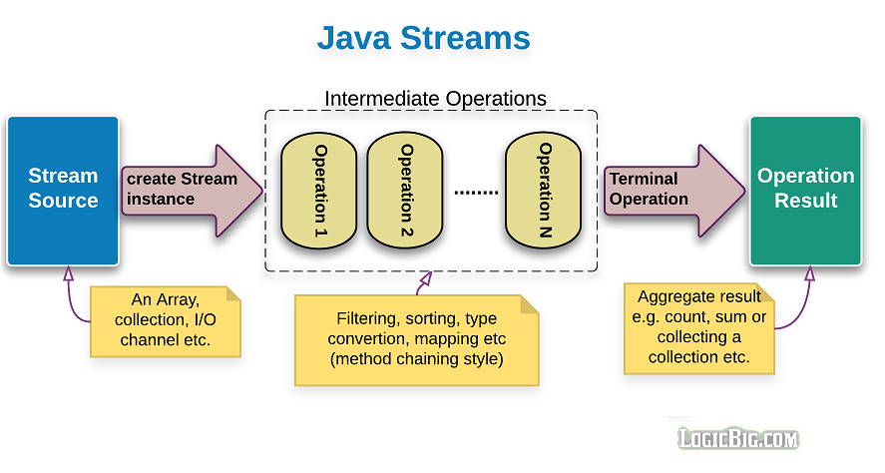

Stream operations

Obtaining a Stream ⇨  ⇩ | Intermediate Operation ⇨  ⇩ | Terminal Operations  ⇩
Collection  stream()  parallelStream()  Stream  IntStream  LongStream  DoubleStream  static generate()Unordered  static of(..)  static empty()  static iterate(..)  static concat(..)  static builder()  IntStream  LongStream  static range(..)  static rangeClosed(..)  Arrays  static stream(..)  BufferedReader  lines(..)  Files  static lines(..)  static list(..)  static walk(..)  static find(..)  JarFile  stream()  ZipFile  stream()  Pattern  splitAsStream(..)  SplittableRandom  ints(..)Unordered  longs(..)Unordered  doubles(..)Unordered  Random  ints(..)  longs(..)  doubles(..)  ThreadLocalRandom  ints()  longs(..)  doubles(..)  BitSet  stream()  CharSequence (String)  IntStream chars()  IntStream codePoints()  StreamSupport (low level)  static doubleStream(..)  static intStream(..)  static longStream(..)  static stream(..) | BaseStream  sequential()  parallel()  unordered()  onClose(..)  Stream  filter(..)  map(..)  mapToInt(..)  mapToLong(..)  mapToDouble(..)  flatMap(..)  flatMapToInt(..)  flatMapToLong(..)  flatMapToDouble(..)  distinct()stateful  sorted(..)stateful  peek(..)  limit(..)stateful,  short-circuiting  skip(..)stateful  IntStream, LongStream and DoubleStream have similar methods as Stream does but with different args.  Here are some extra methods:  IntStream  mapToObj(..)  asLongStream()  asDoubleStream()  boxed()  LongStream  mapToObj(..)  asDoubleStream()  boxed()  DoubleStream  mapToObj(..)  boxed()

