JavaMadeSoEasy.com (JMSE): HashMap in java

HashMap in java
You are here : Home / Core Java Tutorials / Collection framework Tutorial in java

In this Collection framework tutorial we will learn what is java.util.HashMap in Collection framework in java.

Contents of page :
- 1) java.util.HashMap in java
- 2) What is hierarchy of HashMap in java?
- 3) Understanding (k1==null ? k2==null : k1.equals(k2)) >
- 4) Creating java.util.HashMap
- 5) put element in java.util.HashMap
- 6) get elements from java.util.HashMap
- 7) containsKey method in HashMap
- 8) containsValue method in HashMap
- 9) Remove element from HashMap
- 10) Size of HashMap
- 11) Iterate over HashMap
  - 11.1) Iterate over keys -
  - 11.2) Iterate over values -
  - 11.3) Iterate over Entry-
- 12) Some other important methods
- 13) synchronizing HashMap
- 14) Complexity of methods in HashMap
- 15) Features of HashMap
- 16) When to use HashMap
- 17) What is Load Factor?

1) java.util.HashMap in java
java.util.HashMap is implementation of the java.util.Map interface.
java.util.HashMap enables us to store data in key-value pair form. Insertion order of key-value pairs is not maintained.
In an HashMap, two keys k1 and k2 are equal if and only if (k1==null ? k2==null : k1.equals(k2))

2) Understanding (k1==null ? k2==null : k1.equals(k2)) >
If k1 is null, check k2==null, if k2 is also null then k1 and k2 are equal else they are not equal.
If k1 is not null, check k1.equals(k2), if equals return true than k1 and k2 are equal else they are not equal.

Must read : 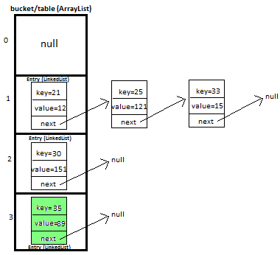HashMap Custom implementation in java
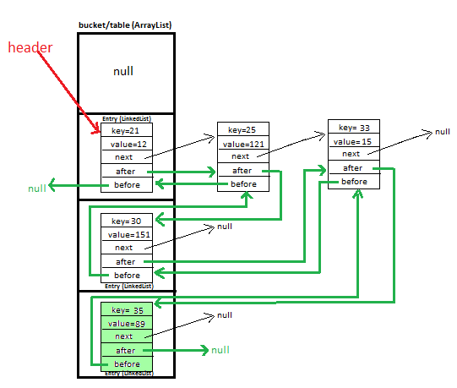LinkedHashMap Custom implementation in java

3) What is hierarchy of HashMap in java?
-java.lang.Object
-java.util.AbstractMap
-java.util.concurrent.HashMap

For more detailed hierarchy information read : Map hierarchy in java

4) Creating java.util.HashMap (using constructor)
Constructs a new HashMap, Its initial capacity is 16. And load factor is 0.75 (We’ll discuss it later in post)
Map<Integer,String> hashMap=new HashMap<Integer,String>();
Defining HashMap<Integer,String> means key can of Integer type and value can be String type only, using any other type will cause compilation error in java.

5) put element in java.util.HashMap
put(K key, V value)
Method allows you put specified key-value pair in HashMap. If the map already contains a mapping for the key, the old value is replaced in java.
hashMap.put(11, "javaMadeSoEasy");

6) get elements from java.util.HashMap
get(Object key)
Method returns value corresponding to key.
Method returns null if map does not contain key.

hashMap.get(2);
Method returns element on 2nd index in java.

7) containsKey method in HashMap
containsKey(Object key)
Method returns true if map contains a mapping for the specified key in java.
hashMap.containsKey(2);

8) containsValue method in HashMap
containsValue(Object value)
Method returns true if map maps one or more keys to the specified value in java.
hashMap.containsKey(2);

9) Remove element from HashMap
remove(Object key)
Method removes specified key-value pair from HashMap and returns value corresponding to specified key.
hashMap.remove(11);

10) Size of HashMap in java
size()
Method returns size of HashMap in java.

System.out.println(hashMap.size());
will print size of hashMap.

11) Iterate over java.util.HashMap >
Before iterating we will put 3 key-value pairs in hashMap.
hashMap.put(11, "javaMadeSoEasy");
hashMap.put(21, "bmw");
hashMap.put(31, "ferrari");

11.1) Iterate over keys -
hashMap.keySet().iterator() method returns iterator to iterate over keys in HashMap.

Iterator<Integer> keyIterator=hashMap.keySet().iterator();
while(keyIterator.hasNext()){
System.out.println(keyIterator.next());
}

/*OUTPUT
21
11
31
*/

Iteration using enhanced for loop in java.
hashMap.keySet() returns set of keys.
Set<Integer> keySet=hashMap.keySet();
for(Integer key :keySet){
System.out.println(key);
}

iterator returned is fail fast in java. Means any structural modification made to HashMap like adding or removing elements during Iteration will throw java.util.ConcurrentModificationException.
Few more important points about iterator >
- Removing element by using iterator may throw IllegalStateException
- If we add some key which is already present in set than no exception is thrown because size of map remains same (it is not structural modification ).

Iterator<String> iterator=hashMap.iterator();
while(iterator.hasNext()){
System.out.println(iterator.next());
hashMap.put(4, "d");
}
key-value has been added (map didn’t contained this key previously) during iteration which cause ConcurrentModificationException to be thrown.

11.2) Iterate over values in java -
hashMap.values().iterator() method returns iterator to iterate over keys in HashMap in java.

Iterator<String> valueIterator=hashMap.values().iterator();
while(valueIterator.hasNext()){
System.out.println(valueIterator.next());
}

/*OUTPUT
javaMadeSoEasy
audi
ferrari
*/

Iteration using enhanced for loop in java.
hashMap.values() returns collection of values.
Collection<String> collection=hashMap.values();
for(String value :collection){
System.out.println(value);
}

iterator returned is fail fast. Means any structural modification made to HashMap like adding or removing elements during Iteration will throw java.util.ConcurrentModificationException.
Few more important points about iterator >
- Removing element by using iterator may throw IllegalStateException
- If we add some key which is already present in set than no exception is thrown because size of map remains same (it is not structural modification ).

Iterator<String> iterator=hashMap.iterator();
while(iterator.hasNext()){
System.out.println(iterator.next());
hashMap.put(4, "d");
}
key-value has been added (map didn’t contained this key previously) during iteration which cause ConcurrentModificationException to be thrown.

11.3) Iterate over Entry in java-
hashMap.entrySet().iterator() method returns iterator to iterate over keys in HashMap.

Iterator<Entry<Integer, String>> entryIterator=hashMap.entrySet().iterator();
while(entryIterator.hasNext()){
System.out.println(entryIterator.next());
}

/*OUTPUT
21=javaMadeSoEasy
11=audi
31=ferrari
*/

Iteration using enhanced for loop in java.
hashMap.entrySet() returns collection of values.
Set<Entry<Integer, String>> entrySet=hashMap.entrySet();
for(Entry<Integer, String> entry:entrySet){
System.out.println(entry);
}

iterator returned is fail fast in java. Means any structural modification made to HashMap like adding or removing elements during Iteration will throw java.util.ConcurrentModificationException.
Few more important points about iterator >
- Removing element by using iterator may throw IllegalStateException
- If we add some key which is already present in set than no exception is thrown because size of map remains same (it is not structural modification ).

12) Some other important methods of java.util.HashMap in java

isEmpty() method returns true if this map contains any key-value pair.

clear() method removes all key-value pair from map.

13) synchronizing java.util.HashMap in java
We can synchronize hashMap by using Collections’s class synchronizedList method.
Map synchronizedMap = Collections.synchronizedMap(hashMap);
Now, no 2 threads can access same instance of map concurrently.

14) Complexity of methods in HashMap in java
Operation/ method | Worst case | Best case
put(K key, V value) | O(n) | O(1)
get(Object key) | O(n) | O(1)

15) Features of java.util.HashMap
- HashMap enables us to store data in key-value pair form in java.

- HashMap is implementation of the java.util.map interface in java.

- Duplicate key- HashMap does not allows to store duplicate keys. If the map already contains a mapping for the key, the old value is replaced in java.

- Null elements - One null key can be added in HashMap. And null values are also allowed in HashMap in java.
- Insertion order - HashMap does not maintains insertion order in java.
Example in java-
Let’s say we add 3 elements in hashMap
hashMap.put(1,"ind");
hashMap.put(2,"aus");
hashMap.put(3,"sa");

On displaying insertion order will not be maintained i.e.
3,sa
2,aus
1,ind

- synchronized - HashMap is not synchronized (because 2 threads on same HashMap object can access it at same time) in java.

- Performance - HashMap is not synchronized, hence its operations are faster as compared to some other synchronized implementation of map interface in java.

16) When to use java.util.HashMap in java

- HashMap can be used when we want to store data in key-value pair form in java.

- HashMap can be used when we want to store only one null key in java.

- HashMap can be used when value corresponding to key might be null in java.

- HashMap can be used when we don’t care about insertion order in java.

- HashMap can be used when we are not working in multithreading environment in java.

17) What is Load Factor in java?
Default load factor is 0.75
That means when set will be 75% filled, it’s capacity will be doubled.

Example in java >
Initially when number of elements is 0, default capacity =16, Load Factor =0.75, HashMap is 0% full.

number of elements | capacity of HashMap | Load factor | HashMap filled in %age
0 | 16 | 0.75 | 0%
4 | 16 | 0.75 | 25%
8 | 16 | 0.75 | 50%
11 | 16 | 0.75 | 68.7%
When next element will be added (i.e. 12th element), hashMap will be 75% filled and capacity will be doubled i.e. from 16 to 32.
12 | 32 | 0.75 | 37.5%

So in this Collection framework tutorial we learned what is java.util.HashMap in Collection framework in java.

Having any doubt? or you you liked the tutorial! Please comment in below section.
Please express your love by liking JavaMadeSoEasy.com (JMSE) on facebook, following on google+ or Twitter.

JavaMadeSoEasy.com (JMSE): HashMap Custom implementation in java - How HashMap works internally with diagrams and full program

HashMap Custom implementation in java - How HashMap works internally with diagrams and full program
You are here : Home / Core Java Tutorials / Data structures / Collection framework
Contents of page :
- 1) Custom HashMap in java >
- 2) Entry<K,V>
- 3) Putting 5 key-value pairs in custom/own HashMap (step-by-step) in java>
- 4) Methods used in custom HashMap in java >
- 5) What will happen if map already contains mapping for key?
- 6) Full Program/SourceCode for implementing custom HashMap in java >
- 7) Complexity calculation of put and get methods in HashMap in java >
  - 7.1) put method - worst Case complexity >
  - 7.2) put method - best Case complexity >
  - 7.3) get method - worst Case complexity >
  - 7.4) get method - best Case complexity >
- 8) Summary of complexity of methods in HashMap in java >

1) Custom HashMap in java >

In this tutorial we will learn how to create and implement own/custom HashMap in java with full working source code.

This is very important and trending topic in java. In this post i will be explaining HashMap custom implementation in lots of detail with diagrams which will help you in visualizing the HashMap implementation. This is must prepare topic for interview and from knowledge point of view as well.

I will be explaining how we will put and get key-value pair in HashMap by overriding-
>equals method - helps in checking equality of entry objects.
>hashCode method - helps in finding bucket’s index on which data will be stored.

We will maintain bucket (ArrayList) which will store Entry (LinkedList).

2) Entry<K,V>
We store key-value pair by using Entry<K,V>
Entry contains
- K key,
- V value and
- Entry<K,V> next (i.e. next entry on that location of bucket).
static class Entry<K, V> {
K key;
V value;
Entry<K,V> next;

public Entry(K key, V value, Entry<K,V> next){
this.key = key;
this.value = value;
this.next = next;
}
}

3) Putting 5 key-value pairs in own/custom HashMap (step-by-step) in java>
I will explain you the whole concept of HashMap by putting 5 key-value pairs in HashMap.

Initially, we have bucket of capacity=4. (all indexes of bucket i.e. 0,1,2,3 are pointing to null)
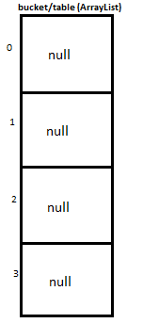

Let’s put first key-value pair in HashMap-
Key=21, value=12
newEntry Object will be formed like this >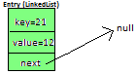

We will calculate hash by using our hash(K key) method - in this case it returns
key/capacity= 21%4= 1.
So, 1 will be the index of bucket on which newEntry object will be stored.
We will go to 1st index as it is pointing to null we will put our newEntry object there.

At completion of this step, our HashMap will look like this-

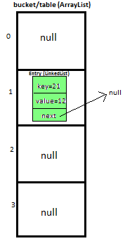

Let’s put second key-value pair in HashMap-
Key=25, value=121
newEntry Object will be formed like this >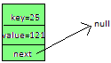

We will calculate hash by using our hash(K key) method - in this case it returns
key/capacity= 25%4= 1.
So, 1 will be the index of bucket on which newEntry object will be stored.
We will go to 1st index, it contains entry with key=21, we will compare two keys(i.e. compare 21 with 25 by using equals method), as two keys are different we check whether entry with key=21’s next is null or not, if next is null we will put our newEntry object on next.

At completion of this step our HashMap will look like this-
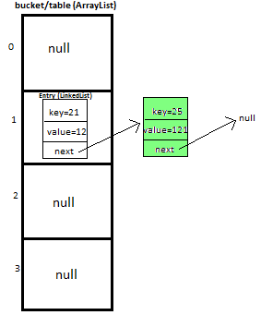

Let’s put third key-value pair in HashMap-
Key=30, value=151
newEntry Object will be formed like this >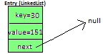

We will calculate hash by using our hash(K key) method - in this case it returns
key/capacity= 30%4= 2.
So, 2 will be the index of bucket on which newEntry object will be stored.
We will go to 2nd index as it is pointing to null we will put our newEntry object there.

At completion of this step, our HashMap will look like this-
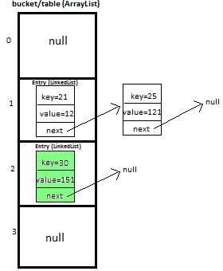

Let’s put fourth key-value pair in HashMap-
Key=33, value=15
Entry Object will be formed like this >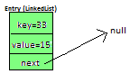

We will calculate hash by using our hash(K key) method - in this case it returns
key/capacity= 33%4= 1,
So, 1 will be the index of bucket on which newEntry object will be stored.

We will go to 1st index -
>it contains entry with key=21, we will compare two keys (i.e. compare 21 with 33 by using equals method, as two keys are different, proceed to next of entry with key=21 (proceed only if next is not null).
>now, next contains entry with key=25, we will compare two keys (i.e. compare 25 with 33 by using equals method, as two keys are different, now next of entry with key=25 is pointing to null so we won’t proceed further, we will put our newEntry object on next.

At completion of this step our HashMap will look like this-

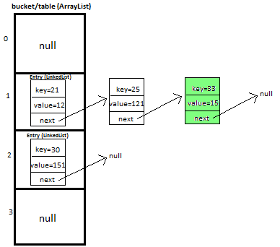

Let’s put fifth key-value pair in HashMap-
Key=35, value=89

Repeat above mentioned steps.

At completion of this step our HashMap will look like this-


Must read: LinkedHashMap Custom implementation
LinkedHashMap Custom implementation - put, get, remove Employee object.

4) Methods used in custom HashMap in java >
public void put(K newKey, V data) | -Method allows you put key-value pair in HashMap  -If the map already contains a mapping for the key, the old value is replaced.  -provide complete functionality how to override equals method.  -provide complete functionality how to override hashCode method.
public V get(K key) | Method returns value corresponding to key.
public boolean remove(K deleteKey) | Method removes key-value pair from HashMapCustom.
public void display() | -Method displays all key-value pairs present in HashMapCustom.,  -insertion order is not guaranteed, for maintaining insertion order refer LinkedHashMapCustom.
private int hash(K key) | -Method implements hashing functionality, which helps in finding the appropriate bucket location to store our data.  -This is very important method, as performance of HashMapCustom is very much dependent on this method's implementation.

REFER: HashMap Custom implementation - put, get, remove Employee object.

5) What will happen if map already contains mapping for key?
If the map already contains a mapping for the key, the old value is replaced.

6) Full Program/SourceCode for implementing custom HashMap in java >
package com.ankit;
/**
* @author AnkitMittal, JavaMadeSoEasy.com
* Copyright (c), AnkitMittal . All Contents are copyrighted and must not be
* reproduced in any form.
* This class provides custom implementation of HashMap(without using java api's)-
* which allows us to store data in key-value pair form.
* insertion order of key-value pairs is not maintained.
* @param <K>
* @param <V>
*/
class HashMapCustom<K, V> {

private Entry<K,V>[] table; //Array of Entry.
private int capacity= 4; //Initial capacity of HashMap

static class Entry<K, V> {
K key;
V value;
Entry<K,V> next;

public Entry(K key, V value, Entry<K,V> next){
this.key = key;
this.value = value;
this.next = next;
}
}

@SuppressWarnings("unchecked")
public HashMapCustom(){
table = new Entry[capacity];
}

/**
* Method allows you put key-value pair in HashMapCustom.
* If the map already contains a mapping for the key, the old value is replaced.
* Note: method does not allows you to put null key though it allows null values.
* Implementation allows you to put custom objects as a key as well.
* Key Features: implementation provides you with following features:-
* >provide complete functionality how to override equals method.
* >provide complete functionality how to override hashCode method.
* @param newKey
* @param data
*/
public void put(K newKey, V data){
if(newKey==null)
return; //does not allow to store null.

//calculate hash of key.
int hash=hash(newKey);
//create new entry.
Entry<K,V> newEntry = new Entry<K,V>(newKey, data, null);

//if table location does not contain any entry, store entry there.
if(table[hash] == null){
table[hash] = newEntry;
}else{
Entry<K,V> previous = null;
Entry<K,V> current = table[hash];

while(current != null){ //we have reached last entry of bucket.
if(current.key.equals(newKey)){
if(previous==null){ //node has to be insert on first of bucket.
newEntry.next=current.next;
table[hash]=newEntry;
return;
}
else{
newEntry.next=current.next;
previous.next=newEntry;
return;
}
}
previous=current;
current = current.next;
}
previous.next = newEntry;
}
}
/**
* Method returns value corresponding to key.
* @param key
*/
public V get(K key){
int hash = hash(key);
if(table[hash] == null){
return null;
}else{
Entry<K,V> temp = table[hash];
while(temp!= null){
if(temp.key.equals(key))
return temp.value;
temp = temp.next; //return value corresponding to key.
}
return null; //returns null if key is not found.
}
}
/**
* Method removes key-value pair from HashMapCustom.
* @param key
*/
public boolean remove(K deleteKey){

int hash=hash(deleteKey);

if(table[hash] == null){
return false;
}else{
Entry<K,V> previous = null;
Entry<K,V> current = table[hash];

while(current != null){ //we have reached last entry node of bucket.
if(current.key.equals(deleteKey)){
if(previous==null){ //delete first entry node.
table[hash]=table[hash].next;
return true;
}
else{
previous.next=current.next;
return true;
}
}
previous=current;
current = current.next;
}
return false;
}

}

/**
* Method displays all key-value pairs present in HashMapCustom.,
* insertion order is not guaranteed, for maintaining insertion order
* refer LinkedHashMapCustom.
* @param key
*/
public void display(){

for(int i=0;i<capacity;i++){
if(table[i]!=null){
Entry<K, V> entry=table[i];
while(entry!=null){
System.out.print("{"+entry.key+"="+entry.value+"}" +" ");
entry=entry.next;
}
}
}

}
/**
* Method implements hashing functionality, which helps in finding the appropriate
* bucket location to store our data.
* This is very important method, as performance of HashMapCustom is very much
* dependent on this method's implementation.
* @param key
*/
private int hash(K key){
return Math.abs(key.hashCode()) % capacity;
}
}
/**
* Main class- to test HashMap functionality.
*/
public class HashMapCustomApp {

public static void main(String[] args) {
HashMapCustom<Integer, Integer> hashMapCustom = new HashMapCustom<Integer, Integer>();
hashMapCustom.put(21, 12);
hashMapCustom.put(25, 121);
hashMapCustom.put(30, 151);
hashMapCustom.put(33, 15);
hashMapCustom.put(35, 89);
System.out.println("value corresponding to key 21="
+ hashMapCustom.get(21));
System.out.println("value corresponding to key 51="
+ hashMapCustom.get(51));
System.out.print("Displaying : ");
hashMapCustom.display();
System.out.println("\n\nvalue corresponding to key 21 removed: "
+ hashMapCustom.remove(21));
System.out.println("value corresponding to key 51 removed: "
+ hashMapCustom.remove(51));
System.out.print("Displaying : ");
hashMapCustom.display();
}
}
/*Output
value corresponding to key 21=12
value corresponding to key 51=null
Displaying : {21=12} {25=121} {33=15} {30=151} {35=89}
value corresponding to key 21 removed: true
value corresponding to key 51 removed: false
Displaying : {25=121} {33=15} {30=151} {35=89}
*/

7) Complexity calculation of put and get methods in HashMap in java >

7.1) put method - worst Case complexity >

O(n).

But how complexity is O(n)?
Initially, let's say map is like this -

And we have to insert newEntry Object with Key=25, value=121 

We will calculate hash by using our hash(K key) method - in this case it returns
key/capacity= 25%4= 1.
So, 1 will be the index of bucket on which newEntry object will be stored.
We will go to 1st index, it contains entry with key=21, we will compare two keys(i.e. compare 21 with 25 by using equals method), as two keys are different we check whether entry with key=21’s next is null or not, if next is null we will put our newEntry object on next.

At completion of this step our HashMap will look like this-


Now let’s do complexity calculation -
Earlier there was 1 element in HashMap and for putting newEntry Object we iterated on it. Hence complexity was O(n).
Note: We may calculate complexity by adding more elements in HashMap as well, but to keep explanation simple i kept less elements in HashMap.

7.2) put method - best Case complexity >

O(1).

But how complexity is O(n)?
Let's say map is like this -

And we have to insert newEntry Object with Key=30, value=151 

We will calculate hash by using our hash(K key) method - in this case it returns
key/capacity= 30%4= 2.
So, 2 will be the index of bucket on which newEntry object will be stored.
We will go to 2nd index as it is pointing to null we will put our newEntry object there.

At completion of this step our HashMap will look like this-


Now let’s do complexity calculation -
Earlier there 2 elements in HashMap but we were able to put newEntry Object in first go. Hence complexity was O(1).

7.3) get method - worst Case complexity >

O(n).

But how complexity is O(n)?
Initially, let's say map is like this -

And we have to get Entry Object with Key=25, value=121 

We will calculate hash by using our hash(K key) method - in this case it returns
key/capacity= 25%4= 1.
So, 1 will be the index of bucket on which Entry object is stored.
We will go to 1st index, it contains entry with key=21, we will compare two keys(i.e. compare 21 with 25 by using equals method), as two keys are different we check whether entry with key=21’s next is null or not, next is not null so we will repeat same process and ultimately will be able to get Entry object.

Now let’s do complexity calculation -
There were 2 elements in HashMap and for getting Entry Object we iterated on both of them. Hence complexity was O(n).
Note: We may calculate complexity by using HashMap of larger size, but to keep explanation simple i kept less elements in HashMap.

7.4) get method - best Case complexity >

O(1).

But how complexity is O(n)?
Initially, let's say map is like this -

And we have to get Entry Object with Key=30, value=151 
We will calculate hash by using our hash(K key) method - in this case it returns
key/capacity= 30%4= 2.
So, 2 will be the index of bucket on which Entry object is stored.
We will go to 2nd index and get Entry object.

Now let’s do complexity calculation -
There were 3 elements in HashMap but we were able to get Entry Object in first go.
Hence complexity was O(1).

8) Summary of complexity of methods in HashMap in java >
Operation/ method | Worst case | Best case
put(K key, V value) | O(n) | O(1)
get(Object key) | O(n) | O(1)

Summary of article >
In this tutorial we learned how to create and implement own/custom HashMap in java with full program, diagram and examples to insert and retrieve key-value pairs in it.

How HashMap works in Java?
How HashMap works in Java?
Hello guys, if you are looking for an answer of popular Java interview question, how HashMap works in Java? or How HashMap works internally in Java then you have come to the right place. In this article, I will not just answer those question but also many related questions like How get() and put() method works in Java? what role equals() and hashcode() play in HashMap, How HashMap resize itself, and why key object of HashMap should be Immutable in Java. Let's start with the basics first. HashMap in Java works on hashing principles. It is a data structure that allows us to store object and retrieve it in constant time O(1) provided we know the key. Also this is one of my most popular article with more than 6 million views and I have now updated it to include latest information like how HashMap now uses a balanced tree instead of linked list for storing collision objects and new diagrams on HashMap working which provide visual explanations.

In hashing, hash functions are used to link keys and values in HashMap. Objects are stored by the calling put(key, value) method of HashMap and retrieved by calling the get(key) method.

When we call the put method, the hashcode() method of the key object is called so that the hash function of the map can find a bucket location to store the value object, which is actually an index of the internal array, known as the table.

HashMap internally stores mapping in the form of Map.Entry object which contains both key and value object.
When you want to retrieve the object, you call the get() method and again pass the key object. This time again key objects generate the same hash code (it's mandatory for it to do so to retrieve the object and that's why HashMap keys should be immutable e.g. String) and we end up at the same bucket location.

If there is only one object then it is returned and that's your value object which you have stored earlier.
Things get a little tricky when collisions occur. It's easy to answer this question if you have read a good book or course on data structure and algorithms like these data structure courses and books. If you know how the hash table data structure works then this is a piece of cake.
Since the internal array of HashMap is of fixed size, and if you keep storing objects, at some point in time hash function will return the same bucket location for two different keys, this is called collision in HashMap. In this case, a linked list is formed at that bucket location and a new entry is stored as the next node.
If we try to retrieve an object from this linked list, we need an extra check to search for the correct value, this is done by the equals() method. Since each node contains an entry, HashMap keeps comparing the entry's key object with the passed key using equals() and when it returns true, Map returns the corresponding value.
Since searching inlined list is an O(n) operation, in the worst case hash collision reduces a map to a linked list. This issue is recently addressed in Java 8 by replacing the linked list with a balanced tree using hashcode to search in O(logN) time.

By the way, you can easily verify how HashMap works by looking at the code of HashMap.java in your Eclipse IDE if you know how to attach the source code of JDK in Eclipse.

How HashMap Internally Works in Java?
How HashMap works in Java or sometimes how does get method works in HashMap is a very common question on Java interviews nowadays.

Almost everybody who worked in Java knows about HashMap, where to use HashMap, and the difference between Hashtable and HashMap then why did this interview question become so special? Because of the depth, it offers.
It has become a very popular Java interview question in almost any senior or mid-senior level Java interview. Investment banks mostly prefer to ask this question and sometimes even ask you to implement your own HashMap based upon your coding aptitude.
The introduction of ConcurrentHashMap and other concurrent collections has also made these questions a starting point to delve into a more advanced feature. let's start the journey.

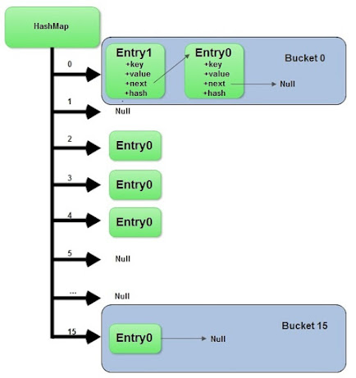

Interview questions start with a simple statement:
1. Have you used HashMap before or What is HashMap? Why do you use it?
Almost everybody answers this with yes and then the interviewee keeps talking about common facts about HashMap like HashMap accepts null while Hashtable doesn't, HashMap is not synchronized, HashMap is fast, and so on along with basics like its stores key and value pairs, etc.

This shows that the person has used HashMap and is quite familiar with the functionality it offers, but the interview takes a sharp turn from here and the next set of follow-up questions gets more detailed about the fundamentals involved with HashMap in Java. Interviewer strike back with questions like:

2. Do you Know how HashMap works in Java or How does get () method of HashMap works in Java
And then you get answers like, I don't bother its standard Java API, you better look code on Java source or Open JDK; I can find it out in Google at any time, etc.

But some interviewee definitely answers this and will say HashMap works on the principle of hashing, we have put(key, value) and get(key) method for storing and retrieving Objects from HashMap.

When we pass Key and Value object to put() method on Java HashMap, HashMap implementation calls hashCode method on Key object and applies returned hashcode into its own hashing function to find a bucket location for storing Entry object, the important point to mention is that HashMap in Java stores both key and value object as Map.Entry in a bucket is essential to understand the retrieving logic.

Here is also a nice flowchart diagram which shows how does get() method of HashMap or Hashtable works in Java and how does it retrieve value:

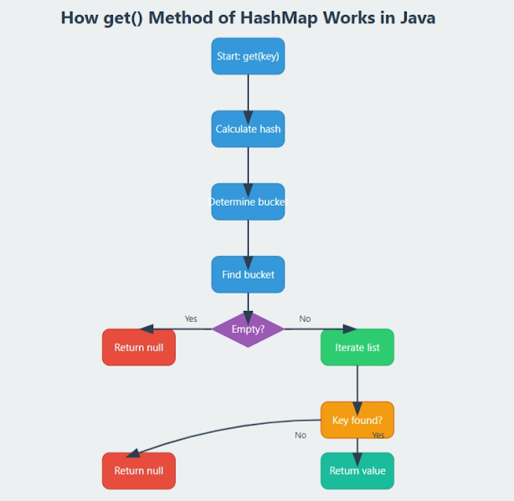
If candidate fails to recognize this and say it only stores Value in the bucket they will fail to explain the retrieving logic of any object stored in Java HashMap.

Though, this answer is very much acceptable and does make sense that the interviewee has a fair bit of knowledge on how hashing works and how HashMap works in Java.

But this is just the start of the story and confusion increases when you put the candidate on scenarios faced by Java developers on day by day basis. The next question could be about collision detection and collision resolution in Java HashMap like:

3. What will happen if two different objects have the same hashcode?
Now from here onwards real confusion starts, sometime candidate will say that since hashcode is equal, both objects are equal and HashMap will throw an exception or not store them again, etc, Then you might want to remind them about equals() and hashCode() contract that two unequal objects in Java can have the same hashcode.

Some will give up at this point and few will move ahead and say "Since hashcode is same, bucket location would be same and collision will occur in HashMap Since HashMap uses LinkedList to store object, this entry (object of Map.Entry comprise key and value ) will be stored in LinkedList.

Great !! this answer makes sense though there are many collision resolution methods available like linear probing and chaining, this is the simplest, and HashMap in Java does follow this. But the story does not end here and the interviewer asks further questions

Btw, here is a nice flowchart diagram which shows what will happen if two different objects hashcode() method will return same value while storing in HashMap

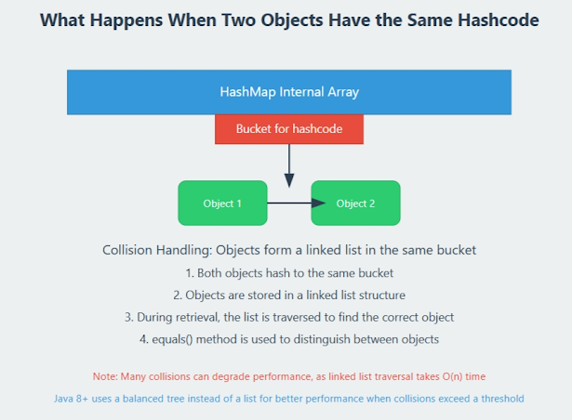

4. How will you retrieve the Value object if two Keys will have the same hashcode?
The interviewee will say we will call the get() method and then HashMap will use Key Object's hashcode to find out bucket location and retrieves the Value object but then you need to remind him that there are two Value objects which are stored in the same bucket, so they will say about traversal in LinkedList until we find the value object.

At that point you can ask how do you identify value object because you don't have value object to compare until they know that HashMap stores both Key and Value in LinkedList node or as Map.Entry they won't be able to resolve this issue and will try and fail.

But those bunch of people who remember this key information will say that after finding bucket location, we will call keys.equals() method to identify a correct node in LinkedList and return associated value object for that key in Java HashMap. Perfect this is the correct answer.

In many cases, interviewee fails at this stage because they get confused between hashCode() and equals() or keys and values object in Java HashMap which is pretty obvious because they are dealing with the hashcode() in all previous questions and equals() come in the picture only in case of retrieving value object from HashMap in Java.

Good and experienced Java developer will point out here that using an immutable, final object with proper equals() and hashcode() implementation would act as perfect Java HashMap keys and improve the performance of Java HashMap by reducing collision.

Immutability also allows caching their hashcode of different keys which makes the overall retrieval process very fast and suggests that String and various wrapper classes e.g. Integer very good keys in Java HashMap.

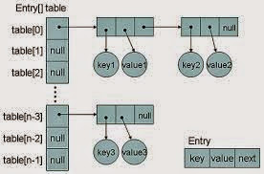

Now if you clear this entire Java HashMap interview, You will be surprised by this very interesting question "What happens On HashMap in Java if the size of the HashMap exceeds a given threshold defined by load factor ?".

Until you know how HashMap works exactly you won't be able to answer this question. If the size of the Map exceeds a given threshold defined by load-factor e.g. if the load factor is .75 it will act to re-size the map once it filled 75%.

Similar to other collection classes like ArrayList, Java HashMap re-size itself by creating a new bucket array of size twice the previous size of HashMap and then start putting every old element into that new bucket array. This process is called rehashing because it also applies the hash function to find a new bucket location.

If you manage to answer this question on HashMap in Java you will be greeted by "do you see any problem with resizing of HashMap in Java", you might not be able to pick the context, and then he will try to give you a hint about multiple threads accessing the Java HashMap and potentially looking for race condition on HashMap in Java.

So the answer is Yes there is a potential race condition that exists while resizing HashMap in Java, if two thread at the same time found that now HashMap needs resizing and they both try to resize.

On the process of resizing HashMap in Java, the element in the bucket which is stored in the linked list get reversed in order during their migration to the new bucket because Java HashMap doesn't append the new element at the tail instead it append new element at the head to avoid tail traversing.

If race condition happens then you will end up with an infinite loop. Though this point, you can potentially argue that what the hell makes you think to use HashMap in a multi-threaded environment to interviewer :)

Other Popular Hashtable and HashMap Questions
Here are few Java HashMap interview questions which is contributed by readers of the Javarevisited blog and I have included them on main article for everyone's benefit.
5. Why String, Integer, and other wrapper classes are considered good keys?
String, Integer, and other wrapper classes are natural candidates of the HashMap key, and String is the most frequently used key as well because String is immutable and final, and overrides equals and hashcode() method. Other wrapper class also shares similar property.

Immutability is required, in order to prevent changes on fields used to calculate hashCode() because if a key object returns different hashCode during insertion and retrieval then it won't be possible to get an object from HashMap.
Immutability is best as it offers other advantages as well like thread-safety, If you can keep your hashCode the same by only making certain fields final, then you go for that as well.

Since the equals() and hashCode() method is used during retrieval of value objects from HashMap, it's important that key objects correctly override these methods and follow contact.

If an unequal object returns different hashcode then the chances of collision will be less which subsequently improves the performance of HashMap.

6. Can we use any custom object as a key in HashMap?
This is an extension of previous questions. Of course, you can use any Object as a key in Java HashMap provided it follows equals and hashCode contract and its hashCode should not vary once the object is inserted into Map.

If the custom object is Immutable then this will be already taken care of because you can not change it once created.

7. Can we use ConcurrentHashMap in place of Hashtable?
This is another question which getting popular due to the increasing popularity of ConcurrentHashMap. Since we know Hashtable is synchronized ConcurrentHashMap provides better concurrency by only locking a portion of the map determined by concurrency level.

ConcurrentHashMap is certainly introduced as Hashtable and can be used in place of it, but Hashtable provides stronger thread-safety than ConcurrentHashMap. See my post difference between Hashtable and ConcurrentHashMap for more details.

Personally, I like this question because of its depth and the number of concepts it touches indirectly if you look at questions asked during the interview this HashMap question has verified
- The concept of hashing
- Collision resolution in HashMap
- Use of equals () and hashCode () and their importance in HashMap?
- The benefit of the immutable object?
- Race condition on HashMap in Java
- Resizing of Java HashMap

Just to summarize here are the answers which do make sense for the above questions

8. How does HashMap work in Java?
HashMap works on the principle of hashing, we have put() and get() method for storing and retrieving objects from HashMap.

When we pass both key and value to put() method to store on HashMap, it uses key object hashcode() method to calculate hashcode and them by applying hashing on that hashcode it identifies bucket location for storing value object.

While retrieving it uses the key object equals method to find out the correct key-value pair and return the value object associated with that key. HashMap uses a linked list in case of collision and objects will be stored in the next node of the linked list.

Also, HashMap stores both key and value tuples in every node of the linked list in the form of Map.Entry object.

9. What will happen if two different HashMap key objects have the same hashcode?
They will be stored in the same bucket but no next node of the linked list. And keys equals () method will be used to identify the correct key-value pair in HashMap.
10. How null key is handled in HashMap? Since equals() and hashCode() are used to store and retrieve values, how does it work in the case of the null key?
The null key is handled specially in HashMap, there are two separate methods for that putForNullKey(V value) and getForNullKey(). Later is an offloaded version of get() to look up null keys.

Null keys always map to index 0.
This null case is split out into separate methods for the sake of performance in the two most commonly used operations (get and put), but incorporated with conditionals in others. In short, the equals() and hashcode() methods are not used in the case of null keys in HashMap.
here is how nulls are retrieved from HashMap
private V getForNullKey() {
if (size == 0) {
return null;
}
for (Entry<K,V> e = table[0]; e != null; e = e.next) {
if (e.key == null)
return e.value;
}
return null;
}

In terms of usage, Java HashMap is very versatile and I have mostly used HashMap as a cache in an electronic trading application I have worked on.

Since the finance domain used Java heavily and due to performance reasons we need caching HashMap and ConcurrentHashMap comes as very handy there.
If you prefer to watch than read then I have also explained this concept of HashMap internal working on our YouTube channel where we have talked about the internal working of HashMap and How HashMap works in general.

