names of the tools used by platform team to monitor the java application in production
For a senior Java (13+ yrs) interview, when they ask:
“What tools are used by platform team to monitor Java applications in production?”
They expect you to answer in categories, not just random tool names.
Here’s a structured answer 👇

🔥 1️⃣ Infrastructure Monitoring Tools
These monitor CPU, memory, disk, network at server/container level:
- Prometheus
- Grafana
- Datadog
- New Relic
- Dynatrace
Used for:
- CPU %
- Memory usage
- Pod health (in Kubernetes)
- Alerts

🔥 2️⃣ JVM & Application-Level Monitoring
These monitor heap, GC, threads, classloading:
- JConsole
- VisualVM
- Java Flight Recorder
- Mission Control
Used for:
- Heap usage
- GC pause time
- Thread states
- Memory leaks

🔥 3️⃣ APM (Application Performance Monitoring) Tools
These are very common in enterprise production:
- AppDynamics
- Dynatrace
- New Relic
- Datadog
Used for:
- Transaction tracing
- Slow API detection
- DB call breakdown
- External API latency
- Error rate tracking

🔥 4️⃣ Logging & Log Monitoring
For centralized log monitoring:
- ELK Stack (Elasticsearch + Logstash + Kibana)
- Splunk
Used for:
- Error analysis
- Production debugging
- Pattern detection
- Audit logs

🔥 5️⃣ Container / Kubernetes Monitoring
If app runs in containers:
- Docker stats
- Kubernetes metrics
- Prometheus + Grafana dashboards
Used for:
- Pod restarts
- OOM kills
- Resource limits
- Autoscaling metrics

🔥 6️⃣ Database Monitoring
- DB native tools (Oracle AWR, MySQL slow query logs)
- APM DB tracing
Used for:
- Slow queries
- Connection pool exhaustion
- Deadlocks

🎯 Interview-Level Smart Answer (How You Should Say It)
You can say:
“In production, platform teams typically use Prometheus and Grafana for infrastructure and JVM metrics, APM tools like AppDynamics or Dynatrace for transaction tracing, ELK or Splunk for log monitoring, and container-level metrics from Kubernetes. For deep JVM troubleshooting, we use heap dumps, JFR, and thread dumps.”
That sounds senior and structured.

💡 Extra Senior Tip
Mention these metrics specifically to impress:
- Heap usage %
- GC pause time
- Thread count
- API latency (p95, p99)
- Error rate
- CPU saturation
- Connection pool usage

If you want, I can next explain:
- 📊 What production metrics every senior Java engineer must monitor
- 🔥 How to troubleshoot High CPU in production
- 💣 How to debug sudden OOM in Kubernetes
- 🧠 How to explain observability in microservices

Understanding Memory Leaks in Java | Baeldung
Understanding Memory Leaks in Java
Last updated: February 25, 2026

Written by:baeldung

Reviewed by:Kevin Gilmore
- Core Java
- Definition

- Garbage Collection

Explore Spring Boot 3 and Spring 6 in-depth through building a full REST API with the framework:
>> The New “REST With Spring Boot”
1. Introduction
One of the core benefits of Java is the automated memory management with the help of the built-in Garbage Collector (or GC for short). The GC implicitly takes care of allocating and freeing up memory, and thus is capable of handling the majority of memory leak issues.
While the GC effectively handles a good portion of memory, it doesn’t guarantee a foolproof solution to memory leaking. The GC is pretty smart, but not flawless. Memory leaks can still sneak up, even in the applications of a conscientious developer.
There might still be situations where the application generates a substantial number of superfluous objects, thus depleting crucial memory resources, and sometimes resulting in the whole application’s failure.
Memory leaks are a genuine problem in Java. In this tutorial, we’ll learn what the potential causes of memory leaks are, how to recognize them at runtime, and how to deal with them in our application.
2. What Is a Memory Leak
A Memory Leak is a situation where there are objects present in the heap that are no longer used, but the garbage collector is unable to remove them from memory, and therefore, they’re unnecessarily maintained.
A memory leak is bad because it blocks memory resources and degrades system performance over time. If not dealt with, the application will eventually exhaust its resources, finally terminating with a fatal java.lang.OutOfMemoryError.
There are two different types of objects that reside in Heap memory, referenced and unreferenced. Referenced objects are those that still have active references within the application, whereas unreferenced objects don’t have any active references.
The garbage collector removes unreferenced objects periodically, but it never collects the objects that are still being referenced. This is where memory leaks can occur:

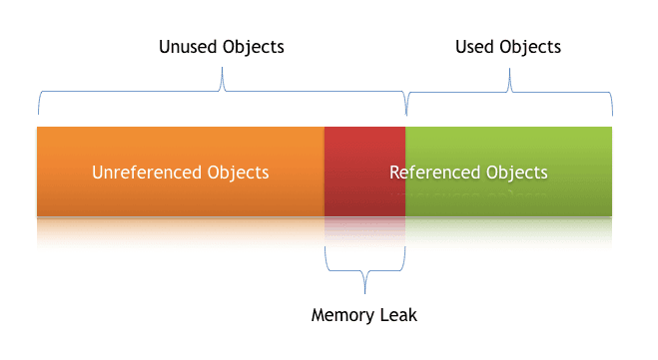
Symptoms of a Memory Leak
- Severe performance degradation when the application is continuously running for a long time
- OutOfMemoryError heap error in the application
- Spontaneous and strange application crashes
- The application is occasionally running out of connection objects.
Let’s have a closer look at some of these scenarios and how to deal with them.
3. Types of Memory Leaks in Java
In any application, memory leaks can occur for numerous reasons. In this section, we’ll discuss the most common ones.
3.1. Memory Leak Through static Fields
The first scenario that can cause a potential memory leak is heavy use of static variables.
In Java, static fields have a life that usually matches the entire lifetime of the running application (unless ClassLoader becomes eligible for garbage collection).
Let’s create a simple Java program that populates a static List:
public class StaticFieldsMemoryLeakUnitTest {
public static List<Double> list = new ArrayList<>();

public void populateList() {
for (int i = 0; i < 10000000; i++) {
list.add(Math.random());
}
Log.info("Debug Point 2");
}

public static void main(String[] args) {
Log.info("Debug Point 1");
new StaticFieldsDemo().populateList();
Log.info("Debug Point 3");
}
}Copy
If we analyze the Heap memory during this program execution, then we’ll see that between debug points 1 and 2, the heap memory increased as expected.
But when we leave the populateList() method at the debug point 3, the heap memory isn’t yet garbage collected, as we can see in this VisualVM response:

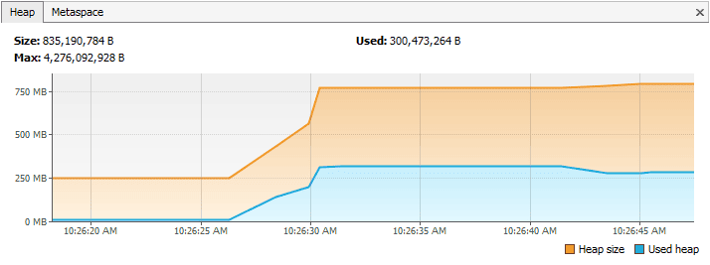
However, if we just drop the keyword static in line number 2 of the above program, then it’ll bring a drastic change to the memory usage, as shown in this Visual VM response:

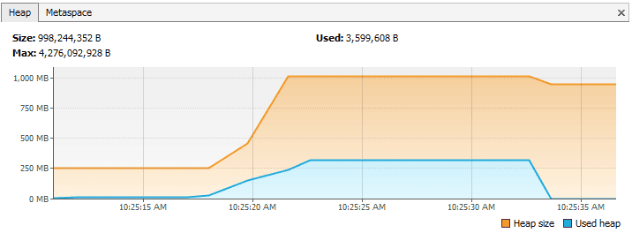
The first part until the debug point is almost the same as what we obtained in the case of static. But this time, after we leave the populateList() method, all the memory of the list is garbage collected because we don’t have any reference to it.
So we need to pay very close attention to our usage of static variables. If collections or large objects are declared as static, then they remain in the memory throughout the lifetime of the application, thus blocking vital memory that could otherwise be used elsewhere.
How to Prevent It?
- Minimize the use of static variables.
- When using singletons, rely upon an implementation that lazily loads the object, instead of eagerly loading.
3.2. Through Unclosed Resources
Whenever we make a new connection or open a stream, the JVM allocates memory for these resources. A few examples of this include database connections, input streams, and session objects.
Forgetting to close these resources can block the memory, thus keeping them out of the reach of the GC. This can even happen in case of an exception that prevents the program execution from reaching the statement that’s handling the code to close these resources.
In either case, the open connection left from the resources consumes memory, and if we don’t deal with them, they can deteriorate performance, and even result in an OutOfMemoryError.
How to Prevent It?
- Always use finally block to close resources.
- The code (even in the finally block) that closes the resources shouldn’t have any exceptions itself.
- When using Java 7+, we can make use of the try-with-resources block.
3.3. Improper equals() and hashCode() Implementations
When defining new classes, a very common oversight is not writing proper overridden methods for the equals() and hashCode() methods.
HashSet and HashMap use these methods in many operations, and if they’re not overridden correctly, they can become a source for potential memory leak problems.
Let’s take an example of a trivial Person class, and use it as a key in a HashMap:
public class Person {
public String name;

public Person(String name) {
this.name = name;
}
}Copy
Now we’ll insert duplicate Person objects into a Map that uses this key.
Remember that a Map can’t contain duplicate keys:
@Test
public void givenMap_whenEqualsAndHashCodeNotOverridden_thenMemoryLeak() {
Map<Person, Integer> map = new HashMap<>();
for(int i=0; i<100; i++) {
map.put(new Person("jon"), 1);
}
Assert.assertFalse(map.size() == 1);
}Copy
Here we’re using Person as a key. Since Map doesn’t allow duplicate keys, the numerous duplicate Person objects that we inserted as a key shouldn’t increase the memory.
But since we haven’t defined the proper equals() method, the duplicate objects pile up and increase the memory, which is why we see more than one object in the memory. The Heap Memory in VisualVM for this looks like:

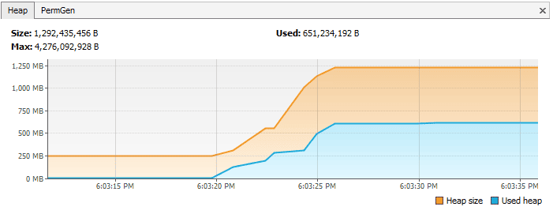
However, if we’d overridden the equals() and hashCode() methods properly, then only one Person object would exist in this Map.
Let’s take a look at the proper implementations of equals() and hashCode() for our Person class:
public class Person {
public String name;

public Person(String name) {
this.name = name;
}

@Override
public boolean equals(Object o) {
if (o == this) return true;
if (!(o instanceof Person)) {
return false;
}
Person person = (Person) o;
return person.name.equals(name);
}

@Override
public int hashCode() {
int result = 17;
result = 31 * result + name.hashCode();
return result;
}
}Copy
And in this case, the following assertions would be true:
@Test
public void givenMap_whenEqualsAndHashCodeNotOverridden_thenMemoryLeak() {
Map<Person, Integer> map = new HashMap<>();
for(int i=0; i<2; i++) {
map.put(new Person("jon"), 1);
}
Assert.assertTrue(map.size() == 1);
}Copy
After properly overriding equals() and hashCode(), the Heap Memory for the same program looks like:

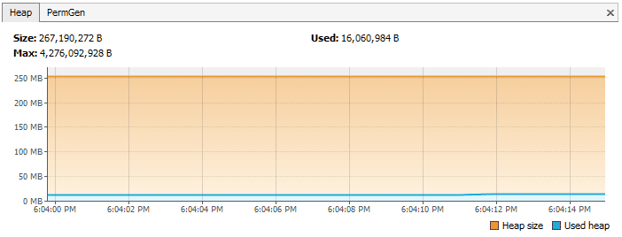
Another option is using an ORM tool like Hibernate, which uses the equals() and hashCode() methods to analyze the objects and saves them in the cache.
The chance of memory leaks is quite high if these methods aren’t overridden because Hibernate wouldn’t be able to compare objects and would fill its cache with duplicate objects.
How to Prevent It?
- As a rule of thumb, when defining new entities, always override the equals() and hashCode() methods.
- It’s not enough to just override, these methods must be overridden in an optimal way as well.
For more information, visit our tutorials Generate equals() and hashCode() with Eclipse and Guide to hashCode() in Java.
3.4. Inner Classes That Reference Outer Classes
Every non-static inner class, including anonymous classes, automatically maintains a hidden reference to the instance of the class that created it. This reference is generated by the compiler and allows the inner class to access fields and methods of the enclosing class.
On its own, this behavior does not create a memory leak.
The Java garbage collector determines whether an object can be reclaimed based on reachability. If an object cannot be reached from any garbage collection (GC) root, it becomes eligible for collection, even if it participates in a circular reference. As a result, if both an outer object and its inner object are no longer reachable, they will be removed during garbage collection.
A problem appears only when an inner class instance is kept alive by something with a longer lifetime. Because the inner instance implicitly refers back to its enclosing object, retaining the inner object also prevents the outer object from being collected.
Let’s consider the following example:
public class Outer {
private byte[] largeData = new byte[10_000_000];

class Worker extends Thread {
@Override
public void run() {
while (true) {
// long-running task
}
}
}

public void start() {
new Worker().start();
}
}Copy
In this scenario, the running thread acts as a GC root. As long as the thread is active, the Worker instance remains reachable. Since Worker is a non-static inner class, it implicitly holds a reference to the outer instance. Consequently, the Outer object, along with its large data array, cannot be reclaimed while the thread is running.
If the Worker class were declared as static, it would no longer carry a reference to the Outer instance. In that case, once the Outer object becomes otherwise unreachable, it could be garbage collected normally.
To prevent this issue, we should follow these practices:
- Make inner classes static when they do not require access to instance members of the enclosing class
- Avoid keeping inner class instances in static variables or other long-lived containers
- Be careful with threads, listeners, executors, and callback registrations
- Always clean up or unregister long-lived components when they are no longer needed.
The important takeaway is that non-static inner classes are not inherently dangerous. Memory retention occurs only when a long-lived reference to the inner object indirectly keeps the enclosing object alive.
3.5. Through finalize() Methods
Use of finalizers is yet another source of potential memory leak issues. Whenever a class’ finalize() method is overridden, then objects of that class aren’t instantly garbage collected. Instead, the GC queues them for finalization, which occurs at a later point in time.
Additionally, if the code written in the finalize() method isn’t optimal, and if the finalizer queue can’t keep up with the Java garbage collector, then sooner or later our application is destined to meet an OutOfMemoryError.
To demonstrate this, let’s imagine that we have a class for which we’ve overridden the finalize() method, and that the method takes a little bit of time to execute. When a large number of objects of this class get garbage collected, it looks like this in VisualVM:

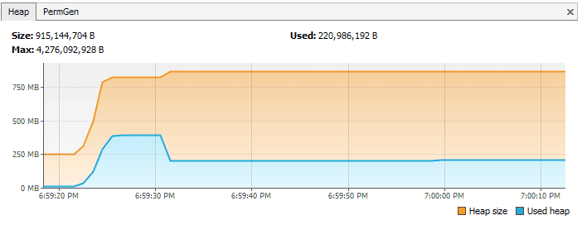
However, if we just remove the overridden finalize() method, then the same program gives the following response:
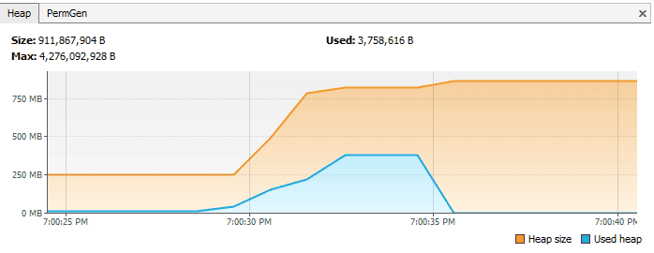
How to Prevent It?
- We should always avoid finalizers.
For more detail about finalize(), we can refer to section 3 (Avoiding Finalizers) in our Guide to the finalize Method in Java.
3.6. Interned Strings
The Java String pool went through a major change in Java 7 when it was transferred from PermGen to HeapSpace. However, for applications operating on version 6 and below, we need to be more attentive when working with large Strings.
If we read a massive String object, and call intern() on that object, it goes to the string pool, which is located in PermGen (permanent memory), and will stay there as long as our application runs. This blocks the memory and creates a major memory leak in our application.
The PermGen for this case in JVM 1.6 looks like this in VisualVM:

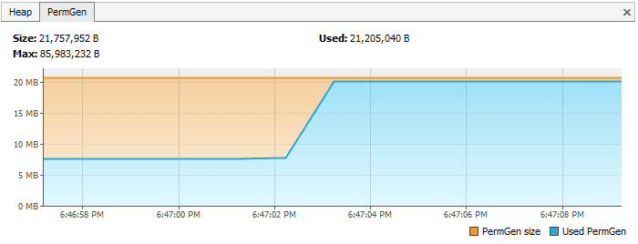
In contrast, if we just read a string from a file in a method, and don’t intern it, then the PermGen looks like:
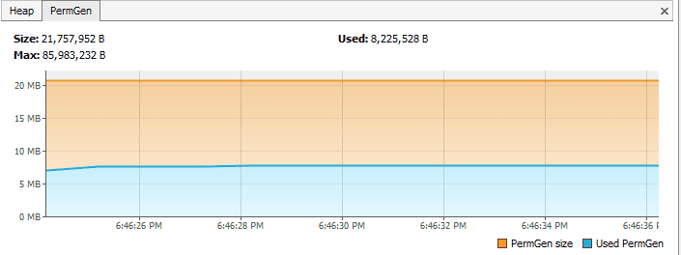

How to Prevent It?
- The simplest way to resolve this issue is by upgrading to the latest Java version, as String pool moved to HeapSpace starting with Java version 7.
- If we’re working on large Strings, we can increase the size of the PermGen space to avoid any potential OutOfMemoryErrors:
-XX:MaxPermSize=512mCopy
3.7. Using ThreadLocals
ThreadLocal (discussed in detail in the Introduction to ThreadLocal in Java tutorial) is a construct that gives us the ability to isolate state to a particular thread, and thus allows us to achieve thread safety.
When using this construct, each thread will hold an implicit reference to its copy of a ThreadLocal variable and will maintain its own copy, instead of sharing the resource across multiple threads, as long as the thread is alive.
Despite its advantages, the use of ThreadLocal variables is controversial, as they’re infamous for introducing memory leaks if not used properly. Joshua Bloch once commented on thread local usage that:
“Sloppy use of thread pools in combination with sloppy use of thread locals can cause unintended object retention, as has been noted in many places. But placing the blame on thread locals is unwarranted.”
Memory Leaks with ThreadLocals
ThreadLocals are supposed to be garbage collected once the holding thread is no longer alive. But the problem arises when we use ThreadLocals along with modern application servers.
Modern application servers use a pool of threads to process requests, instead of creating new ones (for example, the Executor in the case of Apache Tomcat). Moreover, they also use a separate classloader.
Since Thread Pools in application servers work on the concept of thread reuse, they’re never garbage collected; instead, they’re reused to serve another request.
If any class creates a ThreadLocal variable, but doesn’t explicitly remove it, then a copy of that object will remain with the worker Thread even after the web application is stopped, thus preventing the object from being garbage collected.
How to Prevent It?
- It’s good practice to clean-up ThreadLocals when we’re no longer using them. ThreadLocals provide the remove() method, which removes the current thread’s value for this variable.
- Don’t use ThreadLocal.set(null) to clear the value. It doesn’t actually clear the value, but will instead look up the Map associated with the current thread and set the key-value pair as the current thread and null, respectively.
- It’s best to consider ThreadLocal a resource that we need to close in a finally block, even in the case of an exception::

try {
threadLocal.set(System.nanoTime());
//... further processing
}
finally {
threadLocal.remove();
}Copy
4. Other Strategies for Dealing With Memory Leaks
Although there’s no one-size-fits-all solution when dealing with memory leaks, there are some ways by which we can minimize these leaks.
4.1. Enable Profiling
Java profilers are tools that monitor and diagnose the memory leaks through the application. They analyze what’s going on internally in our application, like how we allocate memory.
Using profilers, we can compare different approaches and find areas where we can optimally use our resources.
Throughout section 3 of this tutorial, we used Java VisualVM. Please check out our Guide to Java Profilers to learn about different types of profilers, like Mission Control, JProfiler, YourKit, Java VisualVM, and the Netbeans Profiler.
4.2. Verbose Garbage Collection
By enabling verbose garbage collection, we can track the detailed trace of the GC. To enable this, we need to add the following to our JVM configuration:
-verbose:gcCopy
By adding this parameter, we can see the details of what’s happening inside the GC:
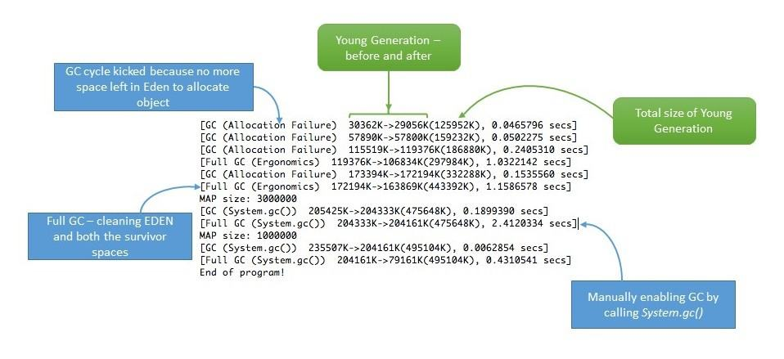

4.3. Use Reference Objects to Avoid Memory Leaks
We can also resort to reference objects in Java that come built-in with the java.lang.ref package to deal with memory leaks. Using the java.lang.ref package, instead of directly referencing objects, we use special references to objects that allow them to be easily garbage collected.
Reference queues make us aware of the actions the Garbage Collector performs. For more information, we can read the Soft References in Java tutorial, specifically section 4.
4.4. Eclipse Memory Leak Warnings
For projects on JDK 1.5 and above, Eclipse shows warnings and errors whenever it encounters obvious cases of memory leaks. So when developing in Eclipse, we can regularly visit the “Problems” tab and be more vigilant about memory leak warnings (if any):
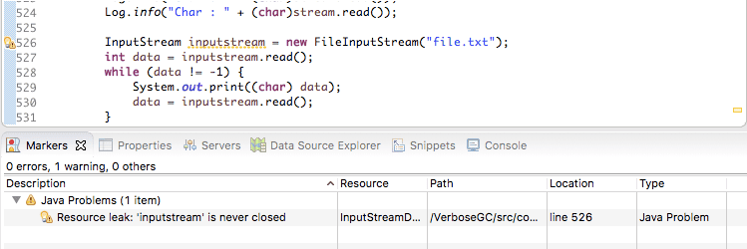

4.5. Benchmarking
We can measure and analyze the Java code’s performance by executing benchmarks. This way, we can compare the performance of alternative approaches to do the same task. This can help us choose the best approach, and may help us conserve memory.
For more information about benchmarking, please head over to our Microbenchmarking with Java tutorial.
4.6. Code Reviews
Finally, we always have the classic, old-school way of doing a simple code walk-through.
In some cases, even this trivial looking method can help in eliminating some common memory leak problems.
5. Conclusion
In layman’s terms, we can think of a memory leak as a disease that degrades our application’s performance by blocking vital memory resources. And like all other diseases, if not cured, it can result in fatal application crashes over time.
Memory leaks are tricky to solve, and finding them requires intricate mastery and command over the Java language. While dealing with memory leaks, there’s no one-size-fits-all solution, as leaks can occur through a wide range of diverse events.
However, if we resort to best practices and regularly perform rigorous code walk-throughs and profiling, we can minimize the risk of memory leaks in our application.

Java Memory Leaks: Detection & Fix | Medium
Java Memory Leaks: Detection and Prevention



Alexander Obregon
Follow
8 min read
·
Nov 12, 2023
856
6


Image Source
Introduction
Memory leaks in Java, despite the language’s robust automatic garbage collection, remain a challenging issue for developers. These leaks occur when objects are no longer needed by the application but are still referenced from other objects, thus preventing the garbage collector from reclaiming their memory. Over time, this can lead to a significant decrease in application performance and even cause it to crash due to an OutOfMemoryError. This post aims to delve into the nuances of Java memory leaks, exploring methods for their detection and strategies for prevention.
Understanding Memory Leaks in Java
Memory leaks in Java, a language renowned for its automatic garbage collection, can still perplex developers. Unlike languages where memory management is explicitly handled by the programmer, Java automates this with its garbage collector. However, this automation doesn’t exempt Java applications from the risk of memory leaks. These occur when objects that are no longer needed by the application continue to be held in memory because they are referenced elsewhere, preventing the garbage collector from reclaiming their space.
Causes of Memory Leaks
Understanding the causes of memory leaks in Java is the first step towards prevention. Here are some common reasons:
- Static References: Static fields in Java are associated with the class and not individual instances. This means they can remain in memory for the duration of the application’s life if not managed carefully. For example, a static collection that keeps adding elements without timely removal can lead to a significant memory leak.
- Listeners and Callbacks: In Java, especially in GUI applications or those that use the observer pattern, listeners and callbacks are common. If these listeners are not unregistered when no longer needed, they can prevent objects from being garbage collected, leading to memory leaks.
- Cached Objects: Caching is a widely used technique to improve application performance. However, objects that are cached and not properly evicted when they are no longer needed can consume significant memory, resulting in a leak.
- Improper use of Collections: Collections like HashMap or ArrayList are fundamental to Java programming. However, improperly managed collections can cause memory leaks. For instance, adding objects to a collection and failing to remove them when they are no longer needed can keep these objects in memory indefinitely.
- Unclosed Resources: Resources like database connections, network connections, or file streams, if not closed properly, can lead to memory leaks. Each open resource holds onto memory, and if not released, this memory remains occupied.
- Inner Classes: Non-static inner classes hold an implicit reference to their outer class. If instances of these inner classes are passed around and kept alive in the application, they can inadvertently keep their outer class instances in memory too.
Identifying Memory Leaks
Detecting memory leaks in Java can be challenging, especially in large and complex applications. Here are some signs and symptoms:
- Decreased Application Performance: As the available memory space decreases, the garbage collector works harder to free up memory, often leading to performance degradation.
- Increasing Memory Consumption Over Time: If your application’s memory usage steadily increases without a corresponding increase in the application’s workload, it could indicate a memory leak.
- Frequent Garbage Collection Activities: Tools like JConsole or VisualVM can show frequent garbage collection activities, which is a red flag for potential memory leaks.
- OutOfMemoryError Exceptions: These exceptions are a definite sign that the application is running out of memory, possibly due to a memory leak.
Analyzing and Diagnosing Memory Leaks
To effectively identify memory leaks, developers can use heap dump analysis. A heap dump is a snapshot of all the objects in memory at a particular moment. Tools like Eclipse Memory Analyzer (MAT) or VisualVM can analyze heap dumps and help pinpoint the objects consuming the most memory and the references preventing them from being garbage collected.
Another approach is to use profiling tools like JProfiler or YourKit Java Profiler. These tools allow developers to monitor memory allocation and garbage collection in real-time, providing insights into which objects are being created and how memory is being used.
Understanding and identifying memory leaks in Java require a deep understanding of how Java manages memory, awareness of common pitfalls, and the effective use of diagnostic tools. By recognizing the causes and symptoms of memory leaks and employing appropriate tools for analysis, developers can significantly enhance the performance and reliability of Java applications.
Tools for Detecting Memory Leaks in Java
Detecting memory leaks in Java is a critical task for ensuring application performance and stability. Fortunately, various tools are available to assist developers in identifying and diagnosing these leaks. These tools range from standard profiling and monitoring tools included in the JDK to advanced third-party applications offering more detailed analysis and user-friendly interfaces.
VisualVM
VisualVM is an all-in-one Java troubleshooting tool that integrates several JDK command-line tools and lightweight performance and memory profiling capabilities. It’s included in the Oracle JDK download.
Key Features:
- Monitor application memory consumption in real-time.
- Analyze heap dumps to identify memory leaks.
- Track down memory leaks with its built-in heap walker.
Usage Example:
VisualVM can be used to monitor the memory usage of a running Java application. If there’s a consistent increase in the heap size combined with full garbage collections not reclaiming much memory, it could indicate a memory leak.
Eclipse Memory Analyzer (MAT)
Eclipse MAT is a specialized tool designed for analyzing heap dumps. It is particularly effective in identifying memory leaks and reducing memory consumption.
Key Features:
- Analyze large heap dumps.
- Automatically identify memory leak suspects.
- Provide detailed reports on memory consumption by objects.
Usage Example:
After obtaining a heap dump from a running application (which can be triggered in the JVM on OutOfMemoryError), MAT can be used to analyze this dump. It provides a histogram of objects in memory, allowing developers to see which classes and objects are consuming the most memory.
JProfiler
JProfiler is a comprehensive profiling tool for Java with capabilities for both memory and performance profiling. It’s a commercial tool but is widely regarded for its user-friendly interface and detailed analysis.
Key Features:
- Real-time memory and CPU profiling.
- Advanced heap analysis and visualization.
- Ability to track every object in the heap and analyze memory consumption.
Usage Example:
JProfiler can be attached to a running application to monitor its memory usage in real-time. It allows developers to see the allocation of objects and identify where in the code the memory-intensive tasks are occurring.
YourKit Java Profiler
YourKit is another powerful, commercial profiling tool known for its broad functionality in both CPU and memory profiling.

Key Features:
- Comprehensive memory and performance profiling.
- Both real-time and post-mortem analysis.
- Supports many different platforms and application servers.
Usage Example:
Similar to JProfiler, YourKit can be attached to a Java application, and developers can use it to monitor memory allocations, investigate garbage collection, and analyze heap contents.
Java Flight Recorder (JFR) and Java Mission Control (JMC)
Java Flight Recorder and Java Mission Control are tools that come with the Oracle JDK. JFR is used for collecting diagnostic and profiling data about a running Java application, while JMC is used for analyzing this data.
Key Features:
- Low overhead data collection.
- Detailed analysis of the collected data.
- Useful for both development and production environments.
Usage Example:
JFR can be used to record data from a running application, which can then be analyzed with JMC to understand memory allocation patterns, identify memory leaks, and optimize memory usage.
The choice of tool often depends on the specific requirements of the project and the preferences of the development team. While tools like VisualVM and Eclipse MAT are great for in-depth analysis of memory issues, profiling tools like JProfiler and YourKit provide a more comprehensive overview of both memory and performance aspects. Java Flight Recorder and Java Mission Control, on the other hand, offer advanced capabilities especially useful in production environments. Utilizing these tools effectively can significantly aid in detecting, analyzing, and resolving memory leaks in Java applications.
Strategies for Preventing Memory Leaks in Java
Preventing memory leaks in Java is crucial for ensuring the performance and scalability of applications. While detecting memory leaks is important, it’s equally, if not more, vital to adopt strategies that minimize their occurrence in the first place. Here are some effective strategies and best practices:
Understand Object Lifecycle and Scope
- Best Practice: Clearly understand when and how objects are created and destroyed. Ensure that objects are in scope only as long as they are needed.
- Example: Use local variables inside methods wherever possible, as they are bound to the method’s lifecycle and are eligible for garbage collection once the method execution completes.
Proper Use of Static Variables
- Best Practice: Use static fields cautiously as they remain in memory for the lifetime of the class. Avoid static collections that grow indefinitely.
- Example: If a static collection is necessary, consider implementing a cleanup strategy that periodically removes unnecessary entries.
Manage Listeners and Callbacks
- Best Practice: Always unregister listeners and callbacks when they are no longer needed, especially in GUI applications or when dealing with external resources.
- Example: In an Android app, unregister broadcast receivers in the onDestroy() method to prevent context leaks.
Implement Effective Caching Strategies
- Best Practice: Use caching wisely with an eviction policy in place. Limit the size of caches and use soft or weak references.
- Example: Utilize java.lang.ref.WeakReference for cache entries so that they can be garbage collected when memory is needed elsewhere.
Use Collections Wisely
- Best Practice: Be vigilant with collections. Remove objects from collections when they are no longer needed.
- Example: In a HashMap, always ensure to remove entries that are no longer in use, especially in cases of cache implementation or managing listeners.
Avoid Memory Leaks in Inner Classes
- Best Practice: Be cautious with inner classes. Non-static inner classes hold an implicit reference to their outer class instances.
- Example: Use static inner classes if an instance of the inner class can outlive its outer class instance.
Close Resources Properly
- Best Practice: Always close resources (files, streams, connections) after use.
- Example: Use try-with-resources statements for automatic resource management.
Monitor and Profile Regularly
- Best Practice: Regularly profile your application for memory usage, especially after adding new features or making significant changes.
- Example: Use tools like VisualVM or JProfiler to monitor heap usage and track down potential memory leaks.
Code Reviews and Pair Programming
- Best Practice: Regular code reviews and pair programming sessions can help identify potential memory leak issues early.
- Example: During code reviews, specifically look for misuse of static fields, improper handling of collections, and resource management.
Unit and Integration Testing
- Best Practice: Write unit and integration tests to check for memory leaks, particularly in critical parts of the application.
- Example: Use frameworks like JUnit along with profiling tools to automate testing for memory leaks.
Incorporating these strategies into your development process can significantly reduce the risk of memory leaks in Java applications. It’s about cultivating good coding practices, being aware of common pitfalls, and regularly monitoring and profiling the application. These proactive measures not only prevent memory leaks but also contribute to cleaner, more efficient, and maintainable code.
Conclusion
Understanding and preventing memory leaks in Java is crucial for developing efficient and reliable applications. By being aware of common causes, utilizing the right tools for detection, and adhering to best practices in coding and memory management, developers can significantly reduce the occurrence of these issues. Regular monitoring, profiling, and code reviews are also key in maintaining a leak-free application throughout its lifecycle.
- Oracle’s Java VisualVM
- Eclipse Memory Analyzer (MAT)
- JProfiler
- YourKit Java Profiler
- Java Flight Recorder and Java Mission Control

