FinPilot: Architecture and Design Report
Investment portfolio and goal monitoring for an internal wealth-service team. All data is synthetic.
Repository state | branch feat/admin-import-reports at f303d81 (API complete), plus this report
Status of parts | API, database, import pipeline, tests and API CI: implemented and described from the code. Web UI (Next.js), container images, the docker.yml workflow and the TLS profile were being built in parallel when this was written; they are described as the agreed design and marked (design)
Companion documents | `DECISIONS.md` (assumptions, omissions, ADRs), `docs/performance/query-plans.md` (EXPLAIN evidence), `docs/sql/reviewer-queries.sql` (SQL tasks), `docs/api/openapi.json` (OpenAPI 3.1)

1. Executive overview
Problem. A service user needs one consolidated, trustworthy view of a customer's accounts, positions, valuation, transactions, risk profile and goals; an operations administrator needs to load daily CSV files without creating duplicates or silently accepting bad rows. The supplied data is deliberately imperfect, so the system has to say what it rejected and why.
Scope delivered. Cookie-session login with VIEWER/ADMIN roles; customer search and profile with latest risk assessment; server-side portfolio valuation (account, asset-class and customer totals, positions, unrealised P&L, data-freshness dates); filtered, sorted, paginated transaction ledger; goal list/create/edit with validation and consistency flags; admin CSV import of transactions with staging, SQL-side validation, idempotent merge and a row-level error report; a firm-wide overview answering the reviewer SQL tasks; health endpoint, structured logs with request correlation, CI.
Out of scope by design. Order execution, payments, investment advice, real-time prices, notifications, multi-tenancy, Kubernetes, microservices (see DECISIONS.md).
Stack.
Layer | Choice | Why, in one line
Database | PostgreSQL 16 | Constraints, NUMERIC, GROUPING SETS, pg_trgm, COPY, advisory locks: the domain rules live where the data lives
API | Python 3.12, FastAPI, Pydantic v2, SQLAlchemy 2 async + asyncpg, Alembic | Typed contracts become the OpenAPI spec; async pool; COPY via asyncpg; migrations with autogenerate drift check
Auth | Argon2id (argon2-cffi), PyJWT HS256 in an HttpOnly cookie | No token reachable by page scripts; stateless verification plus a per-request user re-read
Web (design) | Next.js 15 App Router, TypeScript strict, Tailwind + shadcn/ui, TanStack Query, React Hook Form + Zod, Recharts | Same-origin proxy keeps the cookie model simple; server state is cached, not re-implemented
Delivery | Docker Compose (db, api, web), GitHub Actions | One-command local stack; CI gates on lint, types, migrations and tests against real PostgreSQL

Major design decisions (full ADRs in DECISIONS.md):
1. The database enforces the domain. Natural business keys as primary keys, VARCHAR + CHECK vocabularies, NUMERIC money, composite and conditional CHECKs (e.g. BUY/SELL must have quantity and price > 0; DIVIDEND/FEE must have both = 0). Application validation mirrors these for good error messages; the constraints are the last line of defence.
2. All money arithmetic in PostgreSQL `NUMERIC`. Valuation is a view; aggregation is SQL (GROUPING SETS, window functions). Python only shapes results and rounds half-up to 2 dp at serialisation.
3. Import = stage, validate in SQL, merge, in one transaction; partial acceptance. Good rows load, bad rows are quarantined in import_errors with line number, code, message and the raw row. Re-import is idempotent; a changed row with a known id is rejected, never overwritten.
4. Portfolio is valued from the holdings snapshot, not derived from the ledger, because the supplied ledger does not reconcile to the snapshot (section 4.6).
5. Same-origin deployment. The browser only talks to the web origin; Next.js rewrites /api/v1/* to the API, so the session cookie is first-party and CORS is not on the hot path.

2. System context

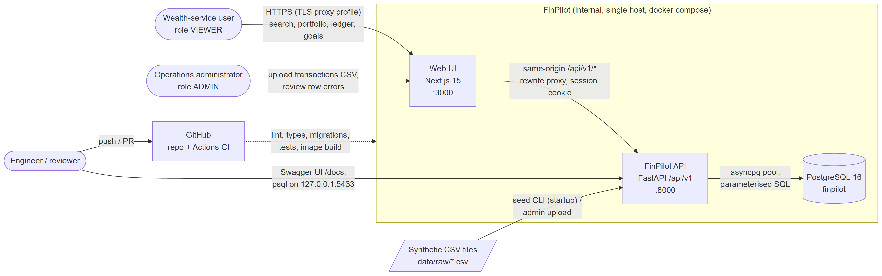
Figure: System context

Actor / system | Interaction
Wealth-service user (VIEWER) | Searches customers, reads portfolio/ledger/overview, creates and edits goals
Operations administrator (ADMIN) | Everything a VIEWER can do, plus transaction CSV upload and import history
Engineer / reviewer | Swagger UI at :8000/docs, psql on 127.0.0.1:5433, GitHub Actions results
Synthetic CSVs (data/raw/) | Loaded by the idempotent seed command at API start-up; transactions also via upload
External dependencies | None at runtime: no market-data feed, e-mail, identity provider or cloud service. Build-time: PyPI/npm registries, Docker Hub, GitHub

3. Component architecture
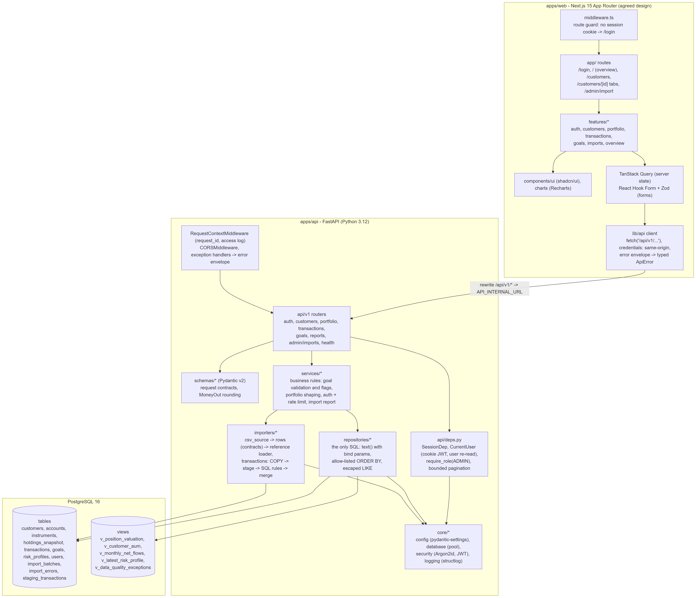
Figure: Component architecture

3.1 Backend layers (implemented)
Layer | Package | Responsibility | Must not
Transport | app/api/v1/*.py, app/api/deps.py | HTTP mapping, status codes, request/response models, auth dependencies (CurrentUser, AdminUser), bounded pagination params, path regexes | Contain SQL or business rules
Contracts | app/schemas/* | Pydantic models: extra="forbid" on writes, enums, decimal precision limits, MoneyOut serialisation | Touch the database
Services | app/services/* | Business rules: goal validation on the merged state and flags, portfolio shaping (every account listed, freshness), login flow + rate limit, import report assembly | Build SQL strings
Data access | app/repositories/* | The only place SQL lives. Parameterised text() or SQLAlchemy Core; allow-listed ORDER BY; one round trip per concern | Make HTTP decisions
Ingestion | app/importers/* | CSV parsing with physical line numbers, row contracts, reference loader, transaction stage/validate/merge, batch lifecycle | Depend on FastAPI
Core | app/core/* | Settings, pooled engine, error envelope, request-id middleware, structured logging, password hashing and JWT | Know about the domain

The dependency direction is strictly inward: routers -> services -> repositories -> core. The importers are reused unchanged by the HTTP endpoint and by the CLI (python -m app.cli seed), which is why the seed and an admin upload produce identical audit records.
Data-access boundary. Repositories return RowMappings or ORM rows; services convert them to Pydantic models. Aggregates are computed by views (v_position_valuation, v_customer_aum, v_monthly_net_flows) so the same definition backs the API, the overview report and the reviewer SQL. There are no per-row queries: the portfolio endpoint issues 5 queries regardless of position count, the customer list 1 (page + total via count(*) OVER ()).

3.2 Frontend modules *(design)*
Module | Content
middleware.ts | Route guard: no session cookie -> redirect to /login (authorisation is still enforced by the API)
app/ routes | /login, / overview, /customers, /customers/[id] with Overview / Portfolio / Transactions / Goals tabs, /admin/import
features/* | auth, customers, portfolio, transactions, goals, imports, overview: each owns its query hooks, components and Zod schemas
lib/api | Typed fetch wrapper calling same-origin /api/v1/*; maps the error envelope to a typed error (field errors -> form fields, 401 -> login)
State | TanStack Query for all server state (cache keys per customer/filter set; keepPreviousData for pagination); URL search params for ledger filters; no global client store
UI | shadcn/ui primitives, Recharts allocation chart with a table fallback, status badges for PENDING/REVERSED

4. Data model

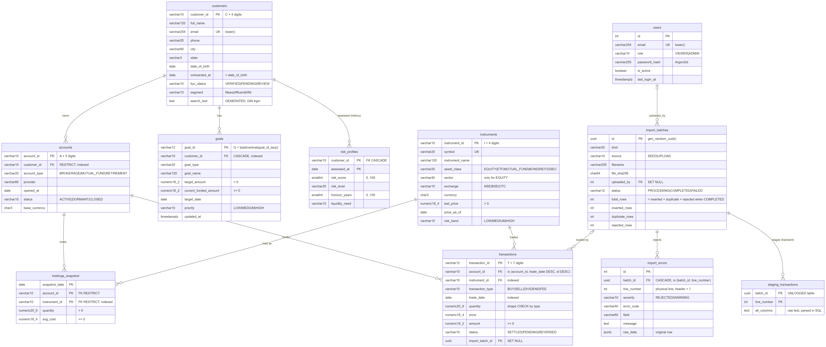
Figure: Entity-relationship diagram

4.1 Tables, keys and cardinalities
Table | Primary key | Relationships | Notes
customers | customer_id (C0001) | 1 -> 0..n accounts, goals, risk_profiles | email unique and lower-case; generated search_text
accounts | account_id | n -> 1 customer (RESTRICT) | status ACTIVE/DORMANT/CLOSED
instruments | instrument_id | 1 -> 0..n holdings, transactions | symbol unique; sector required iff EQUITY
holdings_snapshot | (snapshot_date, account_id, instrument_id) | n -> 1 account, instrument (RESTRICT) | composite key makes a duplicate position impossible
transactions | transaction_id | n -> 1 account, instrument (RESTRICT); n -> 0..1 import batch (SET NULL) | ledger; import_batch_id = lineage
goals | goal_id = `'G' |  | lpad(nextval('goal_id_seq'),5,'0')`
risk_profiles | (customer_id, assessed_at) | n -> 1 customer (CASCADE) | history kept; v_latest_risk_profile picks the latest
users | id (identity) | 1 -> 0..n import batches (SET NULL) | role VIEWER/ADMIN, Argon2id hash
import_batches | id (uuid) | 1 -> 0..n import_errors (CASCADE) | one row per file load, seed or upload
import_errors | id | n -> 1 batch | line_number (physical, header = 1), error_code, field, message, raw_data JSONB
staging_transactions | (batch_id, line_number) | transient | UNLOGGED, every column TEXT

ON DELETE is RESTRICT for financial facts (an account with history cannot vanish) and CASCADE only for customer-owned descriptive data (goals, risk profiles).

4.2 Constraints worth noting
- Types: money NUMERIC(18,2), prices NUMERIC(18,4), quantities NUMERIC(20,6); dates are DATE, audit times TIMESTAMPTZ.
- Vocabularies: VARCHAR + CHECK (x IN (...)) for every enumeration (kyc_status, segment, asset_class, exchange, transaction_type, status, priority, role, ...).
- Identifier formats: CHECK (customer_id ~ '^C[0-9]{4,}$') and equivalents.
- Cross-column: onboarded_at > date_of_birth; (asset_class = 'EQUITY') = (sector IS NOT NULL); transaction shape by type; amount >= 0; quantity > 0 in holdings; goal target_amount > 0, current_funded_amount >= 0.
- Audit integrity: import_batches CHECK (total_rows = inserted_rows + duplicate_rows + rejected_rows OR status <> 'COMPLETED'): a completed batch whose counters do not reconcile cannot be written.

4.3 Indexes and the query each one serves
Indexes are created for measured query patterns only (evidence in query-plans.md).
Index | Serves | Evidence (3M-row dataset)
ix_transactions_account_date (account_id, trade_date DESC, transaction_id DESC) | Ledger page for a customer's accounts in the default order; count(*) as index-only scan; single-account filter returns rows pre-ordered, no sort | page 362 -> 1.3 ms; count 280 -> 0.2 ms
ix_customers_search_trgm GIN (search_text gin_trgm_ops) | search_text LIKE '%term%' (id, name, e-mail, city) | 29 -> 0.21 ms
ix_accounts_customer_id | Every customer-scoped read (portfolio, ledger scope, profile counts) | portfolio 18 -> 0.39 ms
pk_holdings_snapshot | max(snapshot_date) (index-only, backward) and positions of an account on a date | used by every portfolio read
ix_transactions_trade_date | Date-bounded reporting (monthly flows) | 1,276 -> 414 ms with bound pushed down
ix_transactions_instrument_id, ix_holdings_snapshot_instrument_id | Ledger instrument filter, holder counts, FK checks when an instrument is deleted | -
ix_goals_customer_id, ix_import_batches_kind (kind, started_at DESC), ix_import_errors_batch_id_line_number | Goal list; import history; error pages ordered by line | -

4.4 Views (plain, not materialized)
View | Definition / purpose
v_position_valuation | holdings x accounts x instruments with cost_basis, market_value, unrealized_pnl in NUMERIC. Inlined by the planner, so customer predicates reach the indexes
v_customer_aum | Per-customer totals at max(snapshot_date)
v_latest_risk_profile | DISTINCT ON (customer_id) ... ORDER BY assessed_at DESC
v_monthly_net_flows | SETTLED BUY/SELL per month, FILTER aggregates, net = BUY - SELL
v_data_quality_exceptions | UNION ALL of import rejections and reconciliation rules (trade before account opened, position in inactive account, goal over-funded / overdue / name-type mismatch)

They are plain views because at this volume they are always fresh and cost milliseconds; the measured scale limits (customer list AUM, monthly flows) and their fixes are in section 10.

4.5 Money and rounding
Values are exact NUMERIC in the database and Decimal in Python; each figure is rounded half-up to 2 dp only when serialised. Because every figure is rounded independently, a sum of rounded parts can differ from the rounded total by up to 0.01 per part; the OpenAPI description states this. Amounts are emitted as JSON numbers for chart consumers (a trade-off noted in DECISIONS.md).

4.6 Data-quality findings and handling
Discovered by profiling the raw files and pinned by tests (test_import_pipeline.py). Line numbers are physical file lines, header = line 1.
File | Finding | Rows | Handling | Rationale
holdings_snapshot.csv | Exact duplicate positions: A00147/I0049 (line 984), A00145/I0036 (985), A00146/I0010 (986) | 3 | Rejected DUPLICATE_IN_FILE; first occurrence (lines 836, 830, 833) kept | Summing would double-count market value; the composite PK makes the rule structural. 985 -> 982 loaded
transactions.csv | T0000026 repeated (line 4552; first on line 27) | 1 | Rejected DUPLICATE_IN_FILE, first occurrence kept | An id identifies one economic event
transactions.csv | T0004551 references instrument I9999 (4553) | 1 | Rejected UNKNOWN_INSTRUMENT | Cannot value or display an unknown security
transactions.csv | T0004552 FEE with amount -75.00 (4554) | 1 | Rejected NEGATIVE_AMOUNT | Direction is carried by transaction_type; a signed amount would double-negate. Not auto-corrected: the sign may be a data-entry error in either field
transactions.csv | T0004553 trade date 2027-01-05 (4555) | 1 | Rejected FUTURE_TRADE_DATE (after the import business date) | A future trade is not a fact yet
transactions.csv | Trades dated before their account's opened_at | 1,069 | Loaded, flagged (TRADE_BEFORE_ACCOUNT_OPENED in v_data_quality_exceptions) | Plausible migration/back-dating artefact; rejecting 23 % of the ledger would hide more than it protects. Needs a business owner decision
transactions.csv | Trades on CLOSED/DORMANT accounts | 311 loaded (313 in file; 2 are among the rejected rows) | Loaded, visible via reviewer query Q6d | A closed account can have historic trades. Not yet a rule in the exceptions view
goals.csv | goal_name describes a different goal_type (e.g. type TRAVEL, name "Personal Education") | 149 of 177 | Loaded, flagged NAME_TYPE_MISMATCH (API flag + view) | The type drives behaviour; the name is free text. Flag for review, do not guess which is right
holdings vs transactions | Snapshot quantities do not reconcile to the ledger: 0 of 982 positions equal settled net BUY - SELL quantity (only 225 positions have any trades); 1,187 of 3,068 account/instrument pairs would be net short | all | Design decision: portfolio valued from the snapshot; ledger presented as history; reconciliation query Q6e documents the gap | The ledger is evidently a sample, not the full history. Deriving positions from it would produce negative holdings

Result on the supplied data: transactions 4,554 -> 4,550 loaded, 4 rejected; holdings 985 -> 982, 3 rejected; all other files load fully. Total AUM 52,754,963.60 INR across 113 customers with positions (7 customers have accounts but no positions and get a zero portfolio, not an error); top customer C0026 (1,953,574.59).

5. API design

5.1 Endpoint map
All under /api/v1. Every endpoint except health and login requires the session cookie.
Method | Path | Role | Purpose | Notes
GET | /health | public | Liveness + DB readiness | 200 / 503, exposes no secrets
POST | /auth/login | public | Verify credentials, set cookie | 200, 401, 422, 429
POST | /auth/logout | public | Clear cookie | 204
GET | /auth/me | any | Signed-in user | 401
GET | /customers | any | Search (search, kyc_status, segment), sort, page, page_size | includes account count and AUM
GET | /customers/{customer_id} | any | Profile + latest risk | 404 CUSTOMER_NOT_FOUND
GET | /customers/{customer_id}/portfolio | any | Totals, accounts, allocation, positions, freshness | example in OpenAPI
GET | /customers/{customer_id}/transactions | any | date_from, date_to, account_id, instrument_id, repeated transaction_type/status, sort | 422 for inverted dates or foreign account
GET | /customers/{customer_id}/transactions/facets | any | Filter options with counts, date range
GET | /customers/{customer_id}/goals | any | Goals + funded % + flags + summary
POST | /customers/{customer_id}/goals | any | Create | 201 + Location, id from DB sequence
PATCH | /goals/{goal_id} | any | Partial update | rules on merged state
GET | /reports/overview | any | Firm headline, top customers, allocation, flows, holders, underfunded goals, DQ counts
POST | /admin/imports/transactions | ADMIN | Multipart CSV import | 201 report, 403, 413, 415, 422; example in OpenAPI
GET | /admin/imports, /admin/imports/{id}, /admin/imports/{id}/errors | ADMIN | History, one batch, paged row errors

5.2 Conventions
- Authentication: HttpOnly cookie finpilot_session carrying a JWT (section 8). Swagger UI works by calling login first; the browser then sends the cookie.
- Validation: Pydantic at the edge (path regexes such as ^C\d{4,}$, enums, max_length, decimal precision, extra="forbid" on writes, explicit null rejected on PATCH); domain rules in services (funded <= target on the merged row; a changed target_date must be in the future, so an overdue goal can still record funding); database CHECKs as backstop.
- Pagination: page (1-based, <= 100,000) and page_size (<= 100) are bounded so no request can materialise a table; responses carry {page, page_size, total, pages}. Ordering always ends in a unique key, so pages never overlap or skip (tested).
- Errors: one envelope for every non-2xx, including framework 404/405 and validation errors. Unhandled exceptions return a generic 500; the stack trace goes only to the log, under the same request_id that is echoed in X-Request-ID.
HTTP/1.1 422 Unprocessable Content
X-Request-ID: req_3f2a9c1b7d4e5f60
{"error": {"code": "VALIDATION_ERROR",
"message": "current_funded_amount cannot exceed target_amount",
"request_id": "req_3f2a9c1b7d4e5f60",
"details": [{"field": "current_funded_amount",
"message": "current_funded_amount cannot exceed target_amount"}]}}
Codes are stable and specific (CUSTOMER_NOT_FOUND, GOAL_NOT_FOUND, INVALID_CREDENTIALS, SESSION_EXPIRED, RATE_LIMITED, FORBIDDEN, PAYLOAD_TOO_LARGE, FILE_HEADER_INVALID, ...) so the UI can branch on code rather than parse messages.
- Versioning: URI prefix /api/v1. Additive changes (new fields, endpoints) stay in v1; a breaking change gets /api/v2 served side by side until clients move. The OpenAPI 3.1 document is generated from the code and committed (docs/api/openapi.json), so contract changes show up in review diffs.

6. Workflows

6.1 Login and session
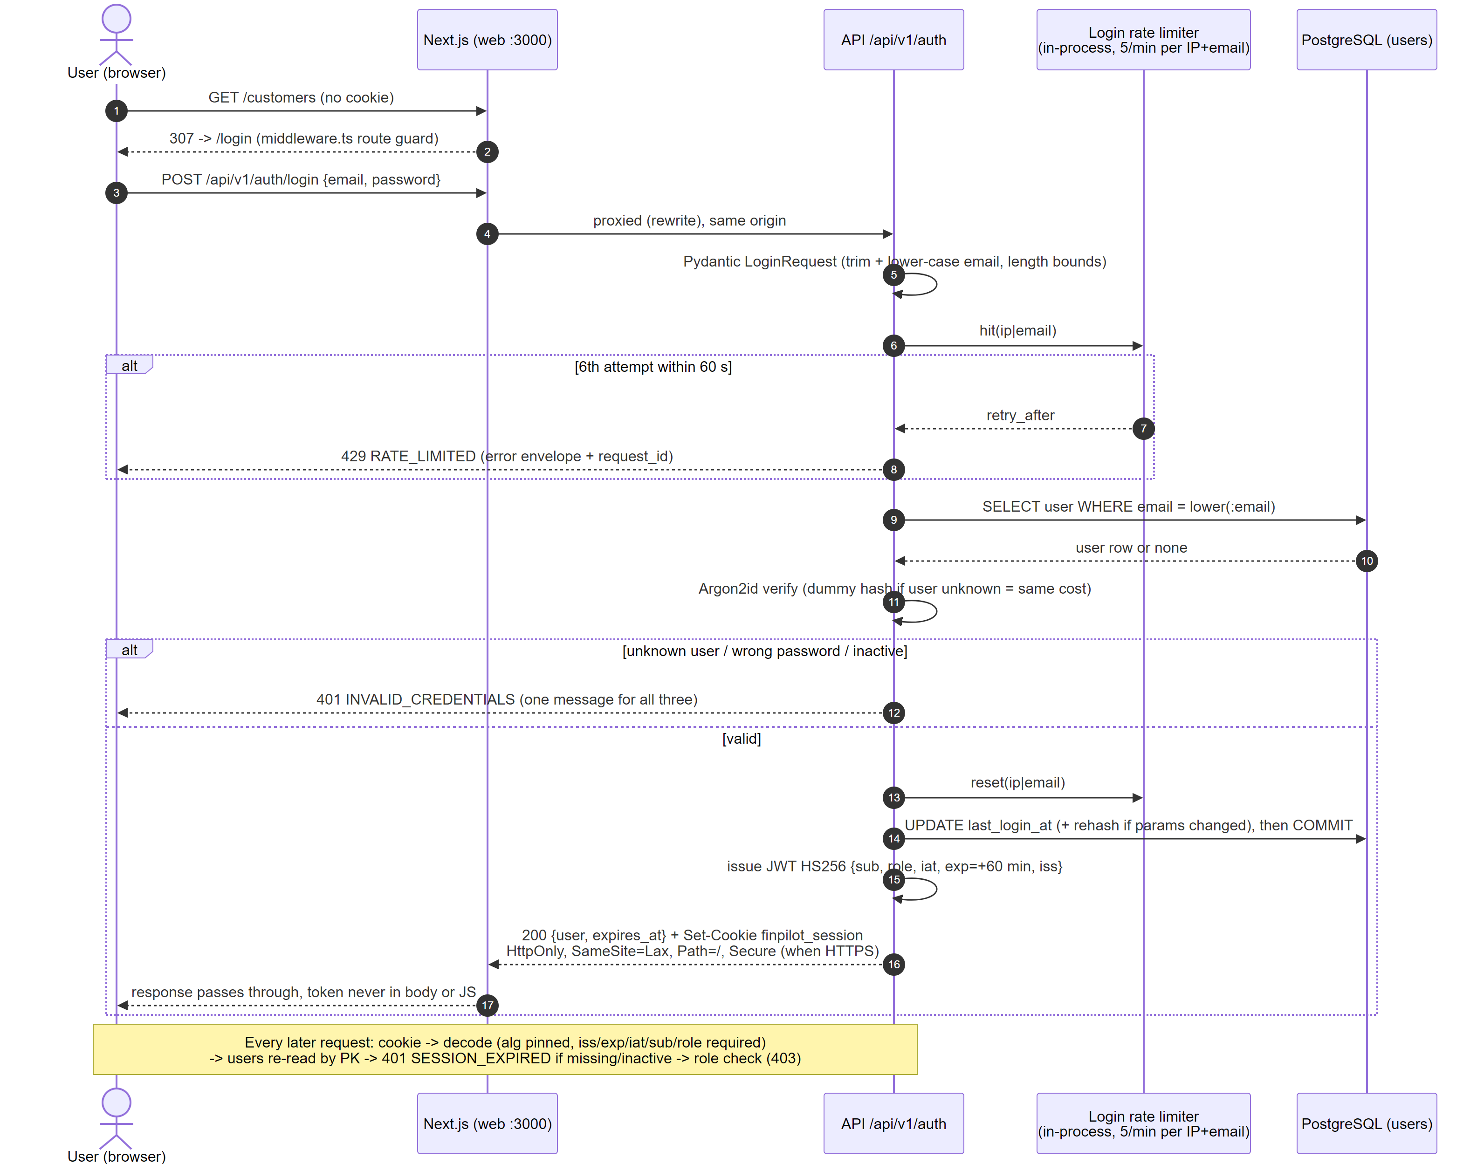
Figure: Login sequence

6.2 Customer portfolio read

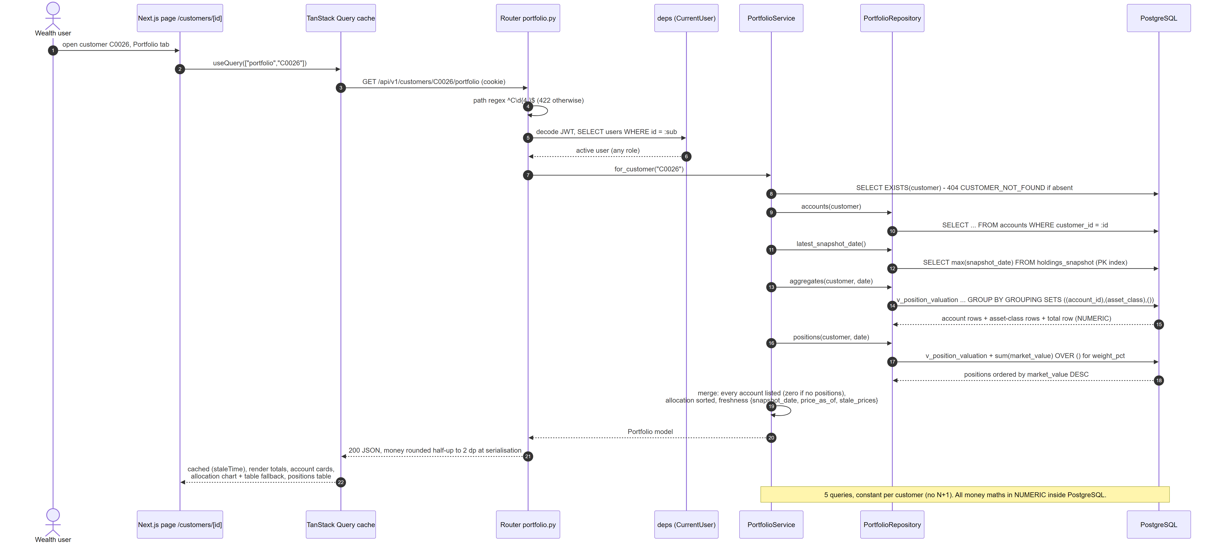
Figure: Portfolio read sequence

6.3 Goal update
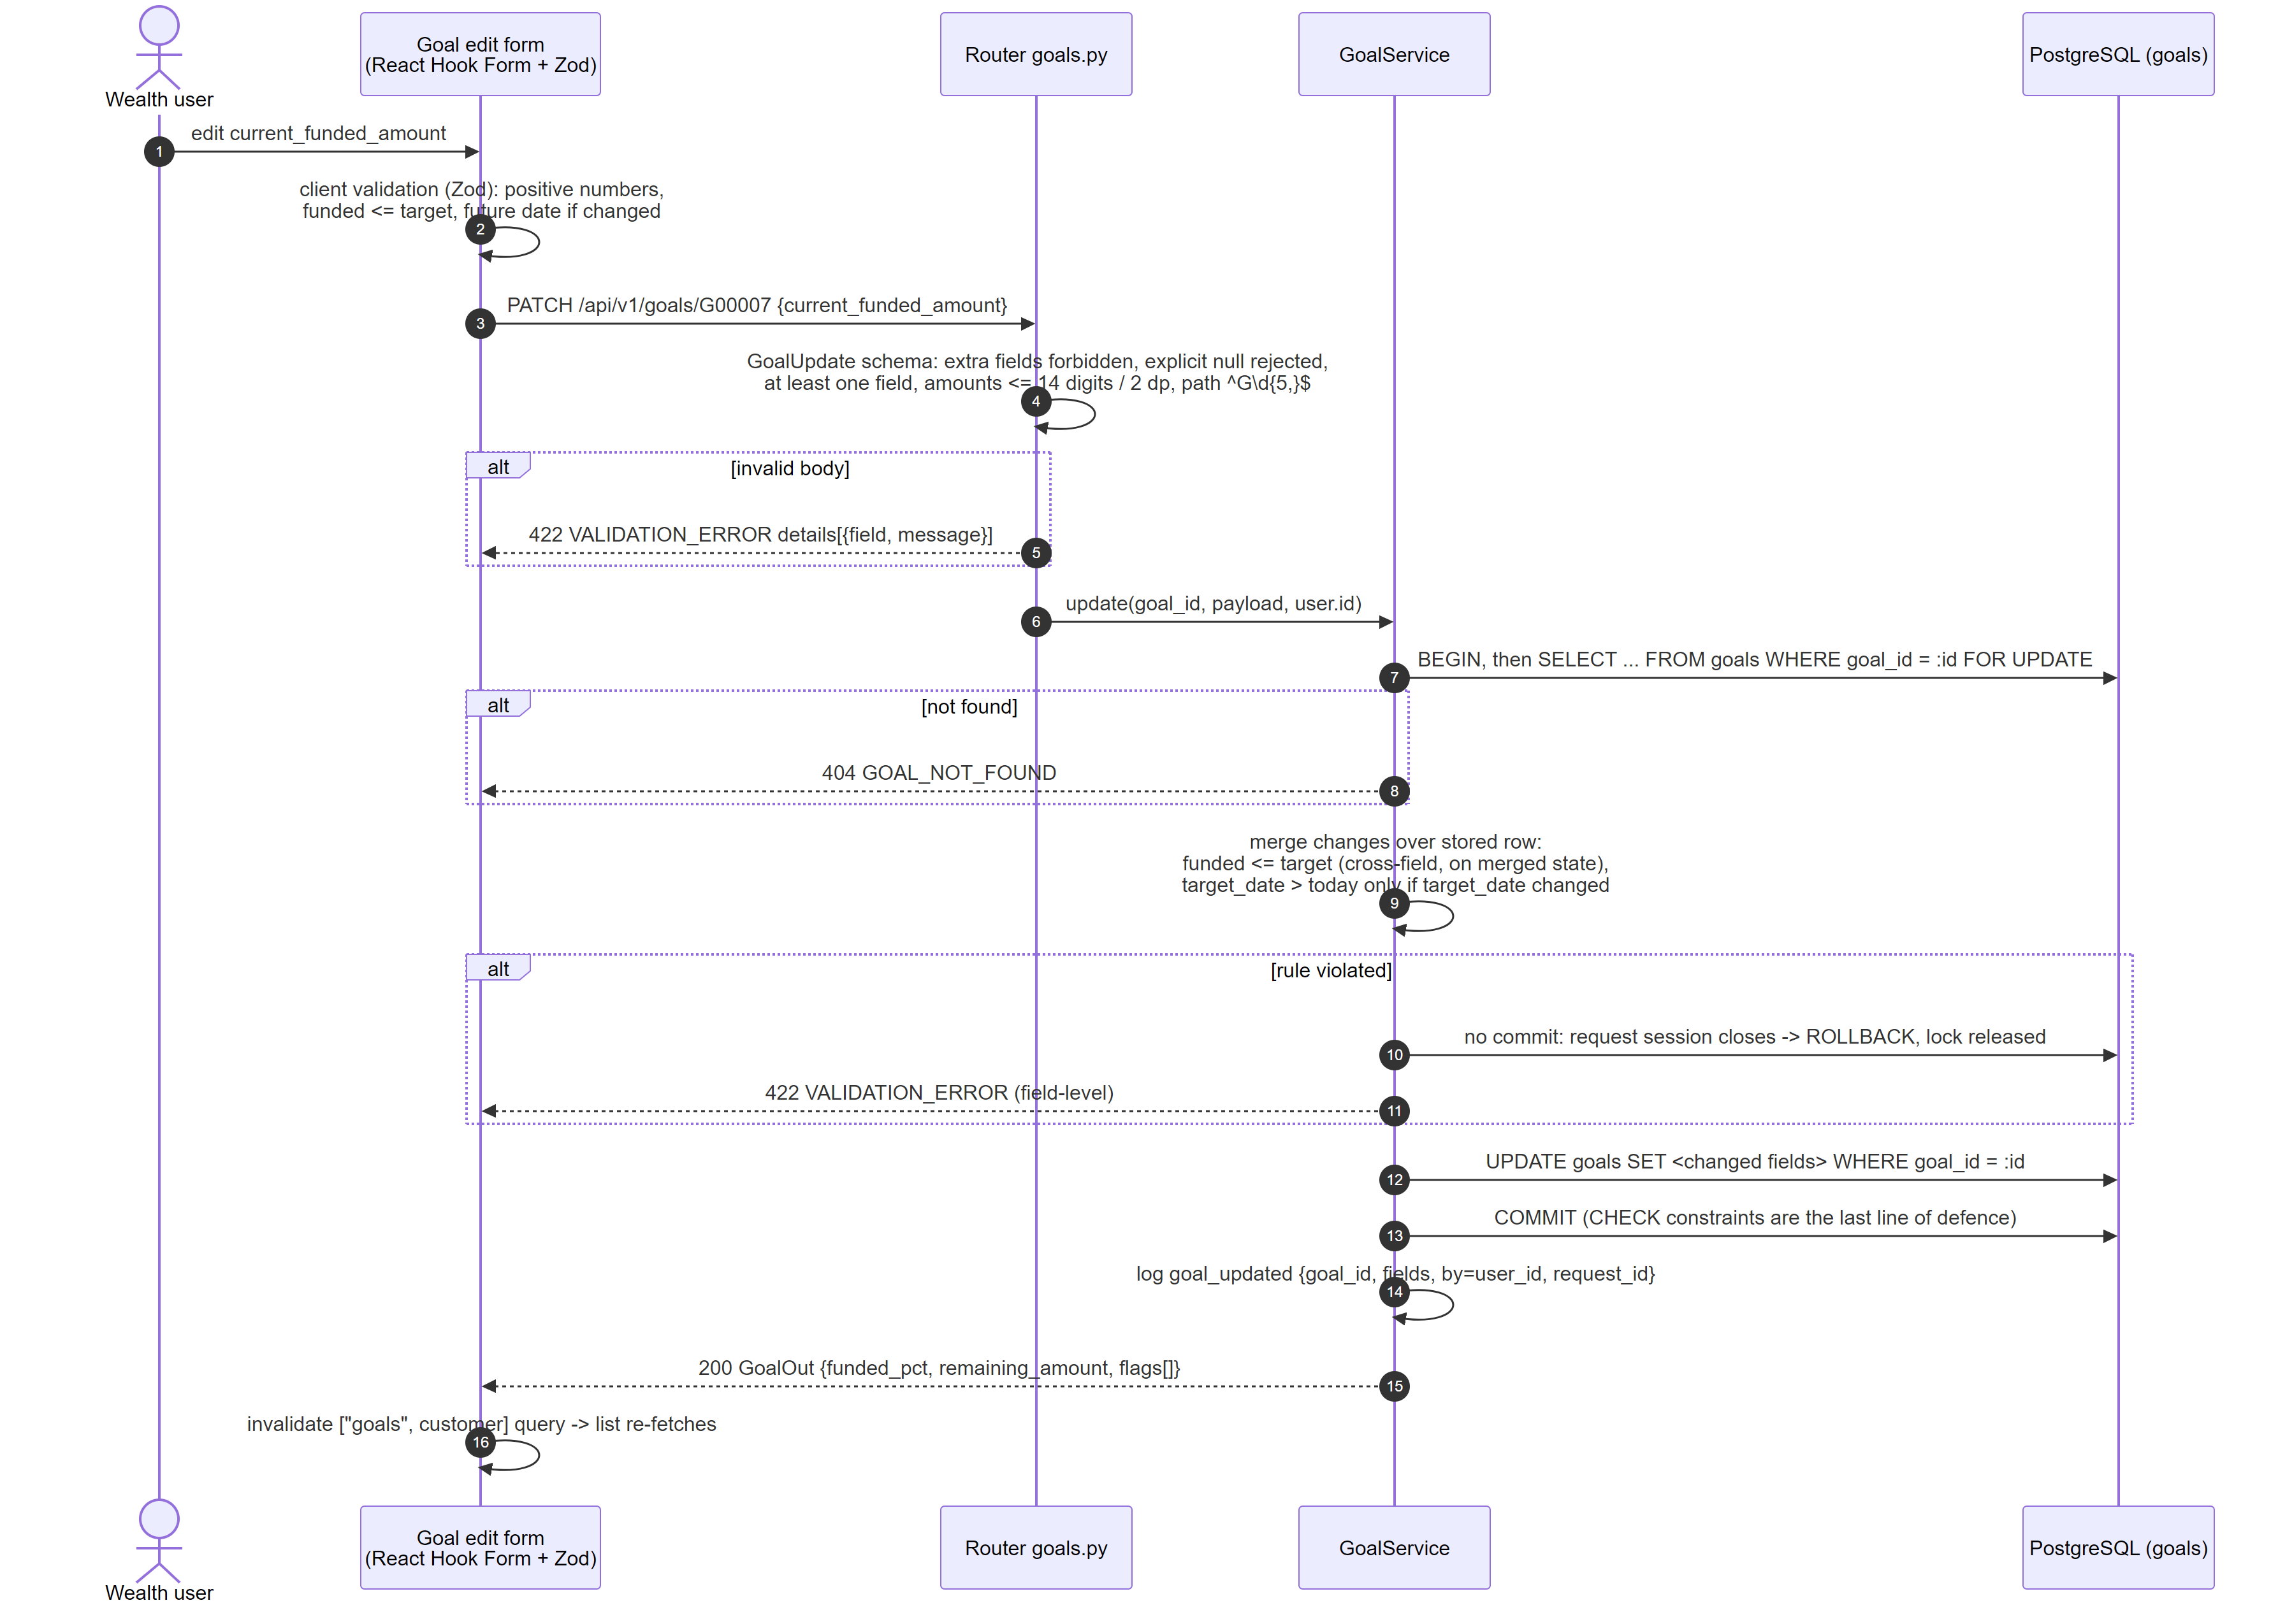
Figure: Goal update sequence
SELECT ... FOR UPDATE serialises two concurrent edits of the same goal, so cross-field rules are always checked against the committed row. It does not detect a stale edit (user B saving over user A's change made after B loaded the form); optimistic concurrency is on the roadmap.

6.4 CSV import (transactions)
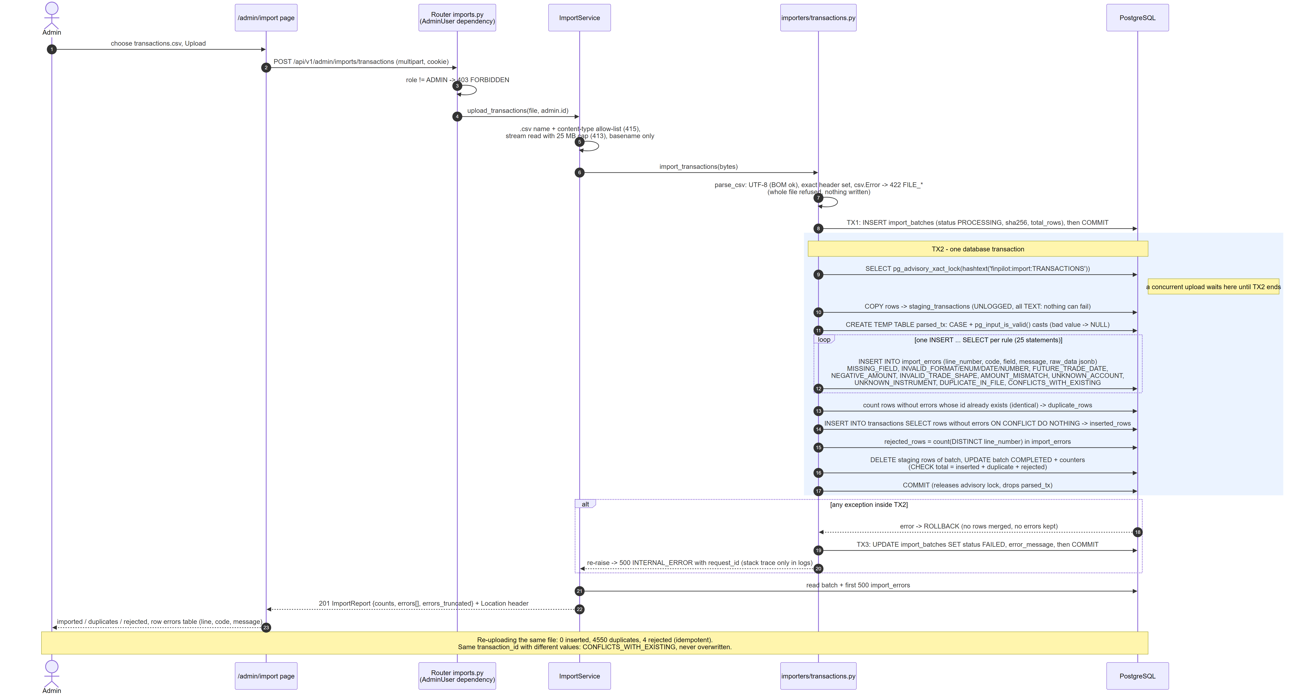
Figure: CSV import sequence
Properties this design guarantees, each covered by a test:
- Structural failure = whole file refused (bad encoding, wrong header, unparseable CSV, > 25 MB, non-CSV): 413/415/422, nothing written.
- Row failure = partial acceptance: every violated rule is recorded (a row can carry several reasons); the remaining rows load.
- Idempotent: an identical existing row is counted as a duplicate; re-uploading the supplied file yields inserted 0, duplicates 4,550, rejected 4.
- No silent overwrite: same transaction_id, different values -> CONFLICTS_WITH_EXISTING.
- Concurrency: pg_advisory_xact_lock serialises transaction imports so duplicate/conflict classification is exact; the primary key is the backstop.
- Auditability: the batch row is committed before the data transaction; if the merge fails it rolls back completely and the batch is marked FAILED with the error message.
- Why SQL-side validation: FK and duplicate checks are set operations against tables that grow to millions of rows; one INSERT ... SELECT per rule is a join, not a Python loop over ids. Casting is guarded with pg_input_is_valid(), so a malformed value becomes a reported error, never an aborted transaction.
Reference files (customers ... holdings) use a sibling path: Pydantic row contracts, in-file duplicate detection (first wins), batched FK checks, INSERT ... ON CONFLICT DO NOTHING, one transaction per file. They are loaded by the seed command only; uploading them is not exposed.

6.5 CI/CD and deployment
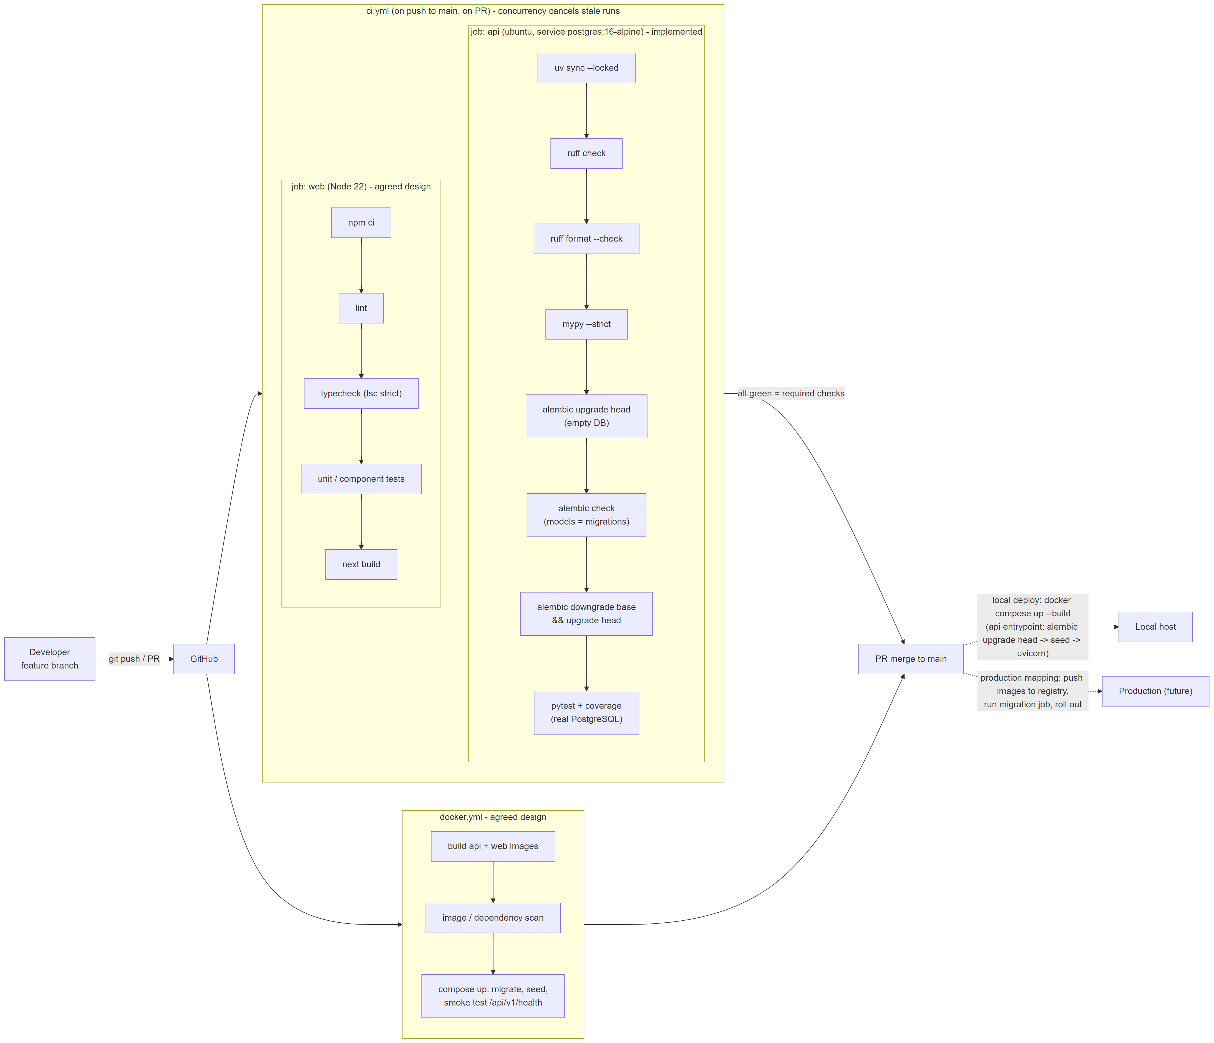
Figure: CI/CD pipeline
The api job is implemented in .github/workflows/ci.yml and runs on every PR and push to main: uv sync --locked -> ruff check -> ruff format --check -> mypy --strict -> alembic upgrade head on an empty PostgreSQL 16 service -> alembic check (models and migrations in sync) -> alembic downgrade base && alembic upgrade head (rollback path proven) -> pytest with coverage against that real database. Any failing step fails the pipeline. The web job and docker.yml (image build, scan, compose smoke test) are (design).

7. Deployment topology
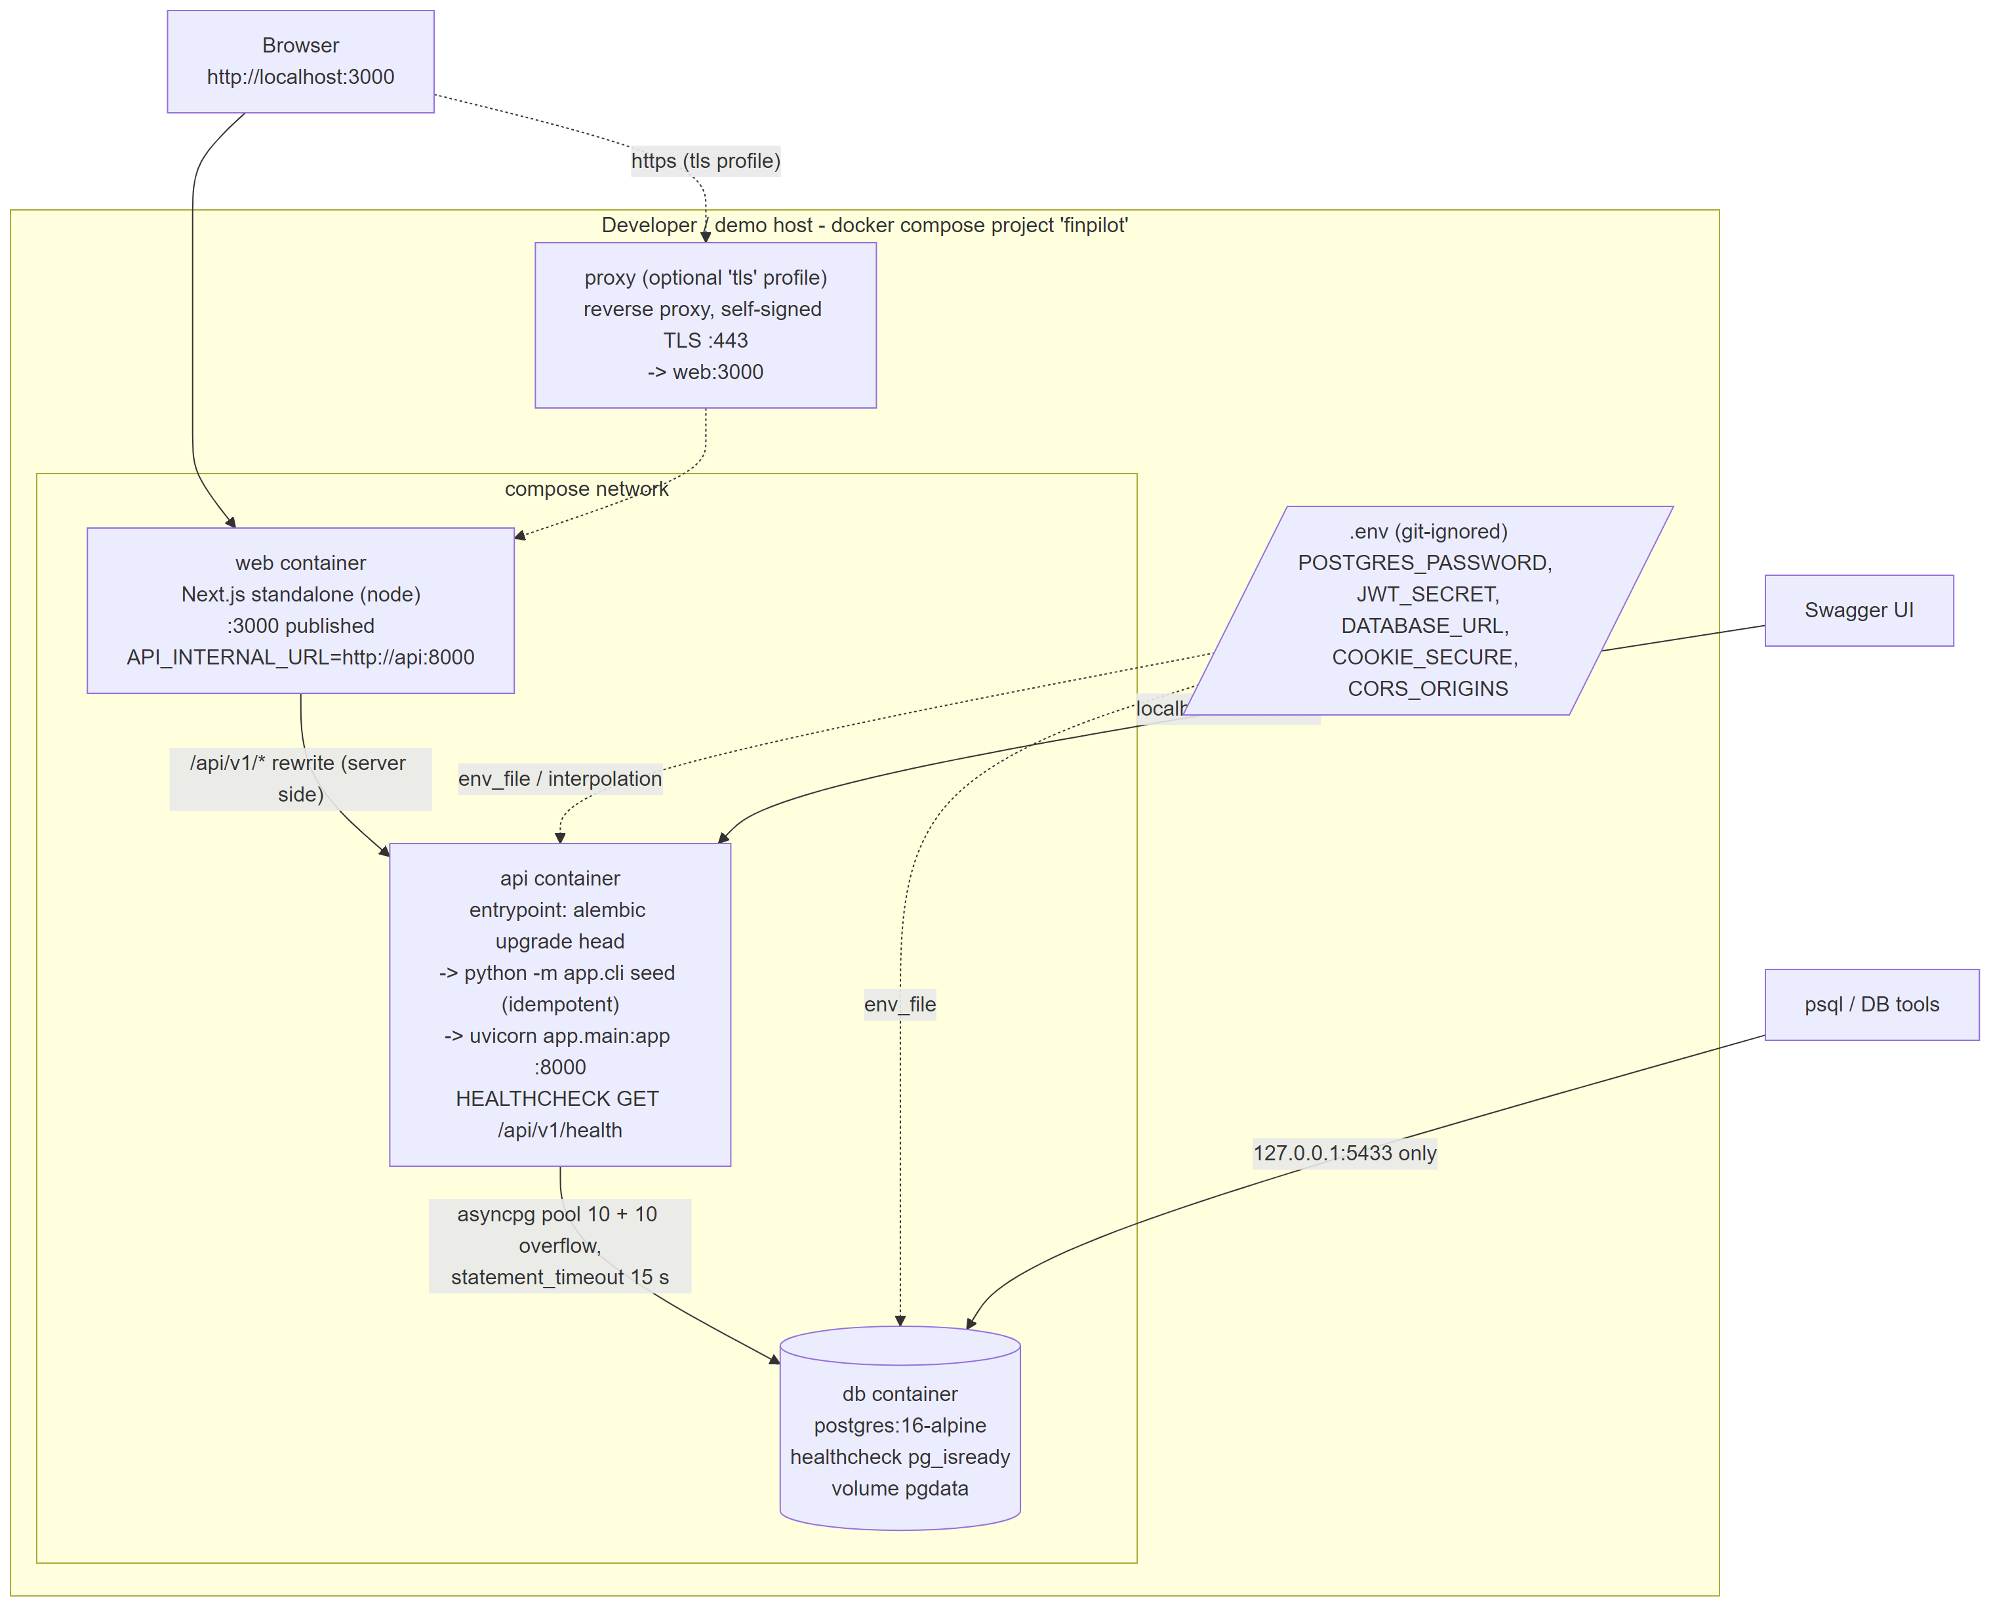
Figure: Deployment topology
Service | Image / runtime | Port (host) | Start-up | Health
db | postgres:16-alpine, volume pgdata | 127.0.0.1:5433 only | - | pg_isready (implemented)
api (design) | Python 3.12 slim, non-root, uv locked deps | 8000 | alembic upgrade head -> python -m app.cli seed (idempotent) -> uvicorn | HEALTHCHECK GET /api/v1/health; starts after db is healthy
web (design) | Next.js standalone output on Node 22 | 3000 | node server.js, API_INTERNAL_URL=http://api:8000 | depends on api healthy
proxy (design, optional `tls` profile) | reverse proxy with self-signed certificate | 443 | - | -

Secrets and configuration. Everything comes from environment variables (pydantic-settings); .env is git-ignored and .env.example documents every key with placeholder values. DATABASE_URL is read by both the API and Alembic (alembic.ini contains no URL). JWT_SECRET must be at least 32 characters or the API refuses to start. Demo users are created by the seed only when ENVIRONMENT != production.
Environments. local (console logs), test (pytest creates and migrates finpilot_test), ci (GitHub service container), production (JSON logs, no demo users, COOKIE_SECURE=true).
Production mapping.
Local | Production
compose db container | Managed PostgreSQL 16 (e.g. RDS / Cloud SQL / Azure Flexible Server): Multi-AZ, automated backups + PITR, private subnet, TLS required
api container | Same image on a container service (ECS/Cloud Run/AKS) behind an internal load balancer; >= 2 replicas; migrations run as a one-off release job before rollout, not by every replica
web container | Same image, or the Next.js app on a platform with the /api/v1 rewrite pointing at the internal API
optional TLS proxy | Managed load balancer / ingress with a real certificate, HSTS, WAF rules; corporate SSO in front for an internal tool
.env | Secrets manager (AWS Secrets Manager / Vault / Key Vault) injected at runtime; rotated; separate DB roles for migration (DDL) and runtime (DML only)
stdout logs | Log shipping to a central store (CloudWatch/ELK/Loki) with retention and PII controls

8. Security
Concern | Control in this implementation
Password storage | Argon2id (argon2-cffi defaults, RFC 9106 low-memory profile); hashes upgraded transparently on login when parameters change
User enumeration | Identical 401 INVALID_CREDENTIALS for unknown user, wrong password and inactive user; identical responses are tested; a dummy hash is verified for unknown e-mails so response time does not reveal existence either
Brute force | 5 attempts / 60 s per client IP + e-mail, sliding window, 429 with retry time; counter resets on success. In-process (see limitations)
Session token | JWT HS256, alg pinned on decode (no none/alg confusion), iss, exp, iat, sub, role required; 60-minute expiry; delivered only as HttpOnly; SameSite=Lax; Path=/ cookie (Secure when served over HTTPS), never in a response body or localStorage, so XSS cannot exfiltrate it
Revocation | The user row is re-read on every request: deactivation or role change takes effect immediately, at the cost of one PK lookup
Authorisation | Role checks are FastAPI dependencies (AdminUser = require_role(ADMIN)) declared on the route, not ad-hoc ifs; 401 vs 403 distinguished. VIEWER can read and maintain goals; only ADMIN can import (tested both ways)
Input validation | Pydantic contracts on every input; path/query regexes; enums; bounded lengths and page sizes; decimal precision; extra="forbid" on writes
SQL injection | All values are bind parameters (text() with :params, SQLAlchemy Core, expanding IN lists). The only dynamic SQL fragments are ORDER BY clauses chosen from a fixed dict by an enum-validated key, and constant WHERE fragments. Search input is lower-cased and %, _, \ are escaped before binding, so wildcards match literally (tested). Import rule SQL is built from module constants; file content only ever arrives via COPY and parameters
CORS | The browser uses same-origin /api/v1 via the Next.js rewrite, so CORS is not needed in normal operation. The API additionally allows only CORS_ORIGINS (default http://localhost:3000) with credentials, methods GET/POST/PATCH/OPTIONS and two headers
CSRF | SameSite=Lax stops the cookie on cross-site POST/PATCH; JSON bodies force a CORS preflight for cross-origin scripts. The multipart upload is a "simple" request, so it relies on SameSite alone; a same-site origin (e.g. another app on localhost) is not covered. Next step: Origin header check or double-submit token on unsafe methods
Upload hardening | ADMIN only; .csv extension + content-type allow-list; streamed read aborted at 25 MB (413); strict UTF-8; exact header; 64 KiB field cap; client path stripped to basename; values staged as text and never executed; SHA-256 recorded per batch
Secrets | None in Git; .env git-ignored; settings use SecretStr (not printed in logs/reprs); CI uses throw-away CI-only values; no secrets in client code (the browser never sees the API URL or any key)
Error disclosure | Generic 500 body with request_id; stack traces only in server logs
Logs and PII | Access log records method, path, status, duration, request_id, user_id, never query strings, bodies, cookies or passwords. Customer ids appear in paths. Failed-login events log the attempted e-mail and client IP (needed for abuse investigation, but it is PII: production would hash or restrict it). All data is synthetic
Network | DB port bound to 127.0.0.1; in compose only api reaches db
Supply chain | uv.lock / package-lock.json pinned; --locked installs in CI; image and dependency scanning in docker.yml (design)

Known security gaps (also in DECISIONS.md): the rate limiter is per process; behind the Next.js proxy request.client.host is the web container unless uvicorn is started with --proxy-headers and a trusted forwarded-allow-ips, which makes the limit effectively per e-mail; no security headers (CSP, HSTS) are set by the API itself (expected from the web tier / proxy); the code default JWT_SECRET is long enough to pass validation, so production must set it (a start-up guard rejecting the default when ENVIRONMENT=production is a one-line fix).

9. Reliability and operations
Area | Current behaviour | Production addition
Health | GET /api/v1/health: runs SELECT 1 through the pool; 200 healthy or 503 unhealthy with database: unavailable. Used for container health and compose start ordering | Split liveness (process up) from readiness (DB + migrations at head) so a DB blip does not restart healthy pods
Logging | structlog JSON to stdout (console renderer locally); one request_completed line per request with request_id, method, path, status, duration_ms, user_id; domain events (login_failed, goal_updated, import_completed with counts, import_failed with stack trace). Incoming X-Request-ID is honoured if well-formed, else generated, and echoed back | Ship to a central store; propagate the id from the web tier; OpenTelemetry traces
Metrics / monitoring | Not implemented | RED metrics per route (rate, errors, p95 latency), pool saturation, import outcomes (rejected-row ratio), pg_stat_statements top queries, replication lag, disk; alerts on 5xx rate, p95 > SLO, failed imports, health 503
Timeouts | DB statement_timeout 15 s per connection; pool checkout timeout 5 s; pool_pre_ping discards dead connections after a DB restart | Upstream timeouts at the proxy; separate longer timeout for the import role
Connection pooling | One async engine per process: pool_size 10 + max_overflow 10 | PgBouncer (transaction mode) or managed proxy when replicas x pool approaches max_connections
Retries | No automatic retries of writes (not idempotent in general). Reads fail fast with 500 + request_id; the UI can retry GETs (TanStack Query retry for idempotent queries (design)). Imports are safe to retry by design: a re-upload is idempotent | Retry with backoff on serialization failures / connection resets for idempotent operations only
Import failure | Structural error: 4xx, nothing written. Merge error: the data transaction rolls back completely, batch row is FAILED with message, error logged with stack; staging rows are deleted in the same transaction or vanish with the rollback | Background job + progress polling for large files
Migration failure | transaction_per_migration=True: PostgreSQL DDL is transactional, so a failing revision rolls back entirely and alembic_version stays at the last good revision. The API container's entrypoint stops before uvicorn starts, so a half-migrated schema is never served. Rollback is alembic downgrade -1, exercised in CI by a full downgrade base / upgrade head round trip | Expand/contract migrations for zero downtime; migration job gated before rollout; never auto-downgrade in production (restore or roll forward)
Backups | Local: named volume pgdata; pg_dump -Fc on demand | Managed automated backups + WAL archiving for PITR (e.g. 7-35 day window), periodic restore drills into a scratch instance, logical dumps before risky migrations
Data durability nuance | staging_transactions is UNLOGGED (truncated after a crash): acceptable because it only holds in-flight batch data that is re-creatable from the uploaded file | -

10. Trade-offs, limits and roadmap

10.1 Deliberate omissions
Order execution, payments, advice, real-time prices, notifications, user management UI, SSO, multi-tenancy, Kubernetes, microservices, event bus. One modular monolith API + one web app + one database is the right size for a read-heavy internal tool with a single team.

10.2 Trade-offs taken
Decision | Gained | Given up
Natural keys as PKs | Readable data, no id mapping in imports, FK errors name real ids | Re-keying an entity is costly (would need ON UPDATE CASCADE or surrogate keys)
VARCHAR + CHECK instead of PG ENUM | Adding a value is a constraint swap in a transactional migration | Slightly more storage; vocabularies duplicated in Python enums (CI drift check catches model/migration mismatch, not enum/CHECK mismatch)
Plain views | Always fresh, zero orchestration | Recomputed per request: fine to ~10^5 positions (section 10.3)
Offset pagination | "Page N of M" UI, simple contract | Linear cost at depth
Cookie JWT + per-request user read | No token in JS; instant revocation | One DB lookup per request; cookie scope ties API to the web origin
Synchronous import in the request | Simple, transactional, immediate report | Request duration grows with file size (fine up to the 25 MB cap)
Snapshot-based valuation | Correct numbers from the authoritative source | Ledger and positions are not reconciled; shown as separate facts

10.3 Expected scale limits (measured, `query-plans.md`)
At the supplied volume every endpoint completes in under 5 ms of database time. On a dataset 100x-1000x larger (100k customers, 300k positions, 3M transactions):
- Ledger page for a typical customer: 1.3 ms; count(*) 0.2 ms (index-only). Fine.
- Customer list: ~530 ms (search) / 1.1 s (unfiltered), because v_customer_aum values every position before the page is cut. First bottleneck.
- Heavy customer (50k transactions over 2 accounts): 129 ms page 1, 293 ms at page 2,000.
- Monthly flows: 1.3 s (full-ledger aggregate).
- Single process rate limiter and single API replica.

10.4 Next steps, in order
1. Customer list: page customers first and value only the page (measured 530 -> 0.6 ms); a materialized customer_aum refreshed after each holdings load for the AUM sort.
2. Keyset pagination for the ledger ((trade_date, transaction_id) < cursor) and per-account LATERAL top-N (measured 293 -> 0.6 ms at depth; 129 -> 0.45 ms page 1).
3. Optimistic concurrency for goals: version column or If-Match: <updated_at> -> 409 on a stale edit.
4. Shared rate limiting (Redis or gateway) and trusted proxy headers before running more than one replica; Origin check for unsafe methods.
5. Background import jobs (job table + worker, 202 Accepted + progress polling) once files exceed what one request should hold; same stage/validate/merge SQL.
6. Monthly-flow summary maintained by the import merge; range-partition `transactions` by `trade_date` at tens of millions of rows (cheap retention, partition pruning for reports).
7. Reconciliation: promote "trade on inactive account" and "position vs ledger" checks into v_data_quality_exceptions; agree with the business whether pre-opening trades are errors.
8. Operability: metrics and alerts, split liveness/readiness, OpenTelemetry, least-privilege DB roles, security headers at the edge.

