23CSE111 OBJECT ORIENTED PROGRAMMING
S2 B.Tech CSE
Department of Computer Science and Engineering
Amrita School of Computing, Amritapuri Campus

CASE STUDY
PHASE – 2 (Design)
Group No: C-14
Team Members:
Roll No | Student Name
AM.SC.U4CSE25254 | Tejas Shrivastava
AM.SC.U4CSE25256 | Varun Nagnath Lokare
AM.SC.U4CSE25207 | Ayush Kushwaha
AM.SC.U4CSE25237 | Nayantheerth Akhil
AM.SC.U4CSE25234 | Manjunadha Reddy

Problem Title: Inventory Management System for Retail Stores
Problem Description: To solve this, an Inventory Management System will be developed using Java. The system will allow users to add, update, delete, and search products, while keeping track of product ID, name, price, and quantity in stock. It will also automatically update stock after sales and alert the user when stock levels are low.

STRUCTURAL DESIGN
Class diagram (draw class diagram that shows different classes and their relationships. Use UML notations)
Product Class
- id: int
- name: String
- price: double
- quantity: int
+ Product()
+ Product(id: int, name: String, price: double, qty: int)
+ displayProduct(): void
+ display(): void
+ getters / setters

Supplier Class
- supplierId: int
- supplierName: String
+ Supplier()
+ Supplier(supplierId: int, supplierName: String)
+ displaySupplier(): void
+ display(): void

Inventory Class
- productList: ArrayList<Product>
+ addProduct(): void
+ displayInventory(): void
+ sellProduct(): void
+ restockProduct(): void
+ searchProduct(): void
+ deleteProduct(): void
+ updateProduct(): void

Main Class
None
+ main(args: String[]): void

Relationships for Diagram:
- Inventory to Product: Composition/Aggregation (1-to-many) because the inventory manages products and stores their details.
- Supplier to Inventory: Association, as the supplier stores supplier information for the inventory.
- Main to Inventory: Dependency, as Main depends on Inventory to run and demonstrate the program.
- Product and Supplier extend InventoryEntity: Inheritance, both classes override the display() method.
- Product implements Alertable: used for low stock checking and alerts.
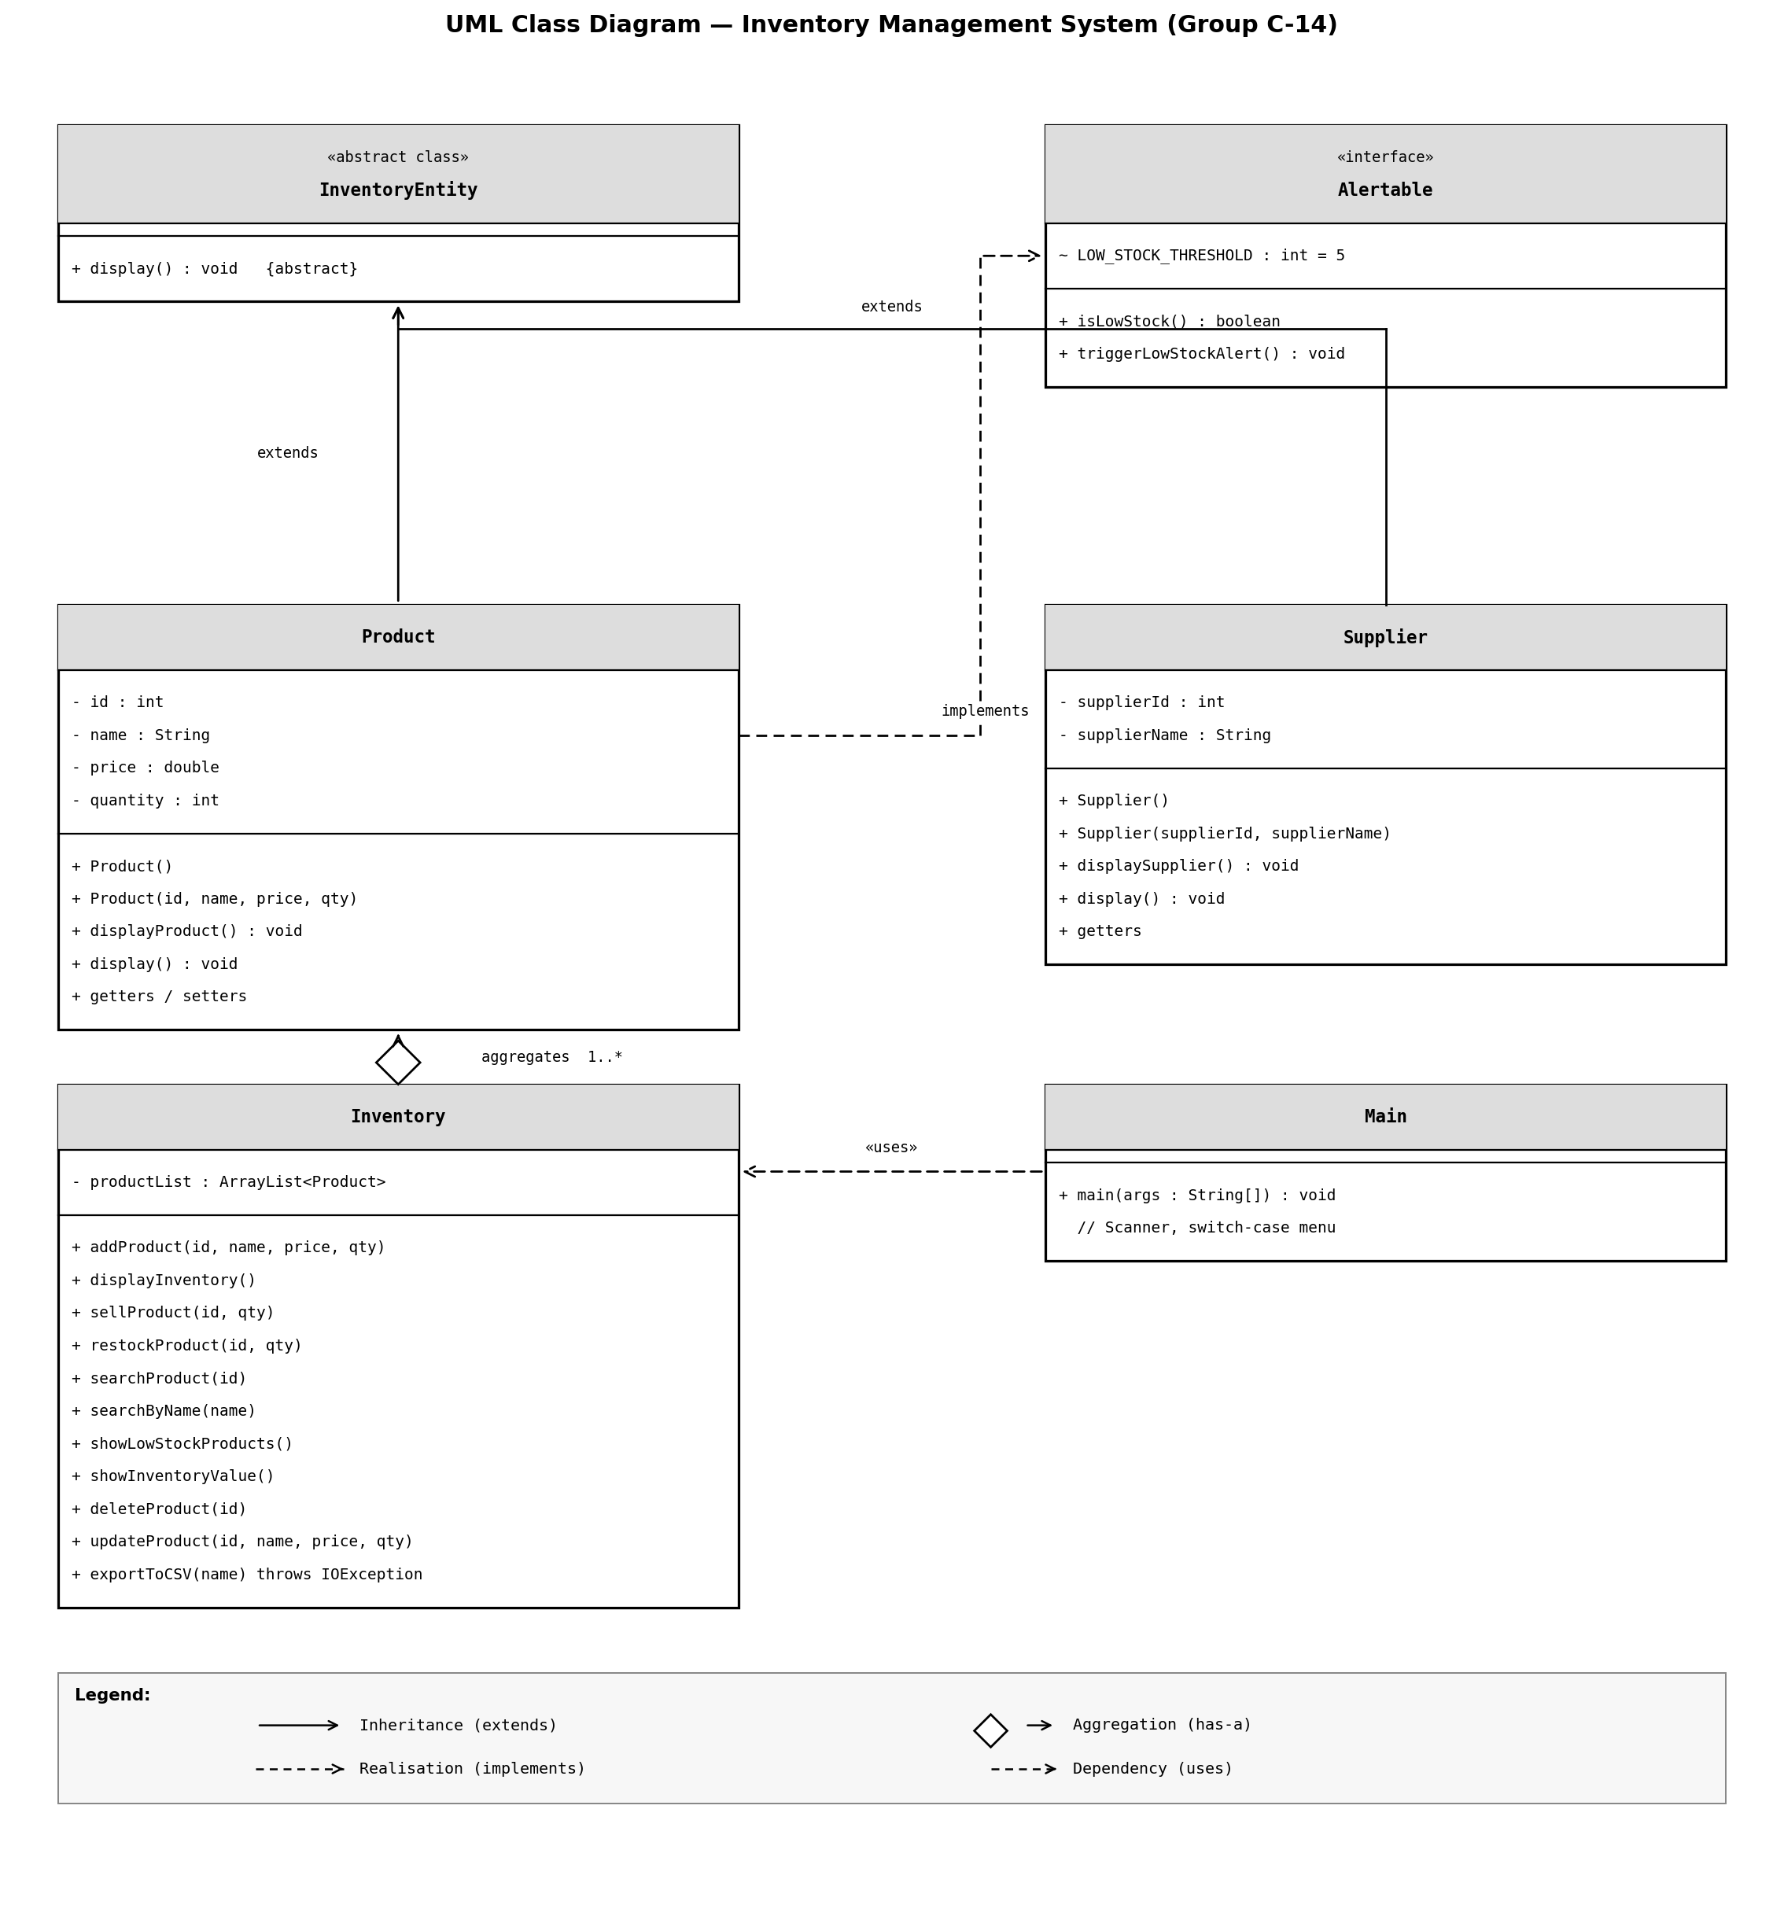

BEHAVIOURAL DESIGN

Use-case diagram
List of actors:
- 1. Store Admin / Manager
- 2. Cashier / Staff Member
- 3. System (Automated alerts)
List of use-cases:
- Add / Update Product: The manager enters details (ID, name, price, quantity) to add new items or updates existing inventory records.
- Delete Product: The manager removes a discontinued or unavailable product entirely from the inventory system.
- Search Product: Any staff member can look up a product by its ID or name to verify its stock and details.
- Sell Product: The cashier records a transaction, which automatically updates and reduces the stock quantity.
- Restock Product: The manager increases the stock levels when new inventory arrives from the supplier.
- Send Low Stock Alert: The system automatically notifies the user when the quantity of a product falls below a specific threshold.

Use case diagram
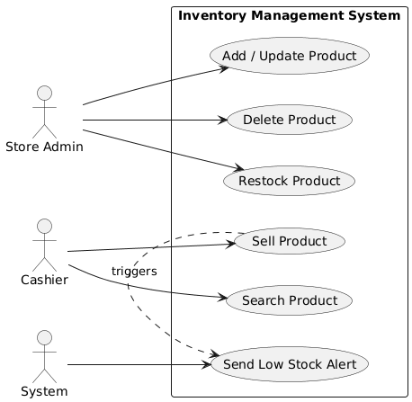

4. Sequence diagram
1. Sequence Diagram for Key Use Case: Sell Product
Scenario Description: The cashier initiates the sale of a product by entering the product ID and quantity sold. The Inventory class checks the product list. If found and sufficient quantity exists, the sellProduct() method updates the stock. If the remaining stock is low, it triggers a low stock alert.
- 1. Cashier -> UI: enterSale(productID, qty)
- 2. UI -> Inventory: sellProduct(productID, qty)
- 3. Inventory -> Product: checkQuantity()
- 4. Product --> Inventory: return currentQty
- 5. Inventory -> Product: updateQuantity(currentQty - qty)
- 6. Product --> Inventory: confirmation
- 7. (Opt) Inventory -> UI: triggerLowStockAlert() (if quantity < threshold)
- 8. Inventory --> UI: saleSuccessful()
- 9. UI --> Cashier: displaySuccessMessage()
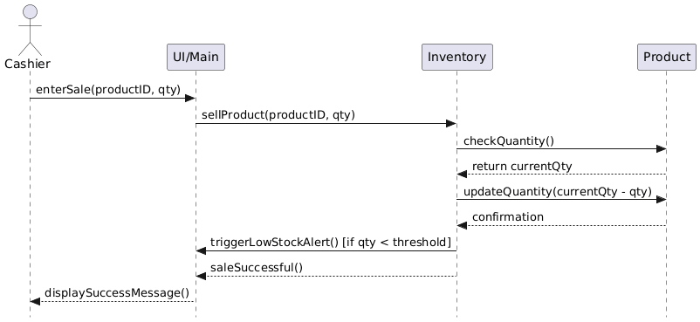

2. Sequence Diagram for Key Use Case: Add Product
Scenario Description: The store manager wants to add a newly supplied item. They enter the product details (ID, name, price, quantity). The system creates a new Product object and adds it to the Inventory list.
- 1. Store Manager -> UI: enterProductDetails(id, name, price, qty)
- 2. UI -> Inventory: addProduct(id, name, price, qty)
- 3. Inventory -> Product: create(id, name, price, qty)
- 4. Product --> Inventory: Product Object created
- 5. Inventory -> Inventory: add to productList
- 6. Inventory --> UI: productAddedSuccessfully()
- 7. UI --> Store Manager: displayConfirmation()
