Error whilst building the front-end

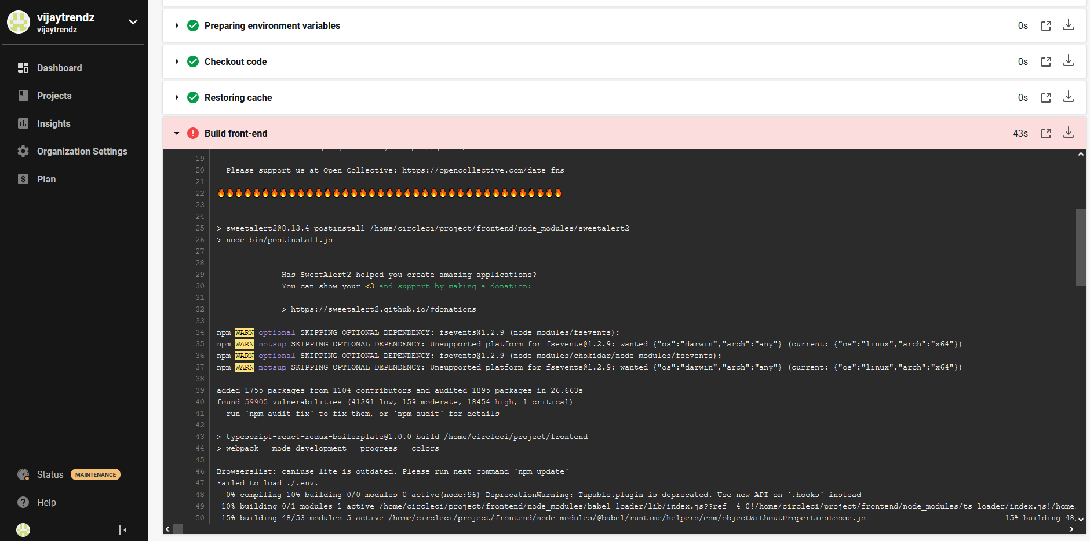

Error during the backend build

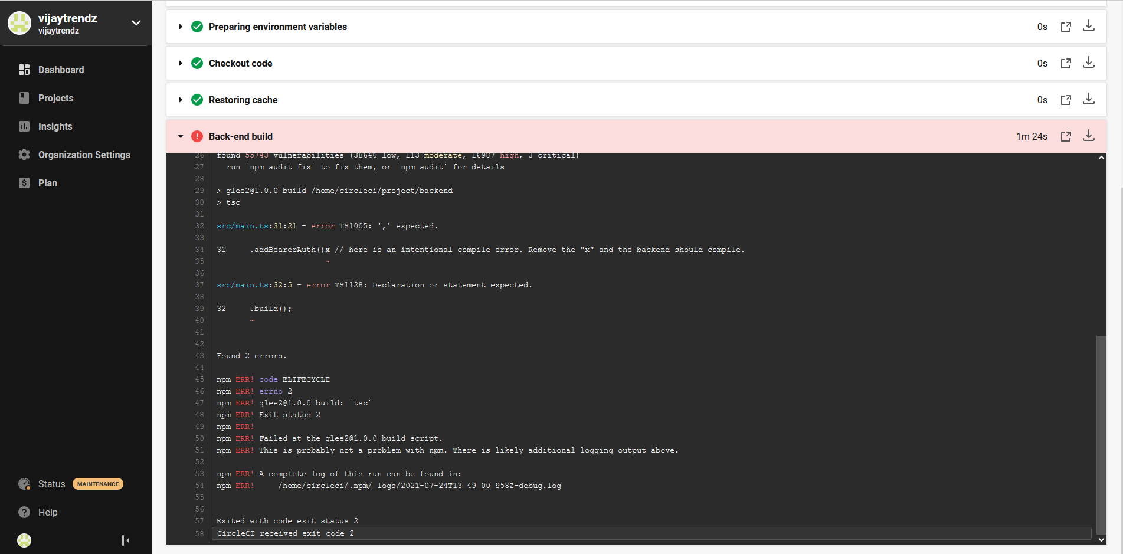

Failed while running test front end

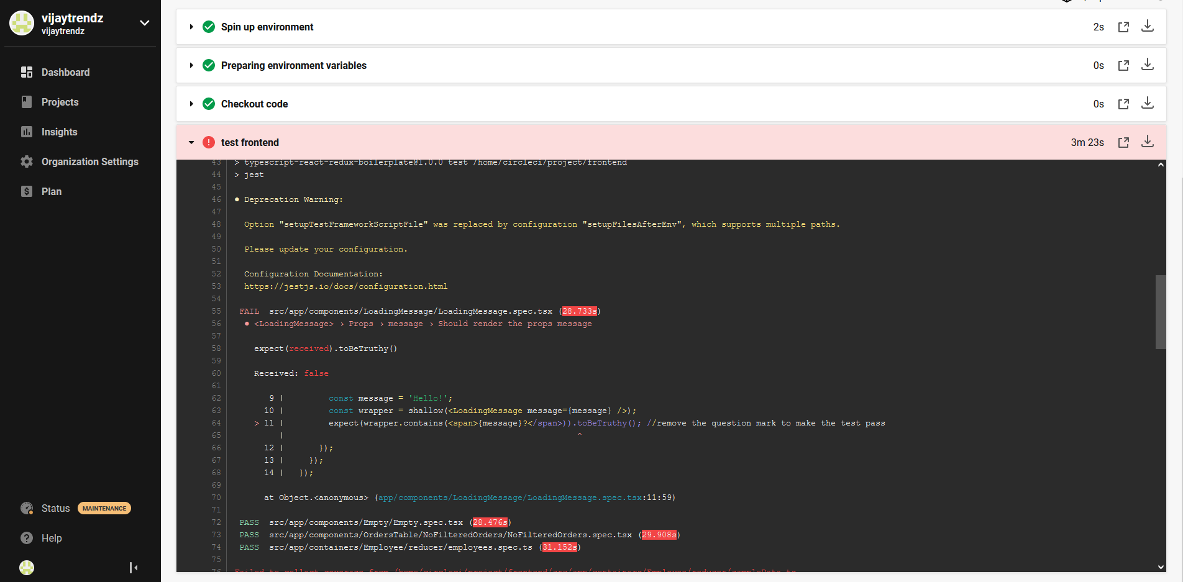

Failed while running test back end

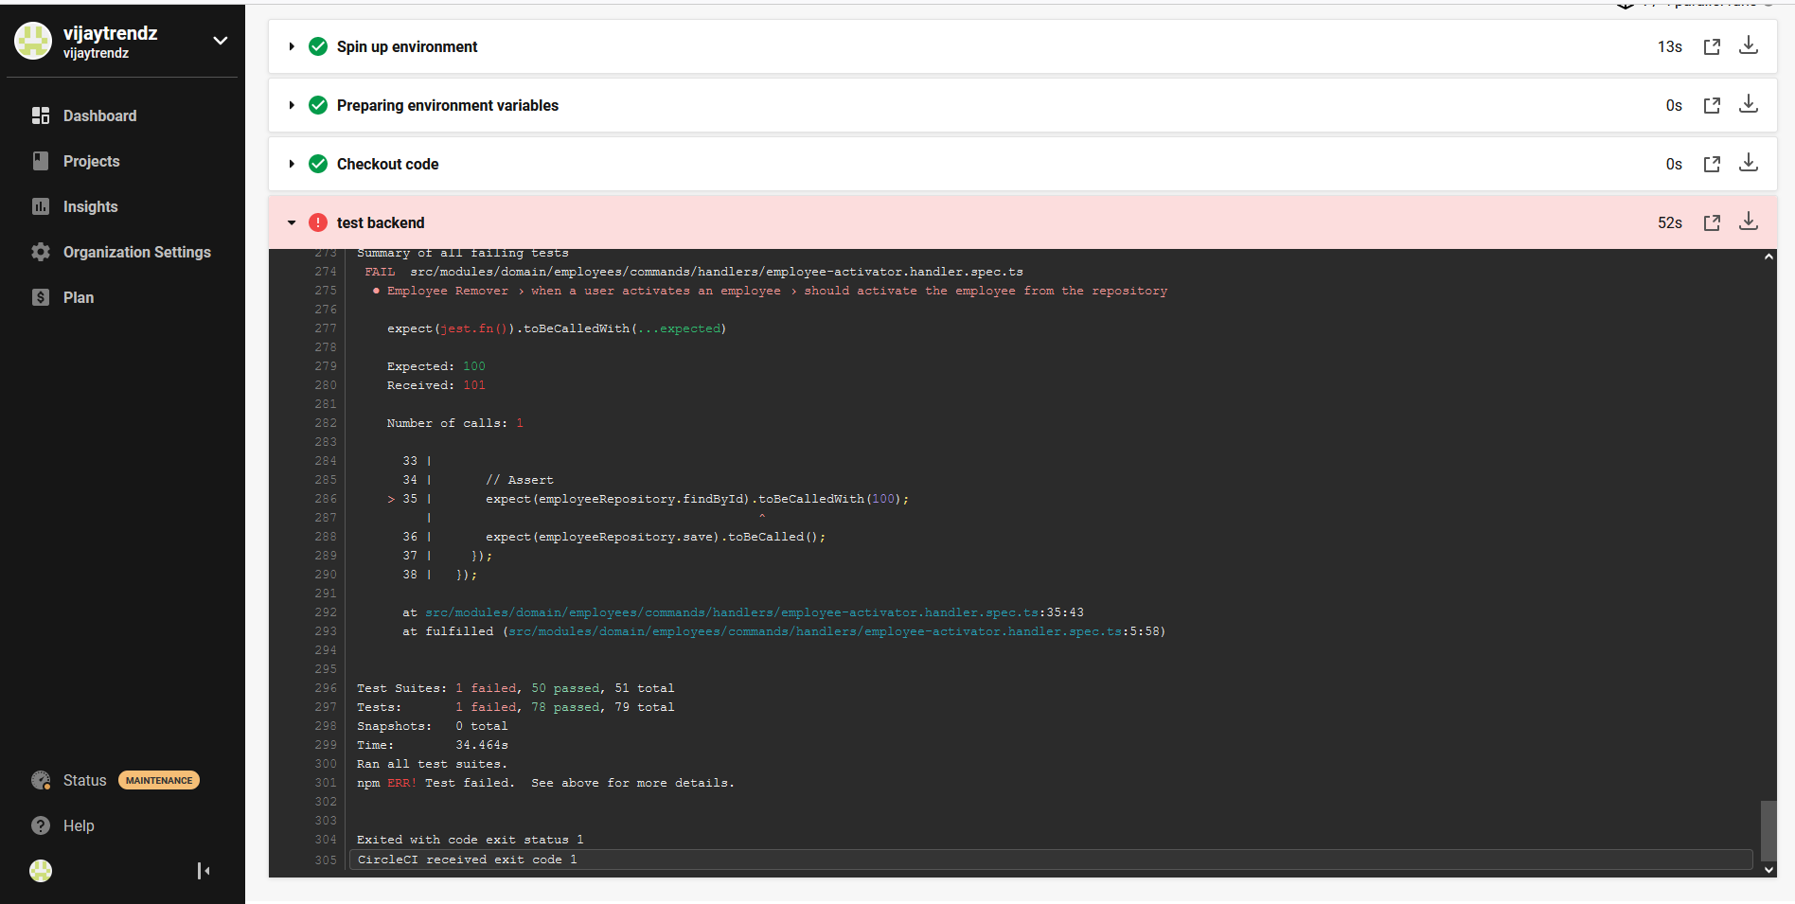

Changes make the test backend to work:

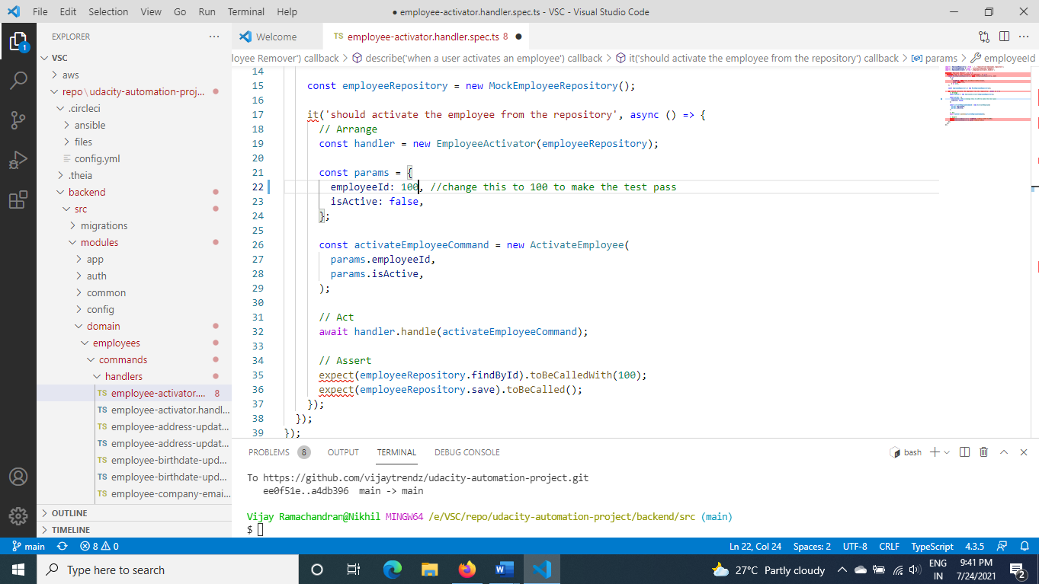

Changes to make the test front end to work:

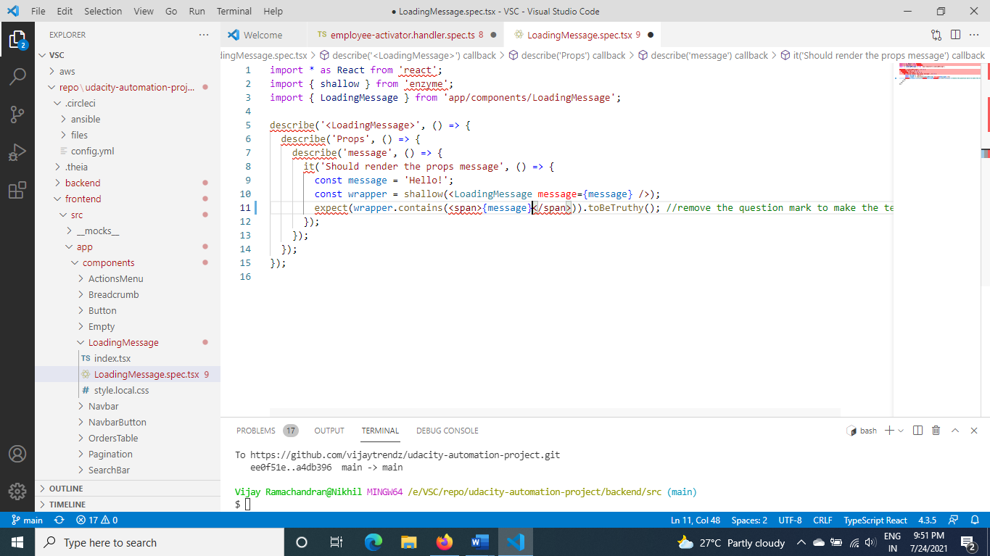

Pipeline succeeded for both test back and front end

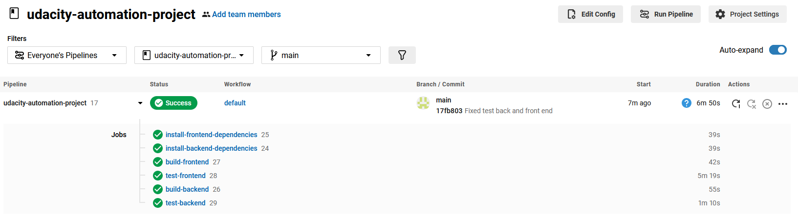

Check for Vulnerability:

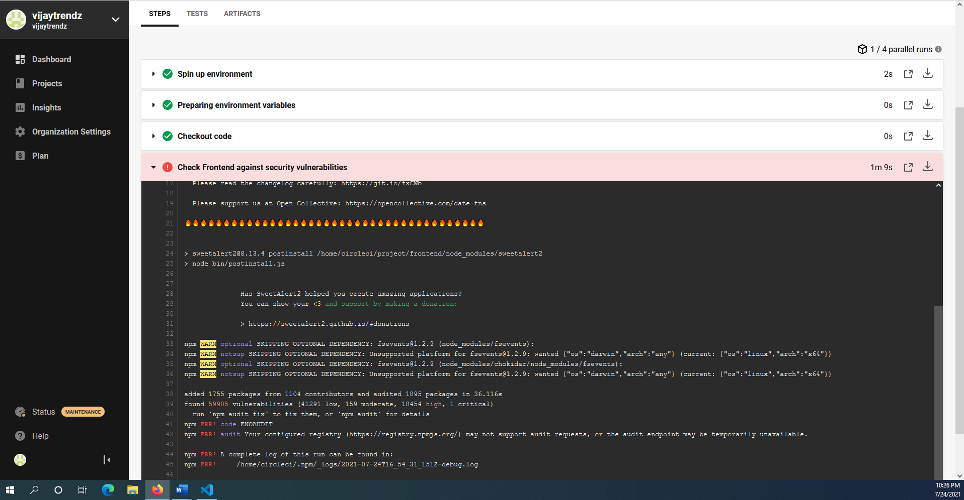

Deploy infrastructure fails:

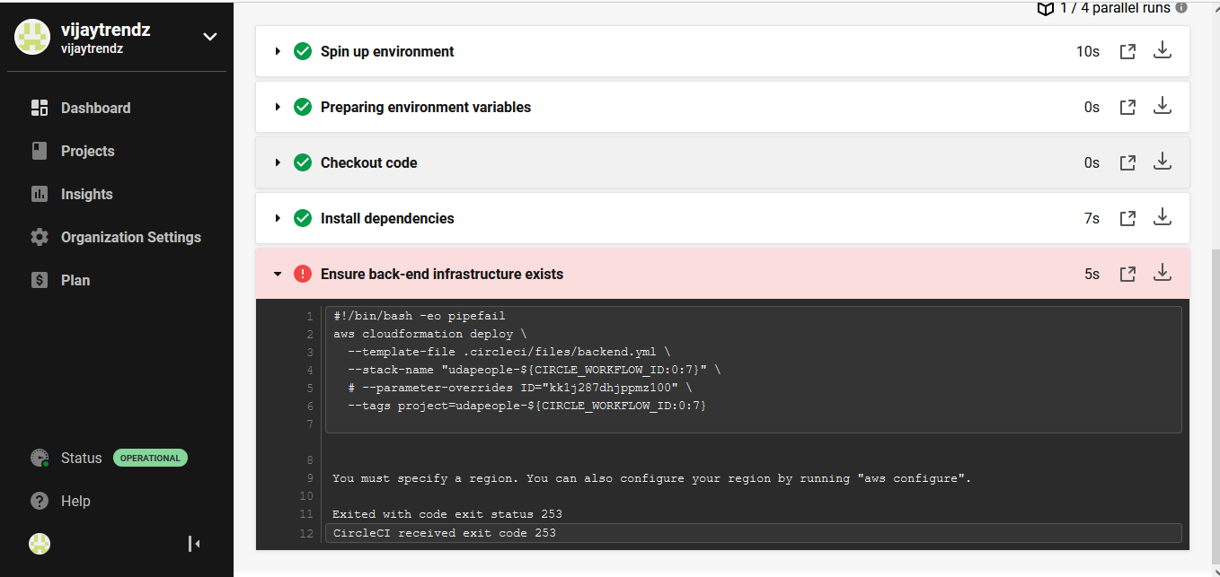

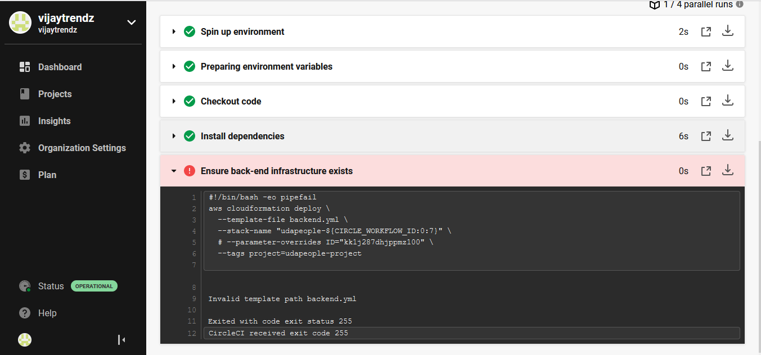

**Fixed the above error after adding parameter over-ride**

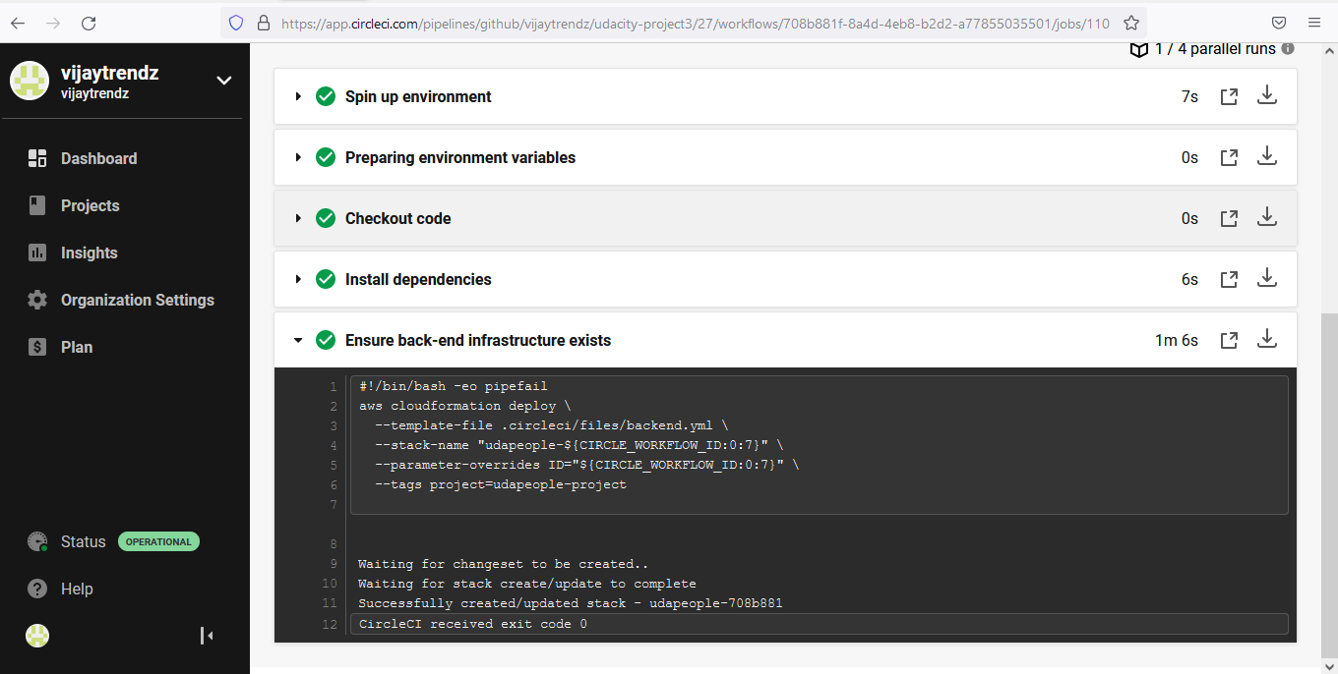

**Fixed both backend and frontend, added memstash to have the backend URL,**

**Migration job failed**

**Migration job succeeded**

**Smoke test failed**

**Prometheus Graph:**

**Alerts**

**Service discovery**

**Update CloudFront Distribution**

**Clean up**

