****

GSTREAMER PIPELINE ANALYSER

Gstreamer framework is used to develop media elements and audio elements to perform media operations. This code is developed to generate the required debug logs and graphical representation of dot file in current working directory. By using this information we can able to analyse the pipeline. In this code the predefined macros i.e., debug and graphviz are generated by using gstreamer framework.

**$GST\_DEBUG=\*:6 gst-launch-1.0 videotestsrc ! videoconvert ! autovideosink**

The following is the output, how it is displayed:

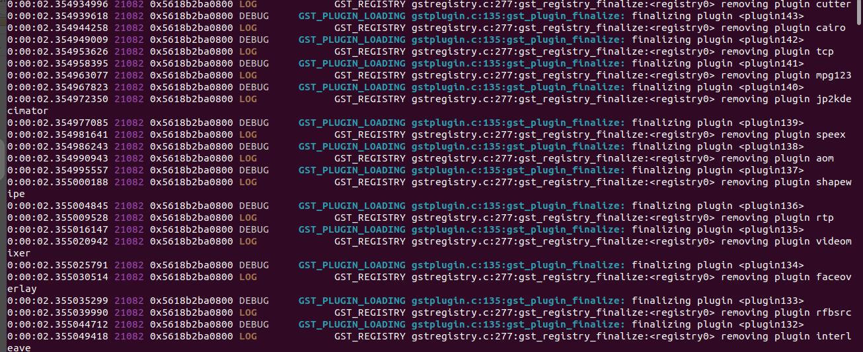

The image shows the loading plugins information and its debug log with the time, base address.

**1. Development:** This code is implemented to generate debugging logs and graph in the current working directory. This code also uses predefined macros which are enabled to generate dot file. The dot file gives the graphical representation of the working pipeline. For this code we need to create pipeline by using gstreamer pipeline API’S, after that we need to run the pipeline by changing state of the pipeline. This code uses predefined macros to get dot and log files .The below header files are used in the code.

“<unistd.h>”:This library is used to set current working directory path for the log file.

“<stdlib.h>”: To perform string operations while setting the file path.

“<gst/gst.h>”:This includes the gstreamer related libraries for audio and video related.

“<stdio.h>”:To perform based basic c operations.

“<string.h>”:To perform string operations while setting the file path.

**2. Availability of code along with working demo:**

<https://github.com/1vijayvanga/gstreamer-pipelin-analysis>

<https://moschipsemiconductor-my.sharepoint.com/:f:/g/personal/vijay_vanga_moschip_com/EkjT4usFihdDvV9zW9JBJXQBhXq-zvGU89yj0o0h2t8Qrw?e=TZxXN4>

**3.Issues:**

**a)Pipeline requirement:**This code is only works for running pipelines which means the given pipeline should be corrects.

**b)Pre-requisites:** While running this code we need graphviz 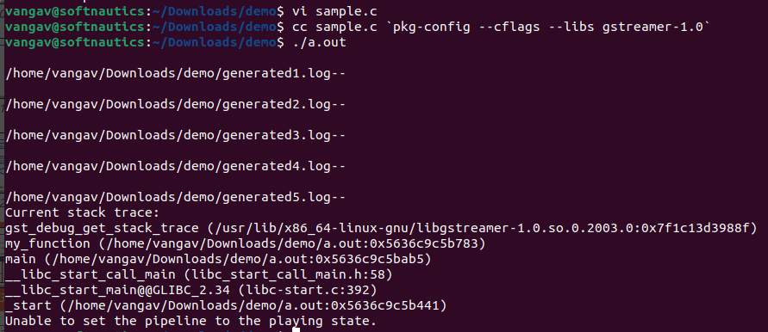application to convert the dot file into png file.

**4.Flow chart:**

Thefollowing flow chart shows the code working flow.

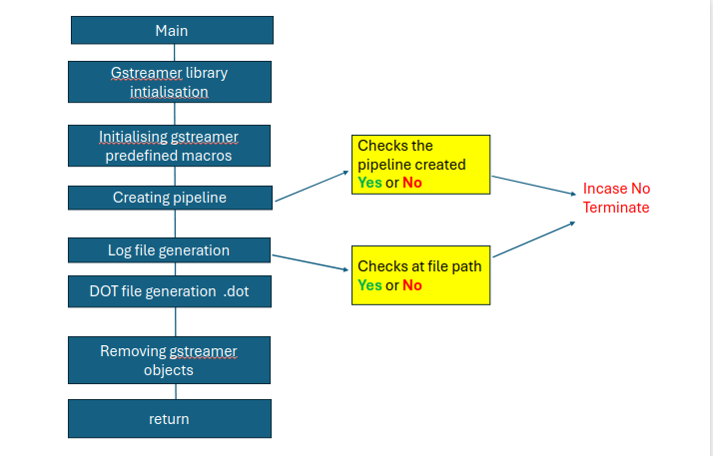

**5. Use case:** This code is usefull to understand the pipeline elements arrangement and pipeline debugging scenarios .

**6.Applications:**

These are applications uses this kind of log which are CI/CD platforms like Jenkins, GitLab CI, GitHub Actions, CircleCI, and Azure .

**7. OS:** Linux

**8. Future Scope:**

* Measure latency of the gstreamer pipeline.
* Frame stepping logs can generate.
* In future we can obtain multiple log files support.

**9.References:**

[https://gstreamer.freedesktop.org/documentation/libav/avenc\_a64multi.html?gi-language=c#avenc\_a64multi:debug](https://gstreamer.freedesktop.org/documentation/libav/avenc_a64multi.html?gi-language=c" \l "avenc_a64multi:debug)

https://man7.org/linux/man-pages/man3/setenv.3.html