**WIRELESS COMMUNICATION USING**

**ZIGBEE IN PARKING LOTS**

Sudhan.M, Vijay.V –B.tech Information technology

Department of Information technology, Rajalakshmi Engineering College, Chennai.

[**Sudhanharry8@gmail.com**](mailto:Sudhanharry8@gmail.com)**,** **vijayvasuv@gmail.com**

**Abstract**

**The new wireless technology evolved to solve many queries which cannot be solved by past technologies is ZigBee. ZigBee was created by ZigBee alliance**.

**Here we propose an idea of applying or using wireless ZigBee technology in the commercial field. The most common problem in all the commercial places but not spoken out is chaos in the parking lot. Among the available wireless communication technologies ZigBee is the best one which marks all the necessary needs to solve the problem. The suitable software module must be developed to avoid the confusion and traffic in the parking slot. The modules fixed in the parking slot monitor and gives information about the free slots by passing the info through the nodes. Every module is connected to another module and forms a network. The main plus of ZigBee is mesh network, and low power consumption. Software must be developed for data transmission, detection, and display. The system will detect multiple sensors within the range of 100m.**

**Keywords: wireless ZigBee, low power consumption.**

INTRODUCTION

Wireless communication is the transfer of information over a distance without the use of enhanced electrical conductors or wires.

The distance involved may vary from short to long, which lead to the development of new wireless communication devices. Ex. A few meter wireless communications may be a TV remote controller and a thousand or millions of kilometers of communication may be a radio. Such a kind of new innovation is the ZigBee device. Here ZigBee is used to find free space in the parking lot and make parking a breeze and confusion less..



One of the most promising HAN (Home Area Network) protocols is ZigBee, a software layer based on the IEEE 802.15.4 standard. ZigBee was created by ZigBee alliance.

ZIGBEE

The name ZigBee is said to come from the domestic honeybee which uses a zigzag type of dance to communicate important information to other hive members. This communication dance lead to the naming of ZigBee, were the transfer of information is in zigzag form. ZigBee is a home-area network designed specifically to replace the proliferation of individual remote controls. ZigBee was created to satisfy the market's need for a cost-effective, standards-based wireless network that supports low data rates, low power consumption, Security and reliability

ZigBee designed for wireless controls and sensors. Operates in PAN (personal area network) and device to device networks.

The network topology used here in ZigBee is given below,

**IEEE 802.15.4 & ZigBee In Context.**

* Star.
* Cluster tree.
* Mesh.

The alliance is working closely with the IEEE to ensure an integrated, Complete and interoperable network for the market. The ZigBee Alliance will also serve as the official test and certification group for ZigBee devices. ZigBee is the only standard based technology that addresses the needs of most remote monitoring and control and sensory network applications.

The 802.15.4 specification only covers the lower networking layers physical and media acess (MAC and PHY). To achieve inter-operability over a wide range of applications such as Home, Industrial or

Building Automation, the higher layers must be standardized as well.

The ZigBee Alliance has produced such a standard, using 802.15.4 wireless (generally in the 2.4 GHz band) as the low-level transport.

TECHNOLOGY COMPARISON

BLUETOOTH:

Data rate=> 0.8 - 1.0 Mb/s

Range=>30 ft

Cost=>Low

Power=> Low

Spectrum=>2.4 GHz

Issues=>Speed and Interference issues.

802.11a:

Data rate=> 54 Mb/s

Range=>90-100 ft

Cost=>High

Power=> High

Spectrum=>5.0 GHz

Issues=>High power consumption, high cost.

802.11b:

Data rate=> 11 Mb/s

Range=>250-300 ft

Cost=>Medium

Power=> Medium

Spectrum=>2.4 GHz

Issues=>Speed and signal strength issues for more range.

802.11g:

Data rate=>54 Mb/s

Range=>100 ft

Cost=>High

Power=> High

Spectrum=>2.4 GHz

Issues=>Connectivity and range problems, high cost.

HYPERLAN:

Data rate=> 25 Mb/s

Range=>100 ft

Cost=>High

Power=> High

Spectrum=>2.4 GHz

Issues=> High cost

HOME RF:

Data rate=>11 Mb/s

Range=>1500 ft

Cost=>Medium

Power=> Medium

Spectrum=>2.4 GHz

Issues=> Speed issues and doesn’t have big player support.

ZIGBEE:

Data rate=> 0.02-02 Mb/s

Range=>20-25 ft

Cost=>Low

Power=> Low

Spectrum=>2.4 GHz

Issues=>low power consumption. Low cost.

By seeing the above information, we can get to know that ZigBee is cost efficient and valuable for the applying in the process.

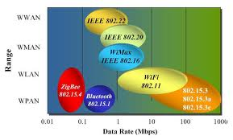

The sensor device has to work autonomously for 4 years on one 9V battery. Plus, the PCB board had very little “real-estate” left for module integration



Most of the leading ZigBee modules boast very low power consumption. However, when it comes to size, only the ZigBit modules from Mesh Netics featuring

a tiny footprint of just over three square centimeters.

* Implementing wireless ZigBee:

ZigBit modules featuring dual chip antennas are integrated into boards connected with a range finder sensor and 9V battery. ZigBit modules take full advantage of the new Atmel’s RF transceiver AT86RF230, which possesses -101dBm of Rx sensitivity and up to +3dBm of TX power.

This combination is known as the "link budget."

The range of AT86RF230 is almost 3 times that of any other 2.4GHz 802.15.4 radio on the market today. This is important in a spacious parking lot. If a module provides a good range, it means that one sensor device can be used to cover several spaces. Besides, the parking lot environment, with its concrete walls, pillars and metal cars, is not exactly an RF signal-friendly place--making strong RF performance a must for the modules.

The ZigBit module-based sensor devices form a self-organizing, self-healing network. Most of the time, the devices remain in sleep mode, saving the batteries.

The devices wake up every minute for a few milliseconds to take measurements, and then go back to sleep.

OUR HYPOTHESIS

* Why ZigBee Technology chosen:

The most challenging role is to select the appropriate communication medium for this idea, Standards after clear benefits, such as interoperability and vendor independence. Among available wireless standards are Bluetooth, WI-Fi and ZigBee. One of the critical requirements, due to concrete walls and pillars in the parking lot, was a self healing multi-top mesh network, capable of re-routing a signal if line-of-sight is blocked. Another important factor was that the wireless devices are battery operated, which placed severe limitations on power consumption characteristics.

At present only ZigBee, a low-power standard for mesh networks, based on IEEE802.15. 4 can meet both criteria. So the choice was made out on ZigBee.

|  |  |  |  |
| --- | --- | --- | --- |
|  | ZigBee | WI-Fi | Bluetooth |
| Data rate | 20, 40, and 250 Kbits/s | 11 & 54 Mbits/sec | 1 Mbits/sec |
| Range | 10-100m | 50-100m | 10m |
| Network topology | Adhoc, peer to peer, star or mesh. | Point to hub | Adhoc, small network |
| Operating frequency | 868Mhz | 2.4Ghz | 2.4Ghz |
| Complexity | Low | High | High |

Thus by analyzing the above data we can get in to the conclusion that the ZigBee is the perfect wireless technology that can implement in the parking lot areas to avoid chaos. The main advantage is the ZigBee module forms a mesh network, to communicate with another module

* ZigBee module:

The working of ZigBee in the parking lot is done by developing the ZigBee modules. Unlike chipsets, module already contains all the design related to RF/MCU, with all required circuitry and antenna added. In addition, modules can also be easily mounted on a PCB enabling greater flexibility, time and cost savings during the design and prototyping phases. No RF expertise is required. Another benefit is that modules come with RF certification approval, which is transferable to the end product.

Two module characteristics were of key importance:

* Power consumption
* Size.

A ZigBee network normally has three types of nodes:

* End devices
* Routers and
* Coordinators.

The end devices, featuring sensors, collect the

data which they then transfer on to a coordinator. In case a coordinator is located too far for a direct link, the routers are used.

The sensor data from the end devices is transmitted within the network on to a coordinator. The coordinator serves a gateway, transferring data to a central server.

This can be accomplished either directly or via GPRS gateway serving as an intermediary. The entire data collection and flow process is fully automated.



ZigBee Network Topology View

The parking lot automation system, called “E-PARK”, comprises of the following components:

* Vehicle Detection Modules (VDMs)
* Info Displays
* Data Management Software
* Gateway to the Back Office

Vehicle Detection Modules (VDMs) are mounted on the ceiling right above the parking spaces, or on the walls. The trial setup was with one VDM monitoring two parking spaces, although the tests showed that a single

VDM can efficiently monitor up to four parking spaces. Each VDM is powered by 9V battery allowing for 4 years of autonomous operation.

Inside every VDM unit is a ZigBit 802.15.4/ZigBee module, enabling it to communicate with other VDMs and form ZigBee network.

Compact displays serve to communicate the useful information to a driver, such as a number of available parking spaces and the number of the closest free spot.

**www.meshnetics.com** 􀁺 **in f o @ meshnetics.com**

**3**



Display at the entrance.

* Advantages of using ZigBee

1. Improved space utilization.
2. Faster vehicles turnover rate.
3. Lower fuel consumption.
4. Significant cruising time savings.
5. Low power consumption batteries.
6. More efficient and safer traffic flow.
7. Added value services foe clients.
8. Guided assistance in finding a free space.
9. Real time parking lot occupancy information.
10. Audio assistance.
11. Less frustration.
12. Reduced carbon dioxide emission.
13. Displays catering to the disabled persons need.
14. Parking usage friend analysis.

* Conclusion.

By using this mechanism we can easily park the vehicle in the lot without any chaos.

Right at the parking lot’s entry, we will be greeted by a large display clearly showing the number of available spaces on each level with a separate number indicating spaces for the disabled.

After making sure that there are spaces available, you proceed to a toll booth where another display repeats that information and recommends the closest free spot. As you enter a level, a smaller display repeats the parking space number previously recommended, or suggests a new one, if it was already taken.

As soon as you park in the suggested spot, the system shows that space as occupied. When you leave, the system updates the information right away, so that other drivers can use the space. Finding a free spot can be an easy and stress-free task after all.

OVERALL APPLICATIONS AND FUTURE USE OF ZIGBEE

ZigBee is applied in many fields. Some of the fields may be achieved or still under process.

1. HOME AUTOMATION

* GENERIC
  + - On/off switch
    - Level control switch
    - On/off output
    - Level controllable output
    - Scene selector
* INTRUDER ALARM SYSTEM
  + - * IAS control and indicating equipment
      * IAS zone
      * IAS warning device.
* CLOSURES.
  + - * Shade
      * Shade controller
* LIGHTNING
  + - * On/off light
      * Dimmable light
      * Color dimmable light
      * On/off light switch
      * Dimmer switch
      * Color dimmer switch
      * Light sensor
      * Occupancy sensor

2. COMMERCIAL BUILDING AUTOMATION

* + Lightning ballast
  + Occupancy sensor
  + System commissioning
  + Lightning management System.
  + PDA controller.
  + Wall switch

3. INDUSTRIAL PURPOSES

* Fingerprint keypad lock.
* Butterfly indoor flyer
* Motion and heat sensing food light
* In wind turbines.

4. MOBILE SERVICES

* m-payment
* m-monitoring and control
* m-security and access control
* m-healthcare and tele-assist

ZIGBEE IN FUTURE

HOME AUTOMATION

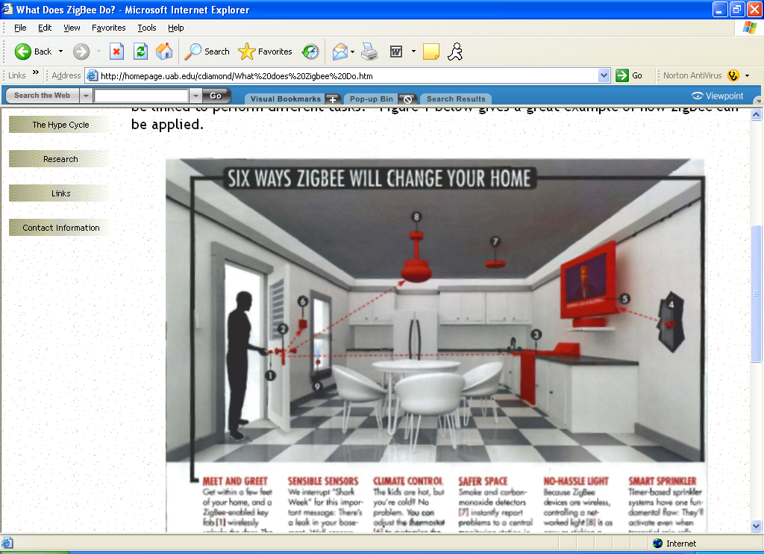

CONCLUSION

It is likely that ZigBee will increasingly play an important role in the future of computer and communication technology. The IEEE 802.15.4–based ZigBee is designed for remote controls and sensors, which are very many in number, but need only small data packets and, mainly, extremely low power consumption for (long) life. Therefore they are naturally different in their approach to their respective application areas. The ZigBee Alliance targets applications "Across consumer, commercial, industrial and Government markets worldwide". Unwired applications are highly sought after in many networks that are characterized by numerous nodes consuming minimum power and enjoying long battery lives. ZigBee technology is designed to best suit these applications, for the reason that it enables reduced costs of development and very fast market adoption. Here we proposed an idea of using ZigBee concept in parking lots to avoid chaos and traffic.

REFERENCES

1. www.ZigBee.com

2. http://www.ZigBee.org/en/documents/ZigBeeov

erview4.pdf

3.ZigBeeSpecification *v1.0*, ZigBee Alliance,

December 14th, 2004.

4. A. Goldsmith, WirelessCommunications, Cambridge University Press 2005.

5. Books of fundamentals of wireless communication.

6. www.meshnetics.com