Expt:1 (a)
<!DOCTYPE html>
<html lang="en">
<head>
<meta charset="UTF-8">
<meta name="viewport" content="width=device-width, initial-scale=1.0">
<title>Working with Lists in HTML</title>
</head>
<body style="background-color: rgba(7, 233, 249, 0.553);">
<h1 style="color: blue;"><center>Welcome To GIET Institutions</center></h1>

<h2>LIst Of GIET Institutions</h2>
<ol>
<li>GGU </li>
<li>GIET ENGINEERING</li>
<li>GIET DEGREE </li>
<li>GIET FORMACEY </li>
</ol>

<h2>LIst Of GIET Institutions Grounds</h2>
<ul>
<li>Cricket</li>
<li>Vally Boll</li>
<li>Busket Boll</li>
<li>Food Boll</li>
</ul>

<h2>Courses Available </h2>
<ul>
<li>GGU
<ul>
<li>CSE</li>
<ol>
<li>CSM</li>
<li>CSD</li>
<li>CSC</li>
</ol>
<li>ECE</li>
<li>EEE</li>
<li>CIVIL</li>
<li>MECH</li>
</ul>
</li>

</ul>

<h2>Definition List</h2>
<p>A definition list is used to display a list of terms and their corresponding definitions.</p>
<dl>
<dt>HTML</dt>
<dd>HTML stands for HyperText Markup Language, and it is the standard language for creating web pages.</dd>
<dt>CSS</dt>
<dd>CSS stands for Cascading Style Sheets, and it is used to style HTML elements on a webpage.</dd>
<dt>JavaScript</dt>
<dd>JavaScript is a programming language used to make web pages interactive.</dd>
</dl>

</body>
</html>

Output::


Expt:1 (b)
<!DOCTYPE html>
<html lang="en">
<head>
<meta charset="UTF-8">
<meta name="viewport" content="width=device-width, initial-scale=1.0">
<title>Working with Hyperlinks in HTML</title>
</head>
<body>
<h1>Understanding Hyperlinks in HTML</h1>

<h2> Basic Hyperlink using <code>&lt;a&gt;</code> and <code>href</code></h2>
<p>Click the link to visit Google:
<a href="https://www.google.com" >Go to Google</a></p>

<h2> Hyperlink Opening in a New Tab using <code>target</code> Attribute</h2>

<p>Click the link to visit Wikipedia, which will open in a new tab:
<a href="https://www.wikipedia.org" target="_blank">Go to Wikipedia</a></p>

<h2> Hyperlink to a Specific Section within the Same Page</h2>
<p>Click the link below to jump to the "Anchor Section" on this page:</p>
<a href="#anchor-section">Jump to Anchor Section</a>

<h2 id="anchor-section">Anchor Section</h2>
<p>This is an anchor section that can be linked to from another part of the page.</p>

<h2> Hyperlink to an Email Address</h2>
<p>Click the link below to open your email program and send an email to support@example.com:</p>
<a href="mailto:support@example.com">Send an Email</a>

<h2> Hyperlink to an contact via tel </h2>
<p>Click the link below to contact us via tel:
<a href="tel:+919999308832">contact us </a> for more info</p>

<h2> Hyperlink to a File</h2>
<p>You can also create hyperlinks to files (like PDF, Word documents, etc.) so that users can download them.</p>
<a href="C:\Users\egala\Downloads\Work Status - Mera SAHAI - Student dashboard (6).pdf" download>Download Sample PDF</a>

</body>
</html>
Output:: 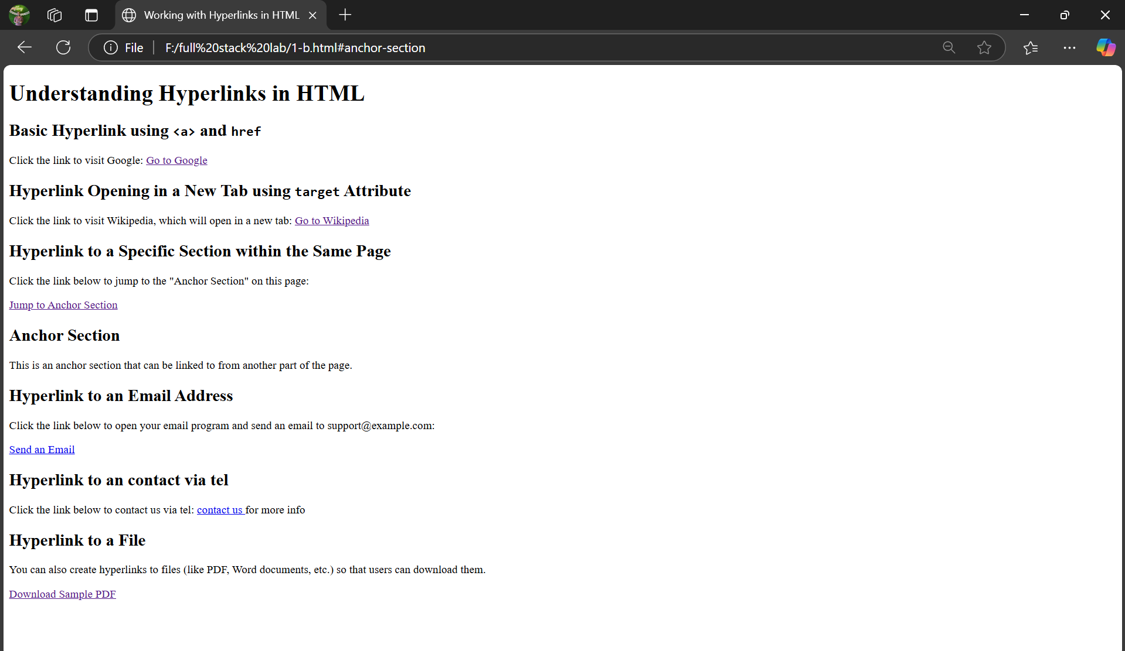

Expt:1 (c)
Note:Save with friend.html

<!DOCTYPE html>

<html lang="en">
<head>
<meta charset="UTF-8">

<meta name="viewport" content="width=device-width, initial-scale=1.0">

<title>Image</title>

</head>

<body>
<center>

<p>my friend image and click on image to visit my friend profile</p>
<a href="friend profile.html" target="_blank">
<img src=
"C:\Users\egala\OneDrive\Desktop\bhanu.jpg" alt="myfrndprofile" width="250" height="250">
</a>
<p>myfrndprofile</p>

<p>my image and click on image to visit my profile</p>
<a href="my profile.html" target="_blank">
<img src="C:\Users\egala\OneDrive\Desktop\kiran.jpg"alt="myprofile" width="250" height="250">
</a>
<p>myprofile</p>

</center>
</body>

</html>

Note:save with – friend profile.html

<html>

<head>

<title>My Profile</title>

<style>
body {

font-family: Arial, sans-serif;

margin: 20px;

line-height: 1.6;

h1 {

color: #333;
}

table {

width: 50%;

border-collapse: collapse;

margin: 20px auto;

}

th,
td {

border: 1px solid #ccc;

padding: 10px;

text-align: left;

th {

background-color: #f4f4f4;

}
</style>

</head>

<body>

<h1>My frnd Profile</h1>

<table>

<tr>

<th>Name</th>

<td>Bhanu</td>
</tr>

<tr>

<th>Date of Birth</th>

<td>04 04 2006</td>

</tr>

<tr>

<th>Department</th>

<td>CSE</td>

</tr>

<tr>

<th>Class</th>

<td>1st Year</td>

</tr>

<tr>

<th>Place</th>

<td>Ongole</td>

</tr>

<tr>

<th>Country</th>

<td>INDIA</td>

</tr>

<tr>

<th>Age</th>

<td>19</td>

</tr>

</table>

</body>
Note:save with – my profile.html

<html>

<head>

<title>My Profile</title>

<style>

body {

font-family: Arial, sans-serif;

margin: 20px;

line-height: 1.6;

h1 {

color: #333;

}

}

table {

width: 50%;

border-collapse: collapse;

margin: 20px auto;

}

th, td {

border: 1px solid #ccc;

padding: 10px;

text-align: left;

}

th {

background-color:
#f4f4f4;

}

</style>

</head>

<body>

<h1>My Profile</h1>

<table>

<tr>

<th>Name</th>

<td>kiran</td>

</tr>

<tr>

<th>Date of Birth</th>

<td>31 12 2005</td>

</tr>

<tr>

<th>Department</th>

<td>CSE</td>

</tr>

<tr>

<th>Class</th>

<td>2nd Year</td>

</tr>

<tr>

<th>Place</th>

<td>vizag</td>

</tr>

<tr>

<th>Country</th>

<td>INDIA</td>

</tr>

<tr>
<th>Age</th>

<td>19</td>

</tr>

</table>

</body>

</html>

Output:
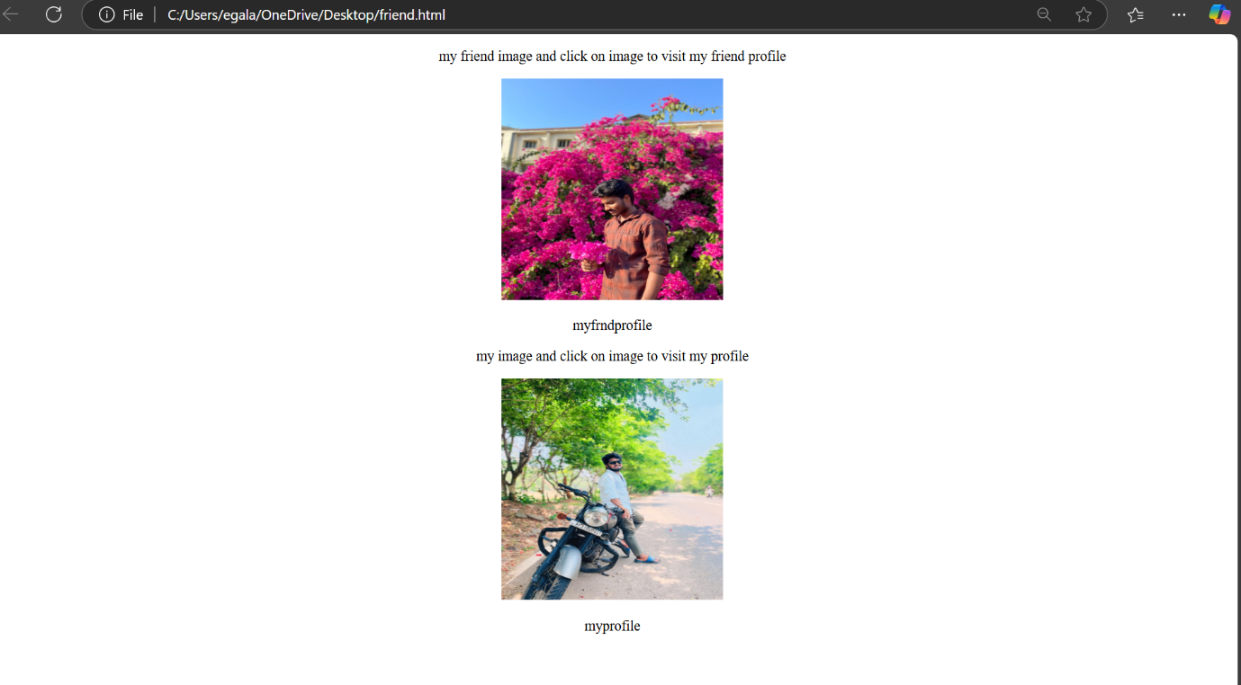

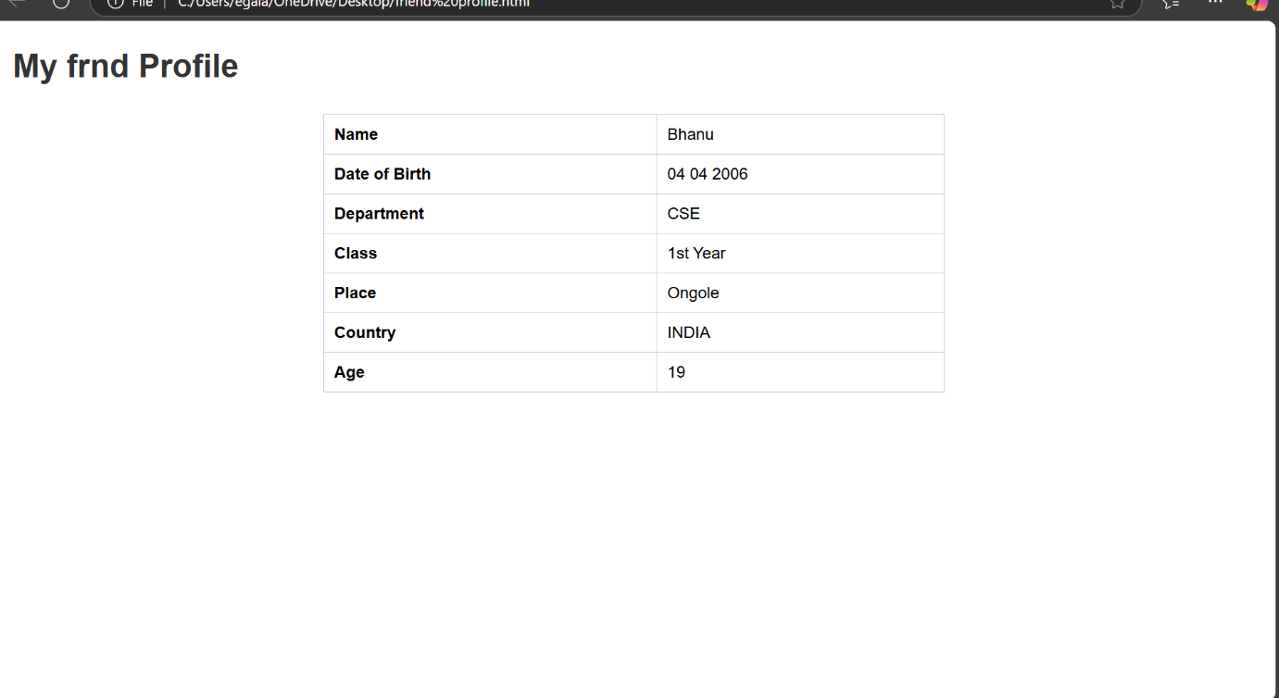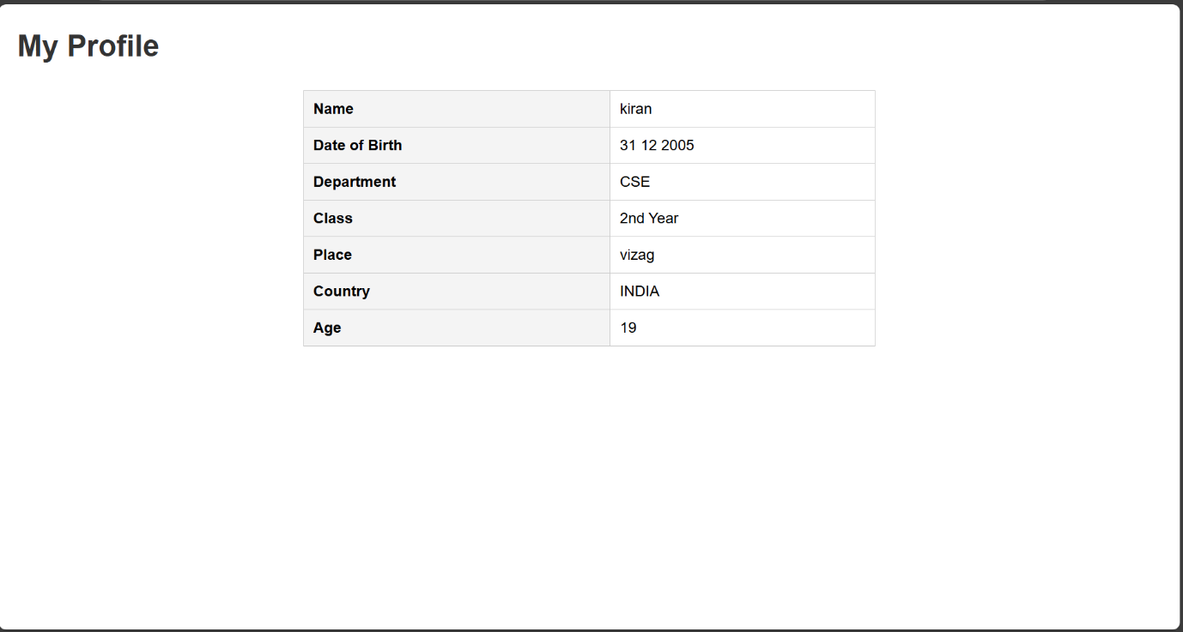

Expt:1 (d)

<!DOCTYPE html>
<html lang="en">
<head>
<meta charset="UTF-8">
<meta name="viewport" content="width=device-width, initial-scale=1.0">
<title>PANCHA BHOOTHALU</title>
<style>
body {
font-family: Arial, sans-serif;
text-align: center;
background-color: #f5f5f5;
}
.gallery {
display: flex;
flex-wrap: wrap;
justify-content: center;
gap: 10px;
padding: 20px;
}
.gallery a {
text-decoration: none;
}
.gallery img {
width: 100px;
height: 100px;
object-fit: cover;
border: 2px solid #ddd;
border-radius: 5px;
transition: transform 0.3s;
}
.gallery img:hover {
transform: scale(1.1);
border-color: #333;
}
</style>
</head>
<body>
<h2>PANCHA BOOTHALU</h2>
<div class="gallery">
<a href="https://th.bing.com/th/id/OIP.vfXiZ2AruG8DM0EEP28sawHaFj?rs=1&pid=ImgDetMain" target="_blank"><img src="https://th.bing.com/th/id/OIP.vfXiZ2AruG8DM0EEP28sawHaFj?rs=1&pid=ImgDetMain" alt="Image 1"><BR>SKY</a>
<a href="https://th.bing.com/th/id/OIP.3Ok8gnh9SIdwCFqXlLK_fwHaEK?rs=1&pid=ImgDetMain" target="_blank"><img src="https://th.bing.com/th/id/OIP.3Ok8gnh9SIdwCFqXlLK_fwHaEK?rs=1&pid=ImgDetMain" alt="Image 2"><BR>LAND</a>
<a href="https://c.pxhere.com/photos/4b/fe/ash_burn_calamity_camp_campfire_danger_fire_flame-1519861.jpg!d" target="_blank"><img src="https://c.pxhere.com/photos/4b/fe/ash_burn_calamity_camp_campfire_danger_fire_flame-1519861.jpg!d" alt="Image 3"><BR>FIRE</a>
<a href="https://th.bing.com/th/id/OIP.uiis928nX9mpStHm1WCzdQHaE8?rs=1&pid=ImgDetMain" target="_blank"><img src= "https://th.bing.com/th/id/OIP.uiis928nX9mpStHm1WCzdQHaE8?rs=1&pid=ImgDetMain" alt="Image 4"><BR>WATER</a>
<a href="https://images.all-free-download.com/images/graphiclarge/hd_sky_picture_01_hd_pictures_166302.jpg" target="_blank"><img src="https://images.all-free-download.com/images/graphiclarge/hd_sky_picture_01_hd_pictures_166302.jpg" alt="Image 5"><BR>AIR</a>
</div>
</body>
</html>

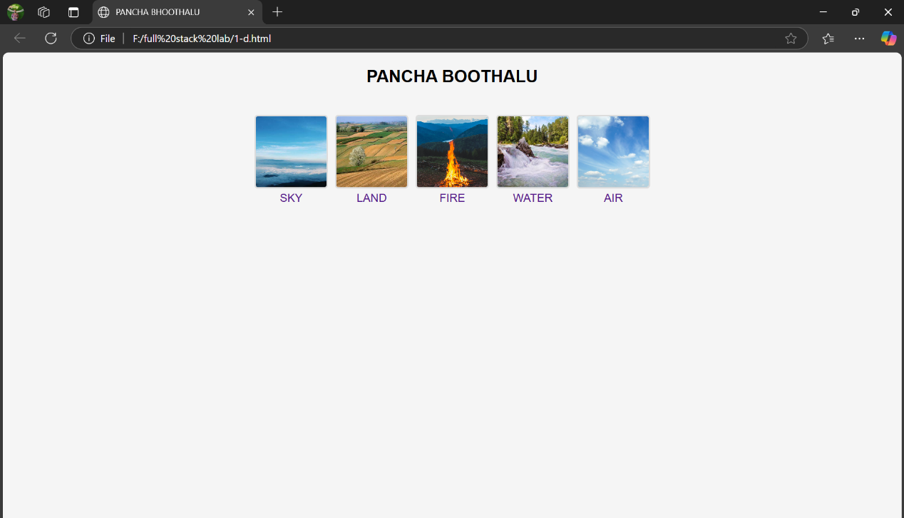

Expt:2 (a)
<!DOCTYPE html>
<html lang="en">
<head>
<meta charset="UTF-8">
<meta name="viewport" content="width=device-width, initial-scale=1.0">
<title>HTML Tables Example</title>
<style>
body {
font-family: Arial, sans-serif;
text-align: center;
background-color: #f5f5f5;
}
table {
width: 50%;
margin: 20px auto;
border-collapse: collapse;
background-color: white;
}
th, td {
border: 2px solid #333;
padding: 10px;
text-align: center;
}
th {
background-color: #ddd;
}
</style>
</head>
<body>
<h2>HTML Table Example</h2>
<table border="1">
<tr>
<th rowspan="2">Category</th>
<th colspan="2">Details</th>
</tr>
<tr>
<th>Name</th>
<th>Value</th>
</tr>
<tr>
<td rowspan="2">Fruit</td>
<td>Apple</td>
<td>Red</td>
</tr>
<tr>
<td>Banana</td>
<td>Yellow</td>
</tr>
<tr>
<td>Vegetable</td>
<td>Carrot</td>
<td>Orange</td>
</tr>
</table>
</body>
</html>

Output::
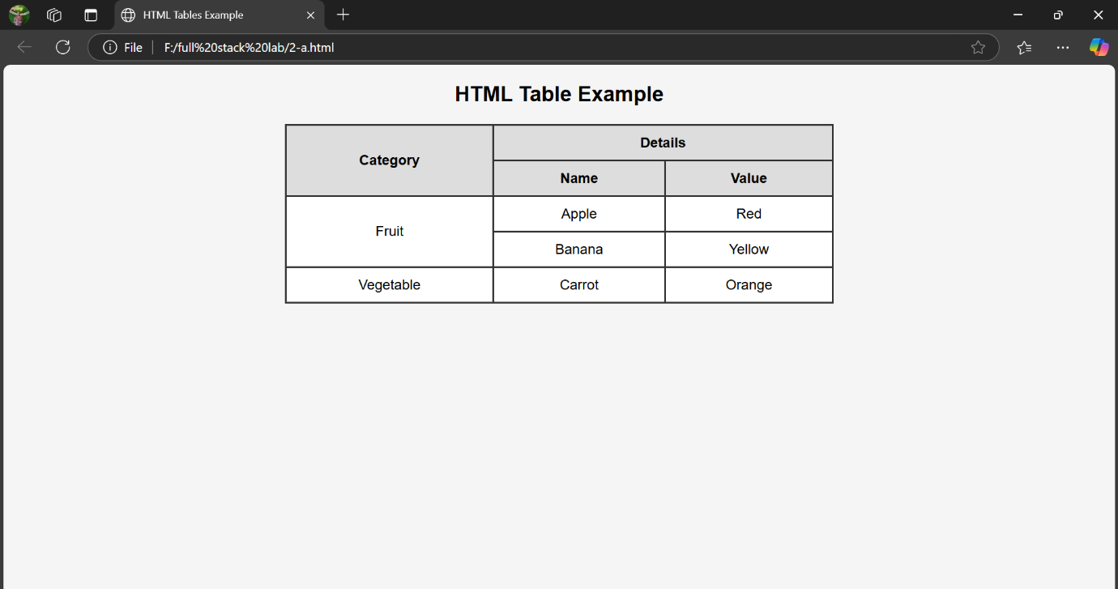

Expt:2 (b)
<!DOCTYPE html>
<html lang="en">
<head>
<meta charset="UTF-8">
<meta name="viewport" content="width=device-width, initial-scale=1.0">
<title>Timetable Example</title>
<style>
body {
font-family: Arial, sans-serif;
text-align: center;
background-color: #f5f5f5;
}
table {
width: 60%;
margin: 20px auto;
border-collapse: collapse;
background-color: white;
border: 2px solid #333;
cellspacing: 10;
cellpadding: 10;
}
th, td {
border: 2px solid #333;
padding: 10px;
text-align: center;
}
th {
background-color: #ddd;
}
</style>
</head>
<body>
<h2>CSE-C TIMETABLE</h2>
<table border="1" cellspacing="10" cellpadding="10">
<caption><strong>Weekly Class Timetable</strong></caption>
<tr>
<th rowspan="2">Day</th>
<th colspan="10">PERIODS</th>
</tr>
<tr>
<th >9:30-10:30</th>
<th >10:30-11:30</th>
<th >11:30-12:30</th>
<th >12:30-01:15</th>
<th >01:15-02:15</th>
<th >02:15-03:15</th>
<th >03:15-04:15</th>
</tr>
<tr>
<td>MONDAY</td>
<td colspan="3">OS-LAB</td>
<td rowspan="6">Lunch</td>
<td>DBMS</td>
<td>SE</td>

<td>MEFA</td>
</tr>
<tr>
<td>TUESDAY</td>
<td>OS</td>
<td>PS</td>
<td>MEFA</td>
<td colspan="3">DBMS-LAB</td>
</tr>
<tr>
<td>WEDNESDAY</td>
<td>PS</td>
<td>OS</td>
<td>DBMS</td>
<td colspan="3">FULL STACK-LAB</td>
</tr>
<tr>
<td>THURSDAY</td>
<td>OS</td>
<td>MEFA</td>
<td>PS</td>
<td>SE</td>
<td>DBMS</td>
<td>SE/LIB</td>
</tr>
<tr>
<td>FRIDAY</td>
<td>OS</td>
<td>PS(A)</td>
<td>DBMS</td>
<td>PS</td>
<td>SE(A)</td>
<td>MEFA(A)</td>
</tr>
<tr>
<td>SATURDAY</td>
<td>DTI</td>
<td>SE</td>
<td>DBMS(A)</td>
<td>OS(A)</td>
<td colspan="2">DIT-LAB</td>
</tr>
</table>
</body>
</html>
Output::
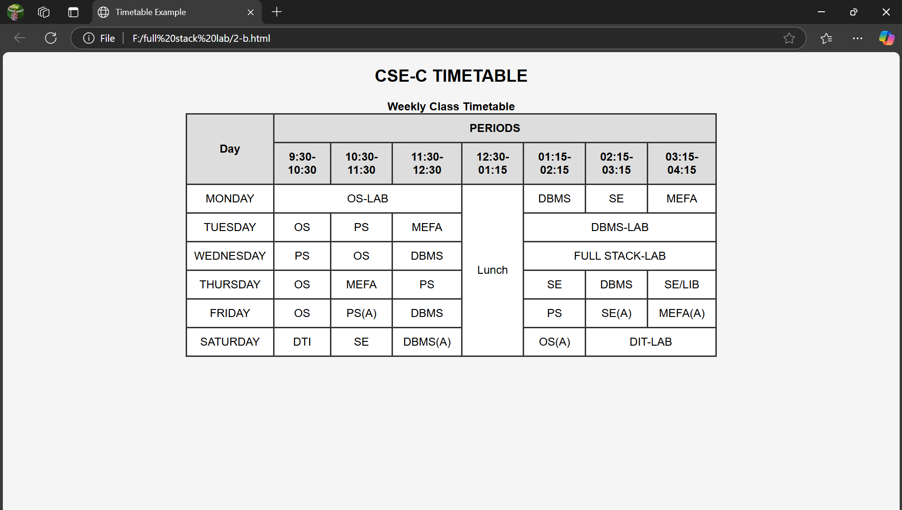

Expt:2 (c)
<!DOCTYPE html>
<html lang="en">
<head>
<meta charset="UTF-8">
<meta name="viewport" content="width=device-width, initial-scale=1.0">
<title>Registration Form</title>
<style>
body {
font-family: Arial, sans-serif;
text-align: center;
background-color: #f0f0f5;
margin: 0;
padding: 0;
}
.container {
width: 40%;
margin: 50px auto;
padding: 20px;
background-color: white;
border-radius: 10px;
box-shadow: 0 4px 8px rgba(0, 0, 0, 0.2);
}
.form-group {
margin-bottom: 15px;
text-align: left;
}
label {
font-weight: bold;
display: block;
margin-bottom: 5px;
}
input, select, textarea {
width: 100%;
padding: 10px;
margin-top: 5px;
border: 1px solid #ccc;
border-radius: 5px;
font-size: 16px;
}
.radio-group, .checkbox-group {
display:flex;
gap: 5px;
}
.buttons {
text-align: center;
margin-top: 20px;
}
input[type="submit"], input[type="reset"] {
width: 48%;
padding: 10px;
border: none;
font-size: 16px;
border-radius: 5px;
cursor: pointer;
transition: 0.3s;
}
input[type="submit"] {
background-color: #28a745;
color: white;
}
input[type="reset"] {
background-color: #dc3545;
color: white;
}
input[type="submit"]:hover {
background-color: #218838;
}
input[type="reset"]:hover {
background-color: #c82333;
}
</style>
</head>
<body>
<h2>Registration Form</h2>
<div class="container">
<form>
<div class="form-group">
<label>Full Name:</label>
<input type="text" name="fullname" placeholder="Enter Full Name" required>
</div>
<div class="form-group">
<label>Password:</label>
<input type="password" name="password" placeholder="Enter Password" required>
</div>
<div class="form-group">
<label>Age:</label>
<input type="number" name="age" placeholder="Enter Your age"required>
</div>
<div class="form-group">
<label>Date of Birth:</label>
<input type="date" name="dob" required>
</div>
<div class="form-group">
<label>Gender:</label>
<div class="radio-group">
<input type="radio" name="gender" value="male"> Male
<input type="radio" name="gender" value="female"> Female
</div>
</div>
<div class="form-group">
<label>Hobbies:</label>
<div class="checkbox-group">
<input type="checkbox" name="hobby1" value="Reading"> Reading
<input type="checkbox" name="hobby2" value="Sports"> Sports
<input type="checkbox" name="hobby3" value="Music"> Music
</div>
</div>
<div class="form-group">
<label>Country:</label>
<select name="country">
<option value="">Select</option>
<option value="usa">USA</option>
<option value="uk">UK</option>
<option value="india">India</option>
<option value="australia">Australia</option>
</select>
</div>
<div class="form-group">
<label>Address:</label>
<textarea name="address" rows="4" required></textarea>
</div>
<div class="buttons">
<input type="submit" value="Submit">
<input type="reset" value="Reset">
</div>
</form>
</div>
</body>
</html>

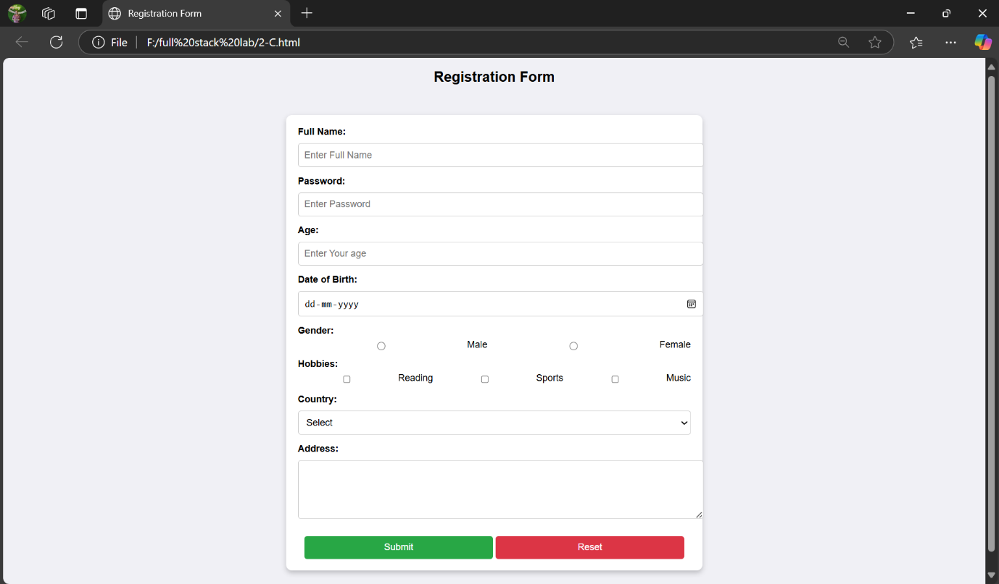

Expt:2 (d):
frames.html
<!DOCTYPE html>
<html>

<head>
<title>Frameset Example</title>
</head>
<frameset cols="33%, 33%, 34%">
<frame src="image.html" name="imageFrame">
<frame src="paragraph.html" name="paraFrame">
<frame src="link.html" name="linkFrame">
<noframes>

<body>
<p>Your browser does not support frames. Please update your browser.</p>
</body>
</noframes>
</frameset>

</html>

Image.html

<!DOCTYPE html>
<html>

<head>
<title>Image Frame</title>
</head>

<body>
<img src="https://i.pinimg.com/originals/96/a5/39/96a539ff1c01448923fb98b00a8ac401.jpg"
alt="Example Image" width="100%">
</body>

</html>
paragraph.html

<!DOCTYPE html>
<html>

<head>
<title>Paragraph Frame</title>
</head>

<body>
<p>The Labrador breed dates back to at least the 1830s, when St. John's water dogs bred by European settlers in
Newfoundland were first introduced to Britain from ships trading between Canada and Poole in Dorset. These were
then bred with British hunting dogs to create what became known as the Labrador Retriever. Its early patrons
included the Earl of Malmesbury, the Duke of Buccleuch, the Earl of Home, and Sir John Scott. Early writers have
confused the Labrador with the much larger Newfoundland and the Lesser Newfoundland, with Charles St. John even
referring to the Lesser Newfoundland as the Newfoundland. Colonel Peter Hawker describes the first Labrador as
being not larger than an English Pointer, more often black than other colours, long in its head and nose with a
deep chest, fine legs, and short and smooth coat, and did not carry its tail as highly as the Newfoundland.
Hawker distinguishes the Newfoundland from both the "proper Labrador" and St. John's breed of these dogs
in the fifth edition of his book Instructions to Young Sportsmen, published in 1846.</p>
</body>

</html>
link.html
<!DOCTYPE html>
<html>

<head>
<title>Link Frame</title>
</head>

<body>
<p>For more information click on the link</p>
<a href="https://en.wikipedia.org/wiki/Labrador_Retriever" target="_blank">Click here to visit</a>
</body>

</html>
Output::
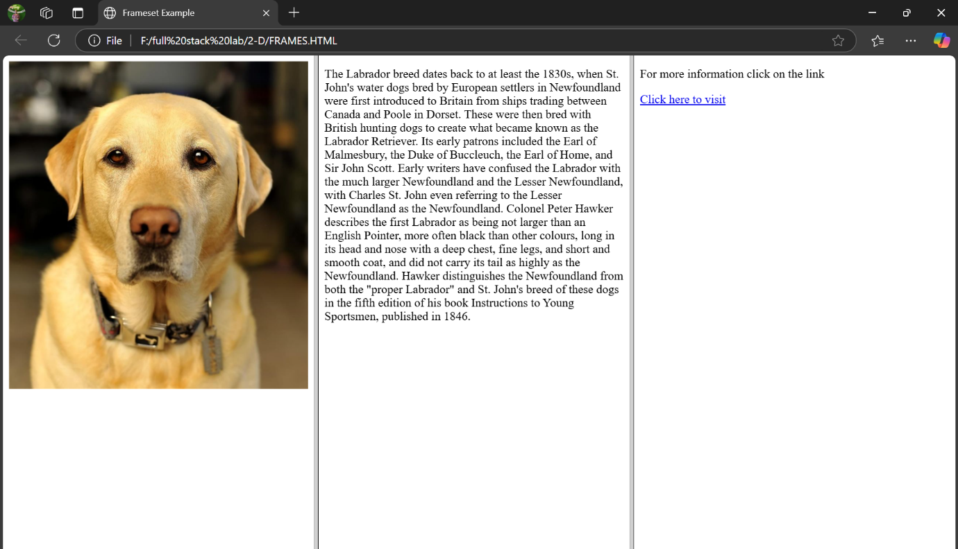

Expt:3 (a)
<!DOCTYPE html>
<html lang="en">

<head>
<meta charset="UTF-8">
<meta name="viewport" content="width=device-width, initial-scale=1.0">
<title>HTML5 Semantic Elements Example</title>
<style>
body {
font-family: Arial, sans-serif;
margin: 0;
padding: 0;
background-color: #f4f4f4;
}

header,
nav,
main,
footer {
padding: 20px;

background: white;
margin: 10px;
border-radius: 5px;
box-shadow: 2px 2px 10px rgba(0, 0, 0, 0.1);
}

nav ul {
list-style-type: none;
padding: 0;
}

nav ul li {
display: inline-flex;
margin-right: 15px;
}

article {
background: #fff;
padding: 15px;
margin: 10px 0;
border-radius: 5px;
box-shadow: 2px 2px 8px rgba(0, 0, 0, 0.1);
}

aside {
background: #ddd;
padding: 15px;
border-radius: 5px;
}

figure {
margin: 10px 0px 0px 0px;
text-align: center;
}

figcaption {
font-style: italic;
margin-top: 5px;
}

footer {
text-align: center;
margin-top: 20px;
}
</style>
</head>

<body>
<header>
<h1>
<center>welcome to My Website</center>
</h1>
</header>

<nav>
<ul>
<li><a href="#">Home</a></li>
<li><a href="https://sharefood.eatrightindia.gov.in/">About</a></li>
<li><a href="kiran@gmail.com">Contact</a></li>
</ul>
</nav>

<main>
<section>
<article>
<h2>Save Food</h2>
<p> It refers to the conditions and practices that preserve the quality of food to prevent contamination
and food-borne illnesses. Safe food does not contain any poisonous, deleterious, or disease-causing
substance or
microorganisms that may render such food injurious to human health</p>
</article>
</section>

<aside>
<h3>Save Food - Share Food</h3>
<p>Food Safety can be defined as the ways and methods that are adopted to ensure that food is fit to be
eaten. It aims at avoiding, minimising, and controlling risks that are biological, chemical and physical
in nature and can cause illnesses or injuries associated with foods. </p>
</aside>

<figure>
<img src="https://edpost.education/images/2021/03/1_hWWewefMOsKjve8b6O6Egw-thegem-blog-timeline-large.jpeg"
alt="Example Image" width="300">
<figcaption>today's waste is tomarow's shortage</figcaption>
</figure>
</main>

<footer>
<p>&copy; 2025 My Website. All rights reserved.</p>
</footer>
</body>

</html>

Output::
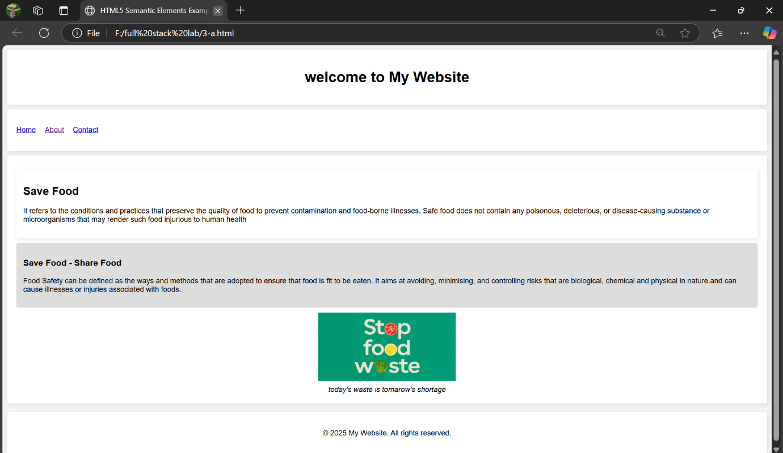

Expt:3 (b):

<!DOCTYPE html>
<html lang="en">
<head>
<meta charset="UTF-8">
<meta name="viewport" content="width=device-width, initial-scale=1.0">
<title>Embed Audio and Video</title>
<style>
body {
font-family: Arial, sans-serif;
text-align: center;
background-color: #f4f4f4;
padding: 100px;
}
.container {
background: white;
padding: 20px;
border-radius: 10px;
box-shadow: 2px 2px 10px rgba(0,0,0,0.1);
display: inline-block;
text-align: left;
}
h2 {
color: #333;
}
</style>
</head>
<body>
<div class="container">
<h2> Audio</h2>
<audio controls>
<source src="C:\Users\egala\Music\Neeve-SenSongsMp3.Co.mp3" type="audio/mpeg">
<source src="audio.ogg" type="audio/ogg">
Your browser does not support the audio element.
</audio>

<h2> Video</h2>
<video controls width="500" autoplay loop muted>
<source src="C:\Users\egala\Downloads\Full Video： Adigaa ｜ Hi Nanna ｜ Nani, Mrunal Thakur ｜ Hesham Abdul Wahab ｜ Krishna Kanth ｜ Shouryuv.mp4" type="video/mp4">
<source src="video.ogg" type="video/ogg">
Your browser does not support the video tag.
</video>
</div>
</body>
</html>

Output::
