# PROJECT TITLE: CRM APPLICATION FOR JEWEL MANAGEMENT

College Name: AG ARTS AND SCIENCE COLLEGE, AVINASHIPALAYAM, TIRUPPUR (638660)

College Code: bru5r

Team ID:NM2025TMID21799

Team Leader Name: VIJAY R

Email: vijayvijay171817@gmail.com

Team Member 1: THIRISHA C

Email: shathiri18@gmail.com

Team Member 2: VASEEMA BEGUM S

Email: vaseemabegum9884791425@gmail.com

Team Member 3: VISWANATHAN L

Email: lviswa09@gmail.com

1. INTRODUCTION
   1. Project overview

CRM application for a jewelry management project aims to improve customer relationships, streamline sales and marketing processes, and centralize customer data to foster growth. Itinclude managing customer proﬁles, tracking purchase history, enabling personalized communication, and analyzing customer behavior to offer purpose tailored recommendations and conduct targeted marketing campaigns. By centralizing information and automating tasks, a jewelry CRM enhances customer satisfaction, drives loyalty, and provides valuable insights for better business decisions and increased sales.

* 1. Purpose

The main purpose of the project is to:

Gathers data on preferences, buying history, and behaviors to personalize outreach and improve satisfaction.

Tracks inquiries and sales leads, automates follow- ups, and enables personalized marketing campaigns based on customer data.

Analyzes sales data to identify top- selling and slow- moving items, helping to optimize stock levels.

Streamlines communication, handles customer feedback, and provides personalized support by documenting all interactions.

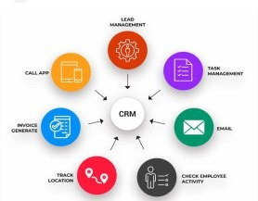

Enhances sales eﬃciency and provides a comprehensive view of the business to facilitate growth

1. DEVELOPMENT PHASE

Creating Developer Account

The project was developed on salesforce developer org, created via: https://developer.salesforce.com/signup

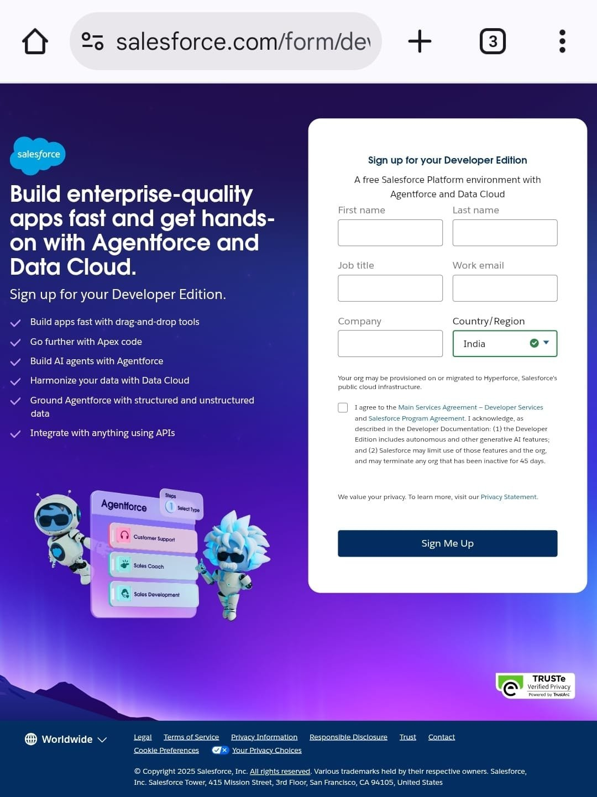

Object Created

Jewel customer – To store and manage information about customer.

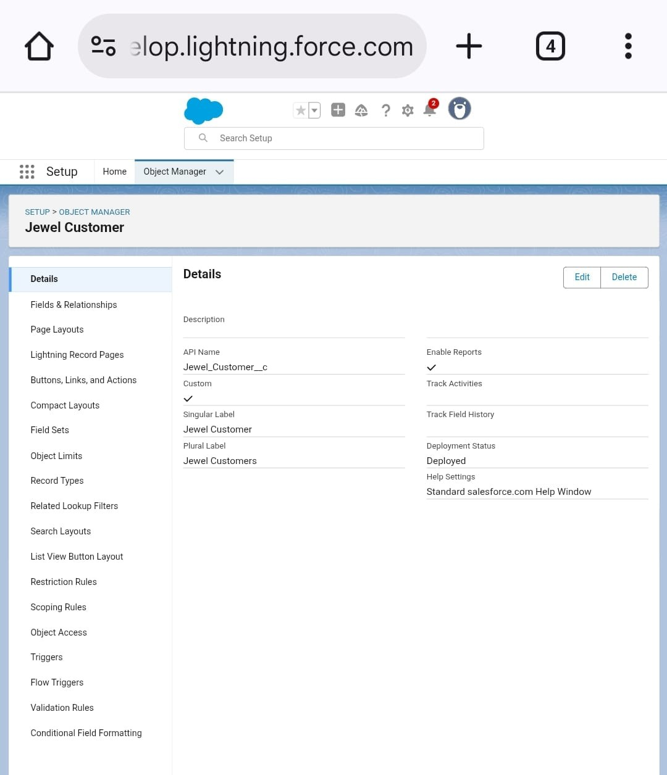

Custom Tabs – Custom object look and behave like the standard tabs provided with salesforce.

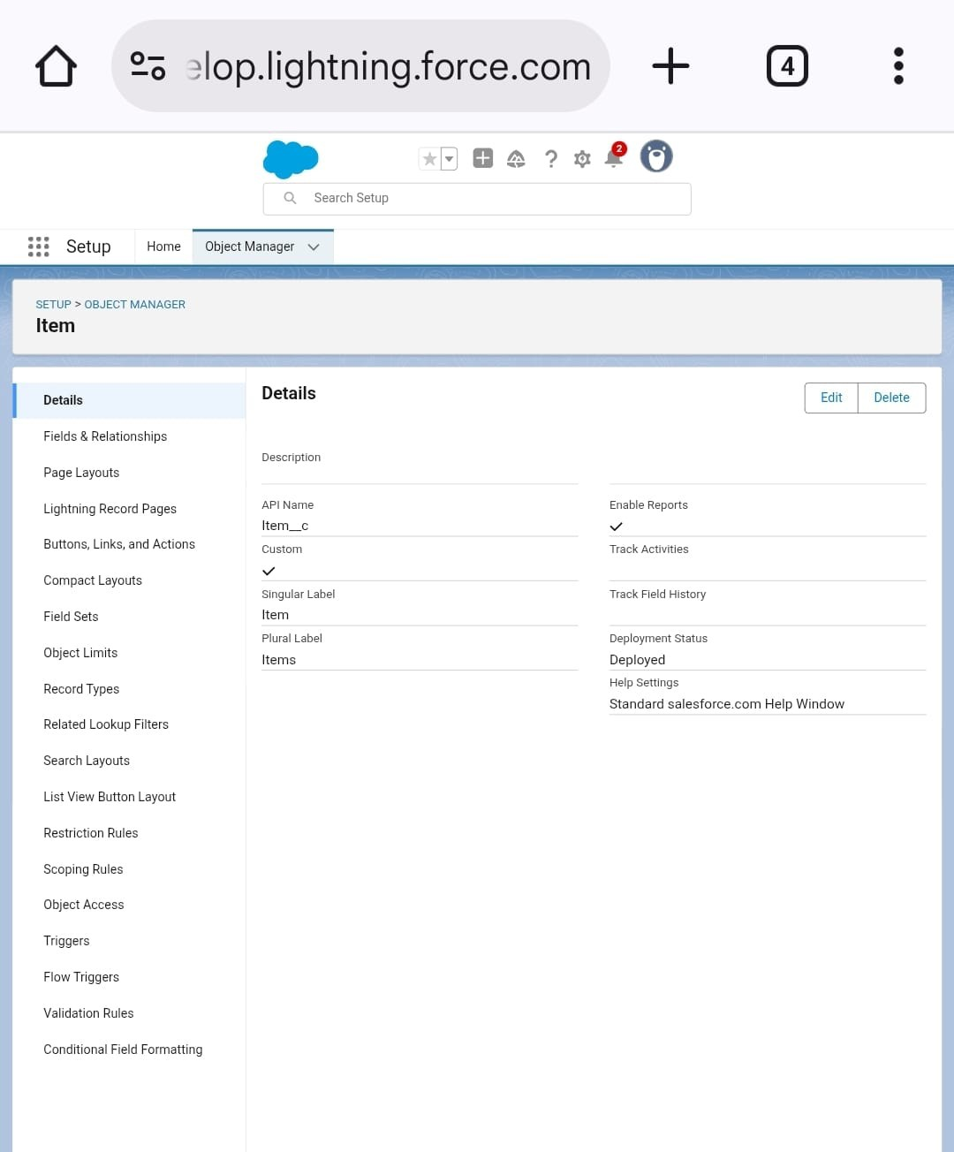

Fields validation rules – Creating the validation rules for postal code ﬁeld in jewel customer object.

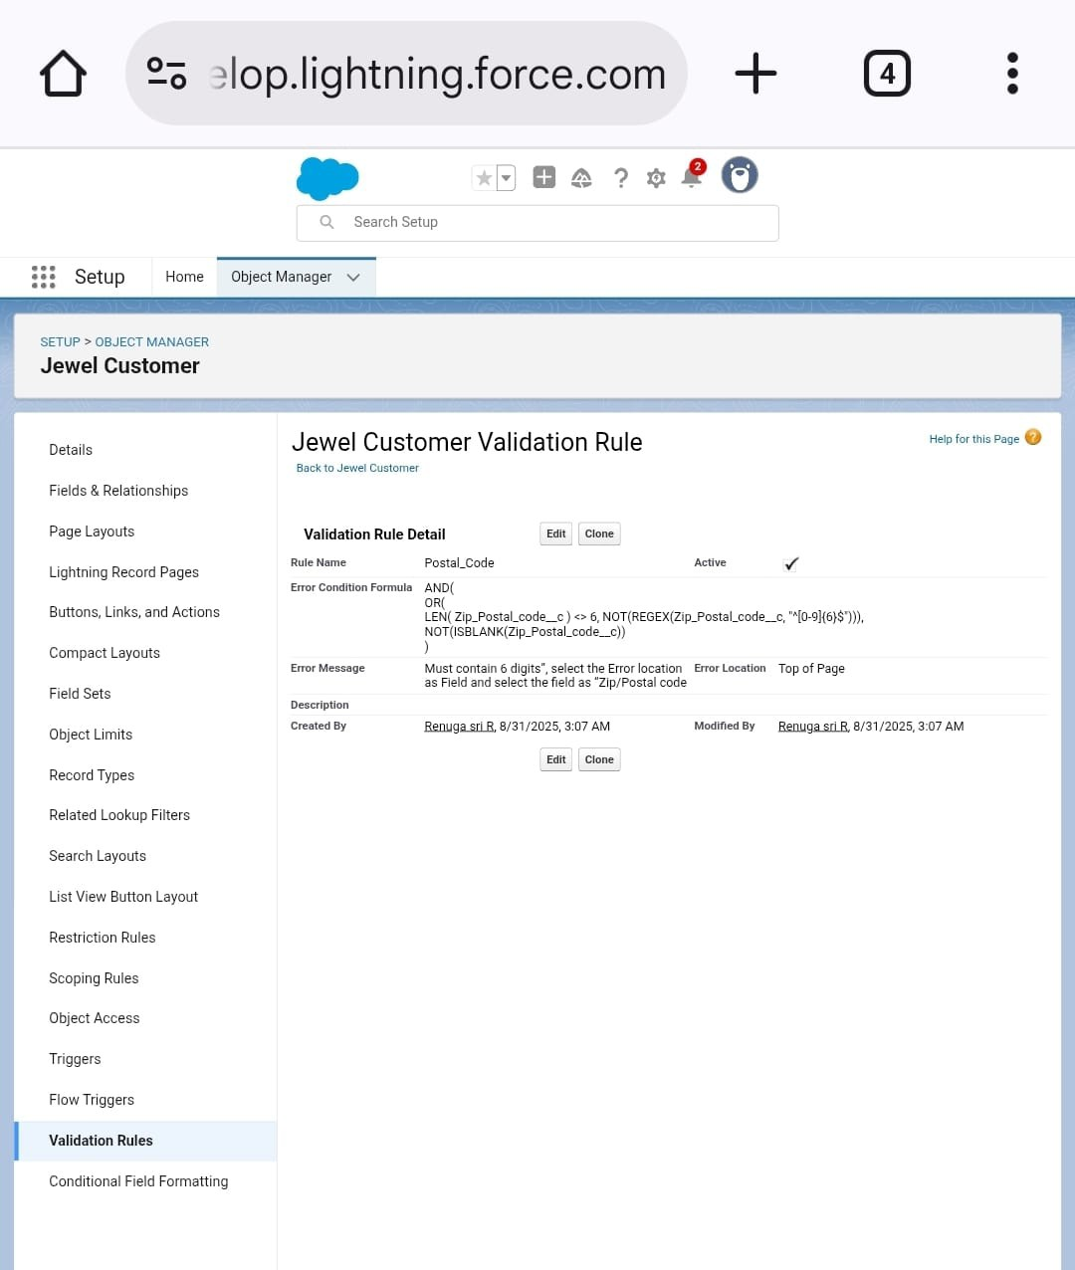

Roles for gold smith - A Role is user visibility access at the record level. Gold – Expand all and click on add role.

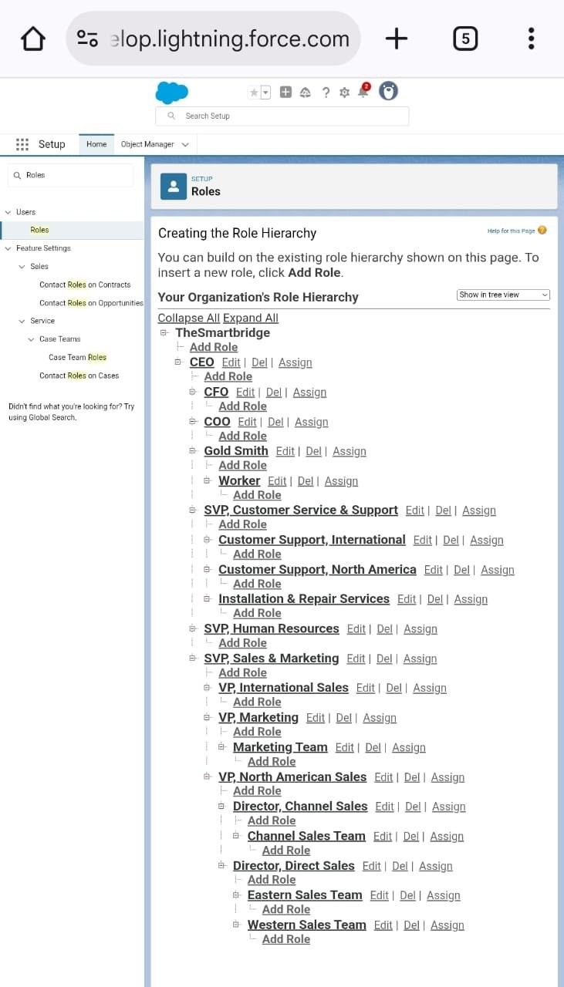

Users – To create two more user in same proﬁle.

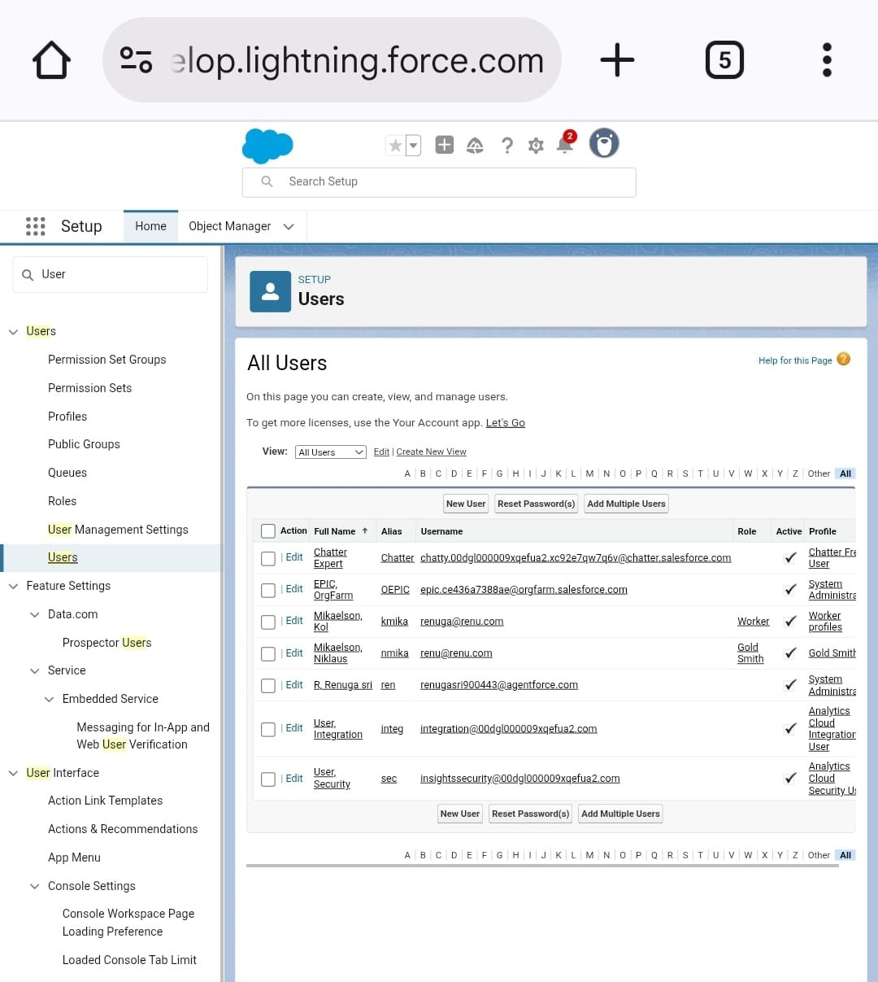

Page layout for gold and silver – A Page layout us to allow customise design and organise detail and edit page of records.

Gold – Click the object manager in page layout, to create the gold page layout. Silver – Like same procedure the silver page layout also.

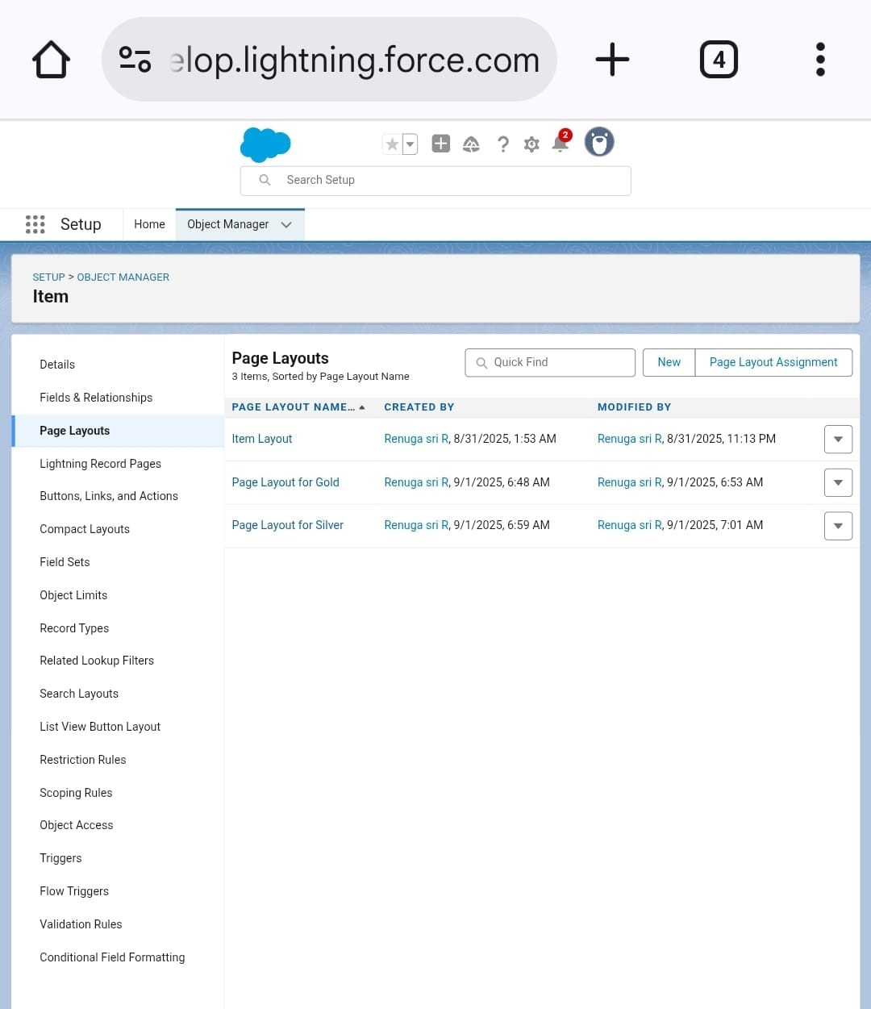

Record Types – Record types are a way of grouping many records of one type for that object. Record types allow administrators to create a different page layout with custom picklist ﬁelds and values for the same business process and various business process.

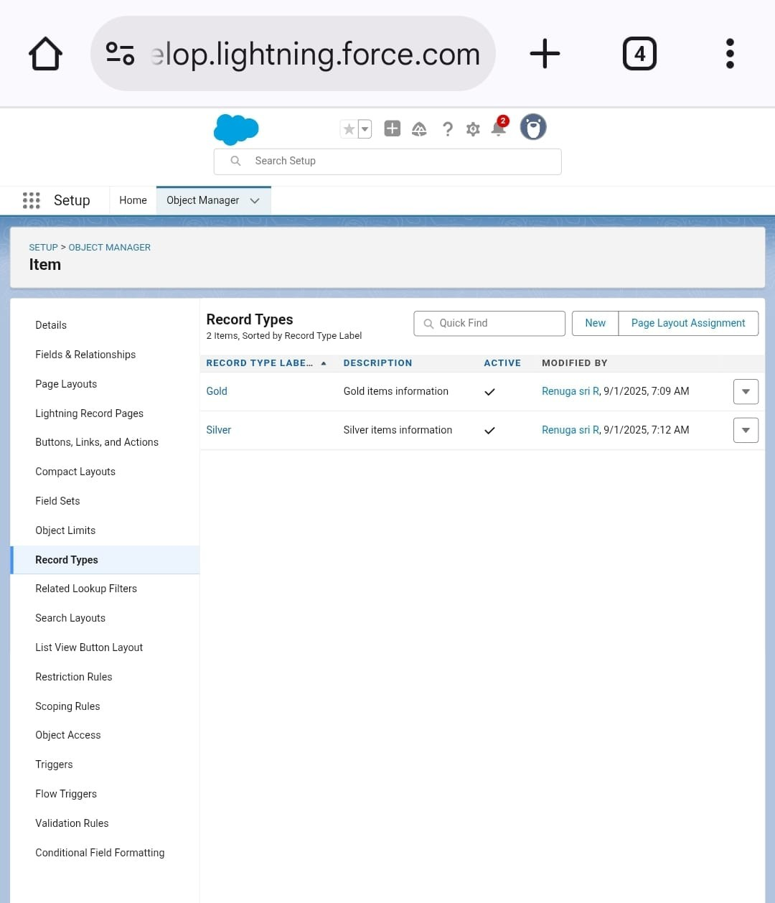

User Adoption – you perform user management tasks like creating and editing users, resetting passwords, granting permissions, conﬁguration data access and much more.

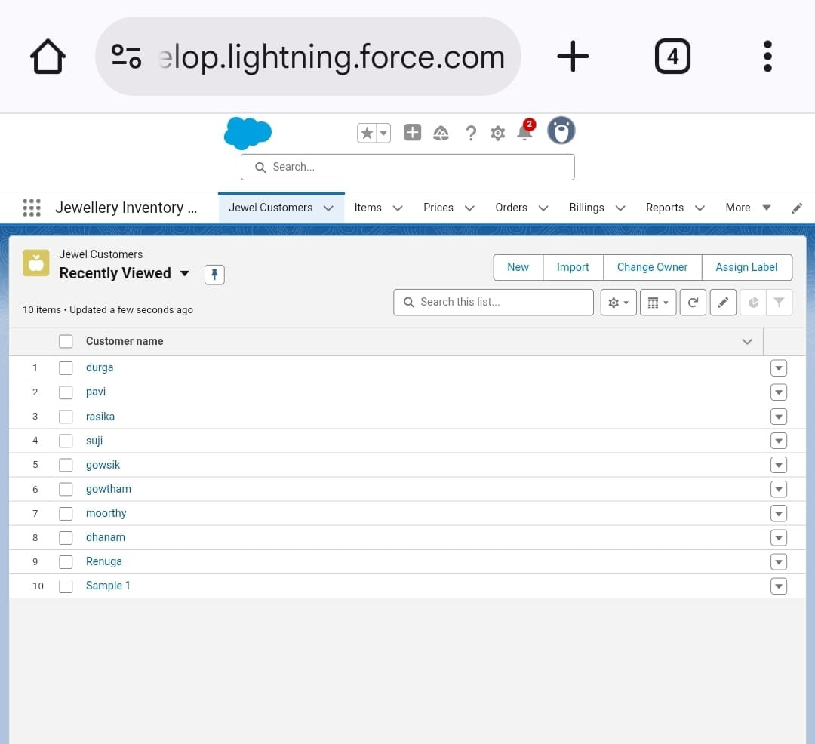

1. IMPLEMENTATION

Proﬁles – A Proﬁle is a group of setting and permission that deﬁne what a user can do. Proﬁle controls “object permission, ﬁeld permission, user permission, tab setting, app setting, apex class access, page layout, record types”.

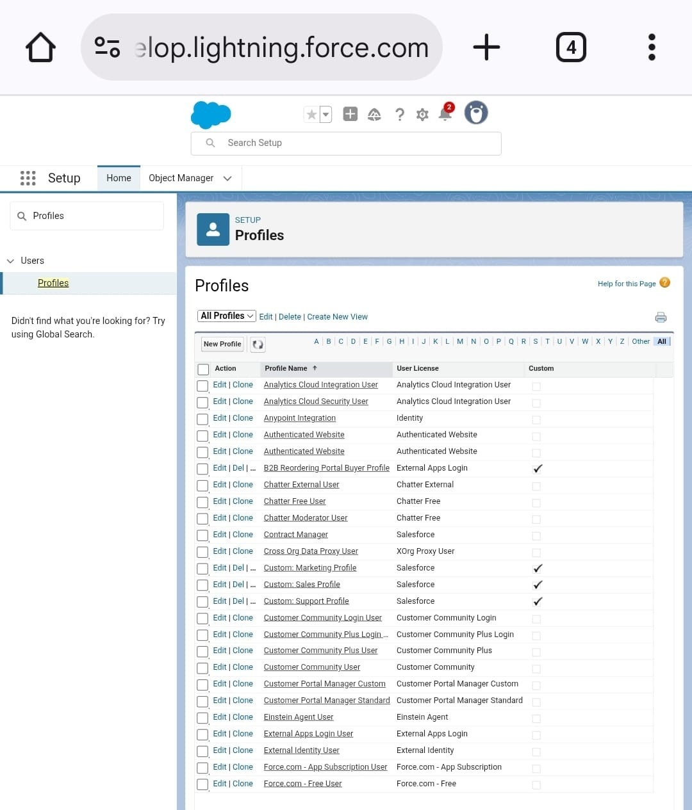

The lightening app – It is used to create a CRM Application for jewel management, which show as a dashboard in that it allows us to provide the data, reports, etc….,

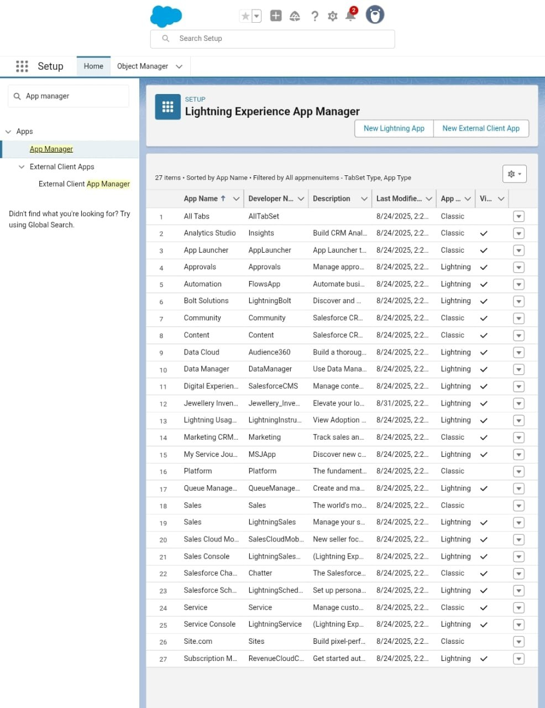

Text ﬁeld: A Text ﬁeld is used whenever you need to capture describe or alphanumeric details that identify, describe, or provide context about jewel items, supplier, or transaction.

Apex class – auto calculate total cost from order items.

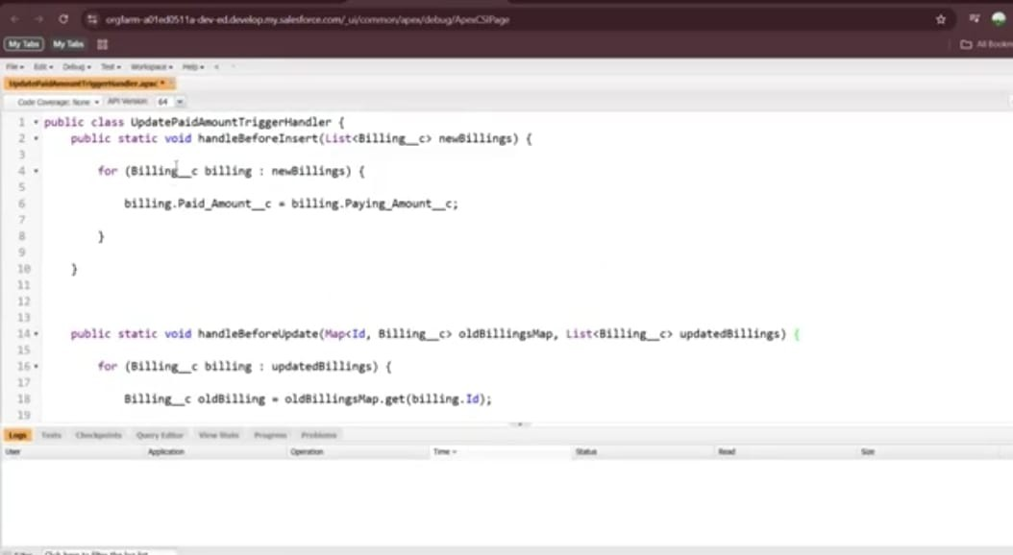

Apex trigger – auto calculate total cost from order item.

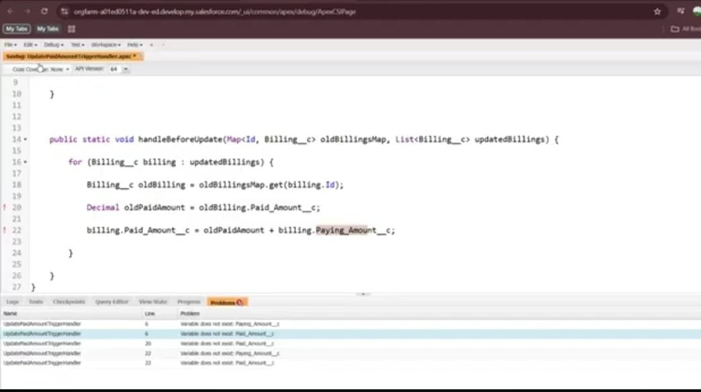

Error handling: Resolved the issues “paying amount”, “paid amount” not found in the ﬁeld, so create these ﬁelds.

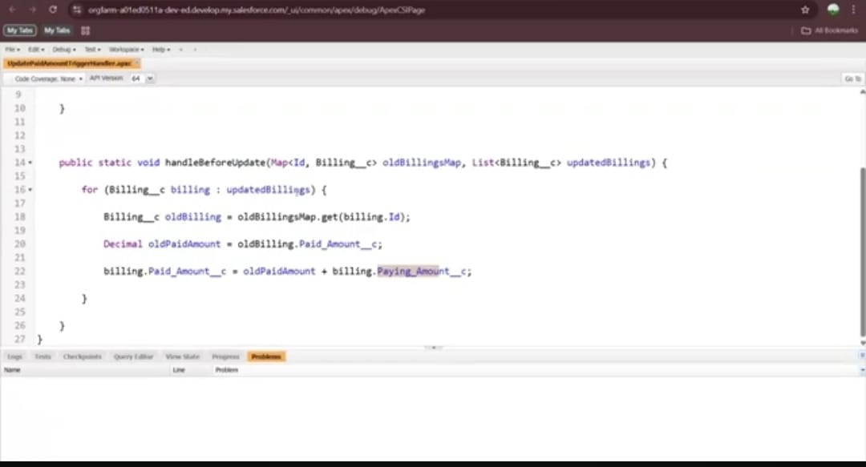

Result

Output screenshots to be inserted.

Permission sets: Permission sets in CRM Application for jewel management are used to give additional access to users to users without changing their proﬁle. They allow speciﬁc staff to perform extra tasks like updating stock, purchase order, or viewing reports when needed.

Flows: ﬂows in CRM Application for jewel management system are used to automate processes like updating stock after a purchase order, sending alerts for low inventory or expired stocks, and reducing manual work to improve accuracy and eﬃciency.

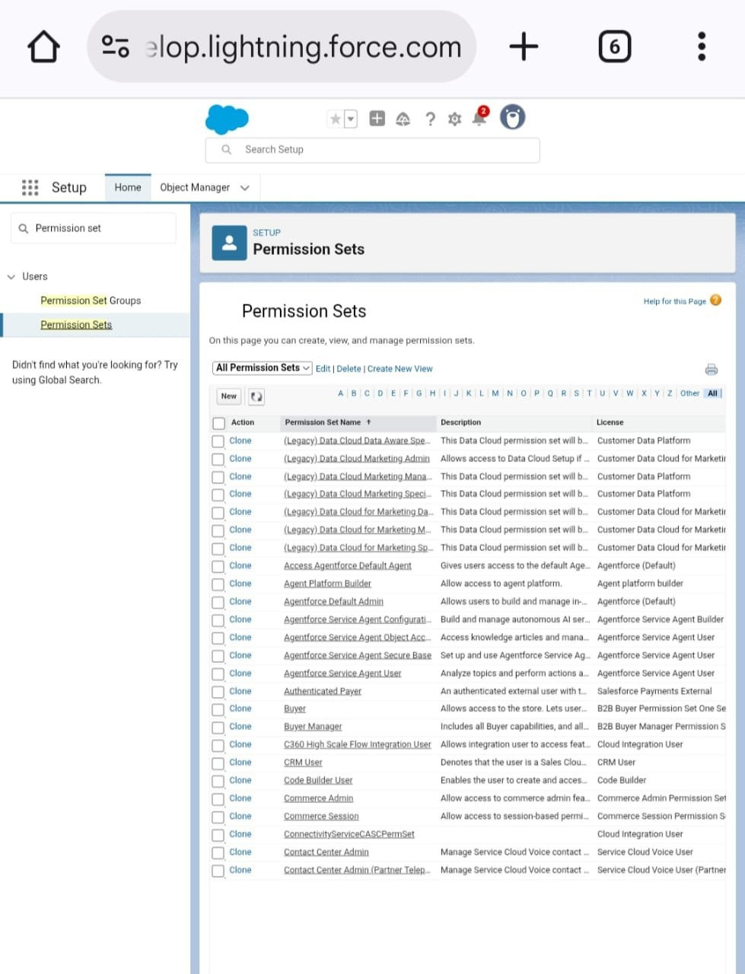

Dashboard: Dashboard help you visually understand changing business

condition so you can make decision based on the real- time data you have gathered with reports.

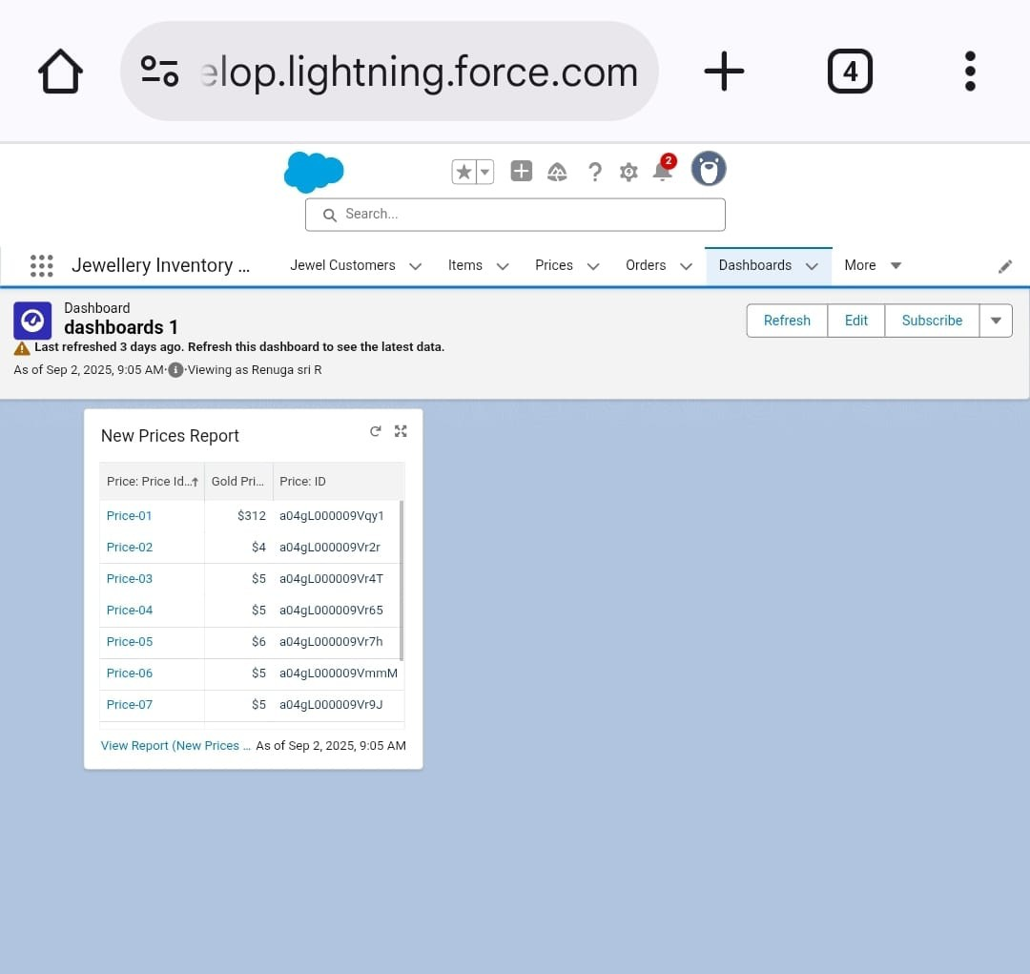

Reports: Report give you access to your data.

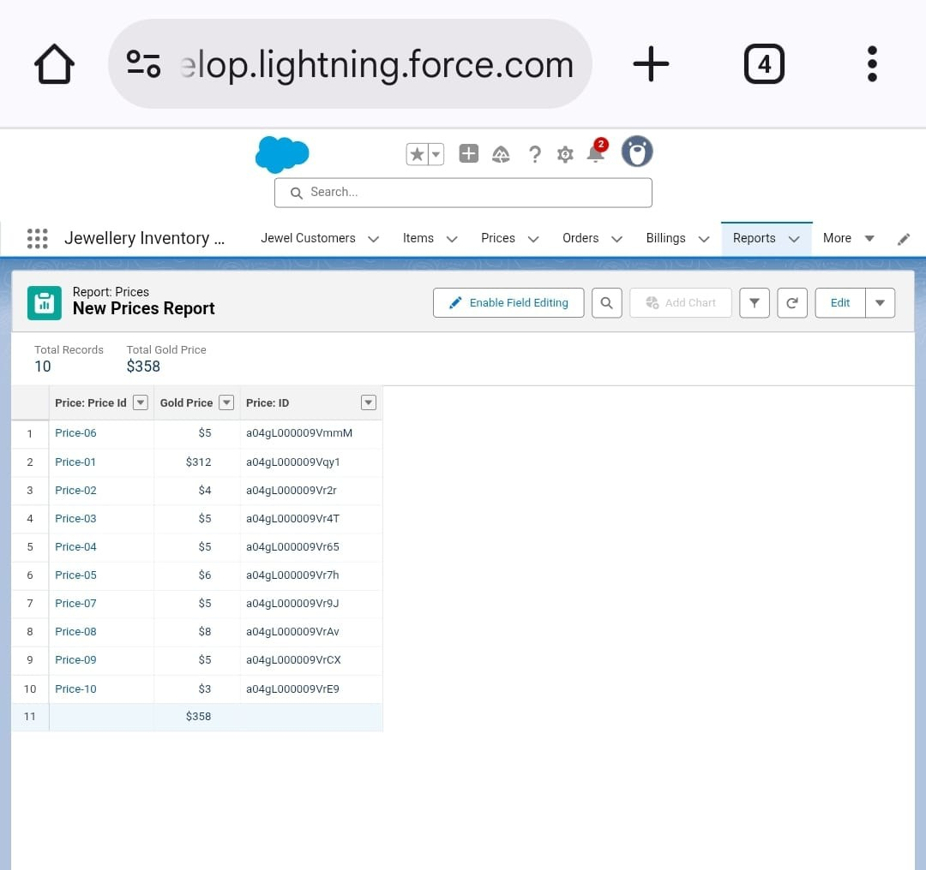

Flows: A Flow is a powerful tool that allow you to automate business processes, collect and update data, and guide user through a series of screens or steps.

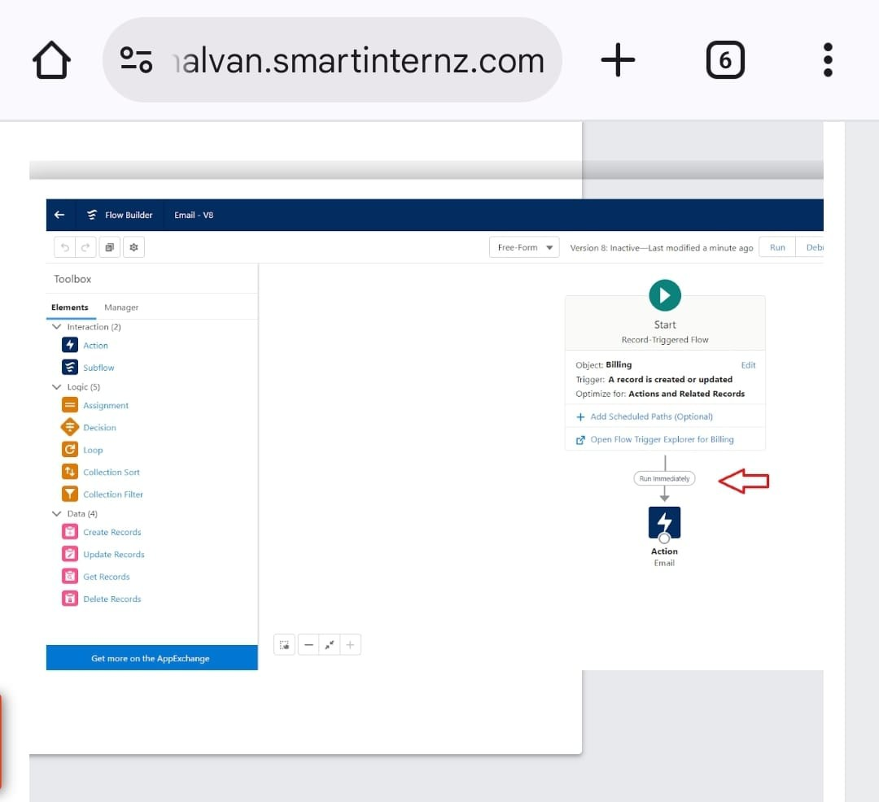

# Advantages and disadvantage

Advantage

CRM helps manage customer data, allowing jewel to understand individual preferences and offer tailored recommendations and services, leading to a better customer experience.

The CRM With detailed customer proﬁles and buying history, jewel can identify proﬁtable customer segments and create targeted marketing campaigns, increasing conversion rates.

CRM can integrate with inventory and sales systems, providing a consolidated view of stock and customer interactions, which streamlines operations.

Disadvantage

Implementing a CRM system can involve signiﬁcant costs for software, customization, and initial training, which might be a barrier for

smaller businesses.

Storing sensitive customer and inventory data in a centralized database raises concerns about potential breaches or unauthorized access, requiring strong security measures.

Staff may resist adopting new technology and workﬂows, especially if they are unfamiliar with the system or perceive it as a threat to their r

# Conclusion

it is a business strategy and toolset for building strong, lasting customer relationships through centralized data, personalized experiences, and streamlined processes, ultimately driving growth, proﬁtability, and customer loyalty. By providing valuable insights and automating tasks, CRM helps businesses foster trust, understand customer needs, and deliver superior value, making it a cornerstone of successful, customer- centric operations