1.Design a simple calculator, and set properties using .xml file

Mainactivity.

<?xml version="1.0" encoding="utf-8"?>

<androidx.constraintlayout.widget.ConstraintLayout xmlns:android="http://schemas.android.com/apk/res/android"

xmlns:app="http://schemas.android.com/apk/res-auto"

xmlns:tools="http://schemas.android.com/tools"

android:layout_width="match_parent"

android:layout_height="match_parent"

tools:context=".MainActivity">

<Button

android:id="@+id/button5"

android:layout_width="wrap_content"

android:layout_height="wrap_content"

android:text="submit"

tools:layout_editor_absoluteX="169dp"

tools:layout_editor_absoluteY="360dp" />

<EditText

android:id="@+id/editTextNumberDecimal2"

android:layout_width="wrap_content"

android:layout_height="wrap_content"

android:ems="10"

android:inputType="numberDecimal"

tools:layout_editor_absoluteX="169dp"

tools:layout_editor_absoluteY="161dp" />

<EditText

android:id="@+id/editTextNumberDecimal4"

android:layout_width="wrap_content"

android:layout_height="wrap_content"

android:ems="10"

android:inputType="numberDecimal"

tools:layout_editor_absoluteX="169dp"

tools:layout_editor_absoluteY="105dp" />

<EditText

android:id="@+id/editTextNumberDecimal3"

android:layout_width="wrap_content"

android:layout_height="wrap_content"

android:ems="10"

android:inputType="numberDecimal"

tools:layout_editor_absoluteX="171dp"

tools:layout_editor_absoluteY="53dp" />

<Button

android:id="@+id/button"

android:layout_width="wrap_content"

android:layout_height="wrap_content"

android:text="ADD"

tools:layout_editor_absoluteX="33dp"

tools:layout_editor_absoluteY="286dp" />

<Button

android:id="@+id/button4"

android:layout_width="wrap_content"

android:layout_height="wrap_content"

android:text="div"

tools:layout_editor_absoluteX="33dp"

tools:layout_editor_absoluteY="360dp" />

<Button

android:id="@+id/button2"

android:layout_width="wrap_content"

android:layout_height="wrap_content"

android:text="SUB"

tools:layout_editor_absoluteX="169dp"

tools:layout_editor_absoluteY="288dp" />

<Button

android:id="@+id/button3"

android:layout_width="wrap_content"

android:layout_height="wrap_content"

android:text="MUL"

tools:layout_editor_absoluteX="287dp"

tools:layout_editor_absoluteY="286dp" />

<TextView

android:id="@+id/textView"

android:layout_width="87dp"

android:layout_height="35dp"

android:text="First number"

tools:layout_editor_absoluteX="57dp"

tools:layout_editor_absoluteY="63dp" />

<TextView

android:id="@+id/textView2"

android:layout_width="83dp"

android:layout_height="34dp"

android:text="Second number"

tools:layout_editor_absoluteX="57dp"

tools:layout_editor_absoluteY="116dp" />

<TextView

android:id="@+id/textView3"

android:layout_width="83dp"

android:layout_height="34dp"

android:text="ANSWER"

tools:layout_editor_absoluteX="57dp"

tools:layout_editor_absoluteY="161dp" />

</androidx.constraintlayout.widget.ConstraintLayout>

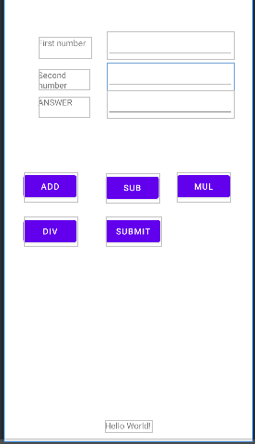

2.. Develop an application for a simple registration page using .xml file

<?xml version="1.0" encoding="utf-8"?>

<androidx.constraintlayout.widget.ConstraintLayout xmlns:android="http://schemas.android.com/apk/res/android"

xmlns:app="http://schemas.android.com/apk/res-auto"

xmlns:tools="http://schemas.android.com/tools"

android:layout_width="match_parent"

android:layout_height="match_parent"

tools:context=".MainActivity">

<TextView

android:id="@+id/textView3"

android:layout_width="148dp"

android:layout_height="27dp"

android:layout_marginStart="16dp"

android:text="first name"

app:layout_constraintStart_toStartOf="parent"

tools:layout_editor_absoluteY="89dp" />

<TextView

android:id="@+id/textView8"

android:layout_width="148dp"

android:layout_height="27dp"

android:layout_marginStart="16dp"

android:text="last name"

app:layout_constraintStart_toStartOf="parent"

tools:layout_editor_absoluteY="145dp" />

<TextView

android:id="@+id/textView9"

android:layout_width="148dp"

android:layout_height="27dp"

android:layout_marginStart="16dp"

android:text="user id"

app:layout_constraintStart_toStartOf="parent"

tools:layout_editor_absoluteY="192dp" />

<TextView

android:id="@+id/textView10"

android:layout_width="148dp"

android:layout_height="27dp"

android:layout_marginStart="16dp"

android:text="password"

app:layout_constraintStart_toStartOf="parent"

tools:layout_editor_absoluteY="242dp" />

<EditText

android:id="@+id/editTextTextPersonName"

android:layout_width="179dp"

android:layout_height="36dp"

android:layout_marginStart="200dp"

android:ems="10"

android:inputType="textPersonName"

app:layout_constraintStart_toStartOf="parent"

tools:layout_editor_absoluteY="80dp" />

<EditText

android:id="@+id/editTextTextPersonName2"

android:layout_width="179dp"

android:layout_height="36dp"

android:layout_marginStart="200dp"

android:ems="10"

android:inputType="textPersonName"

app:layout_constraintStart_toStartOf="parent"

tools:layout_editor_absoluteY="145dp" />

<EditText

android:id="@+id/editTextTextPersonName3"

android:layout_width="179dp"

android:layout_height="36dp"

android:layout_marginStart="204dp"

android:ems="10"

android:inputType="textPersonName"

app:layout_constraintStart_toStartOf="parent"

tools:layout_editor_absoluteY="192dp" />

<EditText

android:id="@+id/editTextTextPassword"

android:layout_width="187dp"

android:layout_height="27dp"

android:ems="10"

android:inputType="textPassword"

tools:layout_editor_absoluteX="197dp"

tools:layout_editor_absoluteY="242dp" />

<Button

android:id="@+id/button"

android:layout_width="195dp"

android:layout_height="35dp"

android:text="submit"

app:layout_constraintBottom_toBottomOf="parent"

app:layout_constraintTop_toTopOf="parent"

app:layout_constraintVertical_bias="0.443"

tools:layout_editor_absoluteX="95dp" />

</androidx.constraintlayout.widget.ConstraintLayout>

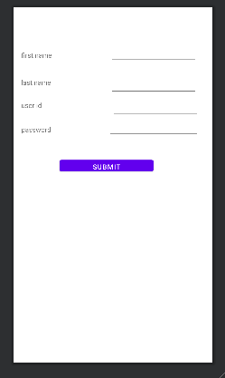

3.Design an application for the login page using .xml file.

<?xml version="1.0" encoding="utf-8"?>

<androidx.constraintlayout.widget.ConstraintLayout xmlns:android="http://schemas.android.com/apk/res/android"

xmlns:app="http://schemas.android.com/apk/res-auto"

xmlns:tools="http://schemas.android.com/tools"

android:layout_width="match_parent"

android:layout_height="match_parent"

tools:context=".MainActivity">

<TextView

android:id="@+id/textView3"

android:layout_width="148dp"

android:layout_height="27dp"

android:layout_marginStart="16dp"

android:text="first name"

app:layout_constraintStart_toStartOf="parent"

tools:layout_editor_absoluteY="89dp" />

<TextView

android:id="@+id/textView8"

android:layout_width="148dp"

android:layout_height="27dp"

android:layout_marginStart="16dp"

android:text="last name"

app:layout_constraintStart_toStartOf="parent"

tools:layout_editor_absoluteY="145dp" />

<TextView

android:id="@+id/textView9"

android:layout_width="148dp"

android:layout_height="27dp"

android:layout_marginStart="16dp"

android:text="user id"

app:layout_constraintStart_toStartOf="parent"

tools:layout_editor_absoluteY="192dp" />

<TextView

android:id="@+id/textView10"

android:layout_width="148dp"

android:layout_height="27dp"

android:layout_marginStart="16dp"

android:text="password"

app:layout_constraintStart_toStartOf="parent"

tools:layout_editor_absoluteY="242dp" />

<EditText

android:id="@+id/editTextTextPersonName"

android:layout_width="179dp"

android:layout_height="36dp"

android:layout_marginStart="200dp"

android:ems="10"

android:inputType="textPersonName"

app:layout_constraintStart_toStartOf="parent"

tools:layout_editor_absoluteY="80dp" />

<EditText

android:id="@+id/editTextTextPersonName2"

android:layout_width="179dp"

android:layout_height="36dp"

android:layout_marginStart="200dp"

android:ems="10"

android:inputType="textPersonName"

app:layout_constraintStart_toStartOf="parent"

tools:layout_editor_absoluteY="145dp" />

<EditText

android:id="@+id/editTextTextPersonName3"

android:layout_width="179dp"

android:layout_height="36dp"

android:layout_marginStart="204dp"

android:ems="10"

android:inputType="textPersonName"

app:layout_constraintStart_toStartOf="parent"

tools:layout_editor_absoluteY="192dp" />

<EditText

android:id="@+id/editTextTextPassword"

android:layout_width="187dp"

android:layout_height="27dp"

android:ems="10"

android:inputType="textPassword"

tools:layout_editor_absoluteX="197dp"

tools:layout_editor_absoluteY="242dp" />

<Button

android:id="@+id/button"

android:layout_width="195dp"

android:layout_height="35dp"

android:text="submit"

app:layout_constraintBottom_toBottomOf="parent"

app:layout_constraintTop_toTopOf="parent"

app:layout_constraintVertical_bias="0.443"

tools:layout_editor_absoluteX="95dp" />

</androidx.constraintlayout.widget.ConstraintLayout>

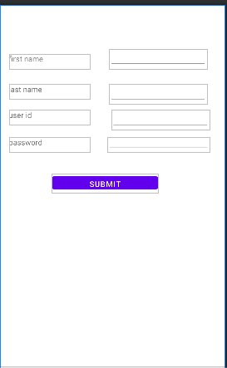

4.Develop your Profile page using .xml file.