**Name :** VIJAY VISHNU PB

**Roll No** : 49

**Batch :** B

**Date :** 19-04-2022

**ADVANCED DBMS LAB**

**Experiment No.: 5**

**Aim**

To familiarize with set operations.

**Commands**

1. **List all the customers who are depositors but not borrowers.**

SELECT c_name FROM deposit WHERE c_name NOT IN (SELECT c_name FROM borrow);

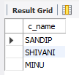

1. **List all the customers who are both depositors and borrowers**

SELECT c_name FROM deposit UNION (SELECT c_name FROM borrow);

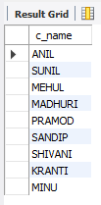

1. **List all the depositors having deposit in all the branches where Sunil is having Account**

SELECT D1.c_name FROM deposit D1 WHERE D1.b_name IN (SELECT D2.b_name FROM deposit D2 WHERE D2.c_name = 'SUNIL' );

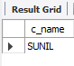

**4. List all the customers living in city NAGPUR and having branch city BOMBAY or   DELHI**

SELECT C1.c_name FROM customer C1,deposit D1, branch B1 WHERE C1.city = 'NAGPUR' AND C1.c_name = D1.c_name AND D1.b_name = B1.b_name AND B1.city IN ('BOMBAY','DELHI');

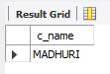

1. **List all the depositors living in city NAGPUR**

SELECT DISTINCT(customer.c_name) from customer,deposit WHERE city='NAGPUR';

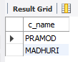

1. **List all the depositors living in the city NAGPUR and having branch in city BOMBAY**

SELECT C1.c_name FROM customer C1,deposit D1, branch B1 WHERE C1.city = 'NAGPUR' AND C1.c_name = D1.c_name AND D1.b_name = B1.b_name AND B1.city IN ('BOMBAY');



1. **List the branch cities of Anil and Sunil**

SELECT B1.city FROM deposit D1, branch B1 WHERE D1.b_name = B1.b_name AND D1.c_name IN ('SUNIL' ,'ANIL');

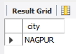

**8. List the customers having deposit greater than 1000 and loan less than 10000.**

SELECT DISTINCT D1.c_name FROM deposit D1, borrow B1 WHERE D1.amount>1000 AND B1.amount<10000;

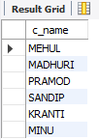

**9. List the cities of depositors having branch VRCE.**

SELECT B1.city FROM deposit D1, branch B1 WHERE D1.BNAME=B1.b_name AND B1.b_name='VRCE';

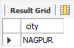

**10. List the depositors having amount less than 1000 and living in the same city as Anil**

SELECT D1.c_name FROM deposit D1,customer C1 , customer C2 WHERE C1.CITY = C2.CITY AND C2.c_name = 'ANIL' AND C1.c_name = D1.c_name AND D1.amount < 1000;

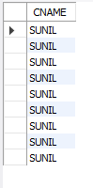

**11. List all the cities where branches of Anil and Sunil are locate**

SELECT B1.city FROM branch B1 WHERE B1.b_name IN (SELECT D1.b_name FROM deposit D1 WHERE D1.c_name IN ('ANIL','SUNIL'));

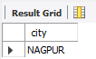

**12. List the amount for the depositors living in the city where Anil is living**

SELECT DISTINCT(D1.c_name),D1.amount ,C1.city FROM deposit D1, customer C1, branch B1 WHERE D1.c_name=C1.c_name AND C1.city IN(SELECT C2.city FROM customer C2 WHERE C2.c_name='ANIL');

