**Name: vijay vishnu p b**

**Roll No:49**

**Batch:MCAB**

**Date:**

**NETWORKING & SYSTEM ADMINISTRATION LAB**

**Experiment No.: 9**

**Aim**

Introduction to Hypervisors and VMs: KVM installation and commands..

**Procedure and output**

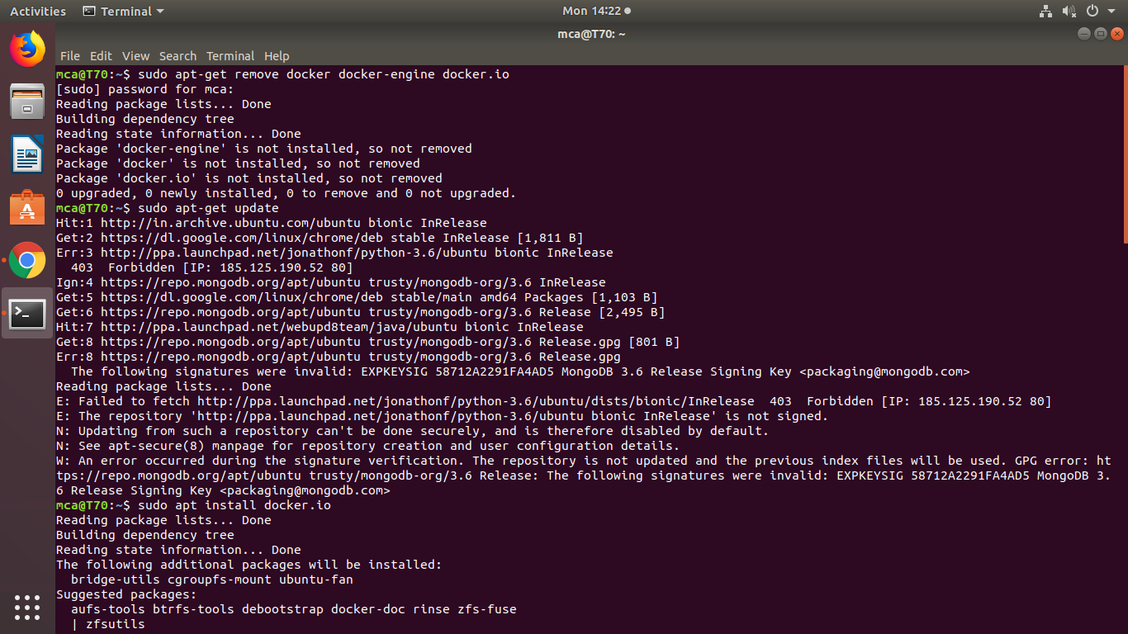**Step 1:** Update the repositories

**Step 2:** Install essential KVM packages

 Install virt-manager, a tool for creating and managing VMs

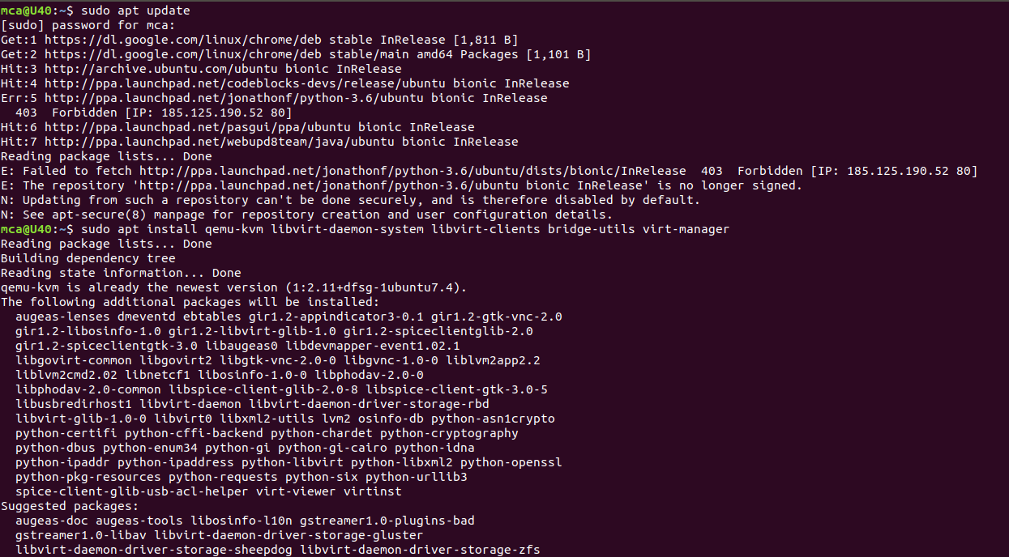

Step 3: Start virt-manager with



Step 4: In the first window, click the computer icon in the upper-left corner,

In the dialogue box that opens, select the option to install the VM using an ISO image. Then click **Forward**.

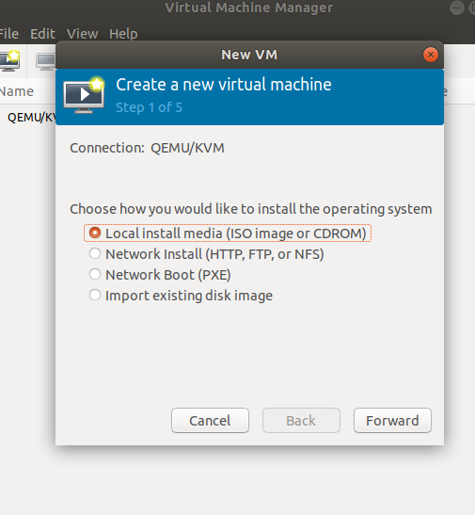

Step 5: Choose ISO,click Forward

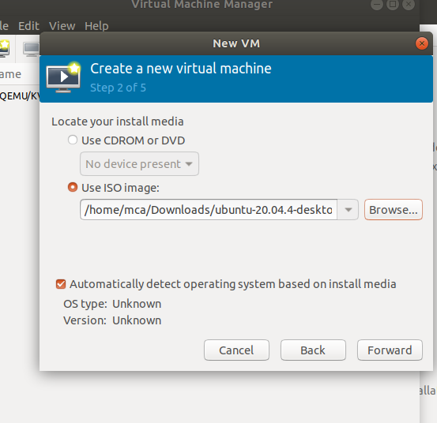

Step 6: Enter the amount of RAM and the number of CPUs you wish to allocate to the VM and proceed to the next step.

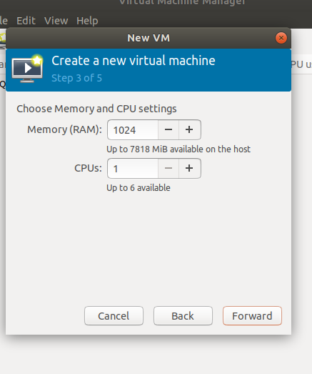

Step 7:  Allocate hard disk space to the VM. Click **Forward** to go to the last step.

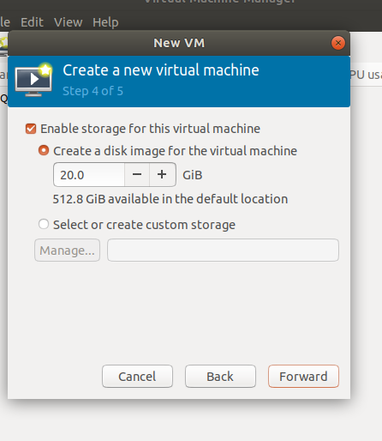

Step 8:  Specify the name for your VM and click **Finish** to complete the setup.

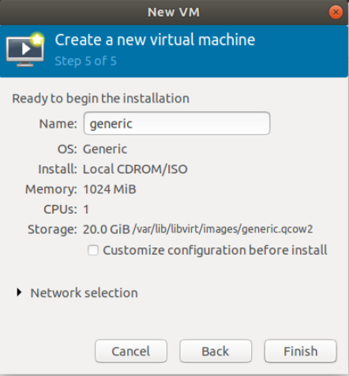

Step 9: Select language

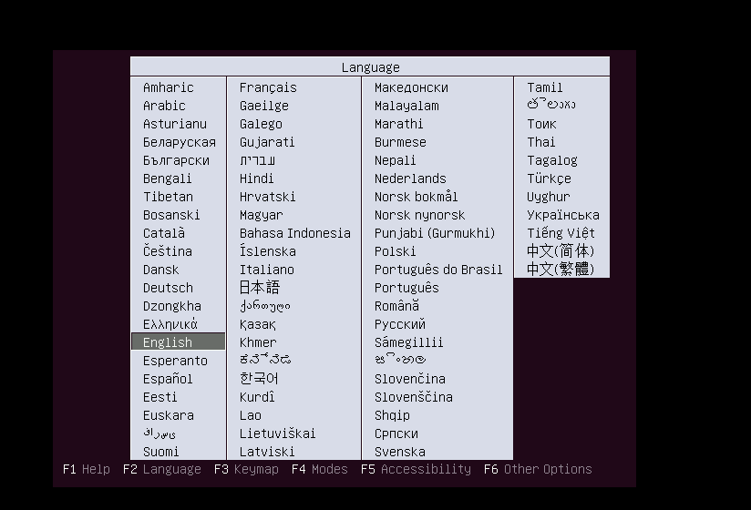

Step 10: The VM starts automatically, prompting you to start installing the OS that’s on the ISO file.

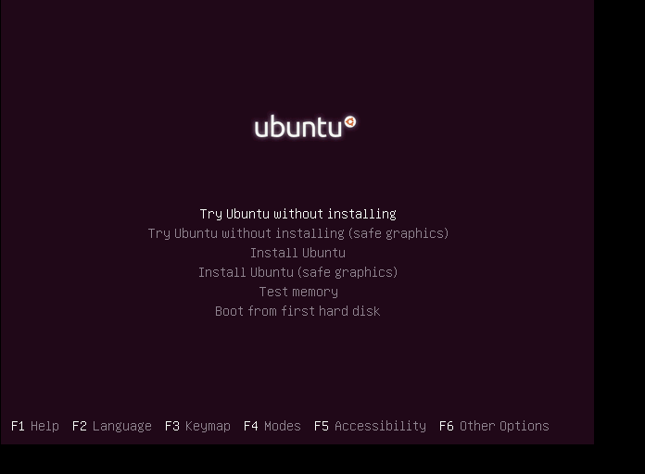

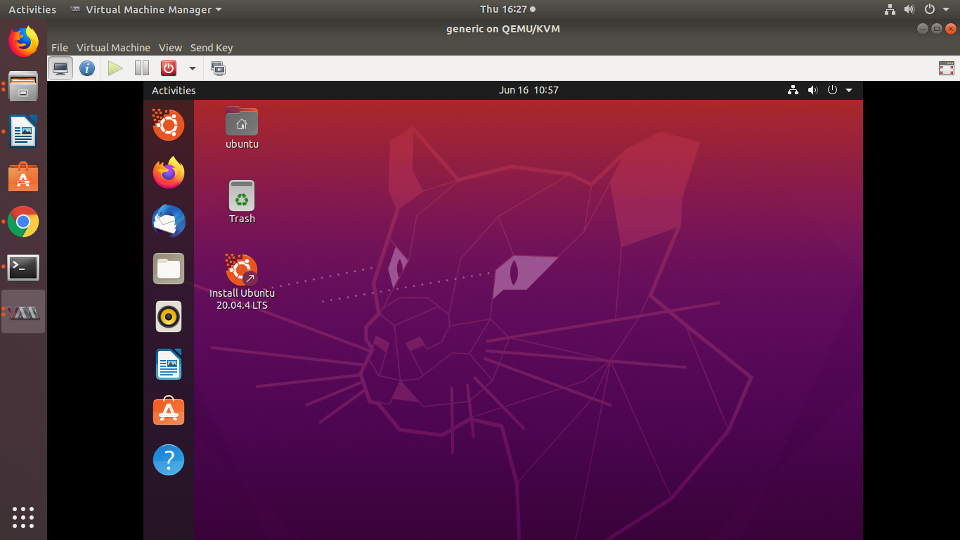

Step 11: Check the state of KVM

