Window-Independent
Document Window
Project Window - Deviation List
Apply the next selected function
Ctrl + N
Create new project
Page up
Previous page
Image Comparison
S Split Image Pair

to all identical Deviations

R Reset edited Deviation
Ctrl + O
Open existing project
Page down
Next page
K Pick Image for linking

Shift + R
Ctrl + S
Save
Rotate 90° counterclockwise

Rotate 90° clockwise

Reset all identical Deviations to unedited state
L Link current Image with picked Image
D Details (Image

A Accept current Deviation
Ctrl + F4
Close
Alt + F4
Exit
Ctrl + – or Ctrl +
Zoom out
Zoom in
Comparison View)
Ctrl + Rotate

Shift + A
¤
Accept all
identical Deviations
clockwise
Rotate counter-
Alt + C
Compare
Ctrl + + or Ctrl + £

M Mark current Deviation clockwise

Ctrl + E
Export Copy
Shift + M
Document Settings
Ctrl + Shift + Zoom in both docu-
ments simultaneously
Ctrl + R
Create Report
as an error in Copy
Mark all identical Deviations as an error in Copy
Ctrl + £
Ctrl + ¤
Enlarge size of Image
Reduce size of Image

J Mark current Deviation as an error in Original
Ctrl + U
User Settings
Ctrl + H
Zoom to window height
B Mark current Deviation in both documents
Ctrl + M
Warning Settings
Ctrl + W Z

Shift + Z O
Shift + O M
Zoom to window width
Zoom to preset zoom level (500% by default)
Apply current zoom level to preset zoom level
Zoom to preset overview level (100% by default)
Apply current zoom level to preset overview level
Manual Map
Alt Replicate Image in other document

© 2016 Schlafender Hase GmbH
+

Shift + B S
F1
View Help
F5
Hand Mode
F6
or
Select Mode
X
Exclusion Area Mode
F7
V
Mark all identical Deviations in both documents
Split a Deviation into an Insertion and a Deletion
Support
International
Phone +49 69 244 4810
Email tvt@sh-p.de
North America
Phone +1 617 607 4900
Email us@sh-p.com

www.text-verification.com
Cut and copy a Deviation to the clipboard
Paste a Deviation from clipboard

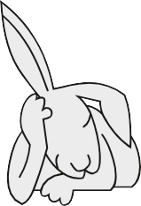
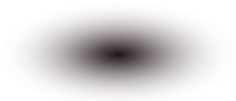


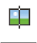
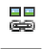

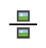
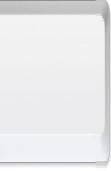
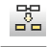
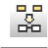

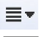
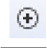
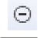
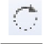
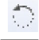
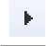
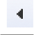



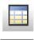


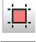
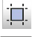
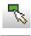







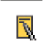
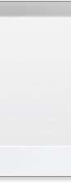

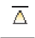
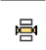
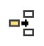
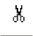
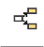
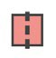

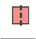
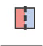
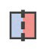
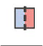
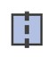
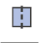

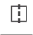
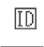
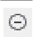


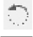

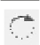
F8
Merge a previously cut Insertion/ Deletion with the selected Deletion/ Insertion into a Deviation
Free Annotation Mode
Document Divider Mode
Table Area Mode
F9

F10

F11
Error Area Mode
Manual Unmap
Set focus on project window
Draw zoom window
U

Space

Ctrl +
P Move to previous unedited Deviation
N Move to next unedited Deviation
Enter Edit Comment
Image Mode
F12
Compare Selections
Ctrl + D
Ctrl+Tab Switch between tabs onwards
Ctrl+Shift+Tab Switch between tabs backwards
Search
Ctrl + F

MORE PROOF. LESS READING.
Color Legend
Ctrl + L
F2 Wizard Toolbar

