Local Domain details
Domain name Steradiansemi.local
Primary domain controller
Ip address 192.168.1.20
Username for machine login:superadmin
Password: 0pt1t@123

Domain admin: administrator@steradiansemi.local
Password: 0pt1t@123

Read only domain controller created within the Qnap Storage server for redudency
Ip address 192.168.1.115
Login details
Username: admin
Password: admin

For creating users in the domain we use RSAT tools which is installed in Mr. Rakesh’s Laptop and IT system
We can create users delete users and reset their password from this rstat tools
Go to start search for ‘active directory users and computer’
Open the active directory users and computer console.

2. Right click the folder name“semiuser” where you want to create the new user account, select new and then click user. If you have not created additional organizational units, you can put the new account in the Users folder. In my example, I’m putting the account in the Winadpro Users folder that I have created.
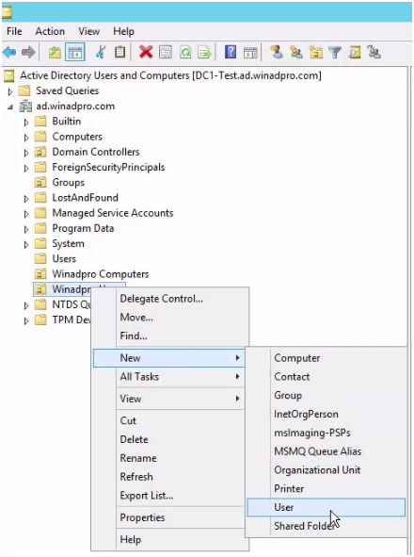
3. Fill out the fields in the New Object – User window
First name: Fill in user’s first name.
Initials: Fill in user’s middle initials. This can be used if there are conflicts when creating the user logon name.
Last name: Fill in user’s last name.
Full name: This will fill in automatically.
User logon name: This is the name used to log into windows domain. You will want to come up with a naming convention for logon names: The two most popular methods I’ve seen are first initial and last name and complete first name and last name. For an in depth look at naming conventions see my article Active Directory user naming conventions.
last name = osmith
Complete first and last name = oliver.smith
If there are conflicts add the middle initial: oasmith or oliver.a.smith
Click Next
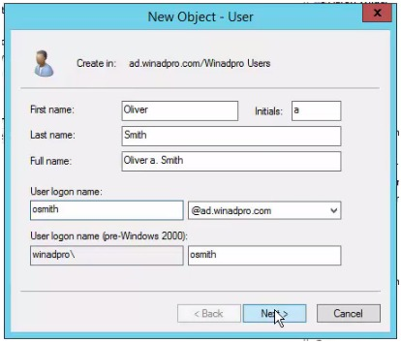
In the password and confirm password field type the user’s password, click next and finish.
What you make the password depends on your company’s security policy. I would recommend using at least 8 characters which include a special character, numbers and upper case letters. I would also check the box “User must change password at next logon”. You want all the accounts to have unique passwords so forcing users to create their own passwords is more secure and best practice.
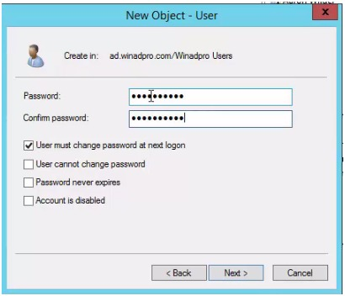
This completes creating the new Active Directory user account. At this point you may need to open the account and add additional information such as: Address, Profile path, Logon script, Organization details and adding the user to other Active Directory groups to provide access to additional domain resources.

Joining windows machine to samba ad
Open Computer and click on the System Properties button.
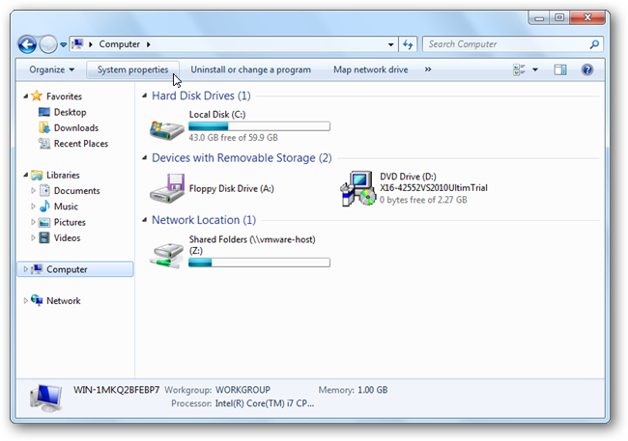
Now click on the Advanced system settings link on the left hand side.
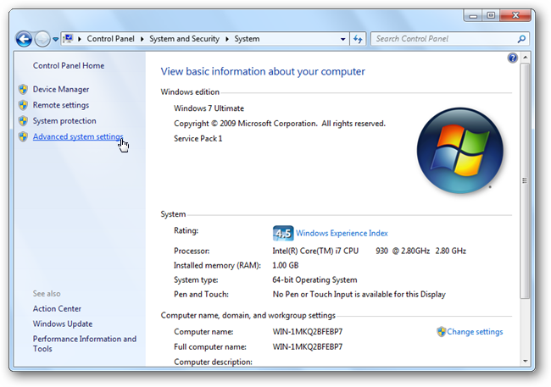
When the advanced system settings open, switch to the computer name tab.
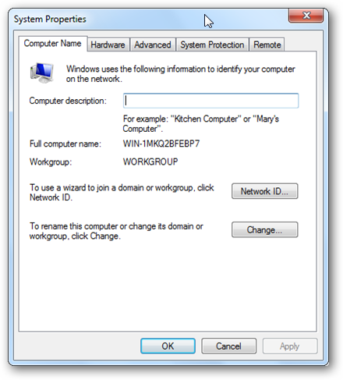
Click on the change button, from here you can change your Computers Name to a more friendly name.
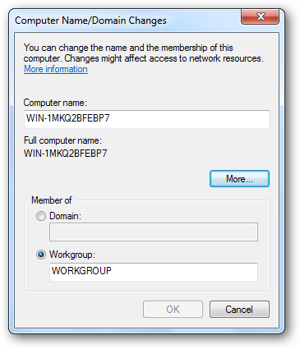
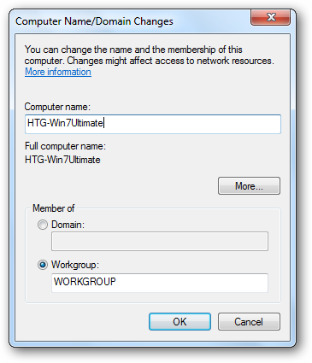
Now switch the radio button, in the bottom section, from Workgroup to Domain. This will make the text box become available.
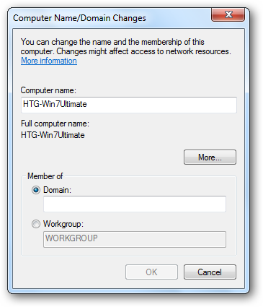
Now type in the name of your domain, ours is Steradiansemi.local, but yours will be whatever you made it when you set up Active Directory.
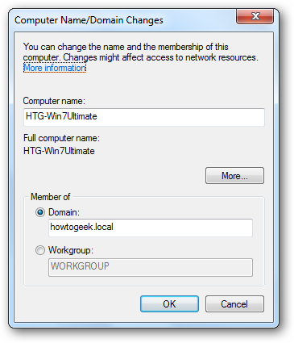
When you hit enter, or click ok, you will be asked for the user name and password of a Domain Admin user account.
Enter administrator@steradiansemi.local
And provide the password
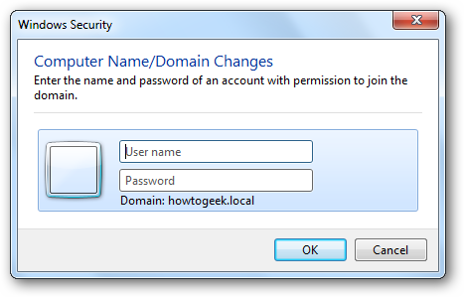
If you specify the correct credentials you will be welcomed to the Domain.
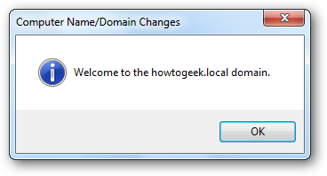

After that it will ask to reboot the machine, reboot the machine to login as a domain user.

Joining Centos to domain
1 .Change the hostname and disable selinux first and reboot the machine.
2. Install the below packages.
yum install sssd realmd oddjob oddjob-mkhomedir adcli samba-common samba-common-tools krb5-workstation openldap-clients policycoreutils-python
3. then join the machine to domain by using the below command
realm join STERADIANSEMI.LOCAL
4.then it will ask for administrator password
5.provide the password of the administrator@steradinsemi.local

6.Create a folder as ‘home1’ in / directory
7.Then mount the nfs directory to ‘home1’ by adding entry in fstab file
Example
192.168.0.115:/homesc /home1 nfs defaults 0 0
- Then issue mount –a to mount the NFS directory in the /home1 folder
- Example how the NFS Directory should be like below mounts cat/etc/fatsb
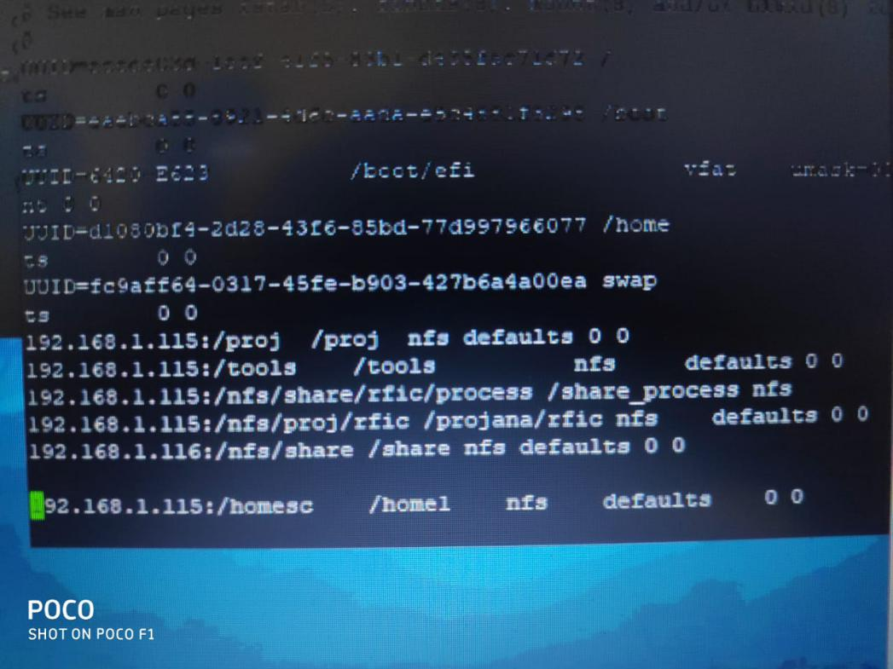

9.Change the following parameters from in /etc/sssd/sssd.conf

use_fully_qualified_names = True
fallback_homedir = /home/%u@%d
default sheel= /bin/sh
to
use_fully_qualified_names = False
fallback_homedir = /home1/%u
default shell= /bin/tcsh

10.restart the sssd service by using ‘systemctl restart sssd ’

11.after service is restart use the domain user to login to the machine and check if the home directory is created of the user in /home1/’username’

