NAME : Bala Vijay S
REG.NO : 192424160
COURSE CODE : DSA0304
COURSE NAME : NATURAL LANGUAGE PROCESSING

ACTIVITY
1.Write program demonstrates how to use regular expressions in Python to match and search for patterns in text.
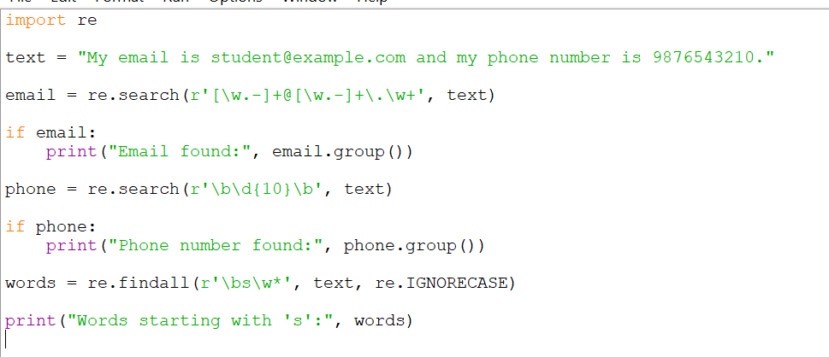
OUTPUT :
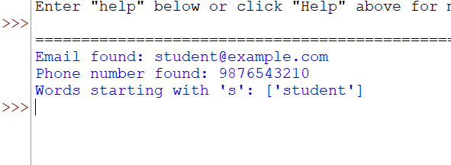

2.Implement a basic finite state automaton that recognizes a specific language or pattern. In this example, we'll create a simple automaton to match strings ending with 'ab' using python.
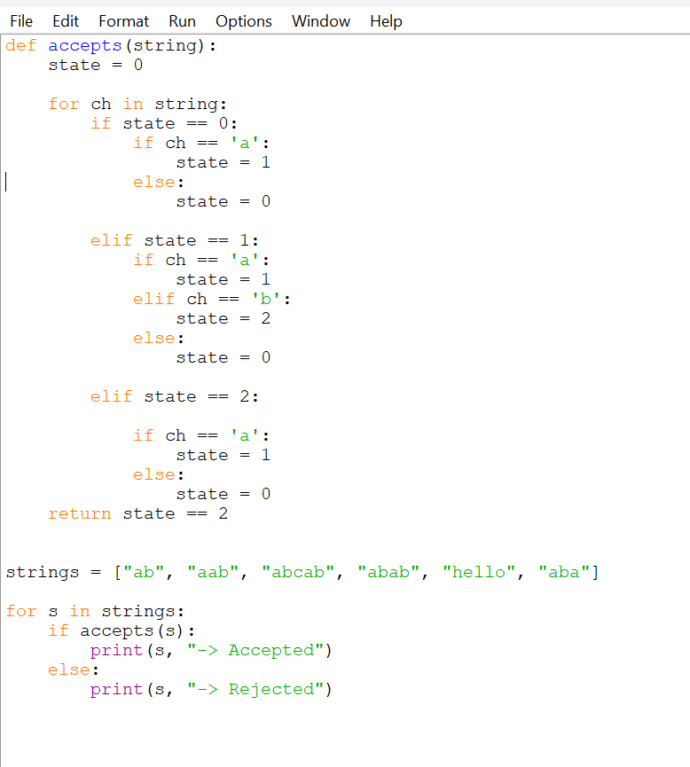
OUTPUT:
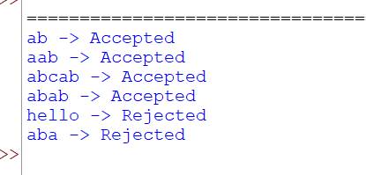

3.Write program demonstrates how to perform morphological analysis using the NLTK library in Python.
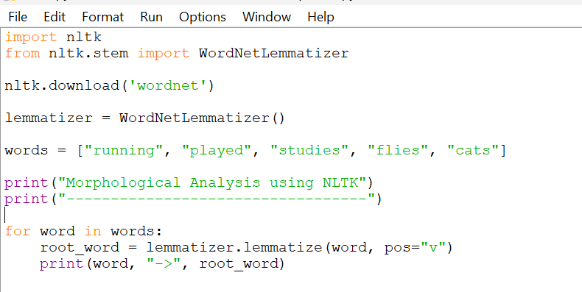
OUTPUT :
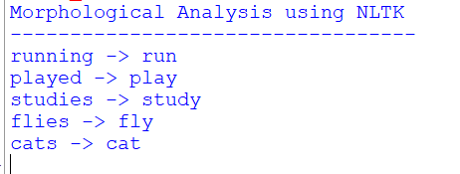

4.Implement a finite-state machine for morphological parsing. In this example, we'll create a simple machine to generate plural forms of English nouns using python.
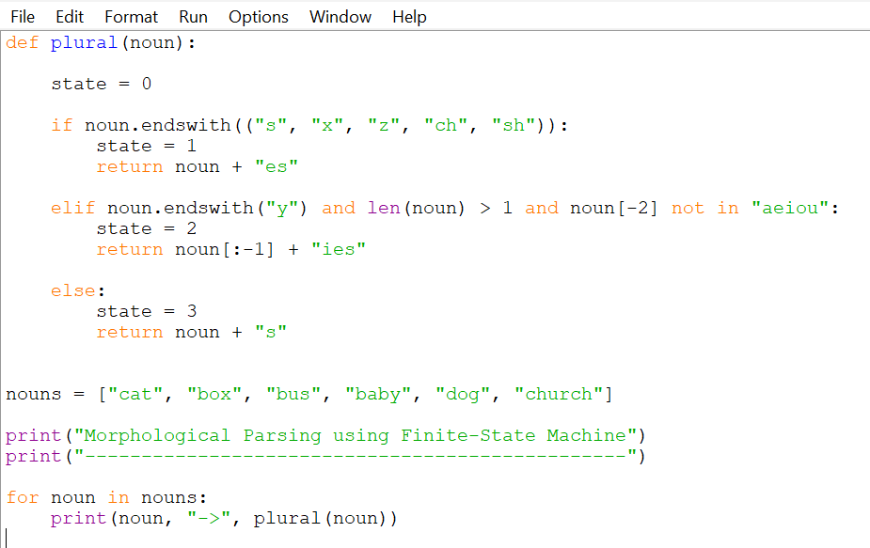
OUTPUT :
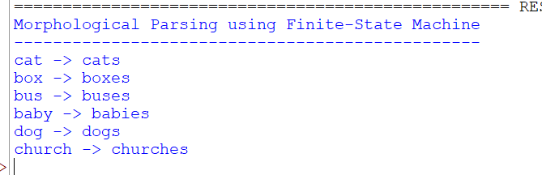

5.Use the Porter Stemmer algorithm to perform word stemming on a list of words using python libraries.
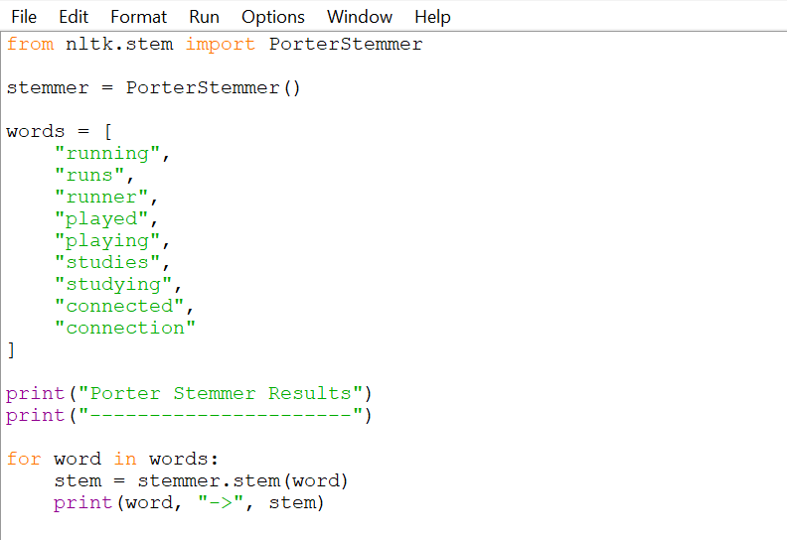
OUTPUT :
