SESSION — ACTIVITY (20 MIN) • STUDENT HANDOUT • SLOT C
Redesign the Misleading Colored Chart
R.No: 5 Reg. No: 192424160 Name: BALA VIJAY S
Chart 1
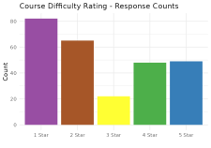
- What is this chart trying to show?
The chart compares the values for five star categories, from 1 Star to 5 Star. The height of each bar represents the value for that category.

- What's wrong with the color choice?
Different bright colors are used for each bar, even though all bars represent the same type of data. This can distract viewers and make the chart confusing.

- Propose a better color scheme (describe it in words):
Use the same color, such as blue, for all bars. Keep a simple white background, clear labels, and light gridlines to make the values easy to compare.
_

Chart 2
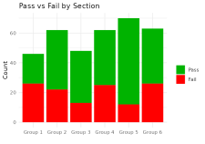
- What is this chart trying to show?
The chart compares two components across six groups. Each bar contains two colored segments, and the total height represents the combined value of both components.

- What's wrong with the color choice?
The red and green colors may be difficult for people with red–green color-vision deficiency to distinguish. The chart also needs a clear legend to explain the two components.

- Propose a better color scheme (describe it in words):
Use two contrasting, color-blind-friendly colors, such as blue and orange. Include a clear legend and use the same colors consistently for each component across all groups.

