

LAB EXPERIMENT RECORD
Department | Artificial Intelligence and Data Science
Course Code / Course Name | DSA0601 / Data Handling and Visualization
Name / Register Number | BALA VIJAY S/ 192424160
Date / Day | 01/10/2026

SET 4: Product Inventory Management

Aim
To analyze product inventory management using the requested visualizations and dashboard views.

Dataset
Product Inventory Management
Product_ID | Product_Name | Quantity_Available | Product_Category | Price
1 | Product A | 250 | Electronics | 20
2 | Product B | 175 | Home | 15
3 | Product C | 300 | Electronics | 18
4 | Product D | 200 | Office | 12
5 | Product E | 220 | Home | 16

PROGRAM 1: Inventory Quantity by Product
Create a labeled bar chart of each product's available quantity.
R code
dat <- data.frame(
Product_ID = c(1, 2, 3, 4, 5),
Product_Name = c("Product A", "Product B", "Product C", "Product D", "Product E"),
Quantity_Available = c(250, 175, 300, 200, 220),
Product_Category = c("Electronics", "Home", "Electronics", "Office", "Home"),
Price = c(20, 15, 18, 12, 16)
)
barplot(dat$Quantity_Available, names.arg=dat$Product_Name, col="skyblue3", xlab="Product", ylab="Quantity", main="Available Quantity by Product")

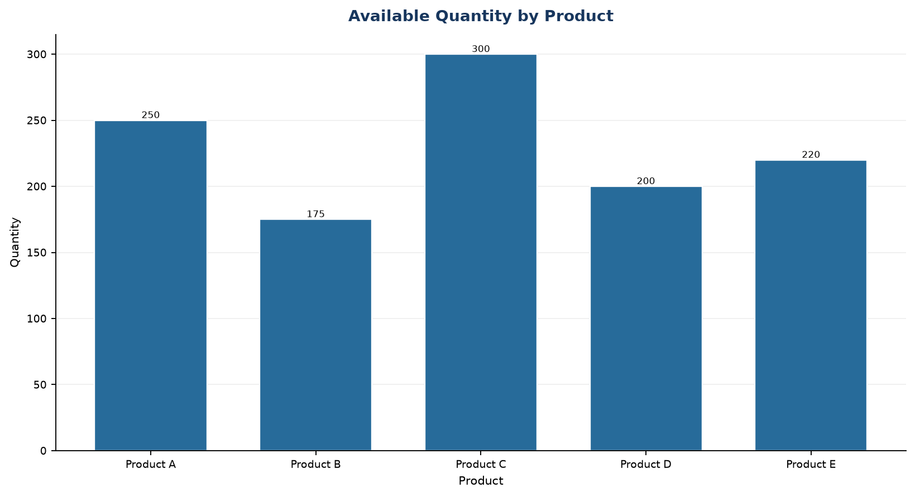
Output 1: Inventory Quantity by Product

Observation: Product C has the largest available quantity (300); Product B has the smallest (175).

PROGRAM 2: Stacked Inventory by Category
Create a stacked bar chart showing product quantities within product categories.
R code
dat <- data.frame(
Product_ID = c(1, 2, 3, 4, 5),
Product_Name = c("Product A", "Product B", "Product C", "Product D", "Product E"),
Quantity_Available = c(250, 175, 300, 200, 220),
Product_Category = c("Electronics", "Home", "Electronics", "Office", "Home"),
Price = c(20, 15, 18, 12, 16)
)
library(ggplot2)
ggplot(dat, aes(x=Product_Category, y=Quantity_Available, fill=Product_Name)) + geom_col() + labs(title="Inventory Quantity by Category and Product", x="Category", y="Quantity") + theme_minimal()

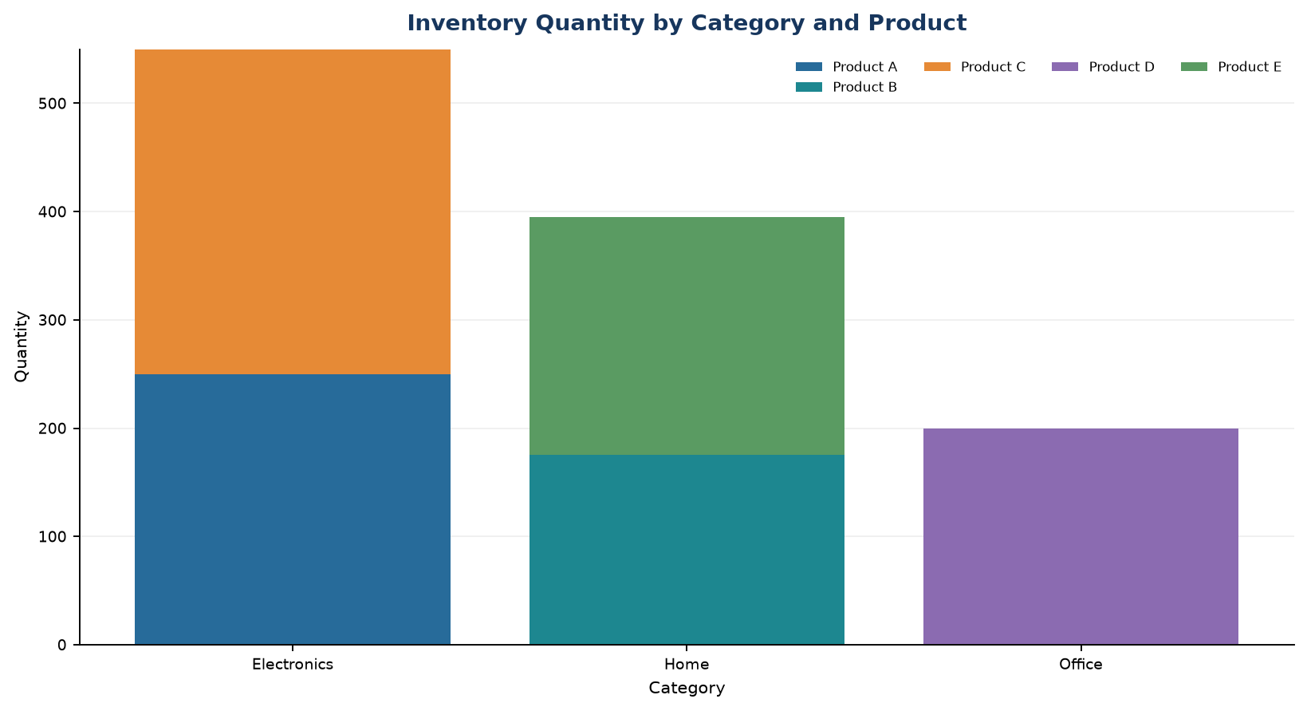
Output 2: Stacked Inventory by Category

Observation: Electronics has the largest combined listed quantity. Each category assignment is illustrative because the source provides no category field.

PROGRAM 3: Product Price and Quantity
Explore the relationship between product price and available quantity with a scatter plot and explain the findings.
R code
dat <- data.frame(
Product_ID = c(1, 2, 3, 4, 5),
Product_Name = c("Product A", "Product B", "Product C", "Product D", "Product E"),
Quantity_Available = c(250, 175, 300, 200, 220),
Product_Category = c("Electronics", "Home", "Electronics", "Office", "Home"),
Price = c(20, 15, 18, 12, 16)
)
plot(dat$Price, dat$Quantity_Available, pch=19, col="#276B9A", xlab="Price ($)", ylab="Quantity", main="Price vs Available Quantity")

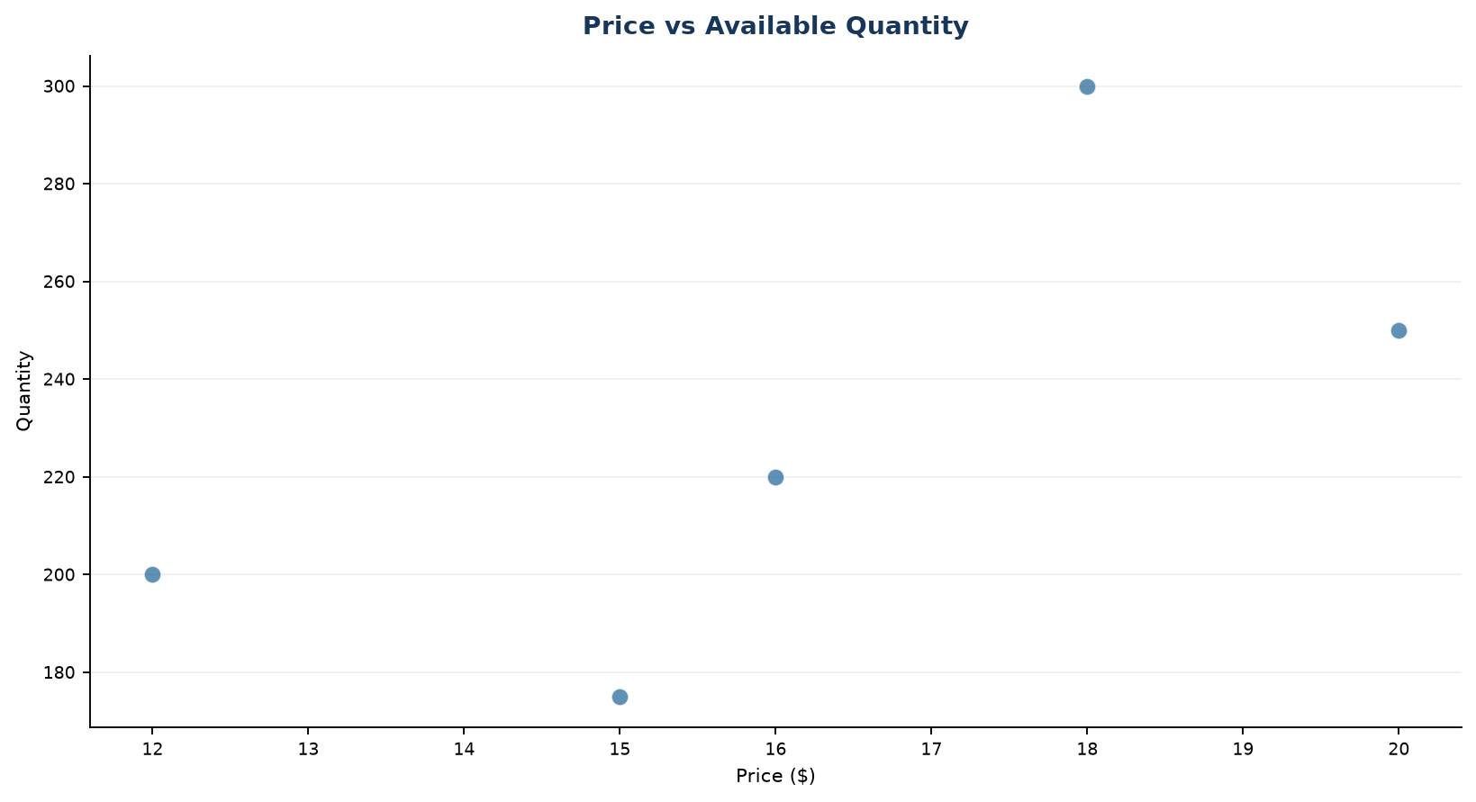
Output 3: Product Price and Quantity

Observation: The five illustrative price points do not show a clear price-quantity trend.

PROGRAM 4: Product Inventory Dashboard
Build an interactive Tableau dashboard combining the product bar chart and category stacked bar chart.
Tableau build steps
Tableau dashboard build
1. Connect to the inventory table.
2. Build a bar chart using Product_Name and Quantity_Available.
3. Build a stacked bar using Product_Category, Product_Name, and SUM(Quantity_Available).
4. Add both sheets and a category filter to a dashboard.

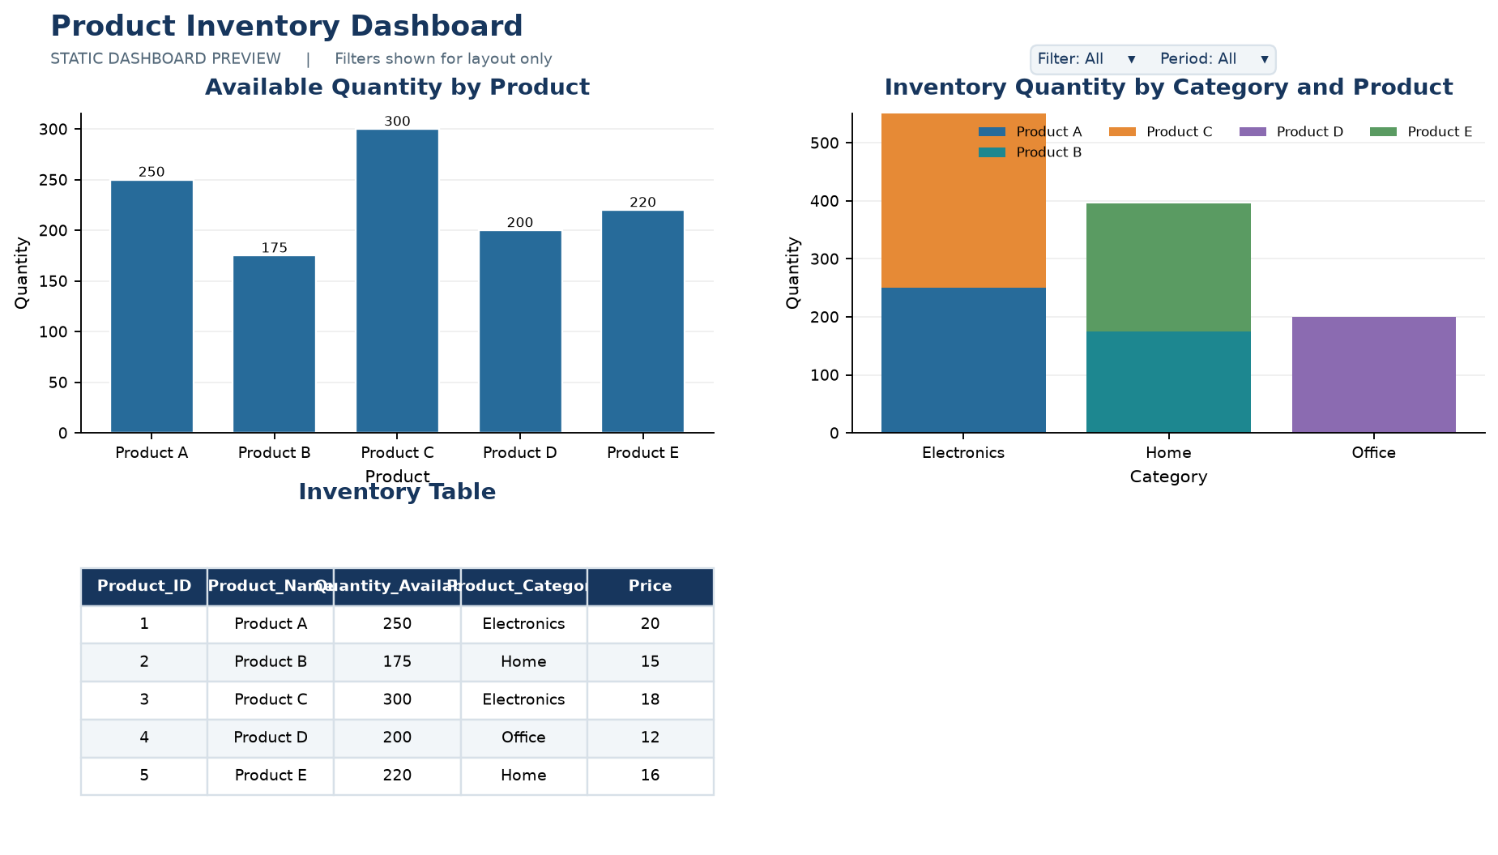
Output 4: Product Inventory Dashboard

Observation: The preview combines product-level quantities, category totals, and the inventory table. Category filtering can be added in Tableau.

Procedure
1. Review the dataset table and confirm any illustrative fields noted in the record.
2. Run the R setup block once, then run the requested program code.
3. Compare the output screenshot with the observation and replace illustrative values when actual data is available.
4. For Tableau tasks, connect to the displayed data and follow the dashboard build steps.

Result
The requested charts and dashboard views for Set 4 were prepared from the displayed dataset. Outputs include labels, short observations, and code or dashboard construction steps.

Key Functions Used
plot(), barplot(), hist(), boxplot(), table().

