Vijay Dharmendra Yadav

Product Analyst Assignment
8th March, 2026

OVERVIEW
HSR Motors currently manages its incoming leads through manual spreadsheets, making it difficult for sales representatives to collaborate in real time and for business managers to gain visibility into lead performance. The dealership receives leads from multiple online and offline channels, each requiring timely follow-up, status updates, and analysis to maximize conversions. The lack of a centralized, interactive system results in inefficiencies such as delayed follow-ups, inconsistent data entry, and limited insights for decision-making.
To solve this, I designed a web-based Lead Management System that acts as a unified workspace for both the Sales Team and the Business Manager. My approach began with identifying the key user groups, understanding their goals, and mapping out their workflows. The Sales Team needs a fast, intuitive interface to update lead statuses and capture customer details, while the Business Manager needs a dashboard that presents actionable metrics at a glance.
I addressed these needs by designing two core screens:
- Lead Listing – A searchable, filterable table for quick triage.
- Dashboard – Visual insights such as lead source performance, conversion funnel, and team productivity.
My solution focuses on clarity, efficiency, and automation, such as automated reminders, smart lead prioritization, and real-time sync. This ensures the system not only replaces spreadsheets but meaningfully improves sales operations and strategic decision-making.

FEATURES
- Centralized Lead Repository
All leads from Facebook, Google Ads, Website, events, and offline sources are captured
in a single unified system.
Use-case: Eliminates the need to check multiple spreadsheets or platforms, ensuring no
lead is ever missed.
- Advanced Lead Listing with Filters & Search
Sales reps can filter leads by status, source, assigned salesperson, budget, or date.
Use-case: A sales rep can instantly view all “New” or “Follow-up” leads and prioritize their daily calls efficiently.
- Detailed Lead Profile View
Every lead has a dedicated page with personal details, car interest, interaction history, notes, and follow-up logs.
Use-case: When calling a customer, the rep can quickly review past conversations and tailor their pitch accordingly.
- Lead Status Management & Notes
Sales reps can update statuses such as New, Contacted, Qualified, Test Drive Scheduled, Converted, etc., along with notes.
Use-case: Improves traceability—managers always know the latest progress of each lead.
- Smart Follow-up Scheduling
Built-in follow-up fields and reminders help sales reps stay consistent with callbacks and appointments.
Use-case: Prevents missed follow-ups, which directly increases conversion chances.
- Automated Lead Prioritization
High-intent leads (e.g., repeat interactions, high-budget cars, referral leads) are automatically highlighted.
Use-case: Reps can focus their time on leads most likely to convert.
- Multi-user Collaboration
Updates sync in real-time across the entire team—no version conflicts like spreadsheets.
Use-case: If one salesperson updates a lead, the manager sees it instantly, enabling faster decisions.
- Dashboard & Analytics
Interactive dashboard with charts on:
- Lead source performance
- Conversion funnel
- Daily/weekly lead trend
- Sales team performance
- Budget and car interest distribution
Use-case: The Business Manager can quickly understand which channels generate the best leads and how well the team is performing.
- Activity Logs & Audit Trail
Tracks who updated what and when.
Use-case: Ensures transparency and team accountability.
- Modern, Clean UI for Faster Workflows
Designed for desktop screens with intuitive navigation, components, and color coding.
Use-case: Reduces training time and boosts productivity since every user immediately understands the interface.

WIREFRAME / MOCKUP / PROTOTYPE
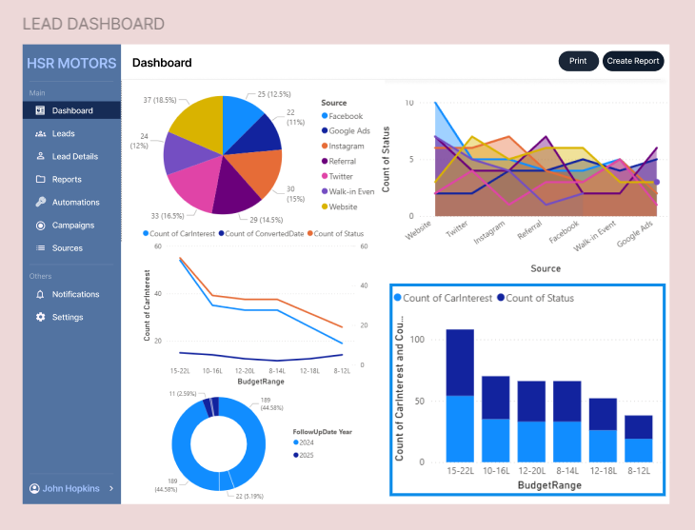

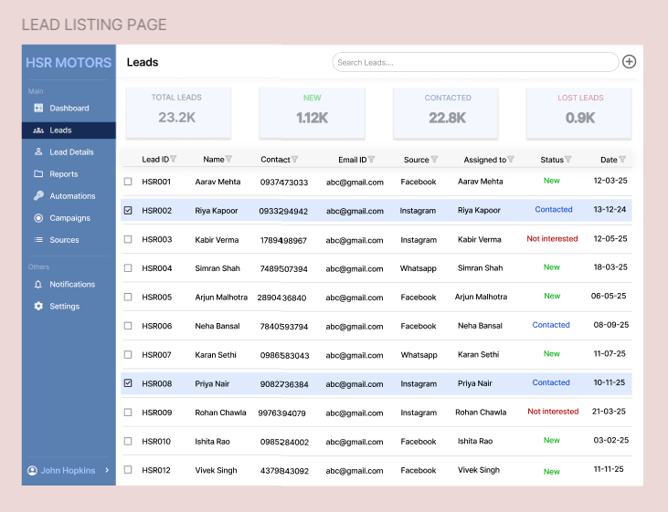
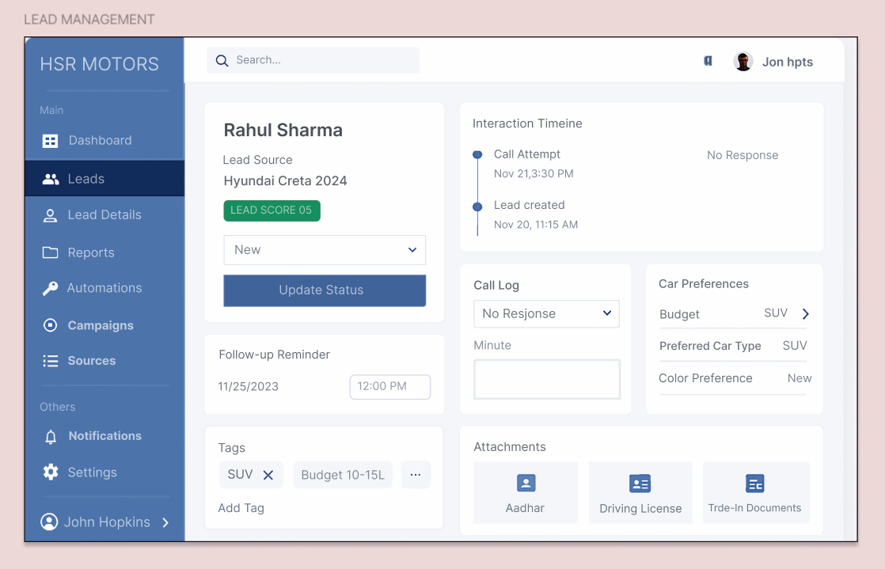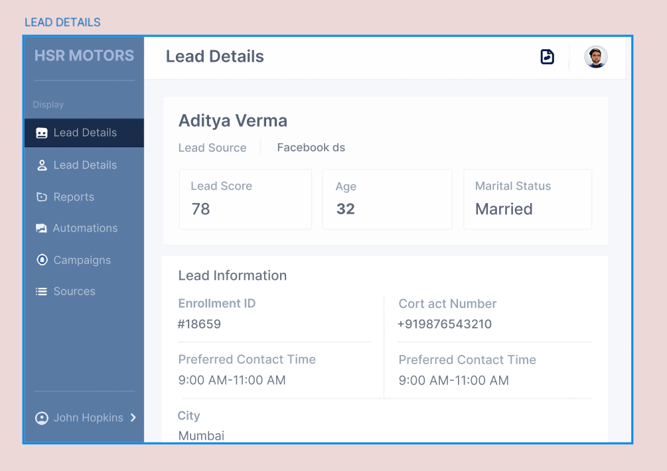USER FLOW

1. Landing on the Lead Listing Screen
The user starts on the Lead Listing page, where all leads are displayed in a clean, filterable table. From here, Sales Representatives can quickly:
- Search for a specific lead
- Filter by status, source, or assigned salesperson
- Sort leads by date or priority
This screen acts as the central hub for all lead-related actions.

2. Opening a Lead Profile (Lead Details Screen)
Upon selecting a lead, the user is taken to the Lead Details screen. This view provides a complete snapshot of the customer:
- Personal information
- Source of lead
- Car interest and budget
- Notes and interaction history
- Upcoming follow-up date
This allows the Sales Team to understand the customer context before making a call.

3. Updating Lead Information (Lead Management Screen)
From the Lead Details screen, the user can proceed to the Lead Management section. Here they can:
- Change the lead status (Contacted, Qualified, Test Drive Scheduled, Converted, etc.)
- Add notes after every conversation
- Schedule reminders or follow-ups
- Assign or reassign the lead to another salesperson
This structured workflow ensures that no interaction is missed and that each lead progresses properly through the sales pipeline.

4. Returning to Dashboard for Insights
Business Managers primarily navigate to the Dashboard, which visually summarizes:
- Top-performing lead sources
- Conversion funnel
- Daily and monthly lead trends
- Sales team performance analytics
- Distribution of car interest and budget ranges
This helps managers monitor performance, identify bottlenecks, and make informed decisions.

5. Continuous Real-Time Collaboration
All updates made by sales reps instantly reflect across the system.
Managers can track progress in real-time, and sales reps always work with the latest information, enabling smooth team collaboration.

OTHER LINKS
Figma Link: https://www.figma.com/design/C9FXRjypylm6X6gDb2Pg5X/VIJAY-YADAV--Product-Analyst?t=DiCjELEuhDVtLpSB-1

