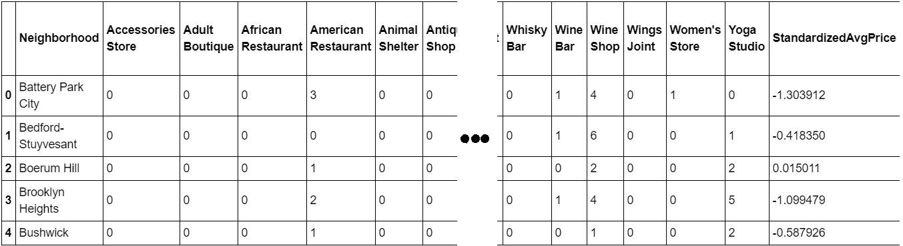
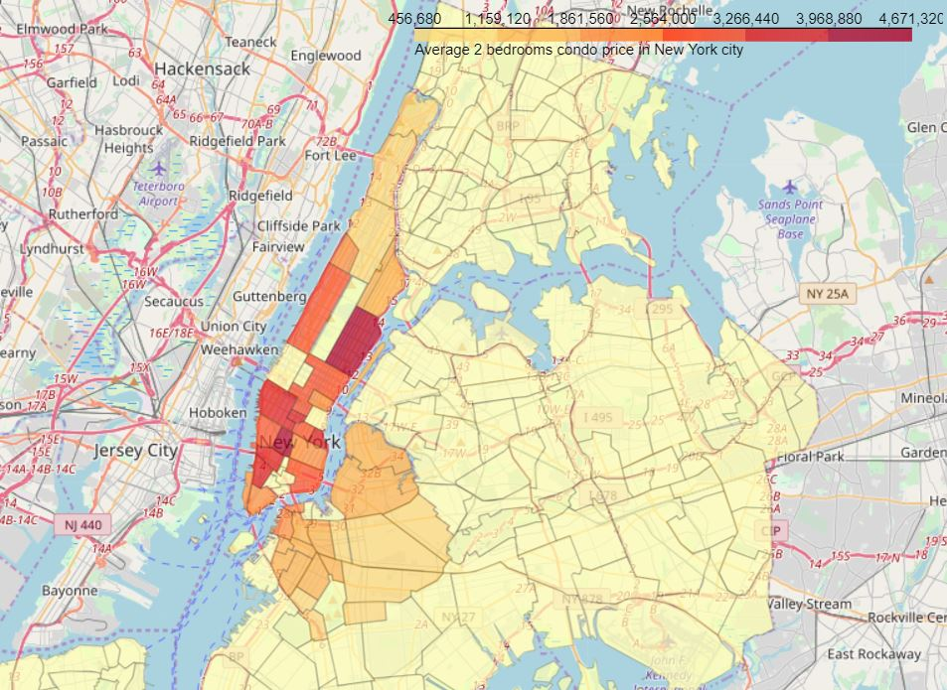
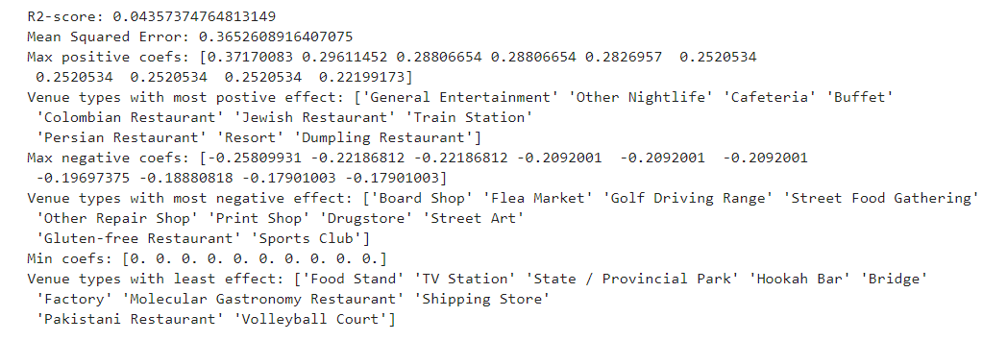
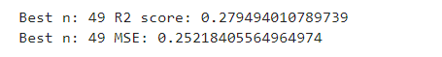
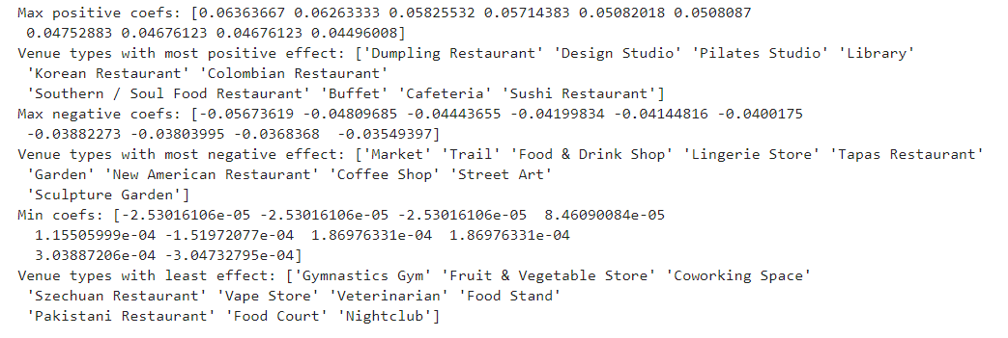
IBM Data Science Professional Certification Course

Final Capstone project
Mumbai Reallocation Problem

- Introduction:
This report is for the final course of the Data Science Specialization. A 9-courses series created by IBM, hosted on Coursera platform. The problem and the analysis approach can be designed with available data, with a requirement of leveraging the Foursquare location data to explore or compare neighborhoods or cities of your choice or to come up with a problem that you can use the Foursquare location data to solve.
The purpose of the problem statement is to guide or give a direction to a new person for places where he can stay and get valuable information related to neighbor outlets and store. The problem is very small in places like New york are other countries where technology is very good and things are to update. But in our scenario we have chosen a city of Dreams. Mumbai city population is estimated to be 12,851,726 in 2018. It is one of the busiest city in India and with huge population the property rates are also too high. The traffic in city is also too bad. So for a new person coming to this kind of place deciding the staying location is very difficult. So we decided to give the right locations where all kind of available will be provided to the person from restaurant to Pub.
The idea comes from the process of a normal family person finding a place to stay after moving to another city. It’s common that the owners or agents advertise their properties are closed to some kinds of venues like supermarkets, restaurants or coffee shops, etc.; showing the “convenience” of the location in order to raise their house’s value.
So, can the surrounding venues affect the price of a house? If so, what types of venues have the most affect, both positively and negatively?
The target audience for this report are:
- Potential buyers who can roughly estimate the value of a house based on the surrounding venues and the average price.
- Real estate makers and planners who can decide what kind of venues to put around their products to maximize selling price.
- Houses sellers who can optimize their advertisements.

- Data description:
Mumbai city neighborhoods were chosen as the observation target due to the following reasons:
- The availability of data. Though very limited.
- The diversity of data between neighborhoods.
- The availability of geo data which can be used to visualize the dataset onto a map.
The dataset will be composed from the following two main sources:
- mapsofindia which provides the neighborhoods of Mumbai. https://www.mapsofindia.com/pincode/india/maharashtra/mumbai/
- Custom made dataset consists of Mumbai Locations with Latitude and Longitude (IN.txt)
- FourSquare API which provides the surrounding venues of a given coordinates.
The process of collecting and clean data:
- Scrap the mapsofindia webpage for a list of Mumbai city neighborhoods and their corresponding places.
- Find the coordinates of geographic data of the neighborhoods.
- For each neighborhood, pass the obtained coordinates to FourSquare API. The “explore” endpoint will return a list of surrounding venues in a pre-defined radius.
- Count the occurrence of each venue type in a neighborhood. Then apply one hot encoding to turn each venue type into a column with their occurrence as the value.
The result dataset is a 2 dimensions data frame (Figure 1):
- Each row represents a neighborhood.
- Each column, is the occurrence of a venue type.

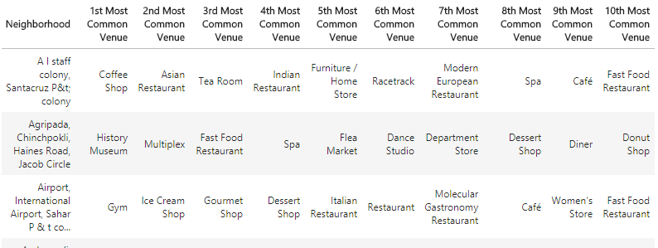
Figure 1 - Final dataset
The dataset has 50 samples. The number of features may vary for different runs due to FourSquare API may returns different recommended venues at different points in time.
Methodology:
The assumption is that places are dependent on the surrounding venue.
At the end, a clustering model will be obtained. Along with a coefficients list which describes how each venue type may be related to the neighborhood’s.
Python data science tools will be used to help analyze the data. Completed code can be found here:

- Results:
Even though the scores seem to be improved after applying a more sophisticate method, the model is still not suitable for the dataset. Thus, it can’t be used to precisely predict a neighborhood.
But again, on the bright side, the insight, gotten from observing the analysis results, seems consistent and logical. And the insight is business venues that can serve the needs of most normal people usually situated in pricy neighborhoods.
- Discussion:
The real challenge is constructing the dataset:
- Usually the needed data isn’t publicly available.
- When combining data from multiple sources, inconsistent can happen. And lots of efforts are required to check, research and change the data before merge.
- For data obtained through API calls, different results are returned with different set of parameters and different point of time. Multiple trial and error runs are required to get the optimal result.
- Even after the dataset has been constructed, lots of research and analysis are required to decide if the data should be kept as is or be transform by normalization or standardization.
It can be considered the most important process in the whole data science pipeline. Which can affect the most on the result.
On the other hand, choosing the suitable technique to construct the model is also a worthwhile process. As this report shows that, by applying a different method, the result can be improved.

- Conclusion:
We can still get some meaningful and logical insights from the result. Going forward we can add the complex queries where we can retrieve the comments or review of locations to the customer through premium call of FourSquare.

