NUMPY
Assignment Deadline: 7th Sept 2018 11:59PM IST
Assignment#1:
Study the complete Numpy and Pandas Lectures (Section 2 and 3) and make documentation in less than 600 words in a word document. A documents can have codes, explanations and logical flowcharts.
Email to amanda@takenmind.com
The Subject of email: Vijender Singh – Assignment#1
Word File Attachment Name: Vijender Singh – Assignment1.DOCX

First Step: Files required to use numpy. If import not found you can also install manually using command as “pip install numpy”
import numpy as np
Creating an Array in Numpy
Explanation: my_list is a list which is converted into numpy array as shown.
- Creating 1d array in numpy

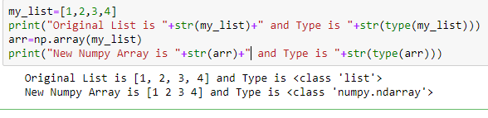

- Creating 2d array in numpy
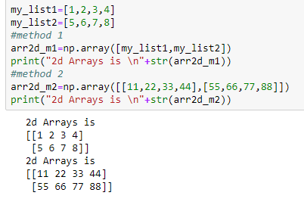
Use of shape, dtype
- shape: The shape tool gives a tuple of array dimensions and can be used to change the dimensions of an array.

- dtype: Datatype of the members of the array.

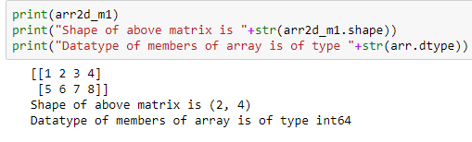
Use of zeros, ones, empty, eye, arrange
- zeros : Return an array of zeros with shape and type of input.
- ones : Return a new array setting values to one.
- empty : Return a new uninitialized array.
- eye : Returns an array with one on diagonals and zero elsewhere.
- arange : Return evenly spaced values within a given interval.
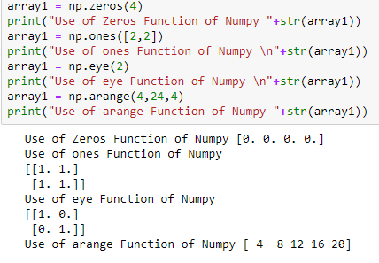
Scalar Matrix
Basic Operations like Multiplication, Exponential, Subtraction, Reciprocal
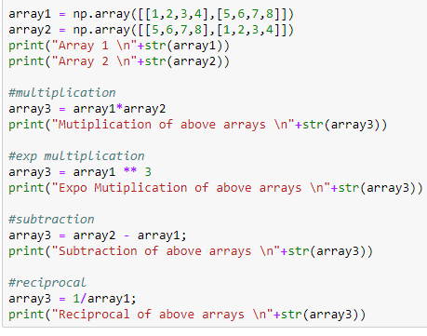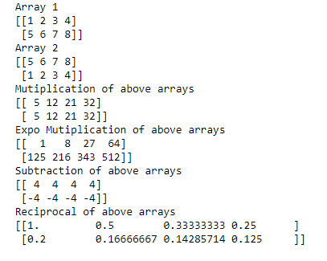

Indexing of Arrays
Slicing
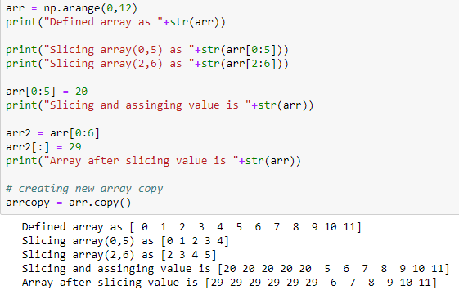

More about Indexing
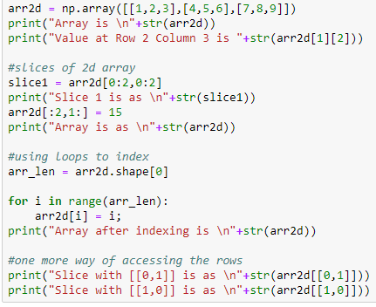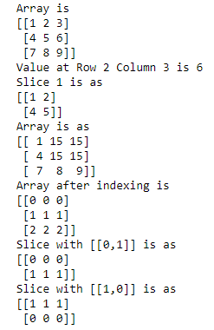
Universal Array Functions

- arange : Returns an array with evenly spaced elements as per the interval.
- sqrt : Returns the square root of any number.
- exp : Calculate the power of E, Where E is Euler's number approximately equal to 2.71828.
- random : Create an array of the given shape and populate it with random samples from a uniform distribution over [0, 1).
- addition : It is used to two arrays.
- maximum : It returns the largest item in an iterable or the largest of two or more arguments.
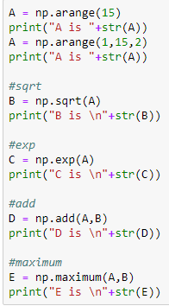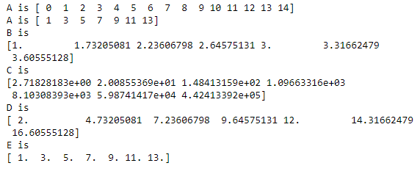

Saving array
Saving single arrays
Load: This function runs Python code contained in a file.
Save: This function saves the Python code in a file.
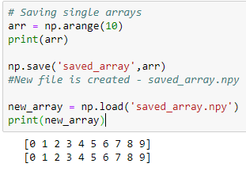
Multiple arrays
Savez: Save several arrays into a single file in uncompressed .npz format.
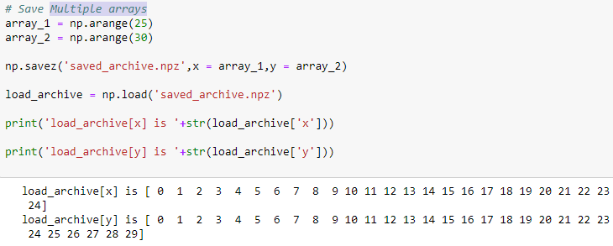
Save to txtfile
savetxt : Save an array to a text file.
loadtxt : Load data from a text file.
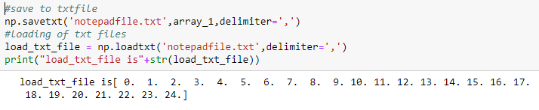

Statistics: This module provides functions for calculating mathematical statistics of numeric (Real-valued) data.

Imshow: This is used to plot numpy arrays as images.
Title: Used to set Title for graph
Colorbar: Add a colorbar to a plot.
Savefig: Save the current figure.

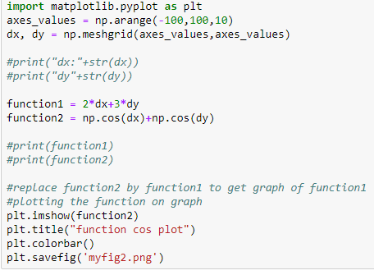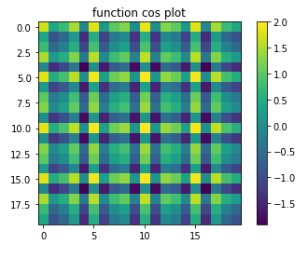

Clausing
Where : Try specifies exception handlers and/or cleanup code for a group of statements.
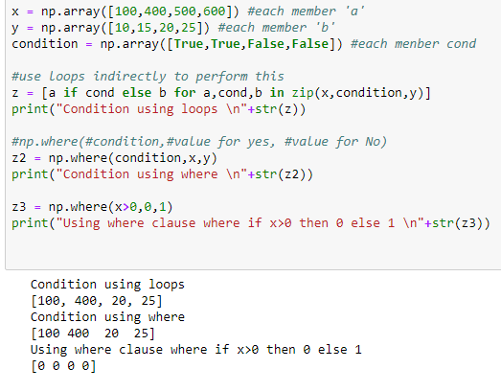
Standard functions of numpy
Mean: It calculates the mean of the array.
Std: It calculates the standard deviation of the given array.
Var: Return variance over requested axis. NA/null values are excluded
Any: Returns true if any of the conditions is true.
All: Returns true if and only if all the conditions are true.
Sort: To sort an array in some order.
Unique: To find the unique elements in the array.
In1d: To find list of elements in an array.
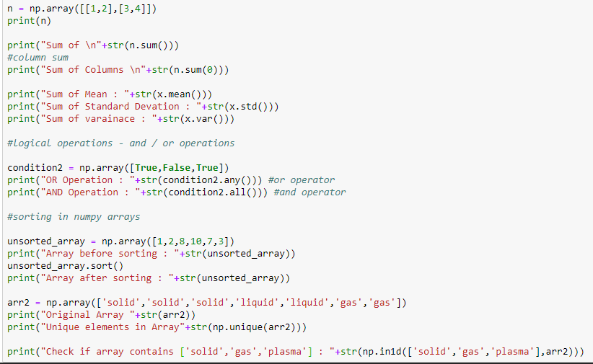
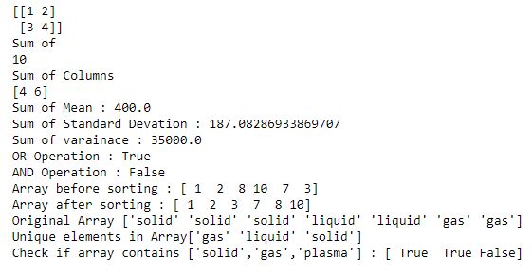

PANDAS
Required Imports
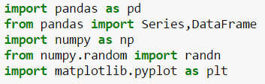
Series:
Working on Series
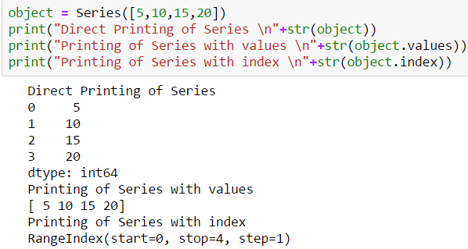
Using Numpy Arrays to Series

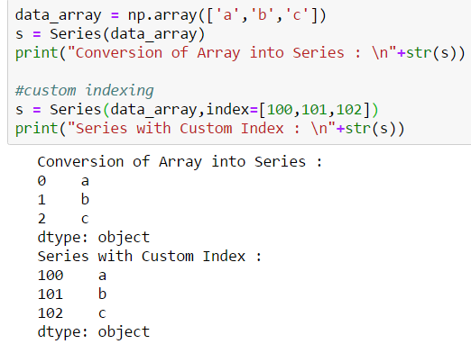
Use of Series
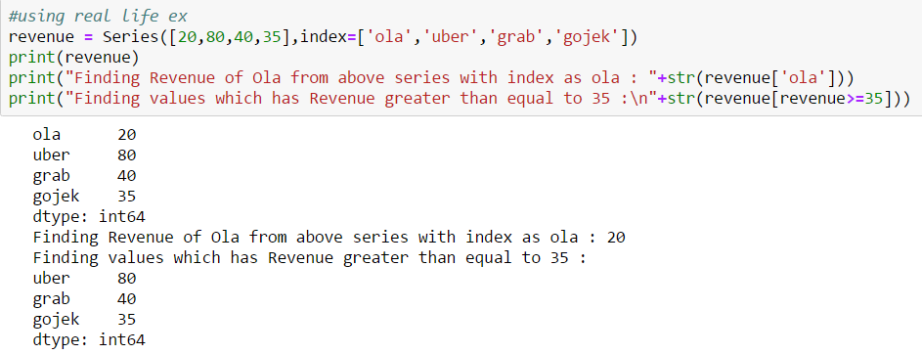
Use of Boolean Conditions, nan Values and addition of Series
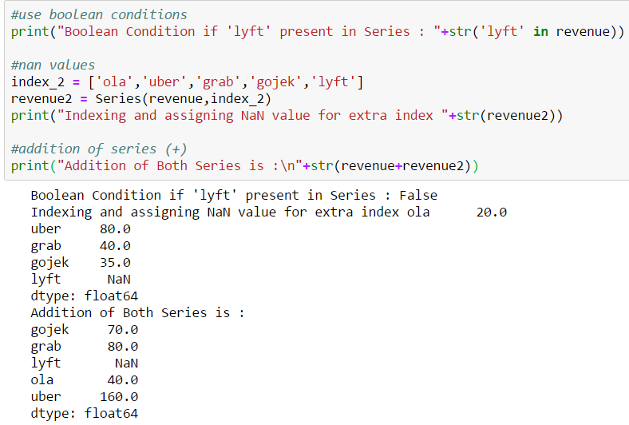
Isnull and Not Null
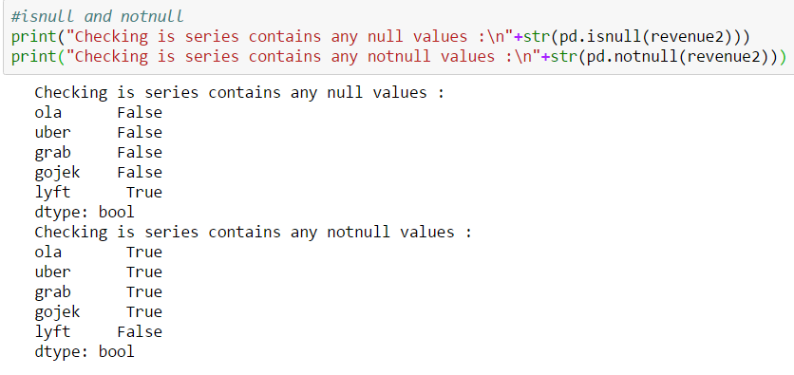
Assigning Name and Index Name and Converting Series into Dictionary
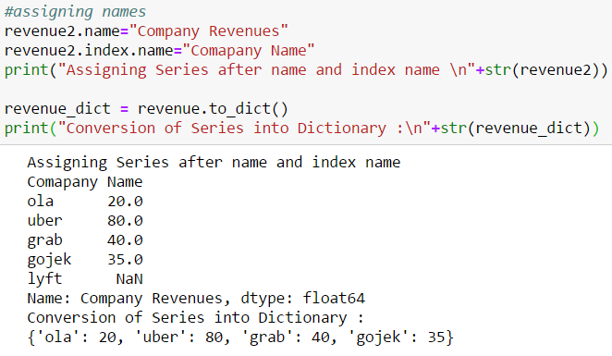
DataFrames for read from clipboard and more
Read_clipboard
Head
Tail
Ix
Del
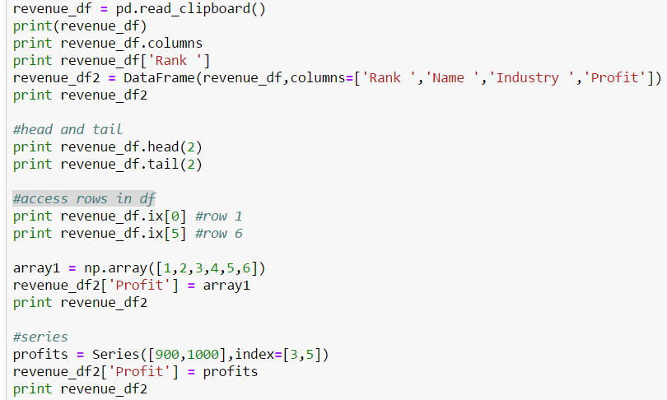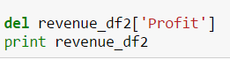
Dictionary to Dataframe
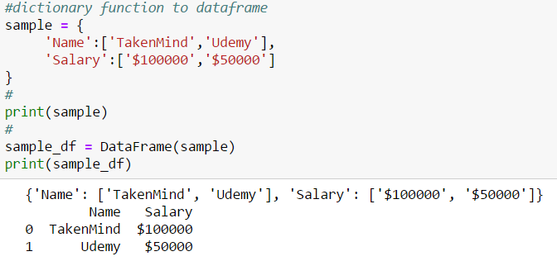

Indexing Objects
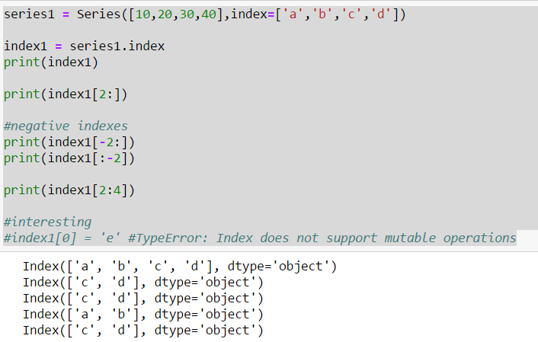
Reindexing in Pandas
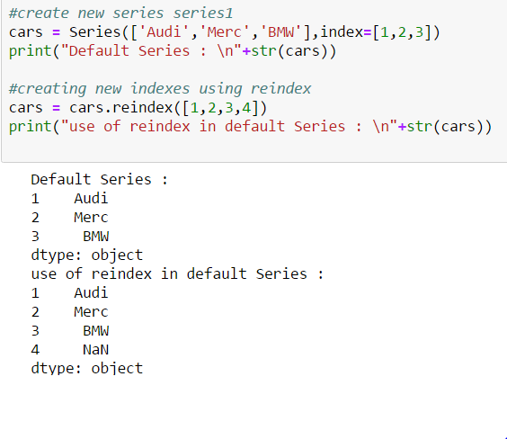
Reindexing using fill_value and ffill
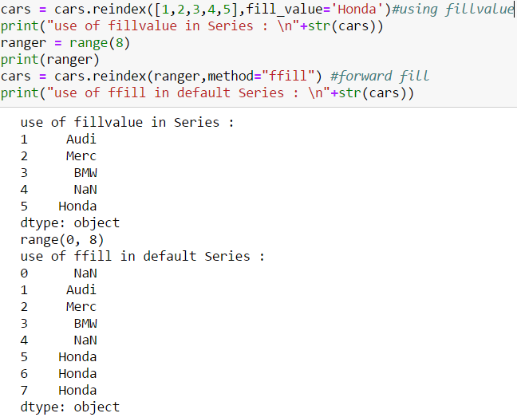
Reindexing DataFrames
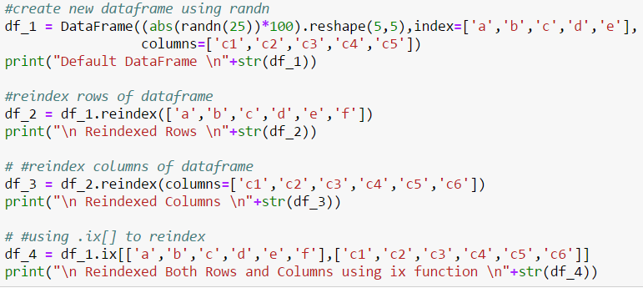
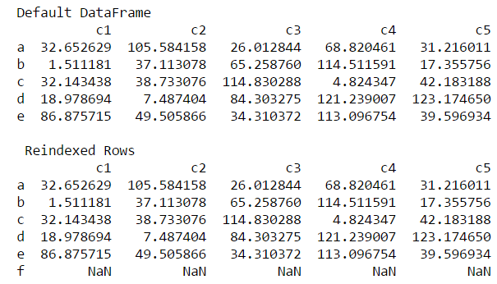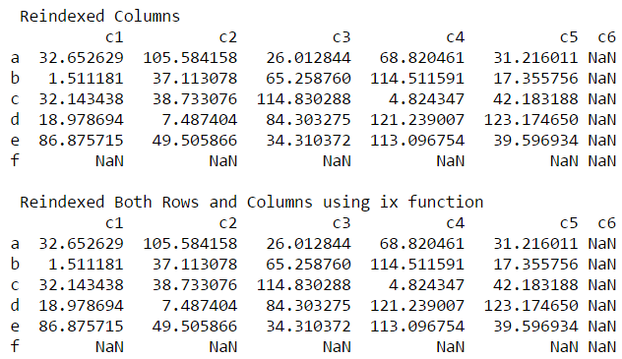
Drop Entries
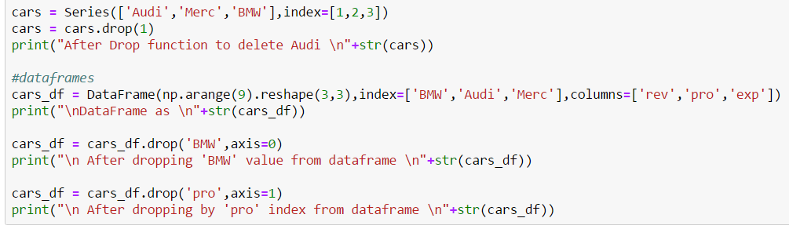
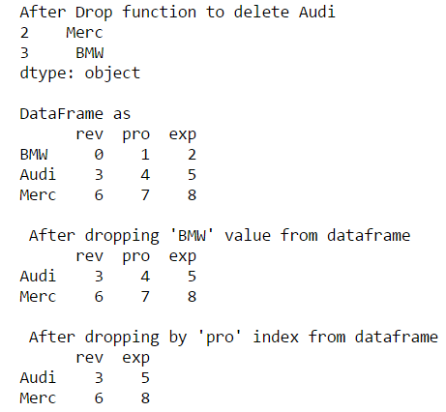
Handling Null Data in Series
Isnull
Dropna
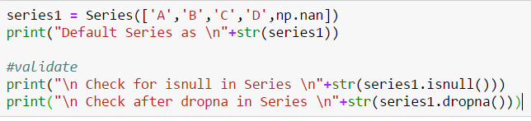
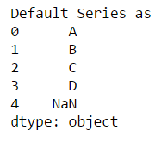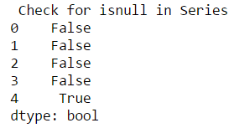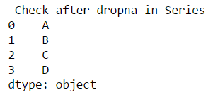
Handling Null Data in DataFrame
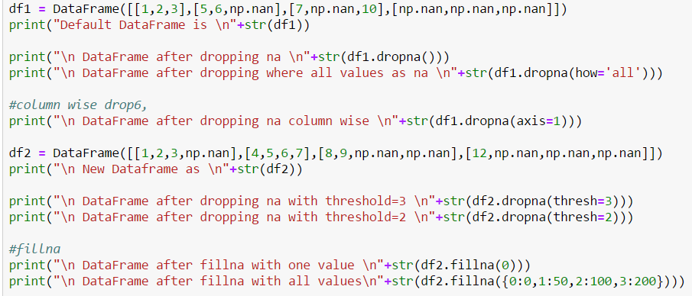
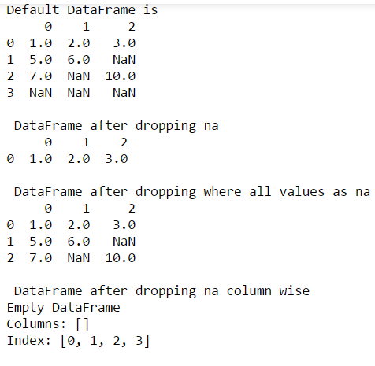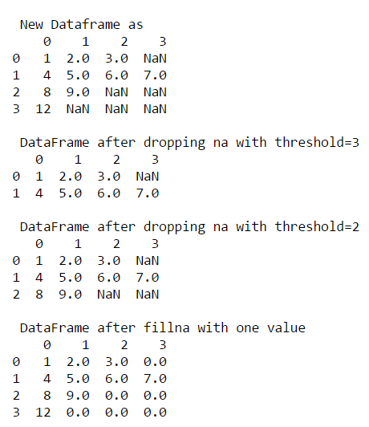
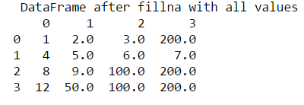
Selecting Moditying Entires
In Series
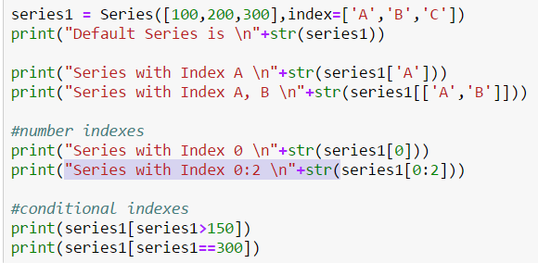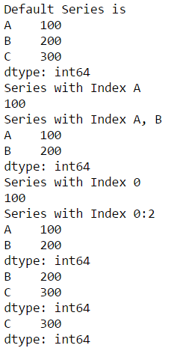
In DataFrames
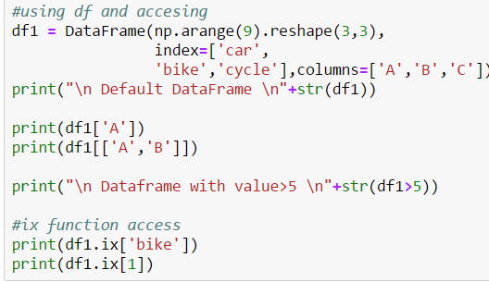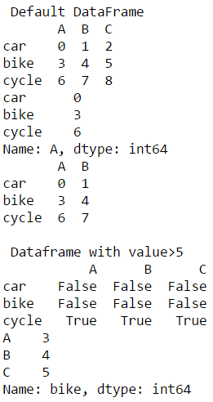
Data Alignment
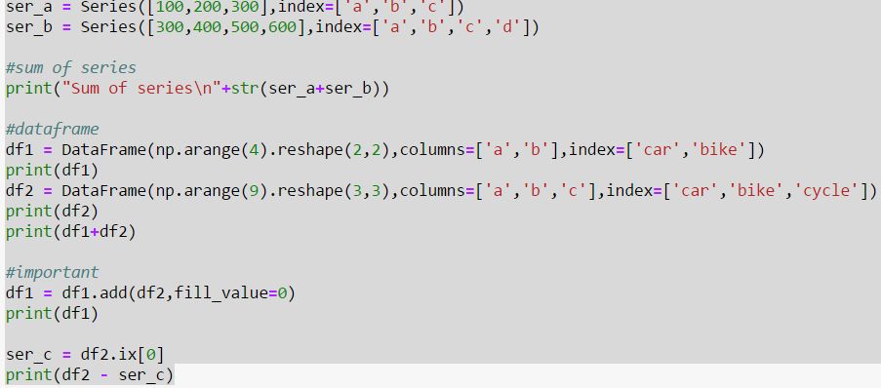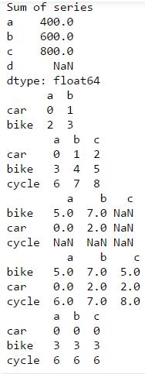
Ranking Sorting
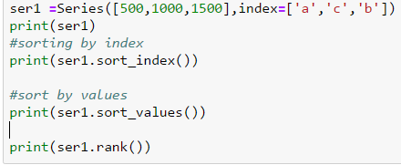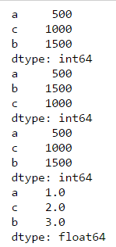
Pandas Statistical
Sum
Min
Max
idxmax : Return index of first occurrence of maximum over requested axis. NA/null values are excluded
cumsum : Return cumulative sum over a DataFrame or Series axis
Describe
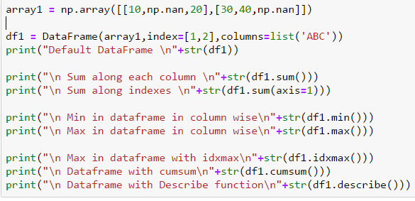
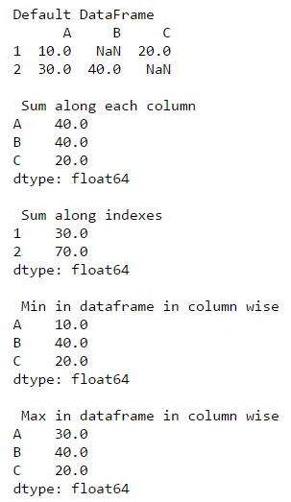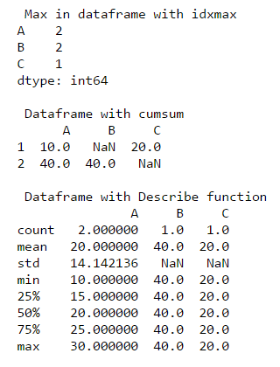
Unique Values in Series and count of unique
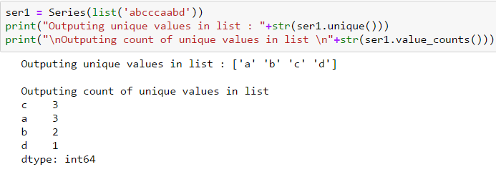
Statistical Plotting DataFrame
