Use Case and Design Specification View Edit Maps
Project – Competitive Migration
Microsoft Dynamics AX 4.0 Migration Toolkit

Author: Abhiram
Document Number: Use Case and Design Specification View Edit Maps V2.0
Document Version Number: Version V2.0 Last Modified: 5th April 2006

Table of Contents

1. Name 2
1.1 Brief Description 2
1.2 Actor Description 2
1.3 Screen mock-up 2
2. Pre Conditions 2
3. Flow of Events 3
3.1 Basic Flow 3
4. Post Conditions 3
5. Sequence Diagram 3
6. Document Change History 3

Use Case Specification- sample

Name
View / Edit Maps

Brief Description
This use case describes the scenario where the user View / Edit the maps between the tables in the source DB to that in the staging DB for the particular entity selected.

Actor Description
Migration toolkit user

Screen mock-up

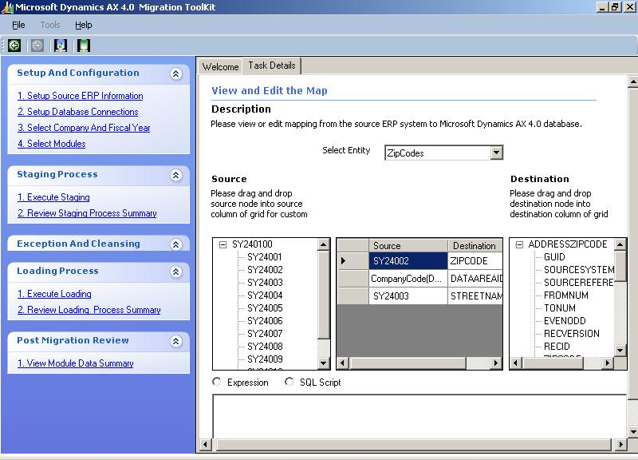

Pre Conditions
The user has selected modules for migration in the previous screen i.e. “Select Modules”

Flow of Events

Basic Flow
- The use case begins when the user navigates to this screen from the previous “Select Modules” screen by clicking the “View/Edit Maps” button.
- The drop down displays the selected modules from the previous screen (Select Module).
- The user selects a particular entity to view the map for the entity
- The system displays the map for that entity.
- The user modifies the map
  - The user selects the source columns and destination columns and add them to map
  - The user selects a derived column in the mapping grid (Center). The system displays the transformation in the transformation grid box.
  - The user modifies the transformation for the derived column
- The user clicks on validate transformation.
  - Validation against the mapped columns of the tables.
  - An error if any (due to improper mapping) is thrown.
- The user clicks “Done” and the system saves the customized package and navigates back to the select modules screen. The default map check box for this entity is un-checked and the customized map is displayed.

Post Conditions
The SSIS maps for the selected module will be modified and persisted to the database for the current migration instance.

Sequence Diagram

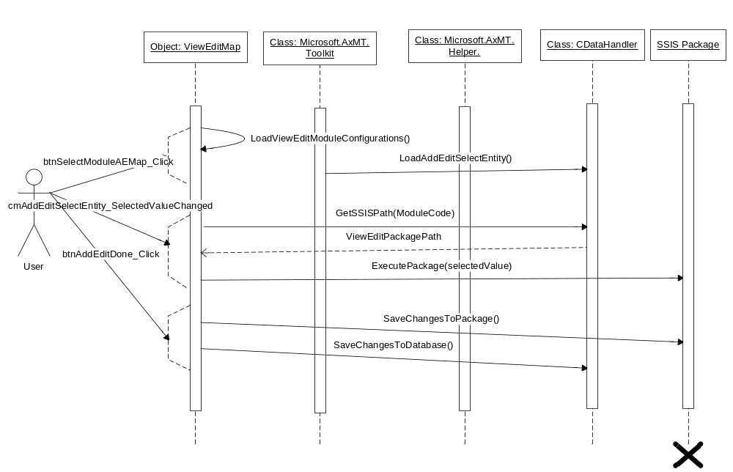

Document Change History

Date | Author/Editor | Description of Change(s)
09/02/2006 | XX | Version 1.0
05/04/2006 | YY | Version 2.0, Incorporated feedback from Madan

