

Vidyavardhini’s College of Engineering & Technology

Department of Artificial Intelligence and Data Science (AI&DS)

|  |  |
| --- | --- |
| **Name:** | Vijendra Mane |
| **Roll No:** | 26 |
| **Class/Sem:** | SE/IV |
| **Experiment No.:** | 4 |
| **Title:** | Program to display character in uppercase and lowercase. |
| **Date of Performance:** |  |
| **Date of Submission:** |  |
| **Marks:** |  |
| **Sign of Faculty:** |  |

**Aim:** Assembly Language Program to display character A to z in both uppercase and lowercase

**Theory:**

DOS provide various interrupt services that are used by the system programmer. The most commonly used interrupt is INT 21H. It invokes inbuilt DOS functions which can be used to perform various tasks. The most common tasks are reading a user input character from the screen, displaying result on the exiding program etc.

In this program, we display the characters A to Z on the DOS prompt. DOS interrupt function 02 displays the contents of DL (ASCII code) on the screen. By loading the ASCII code of 'A' in the DL register, loading AH register with 02h and calling INT 21h it is possible to display character from A to Z on the screen.

INT 21h/AH = 2 - write character to standard output.

Entry: DL = character to write, after execution AL = DL.

**Example :-**

mov ah , 2

mov dl , 'a'

int 21h



**Flowchart:**

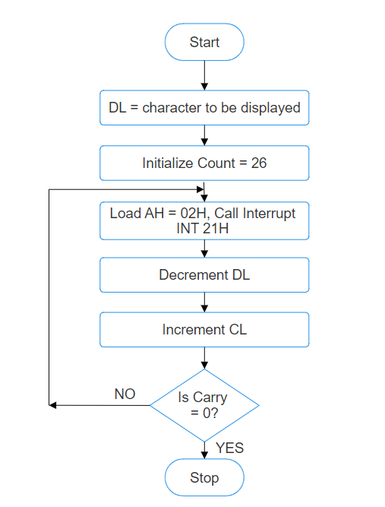

**Algorithm:**

1. Start.

2. Initialize DL with 'A'.

3. Load CL with count = 26.

4. Load AH = 02H and call INT 21H.

5. Increment DL, to next character.

6. Decrement the count.

7. Repeat steps 4,5,6 till CL is not zero.

8. To end the program use DOS interrupt:

1) Load AH = 41H.

2) Call INT 21 H.

9. Stop.

**Assembly Code:**

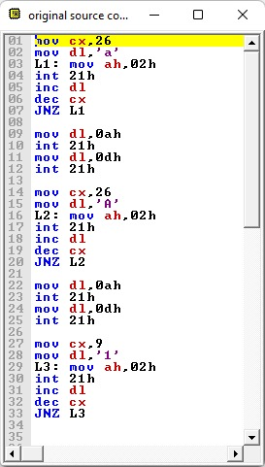

**Output:**

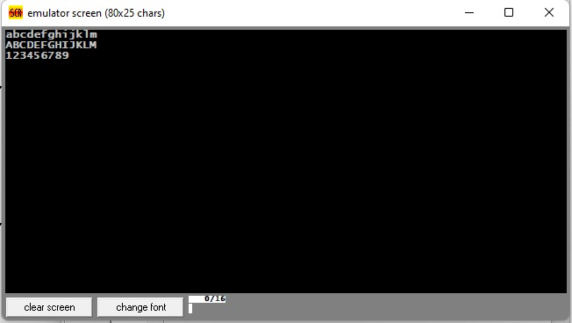

**Conclusion:**

1. Explain INT 21H.



Ans. INT 21h is a software interrupt in x86 assembly language, primarily used in DOS (Disk Operating System) environments. It provides access to various DOS services, such as file operations, input/output, and system functions. Here’s an explanation of INT 21h:

1. Purpose: INT 21h serves as a gateway to DOS services, allowing programmers to perform various tasks related to file management, input/output operations, and system control.
2. Functionality: The specific functionality accessed through INT 21h depends on the value passed in the AH (accumulator high) register before invoking the interrupt. Different values in AH correspond to different DOS services.
3. Common Services:
   * File Operations: Creating, opening, closing, reading from, and writing to files.
   * Directory Operations: Creating, removing, and navigating directories.
   * Input/Output: Reading characters from the keyboard, displaying characters on the screen, and handling input/output redirection.
   * Program Execution: Loading and executing other programs, terminating the current program, and obtaining information about the environment.
4. Example Usage: For instance, to print a character to the screen, the programmer would load the character into the DL register and set AH to the appropriate value for the print function (e.g., AH = 02h for printing a character). Then, the programmer would invoke the INT 21h interrupt, which would cause DOS to perform the requested operation.
5. 5. Limitations: While INT 21h provides convenient access to DOS services, it is specific to DOS environments and may not be available in other operating systems or modern computing environments. INT 21h remains a crucial mechanism for interacting with DOS services and is commonly used in legacy software and DOS emulators.
6. Explain working of increment and decrement instructions.

Ans. Increment and decrement instructions are fundamental operations in computer architecture used to increase or decrease the value stored in a register or memory location by one. Here’s how they work:

1. Increment (INC):
   1. Register Mode: The content of the specified register is incremented by one.
   2. Memory Mode: The content of the memory location addressed by the specified memory address is incremented by one.
   3. After the increment operation, the zero flag (ZF) is set if the result is zero, and the sign flag (SF) is set based on the result’s sign.
2. Decrement (DEC):
   1. Register Mode: The content of the specified register is decremented by one.
   2. Memory Mode: The content of the memory location addressed by the specified memory address is decremented by one.
   3. After the decrement operation, the zero flag (ZF) is set if the result is zero, and the sign flag (SF) is set based on the result’s sign.
3. Overflow and Carry Flags:
   1. These instructions do not affect the overflow (OF) or carry (CF) flags, which are used to indicate arithmetic overflow or carry conditions.
   2. Overflow occurs when the result of an arithmetic operation cannot be represented using the available number of bits.
   3. Carry occurs when an addition operation generates a carry-out or a subtraction operation requires borrowing.