Scribble to Digital

Project Tittle:Scribble to Digital
Team ID:SWTID-2026-1985
Team Size:5
Team Leader:Priyadarshini K
Team Members:Harish T
Team Members:Naveen V
Team Members:Vijayalakshmi S
Team Members:Swathi V

Project Description
Scribble to Digital is a web-based application designed to convert handwritten notes into structured digital text. The system allows users to upload an image of handwritten content, which is then processed using image processing techniques to improve clarity and readability. After preprocessing, the system extracts text from the image using Tesseract OCR.
The extracted text may contain errors due to handwriting variations, so the application uses Google Gemini to correct and refine the text. The AI model improves the readability of the extracted text and identifies actionable tasks from the notes. These tasks are organized into a structured to-do list for better usability.
The application is built using Streamlit, which provides a simple and interactive user interface. Users can upload images, view the raw OCR output, see the AI-corrected text, and download the final result as a text file.
This project demonstrates how modern technologies such as OCR, artificial intelligence, and image processing can be combined to digitize handwritten content efficiently. It is especially useful for students, professionals, and researchers who frequently take handwritten notes and want to convert them into digital format quickly.

Use Case Scenarios
Scenario 1: Handwritten Note Digitization with Image Enhancement
In this scenario, users upload a photo of handwritten notes through the Streamlit interface. Since images may contain shadows, low brightness, or noise, the system first enhances the image using OpenCV.
The enhancement process includes converting the image to grayscale, adjusting brightness and contrast, reducing noise, and applying thresholding techniques. These preprocessing steps improve the clarity of the text within the image.
Once the image is enhanced, it is passed to the OCR engine to extract text more accurately. This process increases the reliability of text recognition even when the original image quality is poor.
The system then provides two outputs:
- Raw text extracted from OCR
- Enhanced image for improved readability

Scenario 2: Intelligent Text Correction and Contextual Reconstruction
After OCR extraction, the text may contain spelling mistakes, broken words, or incomplete sentences due to handwriting variations or recognition errors.
To solve this problem, the system uses a Generative AI model to analyze the extracted text and improve its quality. The AI model performs several tasks including correcting spelling mistakes, improving grammar, reconstructing missing or incomplete words, and organizing the content into readable paragraphs.
This step transforms messy handwritten text into a clear and professionally structured digital format.

Scenario 3: Automatic To-Do Extraction and Task Identification
Handwritten notes often contain both informational content and actionable tasks. Identifying these tasks manually can be difficult and time-consuming.
The AI system analyzes the processed text and detects sentences that indicate actions or tasks. It then extracts these task-related statements and organizes them into a structured bullet-point to-do list.
This feature allows users to quickly identify important tasks separately from general notes, improving productivity and task management.

Architecture Overview
The Scribble to Digital system follows a simple pipeline architecture where each module processes the data step by step. The goal of the architecture is to convert handwritten notes into structured digital text and extract tasks from the notes automatically.
1. Input Layer
The process begins when the user uploads an image containing handwritten notes through the web interface built using Streamlit. The image can be in formats such as PNG, JPG, or JPEG.
2. Image Processing Layer
Once the image is uploaded, it is processed using OpenCV. In this stage, several preprocessing techniques are applied such as:
- Converting the image to grayscale
- Removing noise
- Applying thresholding to enhance text clarity
These steps help improve the accuracy of the OCR process.
3. OCR Processing Layer
After preprocessing, the system extracts text from the image using Tesseract OCR. The OCR engine analyzes the processed image and converts the detected handwritten characters into raw digital text.
4. AI Processing Layer
The raw OCR text may contain spelling errors or unclear formatting. Therefore, the extracted text is sent to Google Gemini. The AI model performs the following tasks:
- Corrects spelling and grammar
- Organizes the text into readable format
- Identifies tasks and converts them into a to-do list
5. Output Layer
Finally, the system displays the results to the user. The output includes:
- Raw OCR text
- AI-corrected text
- Extracted to-do tasks
Users can also download the processed text as a file for future use.

Core Technologies
Streamlit
Streamlit is a Python-based framework used to build interactive web applications. In this project, Streamlit provides the user interface that allows users to upload handwritten images, process them, and view the results in real time.
Google Gemini 2.5 Flash
Gemini 2.5 Flash is a generative AI model used for contextual understanding of text. In the Scribble to Digital system, it is responsible for correcting grammar, reconstructing incomplete sentences, formatting messy text, and extracting to-do tasks from the notes.
OpenCV
OpenCV is an open-source computer vision library used for image processing. In this system, OpenCV enhances the uploaded handwritten images by converting them to grayscale, removing noise, adjusting brightness and contrast, and applying thresholding techniques to improve OCR accuracy.
OCR (Tesseract / EasyOCR)
Optical Character Recognition (OCR) is used to convert text present in images into machine-readable digital text. The Scribble to Digital system uses either Tesseract or EasyOCR to extract handwritten text from the enhanced images.
Python
Python is the primary programming language used to develop the application. It integrates all components including image processing, OCR, AI processing, and file export functionalities.
ReportLab / Python-DOCX
These libraries are used to export the final processed results into downloadable document formats such as PDF and Word files.

Component-Wise Architecture
Streamlit Frontend UI
The Streamlit interface allows users to interact with the system. It provides options to upload handwritten images, initiate processing, and view results including enhanced images, extracted text, corrected notes, and to-do lists.
Image Processing Layer (OpenCV)
This layer enhances the uploaded image before text extraction. It improves text visibility through grayscale conversion, noise reduction, brightness adjustment, and thresholding.
OCR Layer
The OCR layer processes the enhanced image and extracts handwritten text, converting it into machine-readable digital text.
Generative AI Layer (Gemini 2.5 Flash)
This layer processes the OCR output and performs contextual analysis. It corrects spelling and grammar, reconstructs unclear words, organizes the text into paragraphs, and identifies actionable tasks.
Export Module
The export module converts the processed content into downloadable formats such as PDF or Word documents, allowing users to store or share the results easily.

Testing & Optimization Definitions
OCR Accuracy
OCR accuracy refers to the percentage of words correctly recognized from the handwritten image during the text extraction process.
Contextual Correction
Contextual correction is the process in which the AI model improves sentence clarity, grammar, and meaning based on contextual understanding.
To-Do Extraction Accuracy
This refers to the system’s ability to correctly identify actionable tasks from the handwritten notes without including irrelevant information.
Format Consistency
Format consistency ensures that the cleaned text and extracted tasks are displayed in a clear and structured format.
Export Quality
Export quality refers to the correctness and usability of generated files such as TXT, CSV, or PDF after processing.

Steps Involved in the Project
The Scribble to Digital system converts handwritten notes into structured digital text through a series of processing steps. Each step plays an important role in transforming the handwritten image into readable and organized text.
1. Image Upload
The first step is uploading an image that contains handwritten notes.
The user uploads the image through the interface built using Streamlit. The system accepts image formats such as PNG, JPG, and JPEG.
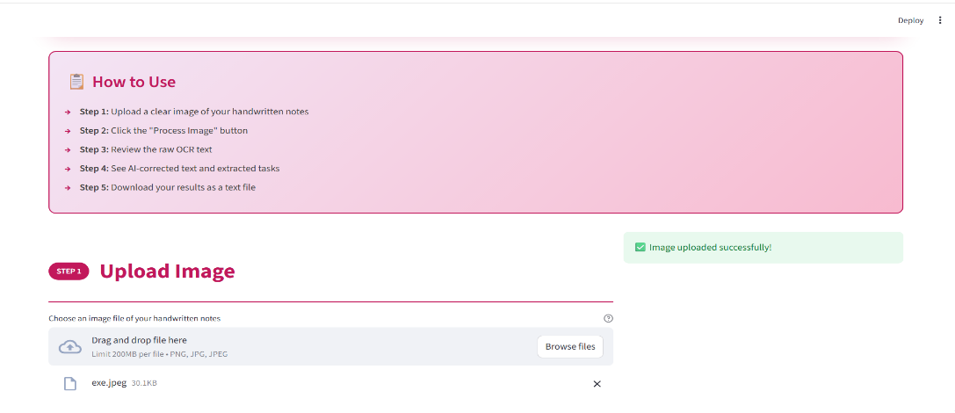

FIG:1 IMAGE UPLOAD

2. Image Preprocessing
After the image is uploaded, it is processed to improve its quality.
Using OpenCV, the system performs operations such as:
- Converting the image to grayscale
- Removing noise from the image
- Applying thresholding to enhance text clarity
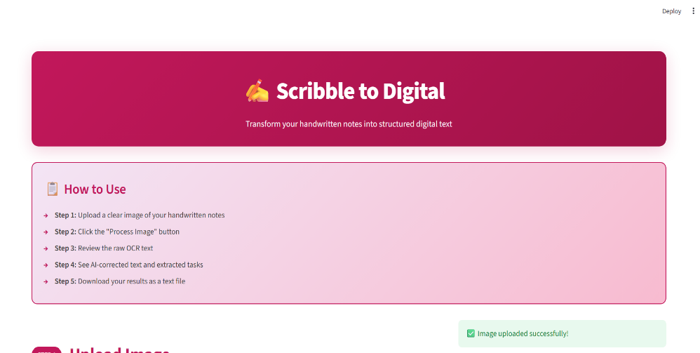
These steps help improve the accuracy of text recognition.

FIG:2 IMAGE PREPROCESSING
3. Text Extraction
In this step, the system extracts text from the processed image using Tesseract OCR.
The OCR engine scans the image and converts the handwritten characters into raw digital text.
Example:
To Buy
Apple
Orange
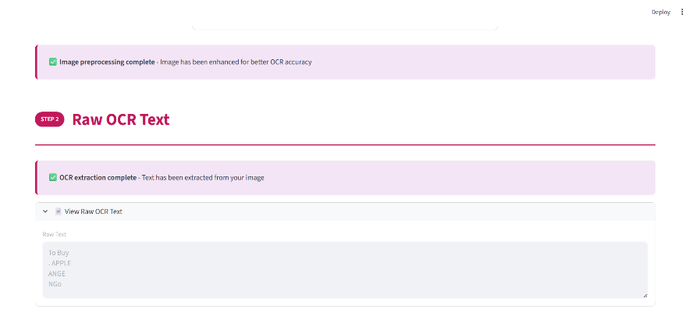
Mango

FIG:3 RAW TEXT

4. AI Text Processing
The raw OCR output may contain spelling mistakes or formatting issues.
The extracted text is therefore processed using Google Gemini, which:
- Corrects spelling and grammar
- Improves sentence structure
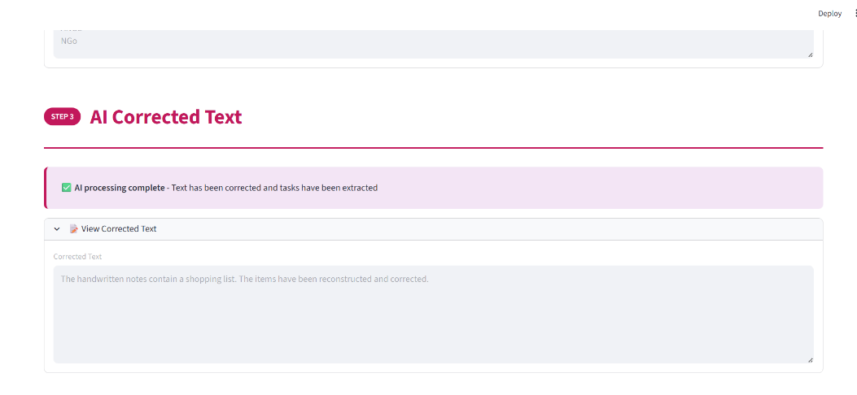
- Extracts tasks from the text

FIG:4 AI TEXT PROCESSING

5. Task Extraction
The system identifies important tasks from the corrected text and converts them into a To-Do list. This helps users quickly understand the important actions mentioned in their handwritten notes.
Example:
- To Buy
- Apple
- Orange
- Mango
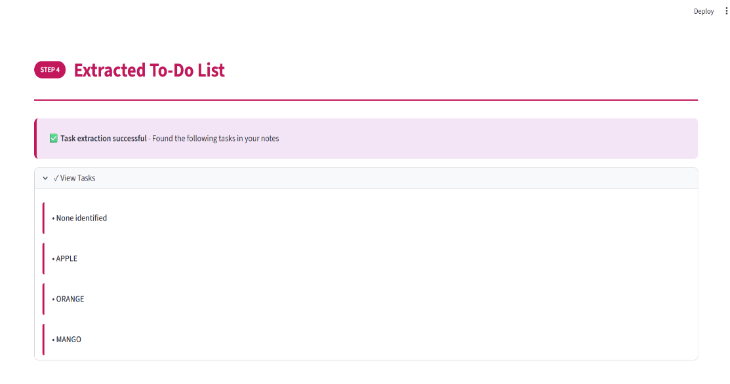

FIG:5 TASK EXTRACTION

6. Display Results
The system displays three types of output to the user:
- Raw OCR text
- AI-corrected text
- Extracted tasks list
This allows users to compare the original OCR result with the AI-improved version.

7. Download Output
Finally, users can download the processed text and extracted tasks as a text file for future reference.
Future Enhancements
The Scribble to Digital project can be improved further by adding more advanced features and improving the accuracy of handwritten text recognition. Some possible future enhancements are listed below.
1. Multi-Language Support
Currently, the system mainly focuses on recognizing English handwritten text using Tesseract OCR. In the future, the system can be enhanced to support multiple languages such as Tamil, Hindi, or other regional languages.
2. Mobile Application
The application is currently developed as a web application using Streamlit. A mobile version of the application can be developed so that users can directly capture handwritten notes using their smartphone cameras.
3. Improved Handwriting Recognition
OCR accuracy depends on handwriting clarity. Advanced machine learning models and improved preprocessing techniques using OpenCV can be implemented to improve the recognition of complex handwriting styles.
4. Cloud Storage Integration
Future versions of the system can include integration with cloud storage platforms such as Google Drive or Dropbox, allowing users to automatically save and access their processed notes online.
5. Export in Multiple Formats
Currently, the output can be downloaded as a text file. Future improvements could allow users to download the results in other formats such as PDF, Word documents, or spreadsheets.
6. Real-Time Note Detection
The system could be enhanced to support real-time handwriting detection from live camera input instead of uploading images manually.
7. Advanced AI Processing
Using advanced AI models such as Google Gemini, the system can further summarize notes, categorize tasks, and even generate reminders automatically.

Challenges Faced
During the development of the Scribble to Digital project, several challenges were encountered while integrating different technologies and ensuring accurate text extraction from handwritten images.
1. Handwriting Recognition Accuracy
One of the main challenges was accurately detecting handwritten text using Tesseract OCR. Handwriting styles vary from person to person, which sometimes caused incorrect or incomplete text extraction.
2. Image Quality Issues
Poor lighting, blurred images, or low-resolution photos affected the OCR accuracy. To overcome this issue, image preprocessing techniques were applied using OpenCV to enhance the image before text extraction.
3. Integration of Multiple Libraries
Integrating different Python libraries such as image processing, OCR, and AI processing into a single workflow required careful handling of dependencies and compatibility.
4. API Configuration
Another challenge was setting up the Google Gemini API key correctly. Errors occurred when the API key was not configured properly as an environment variable.
5. Environment Setup
Installing and configuring required tools such as Tesseract OCR and ensuring it was correctly linked with Python caused some setup difficulties during development.
6. Streamlit Execution Issues
Running the application using Streamlit sometimes produced errors when the required libraries were not installed or when the command was not recognized in the system path.

Conclusion
Scribble to Digital is an AI-powered application designed to convert handwritten notes into organized digital content. By combining OCR technology with generative AI, the system extracts handwritten text, improves readability through contextual correction, and automatically identifies tasks.
The integration of image preprocessing, intelligent text processing, and a user-friendly Streamlit interface enables efficient note digitization. This system helps users save time, improve organization, and enhance productivity by transforming handwritten notes into structured digital information.

