**Jenkins build:**

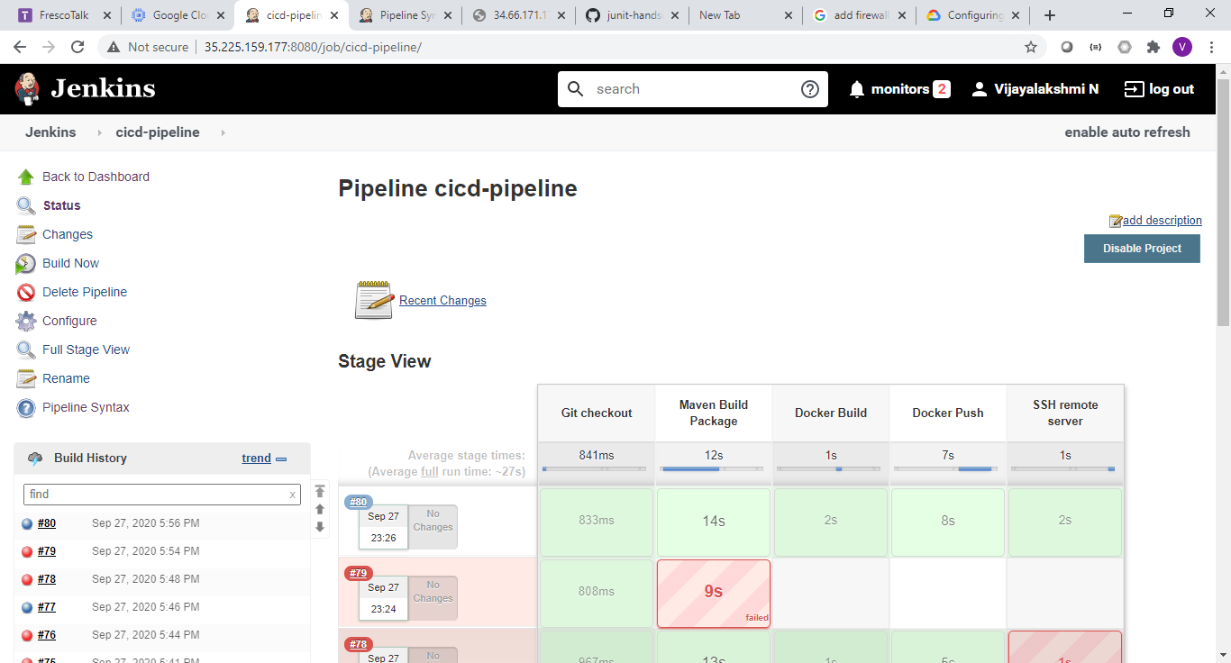

**SSH config:**

Refer:

<https://nozaki.me/roller/kyle/entry/articles-jenkins-sshdeploy>

<https://stackoverflow.com/questions/37331571/how-to-setup-ssh-keys-for-jenkins-to-publish-via-ssh>

1. Generate ssh key in the jenkins server
2. Copy public key to target (remote server)
3. Configure private key in the jenkins
4. Also configure public key in the jenkins to establish remote SSH connection
5. Add jenkins as user in the docker group of remote server

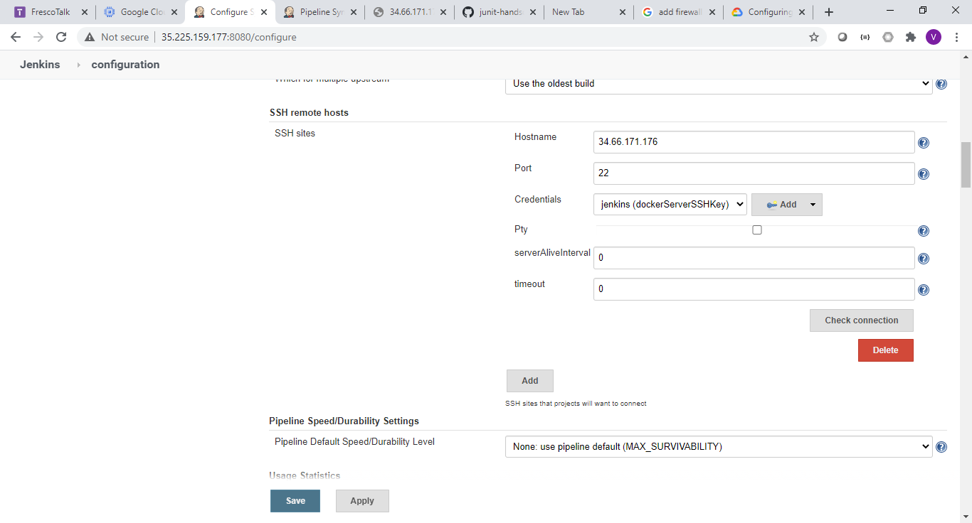

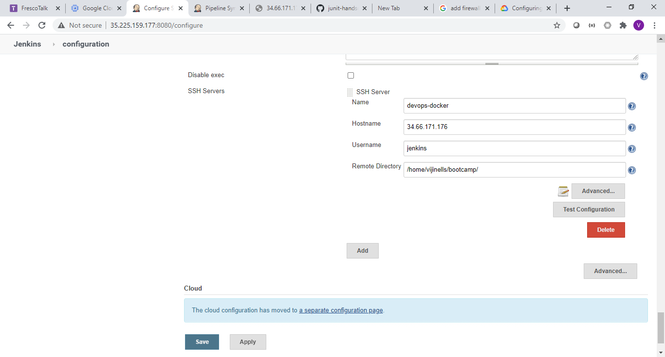

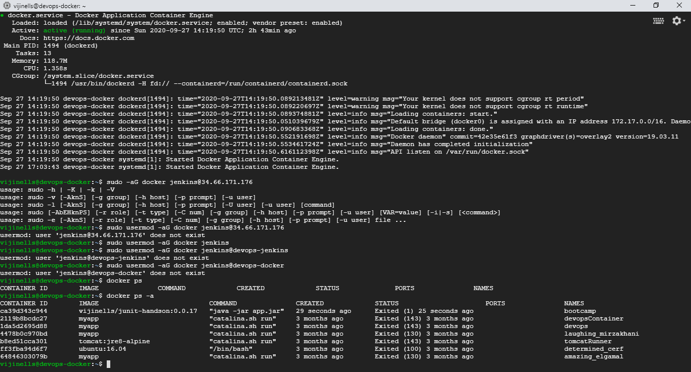

If jar file do maven package spring-boot:repackage

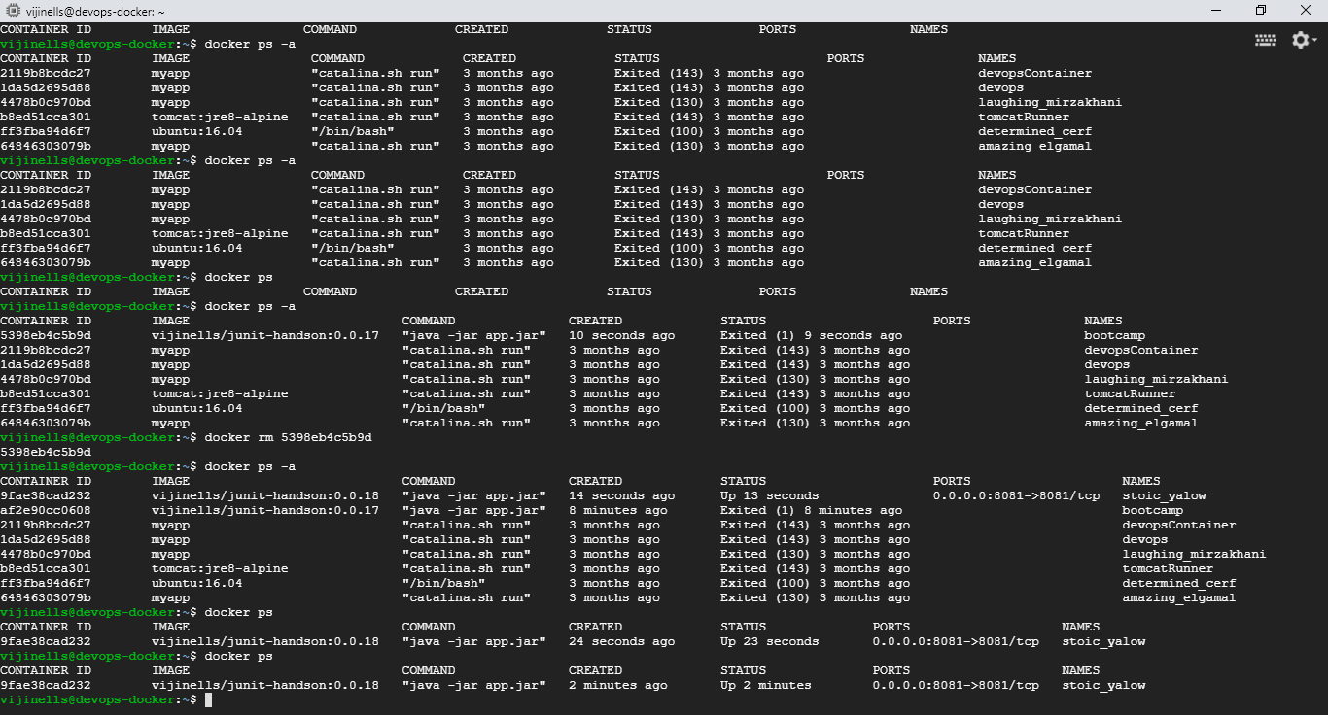

**GCP : (jenkins & docker instances):**

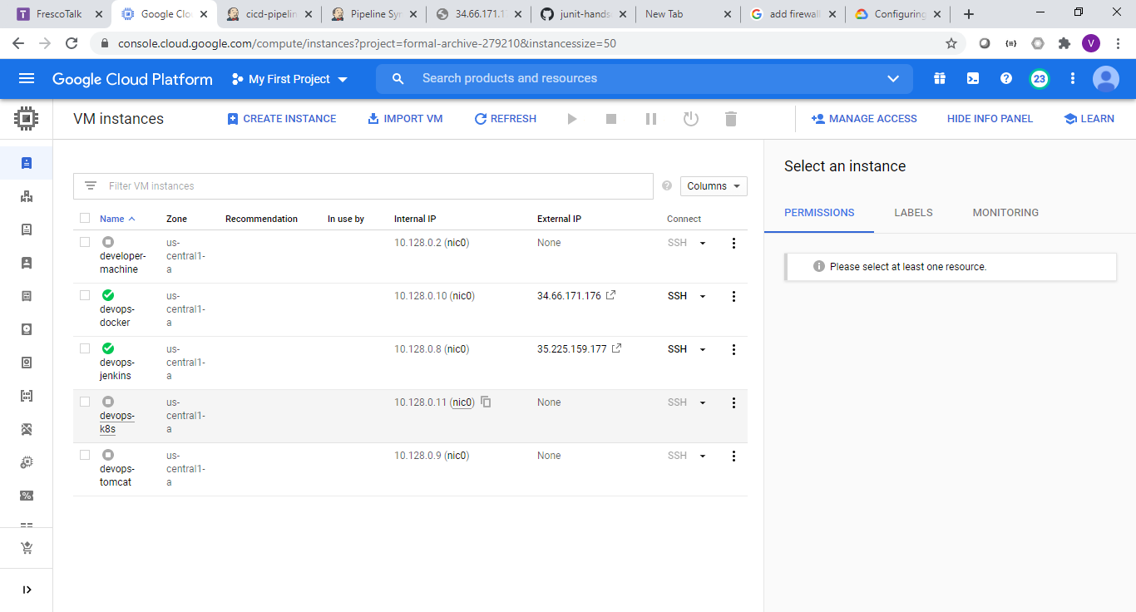

**Firewall allow 8081: (as I have exposed my application in the port 8081 )**

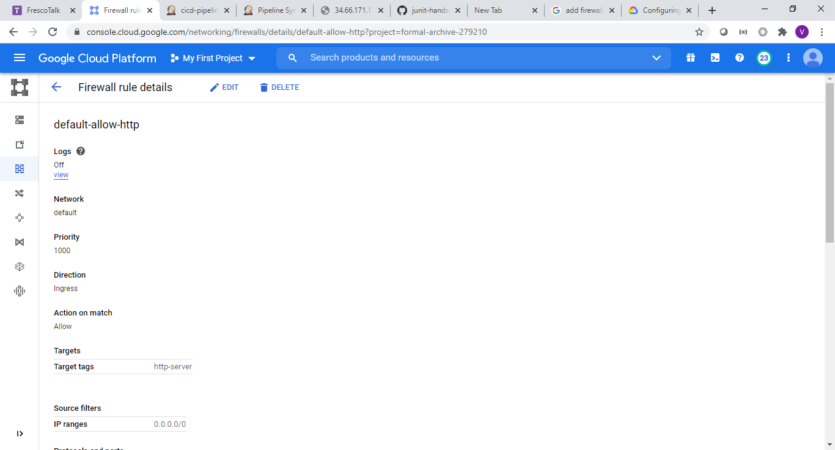

**My Jar file (junit-hands) student service application running in remote server:**

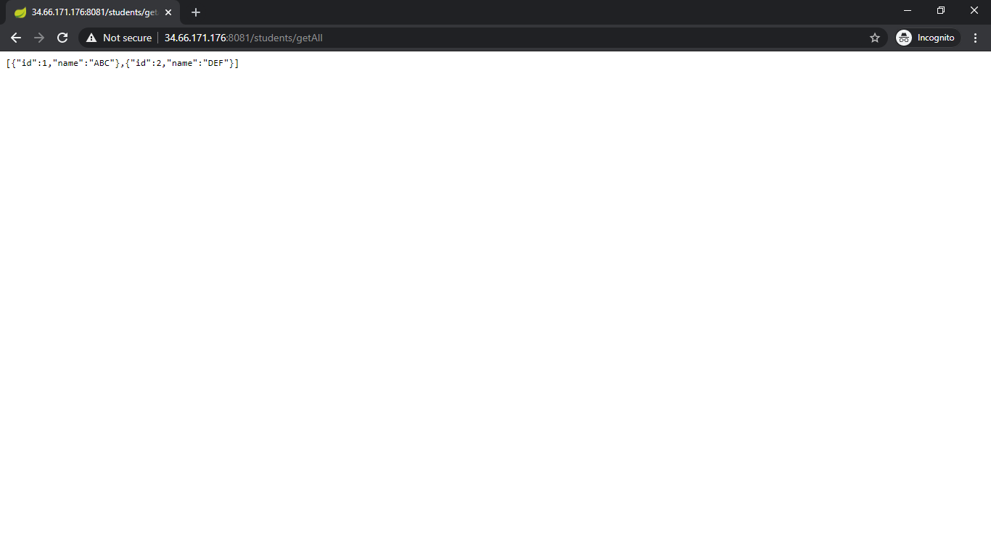

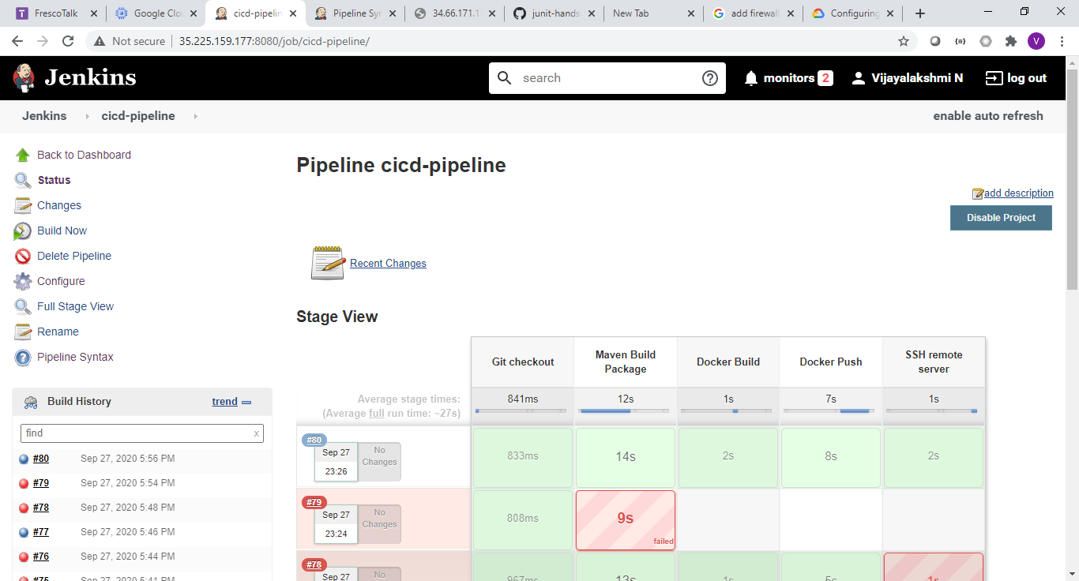

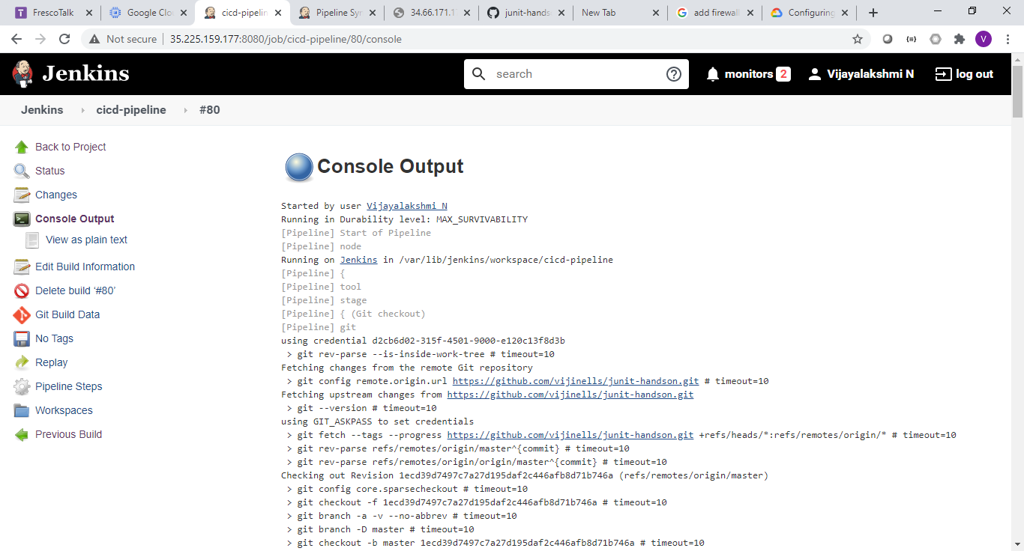

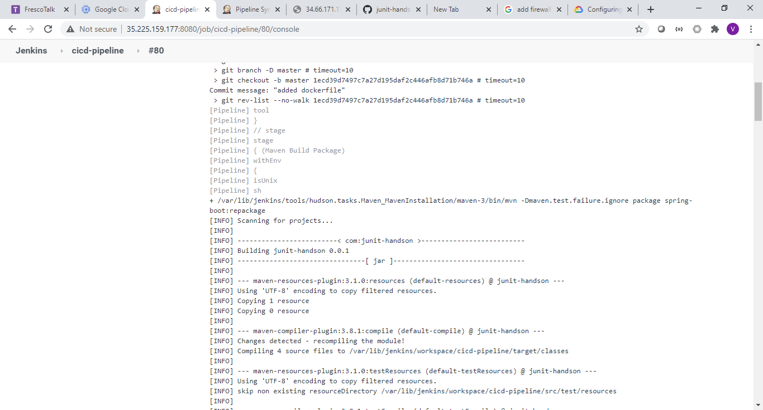

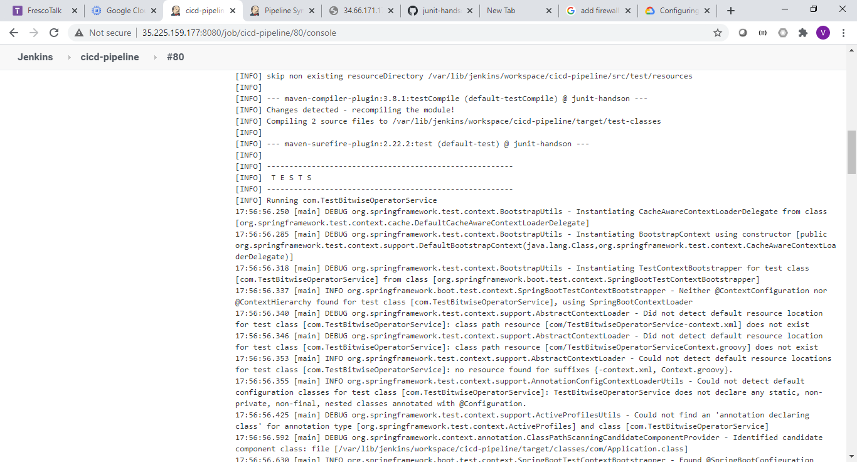

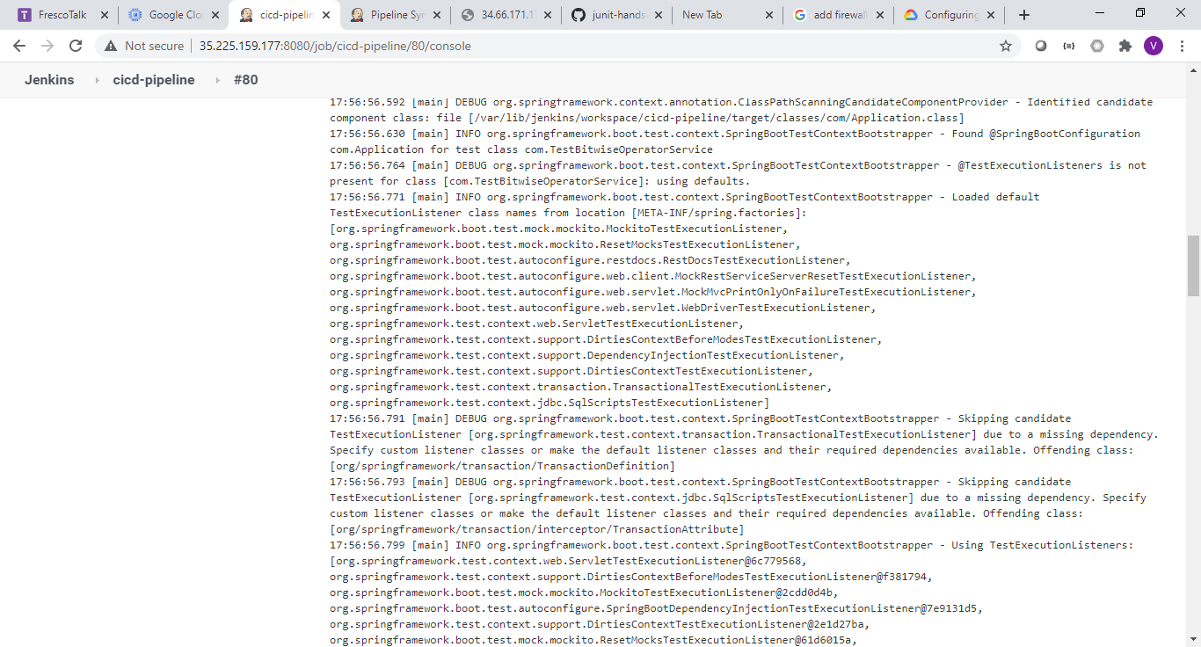

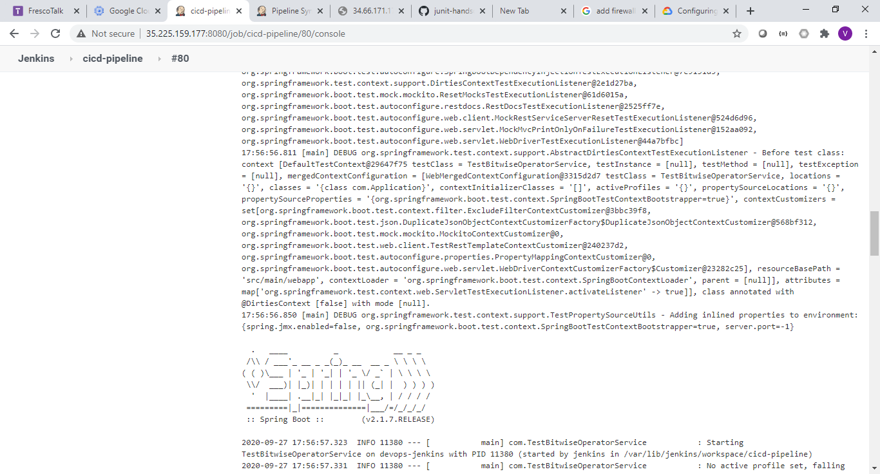

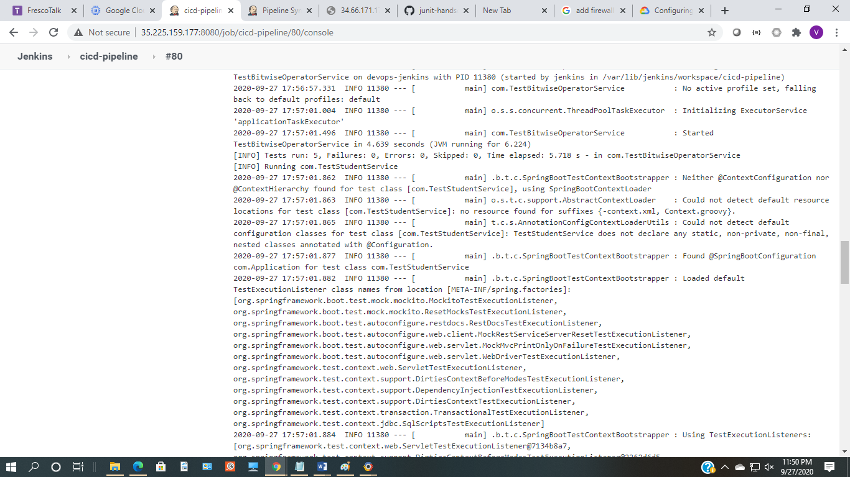

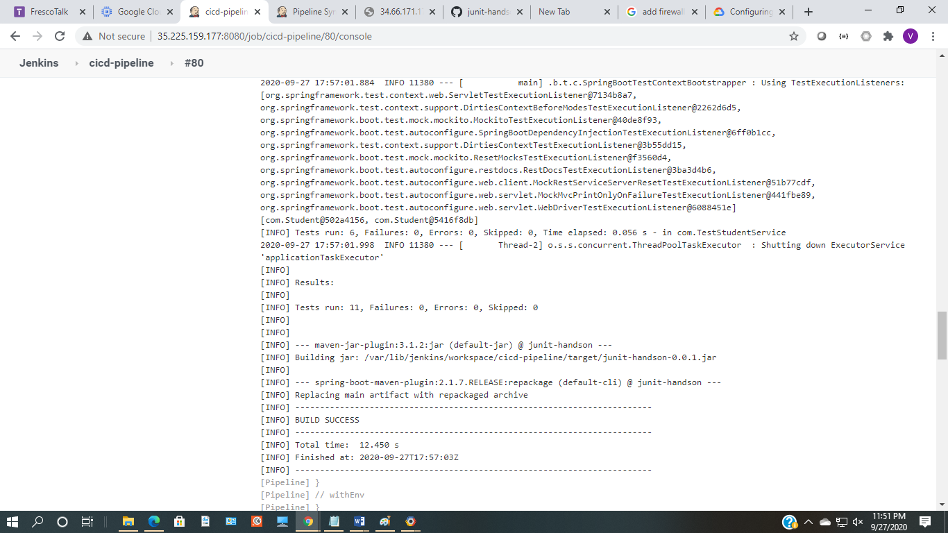

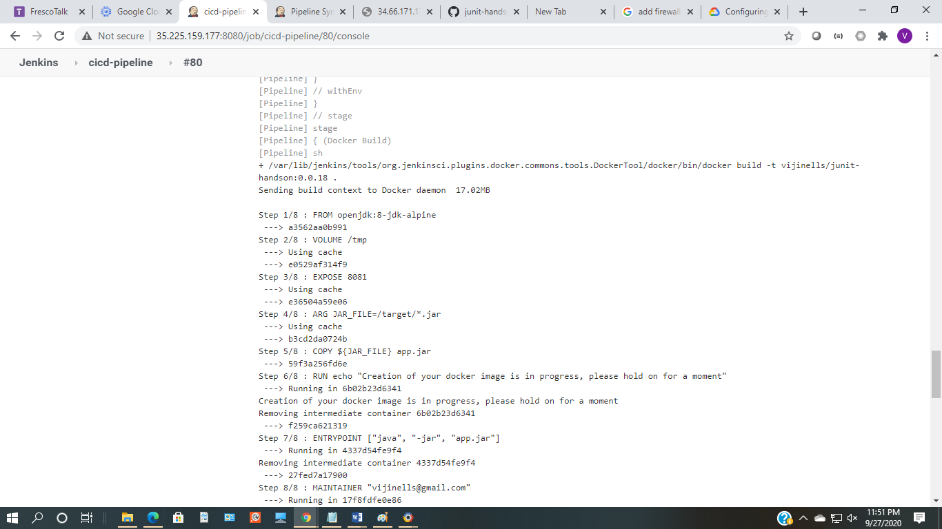

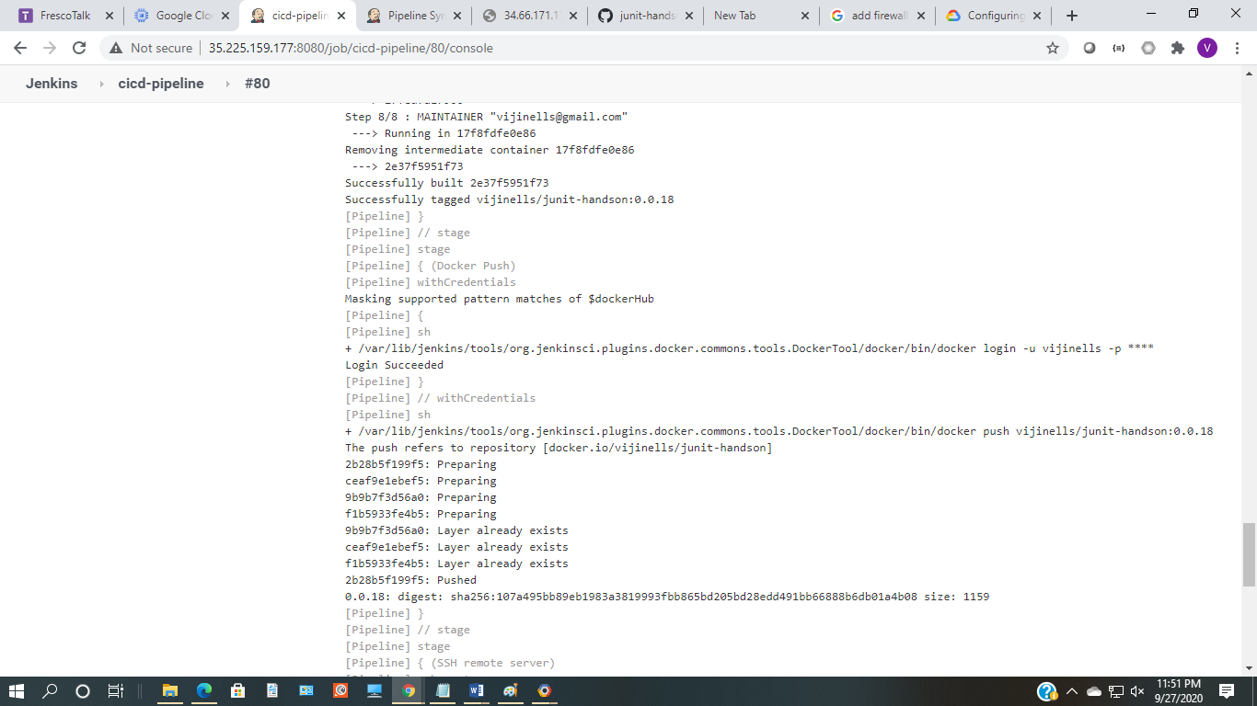

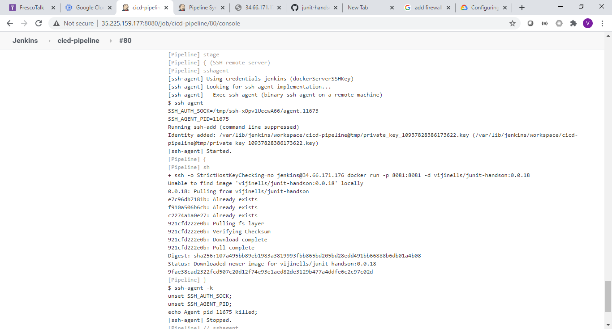

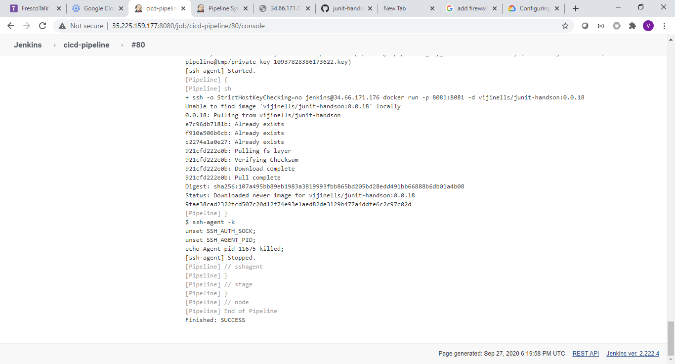

**JenkinsFile:**

node {

def mvnHome

def dockerHome = tool name: 'docker', type: 'dockerTool'

stage('Git checkout') {

git credentialsId: 'd2cb6d02-315f-4501-9000-e120c13f8d3b', url: 'https://github.com/vijinells/junit-handson.git'

mvnHome = tool 'maven-3'

}

stage('Maven Build Package') {

// Run the maven build

withEnv(["MVN_HOME=$mvnHome"]) {

if (isUnix()) {

sh '"$MVN_HOME/bin/mvn" -Dmaven.test.failure.ignore package spring-boot:repackage'

} else {

bat(/"%MVN_HOME%\bin\mvn" -Dmaven.test.failure.ignore clean package/)

}

}

}

stage('Docker Build') {

sh "${dockerHome}/bin/docker build -t vijinells/junit-handson:0.0.18 ."

}

stage('Docker Push') {

withCredentials([string(credentialsId: 'bootcamp', variable: 'dockerHub')]) {

sh "${dockerHome}/bin/docker login -u vijinells -p ${dockerHub}"

}

sh "${dockerHome}/bin/docker push vijinells/junit-handson:0.0.18"

}

stage('SSH remote server') {

def dockerCmd = "docker run -p 8081:8081 -d vijinells/junit-handson:0.0.18"

sshagent(['dockerServerSSHPwd']) {

sh "ssh -o StrictHostKeyChecking=no jenkins@34.66.171.176 ${dockerCmd}"

}

}

}

**Jenkins console output:**

Started by user [Vijayalakshmi N](http://35.225.159.177:8080/user/vijinells)

Running in Durability level: MAX_SURVIVABILITY

[Pipeline] Start of Pipeline

[Pipeline] node

Running on [Jenkins](http://35.225.159.177:8080/computer/(master)/) in /var/lib/jenkins/workspace/cicd-pipeline

[Pipeline] {

[Pipeline] tool

[Pipeline] stage

[Pipeline] { (Git checkout)

[Pipeline] git

using credential d2cb6d02-315f-4501-9000-e120c13f8d3b

> git rev-parse --is-inside-work-tree # timeout=10

Fetching changes from the remote Git repository

> git config remote.origin.url <https://github.com/vijinells/junit-handson.git> # timeout=10

Fetching upstream changes from <https://github.com/vijinells/junit-handson.git>

> git --version # timeout=10

using GIT_ASKPASS to set credentials

> git fetch --tags --progress <https://github.com/vijinells/junit-handson.git> +refs/heads/*:refs/remotes/origin/* # timeout=10

> git rev-parse refs/remotes/origin/master^{commit} # timeout=10

> git rev-parse refs/remotes/origin/origin/master^{commit} # timeout=10

Checking out Revision 1ecd39d7497c7a27d195daf2c446afb8d71b746a (refs/remotes/origin/master)

> git config core.sparsecheckout # timeout=10

> git checkout -f 1ecd39d7497c7a27d195daf2c446afb8d71b746a # timeout=10

> git branch -a -v --no-abbrev # timeout=10

> git branch -D master # timeout=10

> git checkout -b master 1ecd39d7497c7a27d195daf2c446afb8d71b746a # timeout=10

Commit message: "added dockerfile"

> git rev-list --no-walk 1ecd39d7497c7a27d195daf2c446afb8d71b746a # timeout=10

[Pipeline] tool

[Pipeline] }

[Pipeline] // stage

[Pipeline] stage

[Pipeline] { (Maven Build Package)

[Pipeline] withEnv

[Pipeline] {

[Pipeline] isUnix

[Pipeline] sh

+ /var/lib/jenkins/tools/hudson.tasks.Maven_MavenInstallation/maven-3/bin/mvn -Dmaven.test.failure.ignore package spring-boot:repackage

[INFO] Scanning for projects...

[INFO]

[INFO] -------------------------< com:junit-handson >--------------------------

[INFO] Building junit-handson 0.0.1

[INFO] --------------------------------[ jar ]---------------------------------

[INFO]

[INFO] --- maven-resources-plugin:3.1.0:resources (default-resources) @ junit-handson ---

[INFO] Using 'UTF-8' encoding to copy filtered resources.

[INFO] Copying 1 resource

[INFO] Copying 0 resource

[INFO]

[INFO] --- maven-compiler-plugin:3.8.1:compile (default-compile) @ junit-handson ---

[INFO] Changes detected - recompiling the module!

[INFO] Compiling 4 source files to /var/lib/jenkins/workspace/cicd-pipeline/target/classes

[INFO]

[INFO] --- maven-resources-plugin:3.1.0:testResources (default-testResources) @ junit-handson ---

[INFO] Using 'UTF-8' encoding to copy filtered resources.

[INFO] skip non existing resourceDirectory /var/lib/jenkins/workspace/cicd-pipeline/src/test/resources

[INFO]

[INFO] --- maven-compiler-plugin:3.8.1:testCompile (default-testCompile) @ junit-handson ---

[INFO] Changes detected - recompiling the module!

[INFO] Compiling 2 source files to /var/lib/jenkins/workspace/cicd-pipeline/target/test-classes

[INFO]

[INFO] --- maven-surefire-plugin:2.22.2:test (default-test) @ junit-handson ---

[INFO]

[INFO] -------------------------------------------------------

[INFO] T E S T S

[INFO] -------------------------------------------------------

[INFO] Running com.TestBitwiseOperatorService

17:56:56.250 [main] DEBUG org.springframework.test.context.BootstrapUtils - Instantiating CacheAwareContextLoaderDelegate from class [org.springframework.test.context.cache.DefaultCacheAwareContextLoaderDelegate]

17:56:56.285 [main] DEBUG org.springframework.test.context.BootstrapUtils - Instantiating BootstrapContext using constructor [public org.springframework.test.context.support.DefaultBootstrapContext(java.lang.Class,org.springframework.test.context.CacheAwareContextLoaderDelegate)]

17:56:56.318 [main] DEBUG org.springframework.test.context.BootstrapUtils - Instantiating TestContextBootstrapper for test class [com.TestBitwiseOperatorService] from class [org.springframework.boot.test.context.SpringBootTestContextBootstrapper]

17:56:56.337 [main] INFO org.springframework.boot.test.context.SpringBootTestContextBootstrapper - Neither @ContextConfiguration nor @ContextHierarchy found for test class [com.TestBitwiseOperatorService], using SpringBootContextLoader

17:56:56.340 [main] DEBUG org.springframework.test.context.support.AbstractContextLoader - Did not detect default resource location for test class [com.TestBitwiseOperatorService]: class path resource [com/TestBitwiseOperatorService-context.xml] does not exist

17:56:56.346 [main] DEBUG org.springframework.test.context.support.AbstractContextLoader - Did not detect default resource location for test class [com.TestBitwiseOperatorService]: class path resource [com/TestBitwiseOperatorServiceContext.groovy] does not exist

17:56:56.353 [main] INFO org.springframework.test.context.support.AbstractContextLoader - Could not detect default resource locations for test class [com.TestBitwiseOperatorService]: no resource found for suffixes {-context.xml, Context.groovy}.

17:56:56.355 [main] INFO org.springframework.test.context.support.AnnotationConfigContextLoaderUtils - Could not detect default configuration classes for test class [com.TestBitwiseOperatorService]: TestBitwiseOperatorService does not declare any static, non-private, non-final, nested classes annotated with @Configuration.

17:56:56.425 [main] DEBUG org.springframework.test.context.support.ActiveProfilesUtils - Could not find an 'annotation declaring class' for annotation type [org.springframework.test.context.ActiveProfiles] and class [com.TestBitwiseOperatorService]

17:56:56.592 [main] DEBUG org.springframework.context.annotation.ClassPathScanningCandidateComponentProvider - Identified candidate component class: file [/var/lib/jenkins/workspace/cicd-pipeline/target/classes/com/Application.class]

17:56:56.630 [main] INFO org.springframework.boot.test.context.SpringBootTestContextBootstrapper - Found @SpringBootConfiguration com.Application for test class com.TestBitwiseOperatorService

17:56:56.764 [main] DEBUG org.springframework.boot.test.context.SpringBootTestContextBootstrapper - @TestExecutionListeners is not present for class [com.TestBitwiseOperatorService]: using defaults.

17:56:56.771 [main] INFO org.springframework.boot.test.context.SpringBootTestContextBootstrapper - Loaded default TestExecutionListener class names from location [META-INF/spring.factories]: [org.springframework.boot.test.mock.mockito.MockitoTestExecutionListener, org.springframework.boot.test.mock.mockito.ResetMocksTestExecutionListener, org.springframework.boot.test.autoconfigure.restdocs.RestDocsTestExecutionListener, org.springframework.boot.test.autoconfigure.web.client.MockRestServiceServerResetTestExecutionListener, org.springframework.boot.test.autoconfigure.web.servlet.MockMvcPrintOnlyOnFailureTestExecutionListener, org.springframework.boot.test.autoconfigure.web.servlet.WebDriverTestExecutionListener, org.springframework.test.context.web.ServletTestExecutionListener, org.springframework.test.context.support.DirtiesContextBeforeModesTestExecutionListener, org.springframework.test.context.support.DependencyInjectionTestExecutionListener, org.springframework.test.context.support.DirtiesContextTestExecutionListener, org.springframework.test.context.transaction.TransactionalTestExecutionListener, org.springframework.test.context.jdbc.SqlScriptsTestExecutionListener]

17:56:56.791 [main] DEBUG org.springframework.boot.test.context.SpringBootTestContextBootstrapper - Skipping candidate TestExecutionListener [org.springframework.test.context.transaction.TransactionalTestExecutionListener] due to a missing dependency. Specify custom listener classes or make the default listener classes and their required dependencies available. Offending class: [org/springframework/transaction/TransactionDefinition]

17:56:56.793 [main] DEBUG org.springframework.boot.test.context.SpringBootTestContextBootstrapper - Skipping candidate TestExecutionListener [org.springframework.test.context.jdbc.SqlScriptsTestExecutionListener] due to a missing dependency. Specify custom listener classes or make the default listener classes and their required dependencies available. Offending class: [org/springframework/transaction/interceptor/TransactionAttribute]

17:56:56.799 [main] INFO org.springframework.boot.test.context.SpringBootTestContextBootstrapper - Using TestExecutionListeners: [org.springframework.test.context.web.ServletTestExecutionListener@6c779568, org.springframework.test.context.support.DirtiesContextBeforeModesTestExecutionListener@f381794, org.springframework.boot.test.mock.mockito.MockitoTestExecutionListener@2cdd0d4b, org.springframework.boot.test.autoconfigure.SpringBootDependencyInjectionTestExecutionListener@7e9131d5, org.springframework.test.context.support.DirtiesContextTestExecutionListener@2e1d27ba, org.springframework.boot.test.mock.mockito.ResetMocksTestExecutionListener@61d6015a, org.springframework.boot.test.autoconfigure.restdocs.RestDocsTestExecutionListener@2525ff7e, org.springframework.boot.test.autoconfigure.web.client.MockRestServiceServerResetTestExecutionListener@524d6d96, org.springframework.boot.test.autoconfigure.web.servlet.MockMvcPrintOnlyOnFailureTestExecutionListener@152aa092, org.springframework.boot.test.autoconfigure.web.servlet.WebDriverTestExecutionListener@44a7bfbc]

17:56:56.811 [main] DEBUG org.springframework.test.context.support.AbstractDirtiesContextTestExecutionListener - Before test class: context [DefaultTestContext@29647f75 testClass = TestBitwiseOperatorService, testInstance = [null], testMethod = [null], testException = [null], mergedContextConfiguration = [WebMergedContextConfiguration@3315d2d7 testClass = TestBitwiseOperatorService, locations = '{}', classes = '{class com.Application}', contextInitializerClasses = '[]', activeProfiles = '{}', propertySourceLocations = '{}', propertySourceProperties = '{org.springframework.boot.test.context.SpringBootTestContextBootstrapper=true}', contextCustomizers = set[org.springframework.boot.test.context.filter.ExcludeFilterContextCustomizer@3bbc39f8, org.springframework.boot.test.json.DuplicateJsonObjectContextCustomizerFactory$DuplicateJsonObjectContextCustomizer@568bf312, org.springframework.boot.test.mock.mockito.MockitoContextCustomizer@0, org.springframework.boot.test.web.client.TestRestTemplateContextCustomizer@240237d2, org.springframework.boot.test.autoconfigure.properties.PropertyMappingContextCustomizer@0, org.springframework.boot.test.autoconfigure.web.servlet.WebDriverContextCustomizerFactory$Customizer@23282c25], resourceBasePath = 'src/main/webapp', contextLoader = 'org.springframework.boot.test.context.SpringBootContextLoader', parent = [null]], attributes = map['org.springframework.test.context.web.ServletTestExecutionListener.activateListener' -> true]], class annotated with @DirtiesContext [false] with mode [null].

17:56:56.850 [main] DEBUG org.springframework.test.context.support.TestPropertySourceUtils - Adding inlined properties to environment: {spring.jmx.enabled=false, org.springframework.boot.test.context.SpringBootTestContextBootstrapper=true, server.port=-1}

. ____ _ __ _ _

/\\ / ___'_ __ _ _(_)_ __ __ _ \ \ \ \

( ( )\___ | '_ | '_| | '_ \/ _` | \ \ \ \

\\/ ___)| |_)| | | | | || (_| | ) ) ) )

' |____| .__|_| |_|_| |_\__, | / / / /

=========|_|==============|___/=/_/_/_/

:: Spring Boot :: (v2.1.7.RELEASE)

2020-09-27 17:56:57.323 INFO 11380 --- [ main] com.TestBitwiseOperatorService : Starting TestBitwiseOperatorService on devops-jenkins with PID 11380 (started by jenkins in /var/lib/jenkins/workspace/cicd-pipeline)

2020-09-27 17:56:57.331 INFO 11380 --- [ main] com.TestBitwiseOperatorService : No active profile set, falling back to default profiles: default

2020-09-27 17:57:01.004 INFO 11380 --- [ main] o.s.s.concurrent.ThreadPoolTaskExecutor : Initializing ExecutorService 'applicationTaskExecutor'

2020-09-27 17:57:01.496 INFO 11380 --- [ main] com.TestBitwiseOperatorService : Started TestBitwiseOperatorService in 4.639 seconds (JVM running for 6.224)

[INFO] Tests run: 5, Failures: 0, Errors: 0, Skipped: 0, Time elapsed: 5.718 s - in com.TestBitwiseOperatorService

[INFO] Running com.TestStudentService

2020-09-27 17:57:01.862 INFO 11380 --- [ main] .b.t.c.SpringBootTestContextBootstrapper : Neither @ContextConfiguration nor @ContextHierarchy found for test class [com.TestStudentService], using SpringBootContextLoader

2020-09-27 17:57:01.863 INFO 11380 --- [ main] o.s.t.c.support.AbstractContextLoader : Could not detect default resource locations for test class [com.TestStudentService]: no resource found for suffixes {-context.xml, Context.groovy}.

2020-09-27 17:57:01.865 INFO 11380 --- [ main] t.c.s.AnnotationConfigContextLoaderUtils : Could not detect default configuration classes for test class [com.TestStudentService]: TestStudentService does not declare any static, non-private, non-final, nested classes annotated with @Configuration.

2020-09-27 17:57:01.877 INFO 11380 --- [ main] .b.t.c.SpringBootTestContextBootstrapper : Found @SpringBootConfiguration com.Application for test class com.TestStudentService

2020-09-27 17:57:01.882 INFO 11380 --- [ main] .b.t.c.SpringBootTestContextBootstrapper : Loaded default TestExecutionListener class names from location [META-INF/spring.factories]: [org.springframework.boot.test.mock.mockito.MockitoTestExecutionListener, org.springframework.boot.test.mock.mockito.ResetMocksTestExecutionListener, org.springframework.boot.test.autoconfigure.restdocs.RestDocsTestExecutionListener, org.springframework.boot.test.autoconfigure.web.client.MockRestServiceServerResetTestExecutionListener, org.springframework.boot.test.autoconfigure.web.servlet.MockMvcPrintOnlyOnFailureTestExecutionListener, org.springframework.boot.test.autoconfigure.web.servlet.WebDriverTestExecutionListener, org.springframework.test.context.web.ServletTestExecutionListener, org.springframework.test.context.support.DirtiesContextBeforeModesTestExecutionListener, org.springframework.test.context.support.DependencyInjectionTestExecutionListener, org.springframework.test.context.support.DirtiesContextTestExecutionListener, org.springframework.test.context.transaction.TransactionalTestExecutionListener, org.springframework.test.context.jdbc.SqlScriptsTestExecutionListener]

2020-09-27 17:57:01.884 INFO 11380 --- [ main] .b.t.c.SpringBootTestContextBootstrapper : Using TestExecutionListeners: [org.springframework.test.context.web.ServletTestExecutionListener@7134b8a7, org.springframework.test.context.support.DirtiesContextBeforeModesTestExecutionListener@2262d6d5, org.springframework.boot.test.mock.mockito.MockitoTestExecutionListener@40de8f93, org.springframework.boot.test.autoconfigure.SpringBootDependencyInjectionTestExecutionListener@6ff0b1cc, org.springframework.test.context.support.DirtiesContextTestExecutionListener@3b55dd15, org.springframework.boot.test.mock.mockito.ResetMocksTestExecutionListener@f3560d4, org.springframework.boot.test.autoconfigure.restdocs.RestDocsTestExecutionListener@3ba3d4b6, org.springframework.boot.test.autoconfigure.web.client.MockRestServiceServerResetTestExecutionListener@51b77cdf, org.springframework.boot.test.autoconfigure.web.servlet.MockMvcPrintOnlyOnFailureTestExecutionListener@441fbe89, org.springframework.boot.test.autoconfigure.web.servlet.WebDriverTestExecutionListener@6088451e]

[com.Student@502a4156, com.Student@5416f8db]

[INFO] Tests run: 6, Failures: 0, Errors: 0, Skipped: 0, Time elapsed: 0.056 s - in com.TestStudentService

2020-09-27 17:57:01.998 INFO 11380 --- [ Thread-2] o.s.s.concurrent.ThreadPoolTaskExecutor : Shutting down ExecutorService 'applicationTaskExecutor'

[INFO]

[INFO] Results:

[INFO]

[INFO] Tests run: 11, Failures: 0, Errors: 0, Skipped: 0

[INFO]

[INFO]

[INFO] --- maven-jar-plugin:3.1.2:jar (default-jar) @ junit-handson ---

[INFO] Building jar: /var/lib/jenkins/workspace/cicd-pipeline/target/junit-handson-0.0.1.jar

[INFO]

[INFO] --- spring-boot-maven-plugin:2.1.7.RELEASE:repackage (default-cli) @ junit-handson ---

[INFO] Replacing main artifact with repackaged archive

[INFO] ------------------------------------------------------------------------

[INFO] BUILD SUCCESS

[INFO] ------------------------------------------------------------------------

[INFO] Total time: 12.450 s

[INFO] Finished at: 2020-09-27T17:57:03Z

[INFO] ------------------------------------------------------------------------

[Pipeline] }

[Pipeline] // withEnv

[Pipeline] }

[Pipeline] // stage

[Pipeline] stage

[Pipeline] { (Docker Build)

[Pipeline] sh

+ /var/lib/jenkins/tools/org.jenkinsci.plugins.docker.commons.tools.DockerTool/docker/bin/docker build -t vijinells/junit-handson:0.0.18 .

Sending build context to Docker daemon 17.02MB

Step 1/8 : FROM openjdk:8-jdk-alpine

---> a3562aa0b991

Step 2/8 : VOLUME /tmp

---> Using cache

---> e0529af314f9

Step 3/8 : EXPOSE 8081

---> Using cache

---> e36504a59e06

Step 4/8 : ARG JAR_FILE=/target/*.jar

---> Using cache

---> b3cd2da0724b

Step 5/8 : COPY ${JAR_FILE} app.jar

---> 59f3a256fd6e

Step 6/8 : RUN echo "Creation of your docker image is in progress, please hold on for a moment"

---> Running in 6b02b23d6341

Creation of your docker image is in progress, please hold on for a moment

Removing intermediate container 6b02b23d6341

---> f259ca621319

Step 7/8 : ENTRYPOINT ["java", "-jar", "app.jar"]

---> Running in 4337d54fe9f4

Removing intermediate container 4337d54fe9f4

---> 27fed7a17900

Step 8/8 : MAINTAINER "vijinells@gmail.com"

---> Running in 17f8fdfe0e86

Removing intermediate container 17f8fdfe0e86

---> 2e37f5951f73

Successfully built 2e37f5951f73

Successfully tagged vijinells/junit-handson:0.0.18

[Pipeline] }

[Pipeline] // stage

[Pipeline] stage

[Pipeline] { (Docker Push)

[Pipeline] withCredentials

Masking supported pattern matches of $dockerHub

[Pipeline] {

[Pipeline] sh

+ /var/lib/jenkins/tools/org.jenkinsci.plugins.docker.commons.tools.DockerTool/docker/bin/docker login -u vijinells -p ****

Login Succeeded

[Pipeline] }

[Pipeline] // withCredentials

[Pipeline] sh

+ /var/lib/jenkins/tools/org.jenkinsci.plugins.docker.commons.tools.DockerTool/docker/bin/docker push vijinells/junit-handson:0.0.18

The push refers to repository [docker.io/vijinells/junit-handson]

2b28b5f199f5: Preparing

ceaf9e1ebef5: Preparing

9b9b7f3d56a0: Preparing

f1b5933fe4b5: Preparing

9b9b7f3d56a0: Layer already exists

ceaf9e1ebef5: Layer already exists

f1b5933fe4b5: Layer already exists

2b28b5f199f5: Pushed

0.0.18: digest: sha256:107a495bb89eb1983a3819993fbb865bd205bd28edd491bb66888b6db01a4b08 size: 1159

[Pipeline] }

[Pipeline] // stage

[Pipeline] stage

[Pipeline] { (SSH remote server)

[Pipeline] sshagent

[ssh-agent] Using credentials jenkins (dockerServerSSHKey)

[ssh-agent] Looking for ssh-agent implementation...

[ssh-agent] Exec ssh-agent (binary ssh-agent on a remote machine)

$ ssh-agent

SSH_AUTH_SOCK=/tmp/ssh-xOpv1UecwA66/agent.11673

SSH_AGENT_PID=11675

Running ssh-add (command line suppressed)

Identity added: /var/lib/jenkins/workspace/cicd-pipeline@tmp/private_key_10937828386173622.key (/var/lib/jenkins/workspace/cicd-pipeline@tmp/private_key_10937828386173622.key)

[ssh-agent] Started.

[Pipeline] {

[Pipeline] sh

+ ssh -o StrictHostKeyChecking=no jenkins@34.66.171.176 docker run -p 8081:8081 -d vijinells/junit-handson:0.0.18

Unable to find image 'vijinells/junit-handson:0.0.18' locally

0.0.18: Pulling from vijinells/junit-handson

e7c96db7181b: Already exists

f910a506b6cb: Already exists

c2274a1a0e27: Already exists

921cfd222e0b: Pulling fs layer

921cfd222e0b: Verifying Checksum

921cfd222e0b: Download complete

921cfd222e0b: Pull complete

Digest: sha256:107a495bb89eb1983a3819993fbb865bd205bd28edd491bb66888b6db01a4b08

Status: Downloaded newer image for vijinells/junit-handson:0.0.18

9fae38cad2322fcd507c20d12f74e93e1aed82de3129b477a4ddfe6c2c97c02d

[Pipeline] }

$ ssh-agent -k

unset SSH_AUTH_SOCK;

unset SSH_AGENT_PID;

echo Agent pid 11675 killed;

[ssh-agent] Stopped.

[Pipeline] // sshagent

[Pipeline] }

[Pipeline] // stage

[Pipeline] }

[Pipeline] // node

[Pipeline] End of Pipeline

Finished: SUCCESS