DEFECT-AWARE MACHINE LEARNING FOR
PREDICTING TENSILE STRENGTH OF
E-GLASS/EPOXY COMPOSITES
A PROJECT REPORT
Submitted by
JISHNU NARAYANAN [RA2411026010650]
EDSON THOMAS [RA2411026010634]
Under the guidance of
[Guide details to be entered]
[Designation and department]
in partial fulfillment for the award of the degree
of
[DEGREE AND BRANCH]
Department of CINTEL
of
FACULTY OF ENGINEERING AND TECHNOLOGY

[Campus details to be entered]
[SUBMISSION MONTH AND YEAR]
SRM INSTITUTE OF SCIENCE AND TECHNOLOGY
(Under Section 3 of UGC Act, 1956)

BONAFIDE CERTIFICATE
Certified that this project report titled “DEFECT-AWARE MACHINE LEARNING FOR PREDICTING TENSILE STRENGTH OF E-GLASS/EPOXY COMPOSITES” is the bonafide work of JISHNU NARAYANAN [RA2411026010650] and EDSON THOMAS [RA2411026010634], who carried out the project work under my supervision. Certified further that, to the best of my knowledge, the work reported herein does not form any other project report or dissertation on the basis of which a degree or award was conferred on an earlier occasion on this or any other candidate.
SIGNATURE  [Guide details]  GUIDE  [Designation and department]  Signature of the Internal Examiner | SIGNATURE  [Head of department details]  HEAD OF THE DEPARTMENT  [Department]  Signature of the External Examiner

ABSTRACT
This project develops a reproducible machine learning prototype for nominal unidirectional E glass and epoxy tensile strength. A documented simulator generates 2,000 labelled SIMULATED samples using fibre volume fraction, void content and fibre to load angle. Linear Regression and Random Forest use the same 80/20 split. The forest gives a holdout RMSE of 18.21 MPa, compared with 102.03 MPa for the linear baseline. A separate fibre fraction region test gives a forest RMSE of 28.63 MPa. These errors describe agreement with simulated targets. The dashboard demonstrates estimates, scenarios, input checks and direct material parameter experiments. Literature evidence remains separate from training. Eight extracted mean strength rows await review and complete matched inputs; the eligible comparison count is zero. All parameters are nominal assumptions, and independent experimental validation remains outstanding.

ACKNOWLEDGEMENTS
We thank SRM Institute of Science and Technology and the Department of CINTEL for the opportunity to undertake this project. We acknowledge the authors of the cited studies and the developers of the open source scientific software used in the implementation.
Jishnu Narayanan
Edson Thomas

TABLE OF CONTENTS
ABSTRACT iii
ACKNOWLEDGEMENTS iv
LIST OF TABLES vii
LIST OF FIGURES viii
ABBREVIATIONS ix
LIST OF SYMBOLS x
1 INTRODUCTION 1
1.1 Material system and application 1
1.2 Problem identification and research gap 2
1.3 Objectives 2
2 LITERATURE SURVEY 3
2.1 Scope and source selection 3
2.2 Reviewed studies 3
2.3 Findings from literature 11
3 SYSTEM ANALYSIS 12
3.1 Study scope and input domain 12
3.2 Nominal material parameters 13
3.3 Physics calculation 14
3.4 Data provenance and literature extraction 14
3.5 Model persistence and interface 15

TABLE OF CONTENTS continued
4 SYSTEM DESIGN 17
4.1 Methodology flowchart 17
4.2 Training and evaluation workflow 18
4.3 Prediction and direct simulator paths 19
5 CODING, TESTING 20
5.1 Implementation and reproducibility 20
5.2 Random holdout evaluation 20
5.3 Fibre fraction extrapolation 21
5.4 Interpretation and scientific limits 21
5.5 Software checks 22
5.6 Experimental comparison status 22
6 CONCLUSION 24
7 FUTURE ENHANCEMENT 25
REFERENCES 26

LIST OF TABLES
2.1 Reviewed sources 1 to 5 4
2.2 Reviewed sources 6 to 10 5
2.3 Reviewed sources 11 to 15 6
2.4 Reviewed sources 16 to 20 7
2.5 Reviewed sources 21 to 25 8
2.6 Reviewed sources 26 to 30 9
2.7 Reviewed reviews 31 to 35 10
3.1 Input domain and generation settings 12
3.2 Nominal parameter assumptions 13
3.3 Literature extraction audit 15
5.1 Random holdout results 20
5.2 Fibre fraction region test results 21

LIST OF FIGURES
4.1 Methodology and separate evidence paths 17
5.1 RMSE across the two evaluation splits 23
5.2 Angle sensitivity of simulator and surrogate 23

ABBREVIATIONS
CLI Command line interface
CSV Comma separated values
CT Computed tomography
CFRP Carbon fibre reinforced polymer
GFRP Glass fibre reinforced polymer
IEEE Institute of Electrical and Electronics Engineers
ILSS Interlaminar shear strength
JSON JavaScript Object Notation
LR Linear Regression
MAE Mean absolute error
ML Machine learning
MPa Megapascal, equivalent to N/mm²
RF Random Forest
RMSE Root mean squared error
RTM Resin transfer moulding
RVE Representative volume element
UD Unidirectional

LIST OF SYMBOLS
ε Synthetic multiplicative scatter (dimensionless)
η Fibre efficiency factor (dimensionless)
θ Fibre to load angle (degrees, converted to radians)
σ Nominal off axis tensile strength (MPa)
σ_f Effective fibre tensile strength (MPa)
σ_m Matrix tensile strength (MPa)
σ′_m Capped matrix stress at fibre failure (MPa)
E_f Fibre elastic modulus (GPa)
E_m Matrix elastic modulus (GPa)
k_f Longitudinal void coefficient (per percentage point)
k_m Transverse and shear void coefficient (per percentage point)
n Number of evaluated rows (dimensionless)
R² Coefficient of determination (dimensionless)
S or S_0 Nominal shear strength (MPa)
S_v Void reduced shear strength (MPa)
V_f Fibre volume fraction in the mixture (fraction)
V_v Void content in the exponential factors (percentage points)
X or X_0 Nominal longitudinal strength (MPa)
X_v Void reduced longitudinal strength (MPa)
Y or Y_0 Nominal transverse strength (MPa)
Y_v Void reduced transverse strength (MPa)

CHAPTER 1

INTRODUCTION

1.1 Material system and application
A unidirectional composite contains fibres that principally share one direction within the material. Under loading along the fibres, reinforcement carries a large part of the tensile load, while the epoxy matrix binds fibres and transfers load. Loading away from that direction increasingly involves transverse and shear response. Fibre fraction, manufacturing defects and orientation therefore need clear definitions before numerical strengths from different studies can be compared [1], [3], [28].
The present implementation explores three scalar inputs through an explicit nominal formula. It treats the angle as a uniform fibre to load orientation. This is a simplification of real local fibre misalignment and waviness. The simulator does not resolve actual void shapes, interfaces, progressive damage or spatial variations. The machine learning component approximates outputs of this formula. It does not replace the need to determine whether the formula is physically appropriate for a particular manufactured material.
The main application is an undergraduate demonstration of reproducible scientific software and model evaluation. A user can compare two nominal conditions while holding other inputs fixed, inspect the behaviour of a fitted regression model, and examine how error changes when a test region lies beyond the fibre fraction range used for fitting. The tool also illustrates why data origin and compatible test conditions matter.
Potential future work includes calibration against traceable dry UD glass and epoxy measurements, followed by an assessment on separate studies. The current prototype does not provide design allowables, material qualification, safety factors or a manufactured laminate certificate. References on impact, woven reinforcement, carbon epoxy, hybrid laminates and pressure vessels provide methodological context rather than direct evidence of accuracy for this model [2], [5], [11], [20], [27].

1.2 Problem identification and research gap
No laboratory measurements were supplied for this project. The supplied documents contain useful mechanical information, but their architectures, targets and completeness differ. In the extractable tensile tables, void content is not reported for the matched conditions. Other documents concern woven modulus results, broad reviews or carbon epoxy models. Treating these as a complete pooled training dataset would erase material differences and introduce invented inputs.
The project addresses an implementation gap within its educational setting: a small local workflow that connects three inputs to a documented nominal simulator while preserving evidence boundaries. The literature already contains detailed defect aware finite element models, microstructure descriptors and machine learning surrogates [11], [16], [24]. No claim of being the first method to model defect effects is made. The contribution is the combination of explicit assumptions, reproducible generation, two evaluation regimes, saved provenance and a separate review controlled literature comparison.

1.3 Objectives
- Implement the nominal UD model with adjustable parameters and consistent units.
- Generate 2,000 reproducible samples explicitly labelled SIMULATED.
- Compare Linear Regression and Random Forest using holdout MAE, RMSE and R².
- Evaluate separately fitted models across the 55% fibre-fraction boundary.
- Demonstrate domain checks, scenarios and sensitivity in a local dashboard.
- Keep source-referenced literature separate and require human review before use.
- Document limitations and software checks without claiming physical validation.

CHAPTER 2

LITERATURE SURVEY

2.1 Scope and source selection
The review retains 35 numbered sources: 30 research or data articles and five reviews. Thirty two date from 2020 onward; three older supplied papers support specific background or extraction provenance. Table 2.1 to Table 2.7 retain the complete screening matrix. Most records were screened through abstracts or previews, while four supplied PDFs received a local extraction audit. The review distinguishes material architecture, target property and evidence origin rather than treating all papers as matched tensile datasets.

2.2 Reviewed studies
The selected bibliography contains 35 sources: 30 research or data articles and five reviews. Thirty two sources were published from 2020 onward. Three older supplied studies are retained because they directly support the extraction audit or clarify the nominal modelling context. The review distinguishes direct glass epoxy evidence from related material systems and general methods. Published abstracts and article previews support screening of the wider set. The four supplied PDFs received focused page and table inspection. Screening does not mean that every paper has been read in full or that a numerical experimental dataset has been extracted.
The following matrix retains the faculty presentation template fields of title and authors, objective and conclusion. The final column records the finding relevant to this project and its scope. Full bibliographic details appear in References. Literature rows used by the dashboard are separate files with stricter numeric, architecture, domain and human review checks.
Table 2.1: Reviewed sources 1 to 5
Ref and paper | Objective | Finding and scope
[1] Experimental and numerical analysis of the Microstructure and mechanical properties of unidirectional glass fiber reinforced epoxy composites  Turaka et al. (2024)  Research | Orientation-dependent fracture and tensile response | Vacuum-bagged glass/epoxy specimens connect fibre orientation with failure behaviour. Direct glass epoxy.
[2] Identification of damage properties of glass/epoxy laminates using machine learning models  Jalali et al. (2023)  Research | Identify damage properties from impact response | Simulation-trained regression estimates several woven-laminate properties; architecture differs from UD. Direct glass epoxy.
[3] Effects of void content on the moisture uptake and mechanical strength of a glass/epoxy composite  Ayanoglu et al. (2023)  Research | Separate void and moisture effects | Transverse testing motivates separate treatment of dry and conditioned specimens. Direct glass epoxy.
[4] Prediction of tensile properties in fiber-reinforced composites by machine learning models  Rahman et al. (2026)  Research | Compare models for tensile-property prediction | Experimental hybrid laminates illustrate algorithm comparison and small-dataset limitations. Related hybrid laminates.
[5] Experimental and numerical characterization of E-glass/epoxy plain woven fabric composites containing void defects  Siddgonde et al. (2024)  Research | Characterize void defects in woven reinforcement | Microstructure-aware woven models need architecture-specific assumptions. Direct glass epoxy.
Screening basis: supplied PDF inspection for [28] to [31]; publisher abstracts or previews for the other entries. Related systems remain outside the numerical UD E glass comparison dataset.
Table 2.2: Reviewed sources 6 to 10
Ref and paper | Objective | Finding and scope
[6] Experimental Analysis of Pre-Forming Parameters on Abnormalities, Thickness, and Void Content of Glass/Epoxy Composite In VBO-Oven Cure Manufacturing  Md Hanafiah et al. (2024)  Research | Relate pre-forming to laminate quality | Processing changes influence thickness variation and measured void content. Direct glass epoxy.
[7] Significant Effect of Vacuum Bagging Processing on Inter-Laminar Shear Strength and Voids of Composite in Oven Cure  Nur Hafzareen Md Hanafiah et al. (2024)  Research | Relate vacuum bagging to voids and ILSS | Void morphology also matters; ILSS evidence cannot substitute for tensile targets. Direct glass epoxy.
[8] Monitoring damage evolution with acoustic emission in two types of glass epoxy laminates  Roundi et al. (2022)  Research | Monitor damage through acoustic emission | Damage monitoring adds information beyond three scalar input features. Direct glass epoxy.
[9] Using machine learning and experimental study to correlate and predict accelerated aging with natural aging of GFRP composites in hygrothermal conditions  Wang et al. (2024)  Research | Relate accelerated and natural aging | Environmental aging needs separate descriptors and conditions. Related GFRP durability.
[10] Damage Detection in Glass/Epoxy Laminated Composite Plates Using Modal Curvature for Structural Health Monitoring Applications  Govindasamy et al. (2020)  Research | Detect laminate damage using modal curvature | Structural damage detection is a different target from virgin tensile strength. Direct glass epoxy.
Screening basis: supplied PDF inspection for [28] to [31]; publisher abstracts or previews for the other entries. Related systems remain outside the numerical UD E glass comparison dataset.
Table 2.3: Reviewed sources 11 to 15
Ref and paper | Objective | Finding and scope
[11] Predicting the effect of voids generated during RTM on the low-velocity impact behaviour by machine learning-based surrogate models  Mendikute et al. (2023)  Research | Predict void-sensitive impact response | Finite-element-generated data support surrogate development, with a separate experimental validity question. Related defect surrogate.
[12] Impregnation quality diagnosis in Resin Transfer Moulding by machine learning  Mendikute et al. (2021)  Research | Diagnose impregnation quality after RTM | Synthetic-data classifiers can locate quality problems in a defined manufacturing model. Related manufacturing surrogate.
[13] Phase segmentation of uncured prepreg X-Ray CT micrographs  Galvez-Hernandez et al. (2021)  Research | Segment voids and dry regions in micro-CT | Image-based void identification complements scalar void fractions. Related void measurement.
[14] On the understanding of bubble dynamics through a calibrated textile-like porous medium using a machine learning based algorithm  Machado et al. (2024)  Research | Study bubble motion in textile-like media | Calibrated porous-media experiments and ML address void transport rather than tensile failure. Related void transport.
[15] Predicting the non-linear response of composite materials using deep recurrent convolutional neural networks  El Said et al. (2023)  Research | Predict nonlinear composite response | Recurrent convolutional models can incorporate defects in richer microstructural descriptions. Related mechanics surrogate.
Screening basis: supplied PDF inspection for [28] to [31]; publisher abstracts or previews for the other entries. Related systems remain outside the numerical UD E glass comparison dataset.
Table 2.4: Reviewed sources 16 to 20
Ref and paper | Objective | Finding and scope
[16] Machine learning and materials informatics approaches for predicting transverse mechanical properties of unidirectional CFRP composites with microvoids  Li et al. (2022)  Research | Link microvoids to transverse properties | Stochastic microstructures, finite elements and ML connect void geometry with transverse response. Related carbon epoxy.
[17] Out-of-plane tensile failure behavior of fiber reinforced composites due to lay-up temperature induced intra-ply and inter-ply voids  Zhou et al. (2021)  Research | Study void-driven out-of-plane failure | Void location and inter-ply structure affect damage beyond a uniform knock-down. Related void mechanics.
[18] A versatile and highly efficient algorithm to generate representative microstructures for heterogeneous materials  Cai et al. (2023)  Research | Generate representative microstructures efficiently | RVE generation provides a route to richer simulated structure descriptors. Related microstructure method.
[19] Prediction of two-phase composite microstructure properties through deep learning of reduced dimensional structure-response data  Ammasai Sengodan et al. (2021)  Research | Learn structure-response relations in two-phase composites | Reduced-dimensional structure features support nonlinear response surrogates. Related mechanics surrogate.
[20] Predicting mechanical properties of CFRP composites using data-driven models with comparative analysis  Alsheghri et al. (2025)  Research | Compare regressors on measured properties | Model performance depends on the property; strong flexural results do not imply strong tensile results. Related carbon epoxy.
Screening basis: supplied PDF inspection for [28] to [31]; publisher abstracts or previews for the other entries. Related systems remain outside the numerical UD E glass comparison dataset.
Table 2.5: Reviewed sources 21 to 25
Ref and paper | Objective | Finding and scope
[21] Designing bioinspired brick-and-mortar composites using machine learning and statistical learning  Morsali et al. (2020)  Research | Use learning to explore composite geometries | Geometry-conditioned models aid design exploration within the studied representation. Related design method.
[22] A framework based on physics-informed neural networks and extreme learning for the analysis of composite structures  Yan et al. (2022)  Research | Analyze composite structures with informed networks | Physics-informed and extreme-learning methods provide an alternative modelling direction. Related physics method.
[23] A physics-informed machine learning model for global-local stress prediction of open holes with finite-width effects in composite structures  Imran Azeem et al. (2024)  Research | Predict global-local stresses around open holes | Geometry and finite-width effects illustrate omitted structural descriptors. Related physics method.
[24] Harnessing deep learning for physics-informed prediction of composite strength with microstructural uncertainties  Zhou et al. (2021)  Research | Predict composite strength with uncertain microstructure | Physics-informed image models address uncertainty in simulated microstructures. Related strength method.
[25] A dataset of micro-scale tomograms of unidirectional glass fiber/epoxy and carbon fiber/epoxy composites acquired via synchrotron computed tomography during in-situ tensile loading  Mehdikhani et al. (2021)  Data article | Publish tomograms acquired during tensile loading | A microstructural imaging dataset is different from a complete scalar three-input tensile table. Direct imaging data.
Screening basis: supplied PDF inspection for [28] to [31]; publisher abstracts or previews for the other entries. Related systems remain outside the numerical UD E glass comparison dataset.
Table 2.6: Reviewed sources 26 to 30
Ref and paper | Objective | Finding and scope
[26] Static and fatigue tensile properties of carbon/glass hybrid fiber-reinforced epoxy composites  Naito et al. (2022)  Research | Compare static and fatigue tensile properties | Hybrid fibre systems and fatigue require scope distinctions from nominal UD glass/epoxy. Related hybrid laminate.
[27] Prediction of composite pressure vessels’ burst strength through machine learning  Santos et al. (2025)  Research | Predict vessel burst strength from manufacturing signals | Process-based strength regression motivates provenance and uncertainty analysis. Related process strength.
[28] Tensile Properties Study of E-Glass/Epoxy Laminate and π/4 Quasi-Isotropic E-Glass/Epoxy Laminate  Gopalakrishnan et al. (2016)  Research | Compare UD laminae and laminates with quasi-isotropic layups | Printed means are extractable, but missing void measurements prevent complete three-input comparison. Direct supplied PDF.
[29] The Effects of Fibre Volume Fraction on a Glass-Epoxy Composite Material  Larco et al. (2015)  Research | Assess fibre volume effects in woven glass/epoxy | The printed composite comparison concerns modulus; constituent strengths are not laminate targets. Direct supplied PDF.
[30] Effects of Process-Induced Voids on the Properties of Fibre Reinforced Composites  Dong et al. (2016)  Research | Model effects of process-induced voids | Carbon/epoxy RVE modelling informs mechanisms but provides no eligible E-glass tensile rows here. Related supplied PDF.
Screening basis: supplied PDF inspection for [28] to [31]; publisher abstracts or previews for the other entries. Related systems remain outside the numerical UD E glass comparison dataset.
Table 2.7: Reviewed reviews 31 to 35
Ref and paper | Objective | Finding and scope
[31] Void and Moisture Content of Fiber Reinforced Composites  Nurul Zuhairah Mahmud Zuhudi et al. (2021)  Review | Review void and moisture content studies | Measurement methods and conditioning influence interpretation of defect effects. Supplied review.
[32] Machine learning for polymer composites process simulation – a review  Cassola et al. (2022)  Review | Review ML for polymer-composite process simulation | Simulation acceleration needs clear links between process assumptions and outputs. Methods review.
[33] Artificial Intelligence in Predicting Mechanical Properties of Composite Materials  Kibrete et al. (2023)  Review | Review AI for composite mechanical properties | Published applications span different targets and material systems. Methods review.
[34] Machine learning-based inverse design methods considering data characteristics and design space size in materials design and manufacturing: a review  Lee et al. (2023)  Review | Relate inverse design to data characteristics | Interpolation, extrapolation and multi-fidelity problems require different strategies. Methods review.
[35] A review on recent applications of machine learning in mechanical properties of composites  Liang et al. (2025)  Review | Review ML for composite mechanical response | Process, structure and environment descriptors affect modelling scope. Methods review.
Screening basis: supplied PDF inspection for [28] to [31]; publisher abstracts or previews for the other entries. Related systems remain outside the numerical UD E glass comparison dataset.

2.3 Findings from literature
Architecture is a central inclusion criterion. Woven fabrics, cross ply and quasi isotropic layups cannot be represented by substituting a single angle into a uniform UD formula [1], [5], [28]. A fibre fraction also needs its measurement definition. A weight fraction is not a volume fraction, and a missing void fraction is not evidence of zero voids. These distinctions control whether a reported mean can become an eligible comparison row.
Void effects depend on loading mode, matrix contribution, morphology and conditioning. The glass epoxy void and moisture study [3] concerns transverse response and deliberately voided material. Vacuum bagging studies [6], [7] link processing to void content and ILSS, while void imaging methods [13], [25] describe geometry that a scalar void input cannot preserve. These sources motivate adjustable coefficients and clear conditions, rather than a universal percentage loss in tensile strength.
Machine learning surrogates trained on simulation outputs are a recognized modelling approach [11], [12], [16], [24]. Their ability to reproduce simulation targets and their agreement with independent physical measurements remain separate questions. The present project uses that distinction throughout its labels, split design and literature workflow. Different target properties can also produce substantially different predictive performance within a single experimental study [20]. A high score for one property cannot be transferred to another.

CHAPTER 3

SYSTEM ANALYSIS

3.1 Study scope and input domain
This is a software and simulation study. No physical laminate was manufactured and no tensile experiment was performed by the project team. Nominal material assumptions represent effective E glass reinforcement and epoxy in a UD laminate. The source code runs locally without a paid inference service. Python 3.11 is the requested target. The available Windows verification environment used Python 3.14, so users should install dependencies and retrain locally on their selected environment.
Table 3.1: Input domain and generation settings
Input | Unit | Configured range
Fibre volume fraction | percent | 20 to 65
Void content | percent | 0 to 8
Fibre to load angle | degrees | 0 to 45
Dataset size | rows | 2000
Generation and split seed | integer | 42
Nominal noise coefficient of variation | fraction | 0.05

3.2 Nominal material parameters
Table 3.2: Nominal parameter assumptions
Parameter | Default | Meaning
Effective fibre strength | 1750 MPa | Assumed fibre contribution inside the mixture
Fibre modulus | 73 GPa | Nominal elastic stiffness
Matrix strength | 55 MPa | Cap on matrix stress at fibre failure
Matrix modulus | 2.4 GPa | Nominal epoxy stiffness
Transverse strength Y | 40 MPa | Across fibre resistance
In plane shear strength S | 60 MPa | Sliding resistance
Fibre void coefficient | 0.010 per percent point | Longitudinal exponential reduction
Matrix void coefficient | 0.040 per percent point | Transverse and shear exponential reduction
Full efficiency threshold | 55 percent Vf | Start of the efficiency reduction
Efficiency at 70 percent Vf | 0.80 | End point of the linear efficiency rule
All defaults remain nominal modelling assumptions. Some values also appear as constituent data in a supplied woven study [29], but this project has not established their validity as effective UD parameters. They have not been calibrated against the extracted literature means. Void coefficients should be calibrated only when appropriate matched evidence becomes available.

3.3 Physics calculation
Fibre volume fraction is divided by 100 in the mixture calculation. Void content remains in percentage points in the exponential factors. The fibre to load angle is converted to radians for trigonometric functions. The fibre and matrix moduli use the same unit, so their ratio is dimensionless.
${σ′}_{m}\text{ = min(}σ_{m}\text{, }\frac{E_{m}σ_{f}}{E_{f}}\text{)}$ (3.1)
$X = η V_{f}σ_{f}\text{ + (1 − }V_{f}\text{) }{σ′}_{m}$ (3.2)
$X_{v}\text{ = X exp(−}k_{f}V_{v}\text{), }Y_{v}\text{ = Y exp(−}k_{m}V_{v}\text{), }S_{v}\text{ = S exp(−}k_{m}V_{v}\text{)}$ (3.3)
$\frac{\text{1}}{σ^{\text{2}}}$ = $\frac{{\text{cos}}^{\text{4}}θ}{{X_{v}}^{\text{2}}}\text{ + (}\frac{\text{1}}{{S_{v}}^{\text{2}}}\text{ − }\frac{\text{1}}{{X_{v}}^{\text{2}}}\text{) }{\text{sin}}^{\text{2}}θ {\text{cos}}^{\text{2}}θ + \frac{{\text{sin}}^{\text{4}}θ}{{Y_{v}}^{\text{2}}}$ (3.4)
The first three expressions use compact symbols for readability. The final expression is the off axis Tsai Hill interaction used by the code. At zero voids the knock down factors equal one. At zero degrees strength is Xv; at ninety degrees the identity gives Yv, although ninety degrees is outside the app training domain. The efficiency is one through 55 percent fibre and decreases linearly to 0.80 at 70 percent. Dataset scatter multiplies the pure result by a positive factor with nominal coefficient of variation 0.05. Nonpositive random factors are resampled.

3.4 Data provenance and literature extraction
The literature schema contains material and origin fields, the three inputs, tensile strength, source identifiers and optional specimen or study information. The extraction CSV adds source_location, extraction_method and reviewed. Each extracted value comes from printed table or body text. Plot only points are not digitized. Unknown cells remain blank. One row represents one reported mean, with the printed standard deviation retained in notes.
Table 3.3: Literature extraction audit
Supplied document | Extraction decision
Gopalakrishnan et al. 2016 [28] | Eight printed mean strength rows retained as reviewed=no. Void content is absent.
Larco et al. 2015 [29] | Woven material; constituent strengths and composite modulus do not supply eligible laminate strength rows.
Zuhudi et al. 2021 [31] | Review and methods context; no primary matched numerical rows extracted.
Dong 2016 [30] | Numerical carbon epoxy context and plot comparisons; no eligible E glass strength rows extracted.
The eight transcribed means cover six UD lamina or laminate conditions and two quasi isotropic conditions. Two UD conditions use ninety degree loading. Every row lacks a matched reported void content. All have reviewed=no. The comparison module first excludes unreviewed rows, then applies schema, numeric, architecture and domain checks to reviewed rows. The current eligible count is therefore n equals zero. No literature comparison metric is computed.
The extraction log identifies each PDF and journal page, table, short cell excerpt, printed mean and standard deviation. Duplicate summary table values are skipped. The DOI for [28] is verified separately for the report bibliography; it is deliberately not filled into the extraction source reference because it does not appear on the supplied PDF first page. Source PDFs remain local and are excluded from Git and the distribution ZIP.

3.5 Model persistence and interface
The model artifact stores the selected estimator beside JSON metadata. The metadata record contains feature names and units, source origin, UTC creation time, row counts, filtering rules, random and extrapolation metrics, data and parameter hashes, parameter snapshot and software versions. The app accepts no uploaded model files. Its integrity hash detects accidental artifact changes but cannot authenticate a malicious replacement. Models should be regenerated after incompatible library version changes.
The physical phase balance is fibre fraction plus matrix fraction plus void fraction equal to one. The specified nominal longitudinal mixture instead uses a simplified two-phase contribution with a separate void reduction. It therefore does not explicitly resolve all three phases. This modelling approximation, the empirical void coefficients and the fibre efficiency function require calibration and independent physical assessment.

CHAPTER 4

SYSTEM DESIGN

4.1 Methodology flowchart
Figure 4.1 shows the complete software workflow. The two evaluation branches operate on simulated data. The literature comparison path remains separate and has no eligible reviewed rows. The saved estimator comes from selection on the random holdout, while the fibre region experiment uses separately fitted candidate copies.
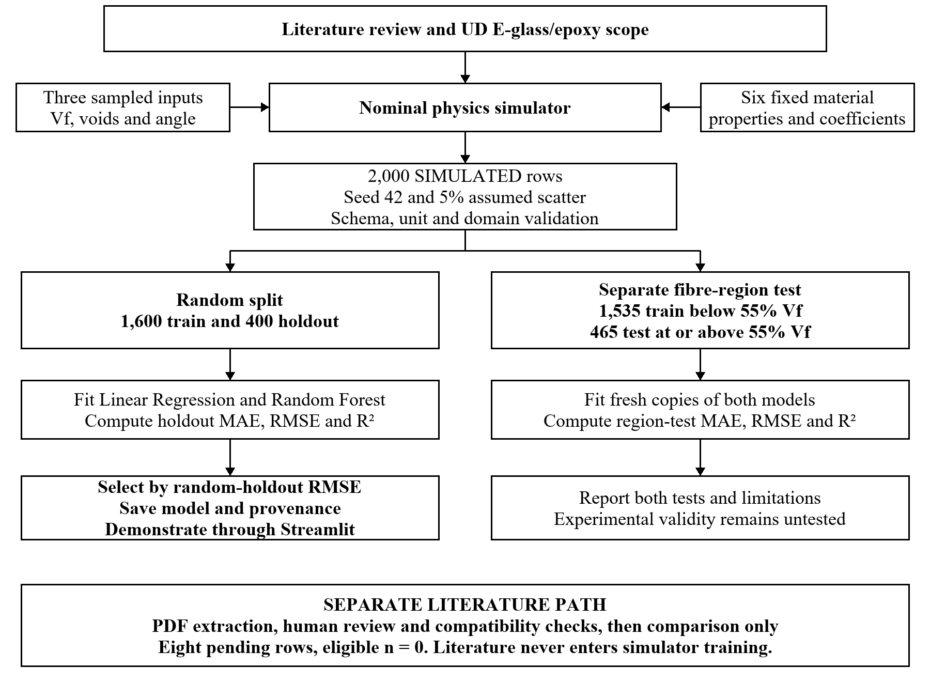
Figure 4.1: Methodology and separate evidence paths

4.2 Training and evaluation workflow
The implementation follows a reproducible sequence. First, the nominal equations and feature ranges define the simulator. Independent uniform draws provide fibre volume fraction, void content and angle. The pure physics function produces a deterministic strength. A fixed pseudo random generator then adds nominal multiplicative scatter to dataset targets only. Every row stores material identifiers and simulated origin.
Row validation checks the schema, numeric finiteness, physical ranges, source information, duplicates and material compatibility. Mixed origin training is blocked. Literature origin is always blocked from training. The dashboard reports accepted, rejected and excluded counts with reasons. It requires rejected rows to be corrected before training. The CLI can train accepted rows while reporting rejected row reasons. No upload is overwritten because saved CSV names use unique identifiers.
For simulated data, train_test_split with random_state 42 holds out 20 percent of rows. Both candidate algorithms use the same partition. Linear Regression provides a baseline. Random Forest uses 120 trees and a minimum of two samples per leaf. The estimator with the lowest held out RMSE is saved with its feature schema, metrics and provenance. It retains the training partition used in evaluation instead of being refitted to all rows. The model selection holdout is not an untouched final scientific benchmark.
A separate test fits fresh estimators on fibre volume fraction below 55 percent and evaluates points at or above 55 percent. This tests a specified shift within the simulator domain. It does not license predictions beyond the supported 20 to 65 percent fibre range. The app blocks out of domain inputs and warns within five percent of a feature boundary. It also blocks nonfinite or negative regression outputs.
The optional experimental upload workflow requires EXPERIMENTAL_UPLOAD and a nonblank study_id. GroupShuffleSplit keeps studies separate. A single study is blocked, while fewer than 30 rows triggers a generalisation warning. Prediction ranges follow the experimental training partition. This optional path has no real training data in the current deliverable.

4.3 Prediction and direct simulator paths
The prediction path checks three inputs and returns a labelled surrogate-model estimate of the simulator using the saved estimator and its metadata. Scenario and sensitivity views reuse that model. The separate direct simulator accepts six additional material properties and evaluates the nominal equations. Changing those properties does not update the saved three-feature forest.

CHAPTER 5

CODING, TESTING

5.1 Implementation and reproducibility
The implementation separates simulator generation, schema validation, training, prediction, scenario arithmetic and literature checks into Python modules. The Streamlit interface exposes nine tabs. The parameter file, CSV origin labels and saved metadata identify which assumptions and dataset produced an estimate. Appendix A gives the runnable commands and evidence files. START_DEMO.bat provides an interactive setup route after the project ZIP is extracted.

5.2 Random holdout evaluation
Table 5.1: Random holdout results
Model | MAE MPa | RMSE MPa | R squared
Linear Regression | 74.18 | 102.03 | 0.6836
Random Forest | 10.79 | 18.21 | 0.9899
The random split contains 1600 training rows and 400 held out rows. Random Forest is selected because its held out RMSE is the smaller of the two candidates. The substantial difference from the linear baseline is consistent with the nonlinear angular interaction embedded in the simulator. It demonstrates approximation ability within this generated dataset; it does not demonstrate accuracy on manufactured laminates.

5.3 Fibre fraction extrapolation
Table 5.2: Fibre fraction region test results
Model | MAE MPa | RMSE MPa | R squared
Linear Regression | 90.99 | 132.68 | 0.6204
Random Forest | 14.18 | 28.63 | 0.9823
This split uses 1535 rows below 55 percent fibre for fitting and 465 rows at or above it for testing. Random Forest RMSE increases from 18.21 to 28.63 MPa. Linear Regression RMSE increases from 102.03 to 132.68 MPa. The test exposes an additional error under a specified fibre fraction shift, even though both sets still come from the same nominal simulator.
MAE is mean absolute error. RMSE is the square root of mean squared error and places greater weight on large deviations. Both use MPa. R squared compares error against predicting the mean of the evaluated target set and can be negative. The implementation reports undefined R squared as null when there are too few or constant targets. Training set errors are not reported as test scores.
Surrogate-model estimate of the simulator (simulated data) — not a measured or validated tensile strength of a real laminate

5.4 Interpretation and scientific limits
The simulator determines the trends available for learning. A high synthetic test score can therefore coexist with a poor physical model. Independent uniform input sampling also differs from real manufacturing, where fibre fraction, voids and processing history may be correlated. Random scatter is an uncalibrated modelling choice. Increasing the number of simulated rows improves coverage of a formula but cannot create missing experimental knowledge.
Sensitivity curves vary one input while holding the other two fixed. Random Forest importance describes the fitted estimator on this dataset. Neither analysis proves a causal physical law. Forest tree spread is not a calibrated prediction interval, so the dashboard provides no such interval. The comparison tool reports absolute and percentage differences from a baseline and uses the term model based scenario comparison. It does not perform a finite element simulation.

5.5 Software checks
The latest model workflow passes 21 pytest checks. They cover physics identities, repeatable generation, CSV validation, incompatible material handling, training splits, provenance, persistence, prediction units, domain rejection, scenario arithmetic, literature metrics and the human review gate. Earlier dashboard checks rendered all nine tabs, exercised the prediction and scenario controls and confirmed headless startup. NumPy and Joblib emit deprecation warnings during persistence tests in the verification environment, while the round trip test succeeds. These checks establish software behaviour, not agreement with real composite specimens.

5.6 Experimental comparison status
No eligible reviewed experimental comparison row is available. Therefore, there is no experimentally measured project result, simulator versus measurement RMSE, surrogate versus measurement RMSE or per study validation score to report. The eight literature means are an auditable extraction queue rather than a complete model test set. Setting reviewed to yes cannot fill the missing void content or change an unsupported architecture.
Figure 5.1 compares RMSE across both splits. Figure 5.2 varies angle at 45 percent fibre fraction and 2 percent void content. Both figures describe simulated results.
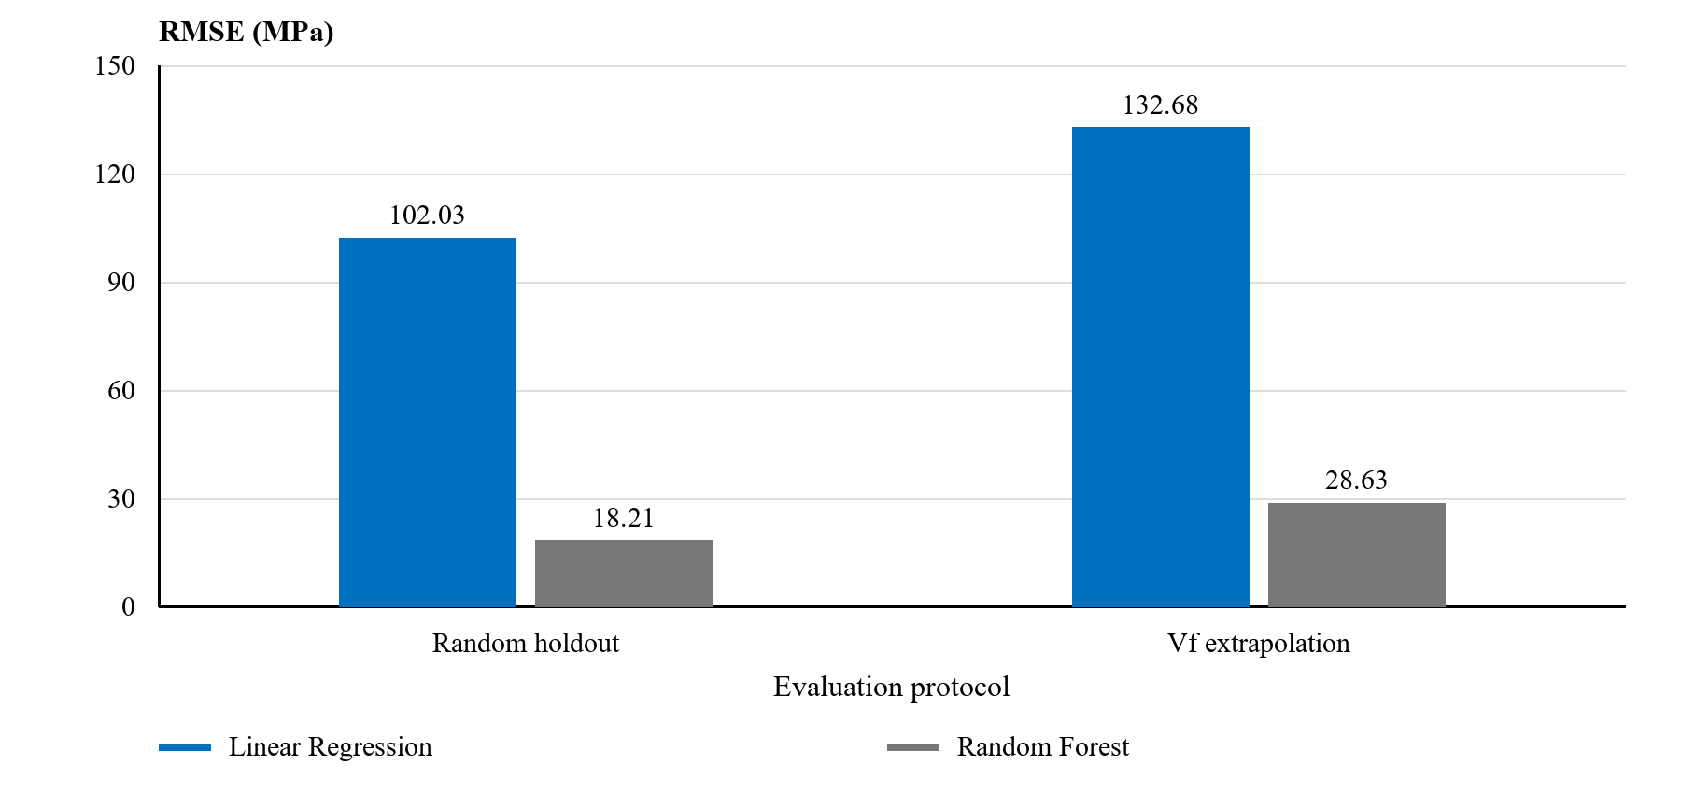
Figure 5.1: RMSE across the two evaluation splits
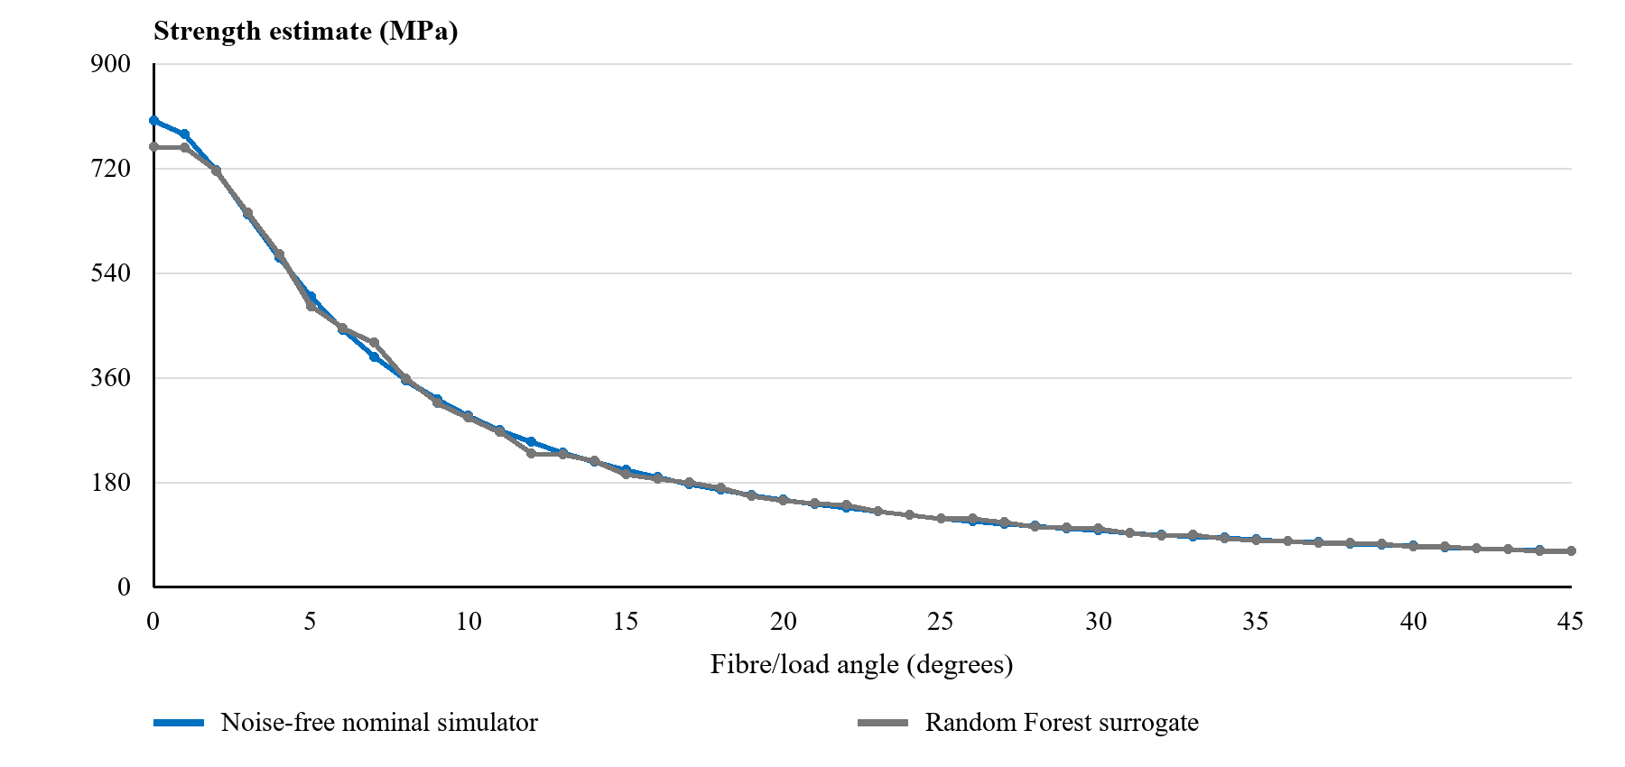
Figure 5.2: Angle sensitivity of simulator and surrogate

CHAPTER 6

CONCLUSION
The project delivers a reproducible simulator based ML prototype with an explicit feature domain and an auditable distinction between simulated training and literature comparison. Linear Regression provides a baseline, while Random Forest gives the lower random holdout error for the generated dataset. The separately fitted extrapolation test shows increased error when the fibre fraction range shifts. A local dashboard makes model behaviour and limitations accessible for demonstration.
The scientific conclusion is limited to software implementation and approximation of the assumed simulator. Parameters remain nominal, experimental comparison count remains zero, and real laminate generalisation has not been established. The project is suitable for demonstrating a careful modelling workflow and for identifying the evidence needed for a later validation stage.

CHAPTER 7

FUTURE ENHANCEMENT
No research paper has been submitted or published as an outcome of this project. Completed work includes the simulator, simulated dataset, fitted estimator, evaluation metadata, Streamlit interface, test suite, documentation and literature extraction audit. The presentation and report communicate the same saved evaluation results.
The immediate next step is human review of each transcribed mean and collection of complete matched dry UD E glass and epoxy conditions, including reported void content. A later calibration should use separate data to estimate the void and strength parameters. Independent studies should then be reserved for evaluation. Relevant test standards, architecture and conditioning must be reconciled before pooling evidence. Uncertainty should be estimated and checked with an appropriate method only after adequate independent observations exist.
Future model inputs may include cure temperature and time, moisture, fibre length, layup and void morphology. Each extension requires a supported physical relationship or complete matched measurements. A new training dataset must vary any intended new feature, and a new estimator must be fitted and evaluated. Adding input fields alone does not extend the current forest.

REFERENCES
References [1] to [30] are research or data articles. References [31] to [35] are reviews. Thirty two of the 35 selected publications date from 2020 onward. Numbered citations identify literature context and do not imply that the corresponding papers supply complete eligible measurement rows.
[1] S. Turaka, R. Chintalapudi, N. Kannaiyan Geetha, B. Pappula, S. Makgato, “Experimental and numerical analysis of the Microstructure and mechanical properties of unidirectional glass fiber reinforced epoxy composites”, Composite Structures, vol. 331, Art. no. 117887, 2024, doi: 10.1016/j.compstruct.2024.117887.
[2] S. S. Jalali, M. Mahzoon, H. Mohammadi, “Identification of damage properties of glass/epoxy laminates using machine learning models”, International Journal of Impact Engineering, vol. 177, Art. no. 104510, 2023, doi: 10.1016/j.ijimpeng.2023.104510.
[3] M. O. Ayanoglu, L. A. Carlsson, E. Du, “Effects of void content on the moisture uptake and mechanical strength of a glass/epoxy composite”, Journal of Composite Materials, vol. 57, no. 2, pp. 325-336, 2023, doi: 10.1177/00219983221144500.
[4] M. M. Rahman, A. E. Ismail, M. F. Ramli, A. H. A. R. Abdul Rashid, “Prediction of tensile properties in fiber-reinforced composites by machine learning models”, International Journal of Automotive and Mechanical Engineering, vol. 23, no. 3, 2026, doi: 10.15282/ijame.23.3.2026.12.1048.
[5] N. Siddgonde, V. Kaushik, A. Ghosh, “Experimental and numerical characterization of E-glass/epoxy plain woven fabric composites containing void defects”, Aerospace Science and Technology, vol. 155, Art. no. 109731, 2024, doi: 10.1016/j.ast.2024.109731.
[6] N. H. Md Hanafiah, A. R. Othman, “Experimental Analysis of Pre-Forming Parameters on Abnormalities, Thickness, and Void Content of Glass/Epoxy Composite In VBO-Oven Cure Manufacturing”, Journal of Engineering and Technological Sciences, vol. 56, no. 2, pp. 219-230, 2024, doi: 10.5614/j.eng.technol.sci.2024.56.2.4.
[7] Nur Hafzareen Md Hanafiah, Abdul Rahim Othman, Mark Ovinis, “Significant Effect of Vacuum Bagging Processing on Inter-Laminar Shear Strength and Voids of Composite in Oven Cure”, Journal of Advanced Research in Applied Sciences and Engineering Technology, vol. 37, no. 1, pp. 69-81, 2024, doi: 10.37934/araset.37.1.6981.
[8] W. Roundi, A. El Mahi, J. Rebiere, A. El Gharad, “Monitoring damage evolution with acoustic emission in two types of glass epoxy laminates”, Polymers and Polymer Composites, vol. 30, Art. no. 09673911221109906, 2022, doi: 10.1177/09673911221109906.
[9] J. Wang, S. Karimi, P. Zeinalzad, J. Zhang, Z. Gong, “Using machine learning and experimental study to correlate and predict accelerated aging with natural aging of GFRP composites in hygrothermal conditions”, Construction and Building Materials, vol. 438, Art. no. 137264, 2024, doi: 10.1016/j.conbuildmat.2024.137264.
[10] M. Govindasamy, G. Kamalakannan, C. Kesavan, G. K. Meenashisundaram, “Damage Detection in Glass/Epoxy Laminated Composite Plates Using Modal Curvature for Structural Health Monitoring Applications”, Journal of Composites Science, vol. 4, no. 4, pp. 185, 2020, doi: 10.3390/jcs4040185.
[11] J. Mendikute, M. Baskaran, I. Llavori, E. Zugasti, L. Aretxabaleta, J. Aurrekoetxea, “Predicting the effect of voids generated during RTM on the low-velocity impact behaviour by machine learning-based surrogate models”, Composites Part B: Engineering, vol. 260, Art. no. 110790, 2023, doi: 10.1016/j.compositesb.2023.110790.
[12] J. Mendikute, J. Plazaola, M. Baskaran, E. Zugasti, L. Aretxabaleta, J. Aurrekoetxea, “Impregnation quality diagnosis in Resin Transfer Moulding by machine learning”, Composites Part B: Engineering, vol. 221, Art. no. 108973, 2021, doi: 10.1016/j.compositesb.2021.108973.
[13] P. Galvez-Hernandez, K. Gaska, J. Kratz, “Phase segmentation of uncured prepreg X-Ray CT micrographs”, Composites Part A: Applied Science and Manufacturing, vol. 149, Art. no. 106527, 2021, doi: 10.1016/j.compositesa.2021.106527.
[14] J. Machado, M. Bodaghi, M. Nikzad, P. P. Camanho, S. Advani, N. Correia, “On the understanding of bubble dynamics through a calibrated textile-like porous medium using a machine learning based algorithm”, Composites Part A: Applied Science and Manufacturing, vol. 177, Art. no. 107955, 2024, doi: 10.1016/j.compositesa.2023.107955.
[15] B. El Said, “Predicting the non-linear response of composite materials using deep recurrent convolutional neural networks”, International Journal of Solids and Structures, vol. 276, Art. no. 112334, 2023, doi: 10.1016/j.ijsolstr.2023.112334.
[16] M. Li, H. Zhang, S. Li, W. Zhu, Y. Ke, “Machine learning and materials informatics approaches for predicting transverse mechanical properties of unidirectional CFRP composites with microvoids”, Materials & Design, vol. 224, Art. no. 111340, 2022, doi: 10.1016/j.matdes.2022.111340.
[17] W. Zhou, W. Zhu, Q. Xu, Y. Ke, “Out-of-plane tensile failure behavior of fiber reinforced composites due to lay-up temperature induced intra-ply and inter-ply voids”, Composite Structures, vol. 271, Art. no. 114150, 2021, doi: 10.1016/j.compstruct.2021.114150.
[18] C. Cai et al., “A versatile and highly efficient algorithm to generate representative microstructures for heterogeneous materials”, Composites Science and Technology, vol. 241, Art. no. 110138, 2023, doi: 10.1016/j.compscitech.2023.110138.
[19] G. Ammasai Sengodan, “Prediction of two-phase composite microstructure properties through deep learning of reduced dimensional structure-response data”, Composites Part B: Engineering, vol. 225, Art. no. 109282, 2021, doi: 10.1016/j.compositesb.2021.109282.
[20] A. Alsheghri, A. Alhammadi, V. Drakonakis, H. Doumanidis, I. Barsoum, M. Maalouf, “Predicting mechanical properties of CFRP composites using data-driven models with comparative analysis”, PLOS ONE, vol. 20, no. 4, pp. e0319787, 2025, doi: 10.1371/journal.pone.0319787.
[21] S. Morsali, D. Qian, M. Minary-Jolandan, “Designing bioinspired brick-and-mortar composites using machine learning and statistical learning”, Communications Materials, vol. 1, no. 1, Art. no. 12, 2020, doi: 10.1038/s43246-020-0012-7.
[22] C. Yan, R. Vescovini, L. Dozio, “A framework based on physics-informed neural networks and extreme learning for the analysis of composite structures”, Computers & Structures, vol. 265, Art. no. 106761, 2022, doi: 10.1016/j.compstruc.2022.106761.
[23] O. A. Imran Azeem, S. T. Pinho, “A physics-informed machine learning model for global-local stress prediction of open holes with finite-width effects in composite structures”, Journal of Composite Materials, vol. 58, no. 23, pp. 2501-2514, 2024, doi: 10.1177/00219983241281073.
[24] K. Zhou, H. Sun, R. Enos, D. Zhang, J. Tang, “Harnessing deep learning for physics-informed prediction of composite strength with microstructural uncertainties”, Computational Materials Science, vol. 197, Art. no. 110663, 2021, doi: 10.1016/j.commatsci.2021.110663.
[25] M. Mehdikhani, C. Breite, Y. Swolfs, M. Wevers, S. V. Lomov, L. Gorbatikh, “A dataset of micro-scale tomograms of unidirectional glass fiber/epoxy and carbon fiber/epoxy composites acquired via synchrotron computed tomography during in-situ tensile loading”, Data in Brief, vol. 34, Art. no. 106672, 2021, doi: 10.1016/j.dib.2020.106672.
[26] K. Naito, “Static and fatigue tensile properties of carbon/glass hybrid fiber-reinforced epoxy composites”, Scientific Reports, vol. 12, no. 1, Art. no. 6298, 2022, doi: 10.1038/s41598-022-10245-5.
[27] R. Santos, D. Vandepitte, D. Moens, “Prediction of composite pressure vessels’ burst strength through machine learning”, Composite Structures, vol. 351, Art. no. 118617, 2025, doi: 10.1016/j.compstruct.2024.118617.
[28] M. Gopalakrishnan, S. Muthu, R. Subramanian, R. Santhanakrishnan, L. Karthigeyan, “Tensile Properties Study of E-Glass/Epoxy Laminate and π/4 Quasi-Isotropic E-Glass/Epoxy Laminate”, Polymers and Polymer Composites, vol. 24, no. 6, pp. 429-446, 2016, doi: 10.1177/096739111602400606.
[29] C. Larco, R. Pahonie, and I. Edu, “The Effects of Fibre Volume Fraction on a Glass-Epoxy Composite Material”, INCAS BULLETIN, vol. 7, no. 3, pp. 113-119, 2015, doi: 10.13111/2066-8201.2015.7.3.10.
[30] C. Dong, “Effects of Process-Induced Voids on the Properties of Fibre Reinforced Composites”, Journal of Materials Science & Technology, vol. 32, no. 7, pp. 597-604, 2016, doi: 10.1016/j.jmst.2016.04.011.
[31] Nurul Zuhairah Mahmud Zuhudi, Afiq Faizul Zulkifli, Muzafar Zulkifli, Ahmad Naim Ahmad Yahaya, Nurhayati Mohd Nur, Khairul Dahri Mohd Aris, “Void and Moisture Content of Fiber Reinforced Composites”, Journal of Advanced Research in Fluid Mechanics and Thermal Sciences, vol. 87, no. 3, pp. 78-93, 2021, doi: 10.37934/arfmts.87.3.7893.
[32] S. Cassola, M. Duhovic, T. Schmidt, D. May, “Machine learning for polymer composites process simulation – a review”, Composites Part B: Engineering, vol. 246, Art. no. 110208, 2022, doi: 10.1016/j.compositesb.2022.110208.
[33] F. Kibrete, T. Trzepieciński, H. S. Gebremedhen, D. E. Woldemichael, “Artificial Intelligence in Predicting Mechanical Properties of Composite Materials”, Journal of Composites Science, vol. 7, no. 9, pp. 364, 2023, doi: 10.3390/jcs7090364.
[34] J. Lee et al., “Machine learning-based inverse design methods considering data characteristics and design space size in materials design and manufacturing: a review”, Materials Horizons, vol. 10, no. 12, pp. 5436-5456, 2023, doi: 10.1039/d3mh00039g.
[35] Y. Liang, X. Wei, Y. Peng, X. Wang, X. Niu, “A review on recent applications of machine learning in mechanical properties of composites”, Polymer Composites, vol. 46, no. 3, pp. 1939-1960, 2025, doi: 10.1002/pc.29082.

