JS: Execution Context, Hoisting & TDZ
Class 3 in JavaScript. Why JS code sometimes runs in ways that look like magic: functions callable before they're written, variables that are undefined when they shouldn't be, and the Temporal Dead Zone that let and const introduced to fix the bugs var caused.
Class: JS 3 · Builds on: variables, functions, and primitives from Classes 1 and 2
Why this matters: Up to now you've written JavaScript as if it runs top to bottom like a book. It mostly does. But the browser does a hidden pass FIRST, setting up memory for every variable and function, and that pass is why hoisting exists, why a function can be called before it's defined, and why var and let behave so differently. Once you understand the two-phase execution model, every weird JS output stops being a mystery.

What you should be able to do after this
- Define functions two ways: as a declaration and as an expression
- Explain what an Execution Context is and the two phases of JS execution
- Trace how a function call creates and discards its own context
- Predict the output of code that uses variables and functions before they're declared
- Define hoisting in your own words and show when it saves you vs when it burns you
- Explain the Temporal Dead Zone and why let / const were designed that way

What's inside
1. Two ways to define a function
2. Execution Context: the two phases of JS
3. Function calls: nested Execution Contexts
4. Hoisting: using things before they're written
5. Temporal Dead Zone: why let and const are stricter
6. Why this all matters

1. Two ways to define a function
In one line: A function can be a declaration (function name() block) or an expression (let name = function()). Same output, different hoisting behaviour.
Key points
- Function declaration: function sayHi() { ... }. Starts with the function keyword at the top level.
- Function expression: let sayHi = function() { ... }. The function is a value assigned to a variable.
- In both cases you call it the same way: sayHi().
- They differ in when they become callable: a declaration is ready from the start of the file; an expression is only ready after its assignment line runs. That's a hoisting difference, covered later.
- This is also why JavaScript calls functions first-class citizens: they can be stored in variables, passed as arguments, returned from other functions. Same as any number or string.
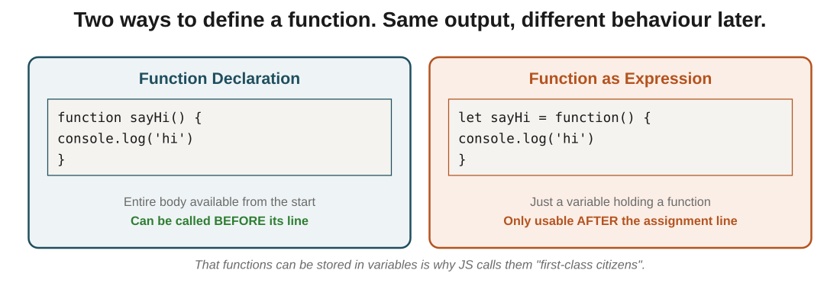
Figure 1: declarations are usable from the start; expressions only after the let line has run.
In the exam: The exam wording to catch: a declaration starts with function; an expression starts with a keyword like let / const / var. If the first token on the line is the variable keyword, it's an expression, and that detail matters when hoisting comes up.

2. Execution Context: the two phases of JS
In one line: Before any line runs, the JS engine does a memory allocation pass. Only then does it run the code line by line.
Key points
- An Execution Context is the environment the engine creates to run your code. There's one Global EC for the whole script.
- Phase 1: Memory Allocation. The engine scans the whole script and sets up memory for every variable and function. Every var gets undefined. Every function declaration gets its full body stored.
- Phase 2: Code Execution. Now the engine runs lines top to bottom. var a = 2 finally assigns 2. add(4, 5) finally runs.
- The two-phase model is why some things that look impossible (calling a function before its line) just work.
- A function expression (let add = function(){}) is treated like a variable in Phase 1: its name is undefined, the function body is NOT ready yet. Only in Phase 2, when the let line runs, does the function become callable.
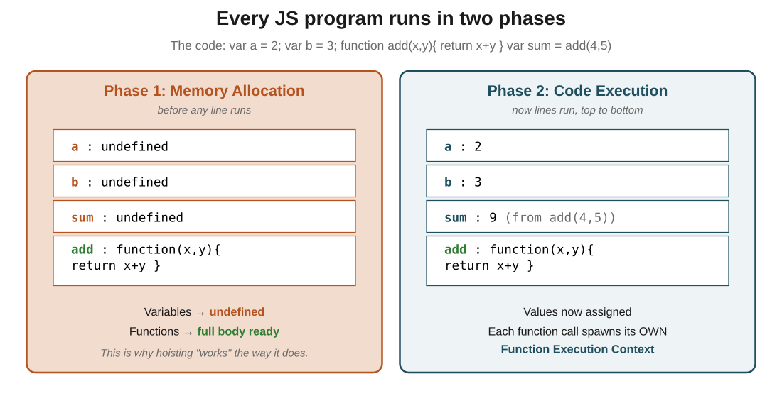
Figure 2: Phase 1 fills memory with undefined (for variables) and full bodies (for functions). Phase 2 then runs each line and assigns real values.
In the exam: The one-liner: memory first, code second. If a question asks why var a reads as undefined before its assignment line, the answer is 'Phase 1 created it, Phase 2 hasn't assigned to it yet'.

3. Function calls: nested Execution Contexts
In one line: Every function call creates a fresh Execution Context on top of the Global one. When the function returns, that context is thrown away.
Key points
- The Global EC starts when the script loads. Each function call then creates a Function Execution Context on top of it.
- Inside each Function EC, the same two-phase thing happens: parameters and local variables get undefined, then the function body runs and assigns real values.
- When the function returns, its context is destroyed. All its local variables are gone.
- That's why variables inside a function don't leak out, and why recursion works: each call gets its own private box.
- Call stack: the Global EC sits at the bottom, each function call stacks on top, and they pop off as they return. This is literally called the call stack, which you'll see later in error messages.
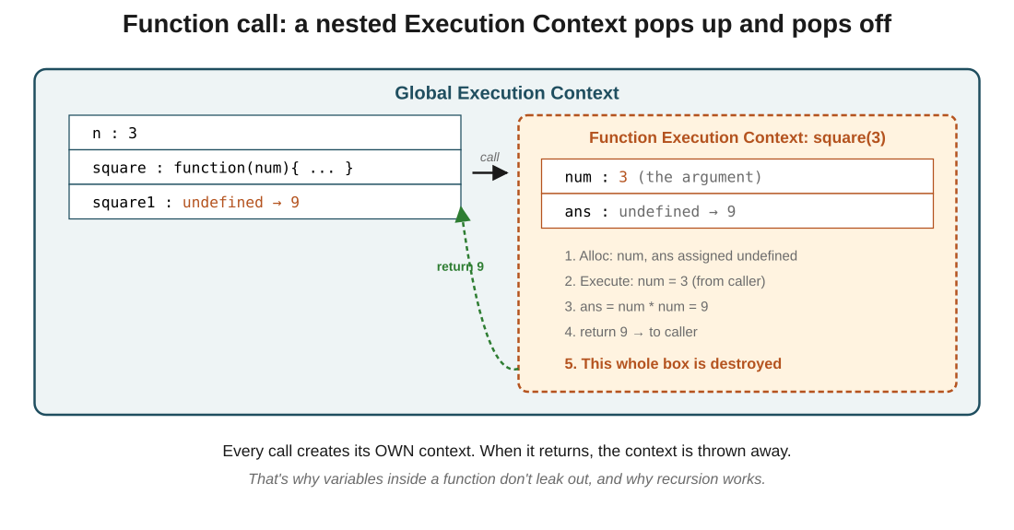
Figure 3: calling square(3) creates a function EC with its own num and ans. When the function returns 9, that EC is destroyed and the value lands back in square1.
In the exam: The thing to internalize: variables inside a function belong only to that call's context. Two calls to the same function don't share any state. That's the whole reason functions are reusable and recursion is safe.
Code walkthrough
var n = 3;

function square(num) {
var ans = num * num;
return ans;
}

let square1 = square(n);
console.log(square1);
Line by line
- Phase 1 (Global EC): memory allocated. n = undefined, square = full function body, square1 = undefined.
- Phase 2 line 1: n assigned 3.
- Phase 2 line 7: square(n) called. A new Function EC pops up.
- Inside the Function EC Phase 1: num = undefined, ans = undefined.
- Inside the Function EC Phase 2: num gets 3 (from the caller), then ans num * num = 9.
- return ans sends 9 back. The Function EC is destroyed; its num and ans vanish.
- Back in the Global EC: square1 gets 9.
- console.log(square1) prints 9
What you see: Console prints 9. During the call, there were briefly two Execution Contexts live at the same time: the Global one holding n, and the Function one holding num and ans. The function one existed for about a microsecond, then disappeared.

4. Hoisting: using things before they're written
In one line: Hoisting is JS's behaviour of making declarations available before the lines where you wrote them, because of the Phase 1 memory allocation.
Key points
- A function declaration can be called before its line in the file. It still works, because Phase 1 put the whole function body in memory.
- A var can be read before its line without crashing. It just reads as undefined, because Phase 1 created the name without a value.
- A function expression (let x = function(){}) cannot be called before its line. The name is undefined, not a function, so calling it throws TypeError: x is not a function.
- The word 'hoisting' makes it sound like code is lifted to the top. It isn't. Nothing moves. What really happens: Phase 1 pre-registers names, so they exist by the time Phase 2 runs any line.
- People say 'function declarations are hoisted with their body; var declarations are hoisted but initialised to undefined'. That's accurate shorthand for the two-phase model.
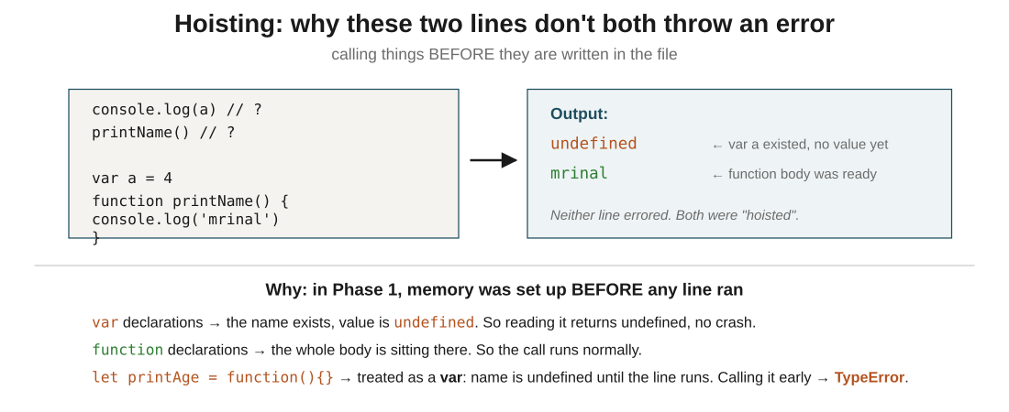
Figure 4: calling printName() before its definition works. Reading var a before its line prints undefined, no crash.
In the exam: The distinction that gets tested: function declarations are callable before their line; function expressions are not. If a question shows let fn = function(){} being called at the top, the answer is TypeError, every time.
Code walkthrough
console.log(a); // ?
printName(); // ?
printAge(); // ?

var a = 4;

function printName() {
console.log('mrinal');
}

let printAge = function() {
console.log(24);
};
Line by line
- Phase 1 scans the file. a = undefined (var), printName = full body (declaration), printAge = undefined (treated as a variable, like let).
- Phase 2 line 1: console.log(a) → a is still undefined. Prints undefined.
- Phase 2 line 2: printName() → the full body is already in memory. Prints mrinal.
- Phase 2 line 3: printAge() → printAge is still undefined, not a function. Throws TypeError: printAge is not a function.
- The rest of the file never gets to run because of that error.
What you see: Console prints undefined, then mrinal, then crashes with TypeError. Declarations survive hoisting with their full body; expressions do not.

5. Temporal Dead Zone: why let and const are stricter
In one line: let and const also get set up in Phase 1, but trying to read them before their line throws an error instead of giving undefined.
Key points
- The Temporal Dead Zone (TDZ) is the window between the start of the script and the actual let / const line. During that window, reading the variable is an error.
- var has no TDZ. Read it early, you get undefined.
- let and const have a TDZ. Read them early, you get: ReferenceError: cannot access 'x' before initialization.
- ES6 added this deliberately. The old var behaviour (silent undefined) hid bugs. Now, if you use a variable before you declared it, JavaScript tells you loudly.
- The TDZ ends the moment the let / const line runs, not the moment it is reached by Phase 1. So the line matters, and the order of your code matters.
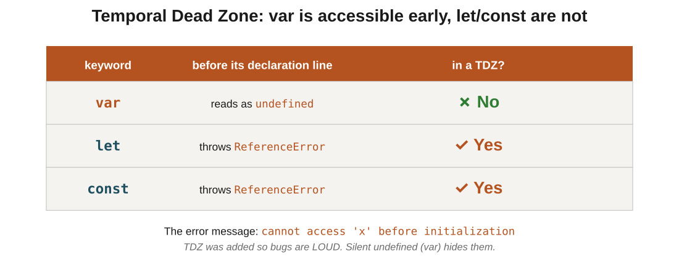
Figure 5: var reads as undefined before its line (no TDZ); let and const throw ReferenceError (TDZ in effect).
In the exam: The three-row rule to memorise: var = no TDZ (undefined), let = TDZ (error), const = TDZ (error). If a question asks which keyword throws 'cannot access before initialization', the answer is let or const.
Code walkthrough
console.log(a); // ReferenceError!
let a = 4;
Line by line
- Phase 1: a is registered as a let. The engine knows it exists, but marks it as uninitialised (in the TDZ).
- Phase 2 line 1: console.log(a) tries to read a.
- The engine sees a is still in its TDZ. Instead of returning undefined (like var would), it throws ReferenceError: cannot access 'a' before initialization.
- The script stops. Line 2 never runs.
What you see: The console shows a ReferenceError and the script halts. If line 1 had been var a, the same read would silently print undefined, and the script would carry on. The TDZ is the safety net that turns the silent bug into a loud one.

6. Why this all matters
In one line: Hoisting isn't a trick. It's the direct consequence of the two-phase model, which is also the reason let / const were designed differently.
Key points
- Phase 1 (memory allocation) is why hoisting exists. Variables get undefined, function declarations get their body.
- Phase 2 (code execution) is the normal top-to-bottom running you expected.
- var is loose: no TDZ, no block scope, silently reads as undefined. Most hoisting bugs come from this.
- let / const are strict: TDZ catches accidental early reads. This is why they're the modern default.
- Rule of thumb for writing new code: declare before you use. Even though hoisting lets you cheat, readable code runs top to bottom. The order you write things should match the order they execute.
In the exam: The one takeaway: the two-phase model explains everything else in this class. If you remember 'memory first, then code', you can derive hoisting, TDZ, and function-expression-vs-declaration behaviour from scratch.

The big picture: what it all comes down to
If it all clicks here, the rest follows: the core ideas, in plain terms.
- JavaScript runs in two phases: Phase 1 allocates memory for every variable (undefined) and function (full body); Phase 2 runs the code line by line.
- An Execution Context is the environment of a run. There's one Global EC, and every function call makes a new Function EC on top.
- Function declarations (function fn()) are fully available from the start of the file. Function expressions (let fn = function()) are not: they're undefined until their line runs.
- Hoisting is just the visible effect of Phase 1: names exist before their line in the source.
- var has no TDZ: reading it early gives undefined. let and const have a TDZ: reading them early throws ReferenceError.
- TDZ is the fix for the silent bugs var caused. That's why let is the modern default.

Quick recap
- A function declaration starts with the function keyword; a function expression stores a function in a variable.
- Every JS program runs in two phases: memory allocation first, then code execution.
- In Phase 1, var gets undefined and function declarations get their full body in memory.
- Every function call creates its own Function Execution Context on top of the Global one, then destroys it on return.
- Hoisting means declarations are available before their line in the source; var declarations give undefined, function declarations give the full function.
- Function expressions (let fn = function(){}) cannot be called before their line, they'd throw TypeError.
- let and const sit in a Temporal Dead Zone until their line runs; reading them early throws ReferenceError.
- var has no TDZ, which is why it was replaced as the default: silent undefined hides bugs; ReferenceError exposes them.

Try it yourself
- Predict the output of: console.log(x); var x = 5; → should print undefined, not throw. Confirm.
- Change the previous to let x = 5. Predict: ReferenceError. Confirm.
- Write a function declaration and call it on the line ABOVE where it's defined. Confirm it works.
- Change the same function to a function expression (let fn = function(){}). Call it above its line. Confirm the TypeError.
- Write a function square(n) that returns n * n. Call it with square(5) and trace by hand: Global EC, then Function EC with num and ans, then return.
- Explain in one sentence why the two-phase model makes hoisting possible. If you can't say it in one sentence, re-read Section 2.

