Introduction to JavaScript
First class in JavaScript. How JS runs (in a browser and in Node.js), how to store values with var, let and const, and the four things every JS program is built from: primitives, functions, arrays, and objects.
Class: Intro to JavaScript · Builds on: your HTML and CSS from the earlier classes
Why this matters: JavaScript is the third leg of the web. HTML gives a page its structure, CSS its look, and JavaScript its behaviour. Buttons that do things when you click them, forms that validate as you type, live search, dynamic charts, chat widgets: all JavaScript. Since 2009 it also runs outside the browser (thanks to Node.js), so the same language powers Zomato's frontend and Zomato's backend servers, VS Code the editor, and even some AI tooling. It's the single most job-relevant language in web development.

What you should be able to do after this
- Explain what JavaScript is and how it runs in a browser vs on a computer (Node.js)
- Run JavaScript three ways: browser console, <script> tag, and node file.js
- Declare variables with var, let, const and know which to use when
- Explain what dynamic typing means and why it matters
- Use all five primitive types: number, string, boolean, undefined, null
- Write functions that take parameters and return values
- Store lists of values in arrays and change them with push, pop, shift, unshift
- Store labelled data in objects and read it with dot or bracket notation

What's inside
1. What JavaScript is, and where it runs
2. Three ways to run JavaScript
3. Variables: var, let, and const
4. Dynamic typing: the same variable can hold anything
5. The five primitive types
6. Functions: reusable blocks of code
7. Arrays: indexed storage
8. Objects: labelled storage

1. What JavaScript is, and where it runs
In one line: JavaScript is a programming language that adds behaviour to web pages, and (since 2009) runs on computers too.
Key points
- Born in a browser. Brendan Eich created JavaScript in 10 days in 1995, so browsers could do more than display static text. It was renamed from LiveScript to JavaScript to ride on Java's popularity (the two languages are unrelated).
- Every browser has a JS engine. Chrome uses V8, Firefox uses SpiderMonkey, Safari uses JavaScriptCore. Different engines, same JavaScript.
- Ryan Dahl freed it. In 2009 he wrapped V8 (Chrome's engine) into Node.js, so JavaScript could run outside a browser: on a server, on your laptop, on any computer with Node installed.
- That single move is why JavaScript now powers: browser UIs, backend servers (Express), mobile apps (React Native), desktop apps (Electron, which is what VS Code is built on), and even AI (TensorFlow.js).
- The language runs the same everywhere. What changes is what it can access: a browser gives it a document and buttons; Node gives it a file system and network.
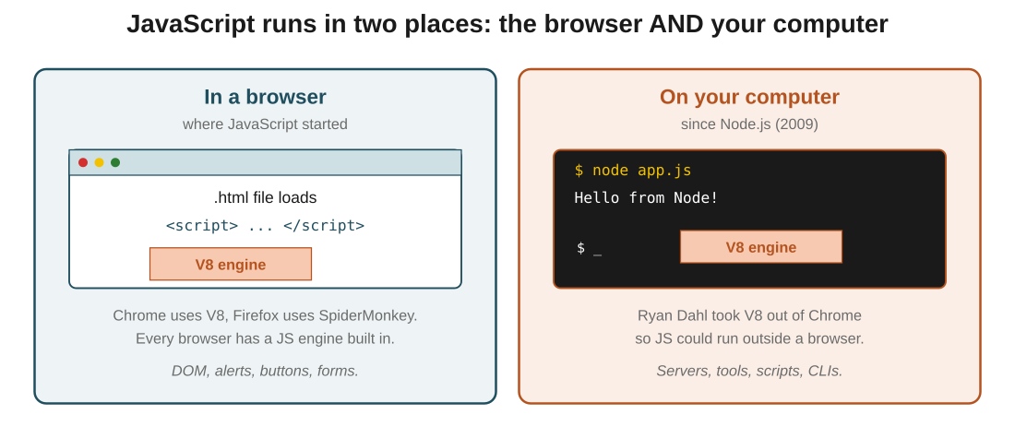
Figure 1: same V8 engine, two homes. In the browser it powers pages; in Node.js it powers everything else.
In the exam: Two names to keep straight: V8 is Chrome's JavaScript engine. Node.js is a program that packages V8 so it can run outside a browser. Every JS engine is a browser thing; Node is the exception that made it a general-purpose language.

2. Three ways to run JavaScript
In one line: In the browser console, in a page via <script>, or in a terminal via node.
Key points
- Browser console (quickest): open DevTools (right-click, Inspect), switch to the Console tab, type JavaScript, hit Enter. Great for experiments.
- In a web page: put your code inside a <script> tag in the HTML, usually just before </body>. The tag runs when the browser reaches it.
- External file: put the code in a .js file and link it: <script src="index.js"></script>. This is how real projects are structured.
- Why script tags go at the bottom of the body: so the HTML above it renders first. The user sees the page while the JavaScript loads, instead of staring at a blank screen.
- In a terminal via Node: install Node.js from nodejs.org (LTS version), then run node file.js in a terminal. No browser needed.
- console.log(x) is how you print in JavaScript. In the browser it prints to the DevTools console; in Node it prints to the terminal.
In the exam: The reason to put <script> at the bottom of the body: rendering. Scripts pause HTML parsing while they load and execute. If they're at the top, the user stares at a blank page. At the bottom, the page paints first and scripts run after.
Code walkthrough
<!-- inside your HTML file -->
<body>
<h1>My Page</h1>

<script>
console.log('Hello from the page');
</script>
<script src="./index.js"></script>
</body>
Line by line
- The <body> holds the visible HTML: a heading first, then two script tags.
- The first <script> has inline JavaScript. It runs the moment the browser reaches it.
- console.log('Hello from the page') prints that string to the browser's DevTools console.
- The second <script src="./index.js"> loads a separate JavaScript file called index.js and runs it.
- The scripts sit at the end of the body so the <h1> has already rendered by the time the JavaScript runs. Faster perceived load.
What you see: The user sees "My Page" on screen immediately. Open DevTools → Console and you'll see "Hello from the page", followed by whatever index.js logs.

3. Variables: var, let, and const
In one line: Use let by default. Use const when the value should never change. Avoid var in new code.
Key points
- A variable is a named storage slot for a value. Declare it with a keyword, give it a name, assign a value.
- var is the original keyword. It allows redeclaration (declaring the same name twice) and reassignment (changing the value). This flexibility caused bugs, so ES6 (2015) added better options.
- let is the modern default. Blocks redeclaration (let a; let a; is an error), allows reassignment (a = 20 is fine).
- const is the strictest. Blocks both redeclaration AND reassignment. Once you set the value, it stays.
- const must be initialised in the same line as its declaration. const x; is an error; you need const x = 5;.
- Redeclaration and reassignment are different things: redeclaring is 'writing the keyword and name again'; reassigning is 'writing the name = a new value'.
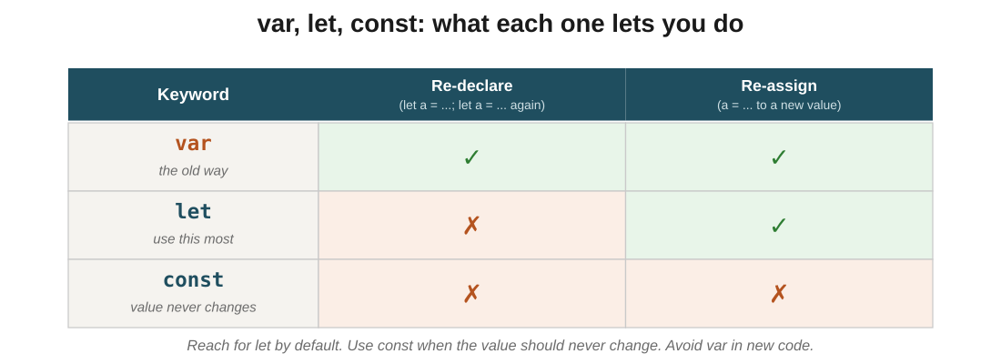
Figure 2: the three keywords and what each one allows. var is the loosest, const is the strictest.
In the exam: The one-line rule they'll test: const can't be reassigned, let can, var is the old way. If a question shows a value that must stay fixed (like pi or a config), const is the right answer.
Code walkthrough
// let: reassign OK, redeclare NOT OK
let city = 'Delhi';
city = 'Mumbai'; // ✓ reassign
// let city = 'Chennai'; // ✗ error: already declared

// const: nothing changes after declaration
const pi = 3.14;
// pi = 3.15; // ✗ error: assignment to constant

// const must have a value at declaration
// const x; // ✗ error: missing initializer
Line by line
- let city = 'Delhi' declares a new variable and gives it a value.
- city = 'Mumbai' reassigns to a new value. Legal with let.
- Trying to let city = 'Chennai' again would fail: 'Identifier city has already been declared'.
- const pi = 3.14 creates a constant. Both declaration and initial value must be on the same line.
- Trying to reassign pi = 3.15 throws 'Assignment to constant variable'.
- Trying const x; with no value throws 'Missing initializer'.
What you see: city ends as "Mumbai". pi stays 3.14. The commented-out lines are what would break if you uncommented them, so you get a feel for what each keyword protects against.

4. Dynamic typing: the same variable can hold anything
In one line: JavaScript doesn't care what type of value you put in a variable. You can even change it midway.
Key points
- Static typing (Java, C++): 'this variable holds an integer, and only an integer, forever'. The compiler enforces it.
- Dynamic typing (JavaScript, Python): 'this variable holds whatever you put in it, whenever'. The language just checks at runtime.
- You can assign a number to a variable, then reassign a string, then reassign a boolean. JavaScript is fine with all of it.
- Pro: less ceremony, faster to prototype.
- Con: more room for bugs. A variable that's 'usually a number' might sometimes hold a string, and the code that reads it may not notice until it crashes.
- This is why TypeScript exists: it adds a type layer on top of JavaScript so tools can catch these bugs at write time.
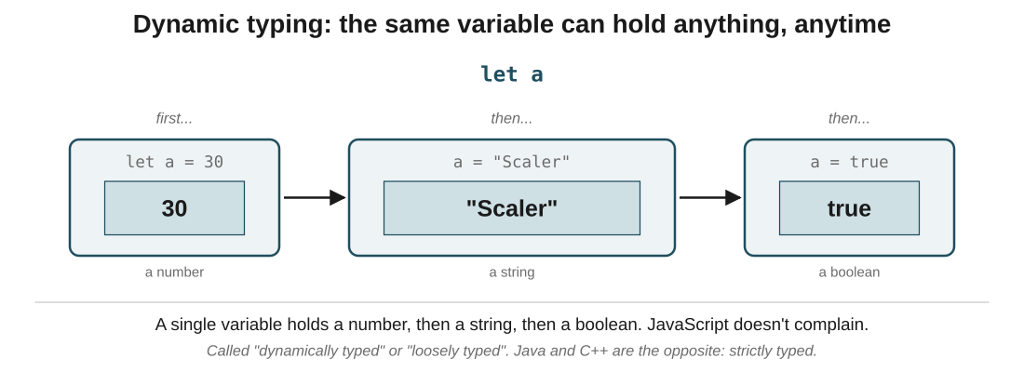
Figure 3: one variable, three types over its lifetime. JavaScript doesn't stop you from doing this, even though it's usually a bad idea.
In the exam: The vocabulary they'll ask about: JavaScript is dynamically typed (also called loosely typed). Java and C++ are statically typed (or strictly typed). If a question says 'a variable's type can change at runtime', the answer is dynamic typing.
Code walkthrough
let a = 30;
console.log(a); // 30 (a number)

a = 'Scaler';
console.log(a); // Scaler (now a string)

a = true;
console.log(a); // true (now a boolean)
Line by line
- let a = 30 declares a and gives it a number.
- a = 'Scaler' reassigns it to a string. JavaScript silently accepts this, no error, no warning.
- a = true reassigns it again, this time to a boolean. Still fine.
- In a strictly typed language, only the first assignment would work; the other two would refuse to compile.
What you see: 30, then Scaler, then true printed to the console. Three completely different types, all in one variable, all legal.

5. The five primitive types
In one line: number, string, boolean, undefined, null. Every JavaScript value is either one of these or a reference (objects, arrays, functions).
Key points
- number: any numeric value, whole or decimal, positive or negative. Also two special ones: Infinity (from 2/0) and NaN ("not a number", from "hello" / 0).
- string: text in ' ', " ", or backticks ` `. Backticks are special: they let you drop variables in with ${name} syntax (called template literals).
- boolean: exactly two values, true and false. Used for yes/no state, conditionals, flags.
- undefined: the default. When you declare let x without a value, x is undefined. JavaScript assigns this automatically.
- null: the deliberate empty. You assign null yourself to say "there is no value here right now". Common for a user that hasn't logged in, a search that hasn't run yet.
- The distinction between undefined and null is one of the most-asked JavaScript interview questions: undefined is what JS gives you; null is what you give JS.
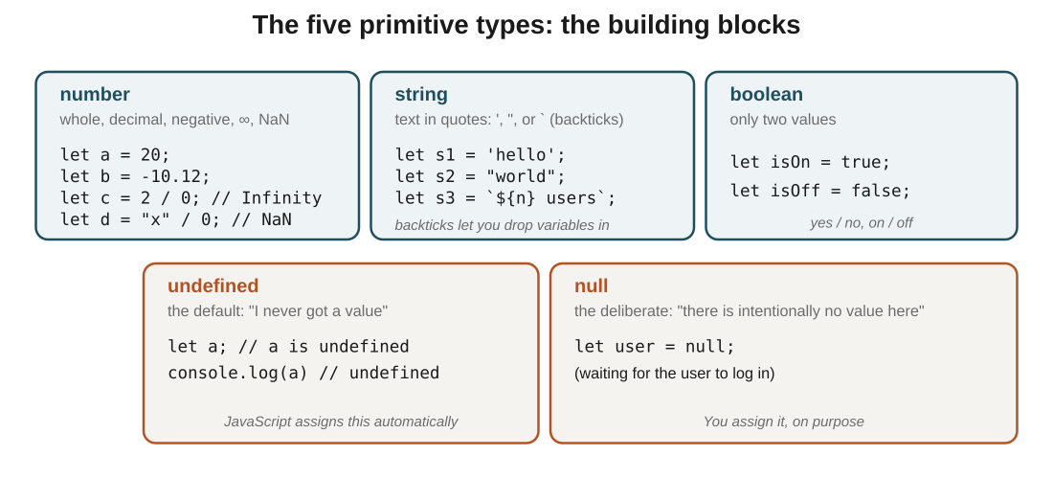
Figure 4: the five primitive types at a glance. Number, string, and boolean carry data; undefined and null both mean 'no value', for different reasons.
In the exam: The line that answers every undefined vs null question: undefined is a value JavaScript assigns for you when nothing else has been set; null is a value you assign explicitly to say 'nothing here'. Both mean 'no value', but the source of that emptiness is different.
Code walkthrough
// number
let a = 20;
let b = 12.57;
let c = 2 / 0; // Infinity
let d = 'hello' / 0; // NaN

// string with a template literal
let activeUsers = 100;
let msg = `There are ${activeUsers} users online`;

// boolean
let isOnline = true;

// undefined vs null
let notSet; // JS assigns undefined
let cleared = null; // you assign null
Line by line
- a and b are ordinary numbers.
- c = 2/0 gives Infinity: JavaScript handles division by zero without crashing.
- d = 'hello' / 0 gives NaN: 'not a number', because a string divided by anything makes no numeric sense.
- msg uses backticks with ${activeUsers} to drop the variable's value into the string. Result: "There are 100 users online".
- notSet was declared but never assigned. JavaScript automatically gives it undefined.
- cleared was explicitly set to null. Same 'no value' idea, but you chose it on purpose.
What you see: a: 20, b: 12.57, c: Infinity, d: NaN, msg: "There are 100 users online", isOnline: true, notSet: undefined, cleared: null.

6. Functions: reusable blocks of code
In one line: A function groups a set of instructions under a name so you can run them any time by calling that name.
Key points
- Declare with the function keyword: function name(parameters) { body }.
- Parameters are placeholders in the declaration. Arguments are the actual values you pass when calling. Same slots, different names by role.
- Call (or 'invoke') with parentheses: serveBeverage('tea'). The value tea gets bound to the drink parameter for that call.
- One declaration, many calls. That's the entire point: write it once, reuse it with different inputs.
- Functions can also return values: function add(a, b) { return a + b; }. The caller then uses that returned value.
- Functions can take zero, one, or many parameters. Same for arguments when calling. They should match up by position.
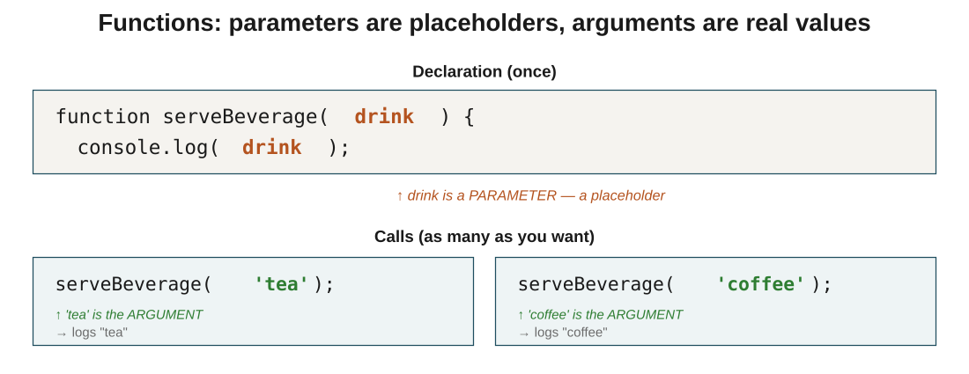
Figure 7: parameters are the placeholders in the declaration; arguments are the actual values in each call. One function definition, many calls.
In the exam: The vocabulary: parameter is the name in the declaration, argument is the value in the call. In function greet(name), name is a parameter. In greet('Osc'), Osc is the argument. Papers love to swap these two.
Code walkthrough
function serveBeverage(drink) {
console.log(drink);
}

serveBeverage('tea');
serveBeverage('coffee');
serveBeverage('juice');
Line by line
- function serveBeverage(drink) declares a function named serveBeverage. Inside the parentheses, drink is a parameter, a placeholder for whatever value gets passed in.
- The body is console.log(drink): print whatever drink holds when the function is called.
- serveBeverage('tea') calls the function with tea as the argument. During this call, drink equals tea.
- The next two calls pass different arguments. Same function, different values.
What you see: The console prints tea, then coffee, then juice, in that order. Same three lines of function code, run three times with three different inputs.

7. Arrays: indexed storage
In one line: An array is an ordered list of values, accessed by numeric index starting at 0.
Key points
- Create with square brackets: let cars = ['swift', 'BMW', 'Audi'].
- Zero-indexed: the first element is cars[0], not cars[1]. The last is cars[cars.length - 1].
- Arrays can hold any mix of types: numbers, strings, booleans, other arrays, functions, objects. All in the same array.
- Change an element by index: cars[1] = 'Ferrari' replaces BMW.
- arr.length gives the total count. It's a property, not a method: no parentheses.
- Four mutation methods you'll use constantly, in two rhyming pairs:
- push(x) adds to the back; pop() removes from the back.
- unshift(x) adds to the front; shift() removes from the front.
- pop and shift also return the removed element, so you can catch it: let last = cars.pop().
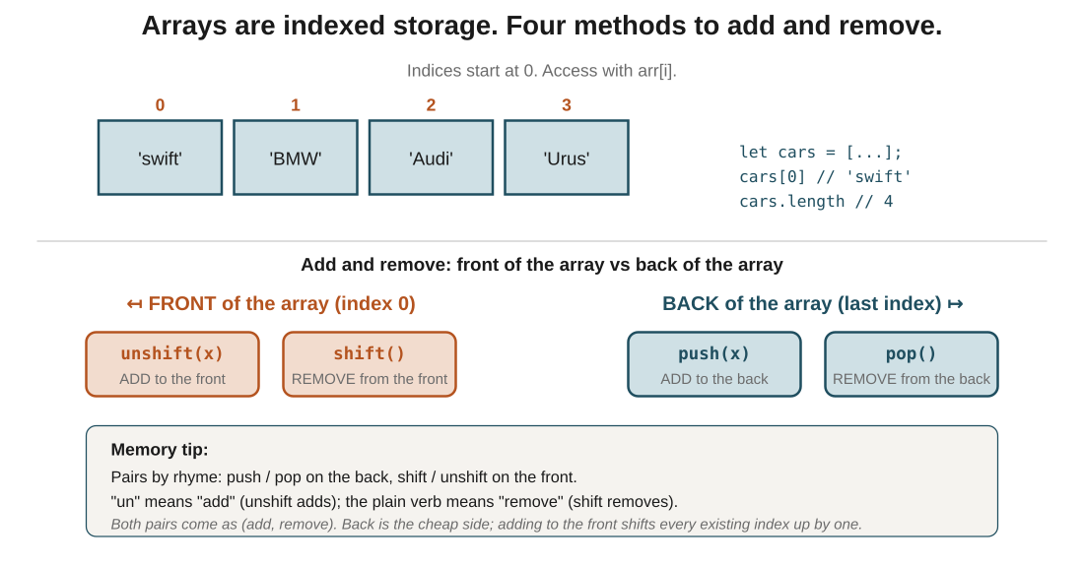
Figure 5: an array is numbered slots. The four mutation methods split naturally into 'front' and 'back' pairs; each pair has an add and a remove.
In the exam: The mnemonic that never fails: push / pop rhyme, both work on the back. shift / unshift are the pair for the front. In each pair, the one starting with 'un' or 'push' adds; the plain one removes.
Code walkthrough
let cars = ['swift', 'BMW', 'Audi'];

cars.push('Urus'); // add to back
// cars is now ['swift', 'BMW', 'Audi', 'Urus']

let removed = cars.pop(); // remove from back, save it
// removed = 'Urus'; cars is ['swift', 'BMW', 'Audi']

cars.unshift('Nano'); // add to front
// cars is now ['Nano', 'swift', 'BMW', 'Audi']

cars.shift(); // remove from front
// cars is back to ['swift', 'BMW', 'Audi']
Line by line
- cars starts as an array of three strings.
- cars.push('Urus') appends to the end. Array is now four items.
- cars.pop() removes the last item and returns it. We caught it in removed, so we can see what got taken.
- cars.unshift('Nano') adds to the front. Every existing index shifts up by one to make room.
- cars.shift() removes the first item. Every remaining index shifts down by one to fill the gap.
What you see: After all four operations, cars is back to ['swift', 'BMW', 'Audi']. Along the way, removed got set to 'Urus' (the value that was popped).

8. Objects: labelled storage
In one line: An object stores values under named keys instead of numeric indices. { name: 'Steve', age: 102 }.
Key points
- Create with curly braces: let person = { name: 'Mrinal', age: 24 }.
- Each entry is a key-value pair: the key is a name (a string), the value can be anything (number, string, boolean, array, another object, or a function).
- Read with dot notation: person.name gives Mrinal. Cleanest when you know the key at write time.
- Read with bracket notation: person['name'] gives the same thing. Needed when the key is stored in a variable: person[whichKey].
- Add a new key by assigning to it: person.city = 'Bengaluru' creates city if it doesn't exist, or updates it if it does.
- Delete a key with the delete keyword: delete person.age removes it entirely.
- Nested objects are common. captain.address.city.pincode drills three levels deep. Same idea, just chained.
- A function stored as a value is called a method. captain.sayHi() calls the function stored under the sayHi key.
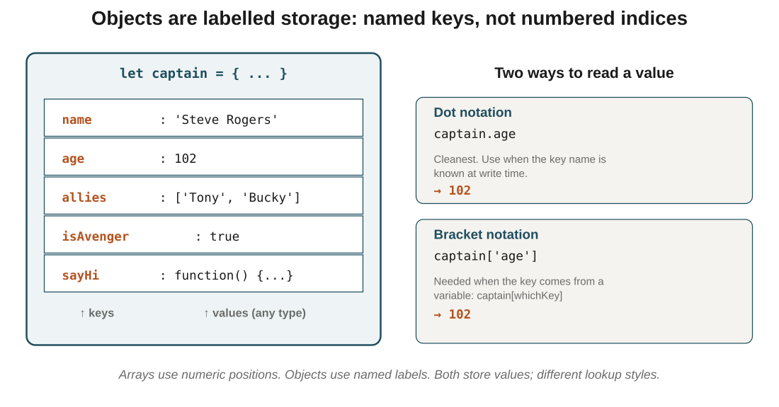
Figure 6: objects are key-value pairs. Dot notation is the default; bracket notation is what you reach for when the key comes from a variable.
In the exam: The one-liner that captures it: arrays use numbers, objects use names. If you're modelling a list of similar things (users, cars, scores), reach for an array. If you're modelling one thing with different properties (a user's name, age, email), reach for an object.
Code walkthrough
let captain = {
name: 'Steve Rogers',
age: 102,
allies: ['Tony', 'Bucky'],
isAvenger: true,
sayHi: function() { console.log('Cap says hi'); },
address: {
country: 'USA',
city: { name: 'Brooklyn', pincode: 12345 }
}
};

console.log(captain.age); // 102
console.log(captain.allies[1]); // Bucky
console.log(captain.address.city.pincode); // 12345
captain.sayHi(); // Cap says hi

captain.isAvenger = false; // update a key
captain.movies = ['Endgame']; // add a new key
delete captain.age; // remove a key
Line by line
- captain is an object with six keys. Values include a string, a number, an array, a boolean, a function, and another (nested) object.
- captain.age reads the age value: 102.
- captain.allies[1] reads the second element of the allies array (0-indexed): Bucky.
- captain.address.city.pincode drills into the nested object twice: 12345.
- captain.sayHi() calls the function stored under sayHi. Prints "Cap says hi".
- captain.isAvenger = false updates an existing key.
- captain.movies = ['Endgame'] adds a new key (movies didn't exist before).
- delete captain.age removes the age key entirely.
What you see: The console prints 102, then Bucky, then 12345, then "Cap says hi". After the last three lines, captain has no age, isAvenger is false, and there's a new movies array.

The big picture: what it all comes down to
If it all clicks here, the rest follows: the core ideas, in plain terms.
- JavaScript runs in every browser (via a JS engine like V8), and also on your computer (via Node.js). Same language, two homes.
- Print with console.log. Add code to a page with <script>, or run a file with node file.js.
- Declare variables with let (reassignable) or const (fixed). Avoid var. Dynamic typing means one variable can hold any type.
- Five primitives: number, string, boolean, undefined (JS-assigned default), null (you-assigned deliberate empty).
- Functions wrap reusable logic. Parameters in the declaration; arguments in the call.
- Arrays are numbered slots (arr[0]). Add/remove at back with push/pop, at front with unshift/shift.
- Objects are named slots (obj.key). Read with . or []. Add, update, or delete any key any time.

Quick recap
- JavaScript is the behaviour layer of the web, and (since Node.js) also runs on servers and computers.
- Every browser has a JavaScript engine built in (Chrome: V8, Firefox: SpiderMonkey).
- Run JS in the browser console, via a <script> tag in HTML, or in a terminal with node file.js.
- var (old, allows redeclaration), let (modern default, no redeclaration), const (no redeclaration or reassignment).
- JavaScript is dynamically typed: a variable can hold a number, then a string, then a boolean.
- Five primitive types: number, string, boolean, undefined (default), and null (deliberate empty).
- Functions are declared with the function keyword; parameters are placeholders, arguments are the actual values passed.
- Arrays are 0-indexed lists; push/pop work on the back, unshift/shift work on the front.
- Objects are key-value pairs; access with dot notation or bracket notation.

Try it yourself
- Open your browser's DevTools console, type console.log('Hi'), press Enter. Then create a var, let, and const and try to reassign each.
- Create an .html file with a <script> tag that logs your name. Then move the code to an external .js file and link it with src.
- Install Node.js and run node --version to check. Then create app.js with console.log('Hello Node') and run it with node app.js.
- Declare let a = 30, then reassign it to a string, then to a boolean, then to null. Log each step. Notice that JavaScript never complains.
- Write a function greet(name) that prints "Hello, name". Call it three times with three different names.
- Create an array of five fruits. Use push to add one, pop to remove the last, unshift to add one at the front, and shift to remove the first.
- Build an object for yourself: name, age, hobbies (an array), and a sayHi function. Log each value using both dot and bracket notation.
- Take the object from the previous task and add a new key, update an existing key, and delete a key.

