JavaScript Deep Dive: Arrays, Strings & Objects
Class 2 in JavaScript. From basic syntax to actual problem solving: traverse arrays with loops, treat strings like arrays of characters, model real-world data with arrays of objects.
Class: JS 2 · Builds on: your JavaScript intro from Class 1
Why this matters: Class 1 was about syntax: how do I declare a variable, what's an array. This class is about how you actually USE those tools. Almost every JavaScript problem, in interviews or in real code, boils down to a small number of patterns: traverse a list, keep a running value, model data as objects, filter or find. Learn these patterns here and most future problems become variations.

What you should be able to do after this
- Traverse any array with a for loop and the arr.length bound
- Apply the accumulator pattern for sums, counts, maximums, and filters
- Use includes, indexOf, slice, and join to work with arrays and strings
- Treat strings like indexed characters, reverse them, and check palindromes
- Use dot vs bracket notation correctly, and know when bracket is required
- Traverse an object's keys with for...in
- Model real-world data as an array of objects and solve problems on it

What's inside
1. The array traversal pattern
2. The accumulator pattern: sum, max, count
3. More array methods: includes, indexOf, slice, join
4. Strings: arrays of characters, essentially
5. Important string methods
6. Objects: dot vs bracket, and the for...in loop
7. Array of Objects: real-world data

1. The array traversal pattern
In one line: A single for loop from 0 to arr.length - 1 is the base pattern for half of all array problems.
Key points
- The loop shape never changes: for (let i = 0; i < arr.length; i++). Start at 0, stop just before length, step by one.
- arr.length is used as the boundary, so the loop grows with the array. No hard-coded numbers.
- Print all: put console.log(arr[i]) inside the loop.
- Print some: wrap that line in an if, like if (arr[i] % 2 = 0) for even numbers, if (arr[i] > 0) for positives.
- The loop stops the moment i < arr.length becomes false. For an array of length 5, that's when i reaches 5.
- Accessing arr[10] on an array of length 5 gives undefined, not an error. JavaScript doesn't complain about out-of-bounds reads.
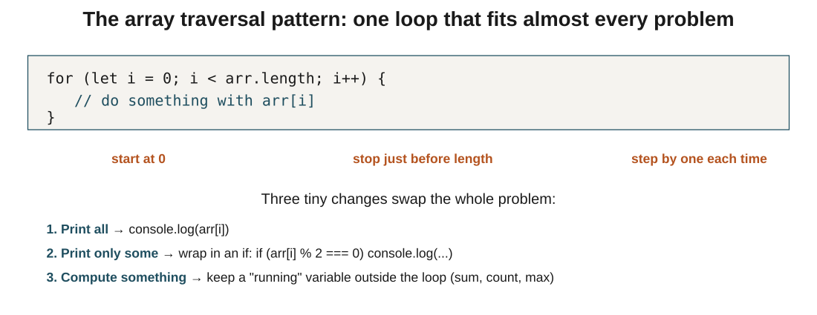
Figure 1: the traversal pattern. Three tiny variations solve print-all, print-some, and compute-something.
In the exam: The classic trap: arr.length - 1 is the last index, arr.length is the count. If an array has 4 elements, length is 4 but the last valid index is 3. Off-by-one bugs almost always come from confusing these two.

2. The accumulator pattern: sum, max, count
In one line: Declare a running variable before the loop, update it inside the loop, use it after. Same shape solves sum, maximum, and count problems.
Key points
- Sum: start with let sum = 0. Each iteration: sum = sum + arr[i]. After the loop, sum holds the total.
- Maximum: start with let max = arr[0] (assume the first is the biggest). Loop from index 1. If arr[i] > max, update max = arr[i].
- Count: start with let count = 0. Each iteration where the condition matches (positive, even, > 40): count++.
- Notice the shape: declare before, update inside, use after. The running variable must live outside the loop, or it resets on every iteration.
- For max, starting from arr[0] and looping from i = 1 is a small optimisation: no point comparing arr[0] to itself.
- For max, arr[0] is a safe starting point only if the array has at least one element. Empty arrays need special handling.
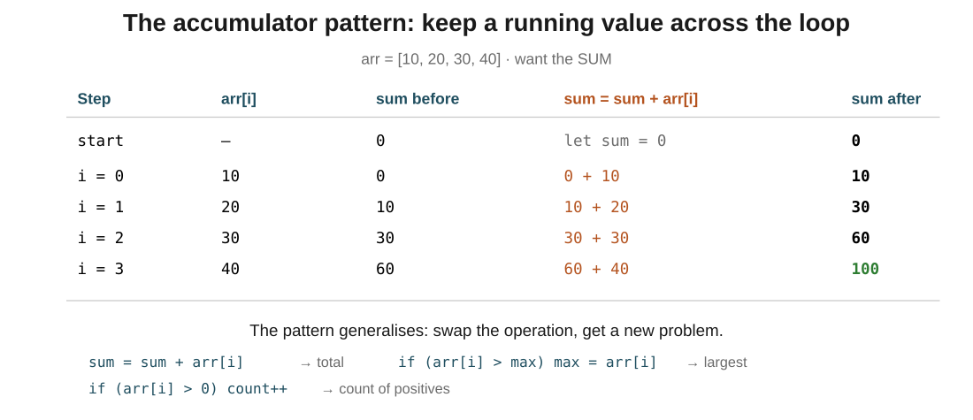
Figure 2: sum step by step. Each iteration, the running total absorbs one more element. Same skeleton works for max (keep the largest seen) and count (add 1 when the condition matches).
In the exam: The initialisation matters: for sum, start at 0; for max, start at arr[0]; for min, start at arr[0]. Never start max at 0 if the array might contain negatives, because a negative array would incorrectly return 0.
Code walkthrough
let numbers = [10, 50, 25, 80, 40];
let max = numbers[0];

for (let i = 1; i < numbers.length; i++) {
if (numbers[i] > max) {
max = numbers[i];
}
}

console.log(max);
Line by line
- let max = numbers[0] assumes the first element (10) is the maximum until proven otherwise.
- Loop starts at i = 1 because we've already used index 0.
- i = 1: numbers[1] is 50. Is 50 > 10? Yes. Update max = 50.
- i = 2: numbers[2] is 25. Is 25 > 50? No. max stays 50.
- i = 3: numbers[3] is 80. Is 80 > 50? Yes. Update max = 80.
- i = 4: numbers[4] is 40. Is 40 > 80? No. max stays 80.
- Loop ends. console.log(max) prints the winner.
What you see: Console prints 80. The trace shows max changing only when a genuinely bigger number is found: 10 → 50 → 80. That's the whole trick.

3. More array methods: includes, indexOf, slice, join
In one line: Four methods that answer four common questions: is X here? where is X? give me a slice. join into a string.
Key points
- arr.includes(x) returns true if x is anywhere in the array, false otherwise. Cleanest way to check membership.
- arr.indexOf(x) returns the index of the first occurrence of x, or -1 if x isn't there. The -1 is the standard 'not found' signal.
- arr.slice(start, end) returns a new array from index start up to (but not including) end. Original array is unchanged.
- The endpoint is exclusive: [10,20,30,40,50].slice(1, 4) gives [20, 30, 40], three elements, not four. Same rule as grid-column: 1 / 3 from CSS Grid.
- arr.slice(2) with only one argument means 'from index 2 to the end'.
- arr.join(sep) converts the array into a single string, gluing elements with sep between them. ['I','love','JS'].join(' ') gives 'I love JS'.
- push, pop, shift, unshift all mutate the array. slice and join do not: they return new values and leave the original alone.
In the exam: The endpoint rule that always shows up: slice(1, 4) gives you 3 elements (indices 1, 2, 3), not 4. If you want indices 1 through 4 inclusive, you have to write slice(1, 5). Count the difference, not the endpoints.

4. Strings: arrays of characters, essentially
In one line: A string is an indexed sequence of characters. Same for loop as arrays, same .length, same arr[i] syntax.
Key points
- str[0] is the first character. str[str.length - 1] is the last. Zero-indexed, just like arrays.
- str.length is a property, not a method. No parentheses.
- Traverse with the same for (let i = 0; i < str.length; i++) loop. Inside, str[i] is a single character.
- Vowel count is the traversal + accumulator pattern: loop through characters, if it's a vowel, increment a counter.
- Cleaner check: instead of five || comparisons for a/e/i/o/u, keep the vowels in a small string 'aeiou' and use vowels.includes(str[i]). Same logic, one line.
- Reverse a string is a backward loop: start i at str.length - 1, decrement to 0, build a new string one character at a time.
- Palindrome check is 'reverse it, compare to the original'. If str = reversed, it's a palindrome.
- One important difference from arrays: strings are immutable. str[0] = 'X' silently does nothing. To 'change' a string, you build a new one.
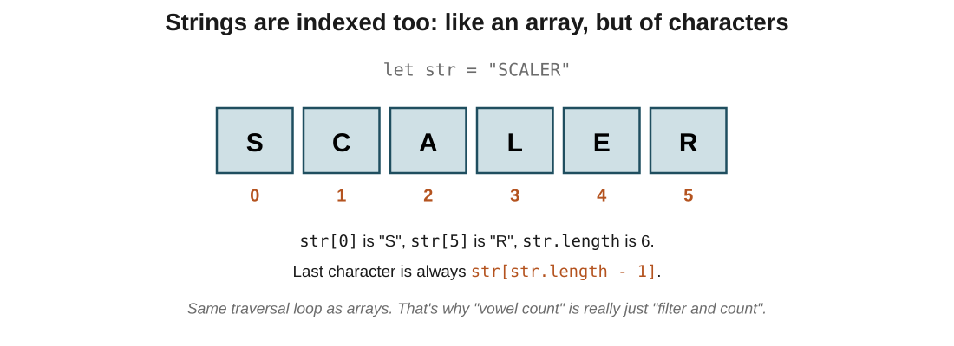
Figure 3: a string is just indexed characters. Same loop, same access syntax as arrays.
In the exam: The direction of the loop is the whole trick: for reverse, start at str.length - 1 and go i--. Everything else (the accumulator, the concatenation) is the same as any other string traversal.
Code walkthrough
let str = "hello";
let reversed = "";

for (let i = str.length - 1; i >= 0; i--) {
reversed = reversed + str[i];
}

console.log(reversed);
Line by line
- reversed starts as an empty string, the accumulator.
- Loop starts at i = str.length - 1, which is 4 (last valid index for a 5-char string).
- i = 4: str[4] is 'o'. reversed becomes "o".
- i = 3: str[3] is 'l'. reversed becomes "ol".
- i = 2: str[2] is 'l'. reversed becomes "oll".
- i = 1: str[1] is 'e'. reversed becomes "olle".
- i = 0: str[0] is 'h'. reversed becomes "olleh".
- Loop ends when i would become -1. Print the result.
What you see: Console prints olleh. The backward loop reads characters right-to-left; the accumulator glues them into a new string left-to-right. Together they reverse the input.

5. Important string methods
In one line: Seven methods you'll use constantly: case conversion, search, slice, trim whitespace, split into an array.
Key points
- str.toUpperCase() and str.toLowerCase() return a new string; the original is untouched.
- str.includes(sub) returns true if sub is anywhere in str. Same idea as the array version.
- str.indexOf(sub) returns the position of the first occurrence, or -1 if not found.
- str.slice(start, end) works exactly like the array version: end is exclusive, and it returns a new string.
- str.trim() removes whitespace from both ends. Great for cleaning up form input where the user typed extra spaces.
- str.split(sep) cuts the string wherever sep appears and returns an array of the pieces. "I love JS".split(" ") gives ["I", "love", "JS"].
- Once you split, you can use array methods. This is how you get 'count the words': sentence.split(' ').length.
- None of these mutate the original. str.trim() returns a new trimmed string; str itself is unchanged. Always assign the result to something, or you lose it.
In the exam: The pair that shows up in interviews: split turns a string into an array; join turns an array back into a string. Reversing a string of words in place is often written as sentence.split(' ').reverse().join(' '), chaining the two.

6. Objects: dot vs bracket, and the for...in loop
In one line: Dot notation reads a known key; bracket notation reads a key stored in a variable. for...in loops over every key.
Key points
- obj.name and obj["name"] do the same thing when you write the key literally.
- The moment the key is stored in a variable (say let key = "name"), you must use bracket notation: obj[key]. Dot notation would look for a literal key called 'key'.
- This matters for dynamic access: user picks a column to sort by, form field to read, config value to look up.
- Add or update any key by assigning: user.city = 'Bengaluru' creates city if it doesn't exist, updates if it does.
- Delete with the delete keyword: delete user.age removes the key entirely.
- Traverse all keys with for (let key in obj). Inside the loop, key is a string; obj[key] is the value.
- for...in is only for objects. For arrays, stick with the numeric for loop (or for...of, which comes later).
In the exam: The one that catches everyone: obj.someVariable is not the same as obj[someVariable]. Dot notation treats the text after it as a literal key name. If the key you want is inside a variable, bracket notation is mandatory.
Code walkthrough
let student = { name: "Rahul", age: 20, city: "Delhi" };
let key = "age";

console.log(student.name); // dot: literal key
console.log(student["name"]); // bracket: literal key
console.log(student[key]); // bracket: key from variable

for (let k in student) {
console.log(k, student[k]);
}
Line by line
- student.name looks up the literal key 'name'. Prints Rahul.
- student["name"] does the same via bracket notation. Prints Rahul.
- student[key] evaluates key first (it holds 'age'), then looks up student.age. Prints 20.
- If we'd written student.key instead, it would look for a literal key called 'key', find nothing, and print undefined.
- The for...in loop visits every key. On each pass, k is 'name', then 'age', then 'city'. student[k] reads the matching value.
What you see: Prints Rahul, Rahul, 20, then three lines: name Rahul, age 20, city Delhi. The dot-vs-bracket difference only shows up on line 3, where the key came from a variable.

7. Array of Objects: real-world data
In one line: Almost all real data is an array of objects: users, products, orders, students. Access is two steps: pick the index, then pick the key.
Key points
- students[0] gives you the whole first-student object. students[0].name drills into that object's name.
- Two-step access: index first (which one?), key second (which piece of info?).
- Print all names: same traversal loop as before, but the body is console.log(students[i].name) instead of students[i].
- Filter: wrap the print in an if. if (students[i].marks >= 40) console.log(students[i].name) prints only the students who passed.
- Find the topper (or oldest, or richest): it's just the max pattern again, but comparing students[i].marks, not students[i], and saving the whole object, not just the value.
- Sum a property across all objects: total order value is sum + orders[i].price * orders[i].quantity. Same accumulator, just a richer expression inside.
- Once you've seen this shape, most real-world data problems reduce to it: loop over an array of objects, do something with one key per object, keep a running result.
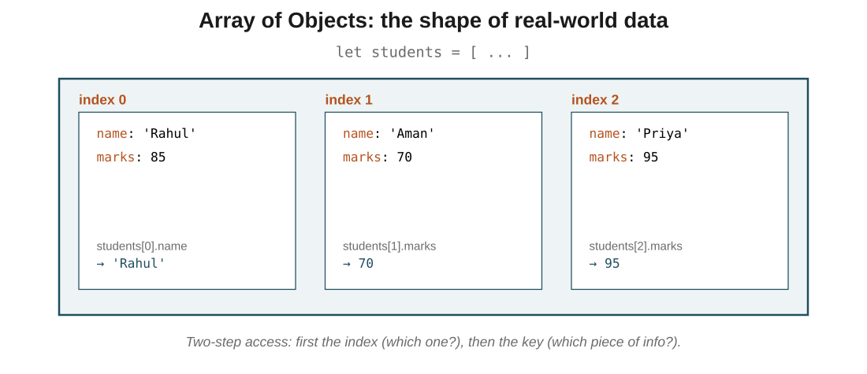
Figure 4: the array holds three objects. Access is students[index].key, one step for the object, one for the field.
In the exam: The lift from 'find max in numbers' to 'find topper in objects': compare a field (students[i].marks > topper.marks) and save the whole object (topper = students[i]). Everything else is the same pattern. This is why practising the number version pays off later.
Code walkthrough
let students = [
{ name: "Rahul", marks: 85 },
{ name: "Aman", marks: 70 },
{ name: "Priya", marks: 95 }
];

let topper = students[0];

for (let i = 1; i < students.length; i++) {
if (students[i].marks > topper.marks) {
topper = students[i];
}
}

console.log(topper.name);
Line by line
- topper starts as the first student (Rahul, 85). We hold the whole object, not just the marks, so we can print the name at the end.
- i = 1 (Aman, 70): is 70 > 85? No. topper stays as Rahul.
- i = 2 (Priya, 95): is 95 > 85? Yes. topper is now Priya.
- Loop ends. topper.name reads the name field of whichever student won.
What you see: Console prints Priya. Compare with the numbers-only max from earlier: identical shape, only the comparison expression (.marks instead of the value) and what we save (the object instead of the number) are different.

The big picture: what it all comes down to
If it all clicks here, the rest follows: the core ideas, in plain terms.
- Traversal pattern: for (let i = 0; i < arr.length; i++). Same loop for arrays and strings.
- Accumulator pattern: declare a running value before the loop, update inside, use after. Powers sum, max, min, count, filter.
- For max/min, initialise to arr[0], not 0. Zero fails on all-negative arrays.
- slice(start, end) has an exclusive endpoint: slice(1, 4) gives 3 elements, not 4. Applies to both arrays and strings.
- Strings are indexed characters: same .length, same for loop, same access syntax. But strings are immutable: str[0] = 'X' does nothing.
- Dot vs bracket: use dot for literal keys, bracket for keys stored in variables. obj.key ≠ obj[key] when key is a variable.
- Array of Objects is the shape of real data. Access is two steps: index, then key. Find-max on objects is find-max on numbers, but comparing a field and saving the whole object.

Quick recap
- The base loop for arrays and strings is for (let i = 0; i < .length; i++).
- Accumulator pattern: sum starts at 0, max starts at arr[0], count starts at 0.
- includes checks membership; indexOf returns position or -1; slice returns a new array/string with the end index excluded; join glues an array into a string.
- Strings are indexed characters and immutable. Reverse a string with a backward loop into an accumulator string.
- toUpperCase, toLowerCase, trim, split, replace all return new strings; the original is unchanged.
- Dot notation for literal keys; bracket notation for dynamic keys stored in variables.
- for...in walks every key of an object; use obj[key] inside to read the value.
- Array of Objects access is arr[index].key: pick the object, then pick the field.

Try it yourself
- Given [10, 5, 30, 2, 50], find the smallest number (same shape as max, opposite comparison).
- Count consonants in 'javascript' (traverse + filter with a vowels string, but count the opposite case).
- Reverse 'scaler' with a backward loop. Expected: 'relacs'.
- Check if 'racecar' is a palindrome by comparing it to its reversed form.
- In [10, 20, 10, 30, 10, 40], count how many times 10 appears using a counter.
- Given an array of product objects with name and price, find the most expensive product (topper pattern).
- For the same products array, compute the total price with the sum accumulator.
- In ['apple', 'banana', 'kiwi', 'watermelon'], find the longest string (max pattern on .length).
- Given an employees array with name and salary, print names of employees earning more than 45000 (filter pattern).
- Given orders with product, price, quantity, compute the total order value using sum + orders[i].price * orders[i].quantity.

