HTML Lists, Tables & Forms
Class 2 notes. The three tags-families that show up on every HTML paper: lists, tables, and forms.
Class: 2 · Exam value: High. These tags are classic MCQ and short-answer material.
Why this matters: Lists, tables and forms are where HTML stops being paragraphs and starts holding real structured content. They are also the single most reliable source of exam questions in this module, because every tag has a clear name and a clear job. Learn the names, learn the jobs, and you can answer on sight.

What you should be able to do after this
- Choose between an ordered and unordered list, and change the marker style
- Build a table from table, tr, th and td, and name every part
- Build a form with the right input type for each kind of data
- Answer the stock exam questions on all three without hesitating

What's inside
1. Lists: ordered vs unordered
2. Tables: rows, columns and the right tags
3. Forms: collecting user input

1. Lists: ordered vs unordered
In one line: If the sequence matters, use <ol>. If it doesn't, use <ul>. Either way, each item is an <li>.
Think of it like: A grocery list versus install steps. Bananas before apples changes nothing. But 'restart' before 'download' breaks everything.
Key points
- <ul> is an unordered list: bullet symbols, order does not matter.
- <ol> is an ordered list: numbered, the sequence is the point.
- Every item in either list is a <li> (list item). No li, no list.
- Change an ol's markers with the type attribute: type="A" (A, B, C), type="a" (a, b, c), type="I" (Roman numerals). Default is 1, 2, 3.
- ul also takes type for its symbol, like type="circle".
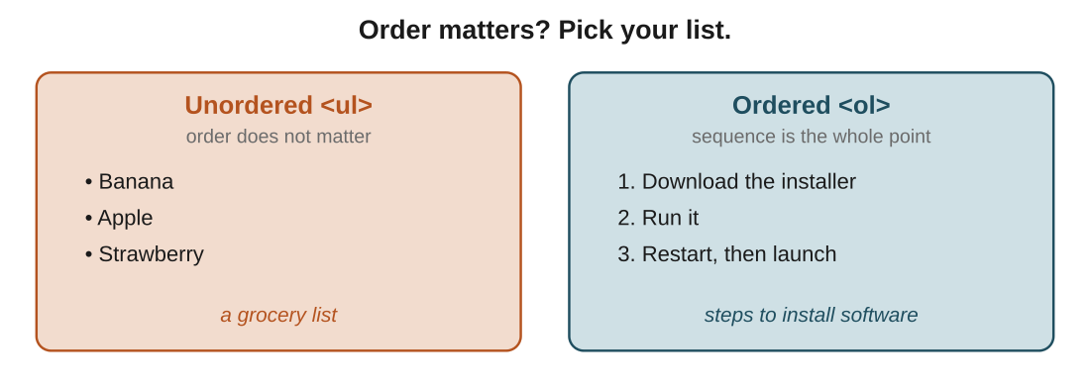
Figure 1: the whole decision is one question. Does order matter? That picks the tag.
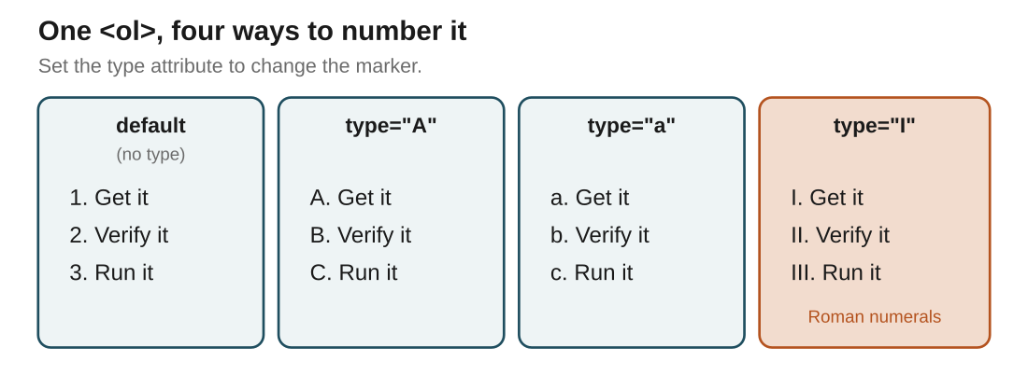
Figure 2: same ol, four markers. The type attribute is the only thing that changed.
In the real world: Recipe steps are an ol (you cook in order). Ingredients for that recipe are a ul (grab them in any order). Same page, two different list tags, chosen by meaning.
In the exam: The classic MCQ: "which tag makes an ordered list?" Answer: <ol>. They love to offer <ul>, <li> and <dl> as the traps. li is the item, not the list.
ul vs ol: the only love triangle in web dev, and yes, li is the third wheel holding both together.

2. Tables: rows, columns and the right tags
In one line: A table is rows of cells. <tr> makes a row, <th> is a header cell, <td> is a data cell.
Key points
- <table> wraps the whole thing.
- <tr> is a table row. Everything lives inside rows.
- <th> is a header cell (bold and centred by default). It labels a column.
- <td> is a table data cell: one piece of actual data.
- <thead> groups the header row; <tbody> groups the data rows.
- <caption> is the table's title, and goes right after the opening table tag.
- The old border attribute still draws lines, but it is deprecated. Style with CSS now.
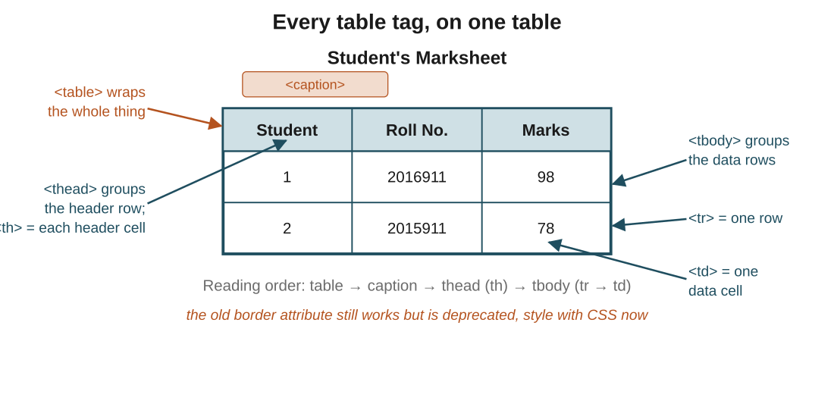
Figure 3: every table tag labelled on one marksheet. The reading order at the bottom is worth memorising as-is.
In the real world: A student marksheet: caption is "Student's Marksheet", the thead row has th cells for Student, Roll No. and Marks, and each student is a tr full of td cells.
In the exam: Two favourites. "What does <th> represent?" Answer: a table header cell. And the <th> vs <td> swap: th is the label, td is the data. Papers rely on you mixing them up.
Nobody: ... HTML tables: let me introduce you to thead, tbody, tr, th, AND td for what is basically a spreadsheet screenshot.

3. Forms: collecting user input
In one line: A <form> wraps inputs that collect data and send it to a server. The type on each <input> decides what it collects.
Think of it like: A paper form at a clinic. Boxes for text, tick-boxes for options, one circle to fill for a single choice, and a submit at the bottom. HTML forms are the same, just clickable.
Key points
- <form> is the container for all the fields.
- <input> is the workhorse, and its type attribute changes everything: text, email, password, number, date, file.
- checkbox lets you tick many options; radio lets you pick exactly one, as long as the buttons share the same name.
- <label> names a field. Match its for to the input's id so clicking the label focuses the box.
- <select> is a dropdown; each choice inside it is an <option>.
- type="submit" is the button that sends the form's data off.
- Handy limits: min and max on numbers and dates, maxlength and pattern to restrict text (like a 10-digit phone number).
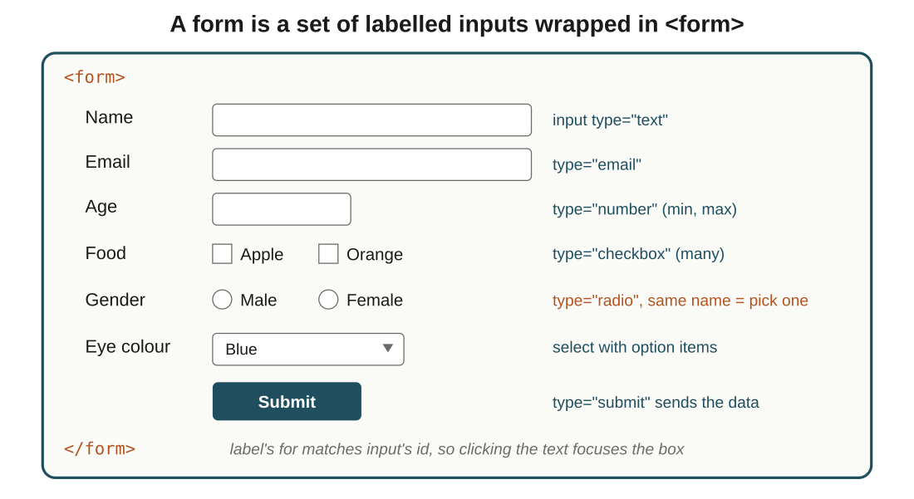
Figure 4: one form, every common input type, with the code that produces each. This single picture answers most form questions.
In the real world: A signup form: text for name, email for the address (the browser checks the @ for you), radio buttons named "gender" so only one can be chosen, checkboxes for interests, a select for country, and a submit button to send it all.
In the exam: The distinction they test: checkbox = choose many, radio = choose one (shared name). And <label> improves accessibility by pairing text to an input via for and id.
radio buttons are called that because, like an old car radio, pushing one pops the others out. Peak 1950s energy, still in your signup form.

The big picture: what it all comes down to
If it all clicks here, the rest follows: the core ideas, in plain terms.
- Lists answer one question: does order matter? <ol> when it does, <ul> when it doesn't, and <li> is always the item.
- The ol type attribute only changes how items are labelled (numbers, letters, Roman), never the order itself.
- A table is just rows of cells: <tr> is a row, <th> labels, <td> holds data. Everything else groups or titles those.
- <th> vs <td> is the whole game: header versus data. If you know which is which, tables are easy.
- A form is inputs with a job. The type on each <input> is what decides the job, so the type is the thing to understand.
- checkbox means many, radio (shared name) means one, <select> is a dropdown. Pick by how many answers you allow.
- <label> tied to an input by for and id is what makes a form usable for everyone, not just decoration.

Quick recap
- Lists come in two kinds: ol when order matters, ul when it doesn't, li for every item.
- The ol type attribute switches numbering between numbers, letters and Roman numerals.
- Tables are built from table, tr, and cells: th for headers, td for data.
- thead, tbody and caption organise and title a table; use CSS to style it, not border.
- Forms collect input inside a form tag, and the input type decides what each field does.
- checkbox is many, radio is one, select is a dropdown, and label makes it all accessible.

Try it yourself
- Write an unordered grocery list and an ordered set of steps, then change the ordered list to Roman numerals.
- Build the student marksheet table from memory, including caption, thead and tbody.
- Add a working contact form to your portfolio: name, email, a message box, radio buttons, and a submit.
- Take one field and restrict it: make the phone input accept exactly 10 digits with pattern and maxlength.

