Styling with CSS: Rules, Selectors & Properties
How CSS actually works: the rule, the three ways to add it, every selector you need, and the color, font and text properties to make it look right.
Class: CSS intro · Builds on: your HTML from the previous classes
Why this matters: HTML gives a page structure. CSS is what makes it look like anything. The whole language is one small idea repeated: pick some elements, then change some of their properties. Once the rule and the selectors click, everything after is just looking up property names.

What you should be able to do after this
- Read and write a CSS rule, and name its selector, property and value
- Add CSS three ways (external, internal, inline) and predict which wins a conflict
- Target exactly the elements you mean with class, id, combinator, attribute and pseudo selectors
- Set color, backgrounds, fonts and text spacing with confidence

What's inside
1. What a CSS rule is
2. Three ways to add CSS
3. Class and id selectors
4. Combinators: reaching nested elements
5. Compound, attribute and pseudo selectors
6. Color and backgrounds
7. Fonts and text

1. What a CSS rule is
In one line: Pick elements with a selector, then set property: value pairs inside curly braces.
Key points
- The selector chooses what to style (here, every h1).
- Inside the { } go one or more declarations.
- Each declaration is a property: value pair, ended with a semicolon: color: red;.
- One rule can hold many declarations, one per line.
- CSS is rule-based: you describe what should be true, the browser makes it so.
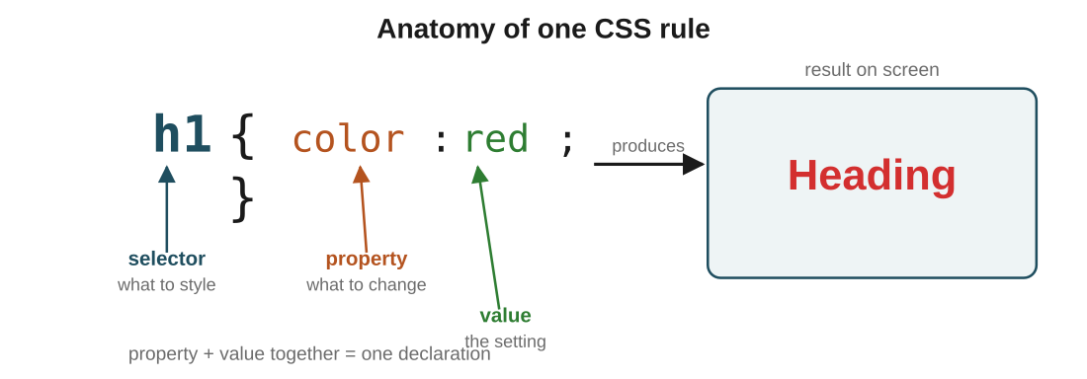
Figure 1: one rule, every part named, and what it does on screen. Selector picks, property + value change, semicolon ends the declaration.
In the real world: To make headings big and red: write h1 { color: red; font-size: 5em; }. Two declarations, one selector, and every h1 on the page obeys.
In the exam: Know the vocabulary cold, because questions lean on it: selector, declaration, property, value. If you can point to each in h1 { color: red; }, you can answer any labelling question.
CSS is just you politely asking the browser to make things red, and the browser mostly agreeing, most of the time, on most browsers.

2. Three ways to add CSS
In one line: External (a linked .css file), internal (a <style> in the head), or inline (a style="" on one element).
Key points
- External: a separate .css file, linked with <link rel="stylesheet" href="style.css">. One file can style the whole site.
- Internal: a <style> block in the head. Styles just that one page.
- Inline: a style="color:blue" attribute right on the element. Styles that one element only.
- Even with no CSS, elements still have a look: that is the browser's user-agent stylesheet, its built-in defaults.
- Precedence: when rules conflict, inline beats internal beats external. Same strength? the later rule wins.
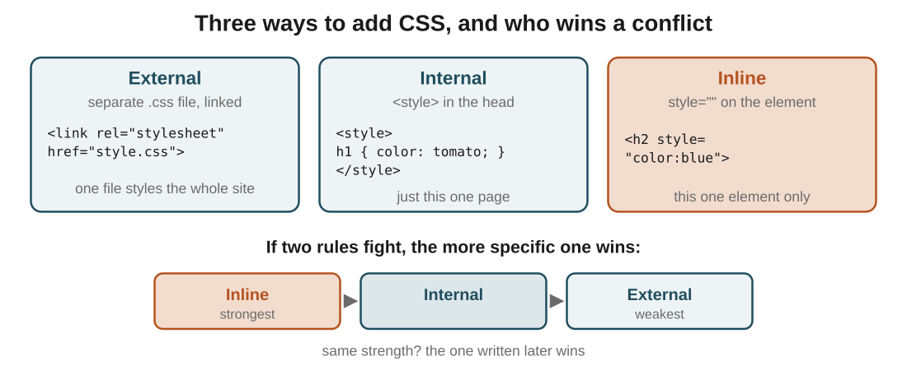
Figure 2: the three ways, and the pecking order when two rules touch the same element. Inline is strongest, external weakest.
In the real world: If style.css says h1 { color: green; } but the h1 has style="color:blue", the heading is blue. Inline sits closest to the element, so it wins.
In the exam: The reasoning behind precedence: the more specific and closer-to-the-element a rule is, the more it wins. Inline is right on the element, so nothing is more specific. That is why it beats the others.
Inline CSS always winning is the group project where one person overrides everyone at the last minute. Powerful, and everyone quietly resents it.

3. Class and id selectors
In one line: .class styles a whole group; #id styles one unique element.
Think of it like: Class is a badge a group of students all wear. id is the unique library number on a single book. Many students, one badge. One book, one number.
Key points
- .className (a dot) selects every element carrying that class. Many elements can share it.
- #idName (a hash) selects the one element with that id.
- An id must be unique on the page; a class can repeat as much as you like.
- Class is for grouping things that should look alike; id is for pointing at exactly one thing.
- This is the difference examiners love: same class = fine, same id = not allowed.
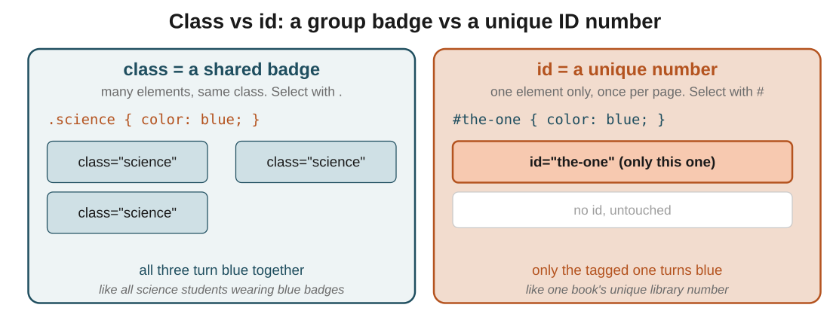
Figure 3: the same code idea on both sides. .science paints every badge-wearer; #the-one paints only the single tagged element.
In the real world: Give three headings class="science" and .science { color: blue; } turns all three blue at once. Give one heading id="the-one" and #the-one { color: blue; } touches only that one.
In the exam: Stock MCQ: "which selector picks the class highlight?" Answer: .highlight (dot). The # is for id. If you remember dot-for-class, hash-for-id, you will never lose this mark.
id is that friend who insists on being unique. Give the same id to two elements and CSS just quietly ignores your life choices.

4. Combinators: reaching nested elements
In one line: A space means any descendant; a > means a direct child only.
Think of it like: Descendant is family: a child, grandchild, great-grandchild all count. Direct child is your kid specifically, not your grandkid.
Key points
- div p (with a space): every p inside a div, no matter how deeply nested.
- div > p (with >): only a p that is a direct child of the div. A p wrapped in something else is skipped.
- The space is a descendant combinator; the > is a child combinator.
- Read a combinator right to left: find the p's, then keep only those with the right ancestor.
- This is the selector people get wrong most, so the picture is worth more than the words.
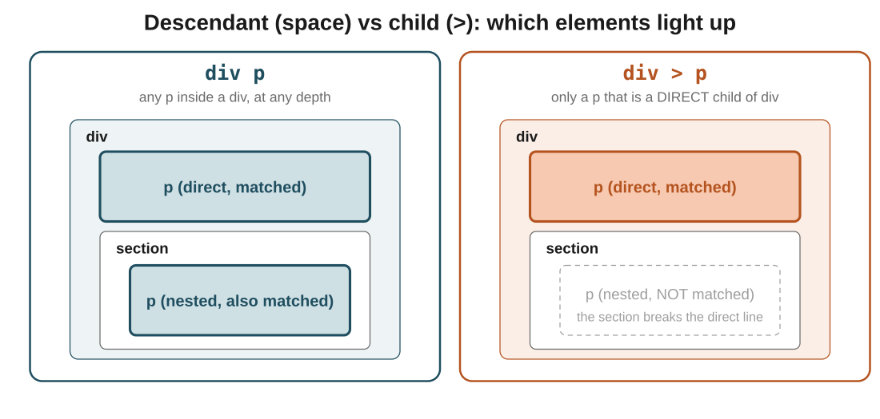
Figure 4: same markup, two selectors. Shaded boxes are what each one reaches. The nested p only lights up for the space, never for the >.
In the real world: If a div holds a p, and also a section that holds another p: div p turns both blue, but div > p turns only the first one, because the second p's direct parent is the section, not the div.
In the exam: The whole idea in one line: space reaches all levels down, > reaches exactly one level. If you can predict which p lights up in Figure 4, you understand combinators.
div > p vs div p: the entire difference is one space character, which is also how most CSS bugs are born.

5. Compound, attribute and pseudo selectors
In one line: Stack selectors to be more precise, match by attribute with [ ], or match by state with :.
Key points
- .m1.m2 (no space): one element that has both classes m1 and m2.
- .c1 .c2 (space): a .c2 that lives inside a .c1 (descendant, from the last section).
- .c1 > p: a p that is a direct child of a .c1.
- Attribute: input[value="Select me"] picks inputs whose attribute matches. Element, then [attribute="value"].
- Pseudo-class: a:hover styles an element in a state, here a link while the mouse is over it. A colon plus the state name.
- Read every selector left to right and it stays readable, however long it gets.
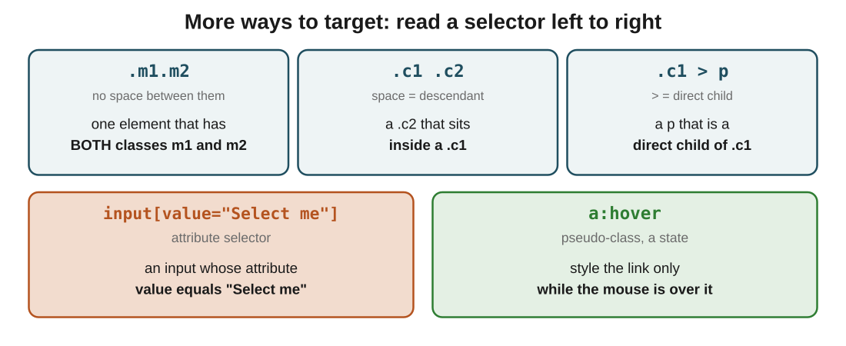
Figure 5: five selector shapes, each with what it targets in plain words. The space vs no-space distinction is the one to burn in.
In the real world: Want a link to darken only when hovered? a:hover { color: darkblue; }. The style switches on when the pointer is over the link and switches off when it leaves, with no JavaScript at all.
In the exam: Two traps live here. .m1.m2 (no space) means one element with both classes; .m1 .m2 (space) means one inside the other. The space changes the whole meaning, so read it carefully.
a:hover is CSS reacting to your mouse in real time. The closest CSS ever gets to saying it noticed you.

6. Color and backgrounds
In one line: color paints the text; background-color paints the area behind it.
Key points
- color changes the letters themselves.
- background-color changes the space behind the letters, not the letters.
- background-image: url(...) puts an image behind the content instead of a flat colour.
- Control it with background-size and stop the tiling with background-repeat: no-repeat.
- By default a background image repeats to fill the space, which surprises everyone the first time.
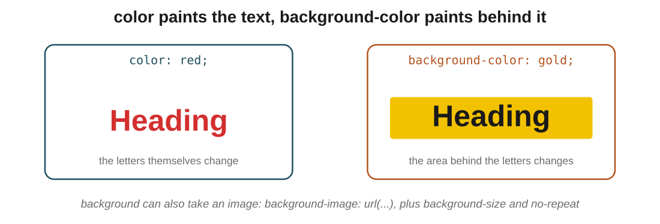
Figure 6: same word, two properties. color recolours the letters; background-color fills the block behind them.
In the real world: h1 { color: white; background-color: navy; } gives white text on a navy block. Swap in background-image: url('hero.jpg') and the heading sits on the photo instead.
In the exam: The distinction they test: color is the text, background-color is behind it. If a question shows coloured letters on a plain page, that is color; a coloured block is background-color.
Every beginner sets color hoping to fill the box, gets red letters instead, and discovers background-color exists. A rite of passage.

7. Fonts and text
In one line: Font properties change how letters look; text properties change how they are arranged.
Key points
- Font (the letterforms): font-family (which typeface, with fallbacks), font-size, font-weight (100 lightest to 800 boldest), font-style (italic).
- font-family takes a fallback list: if the first font is missing, the browser tries the next.
- Need a specific font? Import a Google Font with a link in the head, then use its font-family.
- Text (the arrangement): text-align (left, right, center), text-decoration (underline, line-through).
- word-spacing sets the gap between words; line-height sets the gap between lines.
- Font is about the shape of each letter; text is about the space around them.
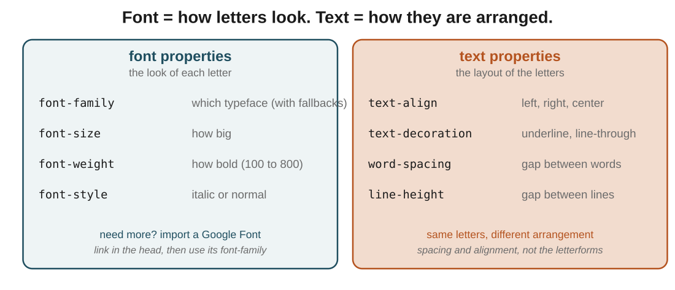
Figure 7: the split that keeps these straight. Font properties on the left change the letters; text properties on the right change their layout.
In the real world: p { font-family: 'Roboto', arial; font-size: 18px; line-height: 1.6; } picks a typeface (falling back to arial), sets the size, and opens up the space between lines so a paragraph is easy to read.
In the exam: The clean line to remember: font = how a letter looks, text = how letters sit together. font-weight is a font property; line-height and word-spacing are text properties.
font-family having fallbacks is CSS admitting the first font probably will not load, so here are three backups, just in case.

The big picture: what it all comes down to
If it all clicks here, the rest follows: the core ideas, in plain terms.
- Every rule is the same shape: selector { property: value; }. Learn to read that and you can read all CSS.
- Adding CSS is external, internal or inline, and in a conflict the closest and most specific wins (inline beats internal beats external).
- Selectors are just aim: .class for a group, #id for one, tag names for a type.
- Combinators narrow the aim by position: a space reaches any descendant, > reaches only a direct child.
- You can also aim by attribute with [ ] or by state with a pseudo-class like :hover.
- color is the text, background-color is behind it, and background images repeat unless you say no-repeat.
- Font changes how letters look, text changes how they are arranged. That one split sorts most property questions.

Quick recap
- A CSS rule is a selector plus declarations, and each declaration is property: value.
- CSS can be external, internal or inline; inline wins conflicts, then internal, then external.
- Class (.) styles many elements; id (#) styles one unique element.
- A space selects any descendant; > selects only a direct child.
- Attribute selectors match by [attribute=value]; pseudo-classes like :hover match by state.
- color is the text, background-color is behind it, and backgrounds can hold images.
- Font properties style the letters; text properties handle alignment and spacing.

Try it yourself
- Style all your h1s red and 2em in an external stylesheet, then override one to blue with inline CSS and watch which wins.
- Give three elements the same class and one element an id, then colour the group and the single element differently.
- Build a small nested list and colour only the direct children with >, then switch to a space and see the extra elements light up.
- Add a :hover colour change to your portfolio's nav links, then set a readable line-height and font-family on the body text.

