**AIOPS Assignment 4**

**1. What is Docker, and why is Docker used?**

Docker is a software platform that allows you to build, test, and deploy applications quickly.

Using Docker, you can quickly deploy and scale applications into any environment and know your code will run.

**2. Explain the Docker architecture?**

Docker follows Client-Server architecture, which includes the three main components that are Docker Client, Docker Host, and Docker Registry.

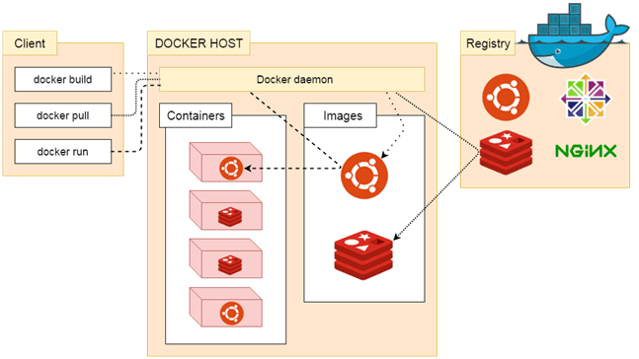

1. Docker Client

Docker client uses commands and REST APIs to communicate with the Docker Daemon (Server). When a client runs any docker command on the docker client terminal, the client terminal sends these docker commands to the Docker daemon. Docker daemon receives these commands from the docker client in the form of command and REST API's request.

Docker Client uses Command Line Interface (CLI) to run the following commands -

docker build

docker pull

docker run

2. Docker Host

Docker Host is used to provide an environment to execute and run applications. It contains the docker daemon, images, containers, networks, and storage.

3. Docker Registry

Docker Registry manages and stores the Docker images.

There are two types of registries in the Docker -

Pubic Registry - Public Registry is also called as Docker hub

Private Registry - It is used to share images within the enterprise.

**3. What do you mean by a Dockerfile?**

A Dockerfile is a text document that contains all the commands a user could call on the command line to assemble an image.

Docker runs instructions in a Dockerfile

**4. What do you mean by Docker Images?**

A Docker image is a file used to execute code in a Docker container.

Docker images act as a set of instructions to build a Docker container, like a template. Docker images also act as the starting point when using Docker. An image is comparable to a snapshot in virtual machine (VM) environments.

Docker images have multiple layers, each one originates from the previous layer but is different from it. The layers speed up Docker builds while increasing reusability and decreasing disk use. Image layers are also read-only files

**5. What do you mean by Docker Hub?**

Docker Hub is a hosted repository service provided by Docker for finding and sharing container images with your team

**6. Which command can be used to check Docker Client and Docker Server Version?**

Docker Hub is a cloud-based repository in which Docker users and partners create, test, store and distribute container...

**7. How to create a Docker container from an Image?**