High Level Class Diagram
TeamBuilder
TeamFinder
TeamServiceImpl
Team
TeamFileExtractor
SoccerLeagueUI
TeamFileHandler
Assumptions:

This program only handles the .dat file types and the data format
- Data File format is as it supplied in the example and not required to handle different file types, file formats and data formats.

- If more than one team has the smallest difference in between for and against goals, all company names display as a single String with comma separated.

Technical Details :

- In this Exercise, TDD approach has been used.

- However BDD approach also demonstrated on developing com.vijitha.soccer.entity.Team
Please refer : com.vijitha.soccer.entity.TeamStory

- Tools used
- mockito-core-1.9.0 has used as Mocking tool
- testng-6.8 has used as Unit testing tool
- swing-layout-1.0.3 has used in developing User Interface
- jbehave-core-3.7.3 has used in developing Behavioural Development

Screen shots:

- User Input screen : click on the Load button and locate the data file
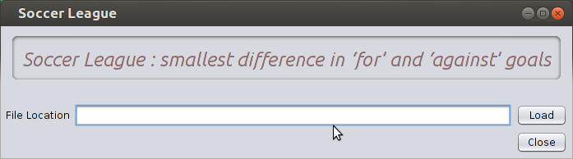

- Error message
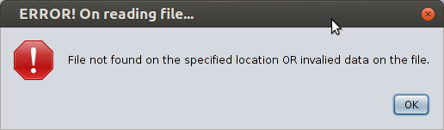

- Success message
