PROJECT REPORT – SHOPSMART

1. INTRODUCTION
1.1 Project Overview
ShopSmart is a full‑stack e‑commerce web application designed to provide users with a simple, secure, and efficient online shopping experience. The system enables customers to browse products, add items to cart, place orders, and manage their purchases through an intuitive interface. Administrators can manage products, users, and orders through a dedicated dashboard.
The application is developed using the MERN stack architecture, where the frontend is built with React, the backend uses Node.js and Express.js, and MongoDB is used for database management. This architecture ensures scalability, performance, and maintainability.
1.2 Purpose
The primary objectives of ShopSmart include:
• Providing a user‑friendly online shopping platform.
• Enabling secure authentication and order management.
• Allowing administrators to manage inventory efficiently.
• Demonstrating full‑stack web development using MERN technologies.
• Delivering a responsive and scalable e‑commerce solution.

2. IDEATION PHASE
2.1 Problem Statement
Traditional shopping methods require physical store visits, limited time availability, and manual billing.
Many small businesses lack affordable digital platforms to sell products online. Therefore, a secure, simple, and scalable e‑commerce solution is required to support both customers and administrators.

2.2 Empathy Map Canvas
Think – Need fast and easy online shopping.
Feel – Want secure payments and trusted service.
Say – Prefer mobile‑friendly and simple UI.
Do – Browse products, compare prices, and order online.

2.3 Brainstorming
• Online product catalog
• User authentication system
• Shopping cart functionality
• Order management system
• Admin dashboard
• Secure database storage
• Future payment gateway integration

3. REQUIREMENT ANALYSIS
3.1 Customer Journey Map
Open Website → Register/Login → Browse Products → Add to Cart → Place Order → Track Order → Logout.
3.2 Solution Requirements

Functional Requirements:
• User registration and login
• Product listing and search
• Add to cart and order placement
• Admin product management
• Order tracking

Non‑Functional Requirements:
• High performance and fast response
• Secure authentication using JWT
• Scalable database design
• Responsive UI for multiple devices

3.3 Data Flow Diagram
User → Frontend (React) → Backend API (Node/Express) → MongoDB → Response → User Interface.

3.4 Technology Stack
Frontend – React.js
Backend – Node.js & Express.js
Database – MongoDB
Authentication – JWT
Testing – Thunder Client & Manual Testing

4. PROJECT DESIGN

4.1 Problem Solution Fit
ShopSmart converts traditional offline shopping into a digital, user‑friendly web platform, improving accessibility, efficiency, and customer convenience.
4.2 Proposed Solution
A secure MERN‑based e‑commerce system supporting authentication, product browsing, cart management, and order processing within a single integrated platform.
4.3 Solution Architecture
Client Layer – React frontend interface.
Server Layer – Node.js & Express REST APIs.
Database Layer – MongoDB collections for users, products, carts, and orders.

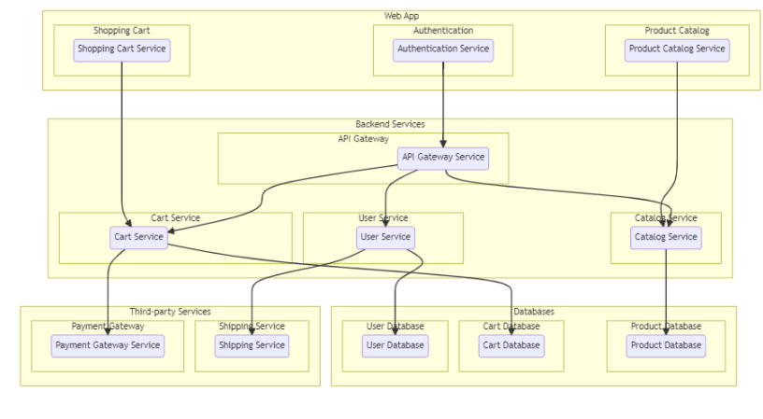
Figure 1: System Architecture
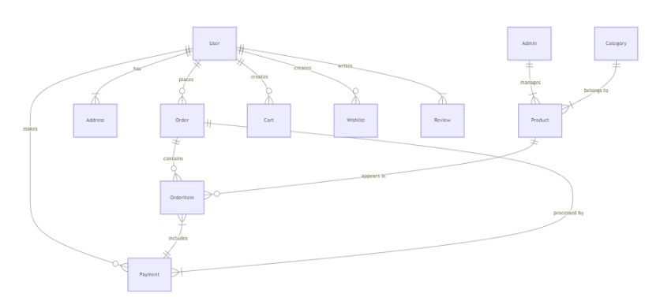
Figure 2: ER Diagram

5. PROJECT PLANNING & SCHEDULING

5.1 Project Planning
Day 1–2 – Requirement analysis and ideation.
Day 3–6 – System design and database schema creation.
Day 7–15 – Frontend and backend development.
Day 16–20 – Testing, debugging, and documentation.

6. FUNCTIONAL AND PERFORMANCE TESTING
6.1 Performance Testing
The system was tested for:
• Login and authentication response time
• Product loading speed
• Cart and order processing accuracy
• API performance and error handling
Results confirmed stable performance and correct functionality under normal usage.
7. RESULTS
7.1 Output Screenshots
The developed system successfully demonstrates:
• User registration and login pages
• Product listing interface
• Shopping cart and checkout
• Admin dashboard for product management
• MongoDB database records
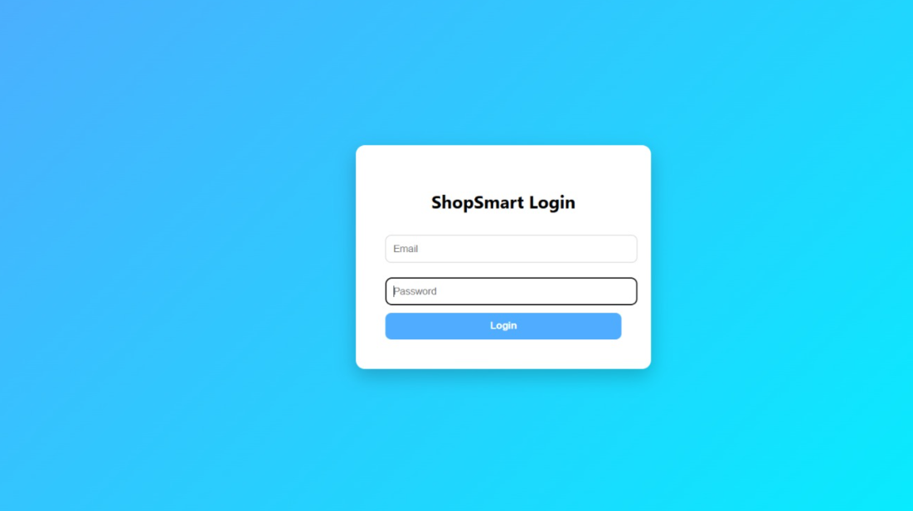
Figure 3: Homepage
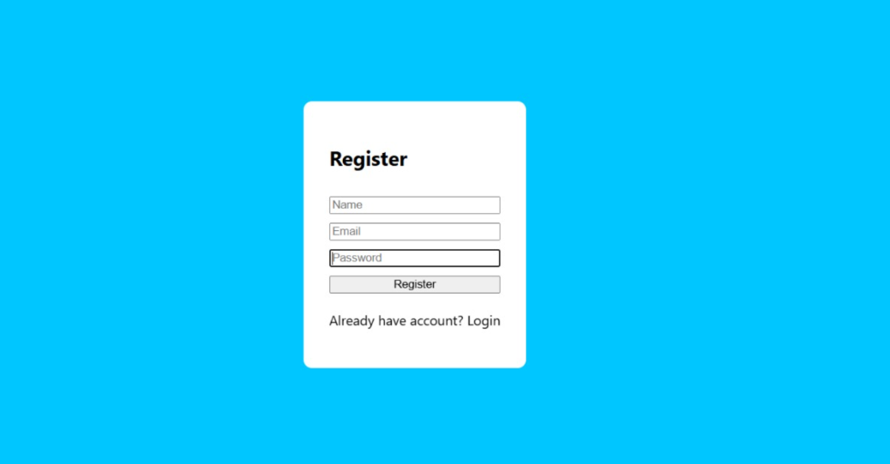
Figure 4: Registration page
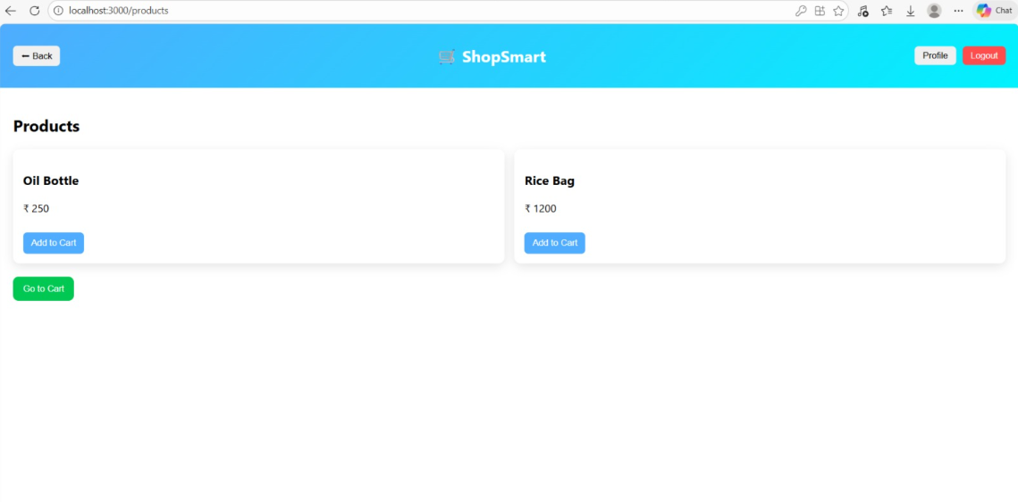
Figure 5: User Dashboard
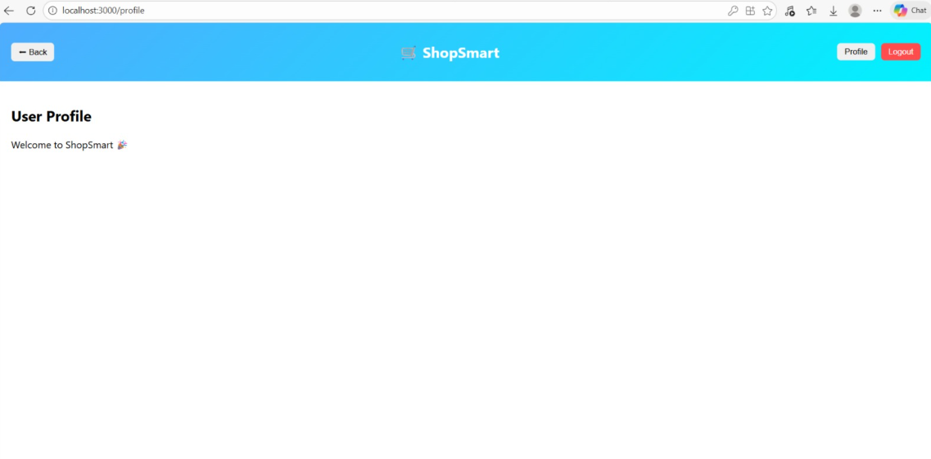
Figure 6: User profile
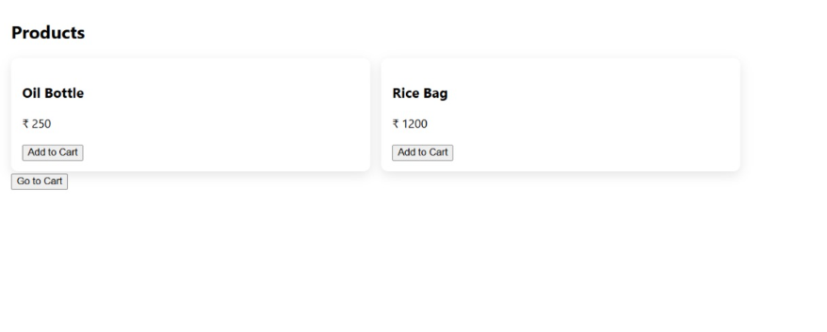
Figure 7: Products Page
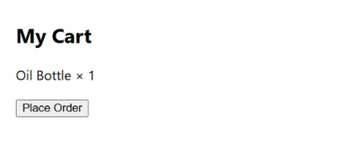
Figure 8: User Cart

Figure 9: Orders page
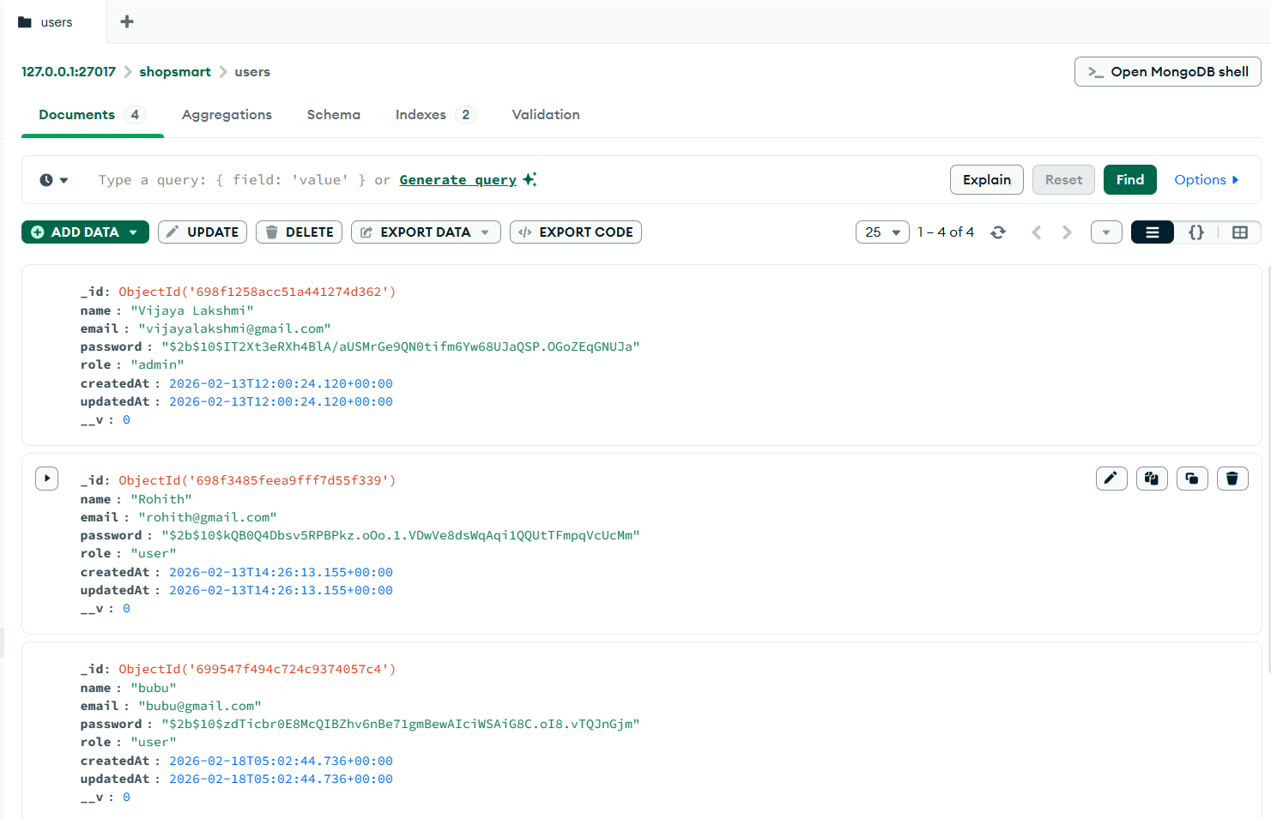
Figure 10: Mango DB database

8. ADVANTAGES & DISADVANTAGES
Advantages:
• Easy online shopping experience
• Secure authentication and data handling
• Scalable MERN architecture
• Efficient admin management system
Disadvantages:
• Requires internet connectivity
• Payment gateway not integrated in current version

9. CONCLUSION
ShopSmart successfully implements a complete full‑stack e‑commerce solution using MERN technologies.
The project demonstrates practical knowledge of frontend, backend, and database integration while providing a real‑world shopping experience.

10. FUTURE SCOPE
• Online payment gateway integration
• Order delivery tracking
• Product reviews and ratings
• Mobile application version
• AI‑based product recommendations

11. APPENDIX
Source Code – https://github.com/vijju-mandapati/Shopsmart.git
Dataset – Product and user database records in MongoDB
Project Demo – https://youtu.be/LY60m87M1to

