Evaluation Only. Created with Aspose.Words. Copyright 2003-2011 Aspose Pty Ltd.
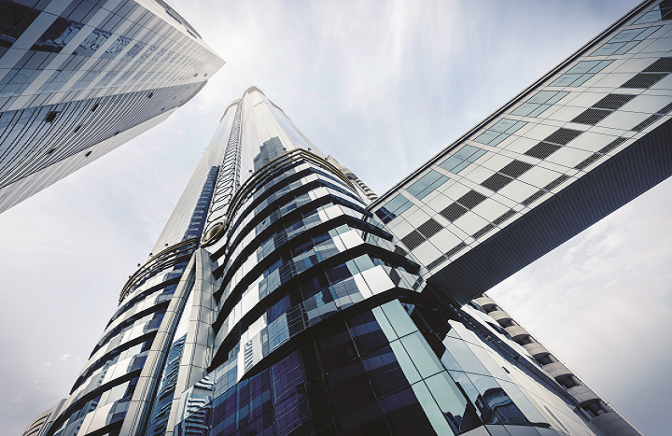
VRF System Selection Report
Project Name :Untitled VRF Project<3><24/04/2019>
Region :ASIA
Selection Mode :Cooling
Sales Engineer :
Company:
Address:
Phone No:
Order Date : 24/04/2019
Delivery required date : 24/04/2019
Client Name :
Post Code :
Tel :
Mail :
CONTENTS
LIMITS OF LIABILITY 1
License Contract 1
Reports 1
SYSTEM SELECTION 2
Outdoor Units 2
Indoor Units 2
SYSTEM DESIGN 3
system 1 3
Outdoor Units of the system 3
Indoor Units of the system 3
PIPING DESIGN 4
system 1 4
Piping Diagram 4
Piping Rules 5
Refrigerant Load & Pipe size 5
Recommendation 5
WIRING DESIGN 6
system 1 6
Wiring Diagram 6
Power Supply 7
RCS link description 7
Central Controller 8
H-Link2 communication line description 8
EQUIPMENT LIST AND INFORMATION 9
Outdoor Units 9
Indoor Units 9
Branch Kit 9
Multikit 9
Field Providing 9
Piping Materials 9
Refrigerant 9

LIMITS OF LIABILITY

License Contract
By using the Global VRF Selection Software, you agree to abide by the terms of this End User License Agreement.
This software is not intended to provide highly accurate or certifiable results taking into account all the factors involved in complex or sophisticated installations.
YORK makes no warranties regarding the accuracy of the results obtained from the use of this software.
In fact, this software is not able to take into account all the site-specific factors that may influence the proper functioning of the selected device (e.g. piping or wiring lengths on site, geometry of the piping network, operating temperatures…).
It may also contain technical inaccuracies or errors, and improvements or modifications may be made to the software by YORK at any time without prior notice.
This software is not intended to replace a thorough evaluation by a professional of the HVAC field.
Accordingly, you are advised not to rely solely on the reports produced by the software to select the appropriate equipment.

Reports
The report is the result of the information transferred and input by the User of the Global VRF Selection Software.
YORK assumes no kind of liability regarding the pre-existing data and information in the Software, as well as the data and information input by the User, and in particular in relation to:
1. The static part of the Software including the information required to carry out the calculations corresponding to each project through preset parameters; this information merely includes the parameters for the preparation of the report in line with the model designed by and with the knowledge of YORK, without this implying any kind of guarantee for the user regarding the precision and reliability of the results of the report.
2. The dynamic part of the Software, which is the result of the information input by the User in correspondence with the said parameters; the User is on all accounts exclusively liable for the accuracy of the information being input in the Software.
3. The failure to include any legal aspects that may correspond or be required according to current laws.
The Software and the issuing of this report are merely informative tools to assist the User in the planning and implementation of a project.

SYSTEM SELECTION

Outdoor Units
Evaluation Only. Created with Aspose.Words. Copyright 2003-2011 Aspose Pty Ltd.
Pictures | Model | Description | Quantity | Components
Pictures | Identification | Description | Quantity | Components
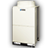 | JTOH080VPEM-0AQ1 | Commercial VRF HP, JTOH-Q | 1 | -
 |  |  |  | -
 |  |  |  | -
 |  |  |  | -

 | JTOH080VPEM-0AQ1
 | Specifications
 | Power supply |  | 380~415V/3Ph/50Hz
 | Nominal capacity | Cooling | 6.4Ton
 | Nominal capacity | Heating | 7.1Ton
 | EER
 | COP
 | SEER
 | SCOP
 | Sound power |  | dB(A)
 | Dimensions | Height | 1,720mm
 | Dimensions | Width | 950mm
 | Dimensions | Depth | 750mm
 | Net Weight |  | 224kg

Indoor Units
Evaluation Only. Created with Aspose.Words. Copyright 2003-2011 Aspose Pty Ltd.
No Room
Indoor Unit |  |  | Nominal Cap. (Ton) |  | Accessories | Control
Picture | Ident. | Description - Model | Cool | Heat | Accessories | Picture | Model | Gp
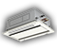 | Ind1 | Two Way Cassette  - | 1.6 | 1.8 | P-AP90DNA
 | Ind2 | Two Way Cassette  - | 1.6 | 1.8 | P-AP90DNA

SYSTEM DESIGN
Evaluation Only. Created with Aspose.Words. Copyright 2003-2011 Aspose Pty Ltd.

system 1
Working Condition |  | Outdoor (Air) |  | Indoor (Air)
Cooling |  | 36.0 °C DB |  | 27.0 °C DB
Cooling |  | 36.0 °C DB |  | 19.6 °C WB (50% RH)
Heating |  | 5.0 °C DB |  | 20.0 °C DB
Heating |  | 3.1 °C WB (74% RH) |  | 20.0 °C DB
Note:
- Actual capacity takes into account all correction factors, including defrosting in heating mode.
- Each Indoor unit’s temperature condition might be different. Software uses minimum wet bulb temperature of indoor for system cooling process and uses maximum dry bulb temperature of indoor for system heating process.

Outdoor Units of the system
Outdoor Unit |  | Connect. Rate (%) |  | Cooling Capacity (Ton) |  |  | Heating Capacity (Ton)
Ref + Description | Ident. | Actual | Max | Nominal | Actual | Required | Nominal | Actual | Required
Commercial VRF HP, JTOH-Q JTOH080VPEM-0AQ1 |  | 50 | 100 | - | 3.0 | - | - | 0.0 | -
Total |  |  |  | - | 3 | - | - | 0 | -

Indoor Units of the system
Indoor Unit |  | Sound Pressure  dB(A) | Air Flow | Cooling Capacity (Ton) |  |  | Heating Capacity (Ton)
Ref + Description | Ident. | Sound Pressure  dB(A) | Speed | Actual | Sensible | Required | Actual | Required
Total |  |  |  | 3.0 | 2.3 | 0.0 | 0.0 | 0.0
Two Way Cassette - | Ind1 | 39 |  | 1.5 | 1.1 | 0.0 | 0.0 | 0.0
Two Way Cassette - | Ind2 | 39 |  | 1.5 | 1.1 | 0.0 | 0.0 | 0.0

This document was truncated here because it was created using Aspose.Words in Evaluation Mode.

PIPING DESIGN
Evaluation Only. Created with Aspose.Words. Copyright 2003-2011 Aspose Pty Ltd.

system 1

Piping Diagram
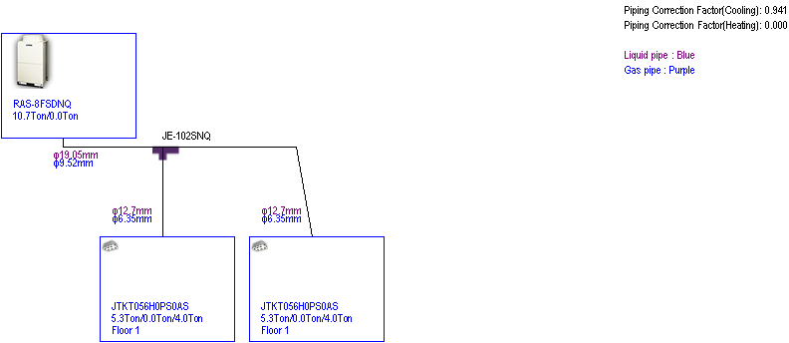

Piping Rules
Commercial VRF HP, JTOH-Q JTOH080VPEM-0AQ1 |  | Project | Max | OK
 |  | m | m | OK
Length | Total pipe length | 0 | 1,000 | ✓✓
Length | Maximum piping length (Actual length) | 0 | 165 | ✓✓
Length | Maximum piping length (Equivalent length) | 40 | 190 | ✓✓
Length | Maximum Piping Length between Multi-kit of 1st Branch and Each Indoor Unit | 20 | 90 | ✓✓
Length | Maximum Piping Length between Each Multi-kit and Each Indoor Unit | 0 | 40 | ✓✓
Height | Height Difference between (O.U. is Upper) | 0 | 50 | ✓✓
Height | Height Difference between (O.U. is Lower) | 0 | 40 | ✓✓
Height | Height Difference between Indoor Units | 0 | 15 | ✓✓
IU connectable ( Min / recommended / Max) |  | 2 | 1 / 8 / 13 | ✓✓
Connected Cap. (Min-Max) |  | 50% | 50%-130% | ✓✓

Refrigerant Load & Pipe size
Commercial VRF HP, JTOH-Q JTOH080VPEM-0AQ1 | Refrigerant Type: R410A
Commercial VRF HP, JTOH-Q JTOH080VPEM-0AQ1 | kg
OU refrigerant load (Charge before shipment) | 8.0
Installation Additional refrigerant load (OU + Piping) | 0.0
Total | 8.0

Recommendation
- If pipe size 1'' is not available in your country, please use 1''1/8 as replacement.

WIRING DESIGN
Evaluation Only. Created with Aspose.Words. Copyright 2003-2011 Aspose Pty Ltd.

system 1

Wiring Diagram
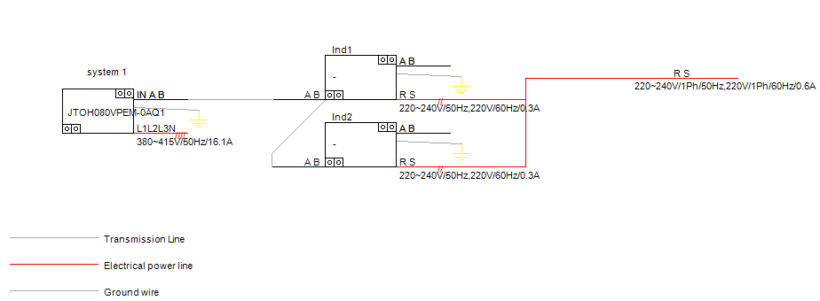

Power Supply
Model |  | Power supply | Input power | Max current
 |  | Power supply | kW0 | A
 | JTOH080VPEM-0AQ1 | 380~415V/3Ph/50Hz | 5.46 | 16.1
 | - | 220~240V/1Ph/50Hz,220V/1Ph/60Hz | 0.06 | 0.3

RCS link description
- Minimum recommended section (up to 500 m): 2 x 0.75 mm² connected to earth at one point.
- Cable characteristics: non polar, twisted shielded pair of cable.
- One Remote Control Switch can control up to 16 Indoor Units as a maximum.
- Two Remote Control Switch can be connected in the same unit or unit group.
- The second one is a subsidiary remote control switch.

Central Controller

H-Link2 communication line description
- Minimum recommended section: 2 x 0.75 mm² connected to earth at one point. Shielding must be renewed every 300m.
- Transmitting wires: non polar, twisted shielded pair of cable.
- Maximum H-Link2 communication line length is 1000 m but can be increased until 5.000m using optional relay PSC-5HR.
- Several refrigerant systems can be connected together on a bus with H-LINK2 wiring using an open loop
- Maximum number of Outdoor Units is 64.
- Maximum number of Indoor Units is 160.
- Number of central controller: 0

EQUIPMENT LIST AND INFORMATION
Evaluation Only. Created with Aspose.Words. Copyright 2003-2011 Aspose Pty Ltd.

Outdoor Units
Model & Components | System Name | Description | Quantity
JTOH080VPEM-0AQ1 | system 1 | Commercial VRF HP, JTOH-Q | 1

Indoor Units
Model | System Name | Description | Quantity
- | system 1 | Two Way Cassette | 2

Branch Kit

Multikit
Model | System Name | Description | Quantity
JE-102SNQ | system 1 | Line branch kit | 1

Field Providing

Piping Materials
Pipe size(mm) | Length
Pipe size(mm) | m
6.35 | 0
9.52 | 0
12.7 | 0
19.05 | 0

Refrigerant
Refrigerant Type | Quantity to be provided
Refrigerant Type | kg
R410A | 0.0

