**Student Performance Analysis**

**1.INTRODUCTION**

* 1. **Overview:**

Student performance analysis and prediction using datasets has become an essential component of modern education systems. With the increasing availability of data on student demographics, academic history, and other relevant factors, schools and universities are using advanced analytics and Machine learning Programs to gain insights into student performance and predict future outcomes. This approach helps educators identify areas of improvement, personalize learning experiences, and provide targeted support to struggling students. Furthermore, student performance analysis and prediction can also aid in decision-making processes for school administrators and policymakers, helping them allocate resources more effectively. In this article, we will explore the benefits of using datasets for student performance analysis and prediction and discuss some of the methods and tools used in this field.

This project understands how the student’s performance (test scores) is affected by other variables such as Gender, Ethnicity, Parental level of education, and Lunch and Test preparation course.

The primary objective of higher education institutions is to impart quality education to their students. To achieve the highest level of quality in the education system, knowledge must be discovered to predict student enrollment in specific courses, identify issues with traditional classroom teaching models, detect unfair means used in online examinations, detect abnormal values in student result sheets, and predict student performance. This knowledge is hidden within educational datasets and can be extracted through data mining techniques.

This project focuses on evaluating students’ capabilities in various subjects using a classificaton task. Data classification has many approaches, and the decision tree method and probabilistic classification method are utilized here. By performing this task, knowledge is extracted that describes students’ performance in the end-semester examination. This helps in identifying dropouts and students who require special attention, enabling teachers to provide appropriate advising and counseling.

* 1. **Purpose:**

• **Parent involvement:** Teachers can keep parents involved by sending progress reports of their children to home for review and sign. By sending progress reports to home, parents are informed about the academic achievement and in class behaviour of their children. This will facilitate parents in making changes at home schedule by devoting more study time for their children. Further they can also appreciate by rewarding their children for doing well. This will ultimately help students to get back on track academically.

**• Student awareness:** Progress Reports help the students in knowing – how well they are doing and what is the perception of teachers in the class towards them. This helps in minimising the shock- which they get at the end of the quarter or year report card. Students have the chance to identify the areas of improvements and they can make changes in their grade before the final report cards are released.

**• Teacher tracking:** Progress reports help the teachers in knowing- how well their students are doing in class. They are forced to review the strengths and weaknesses of students on a regular basis. Moreover, the teachers have to reach the classroom standards; progress reports help them to see whether the class is meeting those standards e.g. academic expectations. Report card sometimes called Progress reports; provide the records of student’s performance based on curriculum outcomes over a period of time. It is the document that should provide straight forward information about what a student knows and can demonstrate. Progress reports are issued to students in every four to six weeks while Report cards are issued at the end of each term i.e. two or three terms in a year.

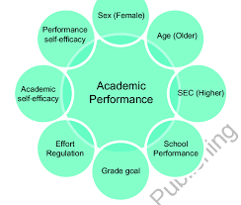

**2.LITERATURE SURVEY**

**2.1 Existing problem:**

One of the most challenging tasks in the education sector in India is to predict student's academic performance due to a huge volume of student data. In the Indian context, we don't have any existing system by which analyzing and monitoring can be done to check the progress and performance of the student mostly in Higher education system. Every institution has their own criteria for analyzing the performance of the students. The reason for this happing is due to the lack of study on existing prediction techniques and hence to find the best prediction methodology for predicting the student academics progress and performance. Another important reason is the lack in investigating the suitable factors which affect the academic performance and achievement of the student in particular course. So to deeply understand the problem, a detail literature survey on predicting student's performance using data mining techniques is proposed. The main objective of this article is to provide a great knowledge and understanding of different data mining techniques which have been used to predict the student progress and performance and hence how these prediction techniques help to find the most important student attribute for prediction. Actually, we want to improve the performance of 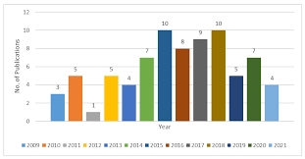the student in academic by using best data mining techniques. At last, it could also provide some benefits for faculties, students, educators and management of the institution.

**2.2 Proposed solution:**

1. **Analyze Why and Where Are They Lacking In Studies?**

It is important as a teacher to understand and analyze the weaker students in which area or subject they are lacking. Talk to them. The more you get familiar with their strengths and weaknesses, the more you can conclude and help them. You may find many reasons for their weak performance like:

1. Lack of Discipline
2. Less exposure to learning opportunities
3. Chaotic home environment
4. Complex study material – difficult to understand
5. Anxiety and Stress

These can be some of the reasons for their weak performance and when you know the problem you can help them better and more effectively.

### **2. Concise Lessons With Demonstrated Examples :**

For the topic you are going to teach, you must be clear about what aspect of your lesson you want to inculcate in students or what is the main purpose or goal. Make it clear or concise as it gets easier for students and teachers to understand and teach.

The involvement of demonstrated examples of each topic makes students more likely to absorb and retain the information. More examples lead to mastery of the topic.

### **3. Focus On Encouragement And Motivation :**

Never mock weaker students in front of the whole classroom as it can make them feel shattered and demotivated. After the class period, brilliant students tease or bully weaker students and as a result, they feel discouraged.

For example, if a student fails to answer, don’t mock or make them feel stupid for their answer. Instead, you should talk to them and encourage and tell them ways to improve. This brings confidence in students.

**3.THEORITICAL ANALYSIS**

**3.1 Block diagram:**

Student Performance Analysis

Data collection & Extraction from Data Base

Define Problem/Problem Understanding

Creating New Story

Creating New Dash board

Data preparation

Web Integration

Performance Testing

Creating New Report

**Project Demonstration & Documentation**

1.Explanation video.

2.Documentation

**4.RESULT**

**REPORT**

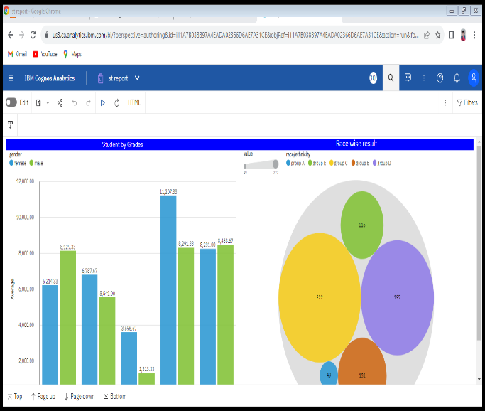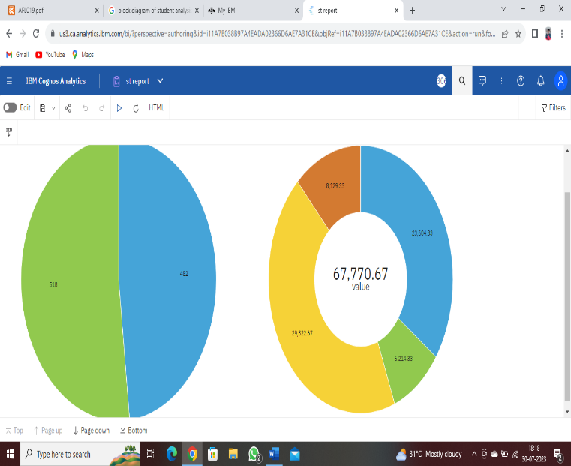

# STORY

# 

# DASH BOARD

# 

**5.ADVANTAGES & DISADVANTAGES**

### **A good academic achievement will give the child a sense of accomplishment.**

### **Academic achievement can help the child get into a good college.**

### **Academic achievement can lead to better job opportunities.**

### **Academic achievement can help the child to develop a love for learning.**

### **Academic achievement can lead to better health later in life.**

### **Academic achievement can help the child develop a strong work ethic**

### **Academic achievement can improve the self-confidence of the child.**

### **Academic achievement can help kids attain a sense of satisfaction and accomplishment.**

### **Help Them Create a Positive Learning Environment**

* Encourage your child to ask questions in class. This will help them understand the material better and participate in discussions. It will also show their teacher that they are engaged in the lesson.

**6.APPLICATIONS**

Students’ feedback is usually gathered in institutions of higher education to evaluate the teaching quality from the students’ perspective, using questionnaires administered at the end of the courses. These evaluations are useful to pinpoint the course strengths, identify areas of improvement, and understand the factors that contribute to students’ satisfaction. They are an important mechanism for improving the teaching and learning processes. However, there is little standardisation in how this kind of feedback is collected, analysed, and used, and their active use for improving the teaching and learning processes is low. Additionally, students are rarely asked if they consider that those aspects included in the questionnaires are really important; this information would allow relativizing students’ evaluations of teaching. This research proposes the use of importance-performance analysis (IPA) together with a student’s evaluation of teaching questionnaire as a tool for lecturers to collect, analyse, and interpret the data obtained from the student’s feedback. This work shows how using IPA lecturers can obtain a visual representation of what teaching attributes are important for their students, how important each attribute is, and how well the instructors performed on each attribute from their students’ point of view. The usefulness of this tool for lecturers to assess students’ evaluation of their teaching and to guide the course programming in higher education is shown.

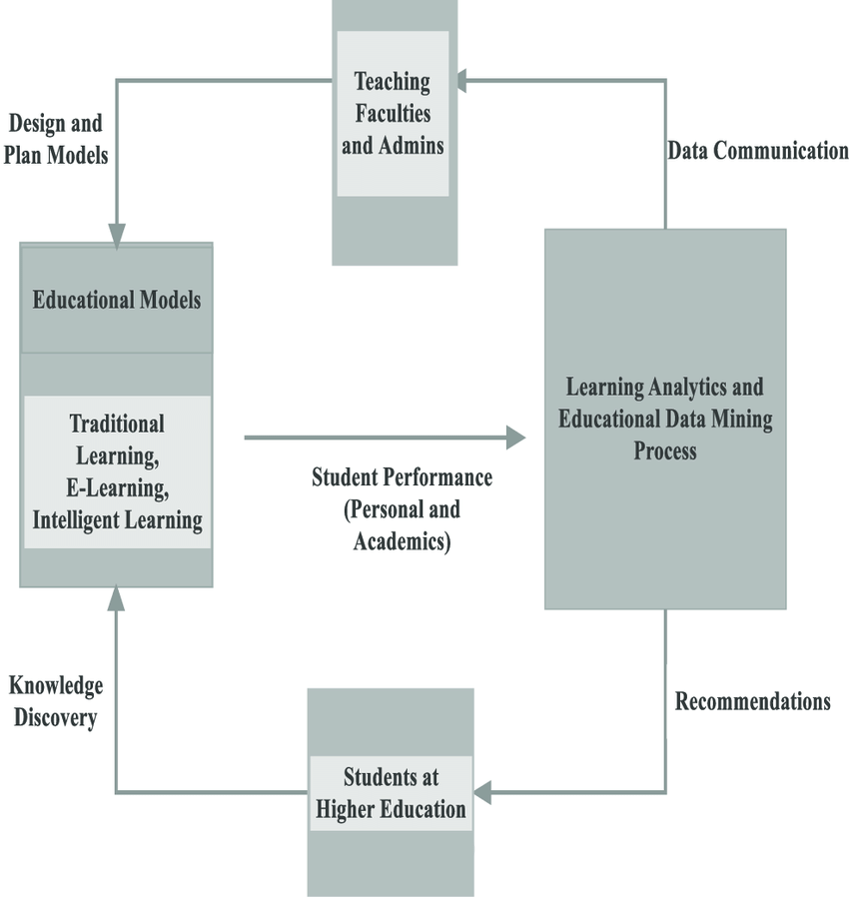

**7.CONCLUSION**

This ‘Student Performance Analysis System’ has been developed successfully and was also tested successfully by taking few test cases. It is user friendly and has required options, which can be used by user to perform desired operation. According to the result analysis the current model works properly and has achieved the goal of getting 100% accuracy within the desired format. We have implemented various best practices to create and train our model. Throughout the development of the model we have learned various best practices and architecture patterns being used in industry today.

**The goals that are achieved by the system are:**

* Optimum utilization of resources.
* Efficient management of records.
* Simplification of Operations.
* Less processing time and easy of getting required information.
* Usefulness and correctness.