Intro
We have previously submitted an entry for a Kaggle competition (https://www.kaggle.com/c/sf-crime/data) to predict crime in each intersection of the Bay area based on historical data; we performed in the top 10% and had a model that has an accuracy of about 67% (for 40 categories) and runs in about 40 seconds for 1 million observations using Random Forest. Naïve Bayes was also run, with an accuracy that was about 1 percent lower. In the training set, the prevalent crimes are as follows: Larceny/Theft, Other Offences, Non Criminal, and Assault.
Research Questions
- What are the common types of crime being predicted?
- What are the misclassifications that usually occur?
- How do varying splits of the train and test data (i.e. 80/20, 90/10) compare to the split performed (70/30)?
- What are the optimal parameters of Random Forest?
Goals
  - Determine the top predicted categories for crime.
  - Perform a sensitivity analysis of the train/test split and Random Forest parameters.
Results
- For Random Forest, the prevalent crimes are Larcency/Theft, Other Offences, Drug/Narcotics, and Vehicle theft. Assault is present at some degree (blue patches in right map).
- For Naïve Bayes, the prevalent crimes include the following: larceny/ theft, other offences, assault, and drug/narcotics.
- Higher ratios of train to test data yield significantly higher accuracies, increasing the number of trees slight improves accuracy.
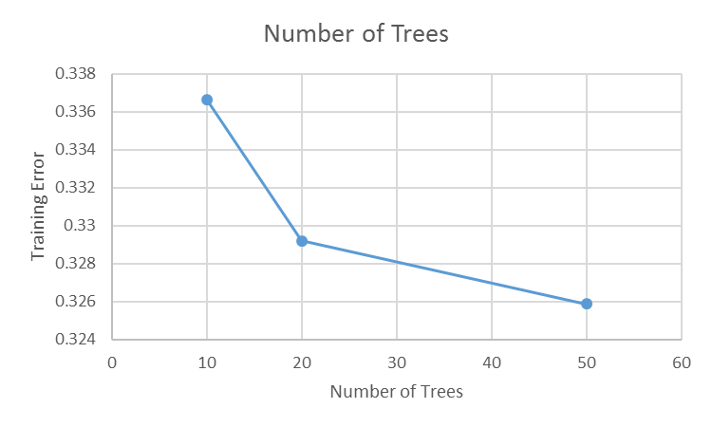
Conclusions and Recommendations
- Use 20 trees in Random Forest.
- Focus on addressing larceny/theft, assault, other offences, and drugs/narcotics.
- The ratio between the size of the train dataset to the test dataset should be maximized, ideally 90/10.
- The amount of predicted crimes is being overestimated (non criminal offenses show up less frequently with respect to the training set); this is good from a prevention standpoint but overuses resources.

