1.

In block-level element, there willalways be a new line after the closing tag. So, no matter how you organize your HTML, block-level elements always create a new line.

Whereas in aninline element, there is never a new line. Therefore, no matter how you organize your inline-elements in the markup, they will always appear side-by-side.

2.

display:none means that the tag in question will not appear on the page at all.

visibility:hidden means that the tag is not visible, but space is allocated for it on the page. The tag is rendered, it just isn't seen on the page.

3.

The clear property is directly related to the float property. It specifies if an element should be next to the floated elements or if it should move below them. This property applies to both floated and non-floated elements.

If an element can fit in the horizontal space next to the floated elements, it will. Unless you apply the clear property to that element in the same direction as the float. Then the element will move below the floated elements.

The clear property can have following values:

* None - the element is not moved down to clear past floats.
* Left - the element is moved down to clear past left floats.
* Right - the element is moved down to clear past right floats.
* Both - the element is moved down to clear past both left and right floats.

The float property is used for positioning and formatting content e.g., let an image float left to the text in a container.

The float property can have one of the following values:

* left - The element floats to the left of its container
* right - The element floats to the right of its container
* none - The element does not float (will be displayed just where it occurs in the text). This is default
* inherit - The element inherits the float value of its parent

In its simplest use, the float property can be used to wrap text around images.

4.

* **Static** - this is the default value; all elements are in order as they appear in the document.
* **Relative** - the element is positioned relative to its normal position.
* **Absolute** - the element is positioned absolutely to its first positioned parent.
* **Fixed** - the element is positioned related to the browser window.

5.

<!DOCTYPE html>

<html>

<head>

<meta charset="UTF-8">

<title>Sample table</title>

<style>

table {

border-collapse: collapse;

border: 5px solid black;

width: 100%;

}

td {

width: 50%;

height: 2em;

border: 1px solid #ccc;

}

</style>

</head>

<body>

<table>

<tbody>

<tr>

<td>ID</td>

<td>Employee Name</td>

<td>Department</td>

<td>Designation</td>

</tr>

<tr>

<td>100</td>

<td>Raj</td>

<td>QE</td>

<td>Trainee</td>

</tr>

<tr>

<td>101</td>

<td>Shivam</td>

<td>QE</td>

<td>Trainee</td>

</tr>

<tr>

<td>102</td>

<td>Rahul</td>

<td>MEAN</td>

<td>Trainee</td>

</tr>

<tr>

<td>103</td>

<td>Rakesh</td>

<td>MEAN</td>

<td>Software engineer</td>

</tr>

<tr>

<td>104</td>

<td>Vishal</td>

<td>iOS</td>

<td>Trainee</td>

</tr>

<tr>

<td>105</td>

<td>Suraj</td>

<td>QE</td>

<td>Team Lead</td>

</tr>

</tbody>

</table>

</body>

</html>

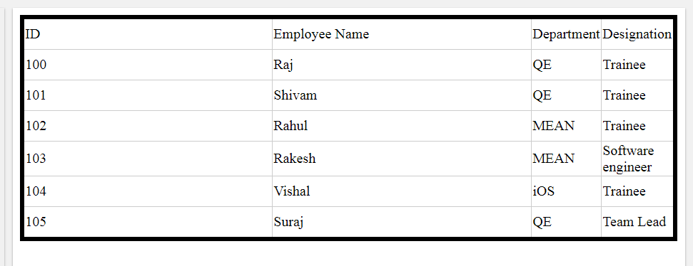

6.

The <meta> tag defines metadata about an HTML document. Metadata is information about data.

<meta> tags always go inside the <head> element, and are typically used to specify character set, page description, keywords, author of the document, and viewport settings.

Metadata will not be displayed on the page, but is machine parsable.

7.

In CSS, the term "box model" is used when talking about design and layout.

The CSS box model is essentially a box that wraps around every HTML element. It consists of: margins, borders, padding, and the actual content.

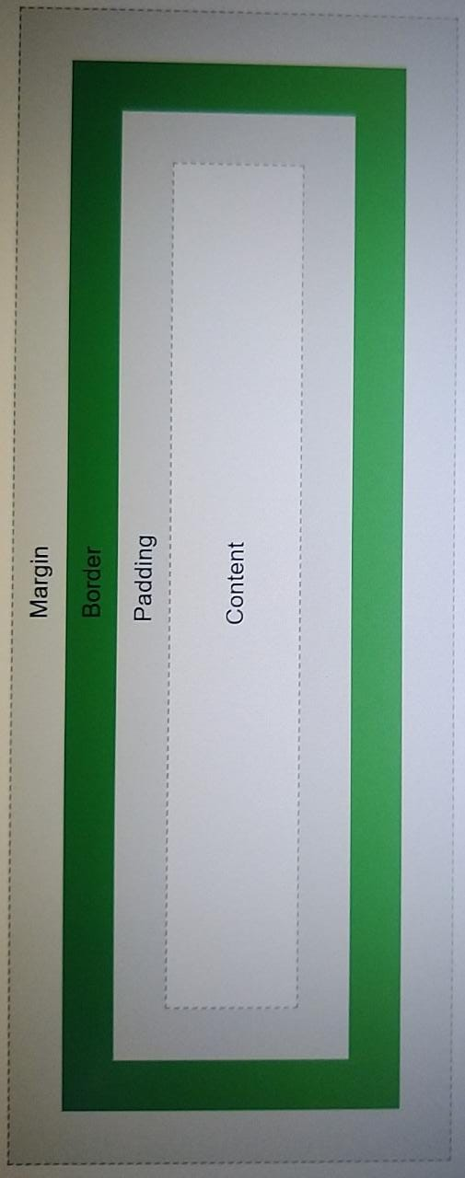

Explanation of the different parts:

* **Content** - The content of the box, where text and images appear
* **Padding** - Clears an area around the content. The padding is transparent
* **Border** - A border that goes around the padding and content
* **Margin** - Clears an area outside the border. The margin is transparent

8.

CSS selectors are used to find the HTML elements you want to style.

We can divide CSS selectors into five categories:

* Simple selectors (select elements based on name, id, class)
* [Combinator selectors](https://www.w3schools.com/css/css_combinators.asp) (select elements based on a specific relationship between them)
* [Pseudo-class selectors](https://www.w3schools.com/css/css_pseudo_classes.asp) (select elements based on a certain state)
* [Pseudo-elements selectors](https://www.w3schools.com/css/css_pseudo_elements.asp) (select and style a part of an element)
* [Attribute selectors](https://www.w3schools.com/css/css_attribute_selectors.asp) (select elements based on an attribute or attribute value)

9.

All HTML documents must start with a <!DOCTYPE> declaration.

The declaration is not an HTML tag. It is an "information" to the browser about what document type to expect.

In HTML 5, the declaration is simple:

<!DOCTYPE html>

10.

## HTML <section> Element

The <section> element defines a section in a document.

According to W3C's HTML documentation: "A section is a thematic grouping of content, typically with a heading."

A web page could normally be split into sections for introduction, content, and contact information.

## HTML <article> Element

The <article> element specifies independent, self-contained content.

An article should make sense on its own, and it should be possible to distribute it independently from the rest of the web site.

Examples of where an <article> element can be used:

* Forum post
* Blog post
* Newspaper article

## HTML <header> Element

The <header> element represents a container for introductory content or a set of navigational links.

A <header> element typically contains:

* one or more heading elements (<h1> - <h6>)
* logo or icon
* authorship information

## HTML <footer> Element

The <footer> element defines a footer for a document or section.

A <footer> element typically contains:

* authorship information
* copyright information
* contact information
* sitemap
* back to top links
* related documents

You can have several <footer> elements in one document.

## HTML <aside> Element

The <aside> element defines some content aside from the content it is placed in (like a sidebar).

The <aside> content should be indirectly related to the surrounding content.

11.

<!DOCTYPE html>

<html lang="en">

<head>

<meta charset="UTF-8">

<meta name="viewport" content="width=device-width, initial-scale=1.0">

<title>1</title>

<style>

*{

margin:0;

padding:0;

}

body{

background:#000;

}

.container {

width:95%;

margin:auto;

letter-spacing: .4px;

}

.nav{

color:#fff;

width:960px;

margin:auto;

}

.nav h2{

margin-top:15px;

font-weight:lighter;

font-size:2rem;

}

.links{

margin-top:30px;

}

.links a{

color:#fff;

margin-right:30px;

}

a{

text-decoration:none;

}

.content{

margin-top:30px;

background:#fff;

padding:30px;

}

.content-container{

width:960px;

margin:auto;

padding-bottom:30px;

}

.content-container>p{

margin-top:15px;

background-color:lightgrey;

padding:15px;

color:rgb(58, 58, 58);

}

.gallery h3{

font-weight:lighter;

margin-top:45px;

padding-bottom:5px;

border-bottom:1px solid lightgrey;

}

.gallery .slides{

margin-top:30px;

display:flex;

justify-content: space-between;

}

.slides .slide{

width:215px;

text-align: center;

color:rgb(58, 58, 58);

}

.slide img{

margin-bottom:10px;

}

.footer{

background:#000;

color:#fff;

padding:15px;

}

.footer .footer-container{

width:960px;

margin:auto;

display:flex;

justify-content: space-between;

}

</style>

</head>

<body>

<div class="container">

<div class="nav">

<h2>To the New</h2>

<div class="links">

<a href="#">Text Link</a>

<a href="#">Text Link</a>

<a href="#">Text Link</a>

<a href="#">Text Link</a>

<a href="#">Text Link</a>

</div>

</div>

<div class="content">

<div class="content-container">

<img src="file:///C:/Users/ASUS/Downloads/960X360.png" alt="">

<p>

Veysasud uad asdguas da usdua d aasd asdsdkja dkjas sdhgsd hsdg hs gshfgh.

agsdjgashd ahsgdjagsjdahsjd.

</p>

<div class="gallery">

<h3>Latest From the Gallery</h3>

<div class="slides">

<div class="slide"><img src="file:///C:/Users/ASUS/Downloads/215x315.png" alt="">

<p>image caption here</p></div>

<div class="slide"><img src="file:///C:/Users/ASUS/Downloads/215x315.png" alt="">

<p>>image caption here</p></div>

<div class="slide"><img src="file:///C:/Users/ASUS/Downloads/215x315.png" alt="">

<p>>image caption here</p></div>

<div class="slide"><img src="file:///C:/Users/ASUS/Downloads/215x315.png" alt="">

<p>>image caption here</p></div>

</div>

</div>

</div>

</div>

<div class="footer">

<div class="footer-container">

<p> Copyright &#169; 2017 - 2021 . All Rights Reserved . To The New</p>

<p> Created by To the New</p>

</div>

</div>

</div>

</body>

</html>

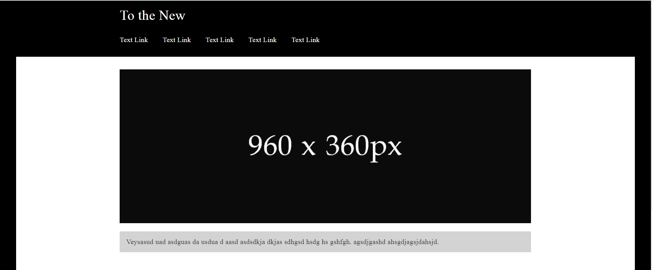

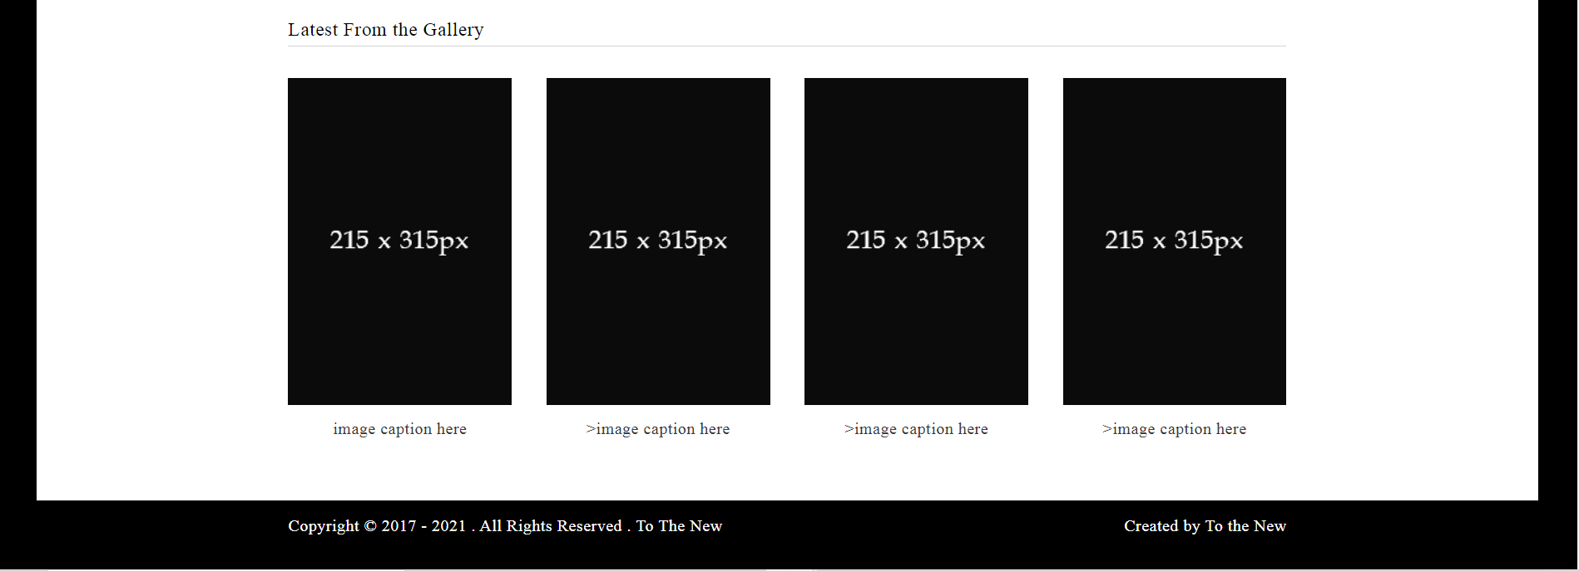

12.

<!DOCTYPE html>

<html>

<head>

<meta charset='utf-8'>

<meta http-equiv='X-UA-Compatible' content='IE=edge'>

<title>Page Title</title>

<style>

*{

margin: 0;

padding: 0;

}

body{

font-family: Ariel;

}

.container{

width: 100%;

margin: auto;

}

.navigation_bar{

display: flex;

justify-content: space-between;

padding: 30px 5px;

margin-left: 20px;

margin-right: 20px;

margin-bottom: 30px;

color: #80d57e;

border-bottom: 1px solid lightgrey;

}

.Link_style a{

color: #80d57e;

text-decoration: none;

margin-left: 12px;

}

.Bug_report_style{

background-color: #cac4a8;

color: Offwhite;

padding: 10px 25px;

border-top-left-radius: 10px;

border-top-right-radius: 10px;

}

.Form_style{

width: 360px;

margin: auto;

}

.Form_container{

padding: 20px 25px;

border: 1px solid lightgray;

border-bottom-left-radius: 10px;

border-bottom-right-radius: 10px;

}

.Form_container form{

display: flex;

flex-direction: column;

}

input[type="radio"]

{

margin:10px 0};

}

input, select, textarea{

margin-bottom: 20px;

padding: 10px;

border-radius: 20px;

}

select {

background-color: #80d57e;

}

input[type="submit"]{

background-color: #80d57e;

}

</style>

<meta name='viewport' content='width=device-width, initial-scale=1'>

<link rel='stylesheet' type='text/css' media='screen' href='main.css'>

<script src='main.js'></script>

</head>

<body>

<div class="container">

<div class="navigation_bar">

<h2>TO THE NEW</h2>

<div class="Link_style">

<a href="#">Home</a>

<a href="#">Quick Help</a>

</div>

</div>

</div>

<div class="Form_style">

<div class="Bug_report_style">

<h3>Bug Report</h3>

</div>

<div class="Form_container">

<form>

<label>TITLE:</label>

<input type="text">

<label>DESCRIPTION:</label>

<textarea cols="30" rows="4"></textarea>

<label>OPERATING SYSTEM:</label>

<select>

<option value="">Windows 7</option>

<option value="">Windows 8</option>

<option value="">Windows 10</option>

<option value="">MAC OS</option>

<option value="">UBUNTU</option>

</select>

<label>PRODUCT:</label>

<select>

<option value="">Formoid</option>

<option value="">Forman</option>

<option value="">Distro</option>

</select>

<label>VERSION:</label>

<input type="text">

<label>LICENSE:</label>

<div>

<span>

<input type="radio">

<label>Free</label>

</span>

<span>

<input type="radio">

<label>Business</label>

</span>

</div>

<label>SEVERITY:</label>

<select>

<option value="">Critical</option>

<option value="">Medium</option>

<option value="">None</option>

</select>

<label>ATTATCHMENTS:</label>

<label><input type="file"></label>

<input type="submit" value="send" style="align-self: flex-end;">

</form>

</div>

</div>

</body>

</html>

