Assignment 1

Data Visualization

Viktoriia Omardybirova

05.04.2024

Contents

1. First Task 2

Policies and Procedures 2

2. Second task 3

Excel 3

3. Third Task 9

Tableau 9

# First Task

## Policies and Procedures

Policies and procedures a data analyst must adhere to:

1. Adhere to any data protection regulations i.e. UK GDPR.

2. Adhere to any workplace policies on working with personal, confidential and sensitive data.

3. Access the data on a need to know basis i.e. access only the data you need to fulfill your tasks and responsibilities.

4. Follow all data access controls setup in an organisation.

5. Adhere to any workplace data security policies e.g. use passwords to protect data when sending over emails.

6. Follow procedures for managing data quality and integrity to prevent data errors, inconsistencies and other issues and to find and fix problems that do occur.

# 2. Second task

## Excel

**GDP Tasks**

1. Set a password to protect the workbook

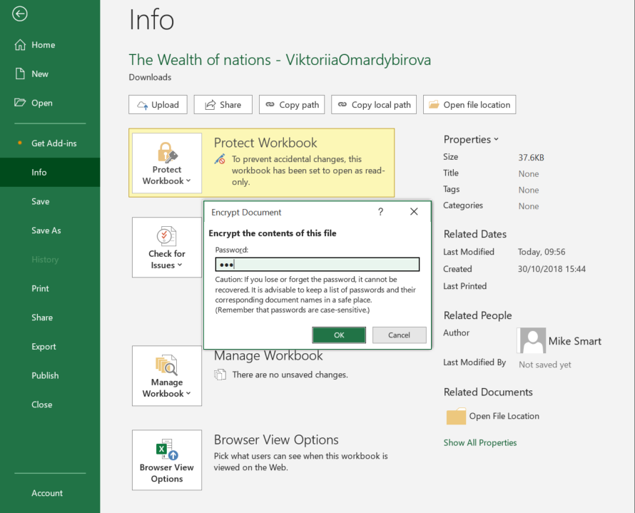 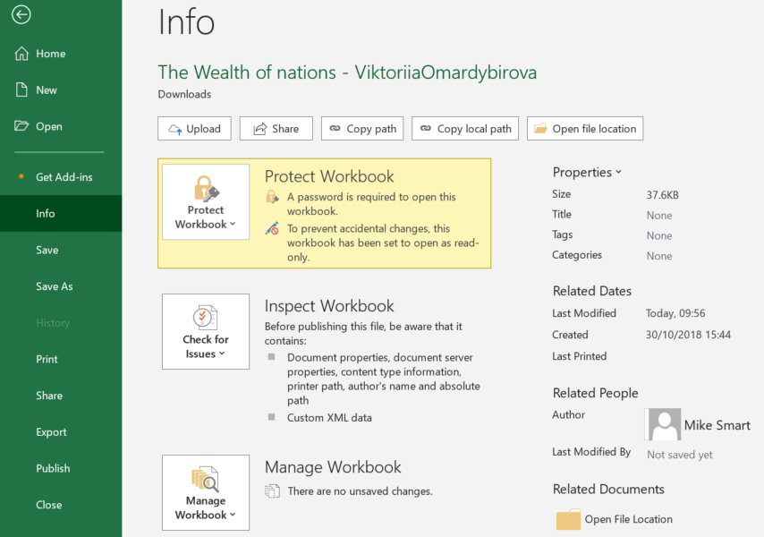

2. Highlight column C and change the data to display in British Pound symbol

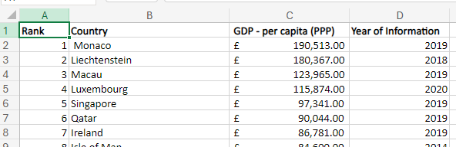

3. Turn the GDP sheet into a table.

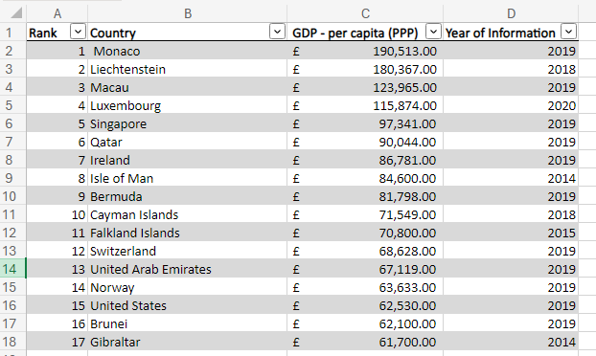

4. Filter the table to display only the information for 2019

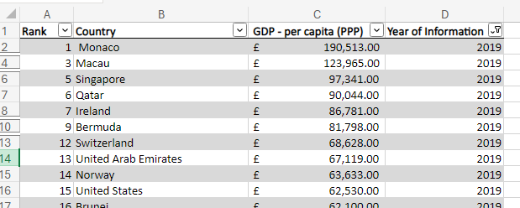

5. Next create a chart that will only display the following data ‘Rank, Country and GDP - per capita (PPP). The chart can be anything as long as it is suitable.

6. Using your creative skills edit the chart

a. Add a title

b. Add X and Y axis labels

c. Make the chart visually pleasing

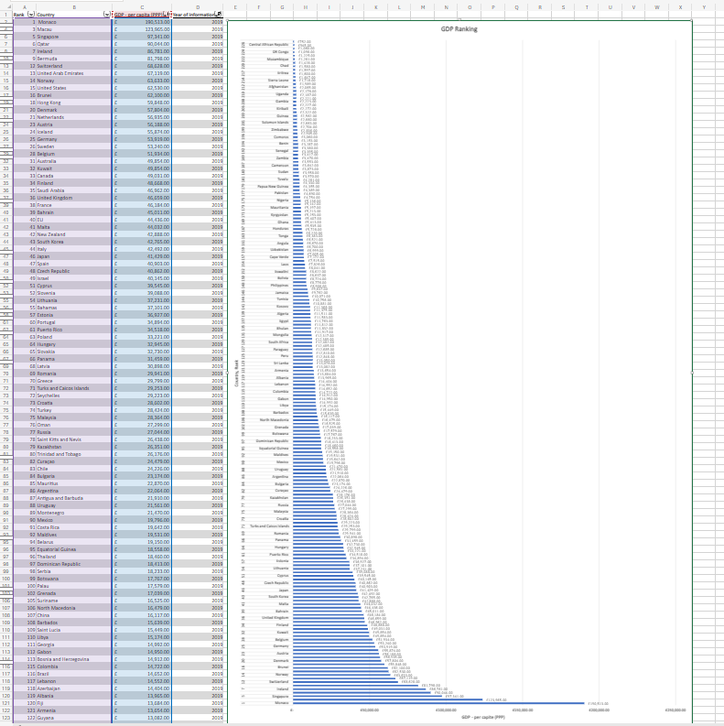

7. Move the chart to a new sheet tab and label with a suitable name

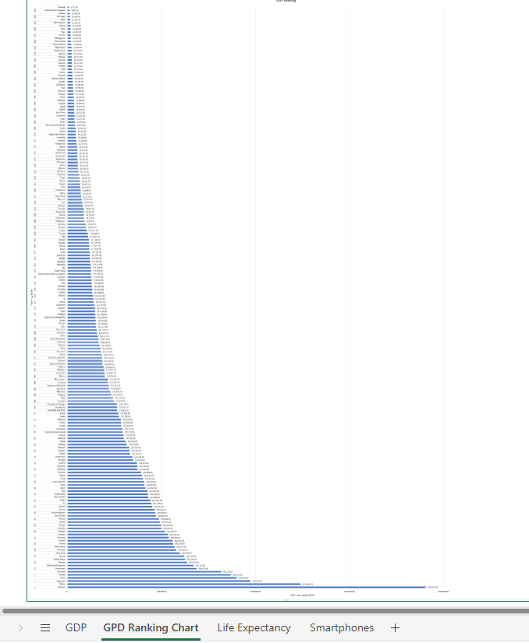

8. Create a sort for the top 20 highest ranking counties

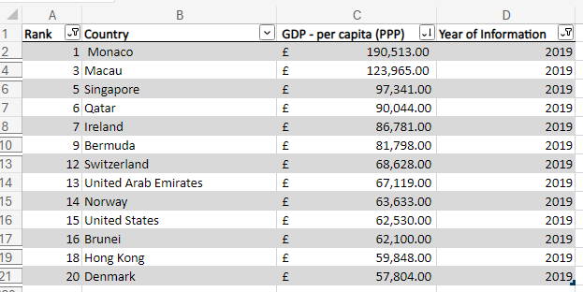

9. Next create a new Bar chart to display the 20 highest ranking countries from your sort and then move the chart to be underneath the table, as shown below.

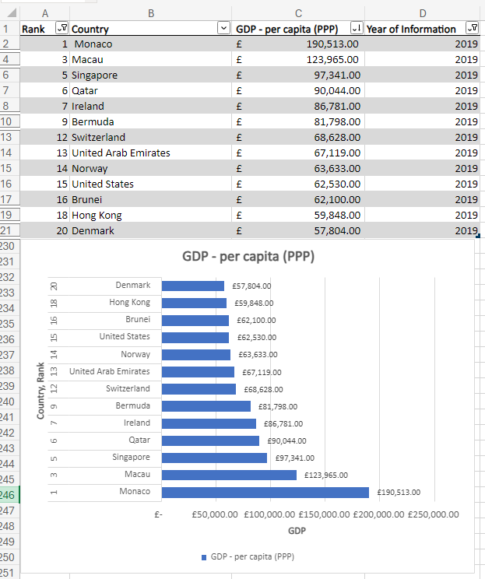

10. Colour the background by highlighting the area underneath the table as shown below. Find the add a fill colour icon and select a colour.

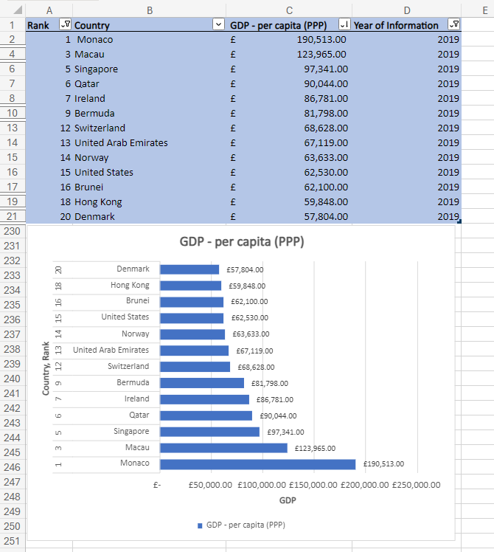

# Third Task

## Tableau

1) Import data

2) Set relationships:

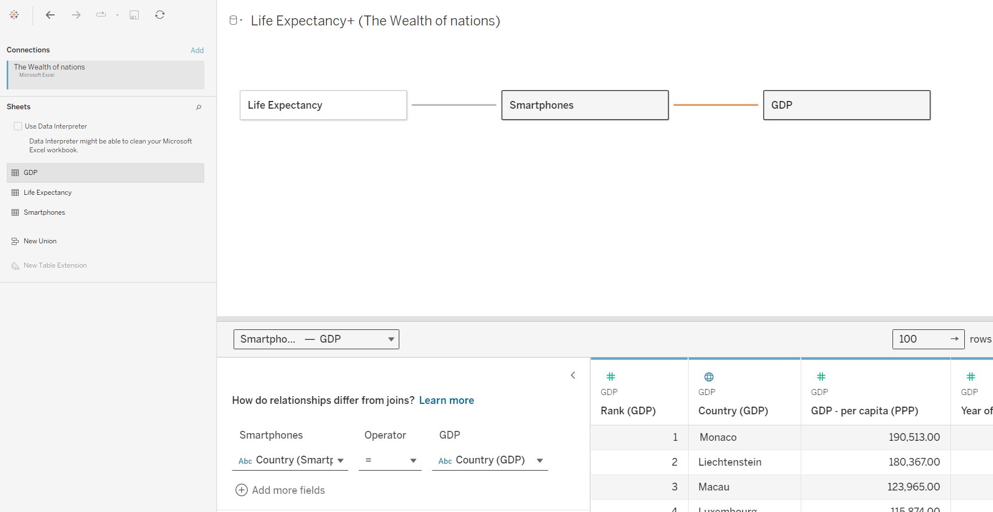

3) Checked data types.

4) Visuals:

Client Requirements

The client is colour blind and requested you to bear this in mind when building your dashboard. The client is only interested in the top 20 highest ranking countries. All your visuals should be for the top 20 highest ranking countries.

5) As you create your charts, if you see a little grey box containing a count of null values, select the filter option.

6) Build your dashboard.

1. **Top 20 GDP Ranking Countries** 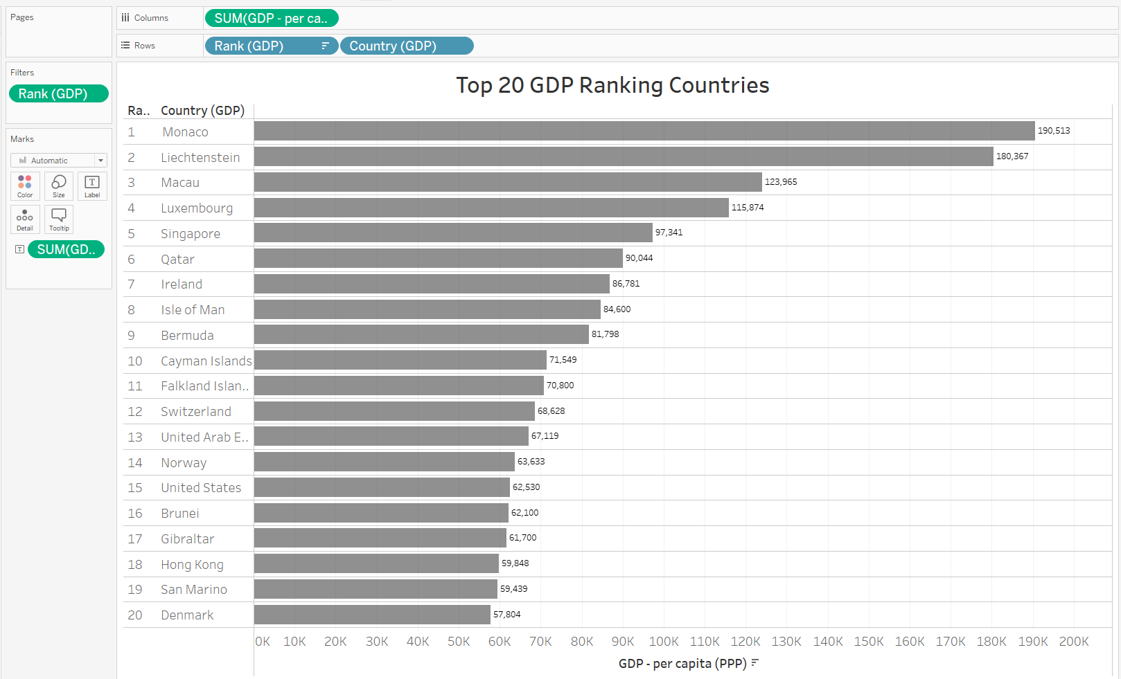
2. **Top 20 Ranking Countries by Number of Smartphone users**

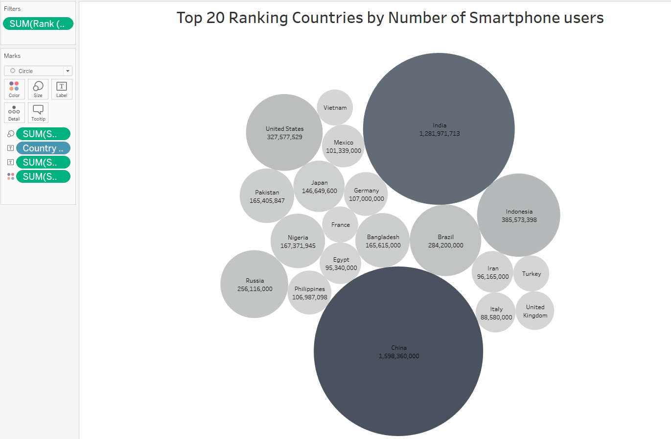

1. **Top 20 Countries by Largest Life Expectancy**

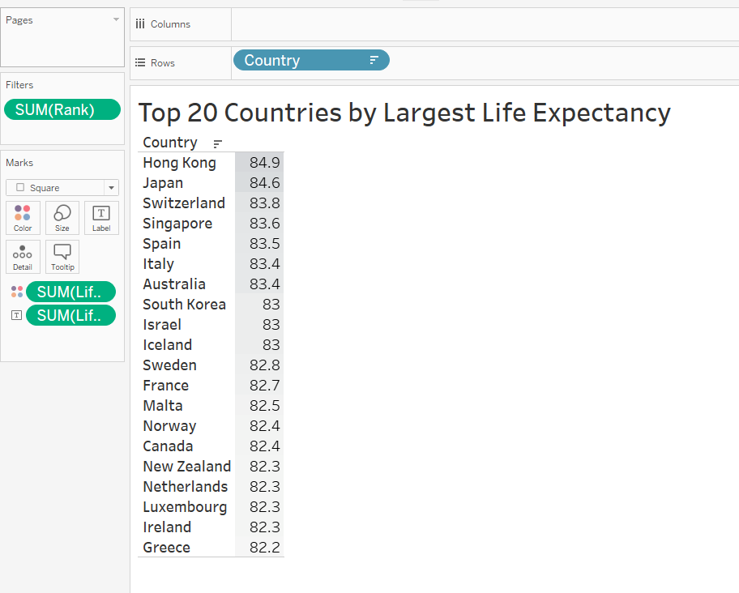

1. **Top 20 Countries by Largest Life Expectancy and their GDP**

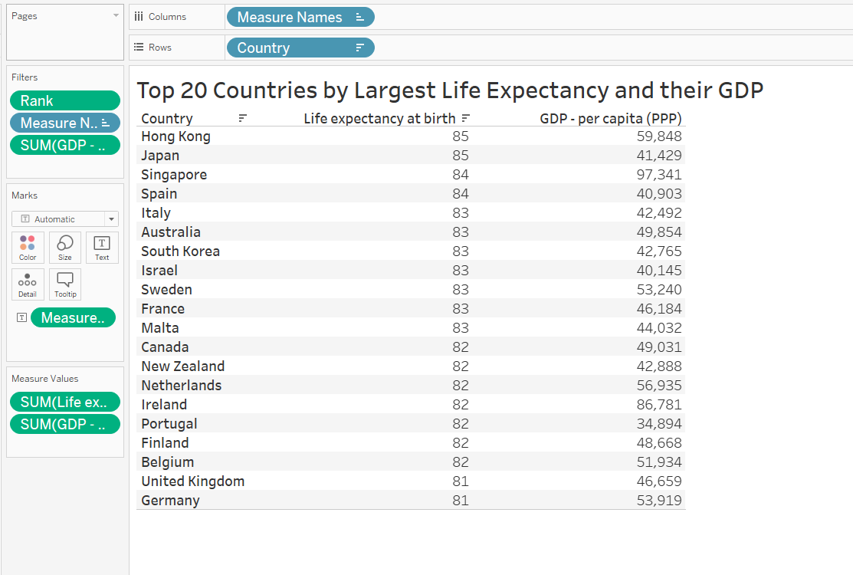

1. **Dashboard**

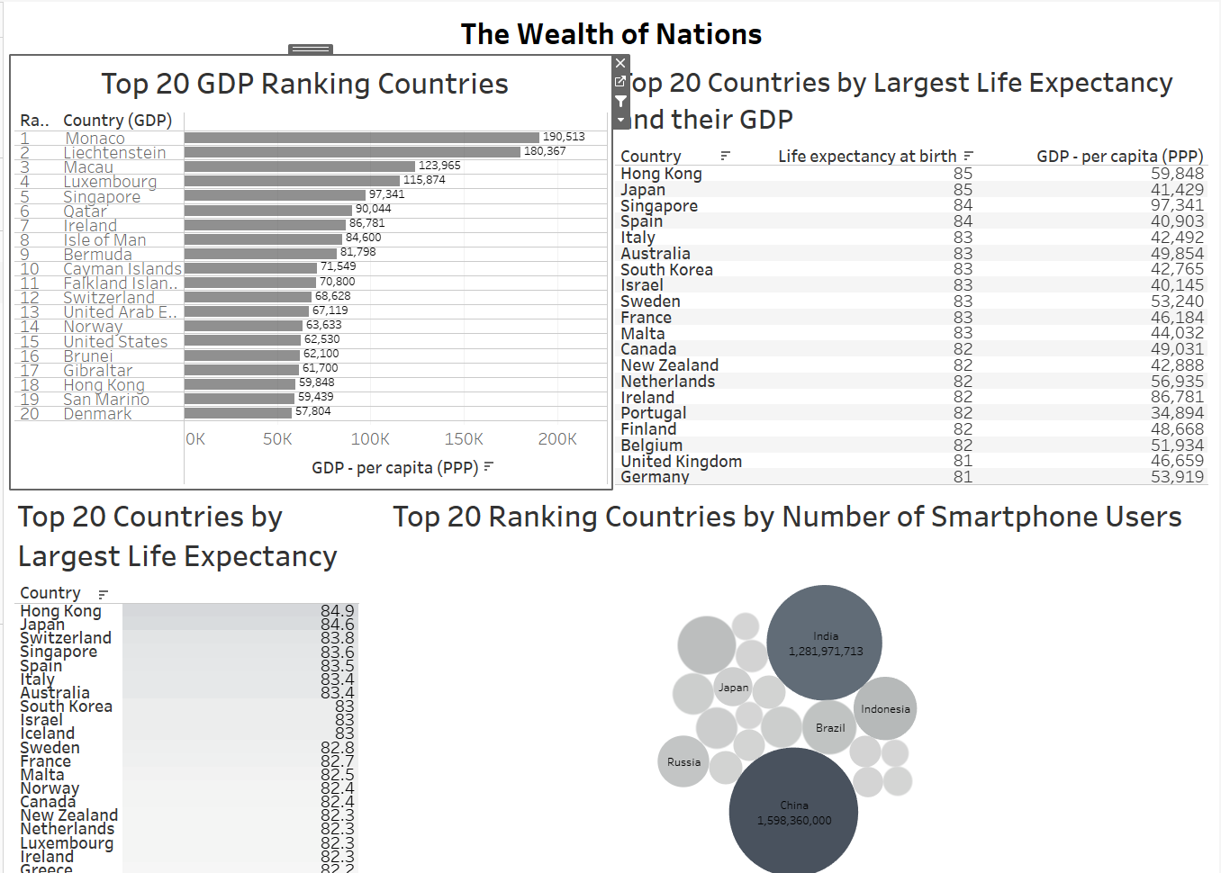

**Link to the published visuals and dashboard:**

[**https://public.tableau.com/views/TheWealthofNations_17123416825760/TheWealthofNations?:language=en-US&publish=yes&:sid=&:display_count=n&:origin=viz_share_link**](https://public.tableau.com/views/TheWealthofNations_17123416825760/TheWealthofNations?:language=en-US&publish=yes&:sid=&:display_count=n&:origin=viz_share_link)