# **Gamma Distribution**

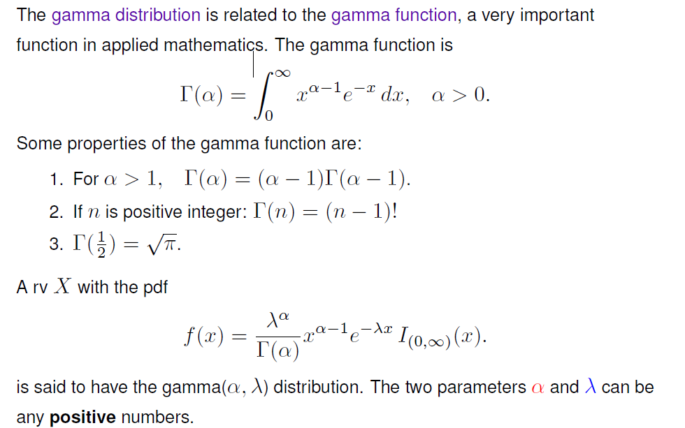

Alpha is the shape and lambda is the scale parameter.

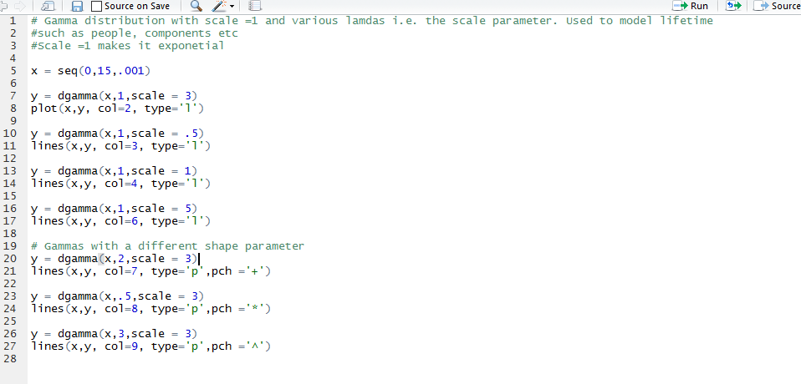

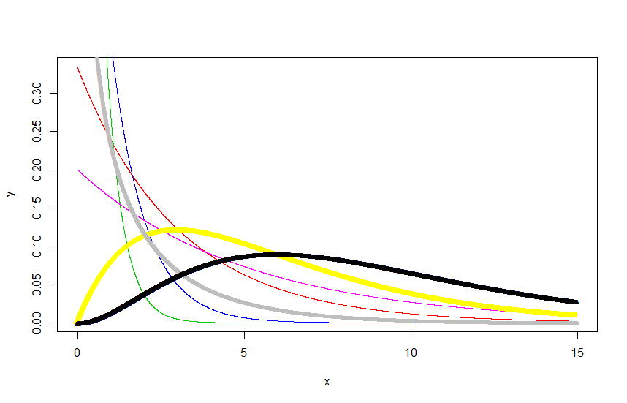

Let *T* be the time between *k* events in a Poisson process with parameter *lamdba* then *T* has a Gamma distribution with alpha = k and beta = 1/lambda

It follows that if *E*1*;E*2*; : : : ;Ek* are i.i.d. Exponential r.v.s with parameter *_* then *T* =

*E*1 + *E*2 + *: : :* + *Ek* has a Gamma distribution with parameters *_* = *k; _*. This form of the

Gamma distribution is referred to as the Erlang distribution

If alpha =1 then the gamma is an exponential distribution

Chi-squared(*nu*) distribution is a Gamma(*alpha* = nu/2*=*2*;beta* = 2) distribution

If Y is a gamma(alpha,beta) and W =sqrt(Y/beta)then W has a mazwell distribution which is used to model particle speeds in gases under speciall conditions.

CDF of a Gamma is not in a closed form, i.e. the definite integrals cannot be computed