NAME OF THE APPLICANT: R.PRITHIVIRAJ PG Scholar
FORM 2
THE PATENTS ACT, 1970 (39 of 1970)
&
The Patent Rules, 2003
COMPLETE SPECIFICATION
(See sections 10 & rule 13)
1. TITLE OF THE INVENTION
"Smart Applicant Tracking System with Intelligent Recruitment & Career
Preparation"
2. APPLICANTS (S)
Name | Nationality | Address
U.Vikram | India | PG Scholar, Department of M.Tech Computer Science and Engineering(Integrated) ,Erode Sengunthar Engineering College, Erode.
Mohankumar.S | India | Assistant Professor, Department of M.Tech Computer Science and Engineering (Integrated), Erode Sengunthar Engineering College, Erode.
T.Abinesh | India | PG Scholar, Department, M.Tech Computer Science and Engineering(Integrated) , Erode Sengunthar Engineering College, Erode.
D.ChennaKrishnan | India | PG Scholar, Department, M.Tech Computer Science and Engineering(Integrated) , Erode Sengunthar Engineering College, Erode.
N.S.Madhumitha | India | PG Scholar, Department, M.Tech Computer Science and Engineering(Integrated) , Erode Sengunthar Engineering College, Erode.
INVENTOR (S)
Name | Nationality | Address
R.Prithiviraj | India | PG Scholar, Department, M.Tech Computer Science and Engineering(Integrated) , Erode Sengunthar Engineering College, Erode.
U.Vikram | India | PG Scholar, Department, M.Tech Computer Science and Engineering(Integrated) , Erode Sengunthar Engineering College, Erode.
T.Abinesh | India | PG Scholar, Department, M.Tech Computer Science and Engineering(Integrated) , Erode Sengunthar Engineering College, Erode.
D.ChennaKrishnan | India | PG Scholar, Department, M.Tech Computer Science and Engineering(Integrated) , Erode Sengunthar Engineering College, Erode.
N.S.Madhumitha | India | PG Scholar, Department, M.Tech Computer Science and Engineering(Integrated) , Erode Sengunthar Engineering College, Erode.
Dr.S.Umarani | India | Professor & Head of the Department, M.Tech Computer Science and Engineering, Erode Sengunthar Engineering College, Erode.
Mohankumar.S | India | Assistant Professor, Department of M.Tech Computer Science and Engineering (Integrated), Erode Sengunthar Engineering College, Erode.
Karpagavalli.S.M | India | Assistant Professor, Department of M.Tech Computer Science and Engineering (Integrated), Erode Sengunthar Engineering College, Erode.
Kiruthika.S | India | Assistant Professor, Department of M.Tech Computer Science and Engineering (Integrated), Erode Sengunthar Engineering College, Erode.
Raghapriya.N.R | India | Assistant Professor, Department of Electronics Communication Engineering , Erode Sengunthar Engineering College, Erode.
Gokul.K | India | Assistant Professor, Department of M.Tech Computer Science and Engineering (Integrated), Erode Sengunthar Engineering College, Erode.
GirijaVasumathi.G.G | India | Assistant Professor, Department of M.Tech Computer Science and Engineering (Integrated), Erode Sengunthar Engineering College, Erode.
Kiruthikaa.K.V | India | Assistant Professor, Department of M.Tech Computer Science and Engineering (Integrated), Erode Sengunthar Engineering College, Erode.

TECHNICAL FIELD
The present invention relates to the field of artificial intelligence-based recruitment, applicant tracking, career preparation, and intelligent job application systems. More particularly, the invention provides an integrated platform that combines recruiter-side candidate screening and evaluation with candidate-side job discovery, resume optimization, interview preparation, and application assistance.
The system utilizes artificial intelligence, natural language processing, semantic matching, large language model APIs, information retrieval, web-based job discovery, resume parsing, portfolio analysis, and voice-based interaction to process recruitment and career-related information. The invention is applicable to organizations, recruiters, job seekers, educational institutions, placement cells, and employment platforms requiring intelligent recruitment and career preparation capabilities.

BACKGROUND OF THE INVENTION
5 Traditional recruitment systems generally depend on manual resume screening, keyword-based filtering, separate interview processes, and independent communication between recruiters and candidates. Recruiters may need to examine a large number of resumes to identify candidates whose skills and experience are suitable for a particular job requirement. Such manual processes can be time-consuming and may not consistently identify relevant candidate capabilities.
10 Conventional Applicant Tracking Systems primarily concentrate on the recruiter or employer side of recruitment. They commonly provide facilities for posting vacancies, collecting applications, filtering candidates, and managing recruitment stages. However, these systems generally provide limited support for candidates after or before submitting an application.
15 On the candidate side, job seekers frequently use separate applications for resume creation, job searching, resume customization, cover-letter generation, interview preparation, and application tracking. The separation of these functions can result in repeated work and does not provide a continuous relationship between the requirements of a particular job and the candidate's preparation activities.
20 Existing AI-based resume-job matching systems can calculate similarity between resumes and job descriptions. However, matching alone does not necessarily provide detailed candidate preparation, portfolio-based evidence, interview preparation, or a mechanism for improving the candidate profile based on interview performance.
25 Similarly, existing AI interview systems can generate questions and provide interview feedback, while job automation systems can search for jobs and assist with applications. However, these functions are generally implemented as independent services rather than as a connected recruitment and career-preparation workflow.
30 There is therefore a need for an integrated artificial intelligence-based system capable of connecting employer-side candidate evaluation with candidate-side personalized career preparation. The system should use job requirements as a common basis for candidate screening, skill-gap identification, resume optimization, interview preparation, performance feedback, and application assistance.

OBJECT OF THE INVENTION
The primary object of the present invention is to provide an intelligent applicant tracking and career preparation system that integrates recruitment and candidate career services within a unified platform.
To provide an AI-assisted system for creating, posting, and managing job requisitions.
To parse job descriptions obtained from manually entered information or publicly available job URLs into structured job information.
To parse candidate resumes into structured candidate profiles containing skills, experience, education, projects, and other relevant information.
To calculate intelligent matching between candidate profiles and job requirements and rank applicants according to their suitability.
To provide recruiters with candidate comparison information including strengths, gaps, skills, experience, and AI-generated insights.
To enable recruiters to manage shortlisted candidates through different recruitment stages.
To provide candidates with an intelligent job discovery mechanism using live job sources.
To enable candidates to evaluate discovered jobs against their existing resume and profile.
To automatically tailor resumes according to selected job requirements.
To generate job-specific cover letters based on candidate profiles and target job requirements.
To provide voice-based mock interview preparation using artificial intelligence.
To identify candidate skill gaps and provide personalized feedback and recommendations after an interview.
To enable candidates to improve their profile and preparation based on interview feedback.
To provide manual and automated job application assistance.
To provide portfolio-building facilities using suitable templates and candidate information.
To provide an AI assistant for candidate queries and career-related interactions through voice-based communication.
SUMMARY OF THE INVENTION
The present invention discloses an artificial intelligence-based integrated recruitment and career preparation system that connects employer-side applicant tracking functions with candidate-side career preparation services.
The system comprises a recruiter interface, candidate interface, job processing module, resume processing module, AI matching module, candidate comparison module, recruitment pipeline module, job discovery module, resume optimization module, cover-letter generation module, voice-based interview module, feedback and recommendation module, application automation module, portfolio module, AI assistant, database, LLM API, and external job information sources.
On the recruiter side, a job requisition may be created manually or by providing a public job URL. The job processing module extracts relevant information including job title, department, location, and job description. Candidate resumes are processed into structured profiles. The AI matching module compares candidate information with the requirements of the job and produces an AI-based match score for ranking applicants.
Recruiters can select suitable candidates and compare their strengths, skill gaps, experience, and AI-generated insights. Selected candidates can subsequently be moved through defined recruitment stages such as New, Screening, Interviewing, Final Round, Offer, or Rejected.
On the candidate side, the candidate may upload a resume to create a structured profile. The candidate can select a target job either from available jobs or by providing a public job URL. The system processes the selected job and compares its requirements with the candidate profile.
A Job Hunt Agent can search external job sources such as Remotive and Arbeitnow, identify relevant job postings, filter them according to the candidate profile, and generate resume-job match scores.
For a selected job, the system can generate a tailored resume and job-specific cover letter. The candidate can subsequently enter a voice-based mock interview in which spoken responses are processed by the system. Where applicable, the interview can include role-relevant coding rounds.
After the interview, the system generates identified skill gaps, feedback, and recommendations. These recommendations can be used to improve the candidate profile, resume, and future interview preparation, thereby establishing a continuous career-preparation loop.
The system further supports manual application and automated application assistance. In automated operation, fresh job postings can be periodically evaluated against the candidate profile and applications can either be proposed for candidate review or submitted according to the selected application mode.
The invention therefore provides a connected workflow from job requirements and candidate evaluation through personalized preparation, interview feedback, profile improvement, and application.

BRIEF DESCRIPTION OF THE DRAWINGS
SL.NO | PART NAME | PART NUMBER
1. | Recruiter Interface | 1
2. | Candidate Interface | 2
3. | Job Requisition Module | 3
4. | Job URL Processing Module | 4
5. | Resume Processing Module | 5
6. | Candidate Profile Module | 6
7. | AI Matching and Ranking Module | 7
8. | Candidate Comparison Module | 8
9. | Recruitment Pipeline Module | 9
10. | Job Hunt Agent | 10
11. | Resume Optimization Module | 11
12. | Cover Letter Generation Module | 12
13. | Voice Interview Module | 13
14. | Feedback and Recommendation Module | 14
15. | Application Automation Module | 15
16. | Portfolio Builder | 16
17. | AI Assistant | 17
18. | LLM API | 18
19. | External Job Sources | 19
20. | Database | 20

BRIEF DESCRIPTION OF THE DIAGRAMS
The present invention will be described with reference to the attached drawings.
The system begins by authenticating the recruiter or candidate and providing access to the corresponding workspace.
On the recruiter side, a job can be created manually or through a publicly available job URL.
The Job URL Processing Module [4] extracts structured information such as job title, department, location, and job description.
Candidate resumes are supplied to the Resume Processing Module [5], which extracts relevant information and creates a structured candidate profile.
The AI Matching and Ranking Module [7] compares candidate profiles with job requirements and generates match scores.
Recruiters can select candidates and use the Candidate Comparison Module [8] to examine strengths, gaps, skills, experience, and AI-generated insights.
Selected candidates are managed through the Recruitment Pipeline Module [9].
A candidate can select an existing job or provide an external job URL for analysis.
The Job Hunt Agent [10] searches supported external job sources and identifies suitable jobs based on the candidate profile.
The Resume Optimization Module [11] generates a job-specific resume, while the Cover Letter Generation Module [12] generates a corresponding cover letter.
The Voice Interview Module [13] conducts a voice-based mock interview and role-specific interview activities.
The Feedback and Recommendation Module [14] identifies gaps and generates personalized recommendations after the interview.
The Application Automation Module [15] assists with manual or automated job applications.
The Portfolio Builder [16] enables the candidate to create a professional portfolio.
The AI Assistant [17] enables candidates to interact with the system using voice-based conversational assistance.
The LLM API [18] provides artificial intelligence capabilities for parsing, generation, reasoning, matching assistance, interview processing, and other intelligent operations.
The Database [20] stores required recruiter, candidate, job, application, profile, and workflow information.

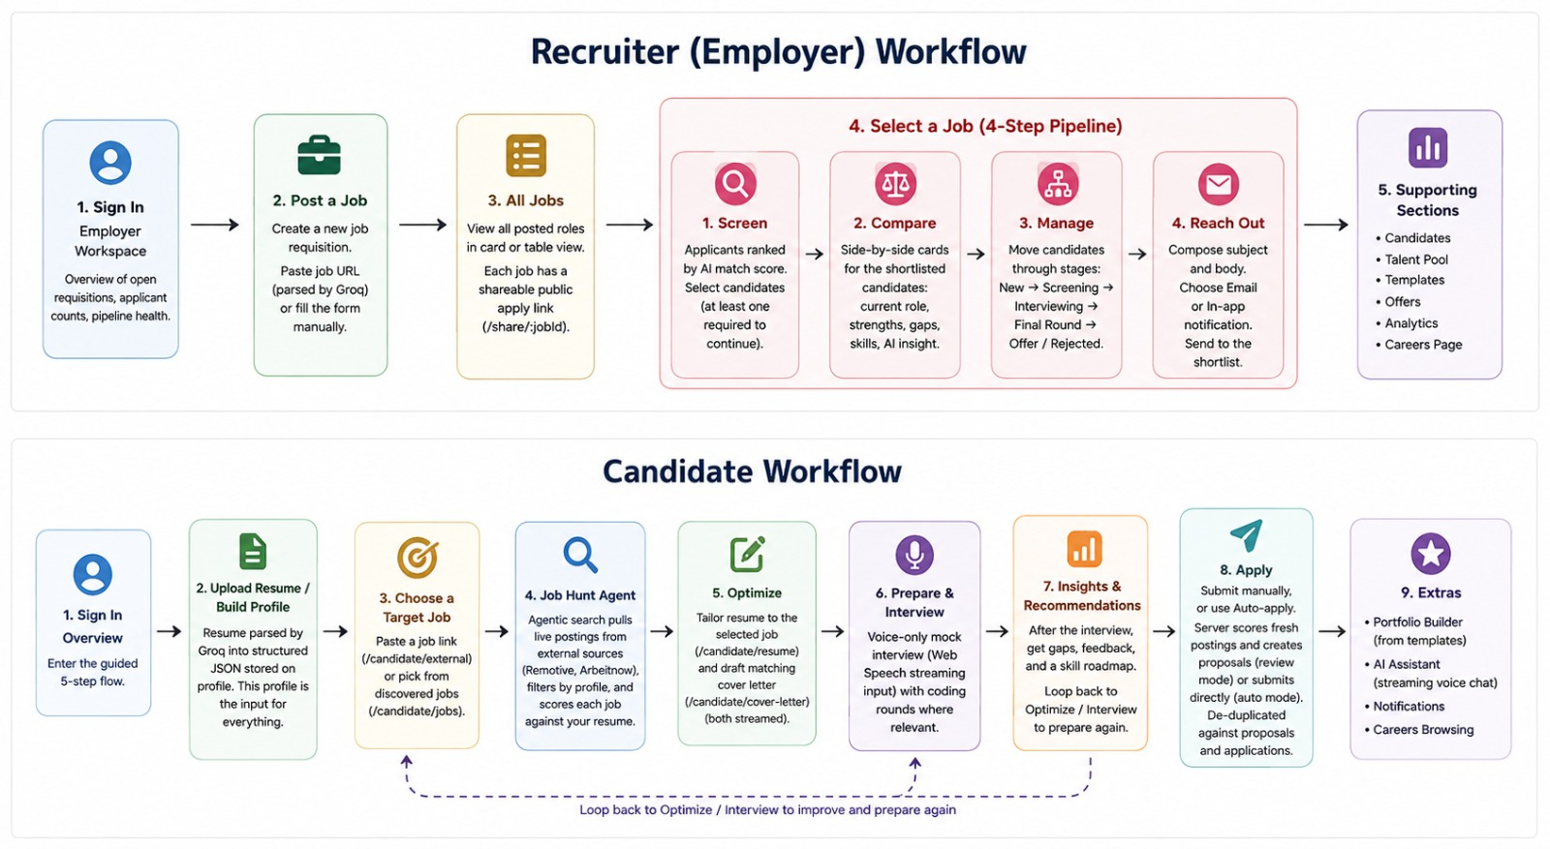

Figure 1 - Candidate Interface:
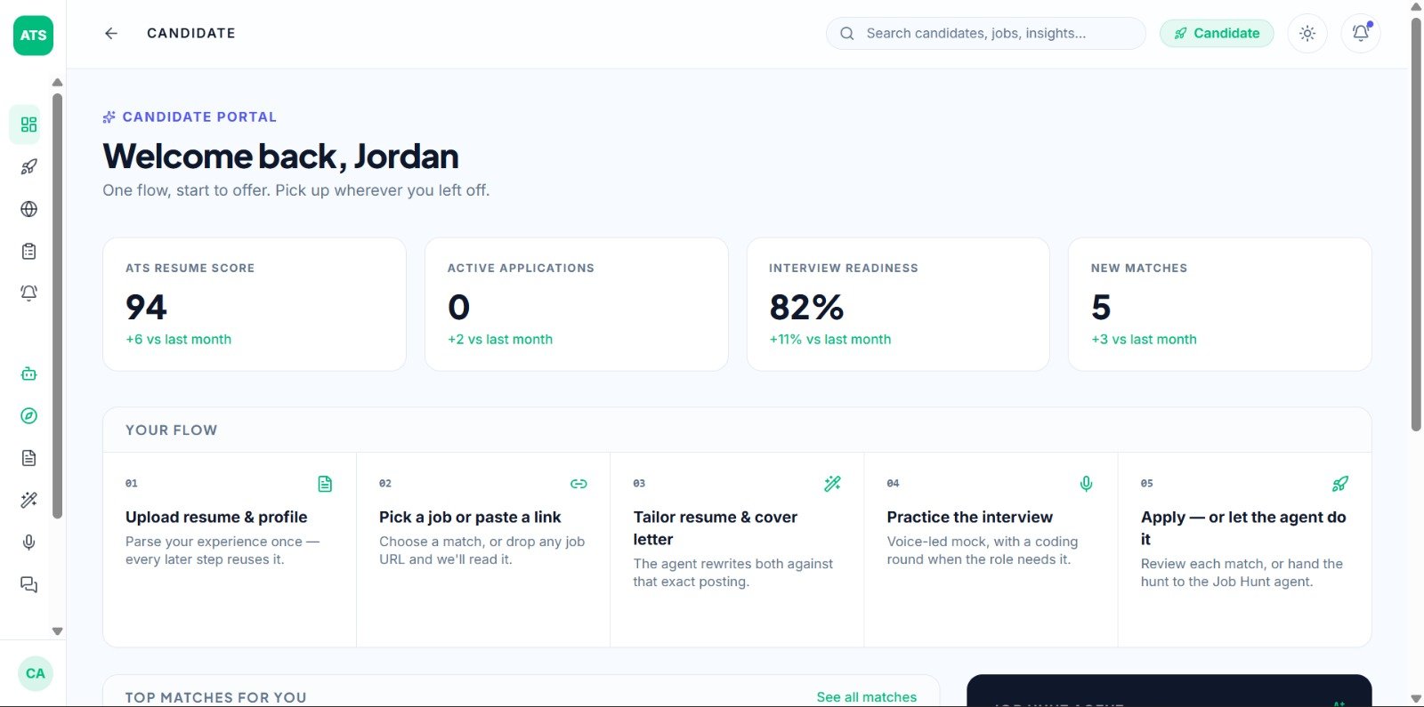

Figure 2 - Resume section:

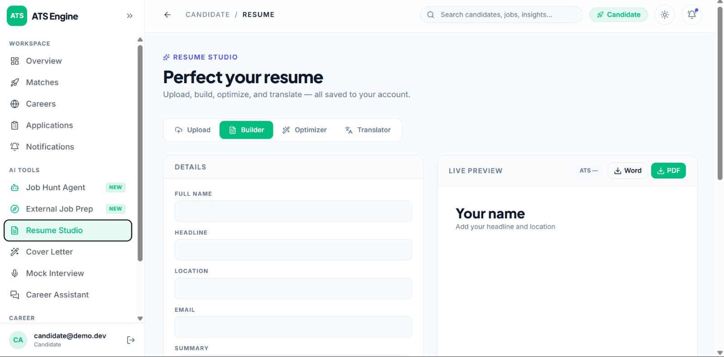

Figure 3 - URLProcessing module:

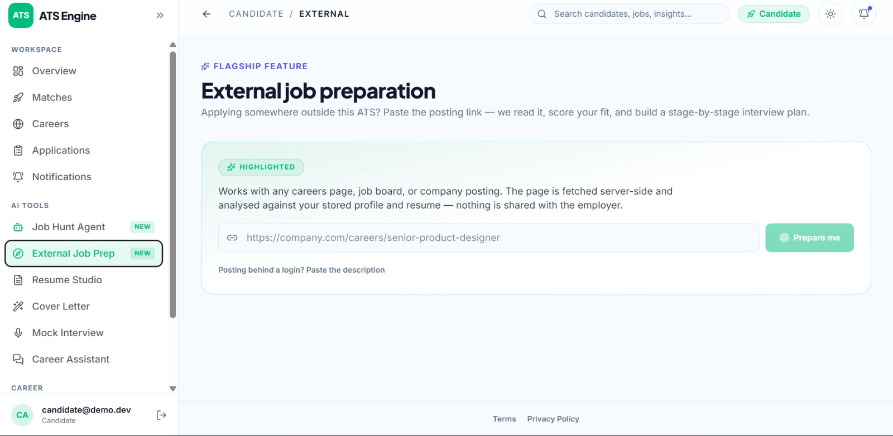

Figure 4 - Recruiter Profile:
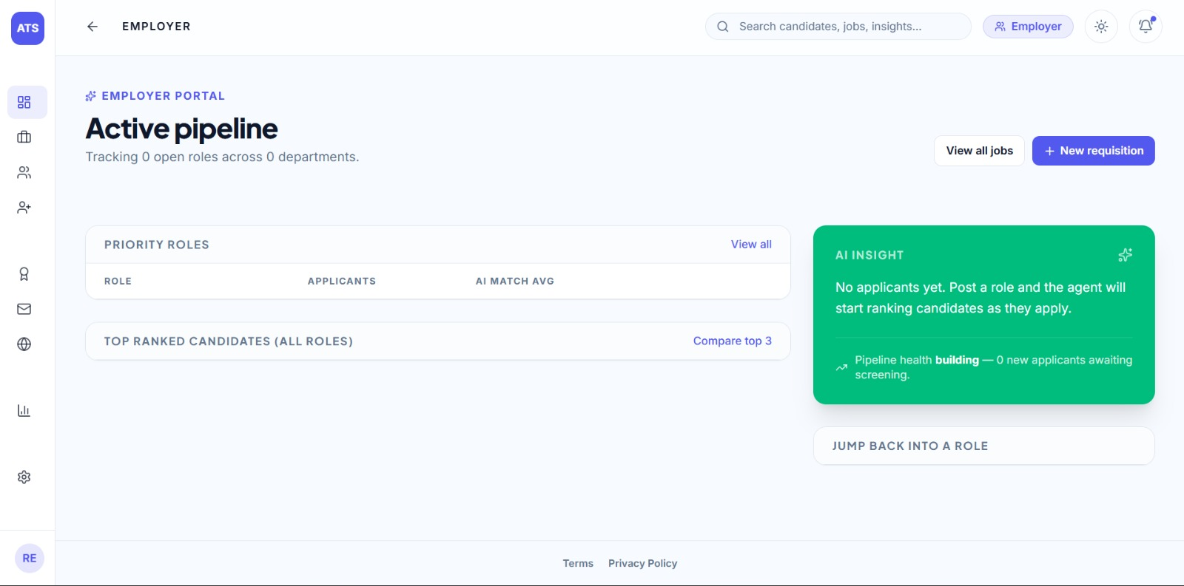

Figure 5 - Job Requisition module:
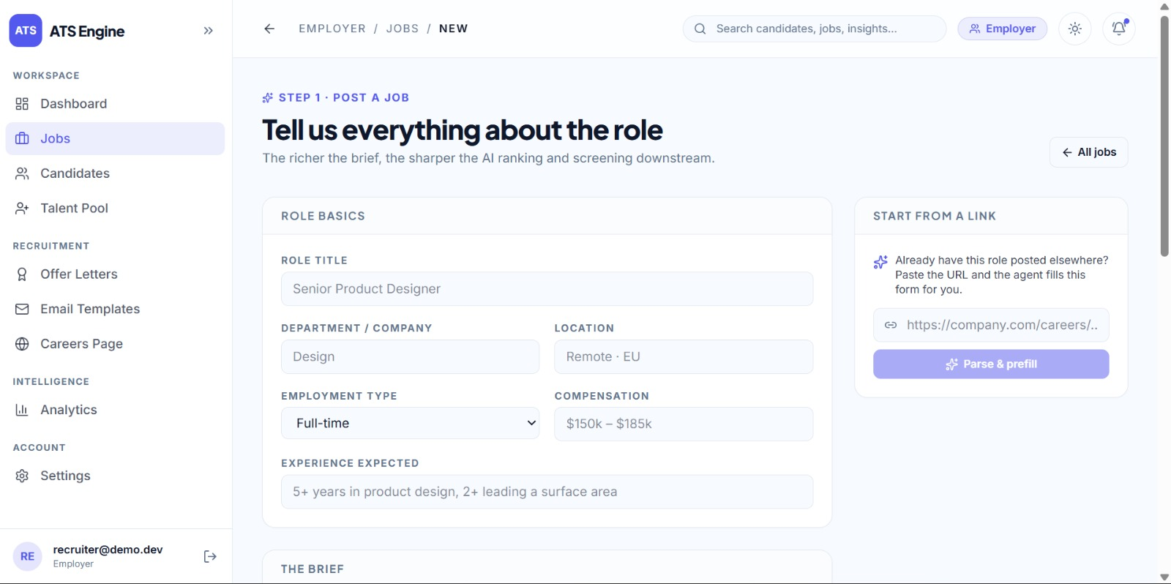

Figure 6 - Candidate profile:
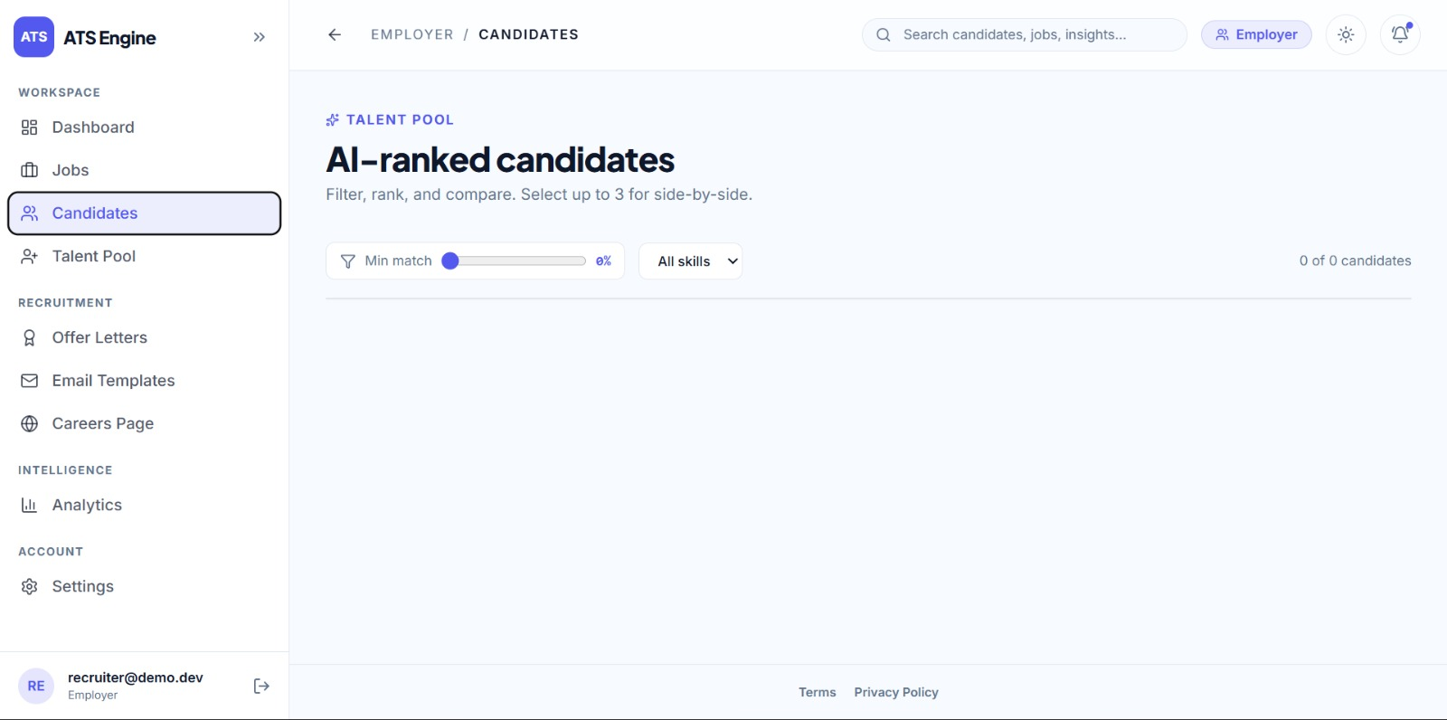

Figure 7 - AI Ranking:
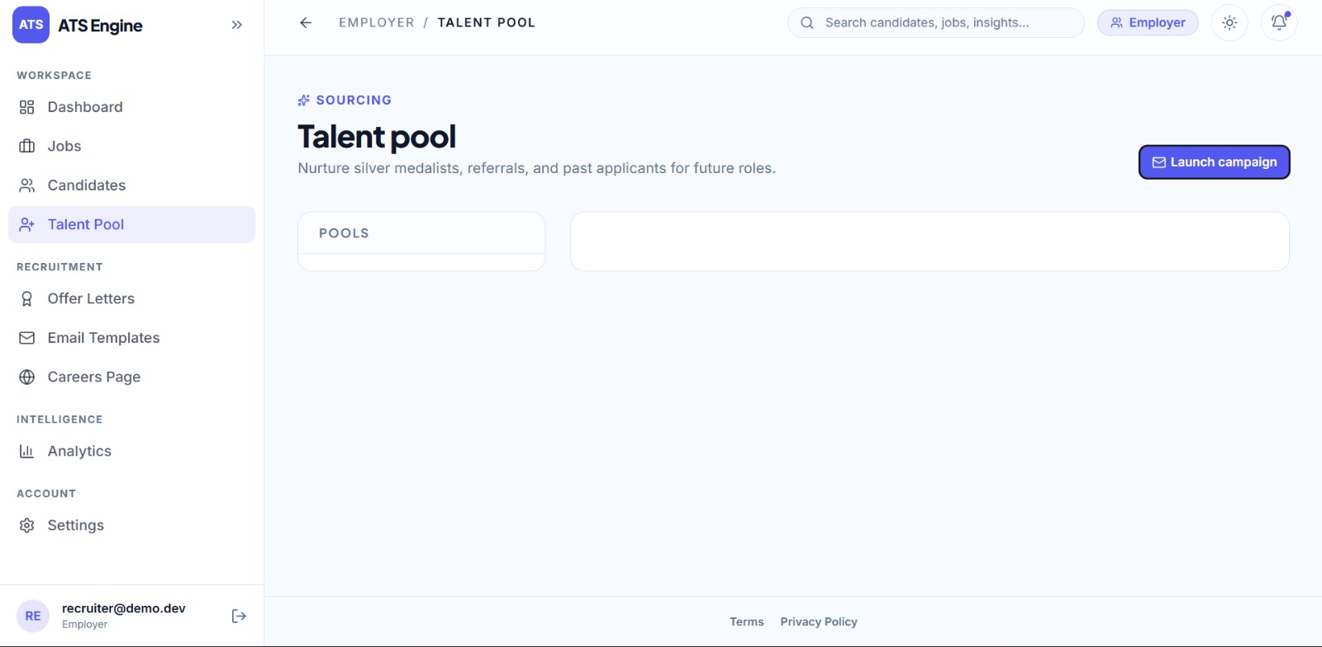

BRIEF DESCRIPTION OF THE INVENTION
The present invention relates to an artificial intelligence-based integrated recruitment and career preparation system that enables organizations to manage applicants while simultaneously providing candidates with personalized job-search and career-preparation facilities.
The system comprises a Recruiter Interface [1], Candidate Interface [2], Job Requisition Module [3], Job URL Processing Module [4], Resume Processing Module [5], Candidate Profile Module [6], AI Matching and Ranking Module [7], Candidate Comparison Module [8], Recruitment Pipeline Module [9], Job Hunt Agent [10], Resume Optimization Module [11], Cover Letter Generation Module [12], Voice Interview Module [13], Feedback and Recommendation Module [14], Application Automation Module [15], Portfolio Builder [16], AI Assistant [17], LLM API [18], External Job Sources [19], and Database [20].
The Recruiter Interface [1] provides an employer workspace through which recruiters can view open requisitions, applicant counts, and recruitment pipeline information. A recruiter can create a new job through the Job Requisition Module [3] either by manually entering job information or by providing a publicly available job URL.
The Job URL Processing Module [4] processes the provided job URL and extracts relevant job information including title, department, location, and job description. The extracted information is used to create a structured job requisition.
The Resume Processing Module [5] receives candidate resumes and extracts relevant candidate information. The extracted information is structured through the Candidate Profile Module [6], which may contain candidate skills, experience, education, projects, and other relevant professional information.
The AI Matching and Ranking Module [7] compares the structured candidate profile with the requirements of a selected job. The module determines an AI-based match score and uses the score to rank applicants according to their suitability for the particular role.
The Candidate Comparison Module [8] allows recruiters to examine selected candidates using information such as current role, strengths, gaps, skills, and AI-generated insights. This enables recruiters to make more informed decisions when creating a shortlist.
The Recruitment Pipeline Module [9] enables selected candidates to be moved through defined recruitment stages. The recruiter may manage candidates through stages including New, Screening, Interviewing, Final Round, Offer, and Rejected.
On the candidate side, the Candidate Interface [2] provides a guided workflow for creating a profile, finding jobs, preparing application material, practicing interviews, and applying for suitable positions.
A candidate can provide a resume to the Resume Processing Module [5] to generate a structured profile. The candidate can subsequently select a target job from available jobs or provide a public job URL for processing.
The Job Hunt Agent [10] provides intelligent job discovery by retrieving live job postings from supported external sources. The agent filters available postings according to the candidate profile and generates matching information for identifying relevant opportunities.
The Resume Optimization Module [11] uses the selected job requirements and candidate profile to generate a tailored resume. The generated resume emphasizes relevant skills, experience, projects, and qualifications corresponding to the selected role.
The Cover Letter Generation Module [12] generates a job-specific cover letter using the candidate profile and requirements of the target position.
The Voice Interview Module [13] provides a voice-based mock interview environment. The candidate responds through speech rather than typed input. The system can generate interview questions relevant to the selected role and may include coding-related rounds where applicable.
The Feedback and Recommendation Module [14] operates after the interview and identifies candidate gaps, provides performance feedback, and recommends areas for improvement. The recommendations can be used for subsequent resume optimization and interview preparation.
The Application Automation Module [15] supports manual and automated application workflows. The system can periodically evaluate fresh job postings against the candidate profile and identify suitable application opportunities. Depending upon the configured application mode, an application may be proposed for review or processed automatically.
The Portfolio Builder [16] provides facilities for creating a professional portfolio using available templates and candidate information. Portfolio information can provide additional evidence of candidate capabilities during the recruitment process.
The AI Assistant [17] provides conversational assistance to candidates through voice interaction for job-related questions and career preparation activities.
The LLM API [18] provides language intelligence for resume parsing, job-description processing, content generation, matching assistance, interview interaction, feedback generation, and other intelligent operations. External Job Sources [19] provide current job-posting information, while the Database [20] maintains the required system information.
The invention creates a continuous workflow connecting employer-side applicant management with candidate-side preparation and application automation, establishing a unified intelligent recruitment platform.
WE CLAIM:
The present invention discloses a "Smart Applicant Tracking System with Intelligent Recruitment & Career Preparation" connecting recruiter-side candidate evaluation with candidate-side career preparation services.

- An artificial intelligence-based recruitment and career preparation system comprising:
a Recruiter Interface [1] configured to provide an employer workspace to view requisitions and manage recruitment pipelines;
a Candidate Interface [2] configured to provide candidate career preparation and application assistance;
a Job Requisition Module [3] and a Job URL Processing Module [4] configured to create structured job requisitions from manual input or extracted job URLs;
a Resume Processing Module [5] and Candidate Profile Module [6] configured to parse candidate resumes into structured candidate profiles;
an AI Matching and Ranking Module [7] configured to compare candidate profiles with job requirements to generate match scores and rank applicants;
a Candidate Comparison Module [8] and Recruitment Pipeline Module [9] configured to compare candidate strengths and gaps, and advance candidates across defined recruitment stages;
a Job Hunt Agent [10] configured to search external job sources and identify job postings matching candidate profiles;
a Resume Optimization Module [11] and Cover Letter Generation Module [12] configured to dynamically tailor resumes and generate job-specific cover letters;
a Voice Interview Module [13] configured to conduct voice-based mock interviews and role-specific coding assessments;
a Feedback and Recommendation Module [14] configured to evaluate interview responses, identify skill gaps, and provide recommendations for candidate profile improvement; and
an Application Automation Module [15] configured to support manual and automated job applications.
2. The system as claimed in claim 1, wherein the Job URL Processing Module [4] automatically extracts and structures job title, department, location, and job description directly from publicly accessible web URLs.
3. The system as claimed in claim 1, wherein the Resume Processing Module [5] extracts candidate skills, experience, education, and projects to construct structured profiles within the Candidate Profile Module [6].
4. The system as claimed in claim 1, wherein the AI Matching and Ranking Module [7] computes match scores using natural language processing and semantic similarity matching between structured profiles and job requirements.
5. The system as claimed in claim 1, wherein the Candidate Comparison Module [8] enables multi-candidate evaluation based on role-specific strengths, detected skill gaps, and AI-generated insights.
6. The system as claimed in claim 1, wherein the Job Hunt Agent [10] periodically polls external job portals to discover matching vacancies based on candidate profiles.
7. The system as claimed in claim 1, wherein the Resume Optimization Module [11] emphasizes role-specific keywords, skills, and qualifications tailored to a selected target job requisition.
8. The system as claimed in claim 1, wherein the Voice Interview Module [13] receives spoken audio responses, converts speech into textual representations, and interactively presents dynamic questions relevant to target positions.
9. The system as claimed in claim 1, wherein recommendations generated by the Feedback and Recommendation Module [14] automatically feed into the Candidate Profile Module [6] and Resume Optimization Module [11] to form a continuous career-preparation loop.
10. The system as claimed in claim 1, further comprising a Portfolio Builder [16] configured to generate professional candidate portfolios, and an AI Assistant [17] configured to provide voice-based career guidance.

Signature
PG Scholar
M.Tech(CSE)
Erode Sengunthar Engineering College Perundurai - 638057
NAME OF THE APPLICANT: R.PRITHIVIRAJ PG Scholar
TITLE OF THE INVENTION
"Smart Applicant Tracking System with Intelligent Recruitment & Career Preparation"
ABSTRACT
The present invention relates to an artificial intelligence-based integrated applicant tracking and career preparation system that connects employer-side recruitment evaluation with candidate-side career preparation services. The system comprises a Recruiter Interface [1], Candidate Interface [2], Job Requisition Module [3], Job URL Processing Module [4], Resume Processing Module [5], Candidate Profile Module [6], AI Matching and Ranking Module [7], Candidate Comparison Module [8], Recruitment Pipeline Module [9], Job Hunt Agent [10], Resume Optimization Module [11], Cover Letter Generation Module [12], Voice Interview Module [13], Feedback and Recommendation Module [14], Application Automation Module [15], Portfolio Builder [16], AI Assistant [17], LLM API [18], External Job Sources [19], and Database [20].
On the recruiter side, job requisitions are created manually or extracted from public job URLs into structured formats, and applicant resumes are parsed into structured profiles. The AI Matching and Ranking Module [7] computes match scores to rank applicants, enabling recruiters to compare candidates across strengths, gaps, and AI insights through pipeline stages. On the candidate side, candidates utilize the Job Hunt Agent [10] to discover matching jobs from live external sources, generate tailored resumes and cover letters, and participate in voice-based mock interviews with role-specific coding rounds. The Feedback and Recommendation Module [14] identifies candidate skill gaps and updates profiles, establishing a continuous preparation loop. The platform provides a complete end-to-end recruitment and career preparation ecosystem.

